Events And Methods in Javascript
An HTML event can be something the browser does, or something a user does.

Onclick – It performs operation when The user clicks an HTML element.
Ex-
<!DOCTYPE html>
<html>
<head>
<script>
function fun() {
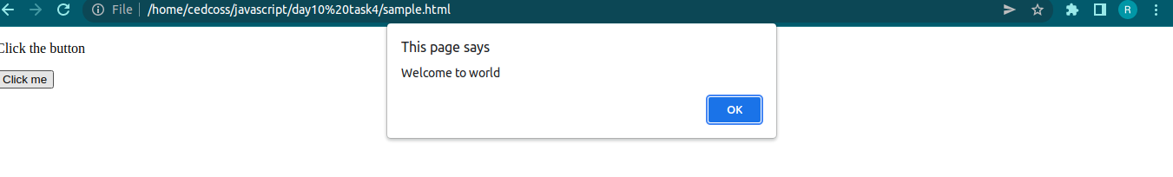
alert("Welcome to world");
}
</script>
</head>
<body>

<p> Click the button </p>
<button onclick = "fun()">Click me</button>
</body>
</html>

Onchange - When you leave the input field, a function is triggered which transforms the input text to upper case.
Ex-
<!DOCTYPE html>
<html>
<head>
<script>
function upperCase() {
const x = document.getElementById("fname");
x.value = x.value.toUpperCase();
}
</script>
</head>
<body>
Enter your name: <input type="text" id="fname" onchange="upperCase()">

</body>
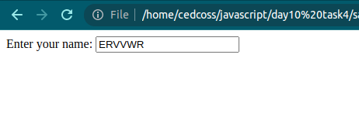
</html>

onsubmit – When user submits the form.
Ex-
<!DOCTYPE html>
<html>
<head>
<script>
function fun() {
alert("form submitted");
}
</script>
</head>
<body>
<form onsubmit = "fun()">

<button type="submit">Click me</button>
</form>
</body>
</html>
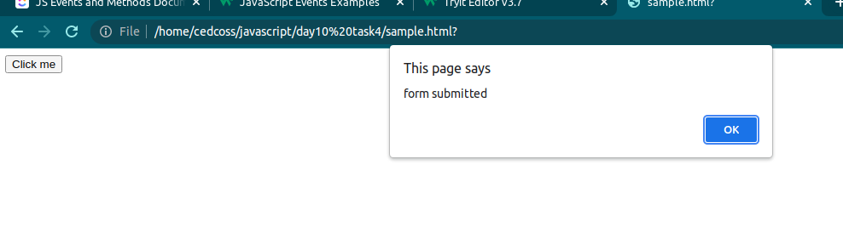
onkeydown - A function is triggered when the user is pressing a key in the input field.
Ex-
<!DOCTYPE html>
<html>
<head>
<script>
function myFunction() {
alert("You pressed a key inside the input field");
}
</script>
</head>
<body>

<input type="text" onkeydown="myFunction()">

</body>

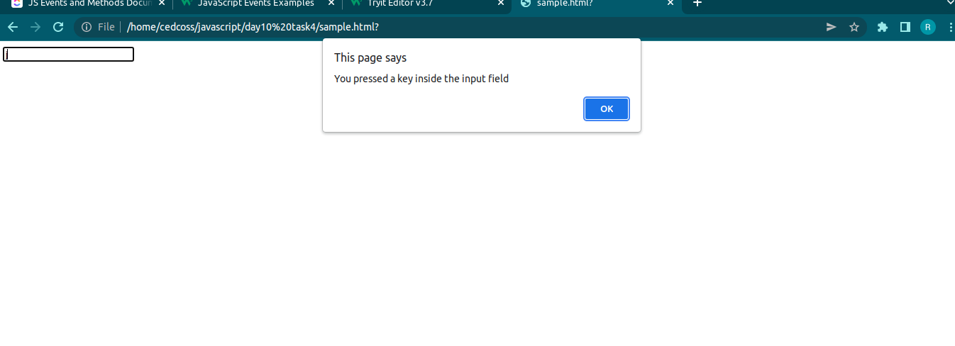
onkeypress - A function is triggered when the user is pressing a key in input field
Ex-
<!DOCTYPE html>
<html>
<head>
<script>
function myFunction() {
alert("You pressed a key inside the input field");
}
</script>
</head>
<body>

<input type="text" onkeypress="myFunction()">

</body>

</html>

onkeyup- A function is triggered when the user releases a key in the input field. The function transforms the character to upper case.</p>

onmouseover/out – when mouse passed over or out from any element
Ex-
<!DOCTYPE html>
<html>
<body>

<h1 onmouseover="style.color='red'" onmouseout="style.color='black'">My name is Rishbabh</h1><!DOCTYPE html>
<html>
<head>
<script>
function fun() {
alert("form");
}
</script>
</head>
<body>
<form>
<input type="text" onchange="" name="">
<button ondblclick = "fun()">Click me</button>
</form>
</body>
</html>

</body>
</html>

ondblclick – when button is doubled click
Ex-
<!DOCTYPE html>
<html>
<head>
<script>
function fun() {
alert("form");
}
</script>
</head>
<body>
<form>
<input type="text" onchange="" name="">
<button ondblclick = "fun()">Click me</button>
</form>
</body>
</html>

Methods in javascript
CharAt() - method returns the character at a specified index (position) in a string.
Index must be starts from 0.
ex-
<!DOCTYPE html>
<html>
<head>
<title></title>
</head>
<body>
<script type="text/javascript">
let t = "Rishabh";
document.write(t.charAt(1));
</script>
</body>
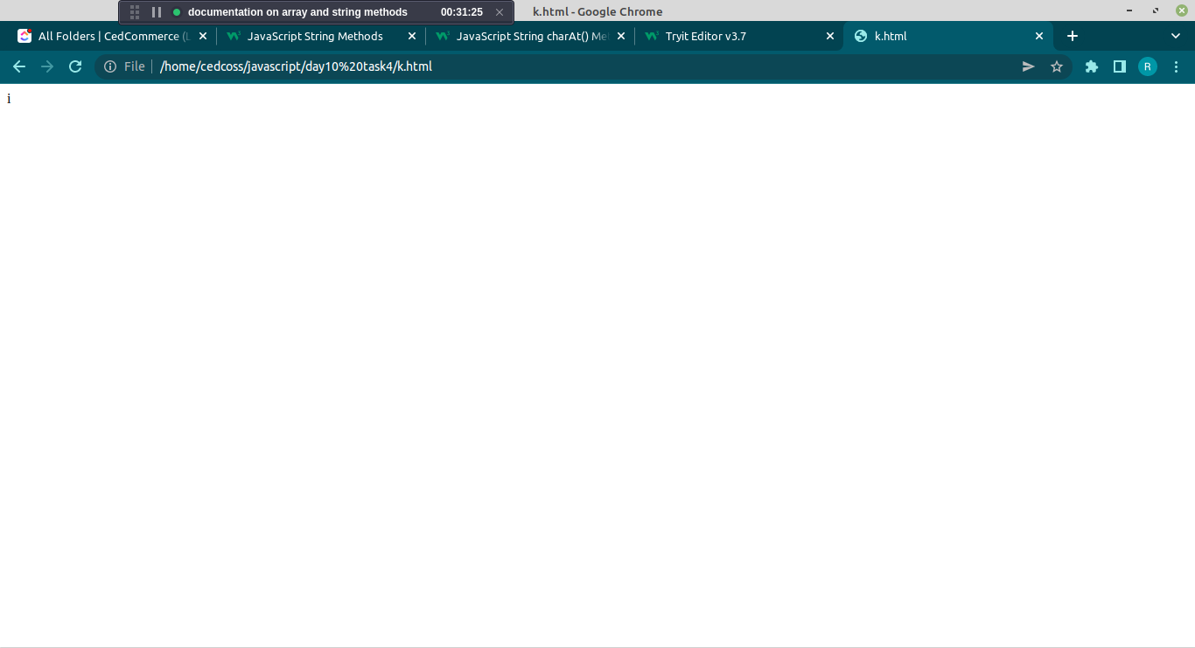
</html>

concat() -The concat() method joins two or more strings.
The concat() method does not change the existing strings.
Ex-
<!DOCTYPE html>
<html>
<head>
<title></title>
</head>
<body>
<script type="text/javascript">
let t = "Rishabh";
let s = "Singh";
document.write(t.concat(s));
</script>
</body>
</html>
Output – Rishabh Singh
Includes() - The includes() method returns true if a string contains a specified string.
Ex-
<!DOCTYPE html>
<html>
<head>
<title></title>
</head>
<body>
<script type="text/javascript">
let t = "Hello World, welcome to the universe.";
let s = t.includes("welcome");
document.write(s);
</script>
</body>
</html>
Output – true
indexOf- returns the position of the first occurrence of a value in a string:
Ex
<script type="text/javascript">
let t = "Hello World, welcome to the universe.";
let s = t.indexOf("o");
document.write(s);
</script> Output – 2
length- (property)- It return the length of string.
Ex-
<script>
let text = "this is mine";
let length = text.length;

document.getElementById("demo").innerHTML = length;
</script> Output – 12

replace() - method returns a new string with the value(s) replaced.
Ex-
<!DOCTYPE html>
<html>
<body>
<script>
let text = "I love John";
document.write(text.replace("love", "hate"));
</script>
</body>
</html> Output - I hate John

slice() - It extract the part of string from the giver string.
Split() - method splits a string into an array of substrings. method returns the new array.
Ex-
<!DOCTYPE html>
<html>
<head>
<title></title>
</head>
<body>
<script type="text/javascript">
let t = "This is my first Vehicle";
let s = t.slice(0,5);
document.write("This is result of slice -"+s+"<br>");
let z = t.split(" ");
document.write("This is result of split -"+z);
</script>
</body>
</html>

