INTERNSHIP REPORT

GAS TURBINE RESEARCH ESTABLISHMENT

DRDO

BANGALORE
By
RISHABH JAIN

Under Supervision of
Dr. Rajeev Jain

Scientist -G (GTRE)
(Duration: 4th JULY, 2022 to 27th AUGUST, 2022)



Gas turbine research establishment Maharaja Agrasen Institute
DRDO Of technology
C.V RAMAN NAGAR Rithala ,Delhi-32

ACKNOWLEDGEMENT

I would like to express my gratitude to my mentor Mr. Rajeev jain for supporting me during the intership. His shared knowledge and experience will never be forgotten by me. The exposure I got during the internship in manufacturing, analysis, Finite element methods and research equipment will help me in becoming a good mechanical engineer. The knowledge of simulations and software’s will help me in field of Design and CAE. My mentor shared his unique method of reading research papers. The knowledge is helping me in working on new subjects in research. I look forward in working with him on several research papers. The experience will open door for me to enter in the vast field of Design. I would like to thank my teammates who supported me in every task. The CAE lab of Gas turbine research establishment had been really helpful. During the internship I also learned how to apply my knowledge of 3-year engineering practically. I got to know about my weakness which I will work upon in near future.

Rishabh jain
Btech (Mechanical Engineering)
7th semester

Self-Assessment of Industrial Training by Student
- Student Name: RISHABH JAIN
- Name and Address of Industry: Gas Turbine Research Establishment (DRDO) C.V Raman Nagar
- Guide/Trainer from Industry with designation: Dr. Rajeev jain (Scientist -G)
- Contact details of Guide/Trainer: Rajeevjain63@gmail.com
- Date of commencement and end: 4th July to 27th August 2022

I hereby declare that I have learnt following skills during my Industrial training:
a) Abaqus
b) Hypermesh
f) Analysis of Components

Date: 9-11-2022 Signature of Student

INDEX

S.no CONTENTS Page no
- Introduction 1
  - Problem statement 2
- Analysis 3
- Literature Review 4
- DEK File 5
- How to make DEK file……………………………………………………………
- Stress Distribution of constant Thickness disc(ANALYTICALY)………………………
- Stress Distribution of constant Thickness disc(FEA)………………………
- Stress Distribution of hyperbolic Disc……………………………………………
- Stress distribution of Varying thickness disc…………………………………….
- Stress distribution of Varying thickness disc(FEA)…………………………………….
- Labs and research Equipment Of GTRE
- Conclusion 16
- Bibliography 17

Learning Objectives/Internship Objectives

- Internships are generally thought of to be reserved for college students looking to gain experience in a particular field. However, a wide array of people can benefit from Training Internships in order to receive real world experience and develop their skills.

- An objective for this position should emphasize the skills you already possess in the area and your interest in learning more

- Internships are utilized in a number of different career fields, including architecture, engineering, healthcare, economics, advertising and many more.

- Some internship is used to allow individuals to perform scientific research while others are specifically designed to allow people to gain first-hand experience working.

- Utilizing internships is a great way to build your resume and develop skills that can be emphasized in your resume for future jobs. When you are applying for a Training Internship, make sure to highlight any special skills or talents that can make you stand apart from the rest of the applicants so that you have an improved chance of landing the position.

INTRODUCTION

PROBLEM STATEMENT

1.As the speed of rotation of a compressor rotor disc increases there comes a point at which the stresses in the material of the disc are so great that the material outside a certain radius ceases to be self-supporting, and the thickness of the disc hub has to be increased to give additional support. In the case of a very high speed compressor the radius at which the material ceases to be self supporting, known as the free hoop radius,
2.Radius can become so small that the disc hub has to be made disproportionately large and the weight penalty becomes very high.
3.It is imperative therefore that as little weight of material as possible in high speed compressors and turbines, lies outside the free hoop radius.

Reference 2 (NAFEMS Journal)
Problem statement of the paper
The reader is asked to use his/her finite element system to determine the angular velocity to cause the two discs of Figure 1 to burst based on a UTS of 1000MPa. For this study, no radial loads due to blades are considered. For the parallel sided disc the theoretical solution based on the Lamé equations can be used for software verification – see for example reference [3]. The second, tapered, disc has no theoretical solution and solution verification will need to be used to ensure that the mean hoop stress calculated by the axisymmetric finite element model has converged sufficiently.

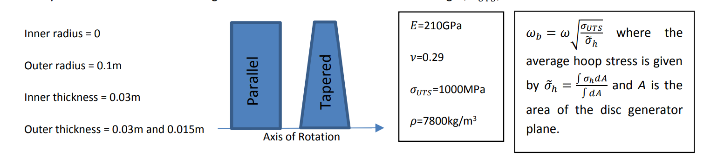
Data assumed for analysis

Theoretical Elastic solution
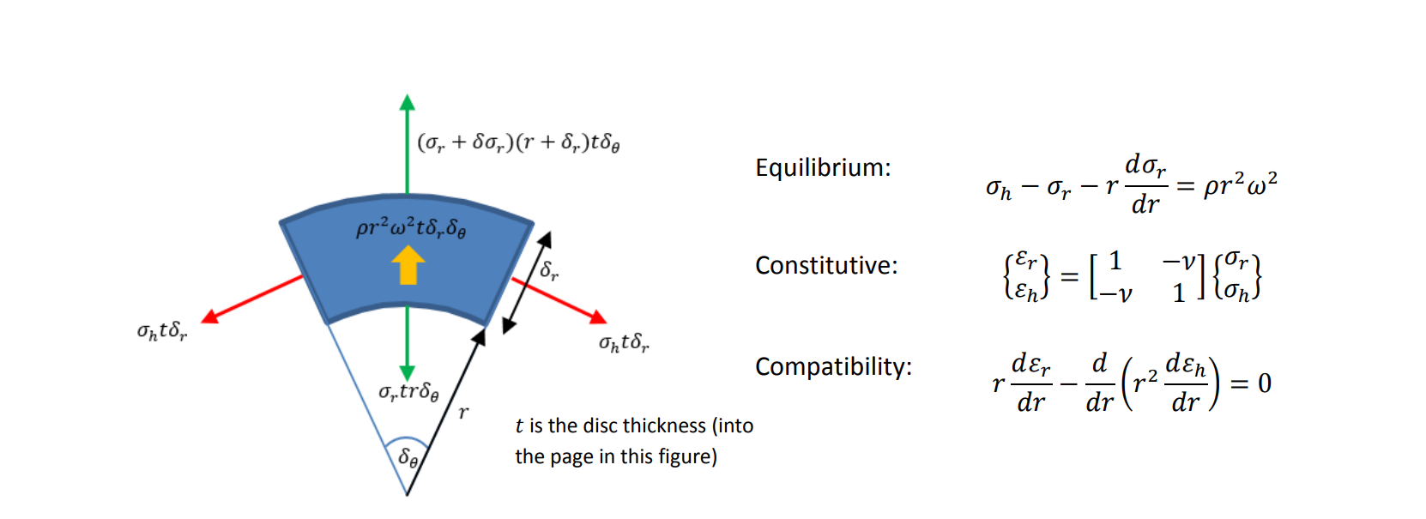

Equation of hoop and radial stress

Elastic - hoop stress $σ_{h}= \frac{ρω^{2}}{8}[\left(3+v\right)R^{2}-\left(1+3v\right)r^{2} ]$

Radial stress $σ_{r}= \frac{ρω^{2}}{8}\left(3+v\right){(R}^{2}-r^{2} )$

Assumption- No radial loads applied at the end( no blades are joined at the end) . hence radial stress at corner is zero.

Elastic Limit Speed (Theoretical)
Using yield stress as design criteria – we=5590 rad/s

Theoretical hyperstatic design solution

A hyperstatic or self-balancing stress field may be added to the particular solution so as to maximise the load carrying capacity of the disc and provide a total solution that does not violate the yield criterion

Hyperstatic Hoop $σ_{h}^{°}= \frac{ρω^{2}}{24}\left(1+3v\right)\left(3r^{2}-R^{2}\right)$
Radial $σ_{r}^{°}= \frac{ρω^{2}}{24}\left(1+3v\right)\left(r^{2}-R^{2}\right)$

The various parts, particular and hyperstatic, of the total solution are shown, as a function of radius in Figure 4 together with the elastic and plastic stress as they lie within the Tresca yield criterion.

plastic limit speed (theoretical)

using Tresca yield criteria wp=6201.7 rad/sec

Finite element model
Assumption -In this study the influence of strain hardening has not been considered

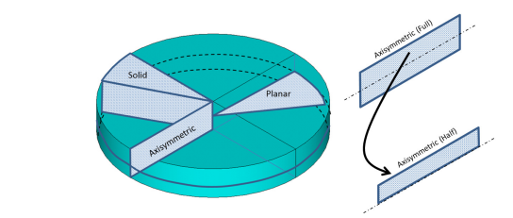
Three types of simulation can be possible
Solid
Planar
Axisymmetric

Here axisymmetric is done
Finite element elastic solution

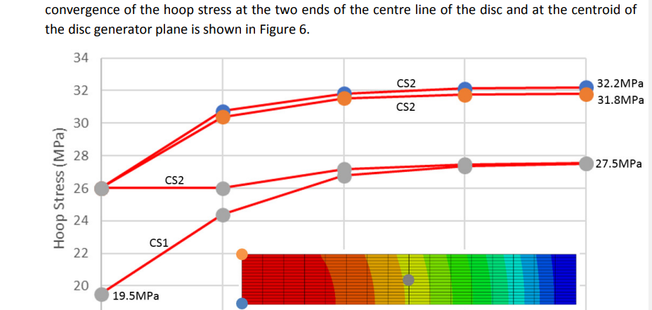

Finite element plastic solution
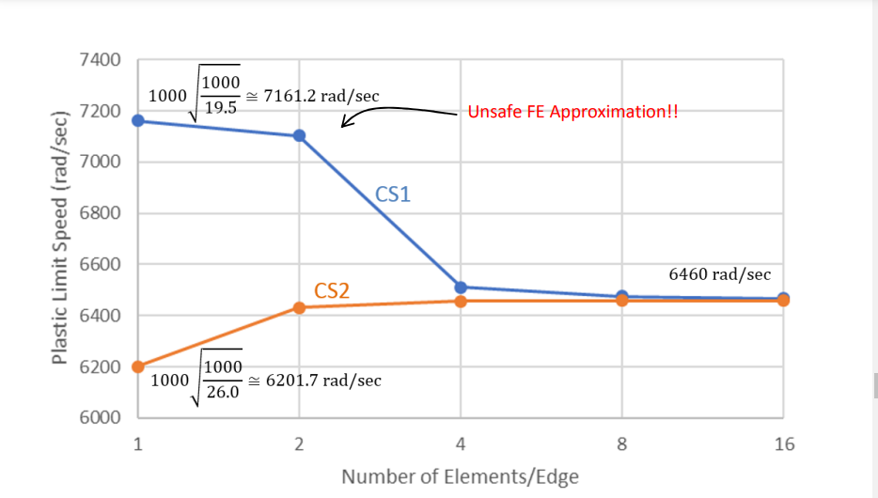

The plastic limit speed predicted by the finite element analysis (6460rad/sec) is about 4% greater than the theoretical value (6202rad/sec). The main reason for this is due to the different yield criterion adopted as shown in Figure 9.

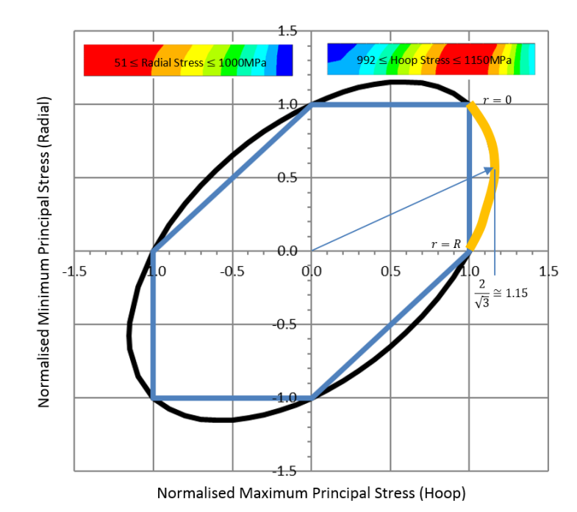

Tapered disc challenge

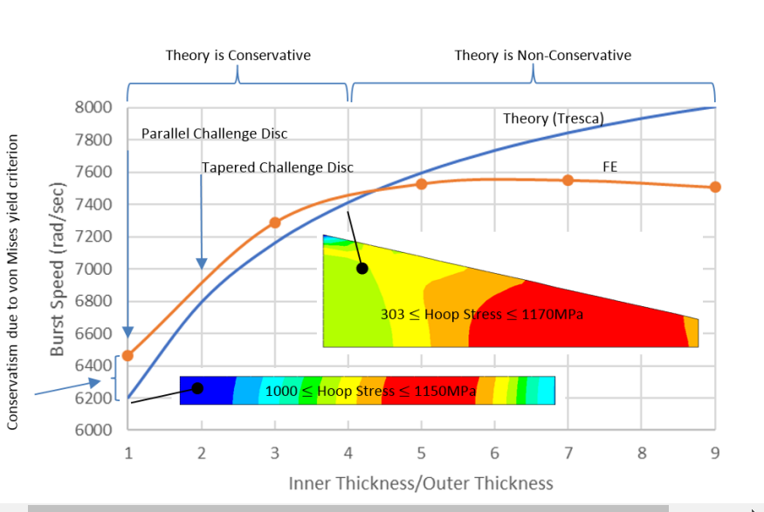

Making DEK file for abacus
Why dek file
The input file is the means of communication between the preprocessor, usually ABAQUS/CAE, and the analysis product, ABAQUS/Standard. It contains a complete description of the numerical model. The input file is a text file that has an intuitive, keyword-based format, so it is easy to modify using a text editor if necessary; if a preprocessor such as ABAQUS/CAE is used, modifications should be made using it. Indeed, small analyses can be specified easily by typing the input file directly.
Steps for creating dek(input) file
The global coordinate system in ABAQUS is a right-handed, rectangular (Cartesian) system. For this example define the global 1-axis to be the horizontal axis of the hoist and the global 2-axis to be the vertical axis (Figure 2–3). The global 3-axis is normal to the plane of the framework. The origin (=0, =0, =0) is the bottom left-hand corner of the frame.
Figure 2–3 Coordinate system and origin for model.
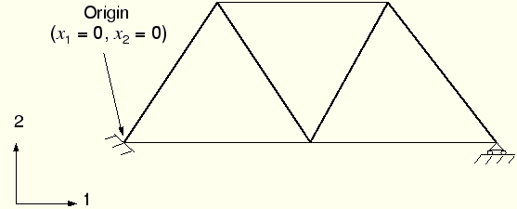
For two-dimensional problems, such as this one, ABAQUS requires that the model lie in a plane parallel to the global 1–2 plane.

2.3.3 Mesh
You must select the element types and design the mesh. Creating a proper mesh for a given problem requires experience. For this example you will use a single truss element to model each member of the frame, as shown in Figure 2–4.

2.3.4 Model data
The first part of the input file must contain all of the model data. These data define the structure being analyzed. In the overhead hoist example the model data consist of the following:
- Geometry:
  - Nodal coordinates.
  - Element connectivity.
  - Element section properties.
- Material properties.
Heading
The first option in any ABAQUS input file must be *HEADING. The data lines that follow the *HEADING option are lines of text describing the problem being simulated. You should provide an accurate description to allow the input file to be identified at a later date. Moreover, it is often helpful to specify the system of units, directions of the global coordinate system, etc. For example, the *HEADING option block for the hoist problem contains the following:
*HEADING
Two-dimensional overhead hoist frame
SI Units
1-axis horizontal, 2-axis vertical
Data file printing options
By default, ABAQUS will not print an echo of the input file or the model and history definition data to the printed output (.dat) file. However, it is recommended that you check your model and history definition in a datacheck run before performing the analysis. The datacheck run is discussed later in this chapter.
To request a printout of the input file and of the model and history definition data, add
*PREPRINT, ECHO=YES, MODEL=YES, HISTORY=YES
to the input file.
Nodal coordinates
<node number>,<-coordinate>,<-coordinate>,<-coordinate>
The nodes for the hoist model are defined as follows:
*NODE
101, 0., 0., 0.
102, 1., 0., 0.
103, 2., 0., 0.
104, 0.5, 0.866, 0.
105, 1.5, 0.866, 0.
Element connectivity
The members of the overhead hoist are modeled with truss elements. The format of each data line for a truss element is
<element number>, <node 1>, <node 2>
where node 1 and node 2 are at the ends of the element (see Figure 2–5). For example, element 16 connects nodes 103 and 105 (see Figure 2–6), so the data line defining this element is
16, 103, 105
The TYPE parameter on the *ELEMENT option must be used to specify the kind of element being defined. In this case you will use T2D2 truss elements.
Element section properties
For the T2D2 element you must use the *SOLID SECTION option and give one data line with the cross-sectional area of the element. If you leave the data line blank, the cross-sectional area is assumed to be 1.0.
In this case all the members are circular bars that are 5 mm in diameter. Their cross-sectional area is 1.963 � 10^{–5} m².
The MATERIAL parameter, which is required for most element section options, refers to the name of a material property definition that is to be used with the elements. The name can have up to 80 characters and must begin with a letter.
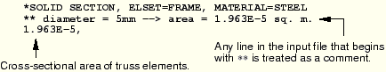
Materials
ABAQUS has a large number of material models, many of which include nonlinear behavior. In this overhead hoist example we use the simplest form of material behavior: linear elasticity. In Chapter 8, “Materials,” two of the most common forms of nonlinear material behavior are considered: metal plasticity and rubber elasticity. A discussion of all the material models available in ABAQUS/Standard can be found in the ABAQUS Analysis User's Manual.
Linear elasticity is appropriate for many materials at small strains, particularly for metals up to their yield point. It is characterized by a linear relationship between stress and strain (Hooke's law), as shown in Figure 2–7.
Figure 2–7 Linear elastic material.
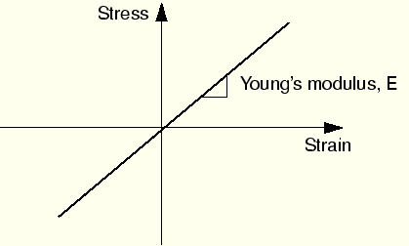
The material behavior is characterized by two constants: Young's modulus, E, and Poisson's ratio, .
A material definition in the ABAQUS input file starts with a *MATERIAL option. The parameter NAME is used to associate a material with an element section property. For example,
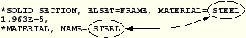
Material suboptions directly follow their associated *MATERIAL option. Several suboptions may be required to complete the material definition. All material suboptions are associated with the material that is listed on the most recent *MATERIAL option until another *MATERIAL option or a non-material option block is given.
Without considering thermal expansion effects (which would be defined with the *EXPANSION material suboption), one material suboption, *ELASTIC, is required to define a linear elastic material. The form of this option block is
*ELASTIC
<E>,<>
Therefore, the complete, isotropic, linear elastic material definition for the hoist members, which are made of steel, should be entered into your input file as
*MATERIAL, NAME=STEEL
*ELASTIC
200.E9, 0.3
The model definition portion of this problem is now complete since all the components describing the structure have been specified.

Designing the turbomachine disc

Free hoop radius- The great difference between the real disc growth and the thin disc growth at the bore. The material at the disc rim is not able to support itself without some assistance from the cob. When we plot the radial growth of both disc with radius , the point where these two curves coincides is called free hoop radius.

We can now discuss the possible sources of stress. Disc stresses arise, in the main, from the following sources:-
a) Centrifugal body force of disc material in a rotary inertial field.
b) Radial centrifugal load, produced by the "dead" mass of the blades, lock-plates, shrouds etc, applied to the circumference of the disc as a "rim-stress".
c) Temperature gradient between bore and rim, in association with the coefficient of thermal expansion, producing a thermal stress.
d) Torque load producing shear stresses in the body of the disc either by steady-state torque transmission from turbine to compressor, or inertia loading created as the machine accelerates or decelerates.
e) Bending loads applied to the disc by the pressure difference across the stage, or from the gas-bending loads on the blades.
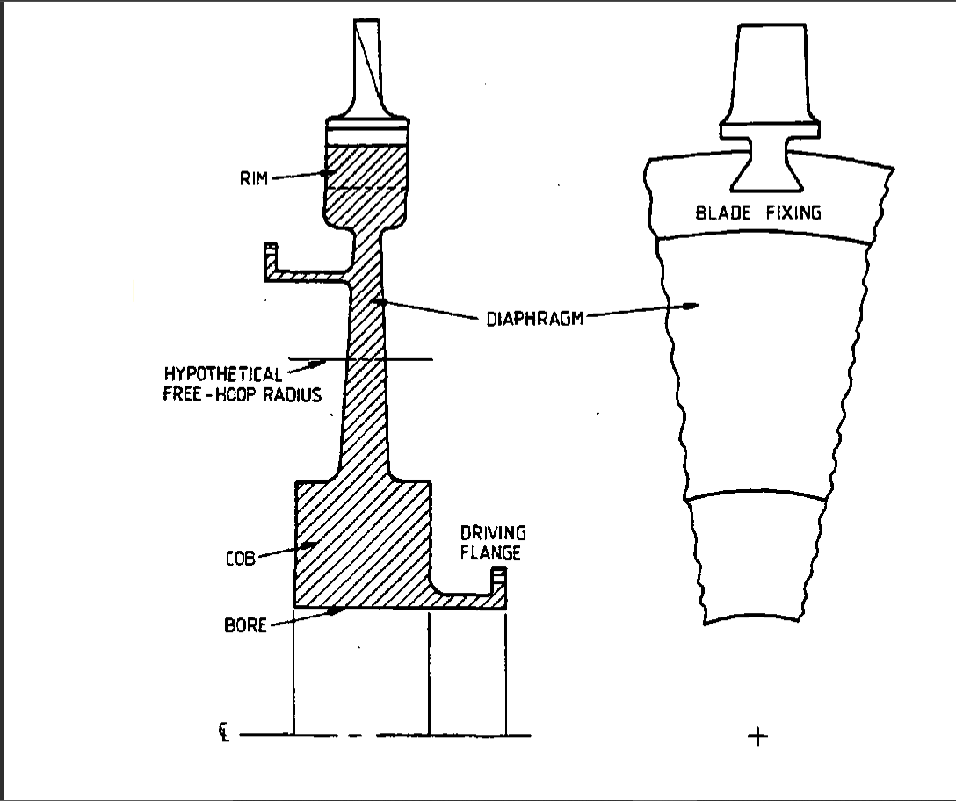

CENTRIFUGAL BODY FORCE

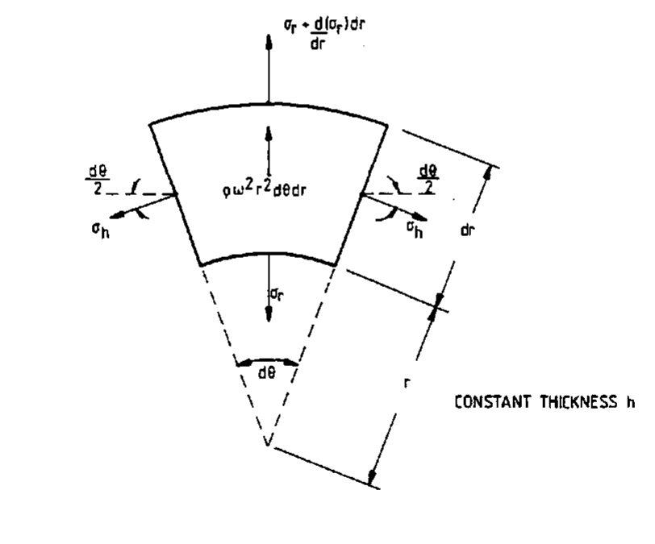

Using equilibrium conditions

$σ_{r}= A-\frac{B}{r^{2}}-\frac{(3+v)ρω^{2}r^{2}}{8}$
$σ_{h}= A+\frac{B}{r^{2}}-\frac{(1+3v)ρω^{2}r^{2}}{8}$

Solid constant thickness disc Hollow constant thickness disc

$σ_{r}= \frac{(3+v)ρω^{2}(r_{0}^{2}-r^{2})}{8}$ $σ_{r}= \frac{\left(3+v\right)ρω^{2}[{r_{0}^{2}+}^{r_{i}^{2}}-\frac{{{r_{0}^{2}+}^{r}}_{i}^{2}}{r^{2}}- -{ r}^{2}]}{8}$
$σ_{h}=[\frac{\left(3+v\right)r_{0}^{2}}{8}-\frac{\left(1+3v\right)}{8}]ρω^{2}$ $σ_{r}= \frac{\left(3+v\right)ρω^{2}[{r_{0}^{2}+}^{r_{i}^{2}}-\frac{{{r_{0}^{2}+}^{r}}_{i}^{2}}{r^{2}}- -{ \{\frac{(1+3v)}{(3+v)} r}^{2}]}{8}$

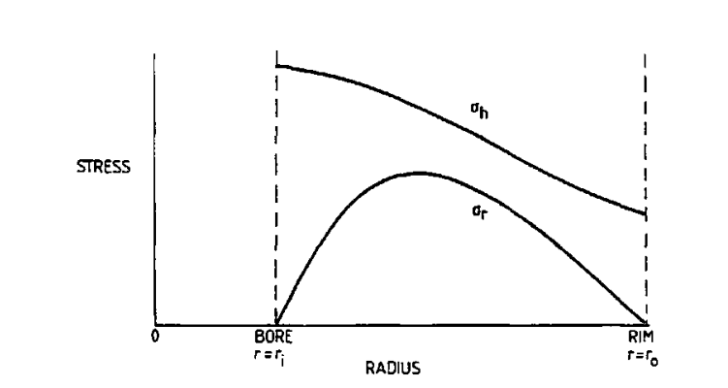

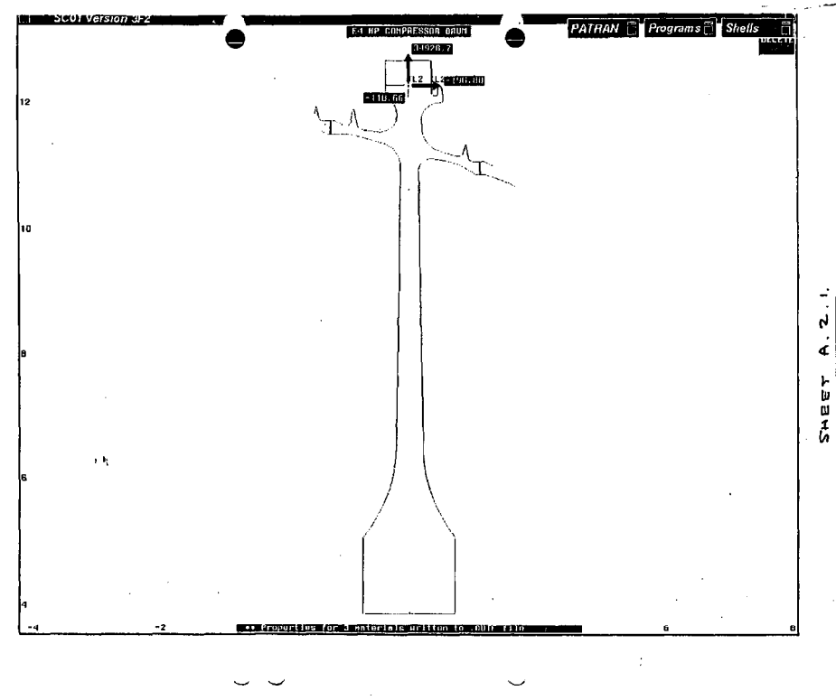

Method to plot stress distribution using tables( on Excel)

- Firstly, the constant value tables are made and some regular expressions values are calculated for different radius values and different heights.
- Different constants like angular velocity, A and B used in radial and tangential velocity formula are calculated.
- Excel sheets are made using formulas.

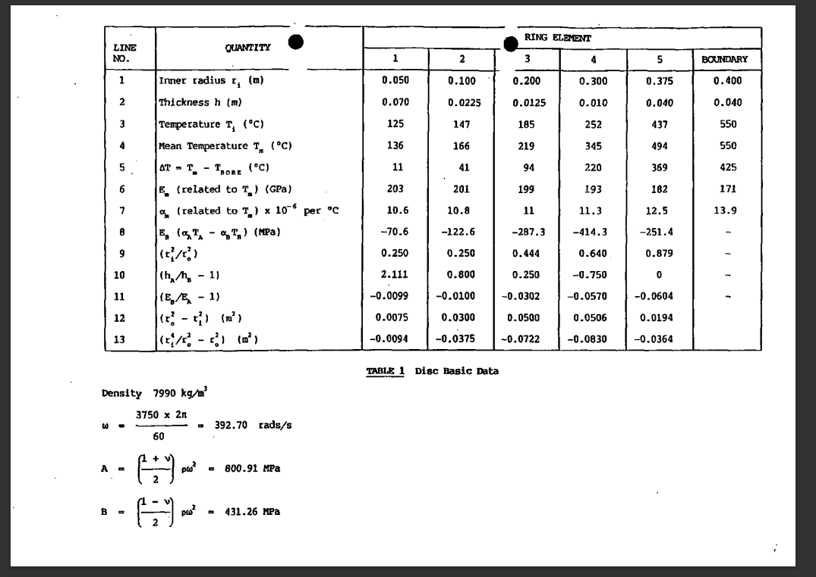

RADIUS AT different heights
CONSTANTS

- Now since we don’t have secondary boundary condition we will use arbitrary values for stress and do calculations
- A correction factor will be introduced for making correct predictions

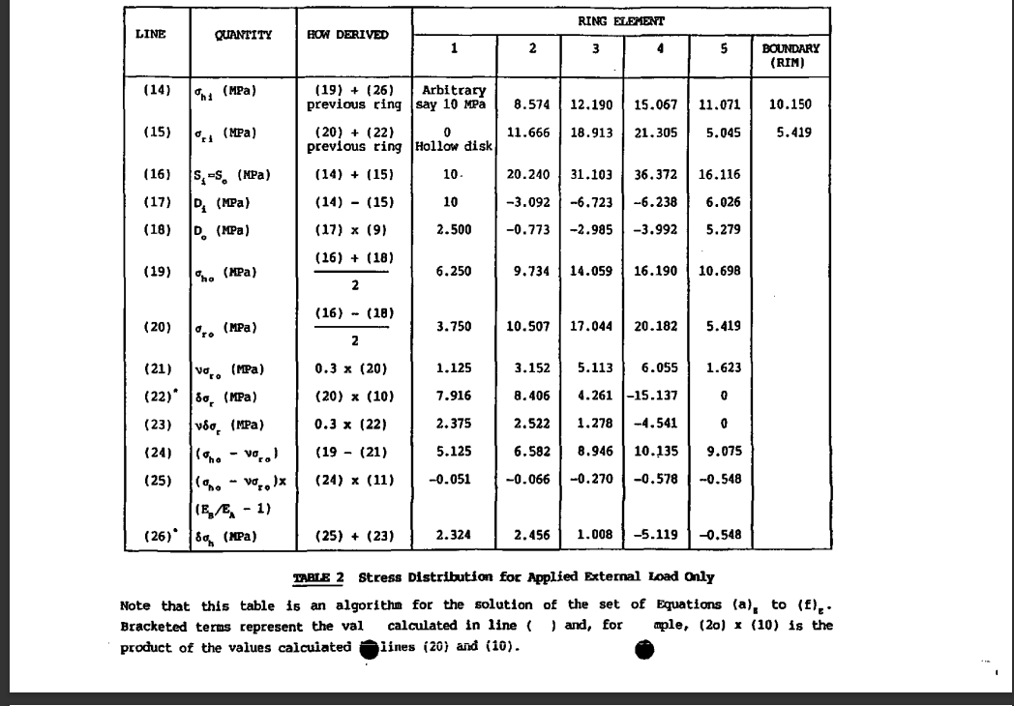

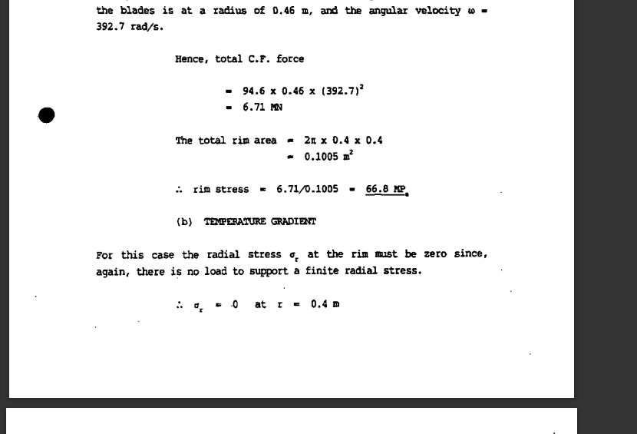
Boundary conditions for correction factor

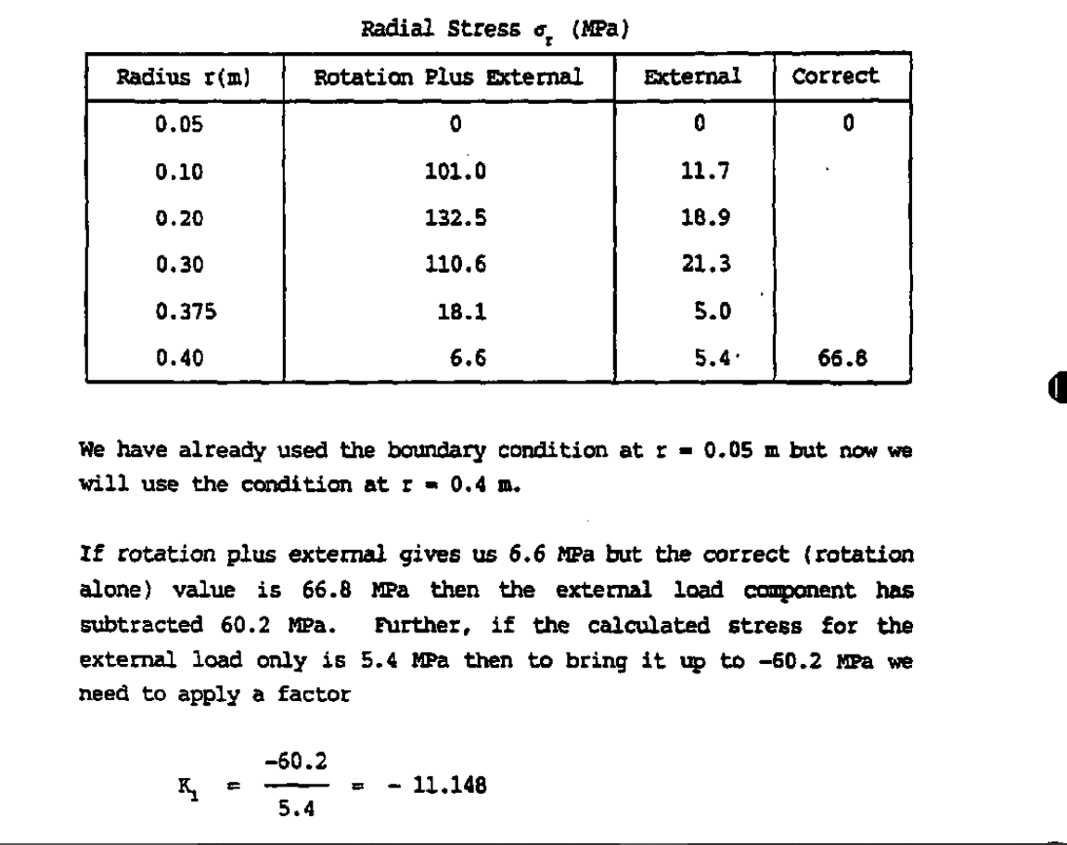

Similarly, correction factor for second table will be calculated.
Now the correction factor is used to correct the stress values for both thermal and rotational loads.

Then the values will be added. The values of roational loads and thermal loads.

The graph is plotted of the resultant values

Beckel FP4NL (3 axis CNC Milling machine)

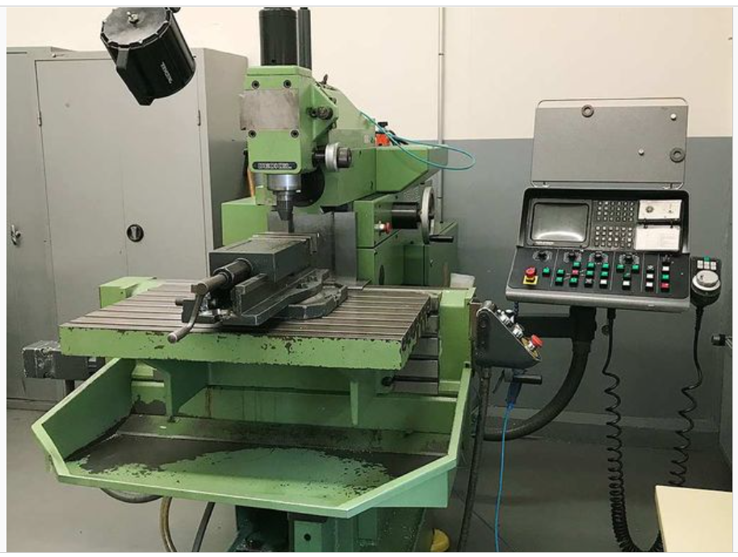

Control system-siemens
Software for importing geometry- hyper mill (cam software)
Precision- 1 micron
Common fixure-sk40
Tool type- t1d1

Types of Tools used
- Cemented carbide
- High speed steel

Type of tool based on tool geometry
- 4 flat end mill Ball Nose Type
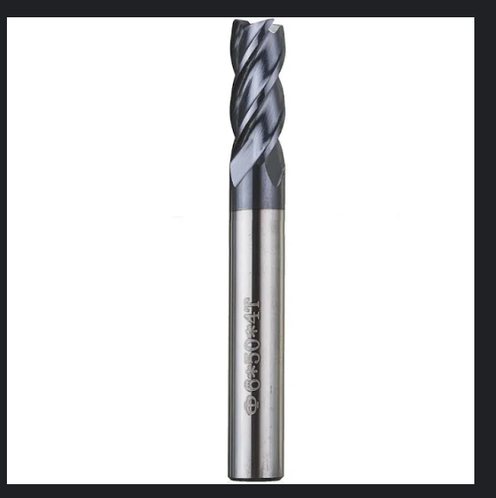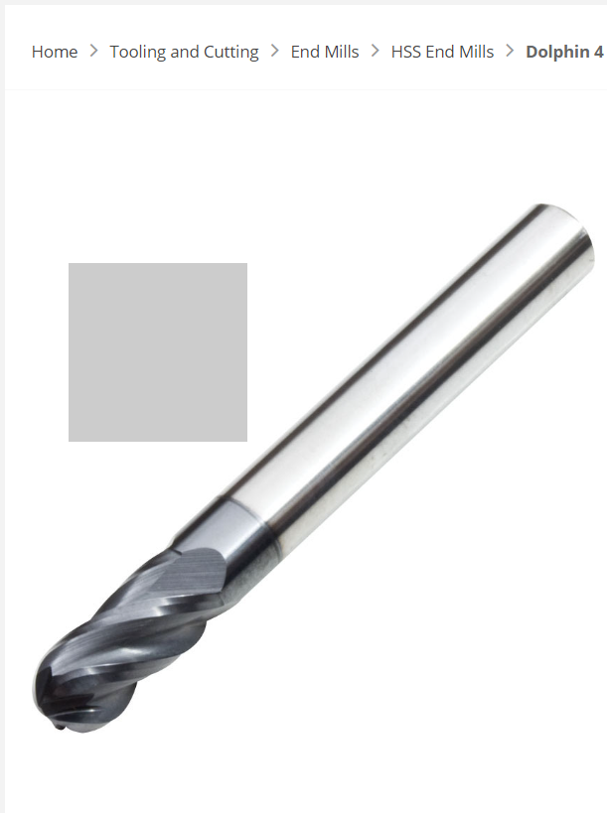

Cutting fluid used- HOCUT795 soluble oil (water diluted in ratio of 1:20)
Quality control group

Coordinate measuring machine
Absolute arm

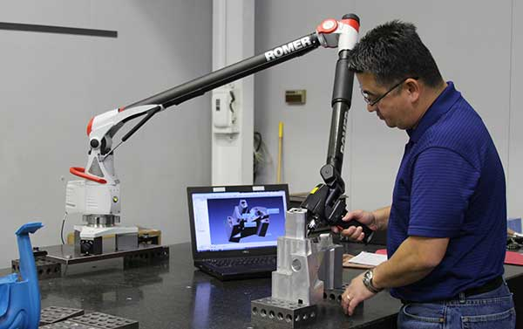

- The flagship of the Absolute Arm range, the Absolute Arm 7-Axis delivers tactile probing and laser scanning in a uniquely ergonomic package. It's the clear choice for high-end portable measurement applications.
- Software used PCDMIS

Advantages
- Can be taken anywhere

Disadvantages
- Difficult to control (robotic arm)
- Expensive as increasing DOF increase in it prize

Mehta Evan-20 Fiber Laser Marking Machine

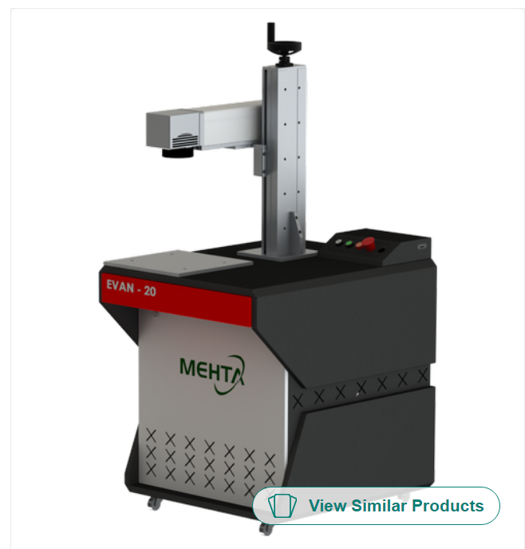

- Marking on all metal products
- Marking on some nonmetals like PVC, Paper ABS, etc.…
- Bar code / Data Matrix Marking
- Serial Number Marking
- Bitmap (Graphics) marking
- High quality gray scale marking.
- Jewelry Metal Cutting
- Long using time: the average using time more than 100000 hours.
- Good stability and free maintenance: No need to do maintenance for laser device.
- Stable performance, small size, low power consumption.
- The operating system is flexible and convenient.
- Stable performance, small size, low power consumption.
- High speed marking (MHz repetition rate).
- First and last pulse equally useable.
- High repeatability/stability design.
- Status monitoring and safe shut down.
- Excellent beam quality, high stability output easy to debug the marking effect.
- High electro-optical conversion efficiency, long useful period.

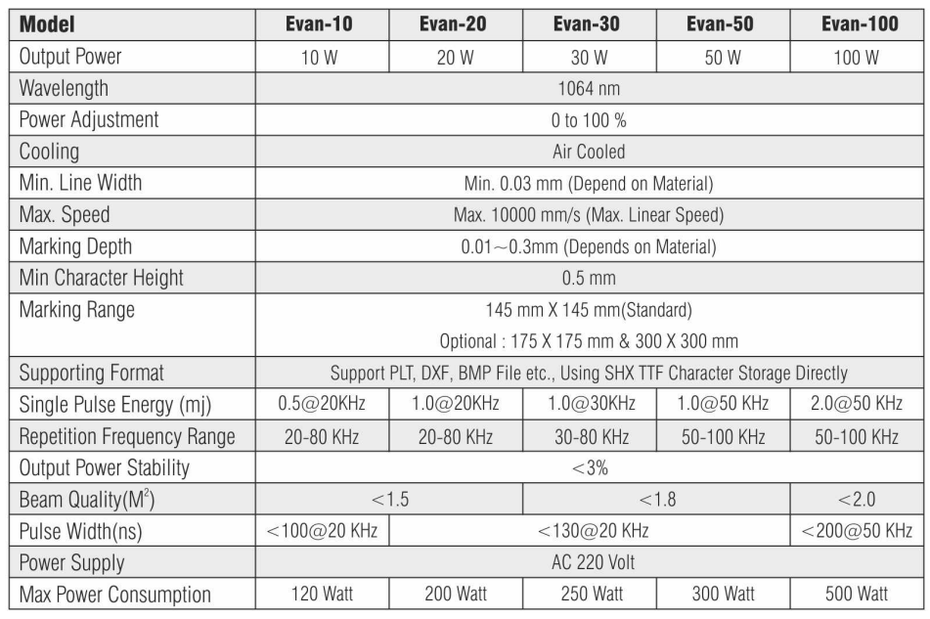

Talyrond® 585H PRO

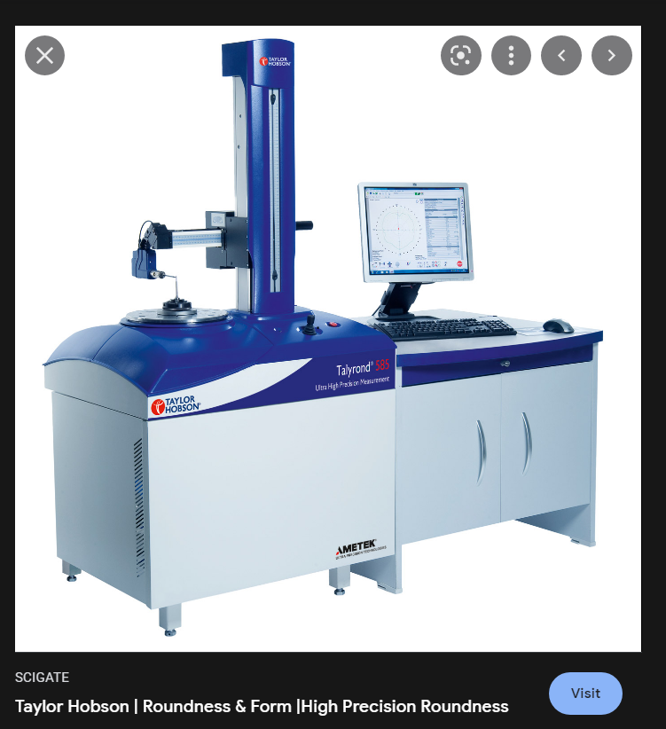

The Talyrond® 585H PRO is a fully automated roundness/cylindricity instrument that is unsurpassed in accuracy and reliability, with 6 versions to choose from offering the right balance of automation and capacity for virtually every application. State of the art electronics have allowed full control of all axes with fast and accurate modes allowing the right combination of measurement and movement speed for the most challenging of components.
Taylor Hobson's patented arm orientation provides full automation in almost any attitude making it the most versatile of instruments and an industry benchmark in roundness instrumentation.

Key features
- Fully Automated arm attitude/orientation mechanism
- Automated Gauge calibration
- Automatic Centre and level with arm follow mode
- High precision air bearing spindle ± 0.015 µm
- Gauge resolution 0.3 nm
- 300 mm, 500 mm, 1000 mm or 1200 mm Vertical straightness unit

Applications
- Ball screw - full length of the contact point of the ball screw or lead screw
- Camshafts - comparison to a DXF or lift data.
- Bearing races - harmonic analysis
- Crankshafts - Roundness, straightness, cylindricity, parallelism, twist and surface texture
- Roller bearings - roughness, form, roundness and part alignment
- Fluid dynamic bearings - roundness, topography and roughness

Universal testing machine

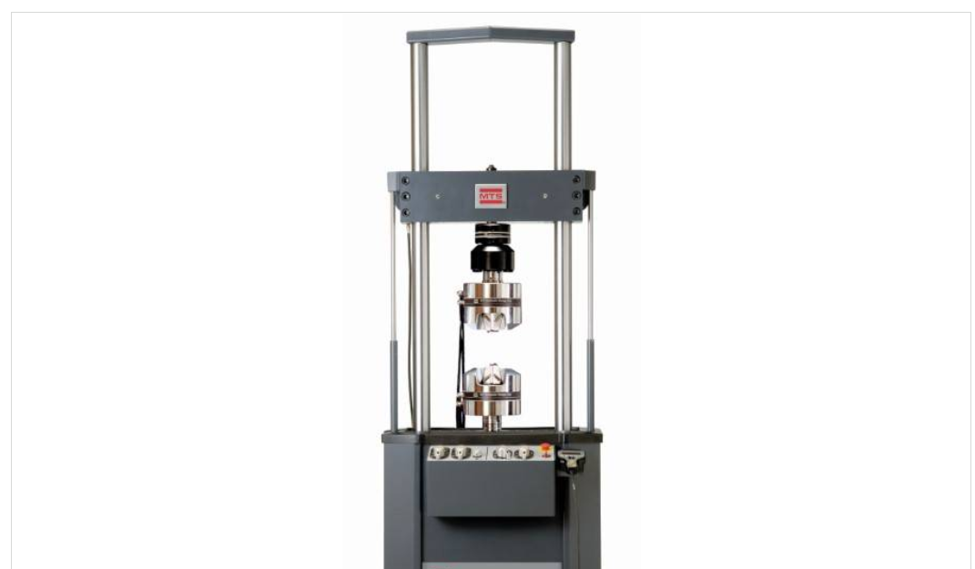

From complex thermomechanical fatigue studies to standard tension and compression tests, MTS Landmark systems deliver accurate, repeatable results. Robustly manufactured with SureCoat® technology that extends actuator rod longevity 10x over conventionally chrome-plated rods, these systems will perform reliably for years
Capacity – 50 tons
Mechanism – servo hydraulic system

Types of gauges used
- Extensometer- for calculating change in length during testing

Thermal testing coupled – the system is coupled with a furnace of capacity of 1000 degrees. The thermomechanical fatigue testing is very common for turbine parts.

The machine consists of three parts that is
- The crosshead
- Time varying load mechanism
- Servo hydraulic system
Servo hydraulic system
The system has a separate unit for compressing fluid . the unit is capable of compressing it till 3000 psi.

The system draw the load deformation diagram and based on it will draw stress strain and true stress strain and other factors.
Wilson® VH1102 & VH1202

The Wilson® VH1102 & VH1202 Vickers/Knoop Series Hardness Testers offer a versatile and user friendly solution for a wide range of micro-hardness scale testing. For single scale micro-hardness testing, the Wilson VH1102 Tester is equipped with a four-position turret which includes one indenter position as well as a 10x and 50x objective. For more demanding applications, the Wilson VH1202 tester is equipped with a six position turret, including two indenter positions as well as 5x, 10x and 50x long working distance objectives. Both units include USB output, nine automatic selectable test forces and a clear full-color touch panel user interface for rapid test method handling and data collect

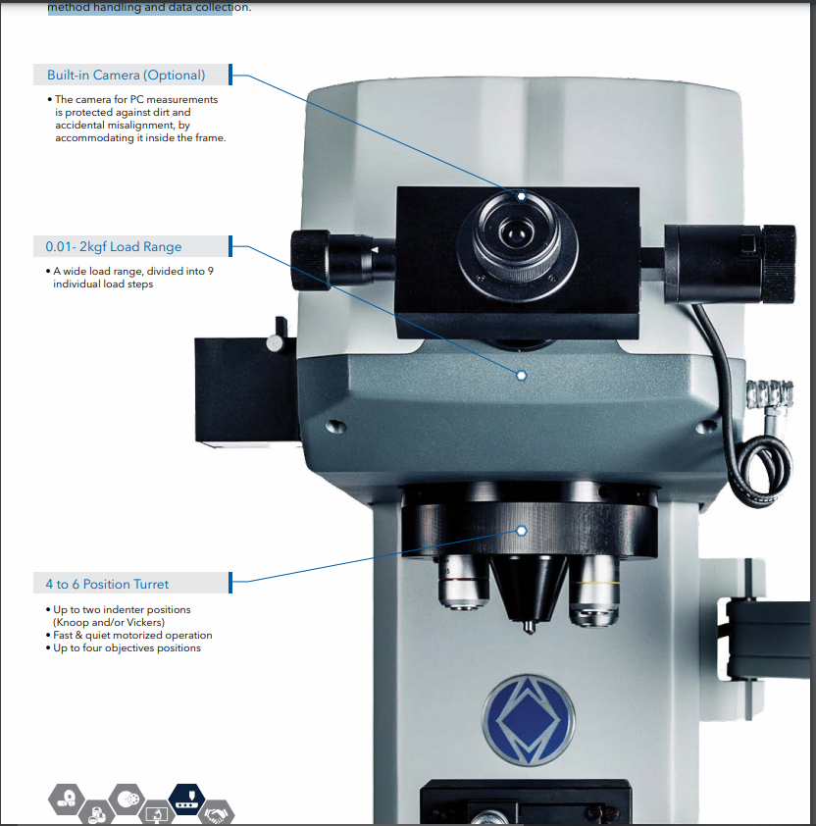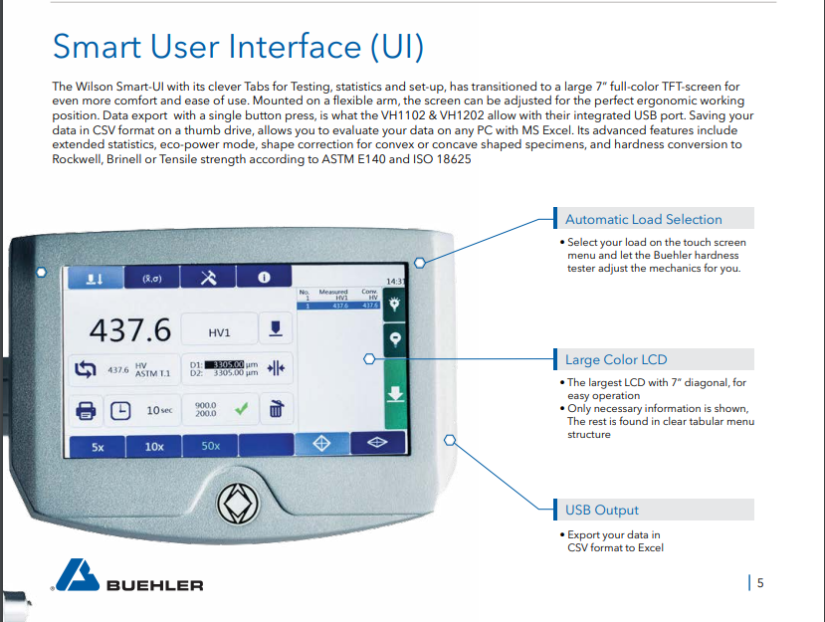
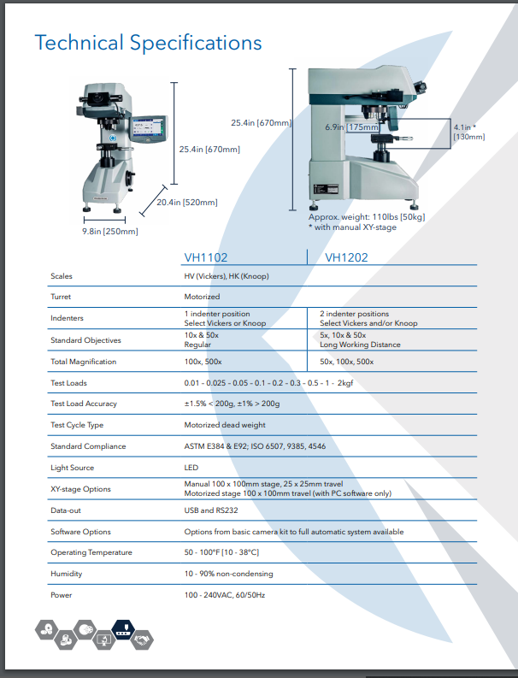 Front Loading / Horizontal Vacuum Furnace by THERELEK

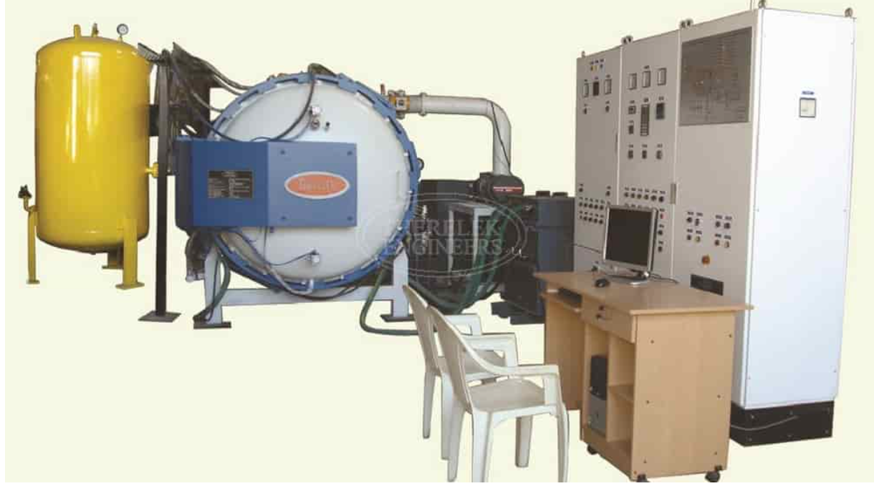

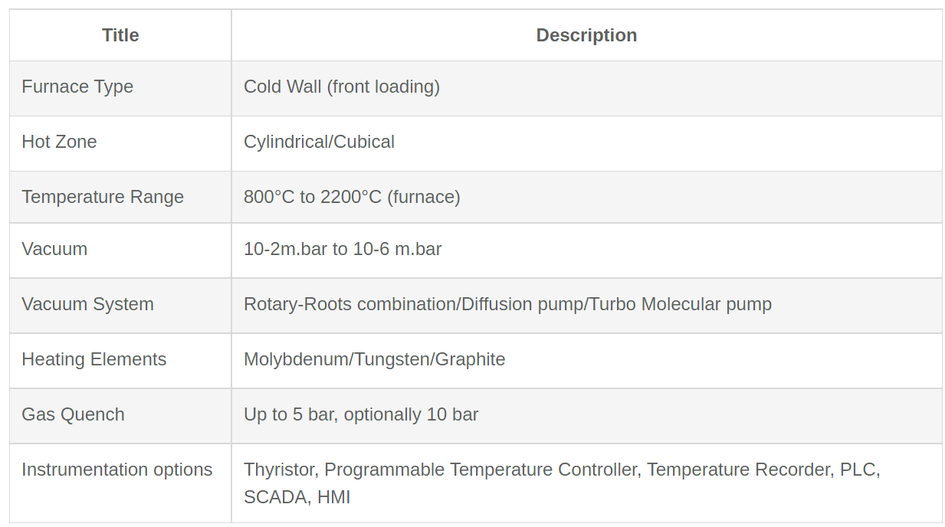

Applications
- Annealing
- Isothermal annealing
- Stress relieving
- Hardening
- Tempering
- Sintering
- Brazing
- Normalizing
- Case hardening
- Pre-sintering
- laboratory applications

Advantages
- cleanliness
- repeat-ability
- reliability
- excellent process parameters and temperature uniformity
- bright oxide- free treatment of most metals and alloys
- safe operation
- easy maintenance
- removal of surface volatile

CONCLUSION

The experience that I got working with top government organization is unique. GTRE is the only organization which is doing manufacturing and research related to gas turbine. The components that are designed in the lab, directly goes to engine to work.
My internship guide was really helpful throughout the internship. Talking with best scientist of the country increased my knowledge. I learned a lot about insights of designing of the components. The software used like Abaqus, Ansys and Hypermesh.
The manufacturing facilities that I saw and the machine’s I worked with cannot be found easily across the country. The scientist have been very kind in sharing knowledge with me.

References

- https://www.ramsay-maunder.co.uk/downloads/nbr08.pdf
- https://www.therelek.com/products/vacuum-furnace/horizontal-vacuum-furnace/
- https://www.buehler.com/products/hardness-testing/vickers-knoop-hardness-testers/wilson-vh1102-1202-micro-hardness-testers/
- https://www.tensiletester.com/products/omnitest-single-column-materials-tensile
- https://hexagon.com/products/absolute-arm-7
- https://www.taylor-hobson.com/products/roundness-form/high-precision

