Predictive Modeling and Optimization in Logistics Systems
  - Week 4 report on demand forecasting and daily staffing
Prepared by Rishabh Bansal
BTech Computer Science and Engineering

Purpose and decision
This report develops a next-day shipment-volume forecast for a hypothetical parcel hub and uses the forecast to allocate daily processing staff. It documents data simulation, feature preparation, model comparison, chronological validation and a constrained staffing calculation. Python code was executed to produce the reported metrics, tables and figures.
The selected Ridge regression model predicts daily demand with a holdout mean absolute error of 11.48 shipments. Forecast-based staffing has a lower simulated cost than a fixed six-worker schedule. Adding a planning buffer further reduces dependence on external processing but increases labour use. The operational choice depends on the acceptable level of overflow and the availability of an external processor.

Executed results
Measure | Result
Simulated history | 420 daily observations; 392 usable modeling rows
Selected model | Ridge regression with alpha 0.1
Final evaluation | 56 rolling next-day forecasts
Forecast MAE and RMSE | 11.48 and 14.50 shipments per day
Forecast R squared | 0.854 on the final holdout
Weekly baseline MAE | 28.14 shipments per day
Calibration buffer | 16.28 shipments above the point forecast

Scope and limits
All demand, productivity, labour costs and outsourcing rates are hypothetical. This Week 4 daily series is a new simulation motivated by the workload issue explored in Week 3; it is not an aggregation of the earlier shipment dataset and does not represent Olist data. Numerical cost differences are scenario results, not verified savings for a real company.
The recommended next step is a shadow pilot using real hub records. Keep forecasting quality and operational cost as separate evaluation criteria, and check that staffing assumptions reflect actual shifts, skills and processing capacity.
GitHub project URL
https://github.com/rishabh230707-afk/logistics-strategic-analysis
The week4 folder contains the report, runnable Python code and result tables.

1 Prediction problem and hypothetical data
At the end of day t minus 1, predict the number of shipments arriving on day t. The decision is made after the previous day closes, so its final count is assumed available. The prediction horizon is one day. Forecasts for later test dates may use earlier observed test counts as lags, because those counts would be available by the next decision time. This is a rolling daily evaluation, not a 56-day forecast made in one batch.

Dataset structure
Field | Definition and availability
date and shipments | Daily date and integer arrival count; shipments is the target
weekday | Calendar category Monday through Sunday, known in advance
promotion | Preannounced seven-day promotion in each 35-day cycle
trend | Days since simulation start, known for the target date
annual_sin and annual_cos | Calendar encodings using a 365.25-day period
lag1 lag7 lag14 | Counts from one, seven and fourteen completed days earlier
mean7 and mean28 | Means of the preceding seven and twenty-eight completed days

Simulation assumptions
The series runs from 1 January 2025 through 24 February 2026, using NumPy seed 42. Expected demand starts at 165 shipments, adds weekday effects of 40, 30, 20, 15, 35, −25 and −40 from Monday to Sunday, and increases by 0.12 shipment per elapsed day. A known promotion adds 45 shipments, and annual seasonality has an amplitude of 18. Independent normal noise has standard deviation 14. Counts are rounded and floored at 40. These are designed patterns, so results favour models that can learn this structure.

Data preparation code
# Historical features exclude the target day's count.
for lag in [1, 7, 14]:
df[f'lag{lag}'] = df.shipments.shift(lag)
for window in [7, 28]:
df[f'mean{window}'] = (
df.shipments.shift(1).rolling(window).mean()
)
df = df.dropna().reset_index(drop=True)
The first 28 days provide history and are removed from the modeling table. No other records are dropped. Dates are unique, demand is nonnegative and usable features contain no missing values. A target-perturbation check confirms that changing a day’s demand does not change its own predictors. In a real feed, a missing day must be investigated rather than silently treated as zero.

2 Chronological validation design
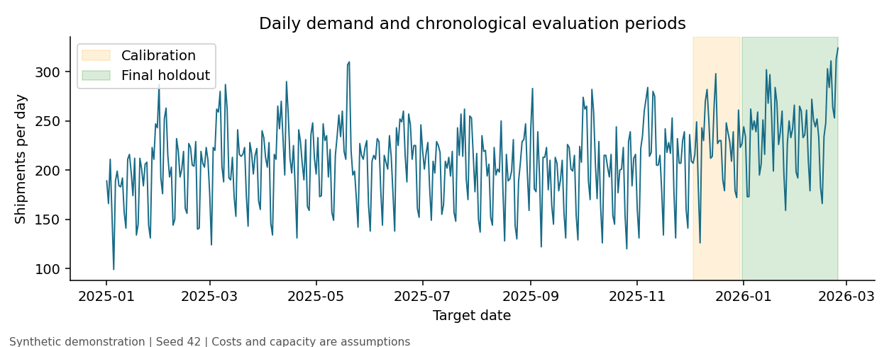
Figure 1 Demand history and reserved evaluation periods. Calendar patterns and growth are simulation assumptions.
Partition | Dates | Days | Purpose
Development | 2025-01-29 to 2025-12-02 | 308 | Model training and tuning
Calibration | 2025-12-03 to 2025-12-30 | 28 | Choose error buffer only
Test | 2025-12-31 to 2026-02-24 | 56 | Final model and policy evaluation

Four expanding training windows inside the development period provide time-series cross-validation [1]. Every validation window contains 35 days; training expands from 168 to 273 days. Random shuffling is avoided because it would mix past and future conditions. No gap is needed under the explicit assumption that the prior day’s count is final by the forecast cutoff; delayed reporting would require a revised availability rule.
Fold | Training ends | Validation dates
1 | 2025-07-15 | 2025-07-16 to 2025-08-19
2 | 2025-08-19 | 2025-08-20 to 2025-09-23
3 | 2025-09-23 | 2025-09-24 to 2025-10-28
4 | 2025-10-28 | 2025-10-29 to 2025-12-02

Preprocessing is fitted separately within each training fold. Model family and hyperparameters are selected by the lowest mean validation MAE. The winning model is then fitted on all 308 development days and frozen. The next 28 days calibrate the planning buffer; the last 56 days are used once for final evaluation. Neither calibration nor test targets enter model fitting.

3 Model selection and training

Why compare these techniques
The seasonal-naive benchmark predicts the count from seven days earlier. It is simple and reflects weekly demand, but cannot anticipate a promotion starting on a different phase of the calendar. Ridge is linear regression with an L2 penalty, which helps control unstable coefficients among correlated lags and rolling averages [2]. It can represent the deliberately additive trend and calendar effects. A random forest provides a nonlinear ensemble alternative, although tree predictions can struggle to extrapolate growth beyond training conditions [3].
Numeric predictors are standardized using training data. Weekday is one-hot encoded. The same preprocessing pipeline is used for both learned model families for consistency; scaling is useful for Ridge and unnecessary but harmless for the forest. Predictions are clipped to zero; fractional point forecasts are retained until staffing converts demand to whole workers.

Cross validation results in shipments per day
Candidate | Mean MAE | Fold MAE SD | Mean RMSE
Ridge alpha 0.1 | 11.38 | 1.20 | 14.79
Ridge alpha 1 | 11.49 | 1.02 | 15.03
Ridge alpha 10 | 13.28 | 1.12 | 16.89
Forest depth None leaf 3 | 14.45 | 2.91 | 18.74
Forest depth 6 leaf 3 | 14.46 | 2.93 | 18.79
Forest depth None leaf 8 | 15.23 | 2.65 | 19.69
Forest depth 6 leaf 8 | 15.23 | 2.71 | 19.70
Seasonal naive | 27.32 | 4.13 | 34.70

The search evaluates three Ridge penalties, alpha 0.1, 1 and 10, and four forest settings: maximum depth 6 or unrestricted, crossed with minimum leaf size 3 or 8. Each forest uses 160 trees and seed 42. Ridge alpha 0.1 has the lowest cross-validation MAE, 11.38. Its small advantage over alpha 1 does not establish a meaningful real-world superiority. Fold standard deviation describes variation across windows, not a confidence interval.

Training and validation excerpt
cv = TimeSeriesSplit(n_splits=4, test_size=35)
for train_idx, valid_idx in cv.split(dev):
fitted = clone(candidate).fit(
dev.iloc[train_idx][FEATURES],
dev.iloc[train_idx].shipments)
pred = np.maximum(0, fitted.predict(
dev.iloc[valid_idx][FEATURES]))
score = mean_absolute_error(
dev.iloc[valid_idx].shipments, pred)
# Select lowest mean fold MAE, then fit on dev only.

4 Holdout forecast performance
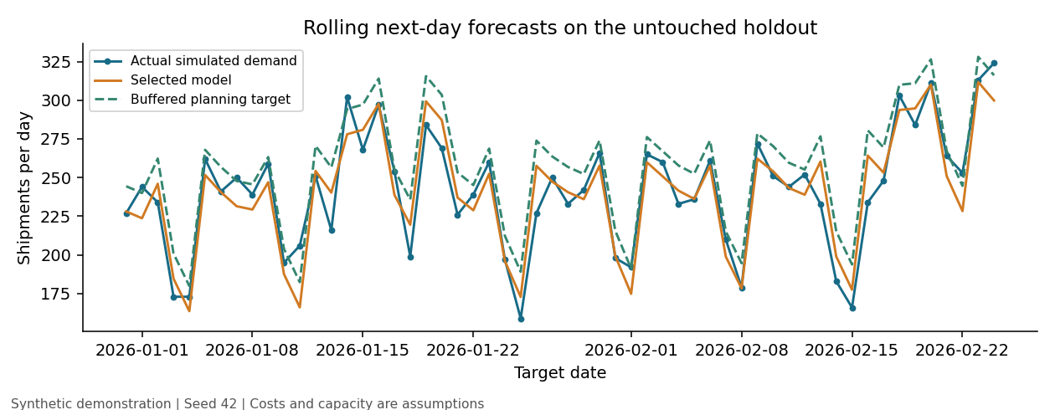
Figure 2 Actual simulated counts, selected forecasts and the buffered staffing target across the 56-day holdout.
Model | MAE | RMSE | R squared | Bias
Ridge alpha 0.1 | 11.48 | 14.50 | 0.854 | -0.87
Seasonal naive | 28.14 | 37.19 | 0.043 | -9.64

Metric definitions and interpretation
MAE is the mean absolute difference between prediction and actual volume. An MAE of 11.48 means the daily forecast misses the observed count by roughly eleven to twelve shipments on average. RMSE is the square root of mean squared error and gives larger misses more influence; its value of 14.50 is higher than MAE because some days have larger errors [4]. Both metrics are in shipments per day.
R squared equals one minus squared prediction error divided by the squared variation around the test-set mean. A value of 0.854 indicates substantial explanatory performance on this simulated holdout; it is not an 85.4 percent accuracy rate. R squared can be negative. Bias is mean prediction minus actual demand; −0.87 indicates slight average underprediction.
MAE is approximately 59.22 percent lower than the weekly baseline, calculated as (28.14 − 11.48) divided by 28.14 using unrounded values. Only the selected model and the predeclared baseline are scored on the final holdout, preventing model selection based on the reported test results.

Evaluation code
mae = mean_absolute_error(actual, predicted)
rmse = np.sqrt(mean_squared_error(actual, predicted))
r2 = r2_score(actual, predicted)
bias = np.mean(predicted - actual)
The chart shows tracking of weekly demand changes and promotion periods. Performance is credible for this generated series, but its simple known structure limits how well these results predict performance on actual parcel volumes.

5 Forecast uncertainty and planning buffer
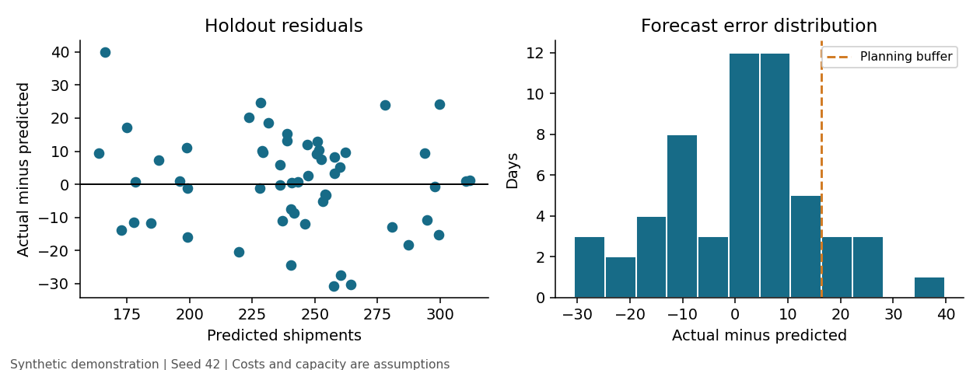
Figure 3 Holdout residuals defined as actual minus predicted volume. Positive values identify underprediction.

Buffer calibration
A point forecast gives an expected workload but leaves exposure to higher-than-predicted demand. The report uses a fixed buffer equal to the nonnegative empirical 90th percentile of actual minus predicted counts in the separate 28-day calibration window. NumPy’s higher quantile method selects an observed residual at or above the requested percentile. The selected buffer is 16.28 shipments.
cal_pred = predict(cal)
residuals = cal.shipments.to_numpy() - cal_pred
buffer = max(0, float(np.quantile(
residuals, 0.90, method='higher')))
test_pred = predict(test)
planning_target = test_pred + buffer
The buffered target covers 26 of 28 calibration days, or 92.86 percent, and 49 of 56 holdout days, or 87.50 percent. The buffer is a practical planning rule, not a calibrated prediction interval with guaranteed future coverage. The small calibration sample, time dependence and changes in demand can alter its reliability.

Residual interpretation
The scatterplot compares error with forecast level, helping reveal whether underprediction concentrates at high workloads. The histogram shows the range and asymmetry of misses and places the planning buffer in that context. The observed residual plot alone does not establish independence, constant variance or a normal error distribution. The larger RMSE relative to MAE supports reviewing larger daily misses separately.
Forecast-target coverage differs from staffing coverage. Workers are allocated in whole units of 45 shipments of capacity, so rounding creates spare capacity beyond the buffered target. This explains why the buffered staffing policy can show no realized overflow even though seven actual counts exceed the unrounded buffered forecast.

6 Constrained staffing optimization

Decision variables and assumptions
Choose an integer worker count w for each day, from 2 to 8. Each worker processes 45 shipments per day and costs INR 900 per worker-day. External processing costs INR 40 for each shipment exceeding internal capacity. These are hypothetical operating assumptions, not wage estimates. Daily staffing can change without hiring, scheduling or cancellation costs; these simplifications must be revisited before deployment.
For planning target z, minimize daily labour cost 900 × w subject to 45 × w being at least min(z, 360), with w an integer from 2 to 8. When z exceeds maximum capacity 360, allocate eight workers and plan external processing for the excess. This is a service-constrained labour minimization problem, not an optimizer of total expected cost under uncertainty.

Exact solution by enumeration
def solve_staff(target, capacity=45):
target = max(0, float(target))
feasible = [w for w in range(2, 9)
if capacity * w >= target]
if feasible:
return min(feasible, key=lambda w: 900*w)
return 8 # Maximum internal capacity
workers = solve_staff(prediction + buffer)
outsourced = max(actual - 45*workers, 0)
realized_cost = 900*workers + 40*outsourced
There are only seven worker choices, so exhaustive enumeration gives an exact solution without a separate optimization package. The operational target comes from the forecast and calibration buffer, never from actual demand. Actual counts are used only afterward to compute overflow and realized cost. For an illustrative target of 250 shipments, six workers provide capacity for 270 shipments and cost INR 5,400 before any realized overflow.

Policies compared on the same holdout
Fixed staffing uses six workers each day. Six is obtained by covering the development-period 90th percentile of actual demand; it is not chosen from test results. Forecast only covers the point forecast. Buffered forecast covers the point forecast plus 16.28 shipments. All policies face the same 13,511 realized holdout shipments, cost rates and staff limits.
External processing is assumed available without a quantity limit and able to handle overflow the same day. Overflow therefore measures dependence on outsourcing, not a measured late-delivery rate. Routing is outside this implementation because there are no vehicle locations, road distances or delivery time windows. A real extension could jointly assign shifts and outsourcing under a cost budget, then use a vehicle-routing model when route data are available.

7 Staffing results and operational tradeoffs
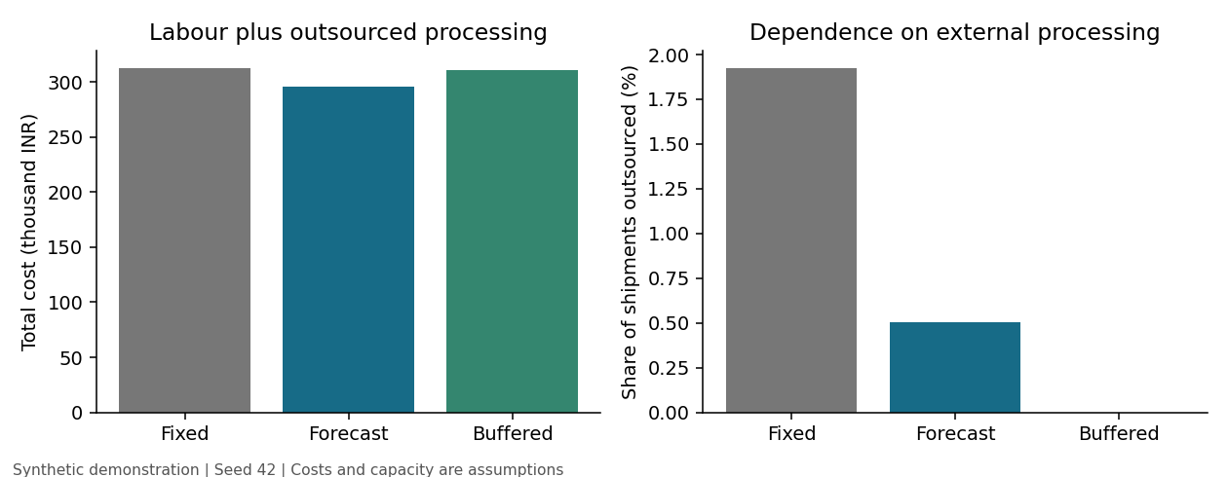
Figure 4 Realized 56-day scenario cost and outsourcing dependence. Each policy uses the same observed synthetic demand.
Policy | Worker days | Outsourced | No overflow days | Total INR
Fixed staffing | 336 | 260 | 47/56 | 312,800
Forecast only | 326 | 68 | 51/56 | 296,120
Buffered forecast | 346 | 0 | 56/56 | 311,400

Forecast-only staffing costs INR 296,120, which is INR 16,680 or 5.33 percent below fixed staffing at INR 312,800. It outsources 68 shipments, or 0.50 percent of demand, compared with 260 shipments, or 1.92 percent, under fixed staffing. Staffing varies with workload, so a lower total worker count can still cover demand better than the fixed schedule.
Buffered staffing uses 346 worker-days and costs INR 311,400. It eliminates observed overflow on these 56 days, while costing INR 15,280 more than forecast-only staffing. Its cost is just INR 1,400 or 0.45 percent below fixed staffing. The appropriate choice depends on whether low cost or reduced outsourcing dependence matters more; the holdout comparison does not prove a globally optimal policy.

Sensitivity to worker productivity
Shipments per worker | Worker days | Outsourced | Total INR
40 | 383 | 14 | 345,260
45 | 346 | 0 | 311,400
50 | 319 | 11 | 287,540

Sensitivity scenarios re-solve buffered staffing at productivity 40, 45 and 50 with forecasts, rates and demand unchanged. Results depend strongly on this assumed capacity. Outsourcing does not decrease monotonically because each scenario chooses a different integer staff count, and the eight-worker ceiling can bind. These scenarios assess robustness; they do not identify actual employee productivity.

8 Recommendations reproducibility and conclusion

Operational recommendations
Start with forecast-only staffing in a shadow pilot if external processing is dependable and cost is the main objective. Use the buffered policy as an alternative when avoiding overflow is more important. Confirm that daily staffing can change as assumed, and evaluate minimum shift lengths, worker skills, equipment capacity, absenteeism and external processing limits before using recommendations in live schedules.
Track rolling MAE, RMSE, signed bias, outsourced volume and cost per processed shipment. Reassess the model and buffer when errors persistently worsen or promotion schedules change. Collect several seasonal cycles and compare against the same weekly baseline on future windows. A prospective pilot should select its policy before measuring outcomes; this report does not claim causal savings from an intervention.

Reproduce the executed analysis
# From the repository root on macOS or Linux:
python3 -m venv .venv
source .venv/bin/activate
python -m pip install -r week4/requirements.txt
python week4/model.py --output week4/results
The script regenerates the synthetic data, cross-validation ranking and windows, holdout predictions, staffing comparison, sensitivity results, summary JSON and four charts. The repository includes these small result tables. The Word report is the written interpretation; the script regenerates analysis outputs rather than rebuilding the document.
Execution used Python with NumPy 2.3.5, pandas 2.2.3, scikit-learn 1.8.0 and Matplotlib 3.10.8. Checks passed for date order, unique dates, missing values, nonnegative demand, target exclusion from its own features, staffing bounds and cost reconciliation. The model and generator use fixed seeds. Real data would require separate provenance, quality and feature-availability checks.

Conclusion
The exercise connects an evaluated daily demand forecast to a concrete staffing decision. Ridge performs best among the tested candidates for this additive simulation. Forecast accuracy improves on the weekly baseline, while the staffing comparison makes the cost and overflow trade-off visible. Short calibration history, a single simulated hub, idealized productivity and flexible staffing limit transfer to real operations.

References
[1] scikit-learn documentation. TimeSeriesSplit and chronological cross validation.
https://scikit-learn.org/stable/modules/generated/sklearn.model_selection.TimeSeriesSplit.html
[2] scikit-learn documentation. Ridge regression and L2 regularization.
https://scikit-learn.org/stable/modules/generated/sklearn.linear_model.Ridge.html
[3] scikit-learn documentation. RandomForestRegressor model and parameters.
https://scikit-learn.org/stable/modules/generated/sklearn.ensemble.RandomForestRegressor.html
[4] scikit-learn documentation. Regression metrics and scoring.
https://scikit-learn.org/stable/modules/model_evaluation.html

