Advanced Data Analysis and Visualization in Logistics
  - Week 3 report on delivery performance volume and cost
Prepared by Rishabh Bansal
BTech Computer Science and Engineering

Purpose and scope
This report analyzes a hypothetical parcel logistics network using Python, pandas and Matplotlib. It extends the analytical approach developed in Weeks 1 and 2 with a new simulated shipment dataset containing transport costs, distance, weight and processing stages. These additional fields are invented for this task; they are not Olist observations or measurements from the Week 2 demonstration.
The analysis covers 2,329 completed shipments entering the network across 84 days, from 5 January to 29 March 2026. All numerical findings and charts are synthetic. The purpose is to demonstrate exploratory analysis and sound interpretation, not to claim performance improvements for a real company.

Main findings from the executed simulation
Measure | Result
On-time delivery | 85.27 percent; 343 late shipments
Delivery duration | Mean 40.47 hours; median 40.19 hours
Tail delivery duration | 90th percentile 58.10 hours
Allocated transport cost | Mean INR 509.33 per shipment
Total allocated transport cost | INR 1,186,235.97 across all simulated shipments

Average weekly volume rises from 168.00 shipments in the first eight weeks to 246.25 in the final four. The shipment-weighted on-time rate falls from 95.01 percent to 71.98 percent. Busy days have longer hub processing times. These relationships are intentionally built into the simulation and illustrate a capacity investigation rather than proving a real bottleneck.

Recommended decision focus
Investigate hub capacity at high workloads, compare regional performance against the actual promise for each region, and review costs within similar distance and weight bands. Protect the tail-delay cases in the analysis so that an average does not conceal service exceptions.
GitHub project URL
https://github.com/rishabh230707-afk/logistics-strategic-analysis
Week 3 code and results are in the week3 folder.

1 Hypothetical dataset and simulation design
One row represents one completed shipment. Shipment volume is a count of rows per network-entry date. Transport cost is a synthetic allocated cost per shipment in INR, not customer freight revenue. Shipment route distance is not a record of fleet vehicle kilometres, so it must not be summed and interpreted as fleet travel.
Variable | Meaning and unit
shipment_id | Unique synthetic shipment identifier
dispatch_date | Network-entry date used for daily and weekly groups
region | North West East or South; hypothetical service zones
distance_km and weight_kg | Shipment route distance in kilometres and shipment mass in kilograms
hub_hours and transit_hours | Processing time at hub and subsequent transport time in hours
delivery_hours | Hub time plus transit time; network entry to receipt
promised_hours | Regional service deadline measured in elapsed hours
cost_inr | Allocated transport cost per shipment in INR
daily_shipments | Daily shipment count repeated on each shipment row
on_time and late_hours | Deadline met indicator and positive excess above deadline

Transparent assumptions
The generator uses NumPy random seed 42. Daily demand follows a Poisson draw with expected volume 27 on weekdays and 17 on weekends, increasing by 12 in the final four weeks. A minimum of eight shipments per day is imposed. Region sampling probabilities are North 30 percent, West 25 percent, East 25 percent and South 20 percent.
Route distance is drawn around regional means of 180, 420, 620 and 850 km with a 75 km standard deviation and a 40 km minimum. Weight follows a lognormal distribution clipped to 0.3–25 kg. Hub time starts at eight hours, adds 1.1 hours per daily shipment above 25, and adds seven hours in East, with random variation. Transit time depends on distance; about three percent of draws receive an extra simulated delay.
Regional promises are 36 hours for North, 48 for West, 60 for East and 72 for South. Cost equals 120 + 0.72 × distance + 9 × weight + a 25 INR surcharge on days above 35 shipments, plus random noise and a positive floor. These coefficients are scenario assumptions, not market prices or estimates fitted from real data.

2 Exploratory methodology and descriptive statistics

Quality checks before analysis
The executed script verifies unique shipment IDs, no missing values, finite positive numeric inputs, reconciliation of delivery time with its two components, and agreement between daily counts and the repeated daily_shipments field. All checks passed. The generated dataset intentionally contains no missing values or duplicate records; no rows were removed or imputed in this Week 3 analysis.

Central tendency and dispersion
Mean describes the arithmetic average; median describes the middle shipment. Standard deviation measures spread around the mean, and the 90th percentile indicates a duration or cost below which approximately 90 percent of observations fall. pandas describe supplies these summaries [1]. The categorical mode is North, with 730 shipments; an exact mode is not useful for continuous simulated measurements.
Variable | Mean | Median | SD | Min | P90 | Max
Delivery hours | 40.47 | 40.19 | 12.82 | 10.03 | 58.10 | 96.32
Hub hours | 17.21 | 16.25 | 8.31 | 2.00 | 29.32 | 42.92
Transit hours | 23.27 | 22.60 | 8.82 | 5.07 | 34.55 | 64.90
Cost INR | 509.33 | 504.39 | 187.62 | 134.22 | 774.62 | 973.08
Distance km | 476.49 | 465.73 | 255.64 | 40.00 | 845.79 | 1092.51
Weight kg | 4.20 | 3.56 | 2.54 | 0.53 | 7.30 | 24.28

Aggregation and comparison rules
Weekly groups run Monday through Sunday, yielding 12 complete weeks. Weekly on-time rate is on-time shipments divided by all shipments in that week. Phase rates use shipment counts rather than averaging weekly percentages. The first phase lasts eight weeks and the second four, so workload comparisons use shipments per week instead of raw phase totals.
Regional comparisons report sample sizes and the regional promise. Correlations use Pearson for linear association and Spearman as a rank-based check [2]. The daily workload relationship uses 84 daily records, avoiding the mistake of treating repeated daily volumes on 2,329 shipment rows as independent workload observations. No significance test or causal estimate is claimed.

Tail review
The delivery-time IQR upper fence is 76.37 hours, with 11 shipments above it. They are retained because the generator explicitly allows exceptional delays. The observed maximum is 96.32 hours. Deleting these shipments would understate service problems. Shipment-average lateness among the 343 late shipments is 6.76 hours.

3 Weekly workload and service reliability
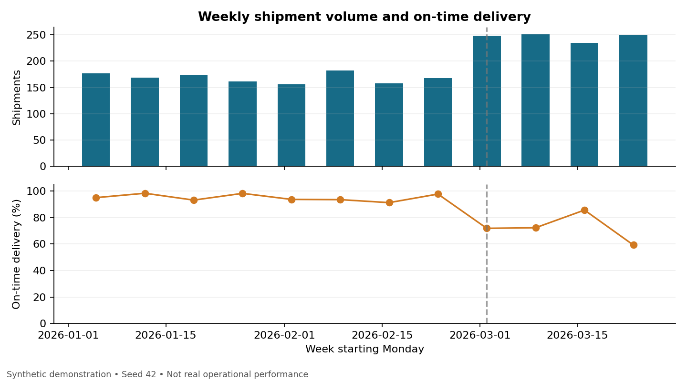
Figure 1 Twelve complete weeks of synthetic shipments. The dashed line marks the higher-demand phase beginning 2 March.

Why this visualization
Aligned bar and line panels show workload and service reliability on the same time axis. Separate vertical axes avoid mixing shipment counts with percentages in a single scale. Weekly aggregation reduces day-to-day noise while preserving the change between the two simulated phases. The on-time axis starts at zero to avoid exaggerating variation.
Phase | Shipments per week | On-time rate | Mean hub time
First 8 weeks | 168.00 | 95.01 percent | 13.35 hours
Last 4 weeks | 246.25 | 71.98 percent | 22.47 hours

Interpretation and operational use
Weekly volume increases by 46.58 percent while on-time delivery falls by 23.04 percentage points. Mean shipment hub time increases by 9.11 hours. These patterns are consistent with the generator’s workload-dependent hub delay. A real operations team could use this view to compare staffing and sorting capacity with demand before peak periods.
The chart alone would not show whether staffing, carrier availability, geography or another factor caused the decline in a real network. Regional mix and promise definitions should be checked before attributing a phase difference to workload. The recommended next step is to collect queue lengths and staffing by shift, then run a measured capacity pilot.

4 Delivery distributions and regional comparisons
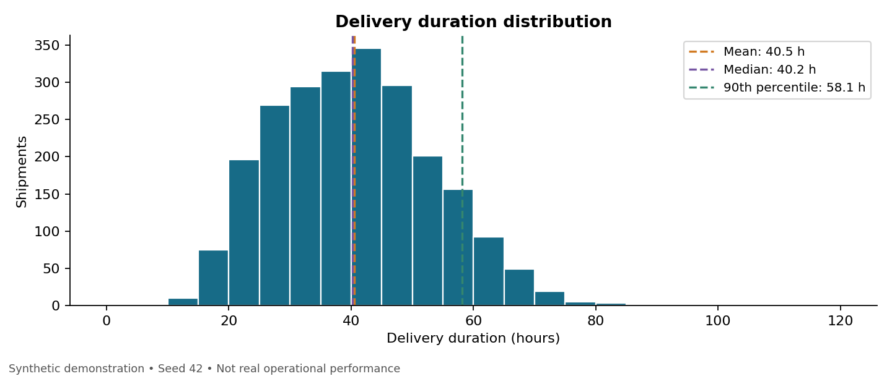
Figure 2 Five-hour histogram bins with mean median and 90th percentile reference lines.
A histogram reveals the typical range and the tail that a single average hides. Mean delivery time is 40.47 hours, median 40.19 hours and P90 58.10 hours. Similar mean and median do not imply that extreme delays are absent; the maximum reaches 96.32 hours.
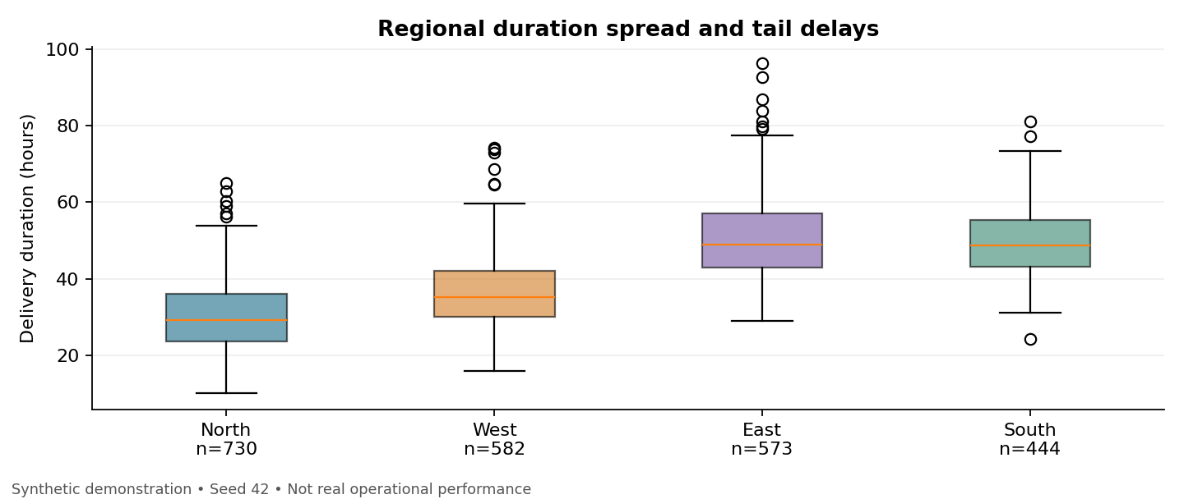
Figure 3 Boxes show quartiles and the median; whiskers extend to observations within 1.5 IQR and points show more extreme values.
Boxplots compare regional spread and exceptions with sample sizes visible. East and South have similar median durations, but their promise thresholds differ. A duration chart therefore cannot be read as a direct ranking of promise reliability. North is fastest on average but has the lowest on-time rate under its tighter 36-hour promise.

5 Transportation costs and regional context
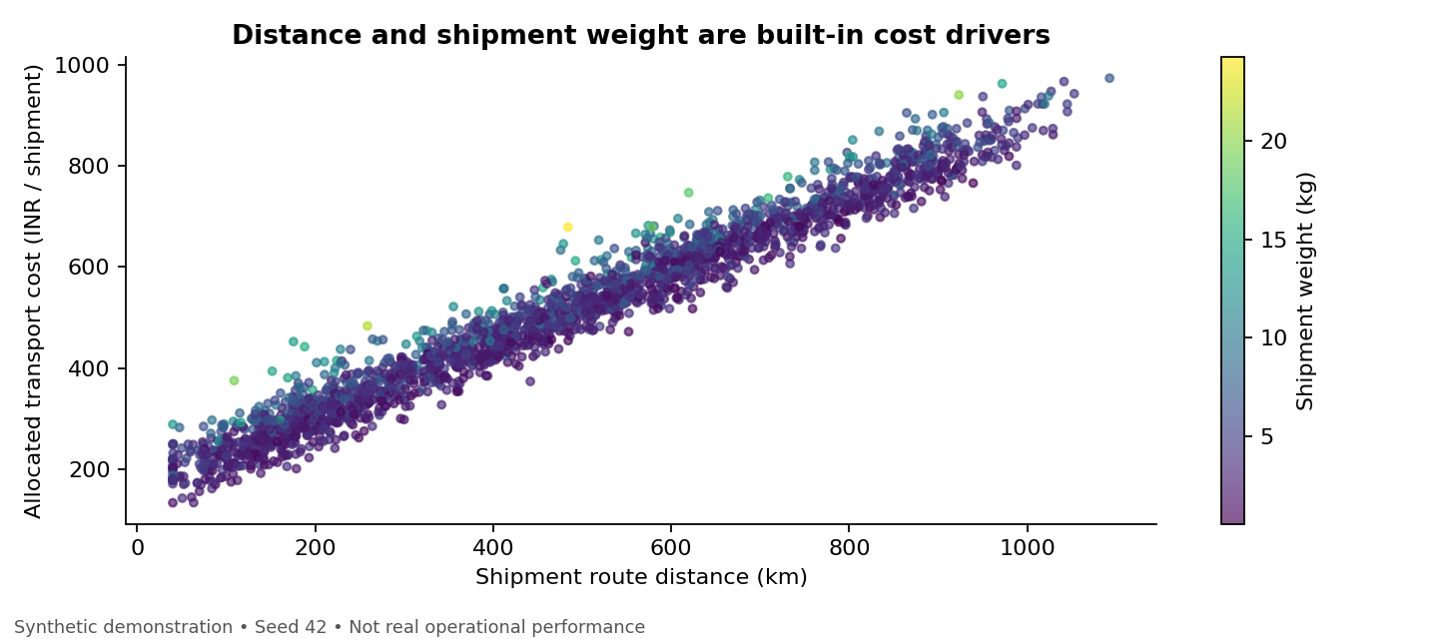
Figure 4 Each point is a synthetic shipment; colour indicates weight and transparent markers reduce overlap.

Why this visualization and what it shows
A scatterplot shows how cost varies with distance while the colour scale adds weight information. Distance and cost have Pearson correlation 0.982 and Spearman correlation 0.983. The strong relationship is expected because distance is an explicit term in the cost formula. Weight also adds cost in the generator, even though its overall Pearson correlation with cost is only 0.124. A weak pairwise correlation does not mean a variable has no role when another component dominates variation.
Region | Mean distance | Mean cost | Promise | On-time
North | 182.3 km | INR 296.18 | 36 h | 74.93%
West | 418.4 km | INR 468.82 | 48 h | 89.00%
East | 619.4 km | INR 613.35 | 60 h | 83.77%
South | 851.9 km | INR 778.64 | 72 h | 99.32%

South costs more per shipment and has longer routes in this scenario. That is not evidence of inefficiency by itself. Compare costs for shipments with similar distance, weight and service requirements before changing allocations. North’s 74.93 percent on-time rate and South’s 99.32 percent rate partly reflect different deadlines; South’s higher reliability does not mean it is faster.

Decision implication
Use route and weight bands for cost reviews, and distinguish total spend from cost per shipment. The simulated average cost rises from INR 501.59 to INR 519.90 between phases, about 3.65 percent, while weekly shipment volume rises much more. No route savings or vendor-price recommendations can be calculated from this invented dataset.

6 Correlations and limits of interpretation
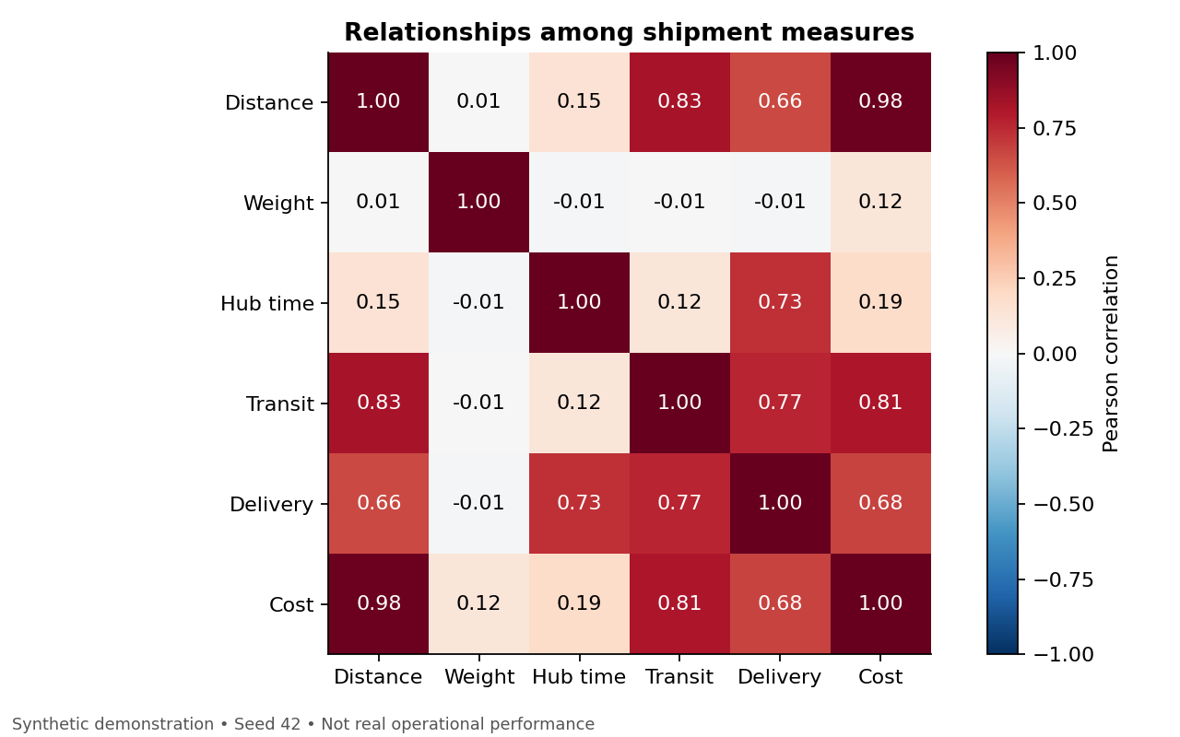
Figure 5 Pearson correlations across 2,329 simulated shipments. The scale is fixed from minus one to one.

Why this visualization
A labelled heatmap makes several pairwise relationships easy to compare. It helps identify related measurements and potential redundancy before later modeling. The colour scale shows direction as well as strength, while printed coefficients support exact reading. The diagonal is one because each variable is perfectly correlated with itself.

How to interpret the matrix
Distance and cost move closely together because the simulation specifies a distance-based cost term. Delivery duration is defined as hub time plus transit time, so correlations between delivery and its components are partly mathematical. They should not be presented as newly discovered independent causes. Likewise, geography affects distance and some hub times by design.
Correlation does not establish that changing one variable would produce an equal change in another. Pearson summarizes linear association and can be affected by unusual observations. Spearman provides a rank-based comparison; the agreement for distance and cost supports a monotonic pattern within this scenario, not a claim about a real business.

Avoiding misleading predictors
If a later model predicts delivery duration when a shipment enters the network, actual transit time, actual hub duration and final lateness would not yet be known. Those fields are useful for retrospective EDA but would leak future information into such a model. Prediction-time feature selection is a separate step from inspecting correlations.

7 Investigating the hub bottleneck
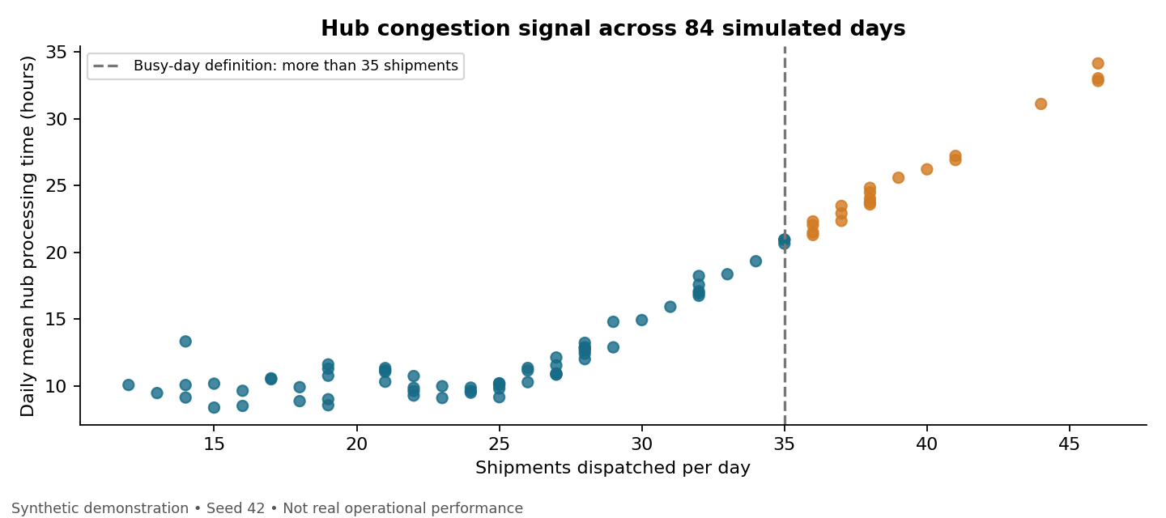
Figure 6 One point per day across 84 days. More than 35 shipments defines a busy day for this descriptive comparison.

Why this visualization
A daily scatterplot compares workload with average processing time at the same level of aggregation. It avoids giving busy days artificial statistical weight by repeating their daily count once per shipment. The dashed threshold is a chosen scenario grouping, not an optimized capacity limit.
Day group | Number of days | Daily mean hub hours
More than 35 shipments | 20 | 25.68
35 shipments or fewer | 64 | 12.05

Interpretation
The daily volume-to-hub-time Pearson correlation is 0.914. Busy days have about 13.63 additional hours of mean hub processing time compared with other days. This is a comparison of equally weighted daily means. It differs from the phase table, which averages hub duration across shipments.
The simulation adds hub delay once daily volume exceeds 25 and also gives East an extra seven hours. Therefore, the observed pattern is expected from the assumptions. It demonstrates a diagnostic approach for a real investigation: inspect queue time, staffing, cutoff adherence, arrival timing and regional handling requirements before selecting a remedy.

Pilot recommendation
Test additional sorting capacity or staggered intake on comparable high-volume shifts. Track median and P90 hub duration, on-time delivery, overtime expense and cost per shipment together. Use a contemporaneous comparison group where feasible and control for shipment mix. Do not claim improved efficiency merely because the queue falls after the demand peak ends.

8 Recommendations code and reproducibility
Priority | Recommended action | What to measure
1 Hub capacity | Investigate queues during expected high demand. | Hub P90, staffing, on-time rate and overtime cost
2 Promise reliability | Review North deadlines and handling; compare like-for-like service. | Late share and hours late within region and distance bands
3 Cost review | Compare distance and weight bands before judging regions. | Allocated cost per shipment and service reliability
4 Exception review | Retain severe delays and document their causes. | Tail durations and recurrence by process stage

Python excerpts
# Shipment-level summaries and relationship checks
summary = df[NUMERIC].describe(percentiles=[.25, .5, .75, .9])
pearson = df[NUMERIC].corr(method="pearson")
spearman = df[NUMERIC].corr(method="spearman")
# Rate denominator is all completed shipments in the group.
weekly = df.set_index("dispatch_date").resample(
"W-MON", closed="left", label="left").agg(
shipments=("shipment_id", "size"),
on_time=("on_time", "mean"))
plt.hist(df.delivery_hours, bins=np.arange(0, 121, 5))
plt.xlabel("Delivery duration (hours)")
plt.ylabel("Shipments")
plt.savefig("delivery_distribution.png", dpi=160)
The full analyze.py generates the data, runs checks, exports descriptive and correlation tables, and creates all six figures. It does not train a predictive model. Run from the repository root:
python3 -m venv .venv
source .venv/bin/activate
python -m pip install -r week3/requirements.txt
python week3/analyze.py --output outputs/week3
Tested with pandas 2.2.3, NumPy 2.3.5 and Matplotlib 3.10.8. Reusing seed 42 and the same environment reproduces the scenario. The script exports the synthetic data locally; published summary tables and the embedded figures document the executed results.

Reflection and references
Useful visualizations connect a metric to a decision while making its denominator, units and assumptions visible. These synthetic findings demonstrate the method. Real adoption requires actual operating records, validation of cost allocation and controlled testing of proposed changes.
[1] pandas descriptive statistics
https://pandas.pydata.org/docs/reference/api/pandas.DataFrame.describe.html
[2] pandas correlations
https://pandas.pydata.org/docs/reference/api/pandas.DataFrame.corr.html
[3] Matplotlib plot types
https://matplotlib.org/stable/plot_types/index.html

