Report
Of
ARTIFICIAL INTELLIGENCE INTERNSHIP
Submitted
To
School of Computer Science and Engineering
IILM University, Greater Noida, U.P.
In partial fulfilment of the requirement of degree of
B.Tech CSE

By
Rishabh Yadav
Roll Number of Student: 25SCS1003004632
Batch: 2CSE6
Internship Organization: DecodeLabs
2025-2029
CANDIDATE’S DECLARATION
I, Rishabh Yadav, do hereby declare that the internship report titled “Artificial Intelligence Internship at DecodeLabs” has been completed by me to fulfil the requirement for the award of the degree of Bachelor of Technology in CSE. The report presents the work completed during the DecodeLabs Virtual Internship Program in Artificial Intelligence, including the three assigned projects: Rule-Based AI Chatbot, Data Classification Using AI, and AI Recommendation Logic.
All project descriptions and technical details in this report are based on the internship material supplied by DecodeLabs and the work covered in the assigned project kits. I affirm that this report is my own work and has not been submitted to any other institute for any degree or diploma requirement. I shall be solely responsible for any kind of copyright violation in this regard.
Signature: __________________________
Student Name: Rishabh Yadav
Roll No.: 25SCS1003004632

ACKNOWLEDGEMENT
I am using this opportunity to express my gratitude to everyone who supported me throughout the Internship Program. I am thankful to DecodeLabs for providing a structured Artificial Intelligence internship that emphasized practical problem solving, logical reasoning and hands-on project development.
I sincerely appreciate the guidance and learning material provided during the internship. The three projects helped me understand how basic rule-based systems can progress toward supervised classification and then toward similarity-based recommendation logic. Working through these milestones strengthened my understanding of control flow, data handling, model training, similarity measures and recommendation concepts.
I also express my gratitude to my teachers, mentors, friends and parents for their encouragement and support throughout the internship and while preparing this report.
Signature: __________________________
Student Name: Rishabh Yadav
Roll_No:25SCS1003004632
INTERNSHIP COMPLETION CERTIFICATE.
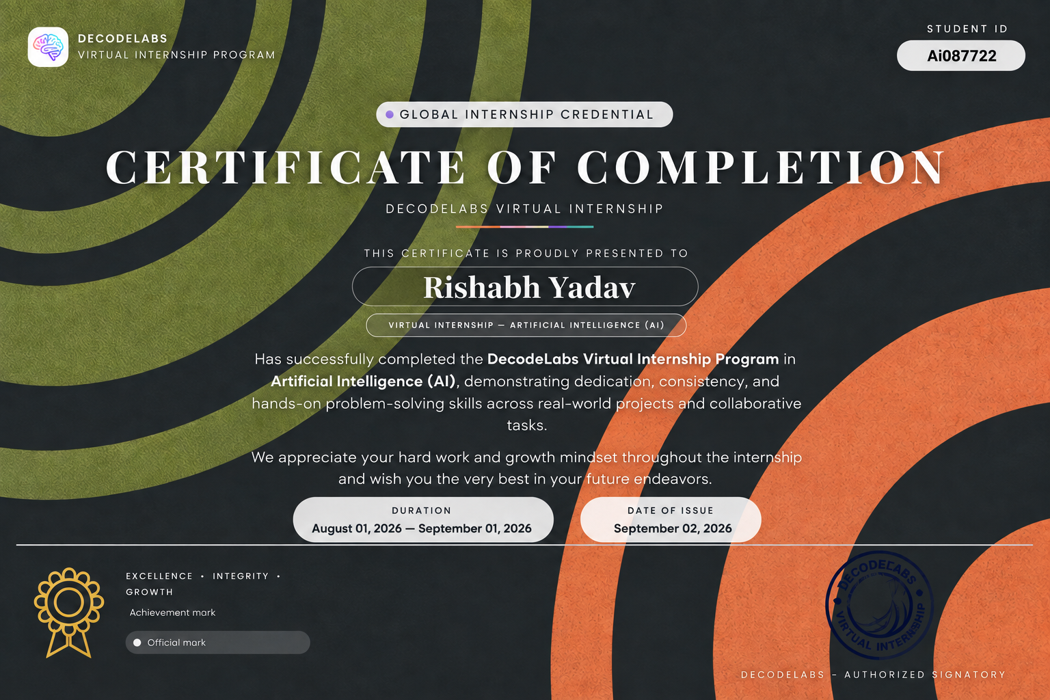
Figure: DecodeLabs Virtual Internship Program – Certificate of Completion (AI087758)
The certificate records successful completion of the DecodeLabs Virtual Internship Program in Artificial Intelligence. The stated internship duration was August 01, 2026 to September 01, 2026, with the certificate issued on September 02, 2026.

TABLE OF CONTENTS
Chapter / Section | Page Nos.
Cover Page | —
1. Candidate’s Declaration | i
2. Acknowledgement | ii
3. Internship Completion Certificate | —
4. Project Description | 1
4.1 Introduction | 1
4.2 Organization Profile | 2
4.3 Problem Statement | 3
4.4 Project Objectives | 4
4.5 Scope of the Project | 5
4.6 Technologies and Tools Used | 6
4.7 System Architecture | 7
4.8 Methodology | 9
4.9 Expected Outcomes | 11
4.10 Certificates of Completion and Communication Proof | 12
5. Bibliography/References | 14

LIST OF FIGURES
Figure | Title | Page
Figure 1 | Project 1 – Input–Process–Output / logic-engine architecture | 7
Figure 2 | Project 2 – K-Nearest Neighbors classification workflow | 7
Figure 3 | Project 2 – Full architecture and validation flow | 8
Figure 4 | Project 3 – Input–Process–Output recommendation architecture | 8
Figure 5 | Project 3 – Four-step ranking pipeline | 10
Figure 6 | Project 3 – Tech Stack Recommender concept | 10

4. PROJECT DESCRIPTION
4.1 Introduction
This internship report presents the work completed during the DecodeLabs Virtual Internship Program in Artificial Intelligence. The internship was designed as a progressive hands-on learning path. The three assigned projects moved from explicit rule-based decision making to supervised data classification and finally to preference matching and recommendation logic.
Project 1 focused on a Rule-Based AI Chatbot. Its goal was to create a continuous interaction loop that accepts predefined user inputs, handles greetings and exit commands, and generates responses using if-else logic. The project introduced control flow, decision-making and basic AI concepts.
Project 2 focused on Data Classification Using AI. The project used a small dataset and introduced the supervised-learning workflow: understanding data, splitting it into training and testing sets, applying a classification algorithm and validating the result. The supplied material uses the Iris benchmark and K-Nearest Neighbors (KNN).
Project 3 focused on AI Recommendation Logic. The project required user preferences or interests to be matched with item attributes using logic or similarity and then displayed as recommendations. The supplied material develops this idea through content-based recommendation, TF-IDF, cosine similarity and a four-step ranking pipeline.
Together, the projects demonstrate a clear progression from deterministic logic to pattern-based prediction and then to similarity-based personalization.

4.2 Organization Profile
DecodeLabs is the organization that provided the Virtual Internship Program in Artificial Intelligence. The internship certificate identifies the program as the “DecodeLabs Virtual Internship Program in Artificial Intelligence (AI)” and records successful completion by Rishabh Yadav. The certificate also records the internship duration as August 01, 2026 to September 01, 2026 and the date of issue as September 02, 2026.
The training material describes the internship as a practical pathway for developing foundational AI engineering skills. Project 1 is presented as the foundation phase, Project 2 as the predictive phase, and Project 3 as the personalization phase. This structure allowed the learner to build concepts incrementally instead of treating AI as a single complex topic.
The supplied project material identifies DecodeLabs as the source of the Industrial Training Kits and gives the organization’s location as Greater Lucknow, India. The material also provides the contact email decodelabs.tech@gmail.com and website www.decodelabs.tech.
The internship approach emphasized experimentation and learning from unexpected outputs. The project conclusions encourage extending solutions, comparing algorithms, testing new data, calculating similarity scores and improving recommendation relevance as ways to deepen practical understanding.

4.3 Problem Statement
The internship addressed three related AI problem types. The first problem was to design a basic conversational interface without a learning model. A chatbot must recognize common user inputs, choose an appropriate response and continue the interaction until the user issues an exit command. The challenge is to organize the decision logic clearly and avoid an unnecessarily complex conditional structure.
The second problem was to classify previously unseen data into known categories. This requires converting a dataset into a form suitable for a machine-learning algorithm, separating training information from testing information, applying a classifier and validating predictions. The supplied Project 2 material uses the Iris benchmark and KNN to demonstrate this workflow.
The third problem was personalization: selecting relevant items from a collection based on a user’s interests or profile. The supplied Project 3 material approaches this as a similarity problem. Text or item attributes are transformed into numerical representations using TF-IDF, similarity is measured using cosine similarity, and candidate items are ranked before the final recommendations are displayed.
Thus, the overall problem addressed by the internship was how to translate user input and raw data into useful, explainable AI-driven outputs using progressively stronger computational techniques.

4.4 Project Objectives
The objectives of the internship were derived from the goals and key requirements stated in the three DecodeLabs project kits.
- Develop a simple rule-based chatbot capable of handling greetings, predefined inputs and exit commands.
- Use if-else control flow and a continuous loop to create an interactive decision-making system.
- Understand the basic supervised-learning pipeline through a small classification dataset.
- Split data into training and testing sets and apply a simple classification algorithm.
- Understand the role of feature scaling and model validation in a classification workflow.
- Build a preference-based recommendation system that accepts user choices or interests.
- Represent item information numerically and compare items using similarity logic.
- Rank candidate items and display recommendations that are relevant to the user profile.
- Develop practical AI problem-solving skills through three progressively advanced projects.

4.5 Scope of the Project
The scope of this internship report is limited to the three projects supplied in the DecodeLabs Artificial Intelligence Industrial Training Kits. The projects are foundational rather than production-scale systems, and the report therefore focuses on the concepts, workflow and architecture presented in the supplied material.
Project 1 scope: a predefined-input chatbot using explicit decision rules, input sanitization, a continuous loop and dictionary-based response lookup. The project also introduces the contrast between a basic rule-based approach and more advanced AI systems.
Project 2 scope: a small supervised classification workflow using the Iris benchmark, feature scaling, train-test splitting, K-Nearest Neighbors, prediction and validation through a confusion matrix and F1-score-oriented evaluation.
Project 3 scope: a content-based recommendation workflow using user/item information, TF-IDF feature extraction, cosine similarity, ranking and filtering. The project material culminates in the concept of a Tech Stack Recommender.
The scope does not claim deployment as a commercial product, large-scale model training, neural collaborative filtering or deep-learning implementation, because these are beyond what is specified in the supplied project kits.

4.6 Technologies and Tools Used
Project | Technology / Concept | Purpose
Project 1 | Conditional logic and control flow | Select responses for predefined inputs.
Project 1 | Continuous loop | Maintain an ongoing chatbot interaction.
Project 1 | Input sanitization | Normalize user input before processing.
Project 1 | Dictionaries / hash maps and get() lookup | Store and retrieve predefined responses efficiently.
Project 2 | Iris benchmark dataset | Provide a small multiclass classification problem.
Project 2 | Train-test split | Separate learning data from evaluation data.
Project 2 | Feature scaling | Put numeric features on a comparable scale.
Project 2 | K-Nearest Neighbors (KNN) | Classify new samples from nearby training samples.
Project 2 | Scikit-learn workflow | Support model training and prediction.
Project 2 | Confusion matrix / F1 score | Validate classification performance.
Project 3 | Content-based recommendation | Match items to user preferences through item attributes.
Project 3 | TF-IDF | Convert text features into numerical vectors.
Project 3 | Cosine similarity | Measure orientation-based similarity between vectors.
Project 3 | Ranking and filtering | Order candidates and return relevant recommendations.

4.7 System Architecture
The three projects use different processing architectures, but all follow the same broad pattern: receive input, transform or interpret it, apply decision logic or an algorithm, and produce an output.
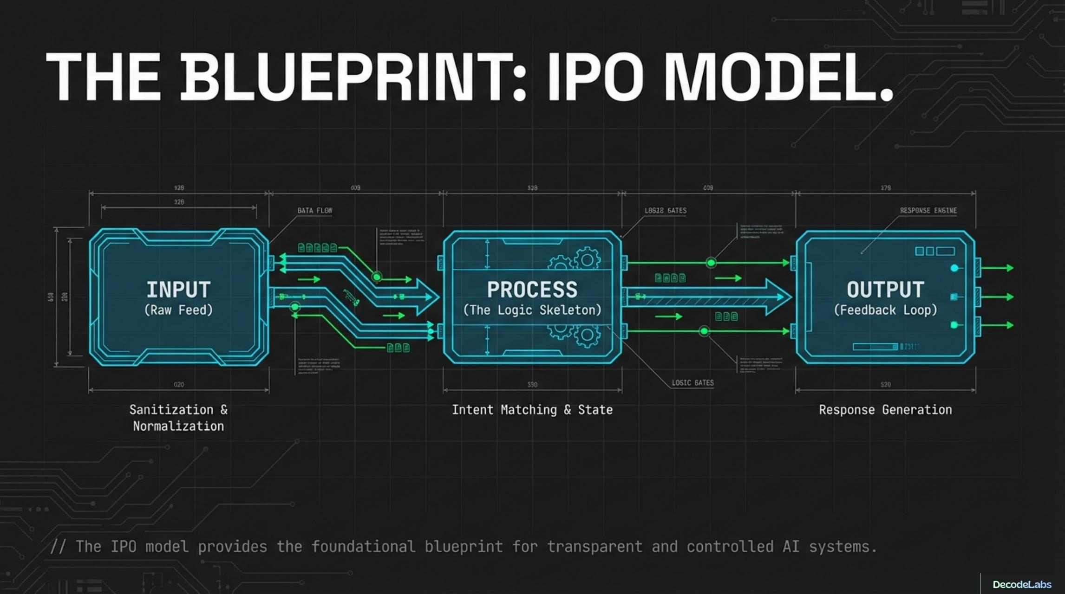
Figure 1: Project 1 – Input–Process–Output / logic-engine architecture (source training material).
For Project 1, the architecture begins with user input and sanitization. The cleaned input is processed through rule matching and dictionary-based lookup, after which the chatbot produces a response. A continuous loop keeps the system active until an exit command is received.
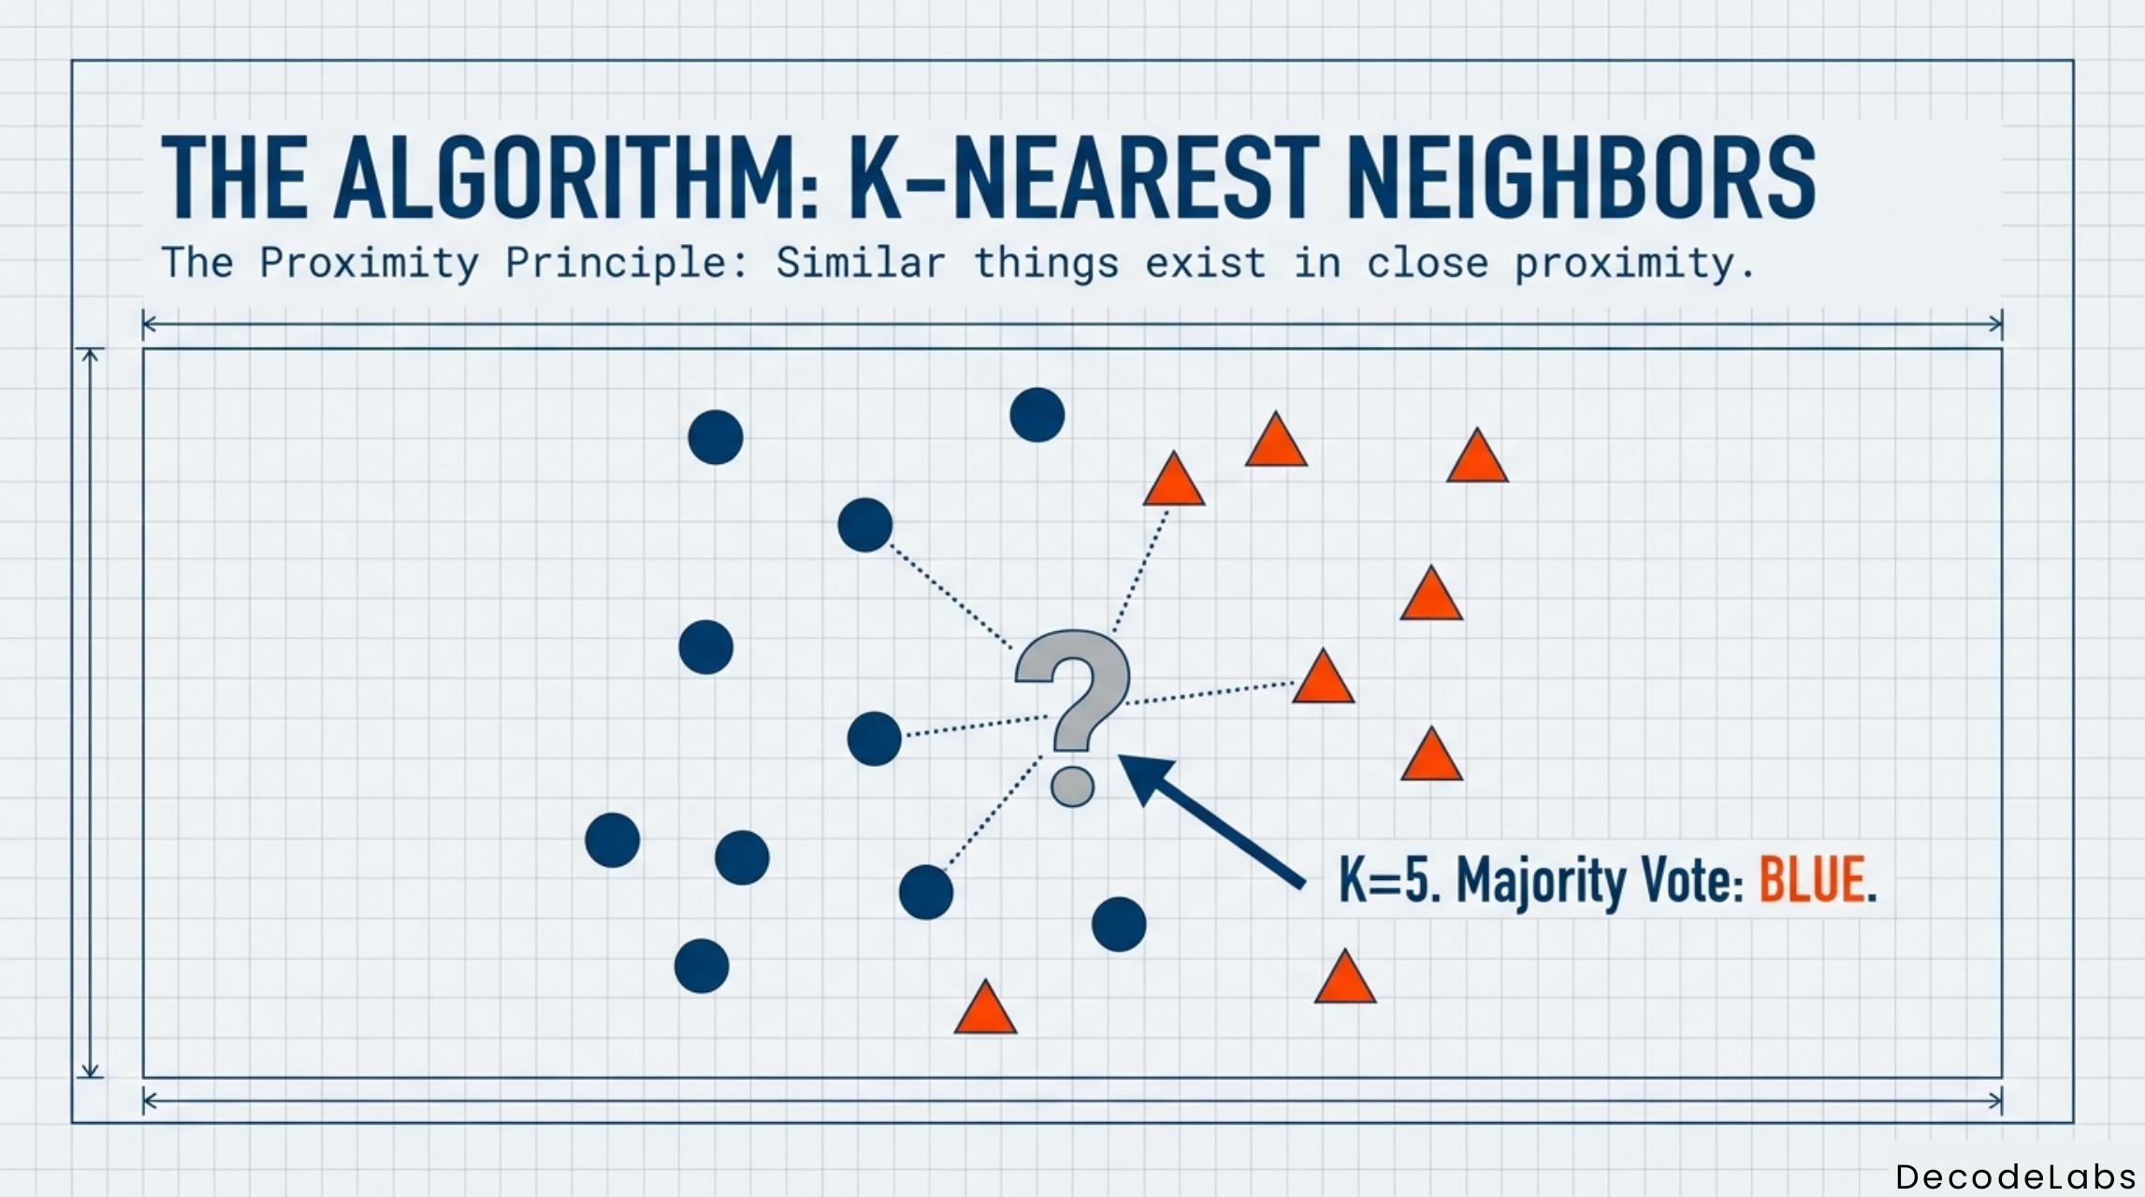
Figure 2: Project 2 – K-Nearest Neighbors classification and neighborhood-based prediction.
4.7 System Architecture (continued)
Project 2 follows an input-process-output machine-learning architecture. The dataset is prepared, features are scaled, the data is divided into training and testing sets, and KNN is applied. The model predicts classes for test samples, and the results are validated using classification metrics such as the confusion matrix and F1 score.
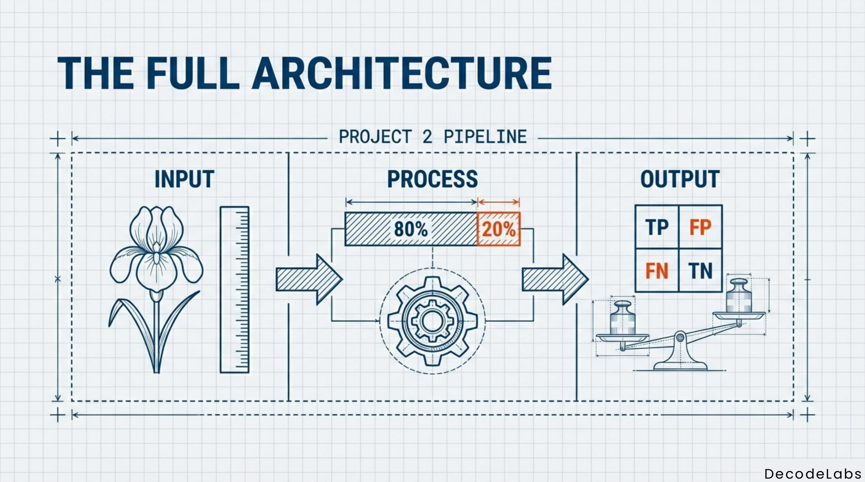
Figure 3: Project 2 – Full architecture showing dataset, processing and validation output.
Project 3 extends the architecture by adding a representation and similarity stage. User preferences and item attributes are converted into comparable feature vectors. TF-IDF is used for textual feature representation, cosine similarity measures closeness, and a ranking-and-filtering stage produces the final recommendations.
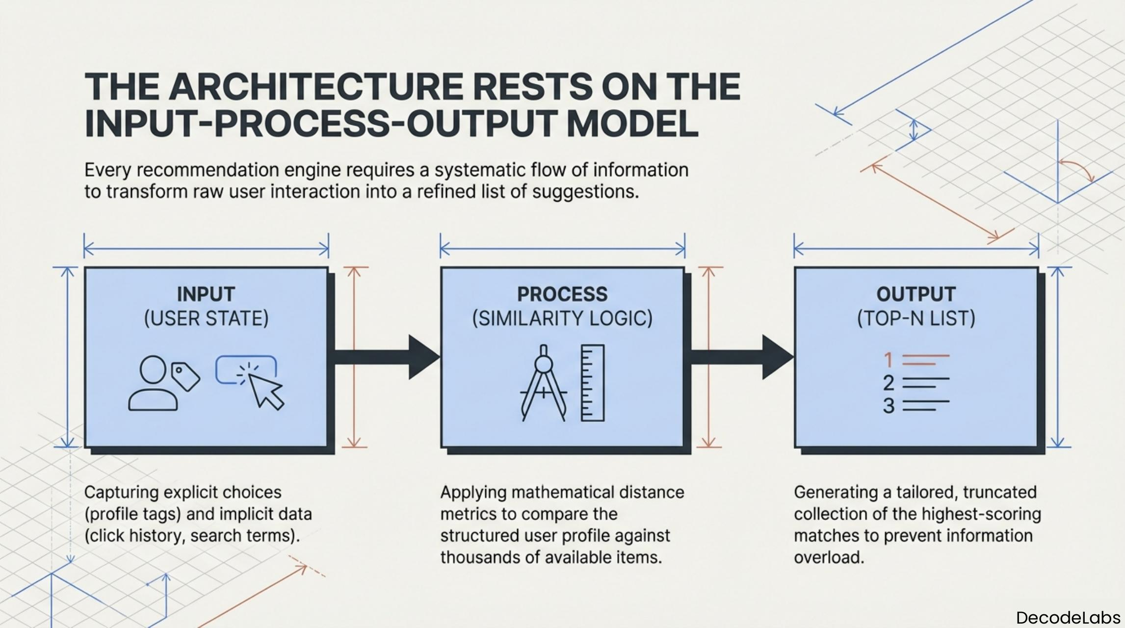
Figure 4: Project 3 – Input–Process–Output recommendation architecture.
4.8 Methodology
Project 1 – Rule-Based AI Chatbot
- Define a set of expected user inputs such as greetings, common questions and exit commands.
- Sanitize or normalize the incoming text so that matching is consistent.
- Use explicit if-else decision logic to identify the appropriate response category.
- Use dictionary/hash-map style storage and get() lookup where appropriate for cleaner response retrieval.
- Run the interaction inside a continuous loop so that multiple user messages can be processed.
- Terminate the loop when the user gives an exit command and display the final response.
Project 2 – Data Classification Using AI
- Load and understand the Iris benchmark dataset and its class labels.
- Prepare the numerical feature data and apply standard scaling so features are comparable.
- Shuffle and split the data into training and testing sets.
- Apply K-Nearest Neighbors as the classification algorithm and choose an appropriate value of K.
- Train the classifier using the training set and generate predictions for the test set.
- Validate the predictions with a confusion matrix and F1-score-oriented evaluation.
Project 3 – AI Recommendation Logic
- Collect user preferences or interests and identify the attributes associated with candidate items.
- Convert relevant textual information into numerical vectors using TF-IDF.
- Compute cosine similarity between the user/item representation and candidate item vectors.
- Rank candidate items according to similarity scores.
- Filter and display the highest-ranked relevant recommendations.
4.8 Methodology (continued)
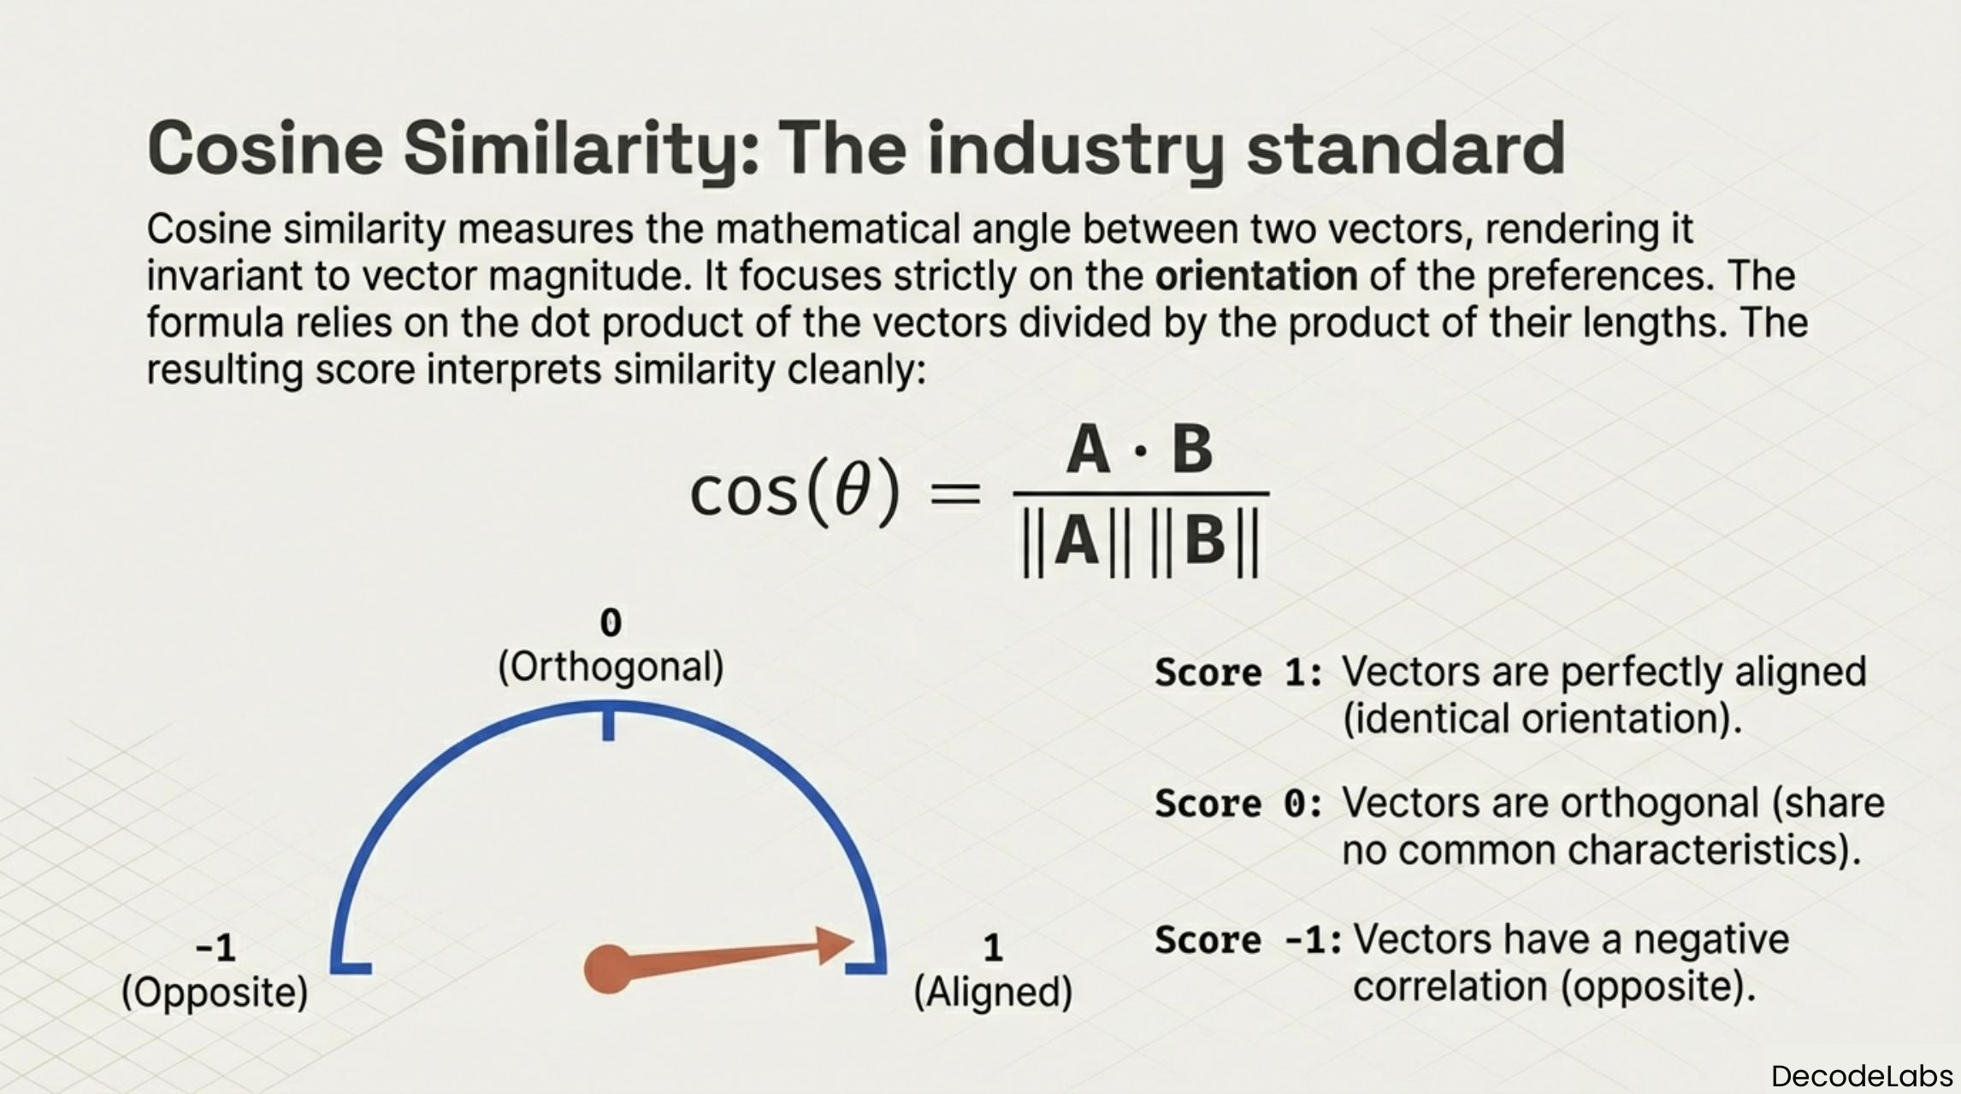
Figure 5: Project 3 – Four-step ranking pipeline: ingestion, scoring, sorting and filtering.
The recommendation workflow shown in the supplied material can be understood as a four-stage ranking pipeline. First, item information is ingested. Second, candidate items receive similarity scores. Third, candidates are sorted by their scores. Finally, filtering selects the most relevant items for presentation to the user.
The Project 3 material also discusses the limitation of binary overlap using simple AND/OR logic and motivates a stronger similarity mechanism. TF-IDF gives more informative weights to terms, while cosine similarity compares vector orientation rather than raw magnitude. This makes the approach suitable for content-based recommendation when item descriptions contain meaningful attributes.
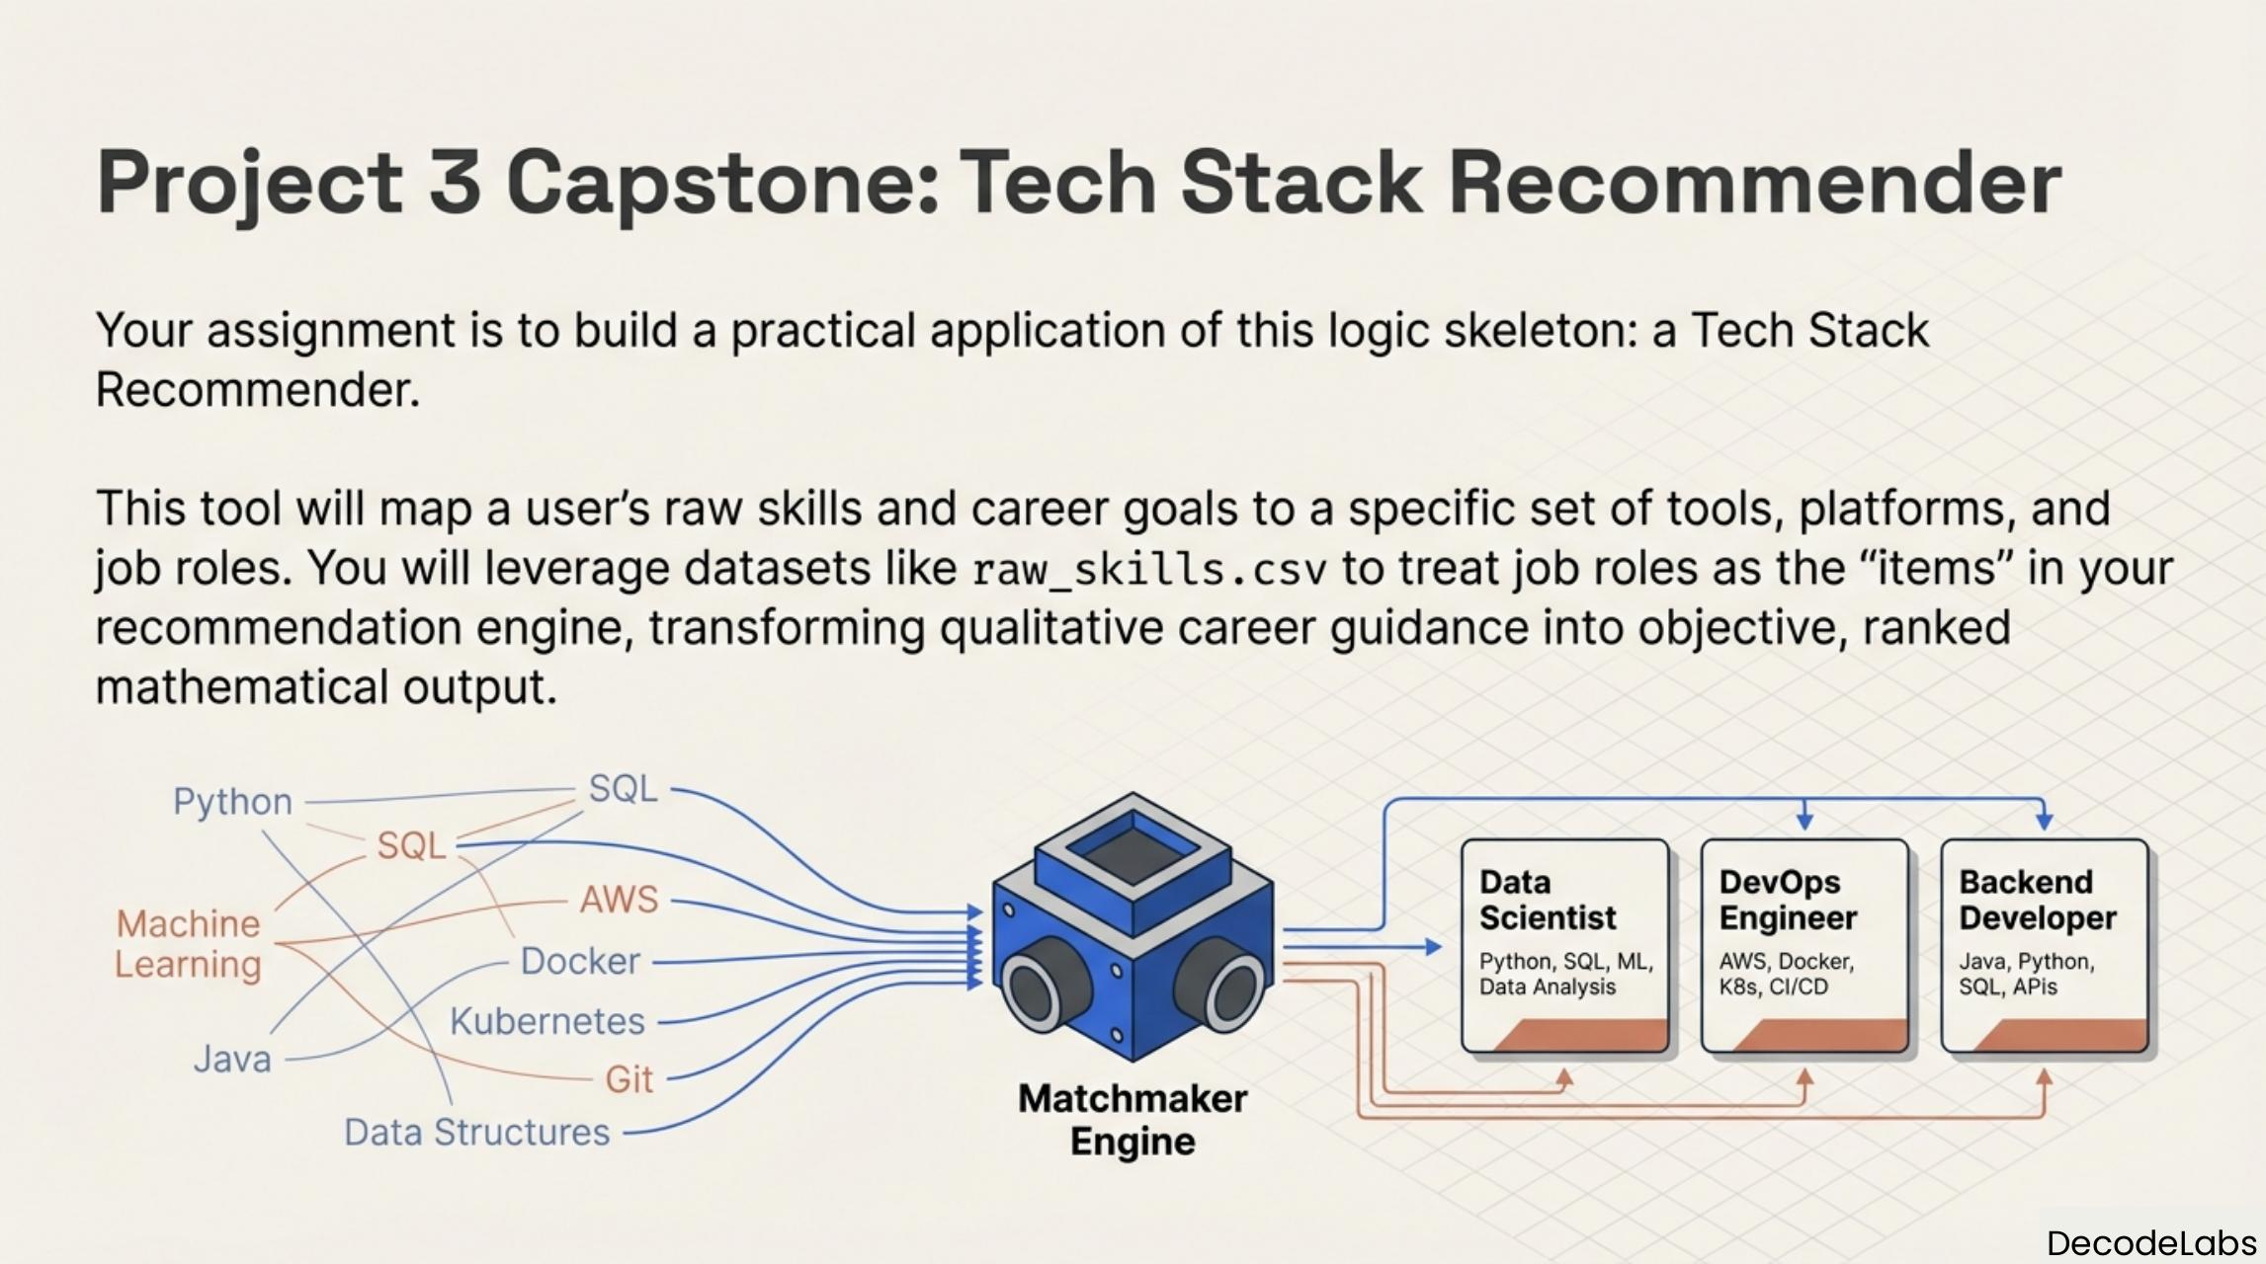
Figure 6: Project 3 – Tech Stack Recommender concept and progression toward a practical application.
4.9 Expected Outcomes
The expected outcomes of the internship are both technical and practical. By completing the three projects, the learner develops a foundation for understanding how AI systems can be built from simple deterministic logic and gradually extended into data-driven and similarity-based approaches.
Outcome | Expected Learning
Rule-based interaction | Ability to design a continuous chatbot loop, handle user input and implement clear decision rules.
Data preparation | Understanding of datasets, feature scaling and separation of training and testing data.
Classification | Practical exposure to KNN, prediction and validation through a confusion matrix and F1-score-oriented evaluation.
Recommendation | Understanding of content-based recommendation, TF-IDF, cosine similarity and ranking.
Algorithmic thinking | Ability to decompose an AI problem into input, processing and output stages.
Practical learning | Experience in interpreting outputs, experimenting with alternatives and improving solutions based on observed behavior.
The DecodeLabs project conclusions emphasize that hands-on practice is the key to mastering Artificial Intelligence. They encourage extending vocabulary and conditions in the chatbot, comparing algorithms and testing new data in classification, and experimenting with similarity scores or user ratings in recommendation systems. These activities provide a foundation for future work in more advanced AI systems.

4.10 Certificates of Completion and Other Communication Proof
A copy of the internship completion certificate issued by DecodeLabs is attached in Chapter 3 of this report. The certificate identifies the credential as a “Global Internship Credential Certificate of Completion,” records Rishabh Yadav as the recipient, and gives certificate/student ID AI087758. It states the program as the DecodeLabs Virtual Internship Program – Artificial Intelligence (AI).
The certificate records the internship duration as August 01, 2026 — September 01, 2026 and the date of issue as September 02, 2026. The certificate is included as a full-page reproduction before the project description, in accordance with the supplied IILM report format.
The supplied report template also instructs that certificates of completion and other communication mail proof should be attached. The available certificate has therefore been included as the formal completion proof. No separate communication email proof was provided in the supplied files, so none has been fabricated or added.
Figure 7: Internship completion certificate – DecodeLabs Virtual Internship Program in Artificial Intelligence.

5. BIBLIOGRAPHY / REFERENCES
DecodeLabs. (2026). Industrial Training Kit – Artificial Intelligence, Project 1: Rule-Based AI Chatbot. Supplied internship material.
DecodeLabs. (2026). Industrial Training Kit – Artificial Intelligence, Project 2: Data Classification Using AI. Supplied internship material.
DecodeLabs. (2026). Industrial Training Kit – Artificial Intelligence, Project 3: AI Recommendation Logic. Supplied internship material.
DecodeLabs. (2026). Global Internship Credential – Certificate of Completion, DecodeLabs Virtual Internship Program in Artificial Intelligence (AI), Certificate/Student ID AI087758.
IILM University, School of Computer Science and Engineering. Internship Report Format / Template, Batch 2026-27. Supplied institutional document.
Note: This report has been prepared using the supplied institutional report template, internship completion certificate and the three DecodeLabs project training kits. Technical claims have been kept within the scope of those materials.

