MODULE 3 — Loops and repeated computation
Question: 1342 — Number of Steps to Reduce a Number to Zero
Platform: LeetCode
Problem Link: 1342 — Number of Steps to Reduce a Number to Zero
C Source Code:
int numberOfSteps(int num) { int steps = 0;

while (num > 0) {
if (num % 2 == 0) { num = num / 2;
} else {
num = num - 1;
}
steps++;
}

return steps;
}

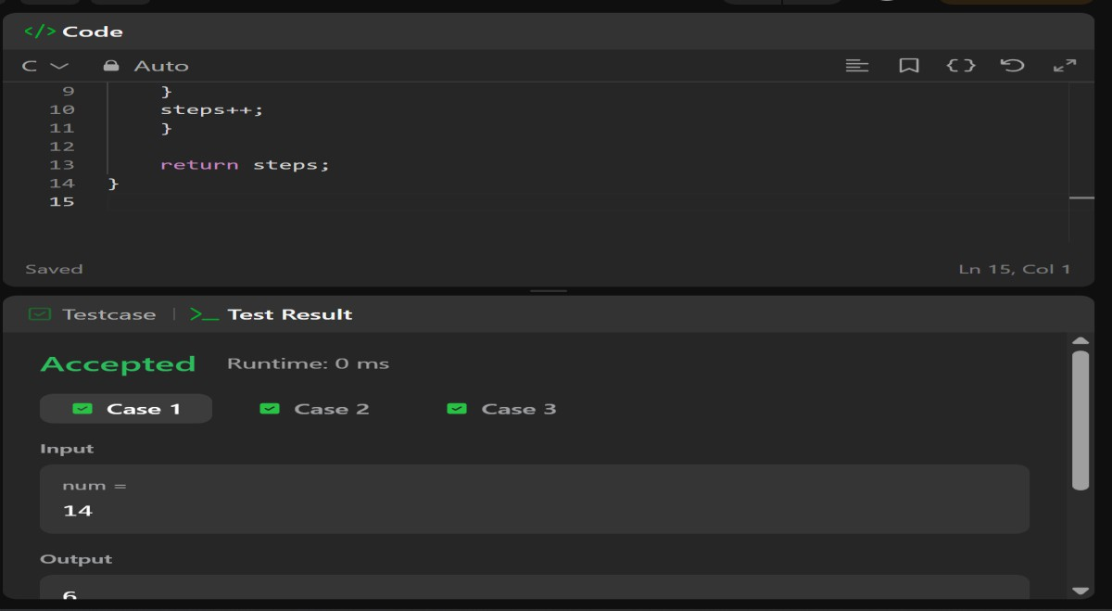
Submission Screenshot:

