MODULE 3 — Loops and repeated computation
Question: 2169 — Count Operations to Obtain Zero
Platform: LeetCode
Problem Link: 2169 — Count Operations to Obtain Zero
C Source Code:
int countOperations(int num1, int num2) { int operations = 0;

while (num1 > 0 && num2 > 0) { if (num1 >= num2) {
num1 = num1 - num2;
} else {
num2 = num2 - num1;
}
operations++;
}

return operations;
}

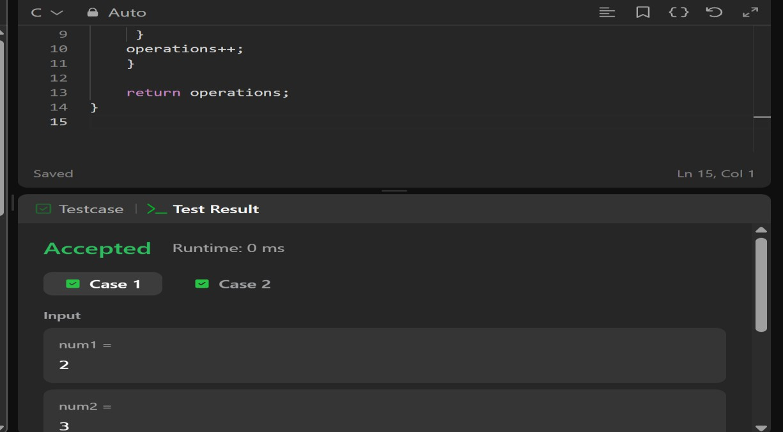
ScreenShot Submission:

