MODULE 4 — Digit extraction and number manipulation
Question: 9 — Palindrome Number
Platform: LeetCode
Problem Link: 9 — Palindrome Number
C Source Code:
bool isPalindrome(int x) { if (x < 0) {
return false;
}

int original = x; long reversed = 0;

while (x > 0) {
int digit = x % 10;
reversed = reversed * 10 + digit; x /= 10;
}

return original == reversed;
}

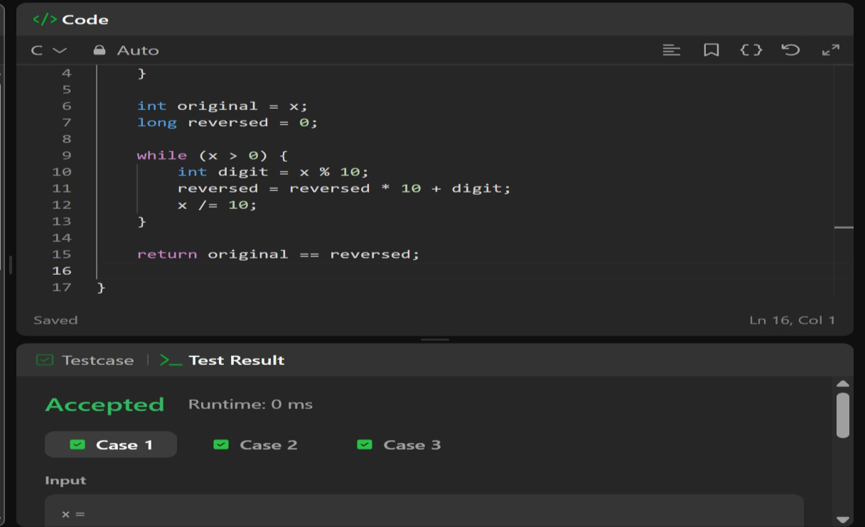
screenshot:

