MODULE 4 — Digit extraction and number manipulation
Question: 7 — Reverse Integer
Platform: LeetCode
Problem Link: 7 — Reverse Integer
C Source Code:
int reverse(int x) { int reversed = 0;

while (x != 0) {
int digit = x % 10; x /= 10;

if (reversed > INT_MAX / 10 ||
(reversed == INT_MAX / 10 && digit > 7)) { return 0;
}

if (reversed < INT_MIN / 10 ||
(reversed == INT_MIN / 10 && digit < -8)) { return 0;
}

reversed = reversed * 10 + digit;
}

return reversed;
}

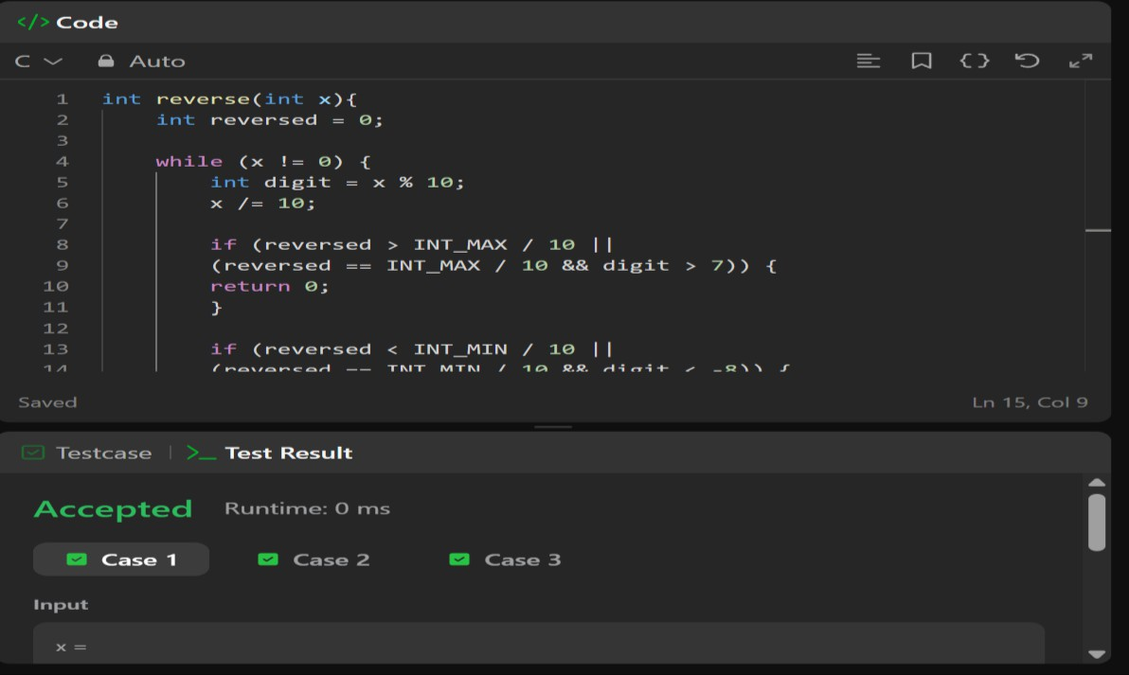
screenshot:

