**Project Report**

*on*

**Hostel Management System**

*For the partial fulfilment of Database Management System Laboratory*

*Submitted By*

**Rishabh Misra**

B160052CS

*Under the Supervision of*

**Dr. Sangram Ray**



**Department of Computer Science and Engineering**

**National Institute of Technology Sikkim**

**Ravangla-737139, Sikkim, India**

**December, 2018**

**CERTIFICATE**



This is to certify that the project report entitled “**Hostel Management System**”, submitted by **Mr. Rishabh Mishra** is an authentic report for the work carried out under my supervision as a part of Database Management System Laboratory during the Monsoon semester, 2018 at National Institute of Technology Sikkim, Ravangla-737139, Sikkim.

**Dr. Sangram Ray**

**Assistant Professor & Head of the Department**

**Department of Computer Science and Engineering**

**National Institute of Technology Sikkim**

**Ravangla-737139, Sikkim, India**

**Acknowledgement**

First and foremost, I would like to express my deepest gratitude to my supervisor, **Dr. Sangram Ray**. It has been an honor for me to do a project under his supervision and sincerely thank him for his excellent guidance, support and motivation in every step throughout during the whole period of my project.

I specially thank to the **Ms. Deepanwita Sodhukhan**, **Mr. Vivek Kumar**, **Ms. Diksha Rangwani**, for their valuable support, patience, critical comments and detailed review during the period of my project. They always inspired me, willing to help and give their best suggestions.

I am indeed grateful to all the faculties and staff of the National Institute of Technology Sikkim for providing an environment conducive to my project.

Finally, I would like to thank God Almighty for giving me the strength, knowledge, ability and opportunity to undertake this project study and to persevere and complete it satisfactorily.

**Rishabh Mishra**

**B160052CS**

**5th semester, 3rd year undergraduate**

**Department of Computer Science and Engineering**

**ABSTRACT**

“HOSTEL MANAGEMENT SYSTEM” is software developed for managing various activities in the hostel. For the past few years the numbers of educational institutions are increasing rapidly. Thereby the numbers of hostels are also increasing for the accommodation of the students studying in this institution. And hence there is a lot of strain on the person who is running the hostel and software’s are not usually used in this context.

This particular project deals with the problems on managing a hostel and avoids the problems which occur when carried manually. The main feature of this project is that user can request to book a room in the hostels by viewing the other roommates in rooms. And room will be allotted after admin’s confirmation.

# **Problem Definition**

# This system is designed in favor of the hostel management which helps them to save the records of the students about their rooms and other things. It helps them from the manual work from which it is very difficult to find the record of the students. All the hostels at present are managed manually by the hostel office. The Registration form verification to the different data processing is done manually. Thus there are a lot of repetitions which can be easily avoided. And hence there is a lot of strain on the person who is running the hostel and software’s are not usually used in this context. This particular project deals with the problems on managing a hostel and avoids the problems which occur when carried manually. Identification of the drawbacks of the existing system leads to the designing of a computerized system that will be compatible to the existing system with the system which is more user-friendly. We can improve the efficiency of the system, thus overcome the drawbacks of the existing system. We design this system of the hostel management especially for the college hostel, through this each user is free to choose their room according to their comfortability.

# **Requirement Analysis**

**Languages Used**

The whole Project is divided in two parts the front end and the back end.

1. **Front end**

* **HTML**
* **CSS**
* **JAVASCRIPT**

1. **Back end**

* **PHP**
* **MySQLi**

**Software Used**

* **Xampp**

**UML DIAGRAMS**

**ENTITY RELATIONSHIP DIAGRAM**

**USECASE DIAGRAM**

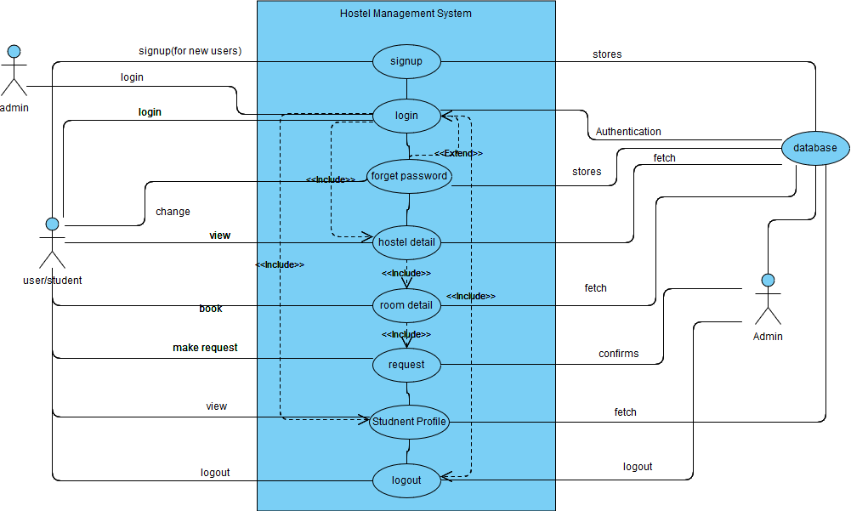

**SEQUENCE DIAGRAM**

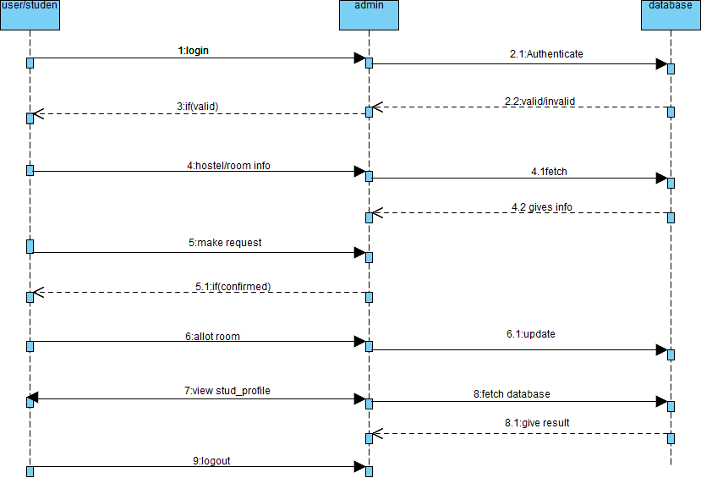

**CLASS DIAGRAM**

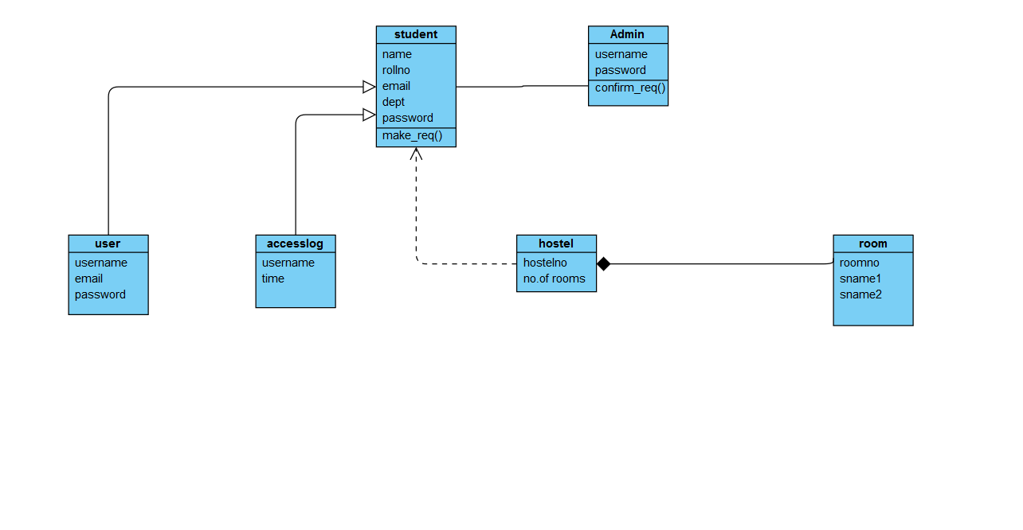

**ACTIVITY DIAGRAM**

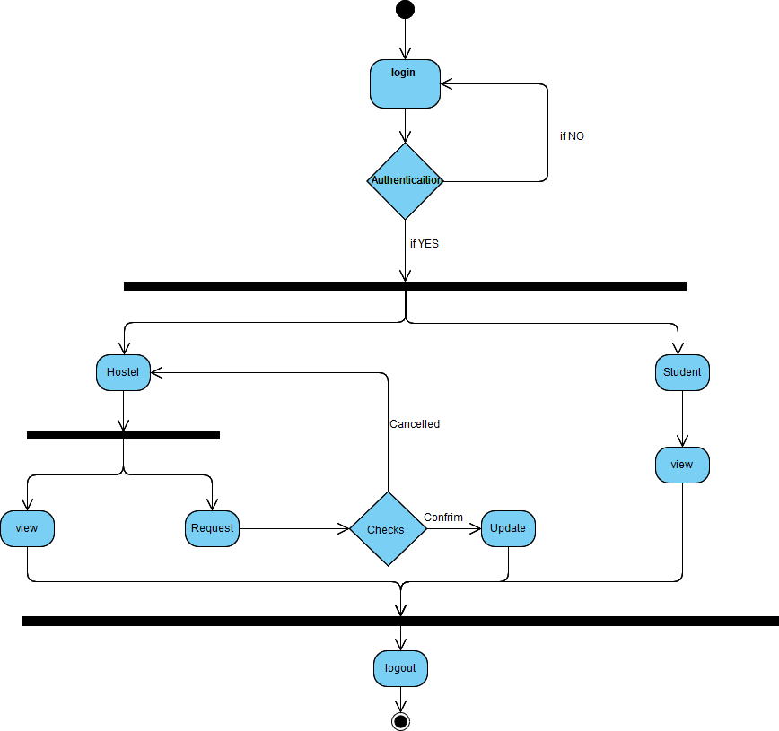

**Database Relationship Schema**

**USER**

**STUDENT**

**ADMIN**

**REQUEST**

**ROOM**

**CONCLUSION**

To conclude the description about the project: The project developed using PHP and MySQLi is based on the requirement specification of the user and the analysis of the existing system, with flexibility for future enhancement.

The expanded functionality of today’s software requires an appropriate approach towards software development. This hostel management software is designed for people who want to manage various activities in the hostel. For the past few years the numbers of educational institutions are increasing rapidly. Thereby the numbers of hostels are also increasing for the accommodation of the students studying in this institution. . And hence there is a lot of strain on the person who is running the hostel and software’s are not usually used in this context. This particular project deals with the problems on managing a hostel and avoids the problems which occur when carried manually.

Identification of the drawbacks of the existing system leads to the designing of a computerized system that will be compatible to the existing system with the system which is more user-friendly and more GUI oriented.