**USE CASE DESCRIPTION**

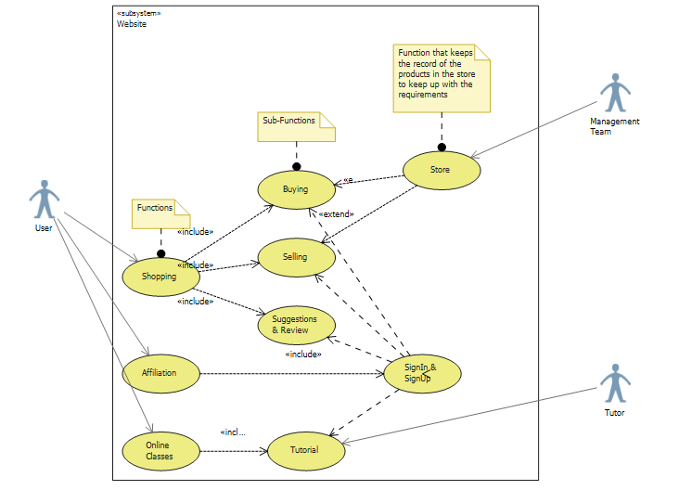

**Description:**

|  |  |
| --- | --- |
| USE CASE | Shopping |
| Primary Actor | User |
| Level | Homepage level |
| Stake Holder | User, Bank, Site Management team |
| Precondition | User Logged in (Sign in/Sign up) |
| Minimal Guarantee | Rollback of transactions |
| Success Guarantee | Easily downloadable games |
| Trigger | User redirected to homepage |

|  |  |
| --- | --- |
| USE CASE | Affiliation |
| Primary Actor | User |
| Level | Homepage level |
| Stake Holder | User, Site Management team |
| Precondition | User accessible to the website, Logged in |
| Minimal Guarantee | Payment failure |
| Success Guarantee | User will be paid for referring the website and its products |
| Trigger | User redirected to homepage |

|  |  |
| --- | --- |
| USE CASE | Online Classes |
| Primary Actor | User |
| Level | Homepage level |
| Stake Holder | User, Tutor |
| Precondition | Logged in (Sign in/Sign up) |
| Minimal Guarantee | Tutorials access failure |
| Success Guarantee | User will be able to learn through online class tutorials |
| Trigger | User redirected to homepage |