**4/16/2021**

**Name** Rishabh Sharma

**Registration Number** 20MAI0082

Classification Algorithms

ASSIGNMENT-4

**GitHub Link :-** https://github.com/rishabh5197/Data-Mining/tree/main/Assignment-4

**Description About dataset**

* There are 400 rows and 5 columns present in our dataset from which user_id is unique and the rest 3 columns are going to be independent data and the last one is going to be the dependent data which is purchased.

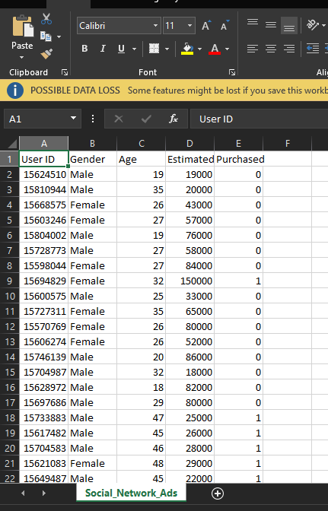

**Python Program Implementation**

* Importing necessary libraries

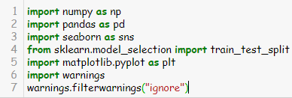

* Reading dataset and selecting the features that are needed. Selecting Independent variable as x and dependent variable as y and dividing the dataset using train_test_split.

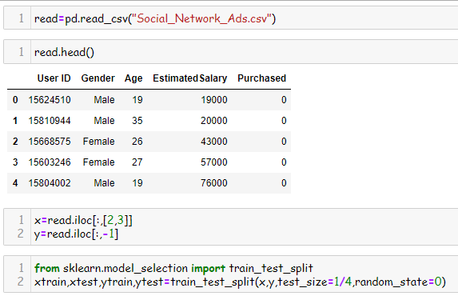

**Firstly, implementing SVM**

* Using Sklearn package to import SVM

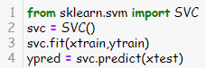

* Getting evaluation of the model using confusion matrix and accuracy score.

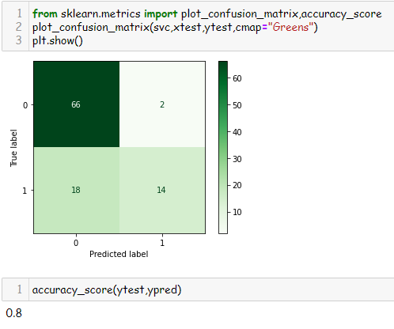

**Implementing Naïve Bayes**

* Using sklearn package to import Naïve Bayes.

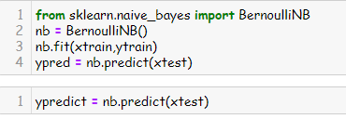

* Getting evaluation of the model using confusion matrix and accuracy score.

