Java ConceptsIntegrated Visual Notes

Table of Contents

How to use this book
A short guide to the structure, the labels, and the fastest route through the material for a specific purpose.

1 The book has one spine, not two
This is a single volume. It is not an I/O book and a database book sharing a cover. Part I establishes the architecture of one application. Parts II to V teach the technologies that make each part of that architecture work. Part VI returns to the whole system and traces real data through it. The revision section at the end is a single coordinated set of comparison tables, questions and exercises covering the entire scope.

2 What every chapter assumes
Chapters are written for a third-semester Computer Science student who can already declare a class, write a loop and call a method. No prior exposure to streams, JDBC or Swing is assumed. Where a chapter depends on an earlier one, a CONNECTION TO ANOTHER CONCEPT box says so explicitly and tells you where to look.

3 The eight labels you will see
Every explanatory box in this book carries one of a small set of labels. The label is a promise about the kind of claim being made, and the difference between them matters.
Label | What it means | Trust level
FROM THE LECTURE NOTES | Terminology, definitions and examples that come from the source lecture material. | Source content
CONCEPT EXPLAINED FURTHER | Additional explanation added by this book to make the concept complete or precise. | Supplementary
BASINWATCH IN PRACTICE | A claim verified against the actual source code of the BasinWatch repository. | Verified in code
RELATED TECHNIQUE — NOT USED IN BASINWATCH | A real technique from the syllabus or the wider ecosystem that this particular project does not implement. | Taught, not used here
CONNECTION TO ANOTHER CONCEPT | An explicit link between this topic and another topic in the book. | Cross-reference
IMPORTANT DISTINCTION | Two things that are often confused, stated side by side. | Clarification
COMMON MISTAKE | An error students and programmers actually make, and how to avoid it. | Warning
TECHNICAL CLARIFICATION | Where a lecture-note statement is dated, incomplete or questionable, with the modern position stated fairly. | Correction
Table 0.1 — The explanatory labels used throughout the book. Two further labels appear inside code walkthroughs: EXAM TIP marks something that is frequently asked, and VISUAL WALKTHROUGH introduces a diagram reading order.

4 Where the code comes from
Java listings fall into three clearly separated groups, and each listing says which group it belongs to:
- Verified BasinWatch code — copied from the repository at github.com/Rishu07368/basinwatch and quoted as it actually appears, sometimes trimmed to the relevant lines. Captions say "from BasinWatch" and name the file.
- Lecture-note style examples — small programs in the shape the notes use, including the Swing login application. Captions say "lecture-note style".
- Illustrative examples — short programs written for this book to demonstrate a syllabus concept the project does not itself exercise. Captions say "illustrative".
COMMON MISTAKENothing in this book is presented as verified project behaviour unless the source file was read. Where a plausible-sounding claim could not be confirmed — for example, that BasinWatch uses Spring, or that it stores passwords — the book says so plainly rather than inventing it. If you are reading this to prepare for a viva, that discipline is itself worth copying.

5 Four routes through the book
If your goal is… | Read | Then
Pass an I/O and file-handling examination | Chapters 4, 5, 6, 7, 8, then 9 | Revision comparison tables and the I/O viva questions
Pass a JDBC and database examination | Chapters 10, 11, 12, 13, then 14 | The JDBC comparison tables, transaction questions and SQL exercises
Explain your project in a viva | Chapter 1, then 20 and 21 | Chapter 2 for object concepts, Chapter 16 for the UI path
Understand how it all fits together | Read straight through, Parts I to VI | Finish with Chapter 21 and the high-yield revision section

6 The BasinWatch repository
BasinWatch is an offline Java desktop simulation that monitors a fictional flood basin, processes incoming observations, coordinates limited response resources, keeps operational history, and presents everything through a Swing interface. It is a planning simulation: it does not forecast real floods, control real equipment, or connect to real services. It is a deliberately bounded teaching artefact that nevertheless uses each technology for a genuine reason.
The project is built with Java 17 and Maven, uses only standard java.io, java.util.concurrent, Swing and raw JDBC, and stores its optional history in a local SQLite file. That last sentence is worth remembering, because it determines which chapters can say "used in BasinWatch" and which must say "related technique".
BASINWATCH IN PRACTICEThe repository files referenced throughout are real: src/main/java/com/basinwatch/{app,domain,engine,io,db,learning}. When a chapter quotes a method, you can open the file and find it. That is the standard this book holds itself to.

7 What this book deliberately does not claim
- It does not claim that BasinWatch uses Spring, JPA, Hibernate, JavaFX, a web framework, or a remote database server. It uses none of them.
- It does not claim that the lecture notes contained every sentence here. Lecture content and supplementary explanation are labelled differently, on purpose.
- It does not present illustrative code as tested project code.
- It does not treat thread priority, serialization, or SQL string building as safe by default; each is discussed with its real limitations.
- Read Chapter 1 before anything else. It gives you the mental model every later chapter refers back to.
- Keep Diagram 1 (the architecture) and Diagram 2 (the connection map) nearby.
- When a chapter says CONNECTION TO ANOTHER CONCEPT, follow the link — that is where the integrated understanding lives.

Understanding the System

The Complete Java System: From Data Input to a Working Application
One application, many technologies. This chapter builds the mental model that every later chapter refers back to.

1.1 The question this book answers
Here is the question. It is short, and it is the reason this book exists rather than a stack of separate revision sheets:
THE CENTRAL QUESTION How do separate Java technologies work together to turn incoming data into a usable application, store information persistently, and display useful results to a user?
A student who has just finished a semester of Java can usually answer each part of that question alone. Streams read and write data. JDBC talks to databases. Swing draws windows. Maven builds projects. Each answer is correct and each is nearly useless on its own, because in a real program these things are not separate. A button press causes a query; a query returns rows that become objects; those objects are rendered; the same data is also written to a log file; a thread produced the data in the first place. The technologies are a system.
So this chapter does not explain any API in depth. It does something more important: it shows you the system, names every component in it, and explains why each technology is present. By the end you should be able to sketch the whole application from memory. Every later chapter fills in one box of that sketch.
CORE CONCEPTThe organising idea of this book is one connected Java application. Every technology you will study is introduced twice: first on its own terms, then in the place where the application actually needs it. If you ever lose the thread, come back to Diagram 1 and find your current topic in it.

1.2 What BasinWatch is trying to accomplish
BasinWatch is an offline floodplain operations console. A basin is a river catchment area; when rain falls and water levels rise, some districts flood before others, and a control room has to decide where to send limited equipment. BasinWatch simulates that situation on a desktop so a student or planner can practise the decisions without any real risk.
The operator's job, in the project's own words, is to watch a schematic basin map as rain and water levels change, review severity-ranked zone alerts, dispatch pumps, levee crews and evacuation teams to concurrent missions, see what resources remain available, then save the session, close the application, and restore the model and active operations later.

What enters the system
- Simulated station observations: rainfall in millimetres and observed water rise in centimetres, for six named zones.
- Simulation pulses marking the passage of a time interval.
- Operator commands: start, pause, step, inject a storm cell, dispatch, save, restore, export a report.
- Selection events: which zone the operator is inspecting.

What leaves the system
- A live map of six zones coloured by risk level.
- A ranked activity timeline and a list of active field operations.
- A resource board showing available and committed units.
- Persistent artefacts: an operational log, a typed binary archive, session saves and readable reports.
- Optional queryable history in a local SQLite database.
Six zones are monitored. Each has a position on a two-by-three schematic grid, an initial water level in metres, and a number of exposed residents. Risk is derived from the water level by fixed thresholds: below 1.7 m is NORMAL, 1.7 m and above is WATCH, 2.6 m and above is WARNING, and 3.6 m and above is CRITICAL.
BASINWATCH IN PRACTICEThose thresholds are real code, not invented for the book. They appear in BasinZone.assessRisk(double):
static

RiskLevel
assessRisk(
double
waterLevelMeters) {

if
(waterLevelMeters >= 3.6)
return

RiskLevel
.CRITICAL;

if
(waterLevelMeters >= 2.6)
return

RiskLevel
.WARNING;

if
(waterLevelMeters >= 1.7)
return

RiskLevel
.WATCH;

return

RiskLevel
.NORMAL;
}

1.3 The verified runtime architecture
The single most useful thing you can learn about a program is which component owns which responsibility and which thread runs which code. BasinWatch's architecture is documented in its own ARCHITECTURE.md, and — importantly — the documentation matches the code. Here is the verified picture.
VISUAL WALKTHROUGHRead Diagram 1 from top to bottom. Follow the arrow from the operator into the Swing interface, down through the application commands into the engine, then along the green sensor path from left to right, and finally down into the two persistence columns. Every box is a real class; every arrow is a real call, stream write or thread hand-off.
Diagram 1 — The complete BasinWatch system. Six layers: the operator, the Swing interface on the event-dispatch thread, the engine's command API, the domain and engine layer, the sensor input path with its piped streams, and the two independent persistence columns for files and JDBC.
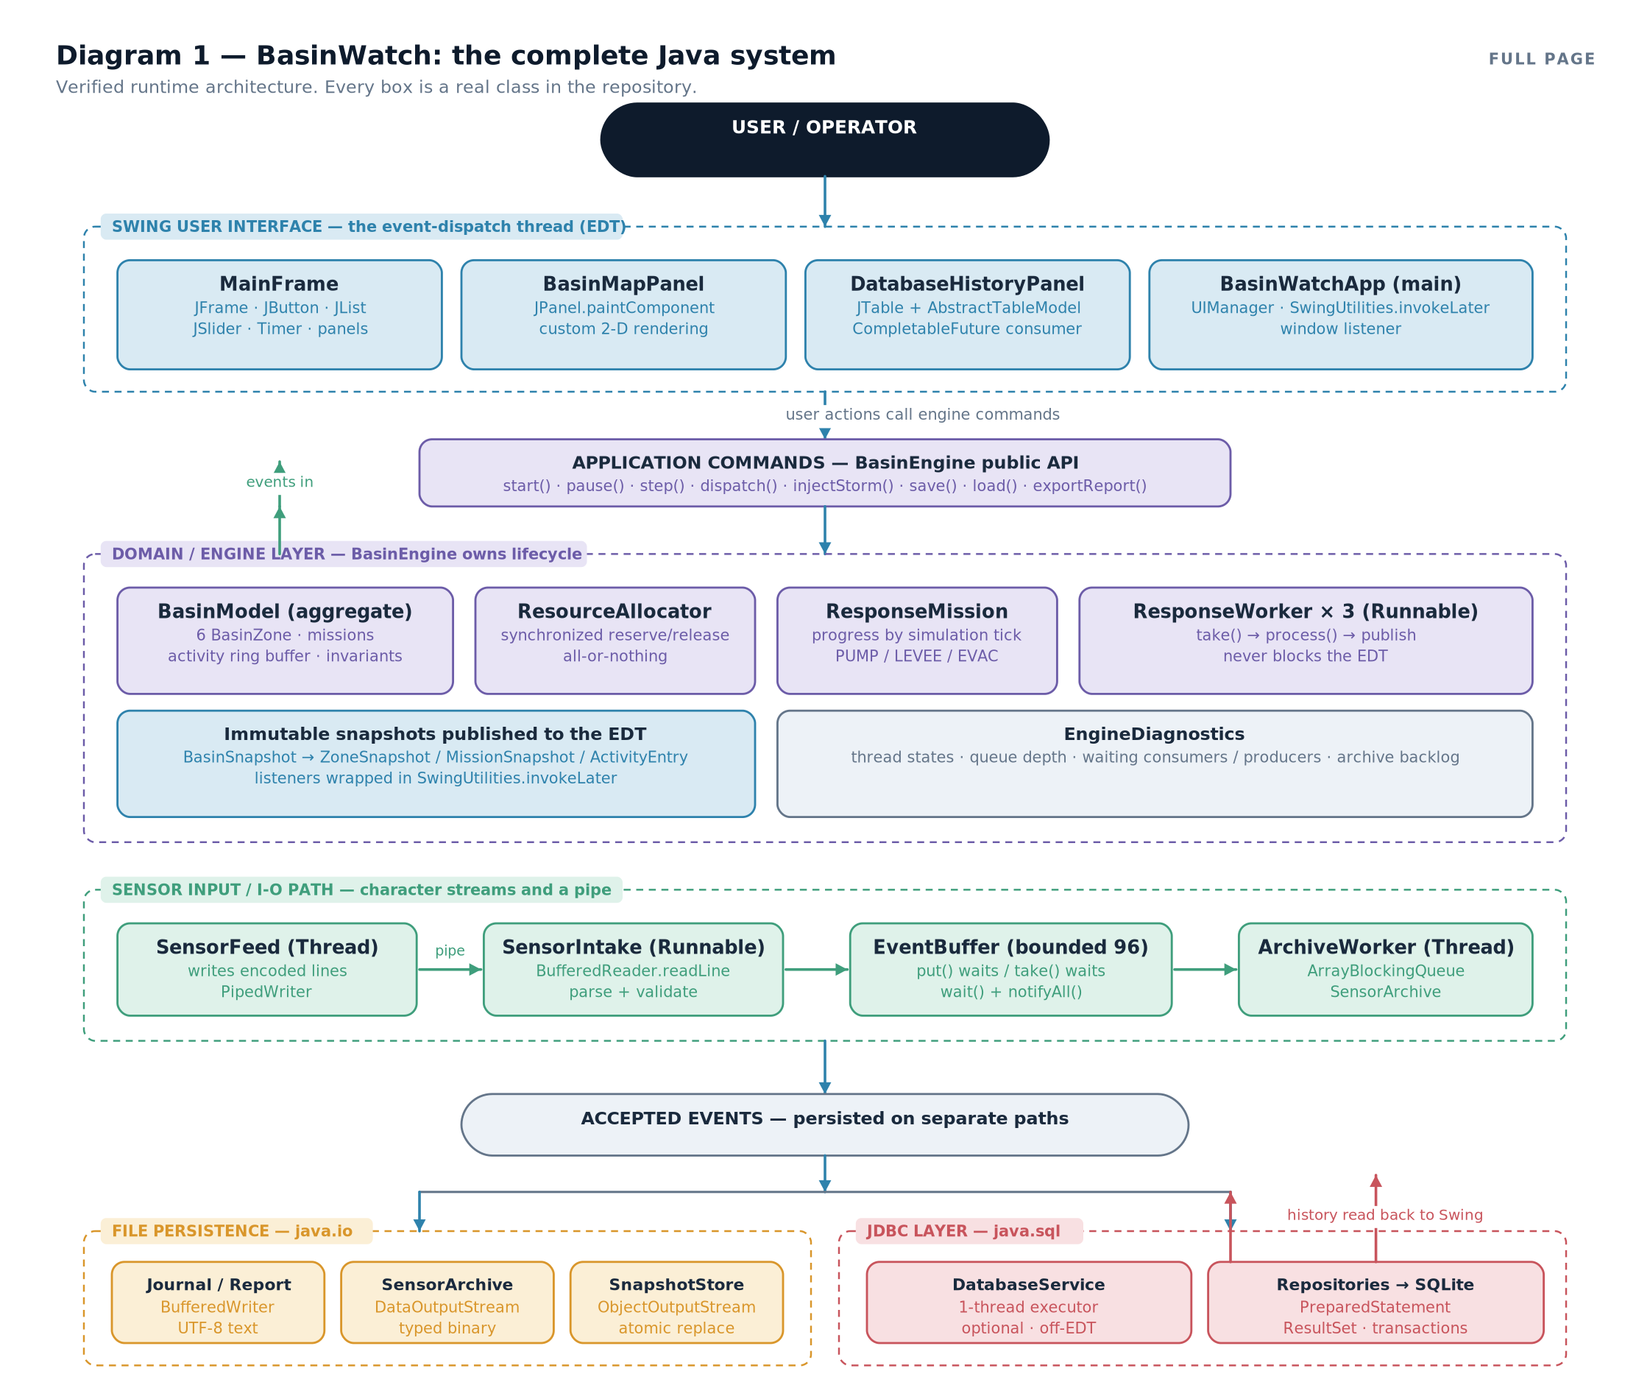

The six layers, in the order data meets them
- The operator and the interface. BasinWatchApp.main sets the system look and feel and then hands control to the event-dispatch thread with SwingUtilities.invokeLater. From that moment the MainFrame owns the window, and only the event-dispatch thread may touch Swing components.
- Application commands. The interface never manipulates the model directly. It calls a narrow set of methods on BasinEngine: start(), pause(), step(), dispatch(...), injectStorm(...), save(...), load(...), exportReport(). Most return a CompletableFuture, so the interface can ask for work and keep painting.
- The domain and engine layer. BasinModel is the aggregate root: it owns the six zones, the mission registry, the recent-activity ring buffer and the resource allocator. It enforces invariants and produces immutable snapshots. Three ResponseWorker tasks consume events and apply them.
- The sensor input path. A dedicated SensorFeed thread encodes observations as text lines and writes them into a PipedWriter. A separate SensorIntake task reads them through a BufferedReader over a PipedReader, validates each record, and places accepted events into a bounded EventBuffer.
- File persistence. Four independent file responsibilities: a UTF-8 append-only operational log, a typed binary sensor archive, versioned session snapshots written through an atomic replace, and human-readable reports.
- The JDBC layer. An optional, single-threaded DatabaseService that writes accepted readings, mission lifecycles, resource allocations and operational events into a local SQLite file through parameterized SQL, and reads recent history back for the interface.
CONNECTION TO ANOTHER CONCEPTNotice that the file column and the database column both hang off the same point — accepted events — but they are not alternatives. Chapter 9 shows what each file is for; Chapter 14 shows what the database adds; Chapter 10 explains why an application would deliberately choose to have both.

1.4 The seven questions the architecture must answer
An architecture is only useful if it answers concrete questions. These are the seven that matter for this application, with the verified answers.

Which component processes incoming data?
Observations arrive as text lines from the pipe. SensorIntake parses each line with SensorReading.parse, which validates the field count, the record type marker and every numeric range. A malformed record is reported and discarded — it does not stop the intake loop. Accepted events go into the bounded EventBuffer, and one of the three response workers takes them from there.

Where is Java I/O needed, and why?
In four genuinely different places, for four genuinely different reasons. The pipe carries observations between threads. The journal and reports give humans a readable audit trail. The archive keeps typed numeric measurements for later diagnosis. The snapshot store captures the whole session so it can be restored. Chapter 9 treats this as a design question rather than a list.

Why does JDBC exist in this application?
Because a file answers a different question than a database. A log file is a sequence of lines; asking "show me the 200 most recent readings for zone MIL, newest first" means reading and filtering the whole file. A database answers that with an index and a LIMIT. BasinWatch therefore keeps both, and the database is optional precisely because it is an addition rather than a requirement.

What does the Swing interface do?
Three things: it renders immutable snapshots, it collects operator intent, and it reports outcomes. It does no domain logic and no persistence. That separation is what makes the rest of the application testable without a window.

Which work happens on background threads?
Observation production (SensorFeed), intake (basin-sensor-intake), response processing (three basin-response-N threads), archiving (basin-sensor-archive), control commands (basin-control) and database writes (basin-database). Only rendering and event handling happen on the event-dispatch thread.

How does data survive the application closing?
Five ways, listed in Table 1.1. On a clean shutdown the engine also writes an automatic last-session.bws snapshot, so the next launch can restore the basin.
Artefact | Written by | Contains | Restored on next launch?
data/logs/operations.log | OperationalJournal | Timestamped operational events as UTF-8 text | No — it is an audit trail
data/archive/sensors.bin | SensorArchive (via ArchiveWorker) | Typed tick, station, zone, rainfall, rise | No — it is a measurement record
data/saves/*.bws | SnapshotStore | Versioned session snapshot: tick, zones, stock, missions, activity | Yes — on request, or automatically for last-session.bws
data/reports/*.txt | ReportWriter | A human-readable situation report | No — it is a document
data/basinwatch.db | DatabaseService + repositories | Sensor readings, missions, resource usage, events in four tables | Read back as history, not as live state

Where do the technologies interact, and where do they stay separate?
They interact at exactly two boundaries. The first is the accepted event: after the model has processed an event, the engine writes to the log, submits to the archive worker, and enqueues a database operation. The second is the published snapshot: the engine hands an immutable value to the interface, the only channel by which background work becomes visible. Everywhere else the layers are deliberately ignorant of one another: the model does not know about files, the repositories do not know about Swing, and the interface does not know about SQL.
IMPORTANT DISTINCTIONThe engine publishes immutable snapshots, not live objects. A BasinSnapshot is a record whose constructor copies every list and map with List.copyOf and Map.copyOf. That single decision is why the interface can render data on the event-dispatch thread while workers continue to mutate the model — the snapshot cannot change underneath it.

1.5 The Java Concepts Connection Map
Every syllabus topic in this book has a home. Diagram 2 places them all at once, grouped into four columns. Use it as a map rather than a summary: when a later chapter introduces a concept, you should be able to point at the column it belongs to.
Diagram 2 — The Java Concepts Connection Map. Language foundations, Java I/O, concurrency, and the combined data/UI/build column. Each entry names a real class or file in the project.
Read the map in four movements:
- Language foundations (Chapter 2) explain the object concepts that make the rest possible: classes and objects, interfaces as contracts, polymorphism, justified inheritance, enums for bounded vocabularies, records for immutable values, encapsulation, and the POJO-versus-JavaBean distinction.
- Java I/O (Chapters 4 to 9) covers byte and character streams, buffering, data streams, byte-array streams, piped streams, serialization and file metadata.
- Concurrency (Chapters 3 and 7, then used everywhere) covers threads, runnables, monitors, condition waiting, the producer–consumer pattern, interruption and joining, and deadlock avoidance.
- Data, UI and build (Chapters 10 to 19) covers JDBC from driver to transaction, Swing from frame to repaint, and the configuration and packaging that make the application run at all.
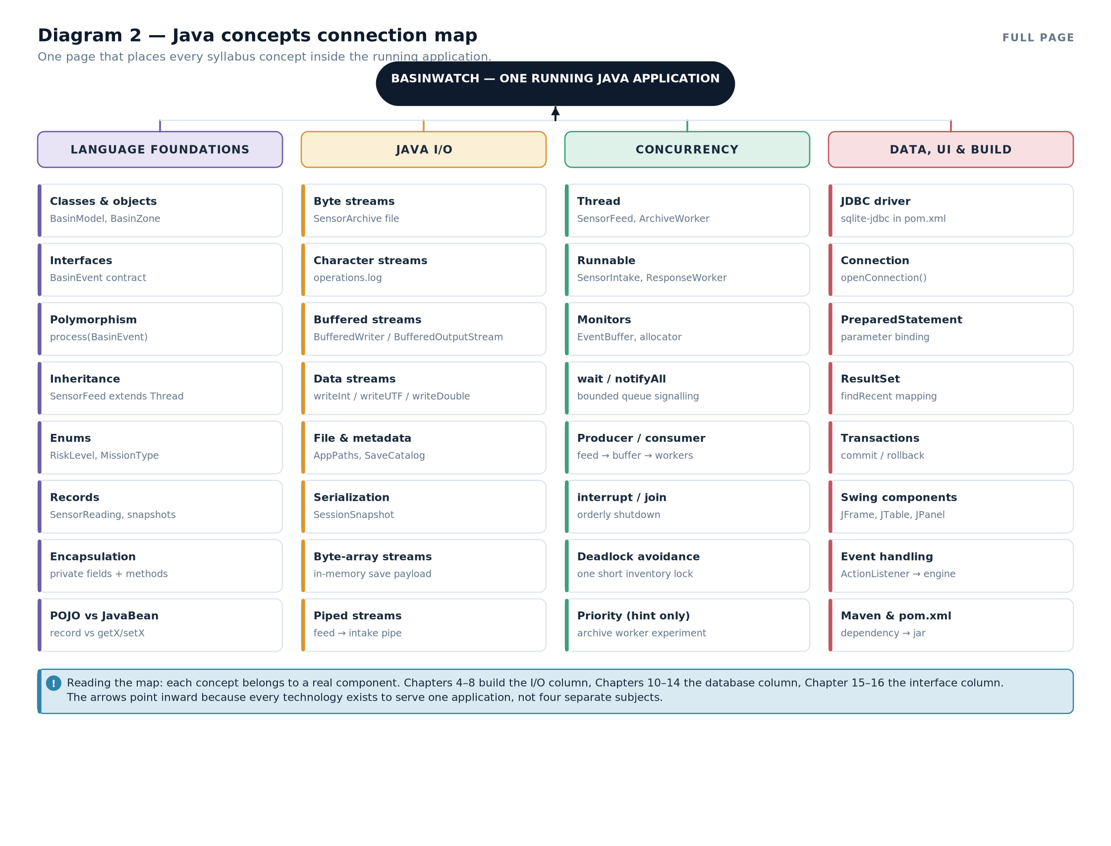

1.6 What is genuinely difficult here
It is worth being honest about which parts of this application are hard, because those are the parts worth understanding deeply rather than memorising.
Concurrency is hard because correctness is invisible. If two dispatches both read the same resource count as available, the bug appears only under load and only sometimes. BasinWatch's answer is a single short synchronized reservation that checks every required resource before decrementing any of them — an all-or-nothing operation. There is no way to observe the intermediate state, because there is no intermediate state.
Shutdown is hard because it is where resources leak. Stopping a feed thread, closing a pipe, waking waiting consumers, draining an archive queue, flushing a journal and writing a final snapshot must happen in the right order. The engine's closeEngine() does exactly this, and reports a timeout rather than pretending success.
Persistence is hard because the easy version is unsafe. Writing a file with ObjectOutputStream is two lines; making it safe means bounding the input size, filtering the classes that may be constructed, checking a format version, and validating the restored domain state. Chapter 8 walks through all four.
COMMON MISTAKEThe most common architectural mistake in student projects is letting the interface do the work. A button handler that opens a database connection, queries, and updates a label feels natural because it is one function in one file. It also freezes the window for the duration of the query, makes the logic untestable without a screen, and spreads SQL across the codebase. BasinWatch's rule — the interface asks, the engine decides, a worker executes, a snapshot reports — is the fix.

1.7 How the rest of the book is organised
Part | Chapters | What you will be able to do afterwards
I — Understanding the System | 1–3 | Sketch the architecture, explain the object concepts, and distinguish six forms of component communication.
II — Java I/O and Persistent Files | 4–9 | Choose and layer the right stream for a task, manage resources safely, and explain four different persistence mechanisms.
III — Databases and JDBC | 10–14 | Open a connection, execute parameterized SQL, map result sets, use transactions, and explain why a database is optional here.
IV — Swing and the User Interface | 15–16 | Build a component tree, handle events, keep the event-dispatch thread free, and show database results safely.
V — Configuration and Related Techniques | 17–19 | Explain how dependencies reach the classpath, what XML and annotations are for, and how JdbcTemplate abstracts raw JDBC.
VI — Putting Everything Together | 20–21 | Trace four real scenarios end to end and answer the eight integration questions.
Revision | R, V, E, G | Revise with comparison tables, answer viva questions, and work through tracing exercises.
Table 1.2 — The book's structure and what each part delivers.EXAM TIPIf you are asked "describe your project architecture" in a viva, do not start with the code. Start with the data. Say what enters the system, which component validates it, where it is processed, what is persisted, and how the result reaches the screen. Then name the classes. Examiners reward the flow; the class names follow naturally.
- BasinWatch is an offline floodplain operations console: a single-process Swing desktop application with no server, no network and no external service.
- Six layers: operator and interface, application commands, domain and engine, sensor input path, file persistence, and the optional JDBC layer.
- The event-dispatch thread owns all Swing components; five other threads do background work and publish immutable snapshots back to it.
- Java I/O appears in four distinct roles: a pipe between threads, a readable log, a typed binary archive, and a session snapshot.
- JDBC exists because selective queries over indexed rows are a different job from reading a text file; the database is an addition, not a replacement.
- Data survives shutdown in five artefacts, of which only the session snapshot restores live state.
- Technologies meet at exactly two boundaries: the accepted event and the published snapshot.
- Aggregate root — the single object that owns a group of related state and enforces its invariants. Here, BasinModel.
- Immutable snapshot — a value object copied out of the model so another thread can read it safely.
- Event-dispatch thread (EDT) — the single Swing thread that runs event handling and painting.
- Bounded buffer — a queue with a maximum size that makes producers wait when it is full.
- Optional subsystem — a component whose failure does not stop the application. Here, the SQLite history.

Java Application Structure and Core Object Concepts
Objects, interfaces, inheritance, enums, records and validation — the vocabulary the rest of the book assumes.

2.1 Why start with objects?
Every later chapter is about a mechanism — a stream, a query, a listener. Each mechanism operates on objects, and each is designed around an object concept. If a method takes an interface, the interface's design determines what the method can do. If a class is a record, it cannot be mutated. So the object model has to come first.
This chapter is not an introduction to writing classes. It is a tour of the specific object decisions BasinWatch makes, with the reason for each, plus the POJO-versus-JavaBean distinction that appears in the syllabus and matters the moment you meet a framework.

2.2 Classes, objects, state and behaviour
A class is a template; an object is an instance of it. An object has state (its fields) and behaviour (its methods), and good design keeps state private so behaviour is the only route in.
DEFINITIONEncapsulation — keeping fields private and exposing only the operations that make sense, so an object can never be placed in an invalid state from outside.
BasinWatch applies this at several levels. BasinZone is package-private: only classes in com.basinwatch.domain may even refer to it. Its fields are private, and it exposes a small set of package-private methods — apply, pump, reinforceLevee, evacuate — plus snapshot(), which returns an immutable copy.
final

class

BasinZone
{

private

final

String
id;

private

final

String
name;

private

double
waterLevelMeters;

private

double
lastRainMillimeters;

private

int
exposedResidents;

private

boolean
leveeReinforced;

private

long
lastReadingTick = -1;

private

RiskLevel
risk;

boolean
apply(
SensorReading
reading) {

if
(reading.tick() <= lastReadingTick) {

return
false;
// a stale reading is rejected, not applied

}
lastReadingTick = reading.tick();
lastRainMillimeters = reading.rainfallMillimeters();

double
runoffFactor = leveeReinforced ? 0.58 : 1.0;

double
rainfallContribution = reading.rainfallMillimeters() * 0.0014;

double
observedRise = reading.observedRiseCentimeters() / 100.0;
waterLevelMeters = Math.min(8.0,
Math.max(0.0, waterLevelMeters + (rainfallContribution + observedRise) * runoffFactor));
risk = assessRisk(waterLevelMeters);

return
true;
}

// pump, reinforceLevee, evacuate, snapshot, restore, assessRisk ...

}
from BasinWatch, domain/BasinZone.java — state is private; behaviour is the only route in. Three things in that listing deserve attention. First, the stale-reading guard: if the incoming tick is not newer than the last one applied, the reading is ignored and the method returns false. That is an invariant, not a nicety — without it, an out-of-order observation could reduce a water level. Second, the reinforced levee multiplies runoff by 0.58, which is a real domain consequence of an earlier operator decision. Third, the water level is clamped to the range 0 to 8 metres on every update, so the field can never hold a physically impossible value.
CONNECTION TO ANOTHER CONCEPTThat guard is why Chapter 20's trace can say "the observation was accepted" and mean something specific. A reading is accepted only if it is newer than the last one for that zone and the model changed as a result. The engine uses exactly that test when deciding whether to write the reading to the database.

2.3 Interfaces as contracts
An interface declares what a type can do without saying how. In BasinWatch, the whole event system is built on one interface with four methods.
public

interface

BasinEvent
{

long
tick();

String
zoneId();

String
category();

String
describe();
}
from BasinWatch, domain/BasinEvent.java Three records implement it: SensorReading, SimulationPulse and DispatchRequest. They are radically different in content — a measurement, a time marker, an operator command — yet they all satisfy the same contract, so a single queue and a single process method can handle all of them.

2.4 Polymorphism: one call, several behaviours
Polymorphism means the same call site behaves according to the actual type of the object. BasinModel.process is the clearest example in the project.
public

synchronized

List
<
String
> process(
BasinEvent
event) {

if
(event == null) {

throw

new

IllegalArgumentException
("
Event
is required.");
}

ArrayList
<
String
> messages =
new

ArrayList
<>();

if
(event
instanceof

SensorReading
reading) {
applyReading(reading, messages);
}
else

if
(event
instanceof

SimulationPulse
pulse) {
applyPulse(pulse, messages);
}
else

if
(event
instanceof

DispatchRequest
request) {
applyDispatch(request, messages);
}
else
{

throw

new

IllegalArgumentException
("
Unsupported
basin event: " + event.getClass().getName());
}

return
List.copyOf(messages);
}
from BasinWatch, domain/BasinModel.java — pattern matching on the event type. This is polymorphism expressed with pattern matching rather than with a method override. Both are valid; the choice here is deliberate. The model wants one place where the complete set of event types is visible, so that adding a fourth event type produces a compile-time-visible gap rather than a silently ignored class. The else branch throws, so an unknown event type is a loud failure rather than a silent no-op.
IMPORTANT DISTINCTIONInterface polymorphism (what the queue relies on) and dispatch polymorphism (what the model performs) are different things. The interface lets the buffer store any event without knowing its type. The instanceof chain is how the model decides which behaviour to run. You need both: the first for type safety, the second for behaviour selection.

2.5 Inheritance: used narrowly and for a reason
Inheritance is the most over-used feature in student Java. BasinWatch uses it exactly twice, and both times because the superclass is a real framework contract rather than a convenience.
- SensorFeed extends Thread. A feed has a genuine lifecycle to own: it must be started, it has a long-running loop, it holds a blocking pipe endpoint, and it must be interruptible and joinable. Extending Thread lets it carry a name ("basin-sensor-feed"), a priority, and a state that diagnostics can report.
- MainFrame extends JFrame, BasinMapPanel extends JPanel, DatabaseHistoryPanel extends JPanel. Swing is an inheritance-based framework: to be a component you must be a component. Overriding paintComponent is how custom drawing is done.
Everywhere else, composition is preferred. BasinEngine does not extend anything; it has an EventBuffer, a DatabaseService, a list of listener lists and an ExecutorService.
public

final

class

SensorFeed

extends

Thread
{

public

SensorFeed
(
Writer
destination,
List
<
String
> zoneIds,
SimulationSettings
settings,

AtomicLong
tickSequence,
Consumer
<
String
> failureReporter) {

super
("basin-sensor-feed");
// a named thread is a diagnosable thread

this.destination = destination;
this.zoneIds = List.copyOf(zoneIds);
this.settings = settings;
this.tickSequence = tickSequence;
this.failureReporter = failureReporter;
setPriority(
Thread.NORM_PRIORITY
);
}

@Override

public

void
run() {
/* the timed emission loop */
}

public

void
requestStop()
throws

IOException
{
/* cooperative shutdown */
}
}
from BasinWatch, engine/SensorFeed.java — the one justified Thread subclass.IMPORTANT DISTINCTIONCompare with SensorIntake, which implements Runnable instead. Why the difference? Because intake is a task — a unit of work — not a lifecycle owner. The engine creates a plain Thread, names it "basin-sensor-intake", and hands it the task. This is the "prefer Runnable unless you must own the thread" rule, applied literally.

2.6 Enums: a fixed vocabulary, typed
When a value comes from a small closed set, an enum beats a String or an int, because the compiler then knows every legal value. BasinWatch has four domain enums, and each carries data with it.
public

enum

RiskLevel
{

NORMAL
("
Routine
", 0),
WATCH
("
Watch
", 1),
WARNING
("
Warning
", 2),
CRITICAL
("
Critical
", 3);

private

final

String
label;

private

final

int
rank;

RiskLevel
(
String
label,
int
rank) { this.label = label; this.rank = rank; }

public

String
label() {
return
label; }

public

int
rank() {
return
rank; }
}
from BasinWatch, domain/RiskLevel.java — each constant carries a label and a rank. The rank() method is what makes risk escalation detectable: applyReading compares currentRisk.rank() > previousRisk.rank() and prefixes the activity message with "Risk increased:" when it is true. That comparison is a domain rule expressed as ordinary code, and it is why the database can be told riskEscalated as a boolean rather than being asked to work it out.
MissionType goes further and carries the whole definition of a mission:
public

enum

MissionType
{

PUMP_DEPLOYMENT
("
Deploy
portable pump", 8, 0.62,
Map.of(
ResourceType.PUMP
, 1,
ResourceType.FIELD_CREW
, 1)),

LEVEE_REINFORCEMENT
("
Reinforce
levee", 10, 0.0,
Map.of(
ResourceType.LEVEE_CREW
, 1,
ResourceType.SUPPLY_TRUCK
, 1)),

EVACUATION
("
Evacuate
exposed residents", 6, 0.0,
Map.of(
ResourceType.EVAC_VEHICLE
, 1,
ResourceType.FIELD_CREW
, 1));

private

final

String
label;

private

final

int
durationTicks;

private

final

double
waterEffectMeters;

private

final

Map
<
ResourceType
,
Integer
> requirements;

// constructor, accessors, toString ...

}
from BasinWatch, domain/MissionType.java — duration, effect and resource cost live with the type.CORE CONCEPTPutting a mission's duration, its effect on water level, and the resources it requires inside the enum constant means there is exactly one place to look when a mission type changes. The allocator, the scheduler and the database all read the same definition. This is the single most useful habit in the whole chapter: make the data live where the knowledge lives.

2.7 Records: immutable values with no boilerplate
A record declares immutable data in one line. The compiler generates a canonical constructor, accessors named after the components, and correct equals, hashCode and toString.
public

record

SensorReading
(

long
tick,
String
stationId,
String
zoneId,

double
rainfallMillimeters,
double
observedRiseCentimeters)
implements

BasinEvent
{

public

SensorReading
{
// compact constructor: validation

if
(tick < 0 || !validIdentifier(stationId) || !validIdentifier(zoneId)
|| !Double.isFinite(rainfallMillimeters) || rainfallMillimeters < 0
|| rainfallMillimeters > 500
|| !Double.isFinite(observedRiseCentimeters) || observedRiseCentimeters < 0
|| observedRiseCentimeters > 200) {

throw

new

IllegalArgumentException
("
Invalid
sensor reading.");
}
}

@Override

public

String
category() {
return
"
OBSERVATION
"; }

public

String
encode() {

return
String.format(
Locale.ROOT
, "
READ
|%d|%s|%s|%.3f|%.3f",
tick, stationId, zoneId, rainfallMillimeters, observedRiseCentimeters);
}

public

static

SensorReading
parse(
String
line) {

String
[] fields = line.split("\\|", -1);

if
(fields.length != 6 || !"
READ
".equals(fields[0])) {

throw

new

IllegalArgumentException
("
Malformed
sensor observation.");
}

try
{

return

new

SensorReading
(Long.parseLong(fields[1]), fields[2], fields[3],
Double.parseDouble(fields[4]), Double.parseDouble(fields[5]));
}
catch
(
NumberFormatException
ex) {

throw

new

IllegalArgumentException
("
Sensor
reading contains an invalid number.", ex);
}
}
}
from BasinWatch, domain/SensorReading.java — a record that validates on construction. Three patterns in that listing are worth naming, because they recur throughout the book.
The compact constructor validates. A record's canonical constructor can be written without repeating the parameter list, and any exception thrown there prevents the object from existing. This is why parse can be trusted: if it returns a SensorReading, the ranges are already correct. Validation happens at the boundary, once, instead of being re-checked by every consumer.
encode and parse are a matched pair. encode() produces a pipe-delimited line; parse() is its inverse and rejects anything that is not exactly six fields beginning with READ. Keeping them next to each other in the same class is what makes the wire format maintainable. Chapter 7 follows that format through the pipe.
Immutability makes the object safe to share. A SensorReading can be handed from the feed thread to the intake thread to a worker thread with no synchronization at all, because no thread can change it.
CONNECTION TO ANOTHER CONCEPTRecords and serialization meet in Chapter 8. A record is an excellent in-memory value, but records are serializable only if every component type is serializable and the record has no non-serializable superclass. BasinWatch's snapshot DTOs are therefore plain final classes with a no-argument constructor rather than records — a deliberate choice explained in that chapter.

2.8 POJO versus JavaBean
DEFINITIONPOJO — a Plain Old Java Object — any ordinary class with fields and methods, subject to no framework convention at all.
DEFINITIONJavaBean — a POJO that follows a convention: a public no-argument constructor, private fields, and public getX/setX accessors, usually implementing Serializable, so that a framework can create and populate it by reflection.
Diagram 3 — POJO versus JavaBean, side by side. Left: BasinWatch's SensorReading record — a POJO with no convention. Right: the same data as a JavaBean with a no-argument constructor and accessors.
The distinction matters practically. A record cannot be a JavaBean: it has no no-argument constructor and no setX methods, so a framework that expects to instantiate a bean and then call setters cannot use it. Conversely, nothing requires a JavaBean to be mutable in practice — it only has to look that way to the framework.
BasinWatch contains three shapes, and each is deliberate:
Shape | Example | Why that shape
Record (immutable POJO) | SensorReading, ZoneSnapshot, DatabaseHistoryEntry | Values that cross a boundary must not change while in flight; the compiler generates accessors and equality.
Plain final class with mutable fields | SavedZone, SavedMission, SessionSnapshot | Serialization restores fields directly, so accessors are unnecessary. A no-argument constructor is required by the serialization mechanism.
Framework-style JavaBean | None in BasinWatch | No framework in this project needs to instantiate objects by name. Chapter 19 shows where a JavaBean would be required.
Table 2.1 — The three object shapes and why BasinWatch uses each.RELATED TECHNIQUE — NOT USED IN BASINWATCHIf BasinWatch used Spring's component scanning, its services would become JavaBeans or annotated components: a no-argument constructor plus @Autowired setters, or a constructor annotated for injection. It does not. Instead, wiring is explicit and visible: BasinEngine constructs the DatabaseService, which constructs the DatabaseManager and passes it to each repository constructor. That is constructor injection performed by hand. Diagram 27 contrasts the two.
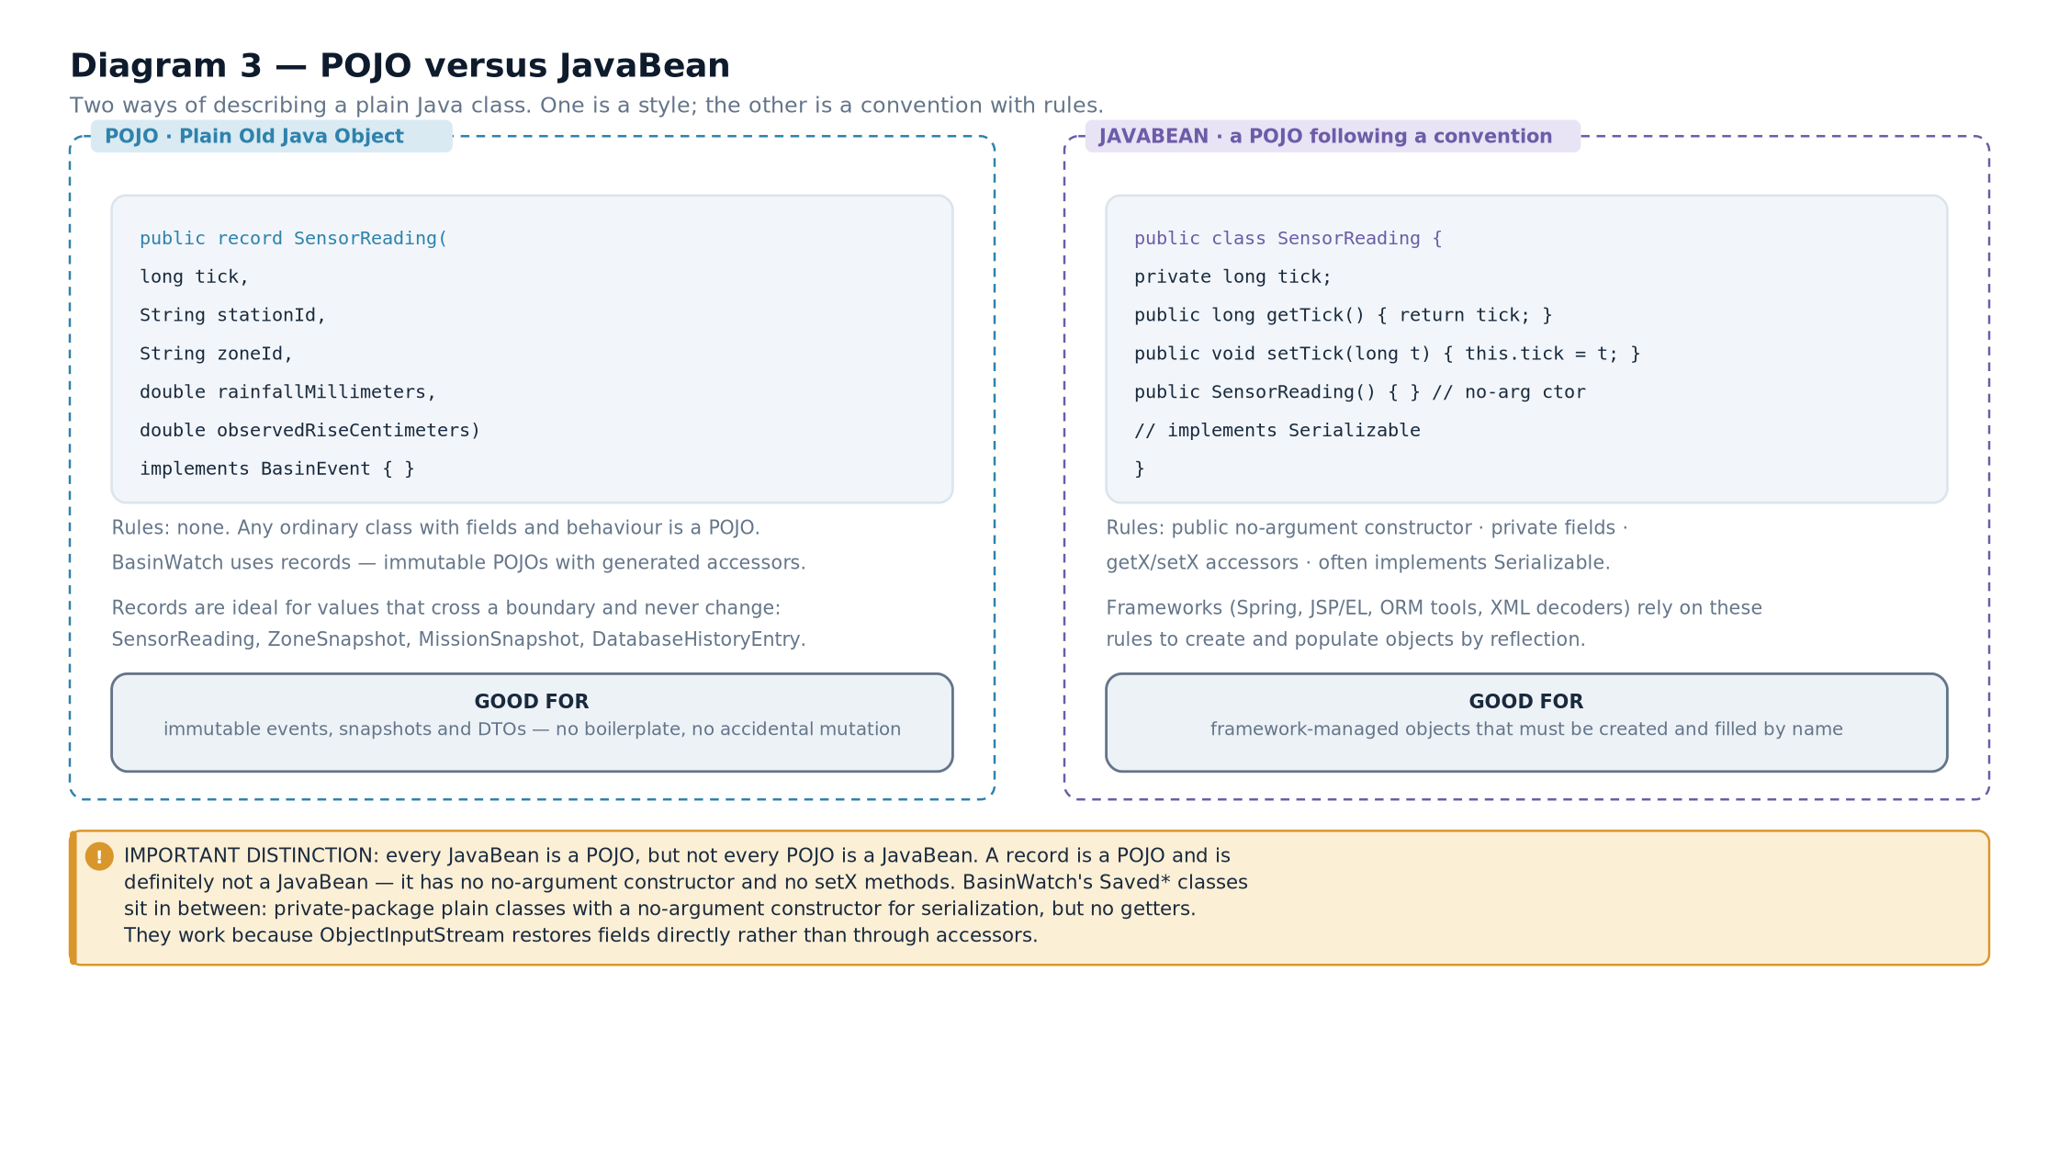

2.9 Access modifiers as a design tool
Modifiers are not decoration; they are how a design is enforced. BasinWatch's choices are systematic.
Modifier | Where it is used | What it prevents
public | Engine commands, domain value types, repository methods called from the service | Nothing — but the set is deliberately small and stable.
package-private | BasinZone, ResponseMission, SavedZone, the connection-taking overloads in repositories | Any code outside the package reaching into the aggregate's internals. Only BasinModel can mutate a zone.
private | Fields, helper methods, the schema array, the filter function | Everything except the class's own methods.
final (class) | BasinModel, BasinEngine, SnapshotStore, OperationalJournal | Subclassing a class that was not designed for it.
static final (constants) | MAGIC, FORMAT_VERSION, MAX_SAVE_BYTES, WORKER_COUNT | Magic numbers scattered through the code, and accidental modification.
Table 2.2 — Access modifiers, their use in the project, and what they enforce.BASINWATCH IN PRACTICEThe connection-taking overloads are a particularly neat example. Each repository has a public method that opens its own connection and a package-private method that accepts an existing one:
public

void
insert(
SensorReading
reading,
ZoneSnapshot
zone,
Instant
timestamp)

throws

SQLException
{

try
(
Connection
connection = database.openConnection()) {
insert(connection, reading, zone, timestamp);
// the package-private overload

}
}
void
insert(
Connection
connection,
SensorReading
reading,
ZoneSnapshot
zone,

Instant
timestamp)
throws

SQLException
{ /* binds and executes */ }
Listing 2.2 — from BasinWatch, db/SensorReadingRepository.java The public overload is for ordinary use. The package-private overload exists so that MissionRepository can enlist several writes in one transaction on one connection — the subject of Chapter 13. Visibility encodes the rule: only a class in the same package may participate in someone else's transaction.

2.10 How BasinWatch divides responsibility
Six packages, six responsibilities. This division is the reason later chapters can be organised by technology without becoming a pile of unrelated facts.
Package | Responsibility | Knows about | Must not know about
app | The Swing window, panels, listeners and entry point | engine commands, snapshots | SQL, streams, files
domain | Zones, events, missions, resources, invariants | nothing outside itself | files, SQL, Swing, threads
engine | Lifecycle, threading, queues, coordination | domain, io, db | Swing components
io | File paths, streams, snapshots, reports | domain values | SQL, Swing
db | Connections, schema, repositories, transactions | domain values | Swing, files
learning | Optional in-application architecture cards | nothing | everything else
Table 2.3 — Package responsibilities and the boundaries between them.EXAM TIPA reliable viva answer to "how is your project structured?" is: "by responsibility, and dependencies point one way — the interface depends on the engine, the engine depends on the domain, file and database layers, and none of those depend back on the interface." Then give one concrete example: the model has no import of javax.swing, which is why it can be tested without a window.
- Encapsulation is enforced by modifiers: BasinZone is package-private and its fields are private, so only the aggregate can change zone state.
- One interface, BasinEvent, unifies three unrelated event records so a single queue and a single process method can handle them.
- Polymorphism appears as pattern matching in BasinModel.process, with an explicit failure branch for unknown types.
- Inheritance is used twice and only where a framework contract requires it: Thread for the feed, Swing components for the UI.
- Enums carry their own data — labels, ranks, durations, water effects and resource requirements.
- Records provide validated immutable values; the compact constructor is the validation point.
- A POJO has no convention; a JavaBean adds a no-argument constructor, accessors and often Serializable. Every bean is a POJO, not vice versa.
- Aggregate — a cluster of objects treated as one unit for change; BasinModel with its zones and missions.
- Compact constructor — a record constructor written without the parameter list, used here purely for validation.
- Pattern matching — testing and binding an object's type in one expression, as in event instanceof SensorReading reading.
- Stale guard — a check that rejects input older than the state already applied.
- Constructor injection — supplying an object's dependencies as constructor arguments, here done by hand rather than by a framework.

How Java Components Communicate
Method calls, shared objects, streams, events, queues and database operations are six different mechanisms. This chapter separates them.

3.1 The problem with saying "they communicate"
When you describe an application it is tempting to say that components "talk to each other" and leave it there. That sentence hides six distinct mechanisms with completely different properties. A method call is synchronous and immediate. A stream carries bytes or characters in one direction and can block. A queue decouples two threads in time. An event listener inverts control. A database operation crosses an execution boundary. An interrupt is a cooperative request, not a command.
Choosing the wrong one produces the classic failures: a frozen interface, a race condition, a lost update, a deadlock, a silent data loss. So this chapter names each mechanism, states its properties, and shows where BasinWatch uses it — and, just as importantly, where it does not.
Diagram 4 — Component dependency graph. Who creates whom, and the one-way direction of dependencies: app depends on engine, engine depends on domain, io and db, and nothing depends back on app.
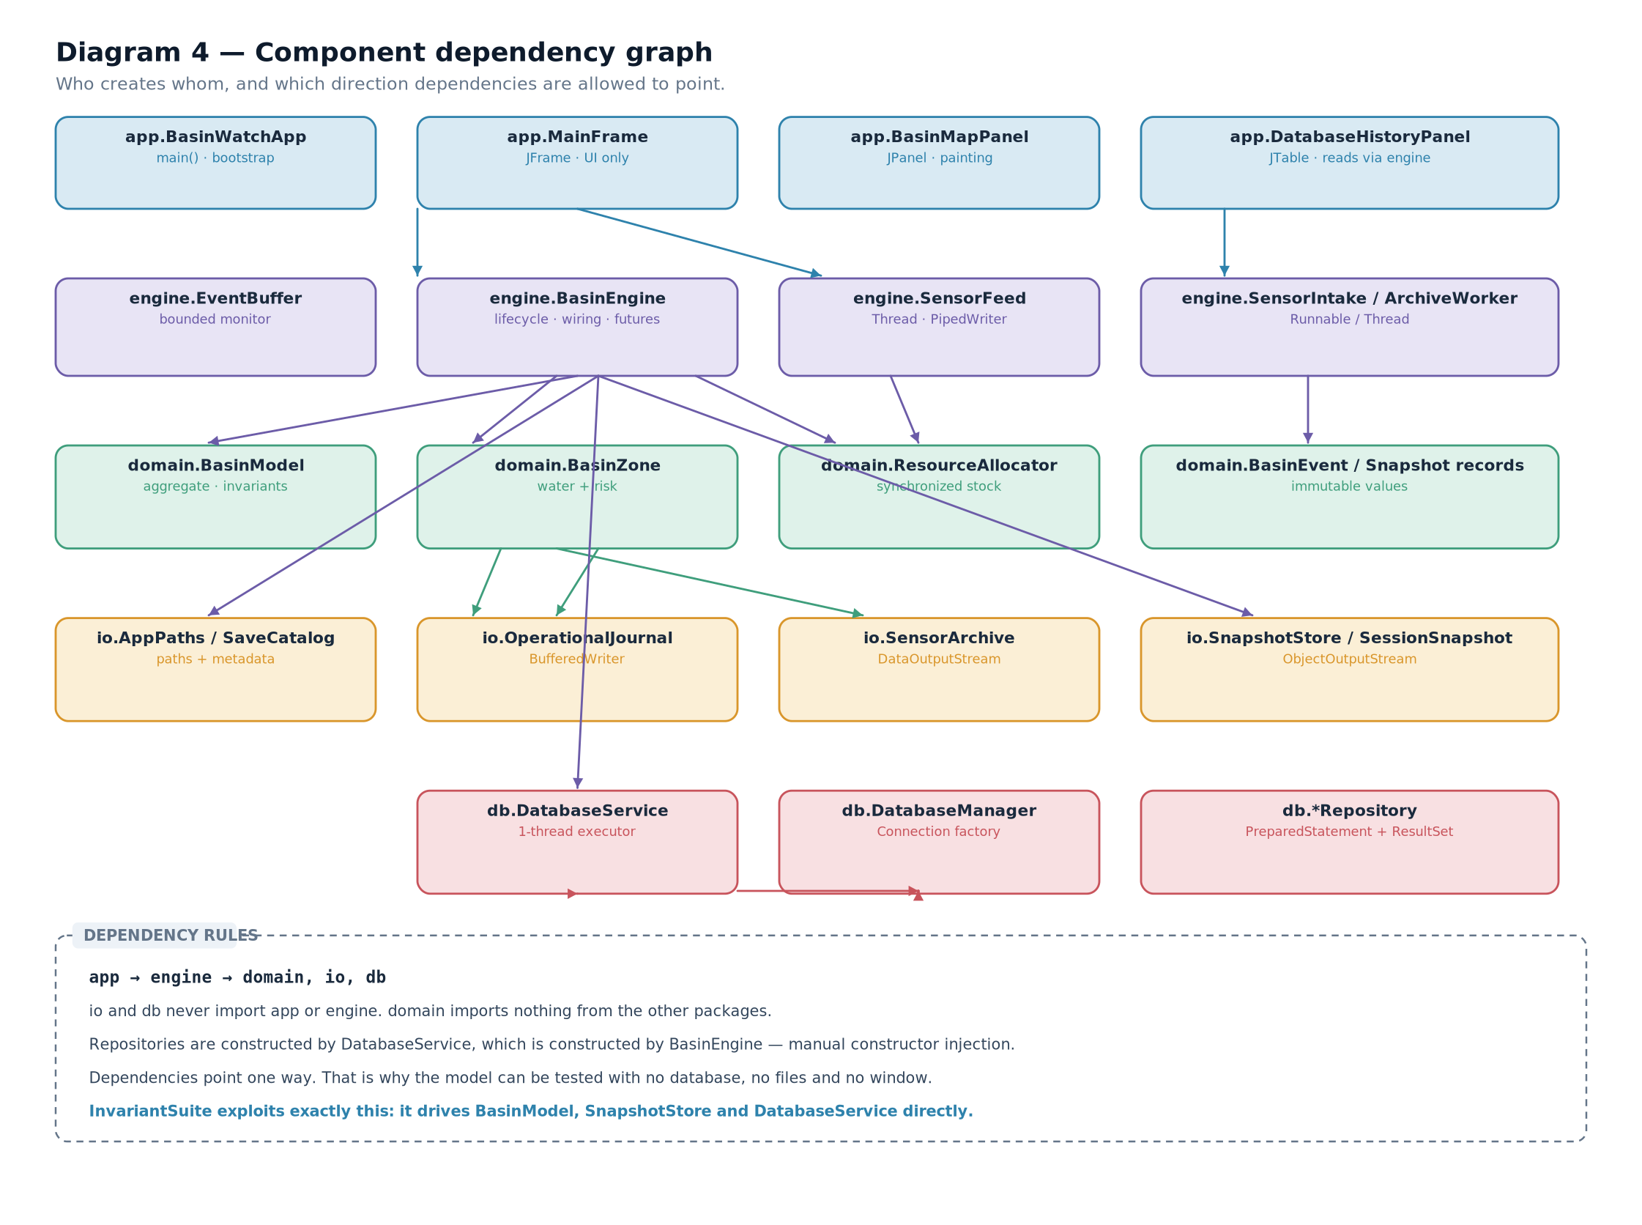

3.2 Mechanism one: the method call
The ordinary method call is synchronous, in-process, typed and immediate. The caller waits, the callee runs on the caller's thread, and arguments and return values are checked by the compiler.
BasinWatch uses method calls for everything that is fast and deterministic. BasinModel.process(event) is a method call. BasinZone.assessRisk(waterLevel) is a method call. SessionSnapshot.from(snapshot) is a method call. None of them touches a disk, a network or a thread.
CORE CONCEPTThe design rule the project follows is: a method call may not block on external work. Anything that reads a disk, waits for another thread, or talks to a database is moved behind a different mechanism — a future, a queue, or a background thread. That is why the model's methods are short and why the engine's file and database work is submitted rather than performed inline.

3.3 Mechanism two: shared objects under a monitor
Two threads can communicate simply by reading and writing the same object. The cost is that every such access needs protection, and the protection is what creates the bugs.
ResourceAllocator is the canonical example: a shared, finite inventory read and written by several response workers.
public

synchronized

boolean
tryReserve(
Map
<
ResourceType
,
Integer
> request) {
validateRequest(request);

for
(
Map.Entry
<
ResourceType
,
Integer
> entry : request.entrySet()) {

if
(available.get(entry.getKey()) < entry.getValue()) {

return
false;
// nothing has been changed yet

}
}
request.forEach((type, amount) -> available.put(type, available.get(type) - amount));

return
true;
}
from BasinWatch, domain/ResourceAllocator.java — check every requirement, then decrement. Read that method twice. The first loop only checks. If any single requirement cannot be met, the method returns false having changed nothing at all. Only after every requirement has been confirmed does the second loop decrement. That is what makes the reservation all-or-nothing: there is no moment at which a caller could observe a partially reserved state, because the entire method holds the object's monitor from start to finish.
CONNECTION TO ANOTHER CONCEPTThis is also the project's deadlock-avoidance strategy, which its own architecture notes describe directly: one short inventory monitor, no I/O inside it, no nested acquisition of another lock, and a stable policy. A lock-ordering cycle requires two locks acquired in opposite orders by two threads; with one lock, that cycle cannot form.

3.4 Mechanism three: streams
A stream is a one-directional channel that carries a sequence of bytes or characters, with its own buffering and blocking behaviour. It is the subject of all of Part II, so here we only need its role in the architecture: it is how the feed thread hands data to the intake thread without either one knowing the other's class.
// BasinEngine.startFeed() — creating the connected pair

PipedWriter
writer =
new

PipedWriter
();
PipedReader
reader =
new

PipedReader
(writer, 8_192);
feedWriter = writer;
intakeThread =
new

Thread
(
new

SensorIntake
(

new

BufferedReader
(reader), eventBuffer,
this
::reportFailure,
ignored -> publishDiagnosticsStatus()), "basin-sensor-intake");
sensorFeed =
new

SensorFeed
(writer, List.of("
UPR
", "
MIL
", "
NOR
", "
OLD
", "
MAR
", "
SOU
"),
settings, tickSequence,
this
::reportFailure);
intakeThread.start();
sensorFeed.start();
from BasinWatch, engine/BasinEngine.java — the writer is handed to the feed, the reader to intake. Note what is not shared: the feed never sees the EventBuffer, and intake never sees the SensorFeed. The only object they have in common is the pipe. This is a much narrower contract than a shared list, and it is why the two threads can be reasoned about separately.

3.5 Mechanism four: the queue with condition waiting
A queue decouples producer and consumer in time. The producer does not wait for the consumer to be ready; the consumer does not poll. The mechanism that makes this work is wait() and notifyAll() under a monitor, and it must be written carefully.
public

synchronized

boolean
put(
BasinEvent
event)
throws

InterruptedException
{

if
(event == null) {

throw

new

IllegalArgumentException
("
Event
is required.");
}

while
(!closed && events.size() == capacity) {
// condition re-checked in a loop

waitingProducers++;

try
{
wait();
// releases the monitor while waiting

}
finally
{
waitingProducers
--;

}
}

if
(closed) {

return
false;
}
events.addLast(event);
notifyAll();
// wake every waiter to re-check

return
true;
}
from BasinWatch, engine/EventBuffer.java — a correct condition-wait loop. Four properties of that code are the whole lesson, and they appear in every correct condition-wait implementation:
- Wait inside a loop, never inside an if. A thread that wakes up is not guaranteed that its condition is now true — another consumer may have taken the item first. So the test is repeated.
- Hold the monitor. wait() may only be called by a thread that owns the object's monitor. The synchronized keyword on the method provides it.
- Signal with notifyAll(), not notify(). Producers and consumers wait on the same monitor, so waking one arbitrary thread might wake a producer when only consumers can progress. notifyAll() lets every waiter re-check, and the ones that cannot proceed go back to waiting.
- Count the waiters. waitingProducers and waitingConsumers are incremented and decremented around the wait in a finally block, so the diagnostic view stays accurate even if the thread is interrupted. These counters are diagnostics, not synchronisation — an important distinction this chapter returns to.
IMPORTANT DISTINCTIONwait() releases the monitor; sleep() does not. This single sentence explains most of the confusion around Java threading. A waiting thread lets another thread enter the synchronized region; a sleeping thread keeps the lock and blocks everyone else. BasinWatch uses wait() for coordination and Thread.sleep(...) only for cadence — the feed's interval and the shutdown quiescence check — never as a signalling device.
COMMON MISTAKEUsing Thread.sleep() to wait for another thread's work, and using a flag variable polled in a loop, are the two most common substitutes for condition waiting. Both are wrong for the same reason: they guess at timing instead of reacting to state. A sleeping consumer may sleep too long (wasted latency) or too little (busy spinning), and a polled flag cannot wake anybody at the moment the state changes.

3.6 Mechanism five: events and listeners
An event listener inverts control: instead of a component asking for data, the component declares interest and is called when something happens. In BasinWatch the interface registers listeners on the engine.
engine.addSnapshotListener(snapshot ->
SwingUtilities.invokeLater(() -> updateSnapshot(snapshot)));
engine.addStatusListener(message ->
SwingUtilities.invokeLater(() -> statusLabel.setText(message)));
engine.addDatabaseStatusListener(message ->
SwingUtilities.invokeLater(() -> databaseStatus.setText(message)));
from BasinWatch, app/MainFrame.java and app/DatabaseHistoryPanel.java — three listener registrations. The engine holds these in CopyOnWriteArrayList instances, which is the right collection when reads vastly outnumber writes and iteration happens concurrently: publication iterates a stable snapshot of the list while a registration safely creates a new array.
The important part of this mechanism is the wrapper. The listener is invoked on a worker thread, and the very first thing it does is post the update to the event-dispatch thread. The listener contract is therefore: I may be called from any thread; I will not touch Swing directly. Chapter 16 examines that hand-off in detail.

3.7 Mechanism six: database operations
A database operation is the only mechanism in this list that leaves the Java execution model. Even with an embedded SQLite file, the operation involves a different execution path: SQL is parsed and planned, rows are read through a cursor, and failures arrive as SQLException rather than as ordinary Java exceptions.
BasinWatch wraps this in two different shapes depending on direction:
- Writes are fire-and-forget. recordSensor, recordDispatch and recordCompletion return void. They enqueue a lambda and return immediately. The caller learns about failure through the status listener, not through a return value.
- Reads return a future. loadHistory returns a CompletableFuture<List<DatabaseHistoryEntry>>, so the interface can attach a callback without blocking.
public

void
recordSensor(
SensorReading
reading,
ZoneSnapshot
zone,
Instant
timestamp,

boolean
riskEscalated) {
enqueue(() -> {
sensors.insert(reading, zone, timestamp);

if
(riskEscalated) {
operationalEvents.insert(timestamp, "
RISK

ESCALATION
", zone.id(),
"
Risk
increased to " + zone.risk().name() + " at " + zone.name());
}
});
}
from BasinWatch, db/DatabaseService.java — a write is a queued lambda, not a blocking call.IMPORTANT DISTINCTIONA CompletableFuture is not a thread. It is a handle to a result that may not exist yet. whenComplete registers work to run when the result arrives, and that work runs on whichever thread completed the future — which is why every UI callback in this project immediately calls SwingUtilities.invokeLater.

3.8 Choosing between the six
Table 3.1 is the decision table this chapter has been building towards. It is worth memorising, because examiners like asking "which mechanism would you use here?"
Mechanism | Direction | Blocking? | Thread boundary? | Used in BasinWatch for
Method call | two-way | yes, briefly | no — same thread | All domain logic; every fast, deterministic operation
Shared object under a monitor | two-way | may block on the lock | yes | The finite resource inventory
Stream | one-way | yes when full or empty | usually yes | Observation text from feed to intake; all file access
Queue with wait/notifyAll | one-way | yes when full or empty | yes | The bounded event buffer between intake and workers
Listener / event | one-way, inverted | no | callback may arrive on any thread | Snapshot, status and database-status publication to the UI
Database operation | request and response | yes unless offloaded | yes — moved to its own thread | Optional SQLite history: writes queued, reads via futures
Table 3.1 — The six communication mechanisms and where each belongs.EXAM TIPIf you are asked why a pipe is used when a shared list would work, the answer is about contract width. A shared list gives both threads access to every element and to the list's own methods, so any bug in either thread can corrupt it. A pipe gives them one narrow operation each: write a character sequence, read a character sequence. Narrower contracts are easier to reason about, and the pipe also provides back-pressure for free — the writer blocks when the buffer is full.

3.9 The two boundaries, restated
Chapter 1 claimed that the technologies meet at exactly two boundaries. With the six mechanisms named, that claim can be made precise.

Boundary one — the accepted event
A worker has just applied an event to the model. At this single point the engine fans out: it appends to the journal, submits to the archive worker, and enqueues a database operation. Everything downstream of that fan-out is persistence, and none of it can change the model.

Boundary two — the published snapshot
The engine calls every registered snapshot listener with an immutable value. That call crosses from background threads to the event-dispatch thread and is the only channel by which background work becomes visible to a human.
CONNECTION TO ANOTHER CONCEPTChapter 20 traces four complete scenarios across these boundaries: an observation, a dispatch with its transaction, a save-and-restore cycle, and a history read. Each scenario exercises a different subset of the six mechanisms, which is exactly why tracing them is a better revision exercise than reciting the table.
- Six distinct communication mechanisms: method call, shared object under a monitor, stream, queue with condition waiting, listener event, and database operation.
- A method call may not block on external work; anything slow moves behind a queue, a future or a background thread.
- Shared state requires a monitor, and the reservation is all-or-nothing: check everything, then change everything.
- A stream is a narrow one-directional contract with built-in back-pressure — that is why a pipe beats a shared list.
- A condition wait must be a loop, must hold the monitor, must use notifyAll, and must re-check its condition.
- wait() releases the monitor; sleep() does not. sleep() is for cadence, never for coordination.
- Writes to the database are queued and non-blocking; reads return CompletableFutures whose callbacks hop back to the EDT.
- Monitor — the lock associated with an object; entered by synchronized.
- Condition wait — wait() inside a loop that re-tests a predicate while holding a monitor.
- Back-pressure — a bounded channel making a fast producer slow down instead of consuming unbounded memory.
- Inversion of control — a component declaring interest and being called, rather than polling for change.
- Fire-and-forget — a call that queues work and returns immediately, reporting failure out of band.

Java I/O and Persistent Files

What Is a Stream?
The stream abstraction, source and destination, direction, and the four hierarchies that organise the whole java.io package.

4.1 The problem a stream solves
Suppose you want to copy a large file. You could read the whole thing into memory as a byte[] and then write it out. That works for a small file and fails for a large one, because the file must fit in memory. It also fails for data that has no end yet — a network socket, a pipe from another process, or a sensor feed that runs for hours.
A stream is the abstraction that solves this. Instead of handling all the data at once, you handle it in pieces: read some, process it, read some more. The stream hides whether the bytes come from a file, memory, a socket or another thread. That is why one read() method can serve a disk file and a pipe.
DEFINITIONStream — an ordered, one-directional sequence of data with a source or a destination, consumed or produced incrementally rather than all at once.
CORE CONCEPTThree properties define every stream in java.io, and every question about streams reduces to them:
- Direction. Input or output — read or write, never both.
- Unit. Bytes (8-bit) or characters (16-bit, with an encoding).
- Source or destination. A file, memory, a pipe, or another stream.
Name those three and you have named the class you need.

4.2 Source, destination and direction
Direction is the first thing to fix, because it determines which of two class families you are in. A source is where data comes from: for an input stream, the source is the file or pipe you read. A destination is where data goes: for an output stream, the destination is the file or pipe you write.
The naming is always from the program's point of view, not the device's. A FileInputStream reads into the program from a file. A FileOutputStream writes out of the program to a file. This is the single most common source of confusion for beginners, and it disappears once you say the direction aloud.
Diagram 5 — Byte streams versus character streams. The same file seen two ways: as raw 8-bit units that only a program can interpret, and as 16-bit characters encoded through a charset such as UTF-8.
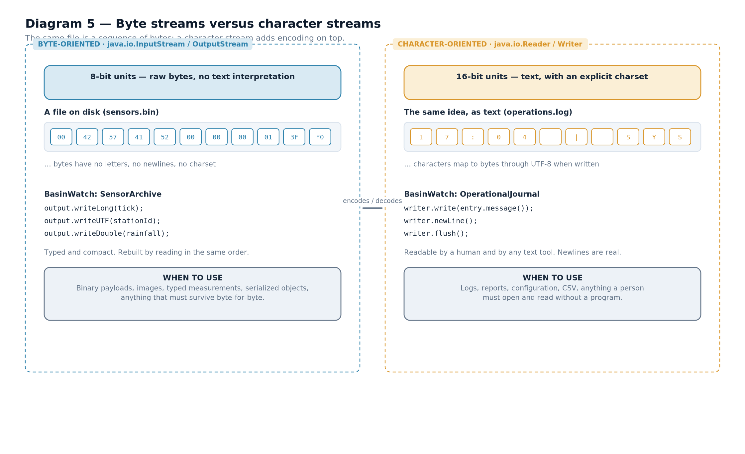

4.3 Byte streams versus character streams
This is the first real decision you make with any stream, and it is a decision about meaning rather than performance.
 | Byte stream | Character stream
Abstract roots | InputStream / OutputStream | Reader / Writer
Unit | one byte (8 bits) | one character (16 bits)
Encoding | none — bytes are just bytes | an explicit charset converts characters to bytes, and back
Main methods | read(), read(byte[]), write(int), write(byte[]) | read(), read(char[]), write(int), write(String)
Convenience | none — you assemble values yourself | readLine(), newLine(), append()
Correct for | images, audio, compressed data, typed measurements, serialized objects | logs, reports, configuration, CSV, HTML, any text a person reads
Wrong for | text you intend a human to read | binary data — encoding will corrupt it
Table 4.1 — The byte/character decision, stated as a comparison.COMMON MISTAKEUsing a character stream on binary data. Reading a PNG through a FileReader does not merely look wrong — it silently replaces byte sequences that are not valid in the current charset with a substitution character, and the file is destroyed. The rule is simple: if a human is meant to read it, use characters; otherwise use bytes.
CONCEPT EXPLAINED FURTHERWhy are characters 16-bit when bytes are 8-bit? Because Java's char is a UTF-16 code unit, chosen so that the common characters of the world's writing systems fit in one unit. The bridge between a 16-bit character and 8-bit storage is the charset — UTF-8, UTF-16, ISO-8859-1 and so on. A character stream always uses one, either explicitly or through the platform default.
IMPORTANT DISTINCTIONEncoding is not encryption and it is not compression. Encoding is a reversible mapping from characters to bytes. Nothing is hidden and nothing is made smaller — UTF-8 often makes text larger than a single-byte encoding would.
BASINWATCH IN PRACTICEBasinWatch uses character streams where a human reads the output and byte streams where a machine must reproduce values exactly:
// character: a person can open this file and read it

writer = Files.newBufferedWriter(path, StandardCharsets.UTF_8,
StandardOpenOption.CREATE, StandardOpenOption.APPEND);
// bytes: values keep their exact type and size

output = new DataOutputStream(new BufferedOutputStream(Files.newOutputStream(path,
StandardOpenOption.CREATE, StandardOpenOption.APPEND)));
Listing 4.1 — from BasinWatch, io/OperationalJournal.java and io/SensorArchive.java Both files store rainfall and water level, and both are correct. The difference is who reads them. operations.log is for an operator; the archive is for the program.

4.4 The four hierarchies
The entire java.io package is organised around four abstract roots, and every concrete class descends from exactly one of them.
Diagram 6 — The Java I/O class hierarchies. Four abstract roots — InputStream, OutputStream, Reader, Writer — and the concrete classes that specialise the source or destination. The wrapper classes take another stream in their constructor, which is what makes layering possible.
Two things are worth noticing in that diagram.
There is a symmetry. Almost every capability exists in four forms. File access is FileInputStream, FileOutputStream, FileReader, FileWriter. In-memory access is ByteArrayInputStream, ByteArrayOutputStream, StringReader, StringWriter. Pipe access is PipedInputStream, PipedOutputStream, PipedReader, PipedWriter. Learn one family and you have learned the others.
Wrapper classes break the pattern deliberately. BufferedInputStream, DataInputStream and ObjectInputStream are not sources at all — they are filters that take another stream and add a capability to it. They sit under FilterInputStream, which is the base class for exactly this purpose.
CONNECTION TO ANOTHER CONCEPTChapter 6 is entirely about those wrappers. The idea they implement — add a capability by wrapping, without changing the underlying source — is the decorator pattern, and it is why a single chain of objects can read a typed double efficiently from a file while the file stream itself knows nothing about doubles.
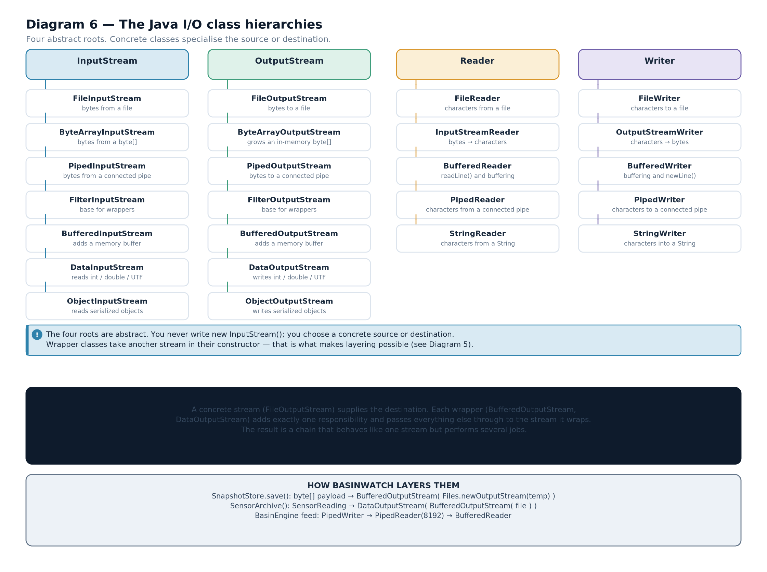

4.5 The methods that actually matter
Java's stream API is large, but a small number of methods carry almost all the work. These are the ones to know by name and return type.
Method | Class | Returns | Meaning
read() | InputStream / Reader | int | The next byte or character as an int in 0–255 (or 0–65535), or -1 at end of stream.
read(byte[] b) | InputStream | int | How many bytes were read into the array, or -1 at end.
read(char[] c) | Reader | int | How many characters were read, or -1 at end.
write(int b) | OutputStream / Writer | void | Writes the low byte, or the character.
write(byte[] b) | OutputStream | void | Writes the whole array.
write(String s) | Writer | void | Writes a string, encoded.
flush() | both output families | void | Pushes buffered data to the destination. Does not close.
close() | all four roots | void | Flushes if applicable and releases the underlying resource. Idempotent.
readLine() | BufferedReader | String | One line without its terminator, or null at end of stream.
newLine() | BufferedWriter | void | Writes the platform line separator.
Table 4.2 — The core stream methods. Note that read() returns int, not byte.IMPORTANT DISTINCTIONWhy does read() return an int instead of a byte? Because a byte cannot represent the end-of-stream marker. Every byte value from 0 to 255 is a legal data byte, so a separate signal is needed: -1. Widening the return type to int makes room for it. This is why the idiom is int b; while ((b = in.read()) != -1) and why casting to byte too early loses the end marker.
COMMON MISTAKEForgetting that readLine() returns null at end of stream while read() returns -1. Mixing them up produces an infinite loop that appears to work until the input ends. BasinWatch's intake loop is written correctly:
String
line;
while
((line = source.readLine()) !=
null
) { ... }
The assignment happens inside the condition, so the loop stops the moment the writer closes the pipe.

4.6 What happens when things go wrong
Almost every stream method declares a checked exception. There are only a few you meet in practice, and they mean different things.
Exception | Thrown when | Typical cause
IOException | Any I/O failure | Disk full, file locked, pipe closed, permission denied
FileNotFoundException | A file cannot be opened for reading | The path does not exist, or the directory does
EOFException | A read hits the end before a full value was read | A truncated archive or an incomplete typed record — a subclass of IOException
UnsupportedEncodingException | The named charset is unavailable | A typo in a charset name
NullPointerException | A null stream or null array is passed | Not an IOException, and not checked — usually a programming error
Table 4.3 — Stream exceptions and what they indicate.EXAM TIPTwo facts about stream exceptions are asked constantly. First, IOException is checked, so the compiler forces you to handle or declare it — that is deliberate, because I/O failure is normal rather than exceptional. Second, EOFException extends IOException, so catching the parent also catches it. BasinWatch relies on that relationship when it validates an archive header:
catch
(
java.io.EOFException
ex) {

throw

new

IOException
(
"Sensor archive header is incomplete."
, ex);
}

4.7 The one rule about closing
Every stream holds an operating-system resource: a file handle, a pipe buffer, a socket. Those are finite. Failing to release them leaks them, and a long-running application will eventually fail to open anything at all.
Java gives you two ways to guarantee release, and both are used in BasinWatch.
// (a) try-with-resources — the preferred form

try
(
BufferedWriter
writer = Files.newBufferedWriter(report,
StandardCharsets.UTF_8
)) {
writer.write("
BASINWATCH
·
SITUATION

REPORT
");
writer.newLine();

// ... more writes

}
// close() runs here, even if an exception was thrown

// (b) implementing AutoCloseable on a component that owns a stream

public

final

class

OperationalJournal

implements

AutoCloseable
{

private

final

BufferedWriter
writer;

private

int
pendingLines;

public

OperationalJournal
(
Path
path)
throws

IOException
{
writer = Files.newBufferedWriter(path,
StandardCharsets.UTF_8
,

StandardOpenOption.CREATE
,
StandardOpenOption.APPEND
);
}

@Override

public

synchronized

void
close()
throws

IOException
{
writer.flush();
writer.close();
}
}
from BasinWatch, io/ReportWriter.java and io/OperationalJournal.java — both release patterns.CORE CONCEPTResources are released in reverse order of acquisition. In try (BufferedInputStream in = new BufferedInputStream(Files.newInputStream(p))) the buffered stream is closed first, which flushes it into the file stream, which is then closed. That order is what makes the last bytes reach the disk.
- A stream is an ordered, one-directional sequence of data, consumed or produced incrementally rather than all at once.
- Every stream is described by three properties: direction, unit (byte or character), and source or destination.
- Four abstract roots: InputStream, OutputStream, Reader, Writer.
- Byte streams carry raw 8-bit units and preserve data exactly; character streams carry 16-bit characters through a charset and are correct for text.
- read() returns int so that -1 can mark end of stream; readLine() returns null instead.
- Stream failures are checked IOExceptions; EOFException is a subclass indicating a truncated read.
- Streams are released by try-with-resources or by implementing AutoCloseable, in reverse order of acquisition.
- Stream — an incremental, one-directional sequence of data.
- Charset — the reversible mapping between characters and bytes, for example UTF-8.
- Filter stream — a stream that wraps another stream and adds a capability.
- try-with-resources — a statement that closes every declared resource automatically, in reverse order.
- End of stream — the signal that no more data will arrive: -1 from read(), null from readLine().

Reading and Writing Files
The file streams and character streams, their constructors and methods, complete read and write workflows, and the resource rules that keep them safe.

5.1 From a stream to an actual file
Chapter 4 described streams in the abstract. To make one real you attach it to a file, and that requires two different objects in modern Java: a Path that names the file, and a stream that reads or writes its contents.
IMPORTANT DISTINCTIONA File or Path is not the file's contents. It is a description of where the file is. You can ask it whether the file exists, what it is called, how large it is and when it was modified — all without opening it. Only when you create a stream do you touch the data. BasinWatch uses this distinction deliberately: it lists saves by inspecting metadata, and reads contents only when a save is actually restored.
public

static

List
<
Path
> list(
Path
directory)
throws

IOException
{

File
folder = directory.toFile();

File
[] files = folder.listFiles((parent, name) -> name.toLowerCase().endsWith(".bws"));

if
(files == null) {

throw

new

IOException
("
Unable
to list session saves in " + directory.toAbsolutePath());
}

return
Arrays.stream(files)
.filter(
File
::isFile)
.sorted(Comparator.comparingLong(
File
::lastModified).reversed())
.map(
File
::toPath)
.toList();
}
from BasinWatch, io/SaveCatalog.java — listing saves needs metadata only, no stream at all. Three details in that method repay attention. The filter runs on the directory listing, so non-matching names are never even considered. The sort is by last-modified time, newest first, which is what an operator expects from a restore dialog. And the null check matters: an unreadable or non-existent directory makes listFiles return null rather than an empty array, and a NullPointerException here would be far less useful than the explicit IOException.

5.2 The file-stream classes
Java has two generations of file-stream API, and both are still in use. Knowing which you are reading matters.
Class | Family | How it is built | Notes
FileInputStream | byte input | new FileInputStream(path) or new FileInputStream(file) | The classic class. Throws FileNotFoundException, a subclass of IOException.
FileOutputStream | byte output | new FileOutputStream(path, true) for append | Without the boolean it truncates the file. The second argument is easy to forget.
FileReader | character input | new FileReader(path, StandardCharsets.UTF_8) | Without a charset it uses the platform default, which differs between machines.
FileWriter | character output | new FileWriter(path, StandardCharsets.UTF_8, true) | Same truncate/append trap, and the same platform-default trap.
Files.newInputStream | byte input | Files.newInputStream(path, StandardOpenOption.READ) | The modern equivalent. Options are explicit; failures are plain IOException.
Files.newBufferedWriter | character output | Files.newBufferedWriter(path, UTF_8, CREATE, APPEND) | Buffered and charset-explicit in one call. This is what BasinWatch uses.
Table 5.1 — The file-stream classes and how each is constructed.COMMON MISTAKETwo classic bugs live in that table. First, forgetting the append flag: new FileOutputStream(path) truncates the file to zero length, so a log that was supposed to grow silently restarts. Second, omitting the charset: new FileWriter(path) uses the platform default encoding, so a file written on one machine can be unreadable on another. BasinWatch never omits either — it uses StandardCharsets.UTF_8 and StandardOpenOption.APPEND explicitly at every site.

5.3 A complete write workflow
Here is the full sequence for writing text to a file, using the modern API. Read it as a template; the same five steps appear in every write in this book.
import

java.io.BufferedWriter
;
import

java.io.IOException
;
import

java.nio.charset.StandardCharsets
;
import

java.nio.file.Files
;
import

java.nio.file.Path
;
public

class

WriteWorkflow
{

public

static

void
main(
String
[] args)
throws

IOException
{

Path
target = Path.of("demo", "notes.txt");
Files.createDirectories(target.getParent());
// 1. ensure the folder exists

try
(
BufferedWriter
writer =
// 2. open in try-with-resources

Files.newBufferedWriter(target,
StandardCharsets.UTF_8
)) {
writer.write("first line");
// 3. write content

writer.newLine();
// a real line separator

writer.write("second line");
writer.newLine();
writer.flush();
// 4. push buffered bytes out

}
// 5. close() runs automatically

System.out.println("
Wrote
" + Files.size(target) + " bytes");
}
}
illustrative — the canonical text-write workflow, mirroring ReportWriter.write The five steps are: create the parent directory, open inside try-with-resources, write the content, flush, and let the block close the stream. The flush at step four is technically optional here because close() flushes, but writing it explicitly documents the intent and matters when a stream is kept open across many writes.
BASINWATCH IN PRACTICEBasinWatch's report writer is the same five steps with real content. Note that the whole file is produced inside one try-with-resources block, so a failure halfway through still closes the stream:
public static

Path
write(
Path
directory,
BasinSnapshot
snapshot)
throws

IOException
{

String
filename =
"basin-status-"
+ FILE_TIME.format(
Instant
.now())
+
"-"
+
UUID
.randomUUID().toString().substring(0, 8) +
".txt"
;

Path
report = directory.resolve(filename);

try
(
BufferedWriter
writer =
Files
.newBufferedWriter(report,
StandardCharsets
.UTF_8)) {
writer.write(
"BASINWATCH · SITUATION REPORT"
);
writer.newLine();
writer.write(
"Generated: "
+
Instant
.now());
writer.newLine();

// ... zone conditions, resources, missions, recent activity

}

return
report;
}
Listing 5.1 — from BasinWatch, io/ReportWriter.java The filename carries a timestamp and eight characters of a UUID. That combination means two reports generated in the same second still get distinct names, and the operator can tell when each was produced without opening it.
Diagram 7 — File persistence lifecycles. Each file is opened, written, flushed and closed on a different schedule. The log appends for the lifetime of the session; the archive is opened once and appended to per observation; the snapshot is written once and replaced atomically; a report is written once and never reopened.
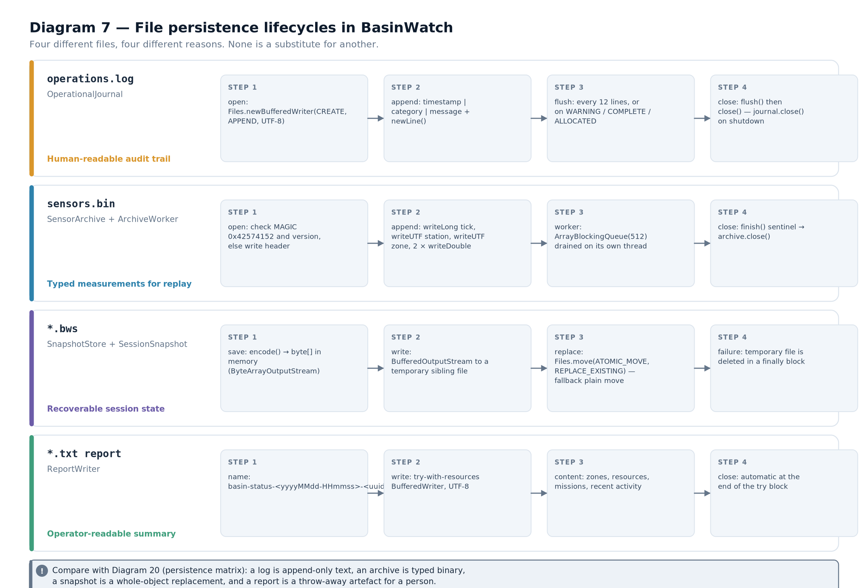

5.4 A complete read workflow
Reading has one extra consideration: you do not know how many lines there are, so the loop must be driven by the read itself.
import

java.io.BufferedReader
;
import

java.io.IOException
;
import

java.nio.charset.StandardCharsets
;
import

java.nio.file.Files
;
import

java.nio.file.Path
;
public

class

ReadWorkflow
{

public

static

void
main(
String
[] args)
throws

IOException
{

Path
source = Path.of("demo", "notes.txt");

if
(!Files.isRegularFile(source)) {

throw

new

IOException
("No such file: " + source.toAbsolutePath());
}

int
lines = 0;

try
(
BufferedReader
reader =
Files.newBufferedReader(source,
StandardCharsets.UTF_8
)) {

String
line;

while
((line = reader.readLine()) != null) {
// null marks end of stream

lines++;
System.out.println(lines + ": " + line);
}
}
System.out.println("
Read
" + lines + " line(s)");
}
}
illustrative — the canonical text-read workflow, mirroring SensorIntake's loop Three habits are worth copying. The existence check produces a clearer message than a raw FileNotFoundException. The charset is explicit, so the file reads identically everywhere. And the loop condition performs the read, so there is no possibility of testing for end-of-stream and then reading anyway — a bug that would skip or duplicate the last line.
BASINWATCH IN PRACTICESensorIntake.run is this workflow applied to a pipe rather than a file, with validation folded in:
try
(source) {
// source is the BufferedReader

String
line;

while
((line = source.readLine()) !=
null
) {

BasinEvent
event;

try
{

if
(line.startsWith(
"PULSE|"
)) {
event =
new

SimulationPulse
(
Long
.parseLong(line.substring(6)));
}
else
{
event =
SensorReading
.parse(line);
}
}
catch
(
IllegalArgumentException
ex) {
warningReporter.accept(
"Discarded malformed sensor record: "
+ ex.getMessage());

continue
;
// skip, keep reading

}

// ... put(event) into the buffer

}
}
catch
(
IOException
ex) {
warningReporter.accept(
"Sensor intake ended with an I/O error: "
+ ex.getMessage());
}
Listing 5.2 — from BasinWatch, engine/SensorIntake.java Note the two different failure responses. A malformed record is reported and skipped, because one bad line should not stop the stream. An I/O error ends the loop, because the stream itself is broken and there is nothing left to read. Distinguishing recoverable bad data from an unrecoverable channel failure is a design decision, not a detail.

5.5 Appending versus replacing
Two very different intentions share the same class, and the difference is one boolean or one option.
Intention | How to open | Effect on existing content
Replace the file | Files.newBufferedWriter(p, UTF_8) | Truncated to zero length immediately on open
Add to the file | Files.newBufferedWriter(p, UTF_8, CREATE, APPEND) | Existing content is preserved; new writes go to the end
Create if absent | CREATE | A missing file is created
Fail if it already exists | CREATE_NEW | Throws FileAlreadyExistsException — useful for safety
Table 5.2 — Open options and their effect on existing data.BASINWATCH IN PRACTICEBasinWatch makes both choices, and each is right for its artefact. The operational journal appends, because it is a running record of everything that has happened:
// OperationalJournal — append

writer = Files.newBufferedWriter(path, StandardCharsets.UTF_8,
StandardOpenOption.CREATE, StandardOpenOption.APPEND);
The report writer replaces, because each report is a fresh snapshot of the current situation and carries a unique name anyway:
// ReportWriter — create a new file

try
(
BufferedWriter
writer =
Files
.newBufferedWriter(report,
StandardCharsets
.UTF_8)) { ... }
Getting this backwards would be a serious defect: a truncating journal would erase history on every restart, and an appending report would mix yesterday's situation into today's document.

5.6 Flushing: when data actually reaches the disk
A buffered stream keeps data in memory until the buffer fills or you flush. This means that "the write succeeded" and "the bytes are on disk" are different statements.
BASINWATCH IN PRACTICEThe journal manages this explicitly, with a policy rather than a reflex. It flushes when twelve lines have accumulated, or immediately when the message is operationally significant:
public synchronized void
append(
ActivityEntry
entry)
throws

IOException
{
writer.write(
DateTimeFormatter
.ISO_INSTANT.format(entry.at()));
writer.write(
" | "
);
writer.write(entry.category().replace(
'\n'
,
' '
));
writer.write(
" | "
);
writer.write(entry.message().replace(
'\n'
,
' '
));
writer.newLine();
pendingLines++;

if
(pendingLines >= 12 || entry.category().contains(
"WARNING"
)
|| entry.category().contains(
"COMPLETE"
)
|| entry.category().contains(
"ALLOCATED"
)) {
writer.flush();
pendingLines = 0;
}
}
Listing 5.3 — from BasinWatch, io/OperationalJournal.java This is a real engineering trade-off. Flushing every line would guarantee durability but cost a system call per line. Never flushing would be fast but could lose a burst of activity in a crash. Flushing on the important categories means that an allocation, a completion or a warning is on disk immediately, while routine readings can wait a few lines.
CONCEPT EXPLAINED FURTHERThe two replace('\n', ' ') calls are not cosmetic. An activity message could contain a newline — from an exception message, for example — and a newline inside a log line would break the file's one-line-per-entry structure. Replacing it with a space preserves the format without losing information.
IMPORTANT DISTINCTIONflush() and close() are not the same. flush() pushes buffered data to the operating system but leaves the stream usable. close() flushes and releases the file handle, after which any further write throws IOException. Calling close() twice is safe and has no additional effect.

5.7 What a real write failure looks like
I/O failures are ordinary events, not exotic ones, and the code should read as though it expects them. BasinWatch's engine treats a journal failure as something to report but not to propagate into the event-processing path:
IOException
journalFailure = null;
for
(
String
message : messages) {

ActivityEntry
entry =
new

ActivityEntry
(Instant.now(), event.category(), message);

try
{
journal.append(entry);
}
catch
(
IOException
ex) {

if
(journalFailure == null) {
journalFailure = ex;
}
else
{
journalFailure.addSuppressed(ex);
// keep every failure, lose none

}
}
}
// ... archive and database work still happen

if
(journalFailure != null) {

throw
journalFailure;
// reported after the rest of the work

}
from BasinWatch, engine/BasinEngine.java — collect failures, continue the work, report at the end. The pattern is worth learning because it appears throughout professional code: attempt every independent piece of work, accumulate the failures, and report them once at the end. It is the opposite of stopping at the first problem, and it matters here because a log failure should not prevent the archive and database writes that follow.
EXAM TIPA very common exam question asks you to write a method that copies a text file line by line and to say what happens if the destination cannot be opened. The expected answer mentions: try-with-resources so both streams close; an explicit charset; the readLine() != null loop; and that an IOException from the opening of the destination means the source is never read. Say the order of operations explicitly — examiners look for it.
- A Path or File describes where data is; only a stream reads or writes the data itself.
- Four classic file classes exist for each direction and unit; the modern Files.newXxx methods make options and charsets explicit.
- Opening a file for output truncates it unless an append flag or option is supplied.
- A complete write workflow is: create the parent, open in try-with-resources, write, flush, close.
- A complete read workflow is: check existence, open with an explicit charset, loop on readLine() != null, close.
- Recoverable bad data should be skipped and reported; an unrecoverable stream failure should end the loop.
- flush() pushes data onward and keeps the stream open; close() flushes and releases the handle.
- Append mode — opening an output stream so new writes follow existing content.
- Truncate — reducing a file to zero length when it is opened for output.
- Flush — forcing buffered data out to the destination without closing the stream.
- Suppressed exception — a secondary failure attached to a primary one so neither is lost.
- Metadata — information about a file (name, size, modification time) as opposed to its contents.

Buffering, Data Streams and Stream Wrappers
How a wrapper adds a capability without changing the source, why buffering changes performance by orders of magnitude, and how typed values are written to a binary file.

6.1 The problem with one byte at a time
Every read() call on a raw file stream is a system call. The operating system has to leave user code, consult its file-system layer, copy a byte, and return. That overhead is roughly the same whether you asked for one byte or eight thousand.
So reading a megabyte one byte at a time means a million system calls to move data that would fit in 128 calls of 8 KB. The CPU spends its time in the kernel boundary rather than on your program. Buffering fixes this by adding an intermediate array.
CORE CONCEPTA buffer is a memory array that sits between your code and the underlying resource. On the first read the buffer is filled with one large request; subsequent reads are served from memory until the buffer is exhausted, at which point it is refilled. Writing works in reverse: bytes accumulate in the buffer and are written out in one large operation when the buffer fills, when you flush, or when you close.

6.2 Layering: the decorator pattern
The classes that add buffering, typing and object support are not sources. They take another stream in their constructor and wrap it. That single design choice is what makes stream code composable.
Diagram 8 — Wrapped and buffered streams. Reading a file through three layers. Each wrapper delegates downward and adds exactly one capability: the buffered stream adds an array, the data stream adds type interpretation. Data flows upward through the same layers.
Read that diagram from the bottom up, because that is the direction data travels on a read. The file stream delivers raw bytes. The buffered stream collects them into an array so the file stream is called rarely. The data stream interprets the next four bytes as a double and the next four as an int. Each layer knows only the layer beneath it.
The same chain on a write goes the other way: your code calls writeDouble, the data stream converts the value to eight bytes, the buffered stream collects those bytes, and the file stream eventually writes them out.
BASINWATCH IN PRACTICEBasinWatch's archive writer is exactly this chain, built in one statement:
private static

DataOutputStream
openArchive(
Path
path)
throws

IOException
{

boolean
fresh = !
Files
.isRegularFile(path) ||
Files
.size(path) == 0;

DataOutputStream
output =
new

DataOutputStream
(
new

BufferedOutputStream
(

Files
.newOutputStream(path,
StandardOpenOption
.CREATE,
StandardOpenOption
.APPEND)));

if
(fresh) {
output.writeInt(MAGIC);
output.writeInt(FORMAT_VERSION);
output.flush();
}

return
output;
}
Listing 6.1 — from BasinWatch, io/SensorArchive.java Three layers, three capabilities: Files.newOutputStream talks to the file, BufferedOutputStream batches the bytes, and DataOutputStream converts typed values to bytes. The fresh test decides whether the header must be written — an archive that already contains data must not get a second header.
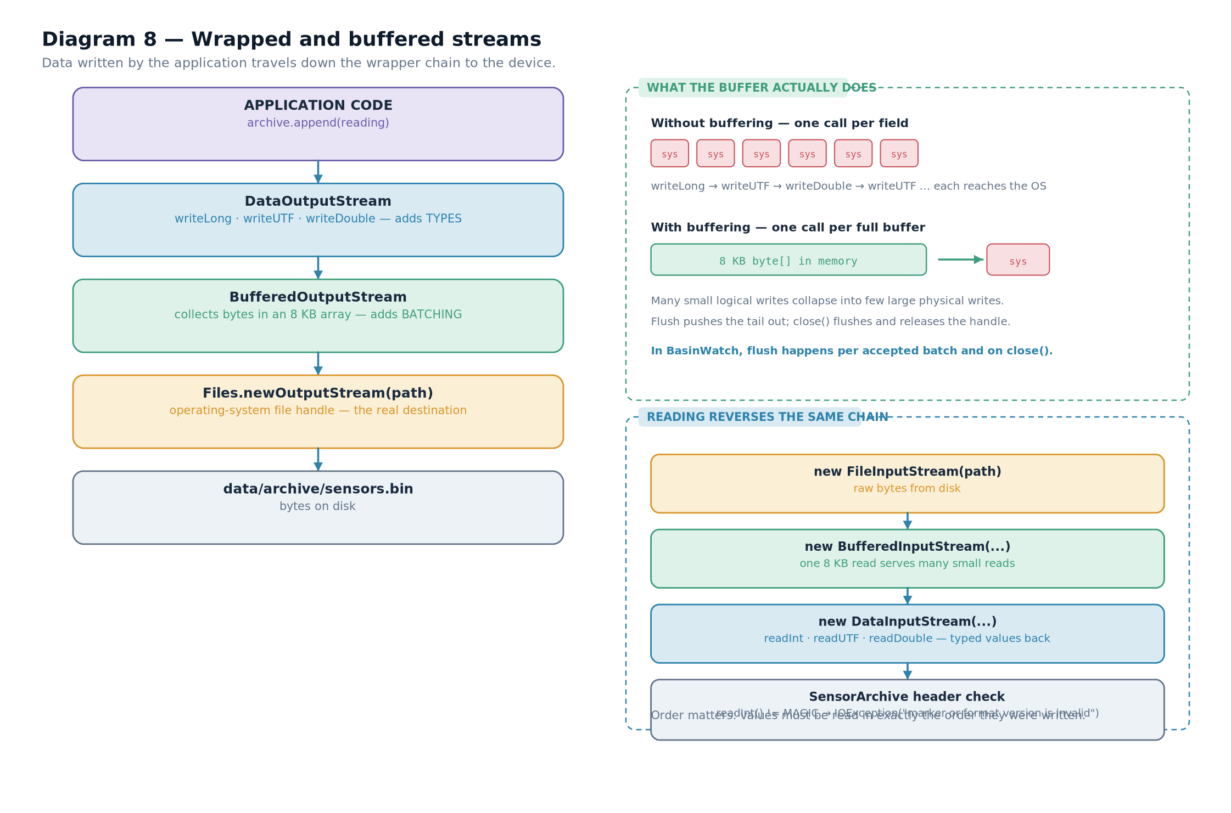

6.3 Buffered streams and buffered readers
Buffering exists in both families, and the character version adds something the byte version cannot have: line awareness.
Class | Wraps | Adds | Characteristic method
BufferedInputStream | any InputStream | an internal byte array, default 8192 bytes | mark() / reset() become usable
BufferedOutputStream | any OutputStream | an internal byte array | flush() actually matters now
BufferedReader | any Reader | a character array and line splitting | readLine()
BufferedWriter | any Writer | a character array and platform line separators | newLine()
Table 6.1 — The four buffering classes and what each adds.IMPORTANT DISTINCTIONreadLine() exists only on BufferedReader. It is not on Reader, not on FileReader, and not on InputStream. This is why the standard idiom is new BufferedReader(new FileReader(path)) — the outer class supplies the convenience method, the inner one supplies the source. BasinWatch's intake wraps its PipedReader in a BufferedReader for exactly this reason.

6.4 Data streams: typed values in a binary file
A character stream can store the text "12.5". A data stream can store the number 12.5 — eight bytes in a defined format that any Java program can read back without parsing.
DEFINITIONDataInputStream / DataOutputStream — filter streams that read and write Java's primitive types and UTF-8 strings in a fixed binary format, independent of locale and of how the value would be printed.
Method | Bytes written | Notes
writeBoolean(boolean) | 1 | A single byte, 0 or 1
writeInt(int) | 4 | Big-endian, most significant byte first
writeLong(long) | 8 | Big-endian
writeDouble(double) | 8 | IEEE 754 double-precision, big-endian
writeUTF(String) | 2 + n | A two-byte length, then modified UTF-8 bytes — maximum 65535 bytes
writeChars(String) | 2 × n | Two bytes per character, no length prefix
Table 6.2 — Data-stream methods and their exact sizes. These sizes are what makes the format self-describing.CORE CONCEPTEvery data-stream write has exactly one matching read, and the order must be identical. A file written as writeInt then writeDouble must be read as readInt then readDouble. There is no self-describing metadata inside a data stream — the sequence of calls is the schema. Change the order in one place and every subsequent read returns garbage, usually without an exception.
COMMON MISTAKEReading a data stream in the wrong order is the classic silent corruption. Because every method simply consumes the next n bytes, a readDouble() where a readInt() was expected does not throw — it returns a perfectly valid but completely wrong number. The only defence is to keep the write order and the read order adjacent in the codebase and to version the format explicitly, which BasinWatch does with FORMAT_VERSION.

6.5 A complete typed-record workflow
Here is the write side and the read side of one record, side by side. BasinWatch writes a header once and then one record per accepted observation.
// --- the header, written once when the archive is created ---

static

final

int

MAGIC
= 0x42574154;
// "BWAT"

static

final

int

FORMAT_VERSION
= 1;

output.writeInt(
MAGIC
);
// 4 bytes: identifies the file

output.writeInt(
FORMAT_VERSION
);
// 4 bytes: which layout follows

// --- one record per accepted observation ---

output.writeLong(reading.tick());
// 8 bytes

output.writeUTF(reading.stationId());
// 2 + n bytes

output.writeUTF(reading.zoneId());
// 2 + n bytes

output.writeDouble(reading.rainfallMillimeters());
// 8 bytes

output.writeDouble(reading.observedRiseCentimeters());
// 8 bytes
// --- reading the header back, and validating it ---

int
magic = input.readInt();
if
(magic !=
MAGIC
) {

throw

new

IOException
("
Sensor
archive has an unexpected signature.");
}
int
version = input.readInt();
if
(version !=
FORMAT_VERSION
) {

throw

new

IOException
("
Unsupported
sensor archive version: " + version);
}
// --- reading records until the file ends ---

while
(true) {

try
{

long
tick = input.readLong();

String
stationId = input.readUTF();

String
zoneId = input.readUTF();

double
rainfall = input.readDouble();

double
rise = input.readDouble();

// ... build a SensorReading and report it

}
catch
(
EOFException
end) {

break
;
// a clean end of file, not an error

}
}
from BasinWatch, io/SensorArchive.java — the write order defines the format.from BasinWatch, io/SensorArchive.java — the matching read order, with EOF as the terminator. Four things in those listings are worth naming, because they are the difference between a toy binary format and a usable one.
A magic number identifies the file. The constant 0x42574154 spells "BWAT" in ASCII. If someone points the reader at a different file, the first read fails immediately with a clear message rather than producing nonsense.
A version number allows the format to change. When the layout gains a field, the version is incremented and the reader can decide what to do. Without it, an old reader would silently misinterpret a new file.
End of file is the terminator. There is no record count, so the loop reads until EOFException and treats that as the normal end. This is why the record must be written completely: a half-written record produces an EOFException in the middle of a record, which the reader cannot distinguish from a clean end unless it tracks how far it got.
The strings use writeUTF. Each string carries its own length, so there is no ambiguity about where one ends and the next begins. That is precisely what writeChars cannot offer.
CONNECTION TO ANOTHER CONCEPTCompare this with Chapter 8's session snapshot, which stores whole objects rather than typed primitives. Both are binary, both are byte streams — but the data stream gives you a format you control field by field, while object serialization gives you a format the JDK controls and that you must actively secure. Neither is universally better; the archive chose control, the snapshot chose convenience plus validation.

6.6 Where each wrapper belongs
Choosing a chain is a small design decision you make constantly. The pattern is always the same: start with the source or destination, then add one wrapper per capability you need.
Task | Chain | Why
Read a large file quickly, byte by byte | BufferedInputStream → FileInputStream | Buffering removes the per-byte system call.
Read a text file line by line | BufferedReader → FileReader | readLine() lives on the buffered reader.
Read typed numbers from a binary file quickly | DataInputStream → BufferedInputStream → FileInputStream | Typing on the outside, buffering in the middle, the file at the core.
Write a log line by line | BufferedWriter → FileWriter | Line methods plus batching, with an explicit charset.
Build bytes in memory then hand them to a socket | DataOutputStream → ByteArrayOutputStream | Chapter 7 covers the in-memory destination.
Table 6.3 — Common wrapper chains and the reason for each layer.EXAM TIPIf asked "why wrap a FileInputStream in a BufferedInputStream?", the precise answer is about call frequency, not speed in the abstract: buffering reduces the number of system calls by roughly the ratio of buffer size to read size, and each system call has a fixed cost that dominates for small reads. Saying "it's faster" without the mechanism usually loses marks.
- A buffer is a memory array between your code and the resource, turning many small operations into few large ones.
- Wrapper classes take another stream in their constructor and add exactly one capability — the decorator pattern.
- Reading travels upward through the chain; writing travels downward. Each layer knows only the layer beneath it.
- readLine() exists only on BufferedReader, which is why buffering is not optional for line-based text.
- Data streams write primitives in a fixed binary format whose write order defines the schema; the matching read order must be identical.
- A usable binary format has a magic number, a version, self-describing strings via writeUTF, and a defined end condition.
- A BufferedOutputStream makes flush() significant — without it, bytes may sit in memory.
- Decorator pattern — adding behaviour by wrapping an object in another object of the same interface.
- Filter stream — a wrapper stream; its constructor takes the stream it wraps.
- Magic number — a constant at the start of a file identifying its format.
- Format version — a number that lets a reader detect an incompatible layout.
- writeUTF — a data-stream method that writes a two-byte length followed by modified UTF-8 bytes.

In-Memory and Piped Streams
Streams whose source is memory, and streams that connect two threads. This chapter covers byte-array streams, piped streams, and the producer–consumer pattern.

7.1 Why a stream with no file?
Not every stream is attached to a device. Two important sources and destinations are entirely inside the program: a byte array in memory, and a pipe connecting two threads.
The in-memory case is useful because it lets you reuse the whole stream API for something that never touches a disk. Building a payload with DataOutputStream gives you the same typed writes as a file, and the result is a byte[] you can hand to a network call, a cache or a test assertion.
The piped case is useful because it solves a real problem: two threads that must exchange a stream of data without sharing a data structure.

7.2 Byte-array streams
A ByteArrayOutputStream collects everything written to it in an internal growable array; toByteArray() hands you the contents. A ByteArrayInputStream reads from an array you already have.
import

java.io.ByteArrayInputStream
;
import

java.io.ByteArrayOutputStream
;
import

java.io.DataInputStream
;
import

java.io.DataOutputStream
;
import

java.io.IOException
;
public

class

InMemoryPayload
{

public

static

void
main(
String
[] args)
throws

IOException
{

byte
[] payload;

// write typed values into memory

try
(
ByteArrayOutputStream
buffer =
new

ByteArrayOutputStream
();

DataOutputStream
out =
new

DataOutputStream
(buffer)) {
out.writeInt(7);
// a tick

out.writeUTF("
MIL
");
// a zone

out.writeDouble(42.5);
// rainfall

out.flush();
payload = buffer.toByteArray();
}

System.out.println("payload size = " + payload.length + " bytes");

// read them back, with no file anywhere

try
(
DataInputStream
in =
new

DataInputStream
(
new

ByteArrayInputStream
(payload))) {
System.out.println("tick = " + in.readInt());
System.out.println("zone = " + in.readUTF());
System.out.println("rain = " + in.readDouble());
}
}
}
illustrative — the same typed format, entirely in memory Expected output, and the arithmetic behind the size:
payload size = 17 bytes
tick = 7
zone = MIL
rain = 42.5
VISUAL WALKTHROUGHSeventeen bytes is not a coincidence. writeInt contributes 4, writeUTF("MIL") contributes 2 for the length plus 3 for the characters, and writeDouble contributes 8. Four plus five plus eight is seventeen. If you can predict that number before running the program, you understand the format.
IMPORTANT DISTINCTIONClosing a byte-array stream has no effect on the array. There is no operating-system resource to release, so close() is a no-op. It is still worth calling — through try-with-resources — because it means the same code shape works when the destination later becomes a file or a socket. BasinWatch's archive code is written so that only the innermost source changes.

7.3 Piped streams
A pipe is a matched pair: a writer at one end, a reader at the other, with a bounded buffer between them. What the writer writes, the reader reads, in order.
DEFINITIONPiped stream — a connected pair of streams, PipedWriter/PipedReader or PipedOutputStream/PipedInputStream, that transfers data from one thread to another through an internal buffer.
Diagram 9 — The piped-stream producer and consumer. SensorFeed writes encoded observation lines into a PipedWriter. SensorIntake reads them from a PipedReader wrapped in a BufferedReader, validates each line, and places accepted events into the bounded EventBuffer. The pipe provides the thread boundary; the buffer provides the queue.
Three properties of that arrangement matter, and each is a design decision.
The pipe is the only shared object. The producer never sees the buffer, the queue or the model. The consumer never sees the producer. Each thread's dependencies are visible in its constructor.
The pipe is bounded, so it provides back-pressure. BasinWatch constructs it with an 8,192-character buffer. If the producer runs faster than the consumer, the producer blocks on write instead of filling memory. This is the same property a bounded queue has, obtained for free.
Both ends must be closed for the reader to finish cleanly. The writer closing is what turns the reader's next readLine() into a null, ending the loop. If the writer never closes, the reader waits forever.
COMMON MISTAKEA pipe is not automatically thread-safe in the sense people assume. A PipedReader and its PipedWriter are intended to be used by different threads. Using both ends in one thread is a classic deadlock: the reader blocks waiting for data that only the same thread could write. If you need a stream in one thread, use a byte-array stream.
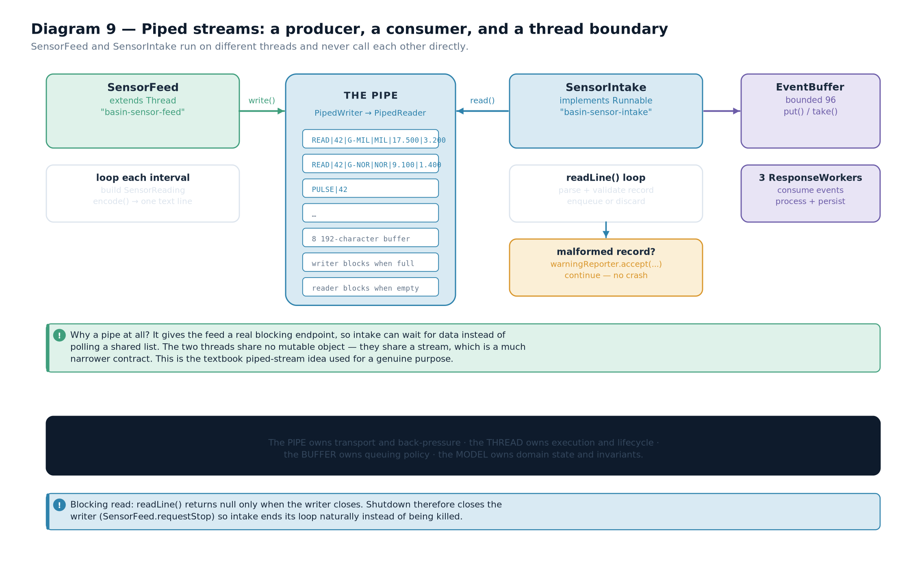

7.4 The producer side
The producer is a thread with a loop, a cadence and a stop flag. Its job is to encode a value and write it as one line.
public

final

class

SensorFeed

extends

Thread
{

private

final

Writer
destination;

private

final

List
<
String
> zoneIds;

private

final

SimulationSettings
settings;

private

final

AtomicLong
tickSequence;

private

final

Consumer
<
String
> failureReporter;

private

volatile

boolean
running = true;

@Override

public

void
run() {

Random
random =
new

Random
();

try
{

while
(running && !isInterrupted()) {

long
tick = tickSequence.incrementAndGet();

for
(
String
zoneId : zoneIds) {

SensorReading
reading =
new

SensorReading
(tick, stationId(zoneId), zoneId,
round1(random.nextDouble() * settings.rainfallMillimeters()),
round1(random.nextDouble() * settings.riseCentimeters()));
destination.write(reading.encode());
destination.write(System.lineSeparator());
}
destination.flush();
Thread.sleep(settings.tickIntervalMillis());
}
}
catch
(
InterruptedException
ex) {
Thread.currentThread().interrupt();
// restore the flag and stop

}
catch
(
IOException
ex) {
failureReporter.accept("
Sensor
feed stopped: " + ex.getMessage());
}
finally
{
closeQuietly();
}
}
}
from BasinWatch, engine/SensorFeed.java — encode one line per observation, then flush. Five details in that loop are worth studying, because each one is a concurrency decision.
running is volatile. It is written by one thread (the caller of requestStop()) and read by another (this loop). Without volatile, the reader could cache a stale value and never stop.
The loop checks both the flag and the interrupt. Either mechanism alone is enough, but checking both means a stop request works whether it arrives between iterations or during the sleep.
InterruptedException restores the flag. Catching the exception clears the thread's interrupt status, so Thread.currentThread().interrupt() puts it back. This is the correct handling and it is easy to get wrong.
The line separator is platform-independent at the source. Using System.lineSeparator() means the encoding matches what readLine() expects on the same machine.
The writer is closed in a finally block. That is what makes the consumer's loop terminate, even if the producer stopped because of an error.

7.5 The consumer side
The consumer reads lines, validates them and passes accepted events onward. It is a Runnable rather than a thread, because the engine owns the thread.
public

final

class

SensorIntake

implements

Runnable
{

private

final

BufferedReader
source;

private

final

EventBuffer
buffer;

private

final

Consumer
<
String
> warningReporter;

private

final

Consumer
<
String
> statusReporter;

@Override

public

void
run() {
statusReporter.accept("
Sensor
intake online");

try
(source) {

String
line;

while
((line = source.readLine()) != null) {

BasinEvent
event;

try
{

if
(line.startsWith("
PULSE
|")) {
event =
new

SimulationPulse
(Long.parseLong(line.substring(6)));
}
else
{
event = SensorReading.parse(line);
}
}
catch
(
IllegalArgumentException
ex) {
warningReporter.accept("
Discarded
malformed sensor
record
: " + ex.getMessage());

continue
;
// one bad line must not stop the stream

}

if
(!buffer.put(event)) {
warningReporter.accept("
Event
buffer closed; intake stopping.");

break
;
}
}
}
catch
(
IOException
ex) {
warningReporter.accept("
Sensor
intake ended with an I/O error: " + ex.getMessage());
}
catch
(
InterruptedException
ex) {
Thread.currentThread().interrupt();
}
finally
{
statusReporter.accept("
Sensor
intake offline");
}
}
}
from BasinWatch, engine/SensorIntake.java — read, parse, report, enqueue.CONNECTION TO ANOTHER CONCEPTNote the interaction of three mechanisms in twelve lines. The pipe supplies characters (readLine()). Parsing supplies validation (SensorReading.parse throws on bad data). The bounded queue supplies hand-off to the workers (buffer.put blocks when full). Chapter 3 named these as three separate mechanisms; here they are one loop.

7.6 Wiring the pair, and shutting it down
Creating a connected pipe requires the writer to exist before the reader, and the reader's constructor to receive the writer. That ordering is why the engine builds both in one method.
private

void
startFeed()
throws

IOException
{

PipedWriter
writer =
new

PipedWriter
();

PipedReader
reader =
new

PipedReader
(writer, 8_192);
// explicit buffer size

feedWriter = writer;
intakeThread =
new

Thread
(
new

SensorIntake
(
new

BufferedReader
(reader), eventBuffer,

this
::reportFailure, ignored -> publishDiagnosticsStatus()), "basin-sensor-intake");
sensorFeed =
new

SensorFeed
(writer, List.of("
UPR
", "
MIL
", "
NOR
", "
OLD
", "
MAR
", "
SOU
"),
settings, tickSequence,
this
::reportFailure);
intakeThread.start();
sensorFeed.start();
}
// --- and the shutdown, in the order that lets the consumer finish ---

public

synchronized

void
closeEngine() {

try
{

if
(sensorFeed != null) {
sensorFeed.requestStop();
// 1. stop producing

}

if
(feedWriter != null) {
feedWriter.close();
// 2. closing the writer ends readLine()

}

if
(intakeThread != null) {
intakeThread.join(2_000);
// 3. wait for the consumer to drain

}
eventBuffer.close();
// 4. wake any waiting workers

// ... archive drain, journal flush, final snapshot

}
catch
(
IOException
|
InterruptedException
ex) {
Thread.currentThread().interrupt();
}
}
from BasinWatch, engine/BasinEngine.java — creation order and shutdown order are both deliberate. The shutdown sequence is the part students most often get wrong, so it is worth stating as a rule. The four steps are ordered by dependency: you must stop the producer before closing the pipe, close the pipe before waiting for the consumer (otherwise the consumer blocks forever), and close the queue after the consumer has drained it (otherwise accepted events are lost).
- Stop the producer. requestStop() sets the flag; the feed loop exits at the next check.
- Close the writer. This flushes any buffered characters into the pipe and signals end of stream.
- Join the intake thread. The consumer's readLine() now returns null, the loop ends, and the thread finishes. A bounded join with a timeout means shutdown cannot hang forever.
- Close the buffer. Waiting workers are woken by notifyAll and see the closed flag, so they exit instead of waiting for events that will never come.
- If you close the writer before stopping the producer: the producer throws IOException on its next write and reports a spurious failure.
- If you close the buffer before joining the consumer: events already read from the pipe are discarded, so the log and database lose the last few observations.
- If you never close the writer: the consumer blocks in readLine() forever and the application will not exit.

7.7 Reading a file, an in-memory payload, and a pipe
The three cases look almost identical at the call site, which is the point of the stream abstraction. Only the constructor differs.
 | From a file | From memory | Through a pipe
Source | Files.newBufferedReader(path, UTF_8) | new ByteArrayInputStream(bytes) | new BufferedReader(new PipedReader(writer))
Blocking behaviour | blocks on disk read | never blocks — data is already present | blocks until the writer produces data
End of stream | when the file ends | when the array is exhausted | when the writer closes
Resource to release | an OS file handle | nothing | a thread waiting at the other end
Thread safety | one reader per stream | safe if the array is not mutated | designed for two different threads
Used in BasinWatch | restoring a session snapshot, listing reports | building a payload before writing | the live sensor feed
Table 7.1 — The same read loop, three different sources.EXAM TIPA frequently asked question is "why does Java need a separate PipedReader when a shared queue would do?" The strongest answer covers three points: the pipe enforces a one-directional contract so neither thread can reach the other's state; the pipe's buffer gives back-pressure without extra code; and the pipe's close protocol gives a natural end-of-stream signal, which a queue must simulate with a sentinel value.
- A byte-array stream uses the whole stream API with no device attached; closing it releases nothing.
- A pipe is a matched writer/reader pair with a bounded internal buffer, intended for two different threads.
- The pipe is the only object the producer and consumer share, which narrows both contracts.
- A bounded pipe provides back-pressure: a fast producer blocks instead of exhausting memory.
- The producer must close the writer for the consumer's read loop to terminate.
- Shutdown order is stop producer, close writer, join consumer, close queue — each step depends on the previous.
- The same read loop works for a file, an in-memory array and a pipe; only the constructor changes.
- Back-pressure — a bounded channel making a fast producer wait rather than buffer without limit.
- End of stream — in a pipe, the signal produced by closing the writer.
- volatile — a field modifier guaranteeing that a write by one thread becomes visible to another.
- Interrupt — a cooperative request for a thread to stop; it does not force termination.
- Bounded join — waiting for a thread with a timeout so shutdown cannot hang indefinitely.

Serialization, Deserialization and Session Persistence
How objects are turned into bytes and back, why that is dangerous by default, and how a real application makes it safe.

8.1 The problem: saving an object graph
A data stream can save a double because a double has a fixed size and layout. But what about an object? An object has fields of different types, may contain other objects, may contain collections of objects, and may have a class hierarchy. Writing it out field by field is tedious and breaks whenever a field is added.
Object serialization solves this by letting the runtime do the traversal. You declare that a class is serializable, and the JVM writes the object's class identity and its non-transient field values, recursing into any objects those fields reference.
DEFINITIONSerialization — the process of converting an object into a byte sequence that can be written to a stream and later reconstructed, preserving the object's class and field values.
DEFINITIONDeserialization — the reverse process: reading that byte sequence and reconstructing an object graph, including the classes it contains.

8.2 How it works
Two classes do the work, and they are both filter streams, so they follow exactly the pattern from Chapter 6.
import
java.io.*;
public

class

SerializeDemo
{

public

static

void
main(
String
[] args)
throws

IOException
,
ClassNotFoundException
{

Path
path = Path.of("demo", "sample.ser");

// ---- serialization: object -> bytes -> file ----

try
(
ObjectOutputStream
out =
new

ObjectOutputStream
(

new

BufferedOutputStream
(Files.newOutputStream(path,

StandardOpenOption.CREATE
,
StandardOpenOption.TRUNCATE_EXISTING
)))) {
out.writeObject(
new

Sample
("
MIL
", 2.45, 12));
out.flush();
}

// ---- deserialization: file -> bytes -> object ----

try
(
ObjectInputStream
in =
new

ObjectInputStream
(

new

BufferedInputStream
(Files.newInputStream(path)))) {

Object
restored = in.readObject();
System.out.println("restored = " + restored);
}
}

static

final

class

Sample

implements

Serializable
{

private

static

final

long
serialVersionUID = 1L;

private

final

String
zone;

private

final

double
level;

private

final

int
residents;

Sample
(
String
zone,
double
level,
int
residents) {
this.zone = zone; this.level = level; this.residents = residents;
}

@Override

public

String
toString() {

return
zone + " " + level + " m / " + residents + " residents";
}
}
}
illustrative — the minimal serialization round trip Expected output:
restored = MIL 2.45 m / 12 residents
Diagram 10 — Serialization and deserialization. An object graph becomes a byte stream headed by the class descriptor and the serialVersionUID, then a field-value sequence. Deserialization reverses it: read the descriptor, load and check the class, then allocate and populate the object without calling its constructor.
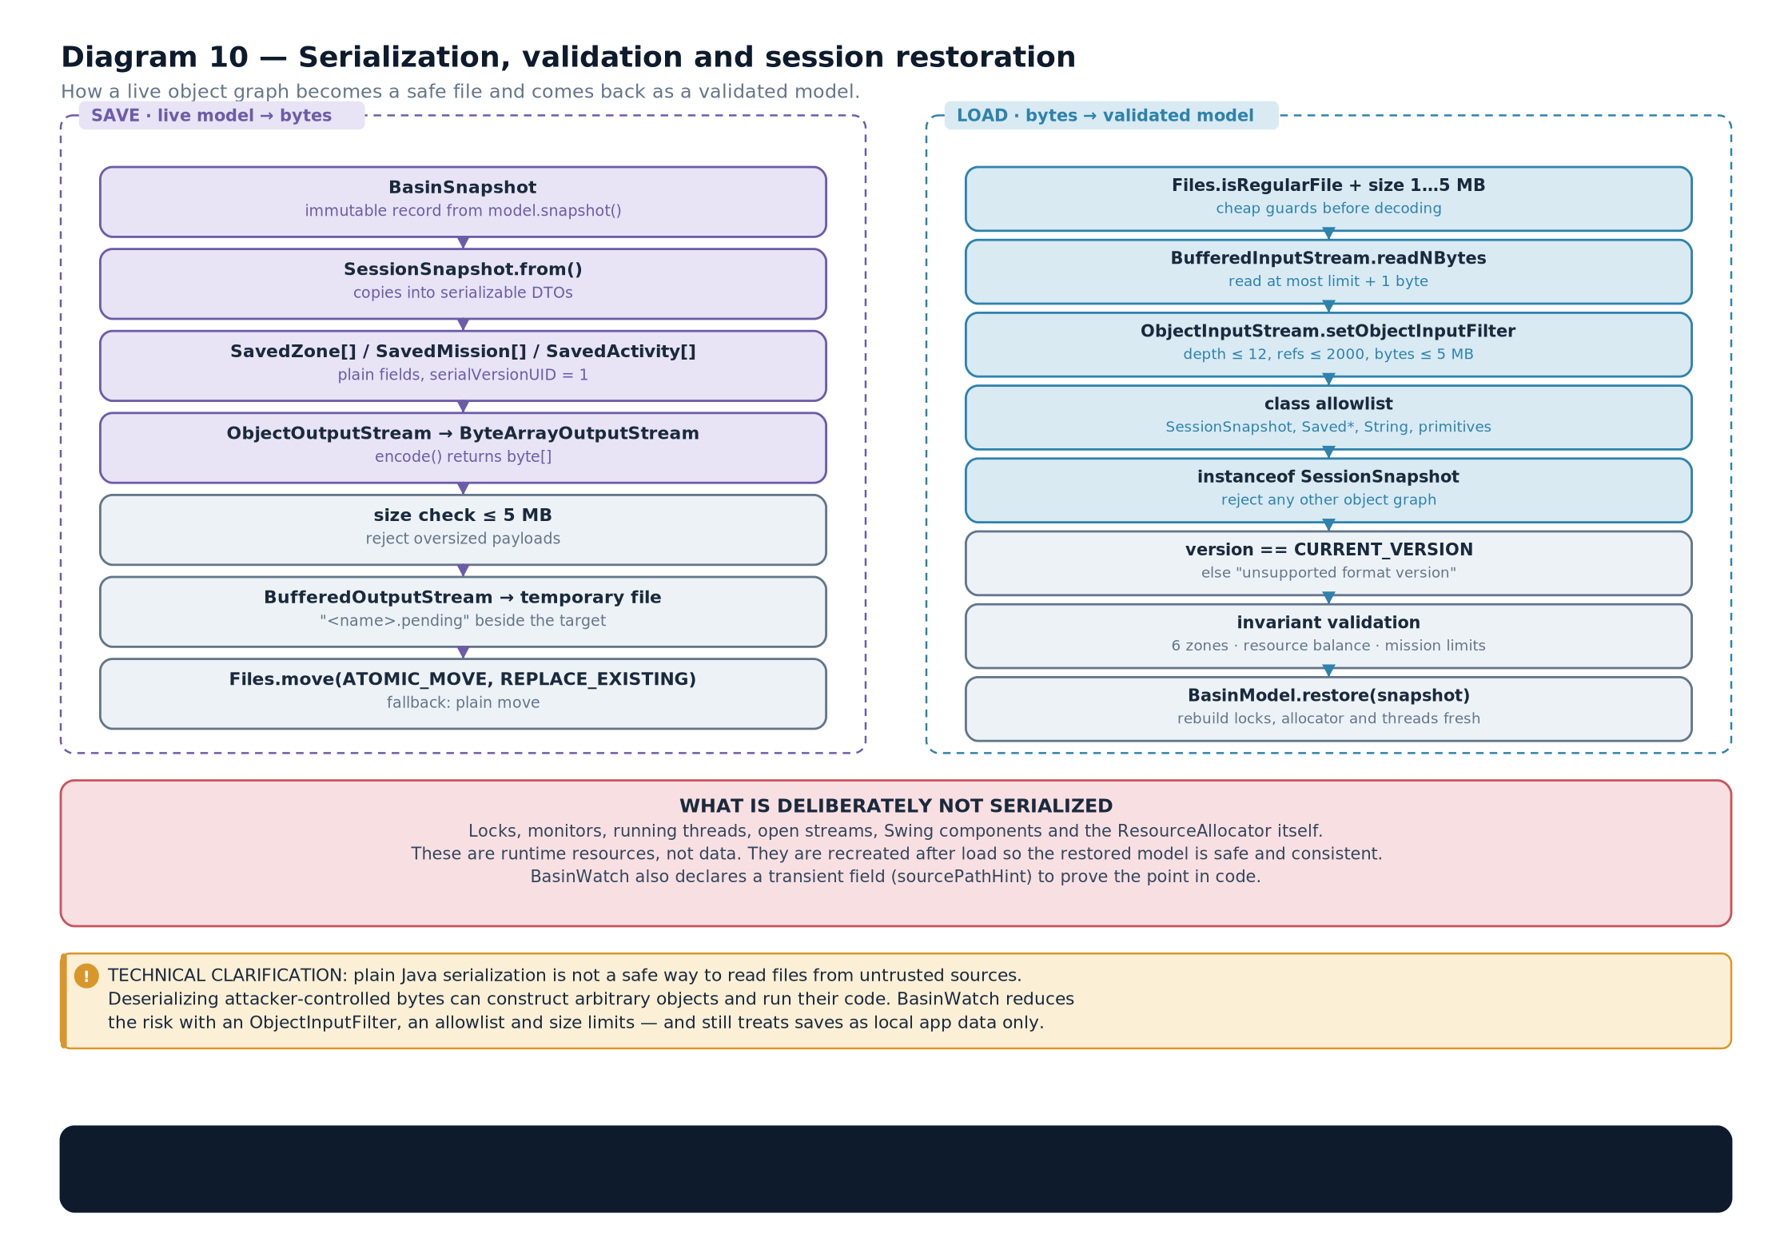

8.3 The five facts that matter
1. A class must implement Serializable. It is a marker interface: it declares no methods. Its only purpose is to permit the runtime to write the object. Any class that does not implement it, and is not an ancestor, causes NotSerializableException at write time.
2. Fields must be serializable too, or marked transient. Serialization recurses, so every non-transient field must itself be serializable or a primitive. A Thread, an open Stream, a Connection — none of these can be serialized, and trying produces an exception naming the offending field.
3. transient excludes a field. A transient field is skipped entirely and, on deserialization, receives its default value: null, 0 or false. This is how you exclude a cache, a lock or a derived value.
4. static fields are not serialized. They belong to the class, not the object, so they are not part of the instance state being written.
5. The constructor is not called on deserialization. The object is allocated and its fields are set directly by the runtime. This is why the no-argument constructor that serialization conventionally requires need not do anything, and why validation placed in a constructor will not run when an object is restored.
CORE CONCEPTFact five is the one that surprises people, and it is the reason a real application cannot simply trust the objects it reads. If a constructor enforces "water level must be between 0 and 8", that rule is bypassed entirely by deserialization. BasinWatch therefore validates the restored state explicitly after reading it, rather than assuming the invariants held.

8.4serialVersionUID and version compatibility
Every serializable class has an identity that the stream records. If you declare it yourself, the compiler uses your value. If you do not, the compiler derives one from the class's structure — its name, its modifiers, its interfaces and every method and field signature.
Situation | Without an explicit serialVersionUID | With an explicit serialVersionUID
Add a harmless method | The derived UID changes | Nothing changes
Change a field's type | The derived UID changes | Deserialization fails with a field-type error
Add a new field | The derived UID changes | The new field receives its default value — old files still load
Remove a field | The derived UID changes | The removed field is ignored — old files still load
Recompile the same source | The derived UID is stable for the same compiler | Stable by construction
Table 8.1 — Why an explicit serialVersionUID is worth declaring.COMMON MISTAKERelying on the computed serialVersionUID. Two builds of the "same" class on different JDK versions or with different compilers can produce different values, and then every saved file becomes unreadable with InvalidClassException: local class incompatible. Declaring the constant explicitly is one line and removes a whole class of support problems.

8.5 Why default serialization is unsafe
Deserialization reconstructs an object graph from bytes that may come from anywhere. The runtime will happily instantiate whatever classes the stream names. That is a security problem, not a theoretical one: a crafted stream can instantiate classes you never intended, and the "gadget chains" that made several widely reported vulnerabilities possible all relied on exactly this.
DEFINITIONDeserialization vulnerability — the risk that a malicious byte stream causes the runtime to instantiate and initialise classes of the attacker's choosing, because deserialization bypasses constructors and honours the class names in the stream.
There are four independent defences, and a robust implementation uses all of them rather than picking one.
Defence | What it prevents | How it is expressed
Bound the input size | Denial of service by an enormous or deeply nested stream | Check the file length against a constant before opening the stream
Filter the classes that may be constructed | Instantiating an attacker-chosen class | ObjectInputFilter via setObjectInputFilter
Validate after reading | Accepting a structurally valid but semantically impossible object | Explicit range and consistency checks on the restored values
Check a format version | Reading a file written by an incompatible build | A version field written in the header and compared on read

8.6 How BasinWatch saves and restores a session
The project's snapshot store is a careful implementation of the four defences, and reading it is the best way to see them in practice. It writes to a temporary file and then replaces the real file atomically, so a crash during a save cannot leave a half-written snapshot in place.
public

final

class

SnapshotStore
{

static

final

int

FORMAT_VERSION
= 1;

static

final

long

MAX_SAVE_BYTES
= 4L * 1024 * 1024;
// 4 MB is generous for this model

public

void
save(
Path
target,
SessionSnapshot
snapshot)
throws

IOException
{
Files.createDirectories(target.toAbsolutePath().getParent());

Path
temporary = target.resolveSibling(target.getFileName() + ".tmp");

try
(
ObjectOutputStream
out =
new

ObjectOutputStream
(
new

BufferedOutputStream
(
Files.newOutputStream(temporary,
StandardOpenOption.CREATE
,

StandardOpenOption.TRUNCATE_EXISTING
)))) {
out.writeInt(
FORMAT_VERSION
);
// written first, so a reader can check it early

out.writeObject(snapshot);
out.flush();
}

try
{
Files.move(temporary, target,
StandardCopyOption.REPLACE_EXISTING
,

StandardCopyOption.ATOMIC_MOVE
);
// atomic replace

}
catch
(
AtomicMoveNotSupportedException
ex) {
Files.move(temporary, target,
StandardCopyOption.REPLACE_EXISTING
);
}
}
}
from BasinWatch, io/SnapshotStore.java — write to a temporary file, then move it into place. Two things in the write path are deliberate. The version is written before the object, so a reader can reject an incompatible file without attempting to interpret it. And the save goes to name.bws.tmp first, with the real file replaced only when the write has succeeded. If the process dies mid-save, the previous good snapshot is still intact.
public

SessionSnapshot
load(
Path
source)
throws

IOException
,
ClassNotFoundException
{

if
(!Files.isRegularFile(source)) {

throw

new

IOException
("
Session
save not found: " + source.toAbsolutePath());
}

if
(Files.size(source) >
MAX_SAVE_BYTES
) {
// defence 1: bound the input

throw

new

IOException
("
Session
save is unexpectedly large: " + Files.size(source) + " bytes");
}

try
(
ObjectInputStream
in =
new

ObjectInputStream
(
new

BufferedInputStream
(
Files.newInputStream(source)))) {
in.setObjectInputFilter(
SnapshotStore
::allowOnlySafeClasses);
// defence 2: filter classes

int
version = in.readInt();

if
(version !=
FORMAT_VERSION
) {
// defence 4: version check

throw

new

IOException
("
Unsupported
session format version: " + version);
}

Object
payload = in.readObject();

if
(!(payload
instanceof

SessionSnapshot
snapshot)) {

throw

new

IOException
("
Session
save does not contain a session snapshot.");
}
snapshot.validate();
// defence 3: validate the domain state

return
snapshot;
}
}
private

static

ObjectInputFilter.Status
allowOnlySafeClasses(
ObjectInputFilter.FilterInfo
info) {

Class
<?> type = info.serialClass();

if
(type == null || type.isPrimitive()) {

return

ObjectInputFilter.Status.ALLOWED
;
}

String
name = type.getName();

if
(name.startsWith("com.basinwatch.") || name.startsWith("java.lang.")
|| name.startsWith("java.util.") || name.startsWith("java.time.")) {

return

ObjectInputFilter.Status.ALLOWED
;
}

return

ObjectInputFilter.Status.REJECTED
;
// everything else is refused

}
from BasinWatch, io/SnapshotStore.java — all four defences in one method.VISUAL WALKTHROUGHRead the load method as four gates. Gate one is the size check, before the stream is even opened. Gate two is the filter, which runs on every class the stream tries to construct. Gate three is the version check, immediately after the header. Gate four is snapshot.validate(), after the object exists. A file must pass all four to be accepted.

8.7 What validation has to check
Because deserialization skips constructors, the restored object can be structurally valid and semantically impossible. The validation method is where the invariants are re-established.
public

void
validate() {

if
(tick < 0) {

throw

new

IllegalStateException
("
Session
tick cannot be negative.");
}

if
(zones == null || zones.size() != 6) {

throw

new

IllegalStateException
("A session must describe exactly six zones.");
}

for
(
SavedZone
zone : zones) {

if
(zone == null || zone.waterLevelMeters() < 0.0 || zone.waterLevelMeters() > 8.0) {

throw

new

IllegalStateException
("
Session
contains an impossible water level.");
}
}

if
(missions == null || resources == null || recentActivity == null) {

throw

new

IllegalStateException
("
Session
is missing a required section.");
}

for
(
Map.Entry
<
ResourceType
,
Integer
> entry : resources.entrySet()) {

if
(entry.getValue() == null || entry.getValue() < 0) {

throw

new

IllegalStateException
("
Session
contains a negative resource count.");
}
}
}
from BasinWatch, io/SessionSnapshot.java — the invariants the constructors would have enforced. Notice that every check here corresponds to a rule that a constructor would normally apply: a non-negative tick, exactly six zones, water levels inside the physical range, a non-negative inventory. That correspondence is not a coincidence — it is the whole point. Validation after deserialization exists to re-apply the rules that deserialization bypassed.
CONNECTION TO ANOTHER CONCEPTCompare this with the sensor archive in Chapter 6. The archive also has a magic number and a version, but it never deserializes objects, so it needs no class filter — the format is a fixed sequence of primitives that cannot name a class. That is a real advantage of the data-stream approach and a real reason to prefer it where the shape is known.

8.8 Serialization versus the alternatives
Object serialization is convenient and, as the previous section showed, needs care. Knowing when it is the wrong tool is part of understanding it.
Approach | Stores | Readable by | Best for | Used in BasinWatch for
Text with a character stream | Characters | a human, and any text tool | Logs, reports, configuration | The operational journal and reports
Data streams | Typed primitives in a fixed order | a Java program that knows the format | Measurement records, wire formats | The sensor archive
Object serialization | An object graph with class descriptors | a Java program with the same classes | Whole-state save and restore | Session snapshots
A database | Rows and columns | any SQL client | Selective queries over many records | Optional SQLite history
JSON or XML | A structured text document | almost anything | Interchange with other languages | Not used — see Chapter 18
Table 8.3 — Five persistence formats and the question each answers.EXAM TIPQuestions on serialization cluster around four points: what makes a class serializable; what transient and static do; why the constructor is bypassed; and what serialVersionUID is for. The constructor point is the one that separates a memorised answer from an understood one — if you can explain that the runtime allocates the object without invoking a constructor, and therefore that validation must be repeated explicitly, you have answered all four coherently.
- Serialization converts an object graph into bytes; deserialization reconstructs it.
- A class must implement Serializable, and every non-transient field must be serializable.
- transient and static fields are not written; a transient field restores to its default value.
- Deserialization bypasses constructors, so constructor validation does not run on restore.
- Declaring serialVersionUID explicitly prevents unrelated recompiles from invalidating saved files.
- Default deserialization is unsafe: bound the size, filter the permitted classes, check a version, and validate the restored state.
- BasinWatch writes to a temporary file and moves it into place, so an interrupted save cannot corrupt an existing snapshot.
- Serializable — a marker interface permitting an object to be serialized.
- serialVersionUID — the explicit version identity of a serializable class.
- transient — a modifier excluding a field from serialization.
- ObjectInputFilter — a hook that approves or rejects each class a deserialization stream tries to construct.
- Atomic move — replacing a file in a single step, so no intermediate state is observable.

How BasinWatch Uses Java I/O
Four file mechanisms, four different purposes. This chapter consolidates Part II into a verified case study of the project's file layer.

9.1 The design question, stated properly
An application that needs to keep data could write everything to one file. BasinWatch uses four different file mechanisms, and the reason is that each answers a different question.
Diagram 11 — Three persistence mechanisms, three questions. File persistence split by the question it answers: a readable log for humans, a typed archive for measurements, and a versioned snapshot for whole-state recovery. The database column is the subject of Part III.
Artefact | The question it answers | Mechanism | Who reads it
operations.log | “What has the application been doing?” | Character stream, UTF-8, append-only, line per event | An operator, or a text editor
sensors.bin | “What exactly did the stations report?” | Byte stream with data-stream typing, header plus fixed records | The program, during diagnosis
*.bws | “How do I get the whole situation back?” | Object serialization of a versioned snapshot DTO, atomic replace | The program, on restore
*.txt reports | “What is the situation right now?” | Character stream, UTF-8, one document per request | A person, outside the application
Table 9.1 — The four file artefacts and the question each one answers.CORE CONCEPTNone of these four is interchangeable with the others, and that is the design lesson of Part II. A log cannot restore a session because it records events, not state. A snapshot cannot answer "what happened at 14:03" because it records only the present. An archive cannot be read by a person because it is binary. A report cannot be queried because it is prose. Choosing the format is choosing which questions the file will be able to answer.
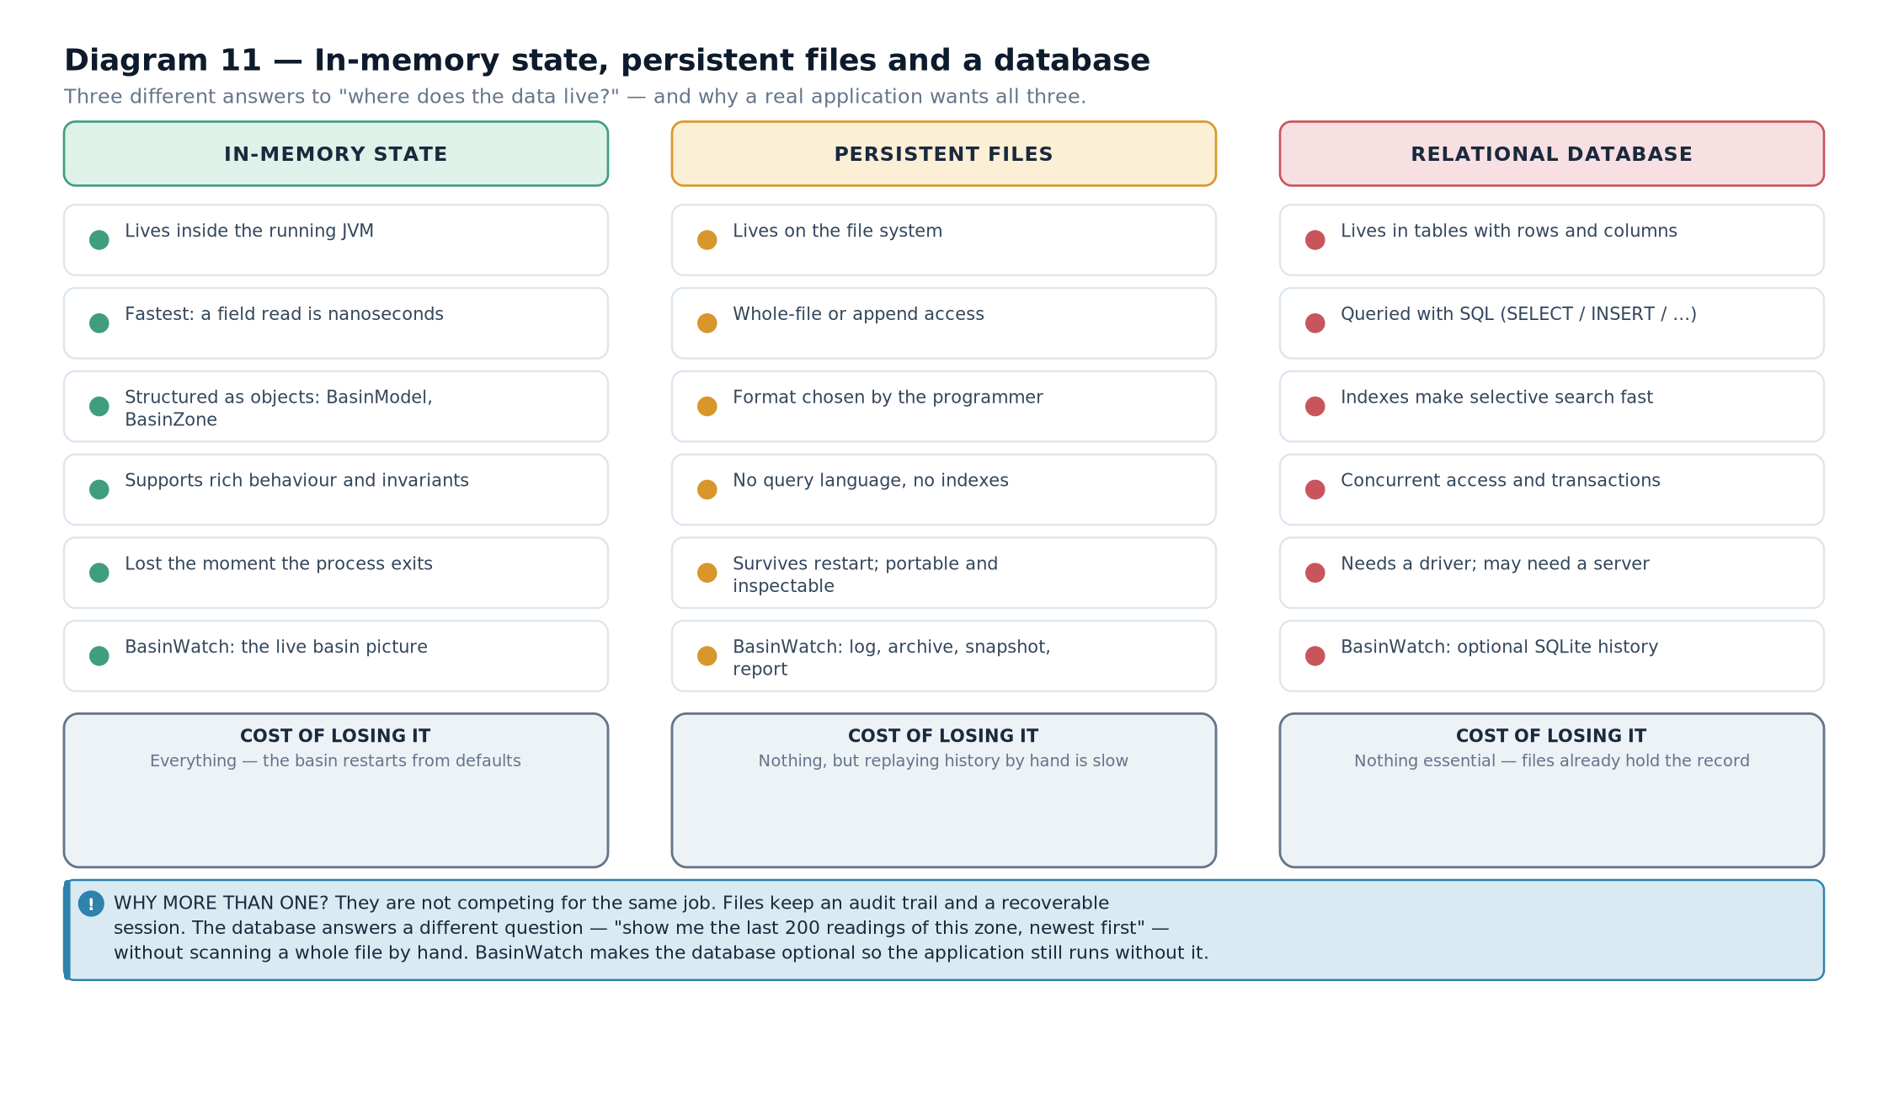

9.2 Where the files live
All paths are derived from one place, so the layout is defined once and cannot drift.
public

final

class

AppPaths
{

private

static

final

Path

ROOT
= Path.of("data");

public

static

Path
logsDirectory() {
return
ROOT.resolve("logs"); }

public

static

Path
logFile() {
return
logsDirectory().resolve("operations.log"); }

public

static

Path
archiveDirectory() {
return
ROOT.resolve("archive"); }

public

static

Path
archiveFile() {
return
archiveDirectory().resolve("sensors.bin"); }

public

static

Path
savesDirectory() {
return
ROOT.resolve("saves"); }

public

static

Path
lastSessionFile() {
return
savesDirectory().resolve("last-session.bws"); }

public

static

Path
reportsDirectory() {
return
ROOT.resolve("reports"); }

public

static

void
ensureDirectories()
throws

IOException
{

for
(
Path
directory : List.of(logsDirectory(), archiveDirectory(),
savesDirectory(), reportsDirectory())) {
Files.createDirectories(directory);
}
}
}
from BasinWatch, io/AppPaths.java — one place that defines the on-disk layout. This small class is more important than it looks. Because every path comes from a method, there are no string literals scattered through the codebase, and a test can reason about the layout without touching the file system. It is the file-system equivalent of a schema.

9.3 The operational log
This is the human-facing record. It is a character stream, it appends, and it flushes on a policy.
data/logs/operations.log
2026-03-04
T09
:15:22.104Z |
OBSERVATION
|
MIL
rainfall 12.4 mm, rise 3.1 cm
2026-03-04
T09
:15:22.109Z |
RISK
|
Risk
increased:
MIL

WATCH
->
WARNING

2026-03-04
T09
:15:31.882Z |
ALLOCATED
|
Deploy
portable pump ->
NOR
using
PUMP
x1,
FIELD_CREW
x1
2026-03-04
T09
:15:39.440Z |
COMPLETE
|
Reinforce
levee on
UPR
finished; levee reinforced
from BasinWatch — the actual line format written by OperationalJournal. Four properties make this file useful, and each was a decision.
The timestamp is ISO-8601 with a Z suffix. That is DateTimeFormatter.ISO_INSTANT, which sorts lexicographically in the same order as it sorts chronologically. A log that sorts correctly as text is a log you can grep.
The category is a separate field. Because it is delimited by " | ", an operator can filter for RISK or ALLOCATED with ordinary text tools.
Newlines inside a message are replaced. Chapter 5 covered this: it keeps one entry on one line, which is what makes the file greppable in the first place.
Flushing is category-aware. Routine observations can wait; warnings, completions and allocations are written through immediately, because those are the entries an investigation would want after a crash.

9.4 The typed sensor archive
Where the log is for reading, the archive is for measurement. It stores exactly what each station reported, in a format that cannot drift.
data/archive/sensors.bin
[ 4 bytes ] magic 0x42574154 ("
BWAT
")
[ 4 bytes ] version 1

--- one record per accepted observation ---

[ 8 bytes ] tick
long

[ 2+n ] stationId
UTF

[ 2+n ] zoneId
UTF

[ 8 bytes ] rainfallMillimeters
double

[ 8 bytes ] observedRiseCentimeters
double
from BasinWatch — the sensor archive layout, as written by SensorArchive.VISUAL WALKTHROUGHCount the bytes of a typical record and you get a feel for why the format is compact. A tick is 8 bytes. Two short identifiers, "MIL-ST-2" and "MIL", cost 2+7 and 2+3, so 14 bytes. Two doubles cost 16. The whole record is 38 bytes, plus the 8-byte header for the first one. A text version of the same record would be roughly 45 characters and would need parsing and locale-independent number formatting to read back.

9.5 The session snapshot
The snapshot is the only artefact that can bring the application back to where it was. It is written on request, and automatically on a clean shutdown, into last-session.bws.
public

static

SessionSnapshot
from(
BasinSnapshot
snapshot) {

ArrayList
<
SavedZone
> zones =
new

ArrayList
<>();

for
(
ZoneSnapshot
zone : snapshot.zones()) {
zones.add(
new

SavedZone
(zone.id(), zone.name(), zone.waterLevelMeters(),
zone.lastRainMillimeters(), zone.exposedResidents(),
zone.leveeReinforced(), zone.lastReadingTick()));
}

ArrayList
<
SavedMission
> missions =
new

ArrayList
<>();

for
(
MissionSnapshot
mission : snapshot.activeMissions()) {
missions.add(
new

SavedMission
(mission.id(), mission.type().name(), mission.zoneId(),
mission.startedTick(), mission.completesAtTick(), mission.status().name()));
}

return

new

SessionSnapshot
(snapshot.tick(), List.copyOf(zones),
Map.copyOf(snapshot.resources()), List.copyOf(missions),
List.copyOf(snapshot.recentActivity()));
}
from BasinWatch, io/SessionSnapshot.java — a deliberate copy from immutable snapshots into serializable DTOs.IMPORTANT DISTINCTIONWhy a separate SessionSnapshot rather than serializing BasinSnapshot directly? Three reasons, and all three matter. First, the domain types may contain things that cannot or should not be serialized. Second, the on-disk format should be a deliberate contract rather than an accident of the current field list — a DTO lets the model change without changing the file. Third, records and enums carry serialization constraints that plain final classes avoid. The DTO is a boundary object, and boundary objects should be explicit.

9.6 Reports
A report is a document, not a record. It is written once, read once, and never parsed.
BASINWATCH
·
SITUATION

REPORT

Generated
: 2026-03-04
T09
:16:02.331Z
Simulation
tick: 214
ZONE

CONDITIONS

MIL

Middle

Basin
2.71 m
WARNING
42 residents 12.4 mm last interval

UPR

Upper

Reach
3.62 m
CRITICAL
18 residents 9.8 mm last interval
...
RESOURCE

BOARD

PUMP
available 2 of 4

FIELD_CREW
available 1 of 3
...
ACTIVE

MISSIONS

M-0007
Deploy
portable pump ->
NOR
started tick 208, completes tick 216
RECENT

ACTIVITY

09:15:22
OBSERVATION

MIL
rainfall 12.4 mm, rise 3.1 cm
...
from BasinWatch — the report structure produced by ReportWriter. The report duplicates information that exists elsewhere, and that is correct. Its value is that it is complete, self-contained and readable without the application. An operator can attach it to an incident note; a reviewer can read it a year later. A format optimised for machine reading would be worse at exactly that job.
Diagram 12 — Which class uses which stream, and why. Every stream class in the project mapped to the class that uses it and the reason that stream was the right choice. The mapping is the argument of this chapter in one picture.
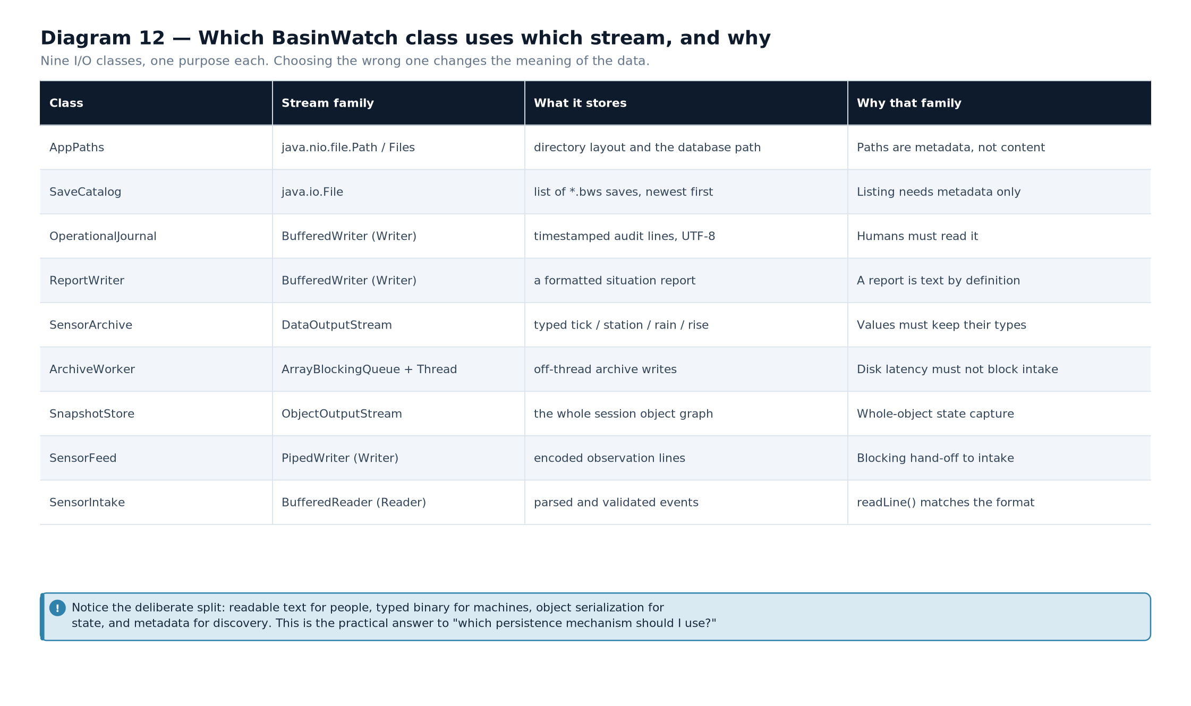

9.7 The four mechanisms side by side
 | Operational log | Sensor archive | Session snapshot | Report
Stream family | character (Writer) | byte (DataOutputStream) | byte (ObjectOutputStream) | character (Writer)
Unit of data | one line per event | one fixed record per observation | one object graph | one document
Open mode | append | append, header if fresh | replace, via temporary file | replace, new name
Reader | a person | the program | the program | a person
Can restore state? | no | no | yes | no
Can be queried? | with text tools | only by the program | no | no
Versioned? | no — append-only | yes, in the header | yes, before the object | no
Failure policy | collect and report at the end | worker thread reports | propagate; the temp file is discarded | propagate to the caller

9.8 Why not one file for everything
It is worth answering the obvious objection directly. Suppose you wrote everything to the log as text. You would then face four problems.
- Restoring state would mean replaying. To recover the model you would have to re-apply every event ever logged, in order, and hope the replay logic still matches the original.
- Numbers would lose precision. A double printed as text and parsed back may not be bit-identical, and any aggregation over thousands of readings would accumulate error.
- Diagnosis would mean parsing. A tool wanting "every reading for MIL above 20 mm" would have to parse the whole file rather than seek.
- One corrupt line would break everything. A truncated final line in an append-only log is normal after a crash; if that log were also the only save file, the session would be unrecoverable.
Conversely, if everything were one binary snapshot, you would lose the audit trail entirely. The four-mechanism design exists because the questions are genuinely different.
EXAM TIPThis chapter's comparison table is one of the highest-yield things in the book for a viva. If asked "why does your project have both a log file and a database?", the answer follows directly: the log records what happened, in order, for a human; the database records structured rows that can be queried selectively. The log is an audit trail; the database is an index. Chapter 10 makes that distinction precise.
- BasinWatch has four file artefacts because each answers a different question: audit, measurement, recovery, communication.
- All paths derive from AppPaths, so the on-disk layout is defined in exactly one place.
- The operational log is UTF-8 text, appended, with ISO-8601 timestamps and category-aware flushing.
- The sensor archive is binary with a magic number, a version and fixed typed records — compact and unambiguous, but unreadable by a person.
- The session snapshot serializes a deliberate DTO, not the live model, and writes through a temporary file.
- Reports are complete, self-contained documents that duplicate other data on purpose.
- None of the four mechanisms can substitute for another, because the format determines which questions the file can answer.
- Audit trail — an ordered record of what happened, for later inspection.
- DTO (data transfer object) — a deliberately separate object used at a boundary, such as persistence or the network.
- Atomic replace — writing to a temporary file then moving it into place so no partial state is visible.
- Header — metadata at the start of a binary file identifying its format and version.
- Append-only — a file opened so that existing content is never modified, only added to.

Databases and JDBC

Why Databases and JDBC Exist
Memory, files and structured storage. Why an application chooses more than one persistence mechanism, and where JDBC fits between Java code and a database.

10.1 Three places data can live
Data in a running Java program lives in three quite different places, and each has a different lifetime and a different set of capabilities.
 | In-memory state | Persistent files | A relational database
Lifetime | Until the process ends or the object is discarded | Until the file is deleted | Until the rows are deleted
Access speed | Nanoseconds — a field read | Microseconds to milliseconds | Microseconds to milliseconds, plus query planning
Can be searched selectively? | Only by writing code to iterate | Only by reading and filtering yourself | Yes — indexes and WHERE clauses
Concurrent access | Requires explicit synchronisation | Effectively one writer | Built-in locking and isolation
Partial update | A field assignment | Rewrite the region or the file | An UPDATE touching one row
Guarantees | None beyond the language | None beyond what you write | Atomicity, consistency, isolation, durability
Structure | Objects and references | Whatever format you invent | Tables, columns, types, constraints
Table 10.1 — Three homes for data, compared.CORE CONCEPTThe decisive difference is not speed. It is selective access. Reading one record out of ten million is trivial in a database and expensive in a file, because a database maintains an index and a file does not. Everything else — transactions, constraints, concurrency — follows from that.

10.2 Why BasinWatch uses more than one mechanism
BasinWatch keeps in-memory state, four kinds of file, and an optional SQLite database. That is not indecision; it is five different questions being asked of the same data.
The question being asked | Best mechanism | Why not the others
What is the water level in MIL right now? | In-memory model | A file read or a query would be slower and would need synchronising.
What has the application been doing today? | Operational log file | A database would work, but a text file is readable without any tooling.
What exactly did station MIL-ST-2 report at 09:15? | Sensor archive | The log does not carry every field; a snapshot keeps only the present.
Restore the situation from yesterday's save. | Session snapshot | Replaying a log is fragile; a snapshot restores state directly.
Show me the 200 most recent readings for MIL, newest first. | Database | A log requires reading and filtering everything; an index and a LIMIT answer it directly.
How many missions completed in the last hour? | Database | Aggregation is one SQL expression over indexed rows; over a text file it is a full scan in application code.
Table 10.2 — Six questions, and the mechanism that answers each best.IMPORTANT DISTINCTIONA database is not simply "a better file". For a single-user desktop application, adding a database adds a dependency, a driver, a schema, a migration concern and a failure mode. BasinWatch treats its database as optional precisely because the file layer already satisfies the essential requirements. The database earns its place by enabling queries, not by being more modern.

10.3 Relational structure in one page
A relational database stores data in tables. A table has named columns with declared types and zero or more rows. A primary key uniquely identifies a row; a foreign key references a row in another table, which is how relationships are expressed.
CREATE

TABLE
sensor_readings (
id
INTEGER

PRIMARY

KEY

AUTOINCREMENT
,
reading_tick
INTEGER

NOT

NULL
,
station_id
TEXT

NOT

NULL
,
zone_id
TEXT

NOT

NULL
,
rainfall_mm
REAL

NOT

NULL
,
rise_cm
REAL

NOT

NULL
,
water_level_m
REAL

NOT

NULL
,
risk_level
TEXT

NOT

NULL
,
risk_escalated
INTEGER

NOT

NULL
,
recorded_at
TEXT

NOT

NULL

);
CREATE

INDEX
idx_sensor_readings_zone_time

ON
sensor_readings (zone_id, recorded_at
DESC
);
from BasinWatch, db/DatabaseInitializer.java — one table and the index that makes the history query fast. Read that definition as a set of promises the database will enforce for you.
PRIMARY KEY AUTOINCREMENT gives every row a unique identity without the application inventing one. NOT NULL on every column means a missing value is rejected rather than silently stored as null. The types are declared, so rainfall_mm cannot hold the text "twelve".
The index is the important line. Without it, a query for one zone's recent readings must examine every row. With it, the database walks the index directly to the matching rows in the right order — which is exactly the query the interface makes.

10.4 SQL in four verbs
Almost everything an application does with a database is one of four operations, and the acronym CRUD names them.
Operation | SQL | Returns | BasinWatch example
Create | INSERT INTO table (columns) VALUES (?, ?) | an update count | Store one accepted sensor reading
Read | SELECT columns FROM table WHERE condition | a result set | The 200 most recent history entries
Update | UPDATE table SET column = ? WHERE condition | an update count | Mark a mission as completed
Delete | DELETE FROM table WHERE condition | an update count | Not used — history is retained by design
Table 10.3 — CRUD mapped to SQL, with the project's use of each.RELATED TECHNIQUE — NOT USED IN BASINWATCHBasinWatch never deletes from its history tables. For an audit log that is the right choice — you want to be able to explain what happened last month. Real systems handle retention with a time-based purge, an archival export, or partitioning. If you are asked in a viva "what about the database growing forever?", that is the honest answer: the current design trades disk space for a complete record, and a production system would add a retention policy.

10.5 Where JDBC fits
Java cannot speak SQL to a database directly. There is no shared memory, no common protocol, and each database vendor has its own wire format. JDBC is the layer that bridges the gap.
DEFINITIONJDBC — the Java Database Connectivity API: a standard set of interfaces in java.sql that let Java code open a connection, send SQL, and read results without depending on a particular database product.
Diagram 13 — The JDBC architecture. Java application code calls only the java.sql interfaces. DriverManager selects a registered driver, the driver converts the calls into the database's own protocol, and the database executes the SQL. Results travel back through the same layers.
The key idea is that the application depends on interfaces, not on the database. Change from SQLite to PostgreSQL and the application code does not change — only the driver on the classpath and the connection URL do.
CONNECTION TO ANOTHER CONCEPTChapter 17 shows how that driver actually arrives on the classpath: as a Maven dependency. And Chapter 19 shows what happens when a framework like Spring wraps these same interfaces in a higher-level abstraction. JDBC is the foundation both approaches share.
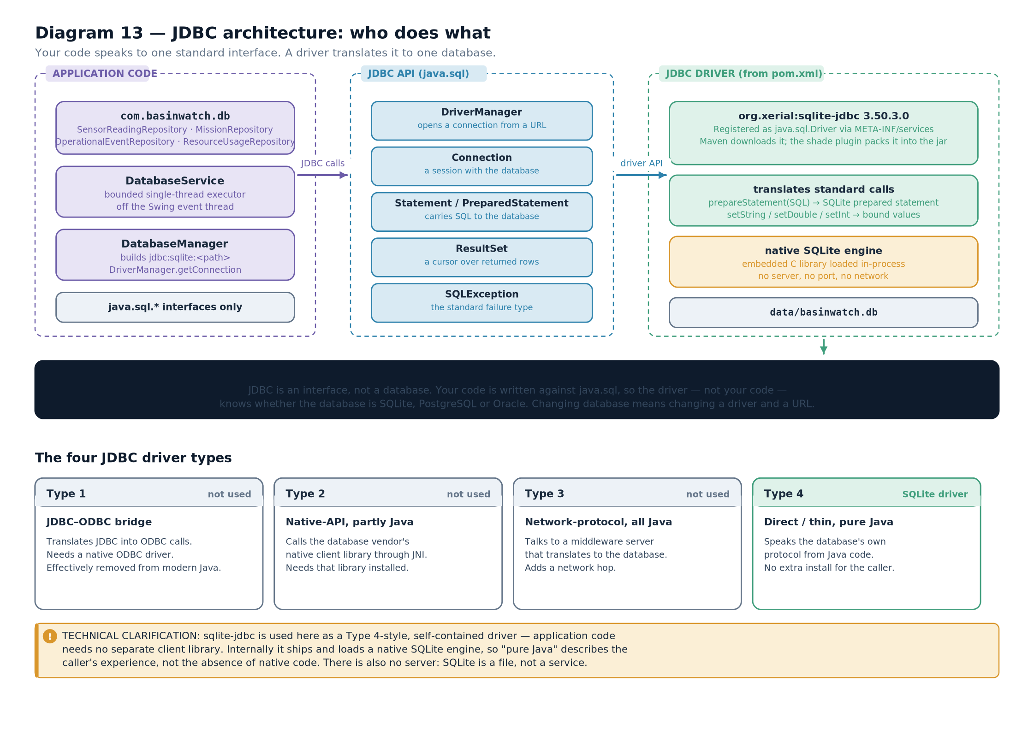

10.6 Why SQLite specifically
SQLite is a complete relational database implemented as a library, not as a server. The database is a single file on disk, and the "connection" is a handle to that file. For an offline desktop application that is an ideal fit.
Property | Server database (PostgreSQL, MySQL) | SQLite
Process | A separate server process | Linked into your program as a library
Installation | Install, configure and start the server | Add one jar to the classpath
Connection | Network connection, host, port, credentials | A path to a file
Concurrent writers | Many, with row and table locking | One at a time — the whole file is locked for a write
Ideal for | Multi-user, network, high concurrency | Embedded, single-user, desktop, testing
Used by BasinWatch? | No | Yes — the only database the project uses
Table 10.4 — Server databases and SQLite, and why the latter suits a desktop application.EXAM TIPA common question asks why JDBC is described as a "thin" API. The answer is that it does very little itself: it defines interfaces and a driver-registration mechanism, and delegates almost all real work to the driver. That thinness is exactly why it works with any database and why frameworks can build on it.
- Data can live in memory, in files, or in a database; the decisive difference is selective access via indexes.
- BasinWatch keeps all three because different questions need different mechanisms, not because one is superior.
- A relational table declares columns, types and constraints, and a primary key gives every row an identity.
- An index is what makes a query fast; without one, the database examines every row.
- CRUD maps to INSERT, SELECT, UPDATE and DELETE, and the project deliberately never deletes.
- JDBC is a set of interfaces plus a driver mechanism; the application depends on the interfaces, so the database can be swapped.
- SQLite is a library, not a server, which is why it suits an offline desktop application.
- Table — a named collection of rows sharing the same columns.
- Primary key — the column or columns uniquely identifying each row.
- Index — an auxiliary structure that speeds up lookups on particular columns.
- Constraint — a rule the database enforces, such as NOT NULL.
- JDBC — the standard Java API for relational database access.

JDBC Architecture and Drivers
The interfaces, the driver's job, the four driver types, and how a connection is actually established.

11.1 The two halves of JDBC
JDBC is deliberately split in two. One half is fixed and shipped with Java: the interfaces in java.sql. The other half is supplied by whoever makes the database: the driver, which implements those interfaces for one specific product.
Interface | Defined in | Implemented by | The application uses it to
Driver | java.sql | The database vendor | Accept a URL and decide whether it can handle it
Connection | java.sql | The vendor's driver | Hold a session with the database
Statement | java.sql | The vendor's driver | Send fixed SQL
PreparedStatement | java.sql | The vendor's driver | Send parameterized SQL, safely
CallableStatement | java.sql | The vendor's driver | Invoke a stored procedure
ResultSet | java.sql | The vendor's driver | Iterate over the rows a query returned
SQLException | java.sql | The vendor's driver | Report a database error
DriverManager | java.sql | The JDK | Choose a driver for a URL and hand back a connection
Table 11.1 — The JDBC interfaces and who implements them.CORE CONCEPTThis is the single most important structural fact about JDBC, and it is worth stating plainly: every method you call on a Connection is code you have never read. The interface is in the JDK; the implementation is in the driver jar. That is why changing the driver can change behaviour, and why exact exception messages differ between databases.

11.2 What the driver actually does
A driver has four responsibilities.
- Recognise its own URLs. Given jdbc:sqlite:data/basinwatch.db, the SQLite driver accepts it and other drivers decline.
- Open a connection. For SQLite that means opening the file; for PostgreSQL it means a TCP connection, a handshake and authentication.
- Translate calls into the database's protocol. A PreparedStatement.setDouble(3, 12.4) becomes whatever bytes that database expects.
- Translate results back. A result row becomes a ResultSet positioned on that row, with typed getters.
VISUAL WALKTHROUGHFollow Diagram 13 with those four responsibilities in mind. The application touches only the top band. DriverManager is the switchboard. The driver is the translator. Everything below it belongs to the database.

11.3 The four driver types
JDBC drivers are classified into four types by their architecture. The classification is a standard examination topic, and it is also genuinely useful for understanding why modern drivers are the way they are.
Type | Name | How it works | Pros | Cons
1 | JDBC–ODBC bridge | Java calls an ODBC driver through native code | Could reach any database with an ODBC driver | Deprecated and removed; required native code and a platform ODBC stack
2 | Native-API driver | Java calls the vendor's native client library | Slightly faster than type 1 | Requires the vendor's client library installed on every machine
3 | Network-protocol driver | Java talks to a middleware server that talks to the database | One driver for many databases; useful behind a firewall | An extra server to install, configure and maintain
4 | Thin driver | Pure Java, speaks the database's own protocol directly | No native code, no middleware, one jar, portable | One driver per database product
Table 11.2 — The four JDBC driver types.TECHNICAL CLARIFICATIONType 1 is no longer available. The jdbc-odbc bridge was deprecated and then removed from the JDK; it does not exist on a modern Java runtime. If a lecture note presents it as a current option, the correct modern position is: it was type 1, it is historical, and types 3 and 4 are what remain in practice. Types 3 and 4 have largely converged, because modern databases provide efficient binary wire protocols that a thin driver can speak directly.

11.4 How a connection is established
Three things are needed: a URL, the driver on the classpath, and a call to DriverManager.
// the URL names the driver family, then whatever that driver needs

jdbc:sqlite:data/basinwatch.db
jdbc:postgresql:
//localhost:5432/basinwatch

jdbc:mysql:
//localhost:3306/basinwatch?useSSL=false

// opening a connection

String
url = "jdbc:sqlite:data/basinwatch.db";
try
(
Connection
connection = DriverManager.getConnection(url)) {

// ... use the connection

}
// the connection is closed here
illustrative — the JDBC URL shape and the connection call The URL is the only piece of configuration that names the database product, which is why changing databases is usually a change to one string and one dependency.

11.5 Driver registration
For DriverManager to find a driver, the driver class must be registered. There are three ways this can happen.
Mechanism | How it works | When to use it
Service provider file | The driver jar contains META-INF/services/java.sql.Driver naming the class. The JDK loads it automatically. | The normal case. Modern drivers do this, so no code is needed.
Class.forName(...) | Explicitly loads the driver class, which registers itself in a static initialiser. | Legacy code, or a driver with no service file. Still seen in older textbooks.
DriverManager.registerDriver(...) | Registers a driver instance directly. | Unusual; used when constructing a driver manually.
Table 11.3 — Three ways a driver becomes available to DriverManager.COMMON MISTAKEWriting Class.forName("org.sqlite.JDBC") in modern code. It is harmless but unnecessary: the SQLite driver ships a service file, so the JDK discovers it automatically. More importantly, the habit hides a real question — is the driver actually on the classpath? If it is not, DriverManager throws SQLException: No suitable driver found for jdbc:sqlite:..., and no amount of forName will help. The fix is a Maven dependency, not a line of code. Chapter 17 covers exactly that.

11.6 How BasinWatch manages connections
The project wraps connection handling in one small class, so no repository has to know the URL.
public

final

class

DatabaseManager
{

private

static

final

String

DRIVER_CLASS
= "
org.sqlite.JDBC
";

private

final

String
url;

public

DatabaseManager
(
Path
databaseFile) {
this.url = "jdbc:sqlite:" + databaseFile.toAbsolutePath();
}

public

Connection
openConnection()
throws

SQLException
{

Connection
connection = DriverManager.getConnection(url);
connection.setAutoCommit(true);
// each statement commits on its own

return
connection;
}

public

boolean
isAvailable() {

try
(
Connection
connection = openConnection()) {

return
connection.isValid(2);
// two-second validity check

}
catch
(
SQLException
ex) {

return
false;
// absence is reported, not thrown

}
}

public

String
url() {

return
url;
}
}
from BasinWatch, db/DatabaseManager.java — one place that knows the URL. Three decisions in that class shape everything downstream.
The URL is built once, in the constructor. No other class contains the string "jdbc:sqlite:".
isAvailable returns a boolean rather than throwing. This is what makes the database optional. The application asks "is history available?" and handles both answers, instead of being forced to handle an exception merely to find out.
Autocommit is set explicitly. It is the default, but stating it documents the decision — and Chapter 13 shows the one place where it is deliberately turned off.
CONNECTION TO ANOTHER CONCEPTNotice that isAvailable catches SQLException and converts it into false. That is an exception-translation decision, and Chapter 14 explains why the rest of the application depends on it: an unavailable database must not prevent the application from running.
EXAM TIPTwo questions recur. "What does the driver do?" — answer with the four responsibilities: recognise the URL, open the connection, translate calls to the protocol, translate results back. "Which driver type does your project use?" — type 4, a pure-Java thin driver, which is why it needs only a jar on the classpath and no native library.
- JDBC is split between fixed interfaces in java.sql and a vendor-supplied driver that implements them.
- A driver recognises its own URLs, opens connections, translates calls to the database protocol, and translates results back.
- The four driver types are the ODBC bridge (removed), native-API, network-protocol middleware, and the pure-Java thin driver.
- A connection needs a URL of the form jdbc:product:details and a driver on the classpath.
- Modern drivers register themselves through a service file, so Class.forName is no longer required.
- “No suitable driver found” means the driver jar is missing, not that registration code is missing.
- BasinWatch builds the URL in one place and reports database availability as a boolean rather than an exception.
- JDBC URL — a string of the form jdbc:product:details identifying a database to connect to.
- Thin driver — a pure-Java type 4 driver that needs no native code.
- DriverManager — the JDK class that selects a registered driver for a URL and returns a connection.
- Service provider file — META-INF/services/java.sql.Driver, which lets a driver register itself automatically.
- Autocommit — the mode in which each statement is its own transaction.

SQL Execution Through JDBC
Connection, Statement, PreparedStatement, CallableStatement, ResultSet, CRUD operations, and the complete execution lifecycle.

12.1 The objects in one query
Executing a query involves a small cast of objects, each with one job. It is worth meeting them before looking at any code.
Object | Job | Created by | Closed by
Connection | A session with the database | DriverManager.getConnection(url) | try-with-resources
Statement | A container for fixed SQL | connection.createStatement() | try-with-resources
PreparedStatement | A pre-compiled statement with placeholders | connection.prepareStatement(sql) | try-with-resources
CallableStatement | A stored-procedure invocation | connection.prepareCall(sql) | try-with-resources
ResultSet | A cursor over the rows a query returned | Returned by executeQuery() | try-with-resources
SQLException | A database failure | Thrown by any of the above | Caught by the caller
Table 12.1 — The objects involved in executing SQL.Diagram 14 — The SQL execution lifecycle. From obtaining a connection through preparing a statement, binding parameters, executing, iterating the result set, and closing every resource in reverse order. The two execution paths — query and update — diverge after execution and converge again at cleanup.
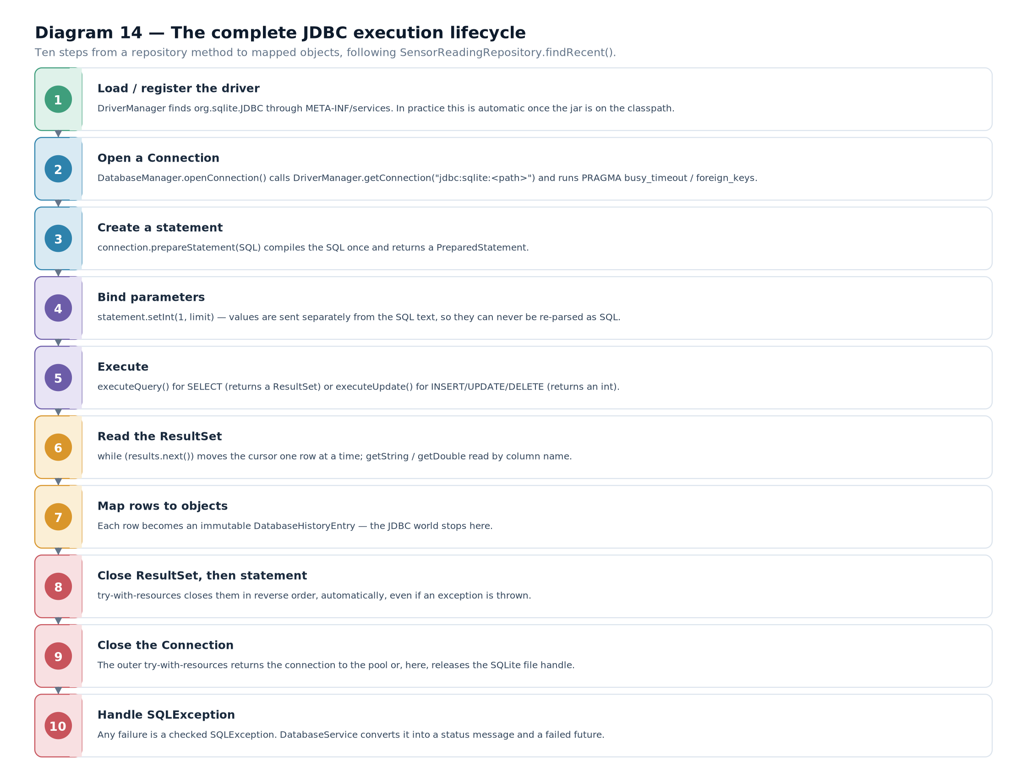

12.2 Three kinds of statement
All three statement types implement the same interface, but they exist for different reasons and one of them is the right default.
 | Statement | PreparedStatement | CallableStatement
SQL | Fixed, assembled in Java | Fixed template with ? placeholders | A stored procedure call
Parameters | None — values are concatenated into the string | Bound with typed setters | Bound as input, and registered as output
Pre-compiled by the database? | No — parsed on every execution | Yes — parsed once, executed many times | Yes
Safe against SQL injection? | No | Yes | Yes
Efficient in a loop? | No — reparsed each time | Yes | Yes
Typical use | A one-off DDL statement such as CREATE TABLE | Everything the application does repeatedly | Calling a procedure that returns values
Table 12.2 — The three statement types and when each is appropriate.Diagram 15 — Statement, PreparedStatement and CallableStatement. One interface family, three levels of capability. Statement sends fixed SQL with no parameters; PreparedStatement adds numbered placeholders and pre-parsing; CallableStatement adds stored-procedure invocation with registered output parameters.
CORE CONCEPTUse PreparedStatement by default. It is safer, it is faster when reused, and it makes the SQL readable by separating the statement from the values. Statement is for statements that genuinely have no parameters — schema creation, for example — and CallableStatement is for stored procedures.
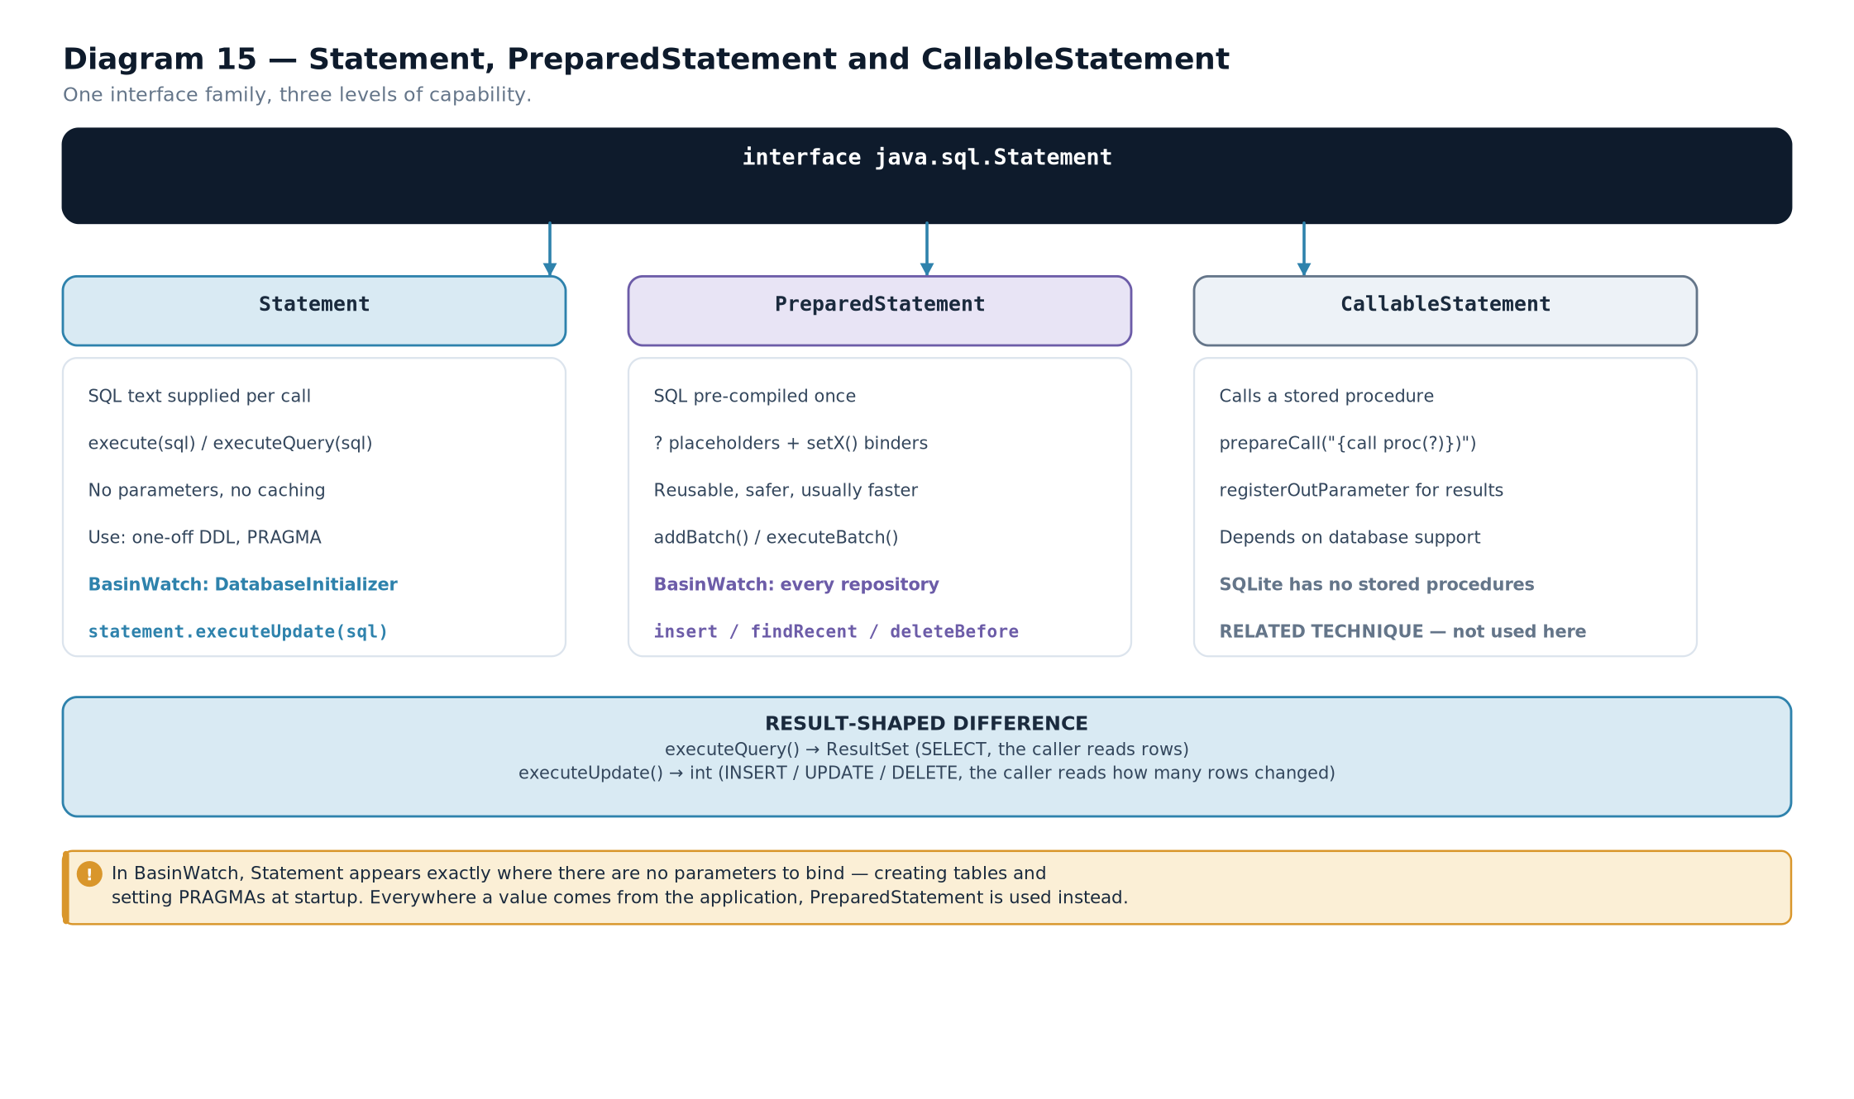

12.3 Why PreparedStatement matters: SQL injection
This is the most important practical lesson in the chapter, and the demonstration is short.
// ---- DANGEROUS: values concatenated into the SQL text ----

String
zone = userInput;
// e.g. MIL' OR '1'='1

String
sql = "
SELECT
*
FROM
sensor_readings
WHERE
zone_id = &
#x27;" + zone + "'";

Statement
statement = connection.createStatement();
ResultSet
rs = statement.executeQuery(sql);
// the database actually receives:

// SELECT * FROM sensor_readings WHERE zone_id = 'MIL' OR '1'='1'

// the OR clause is now part of the statement, so EVERY row matches.

// ---- SAFE: the value is bound, never parsed as SQL ----

String
safeSql = "
SELECT
*
FROM
sensor_readings
WHERE
zone_id = ?";
try
(
PreparedStatement
ps = connection.prepareStatement(safeSql)) {
ps.setString(1, userInput);
// bound as a VALUE

try
(
ResultSet
rs2 = ps.executeQuery()) {

// the database receives a plan for the fixed text,

// plus one parameter whose value is MIL' OR '1'='1 -- a literal string

}
}
illustrative — the injection vulnerability and its fix The difference is not about escaping characters. With a PreparedStatement, the SQL text is sent to the database and parsed before the parameter values are supplied. The parser has already decided what is a statement and what is a value, so no value can become part of the statement's structure. Quoting and escaping become irrelevant because the value never enters the parser's input.
IMPORTANT DISTINCTIONConcatenating values into SQL is unsafe even when you escape them yourself. Manual escaping has to handle quote characters, backslashes, multi-byte encodings and database-specific syntax, and getting it subtly wrong is easy. Binding parameters removes the problem entirely rather than mitigating it. BasinWatch uses PreparedStatement at every site, including the statements with no parameters.

12.4 Binding parameters
Placeholders are numbered from one, and each needs a typed setter matching the column's type.
Diagram 16 — PreparedStatement parameter binding. An SQL template with numbered placeholders, the typed setter call for each, and the value the database receives. The order of the placeholders is what the index refers to — not the order of the setter calls.
String
sql = """

INSERT

INTO
sensor_readings (reading_tick, station_id, zone_id, rainfall_mm,
rise_cm, water_level_m, risk_level,
risk_escalated, recorded_at)

VALUES
(?, ?, ?, ?, ?, ?, ?, ?, ?)
""";
try
(
PreparedStatement
statement = connection.prepareStatement(sql)) {
statement.setLong(1, reading.tick());
// 1 -> reading_tick

statement.setString(2, reading.stationId());
// 2 -> station_id

statement.setString(3, reading.zoneId());
// 3 -> zone_id

statement.setDouble(4, reading.rainfallMillimeters());
// 4 -> rainfall_mm

statement.setDouble(5, reading.observedRiseCentimeters());
// 5 -> rise_cm

statement.setDouble(6, zone.waterLevelMeters());
// 6 -> water_level_m

statement.setString(7, zone.risk().name());
// 7 -> risk_level

statement.setInt(8, riskEscalated ? 1 : 0);
// 8 -> risk_escalated

statement.setString(9, timestamp.toString());
// 9 -> recorded_at

statement.executeUpdate();
}
from BasinWatch, db/SensorReadingRepository.java — nine placeholders, nine typed setters.VISUAL WALKTHROUGHCount the placeholders in that statement, then count the setter calls. There are nine of each, and the indices run 1 to 9 with no gaps. That is the check to perform whenever you read JDBC code: a missing setter, or an index that skips a number, means a parameter silently retains whatever value it had.
SQL type | Setter | Java type
INTEGER | setInt / setLong | int / long
REAL | setDouble / setFloat | double / float
TEXT | setString | String
BOOLEAN | setBoolean | boolean
NULL | setNull(index, java.sql.Types.X) | any reference type
A date or timestamp | setTimestamp / setDate | java.sql.Timestamp / java.sql.Date
Table 12.3 — The common setters and the SQL types they correspond to.COMMON MISTAKETwo binding mistakes appear constantly. First, off-by-one indices: placeholders are 1-based, so the first setter is setX(1, ...), not zero. Second, treating a boolean as a boolean in SQLite: the column here is declared INTEGER, so the code converts with riskEscalated ? 1 : 0 rather than assuming a native boolean type exists.
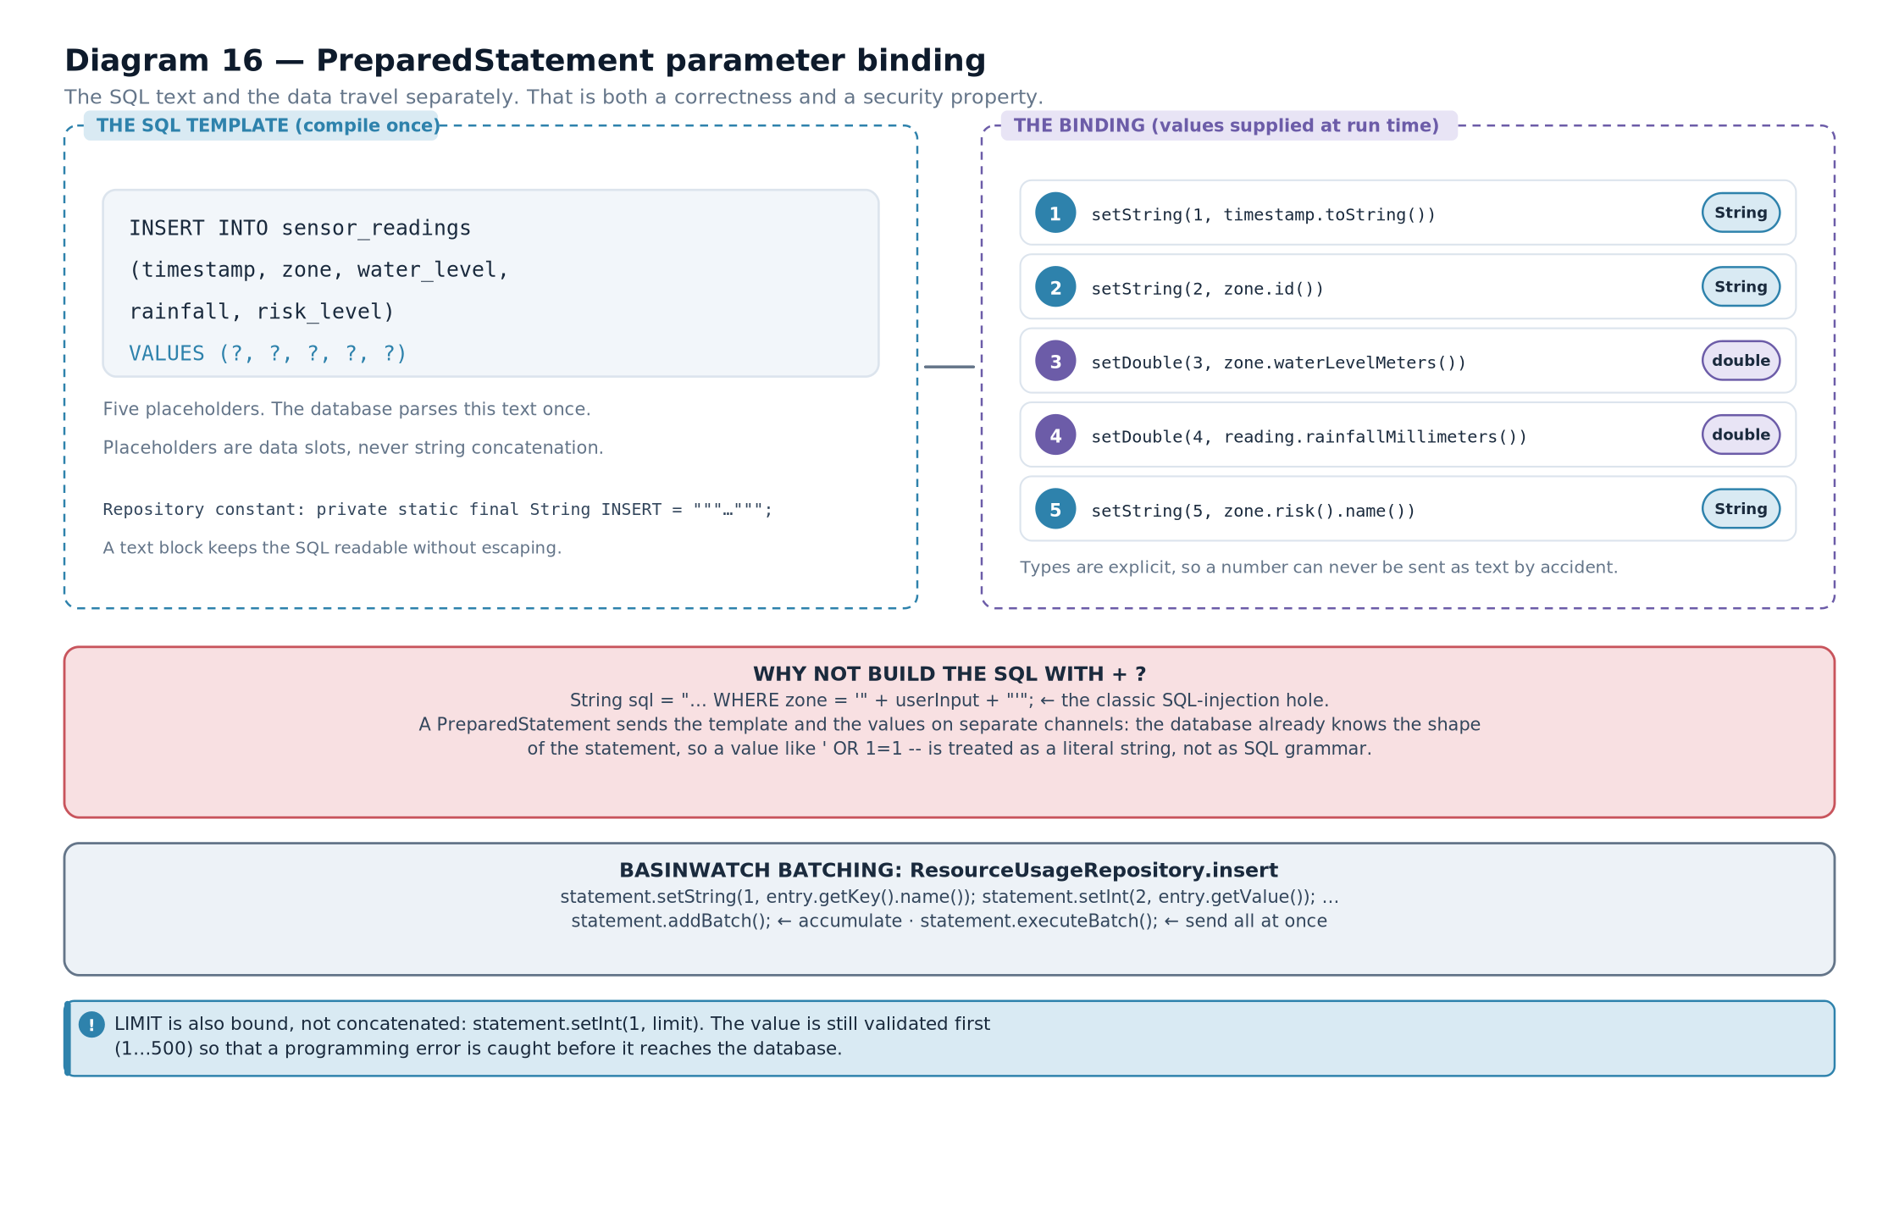

12.5 Executing: query versus update
After binding, the two execution paths diverge and the choice is determined by whether the statement returns rows.
Method | Use for | Returns | Typical statement
executeQuery() | Statements that produce rows | A ResultSet | SELECT
executeUpdate() | Statements that change rows | An int: rows affected | INSERT, UPDATE, DELETE
execute() | When you do not know which will happen | A boolean: true if a result set is available | Dynamic or DDL statements
executeBatch() | Several statements at once | An int[] of counts | Bulk inserts
Table 12.4 — Execution methods and what each returns.CORE CONCEPTThe return value of executeUpdate() is worth using rather than discarding. It is the number of rows the statement actually affected, which tells you whether your WHERE clause matched anything. An UPDATE returning zero almost always means the condition was wrong, and that is worth knowing.

12.6 Reading a ResultSet
A result set is a cursor. It starts before the first row, so the loop must advance before reading.
public

List
<
DatabaseHistoryEntry
> loadHistory(
Connection
connection,
int

limit
)

throws

SQLException
{

String
sql = """

SELECT
occurred_at, event_type, zone_id, detail

FROM
operational_events

ORDER

BY
occurred_at
DESC

LIMIT
?
""";

ArrayList
<
DatabaseHistoryEntry
> entries =
new

ArrayList
<>();

try
(
PreparedStatement
statement = connection.prepareStatement(sql)) {
statement.setInt(1,
limit
);

try
(
ResultSet
rows = statement.executeQuery()) {

while
(rows.next()) {
// advance, then read

entries.add(
new

DatabaseHistoryEntry
(
DatabaseHistoryType.valueOf(rows.getString("event_type")),
rows.getString("zone_id"),
rows.getString("detail"),
Instant.parse(rows.getString("occurred_at"))));
}
}
}

return
List.copyOf(entries);
}
from BasinWatch, db/OperationalEventRepository.java — the canonical read loop. Four habits in that method are the whole of result-set handling.
The loop is while (rows.next()). next() moves the cursor and returns false when there are no more rows. A do-while would be wrong, because the cursor starts before the first row.
Columns are read by name. rows.getString("event_type") is clearer than rows.getString(2) and survives a change to the select list. The trade-off is a small lookup cost, which is irrelevant here.
Each row is converted into a domain object inside the loop. The method returns List<DatabaseHistoryEntry>, not a ResultSet. That is essential: a result set is tied to its statement and its connection, and once they close it is unusable. Converting immediately means the caller receives ordinary values.
List.copyOf makes the result immutable. The same discipline as every other boundary in the project.
COMMON MISTAKEReturning a ResultSet from a method that also closes the connection. The caller receives an object that looks usable and fails with SQLException: ResultSet closed on the first next(). The rule is that a result set never outlives the block that created it — map rows into your own objects before leaving.

12.7 SQLException and what it tells you
Every JDBC method that touches the database can throw SQLException. It is checked, and it carries more information than a plain message.
Method | Meaning
getMessage() | The driver's description, often including the database's own error text
getSQLState() | A five-character standard code, such as 23505 for a unique-constraint violation
getErrorCode() | A vendor-specific numeric code
getNextException() | A chained second failure, when one statement produces several errors
getCause() | The underlying exception, such as an IOException from the database file

12.8 The complete lifecycle, in order
Everything in this chapter reduces to one sequence. Learn it as a sequence, because examiners and reviewers both ask for it.
- Obtain a connection. DriverManager.getConnection(url), inside try-with-resources.
- Prepare the statement. connection.prepareStatement(sql) sends the SQL text to the database, which parses and plans it once.
- Bind every parameter. One typed setter per placeholder, indices 1 to n, no gaps.
- Execute. executeQuery() for a read, executeUpdate() for a write.
- Consume the result. For a query, loop with while (rows.next()) and map each row into a domain object. For an update, check the returned row count.
- Close the result set. Handled by its own try-with-resources block.
- Close the statement. Handled by the statement's try-with-resources block.
- Close the connection. Handled by the outermost try-with-resources block — and this is where a transaction would be committed or rolled back.
CONNECTION TO ANOTHER CONCEPTStep eight is where Chapter 13 begins. Everything above happens inside a transaction, whether you think about it or not: in autocommit mode each statement is its own transaction, and turning autocommit off lets several statements share one.
EXAM TIPIf asked to "write the code to insert a row safely", the marks are distributed roughly as follows: using PreparedStatement rather than concatenation; binding every parameter with the correct type and 1-based index; using executeUpdate; and closing all three resources. Mentioning try-with-resources explicitly is usually worth a mark on its own.
- A query involves a Connection, a Statement of some kind, and possibly a ResultSet, all of which must be closed.
- PreparedStatement is the default choice: safer, pre-parsed, and reusable.
- Concatenating values into SQL permits injection; binding parameters makes the value unable to become part of the statement.
- Placeholders are numbered from one and each needs a typed setter whose Java type matches the SQL type.
- executeQuery returns a ResultSet; executeUpdate returns a row count; execute returns a boolean.
- A ResultSet cursor starts before the first row, so the loop must call next() before reading.
- Map each row into your own object inside the loop; never return a ResultSet from a method that closes its connection.
- SQLException carries a message, an SQLState, a vendor error code, and possibly chained exceptions.
- Placeholder — the ? character in a prepared statement, replaced by a bound value.
- SQL injection — an attack in which user input becomes part of a statement's structure.
- ResultSet cursor — the position marker that starts before the first row.
- Row count — the number of rows an update affected, returned by executeUpdate.
- SQLState — the standard five-character error code carried by a SQLException.

Database Transactions and Reliable Persistence
Transaction boundaries, commit and rollback, and why several related changes must succeed or fail together.

13.1 The problem: a half-finished operation
Consider what a dispatch actually involves. A mission row must be created. Several resource counts must be decremented. An event must be recorded for the audit trail. These are three separate statements against three separate tables.
If the first succeeds and the second fails, the database now claims a mission is running with resources that were never deducted. That is not a small inconsistency: the resource board will be wrong for the rest of the session, and the history will not explain why.
DEFINITIONTransaction — a group of database operations treated as a single unit: either every operation in the group takes effect, or none of them does.
Diagram 17 — Transaction commit and rollback. Three statements inside one transaction. On success the connection commits and all three changes become visible together. On failure the connection rolls back and the database returns to its state before the transaction began — including the statements that had already succeeded.
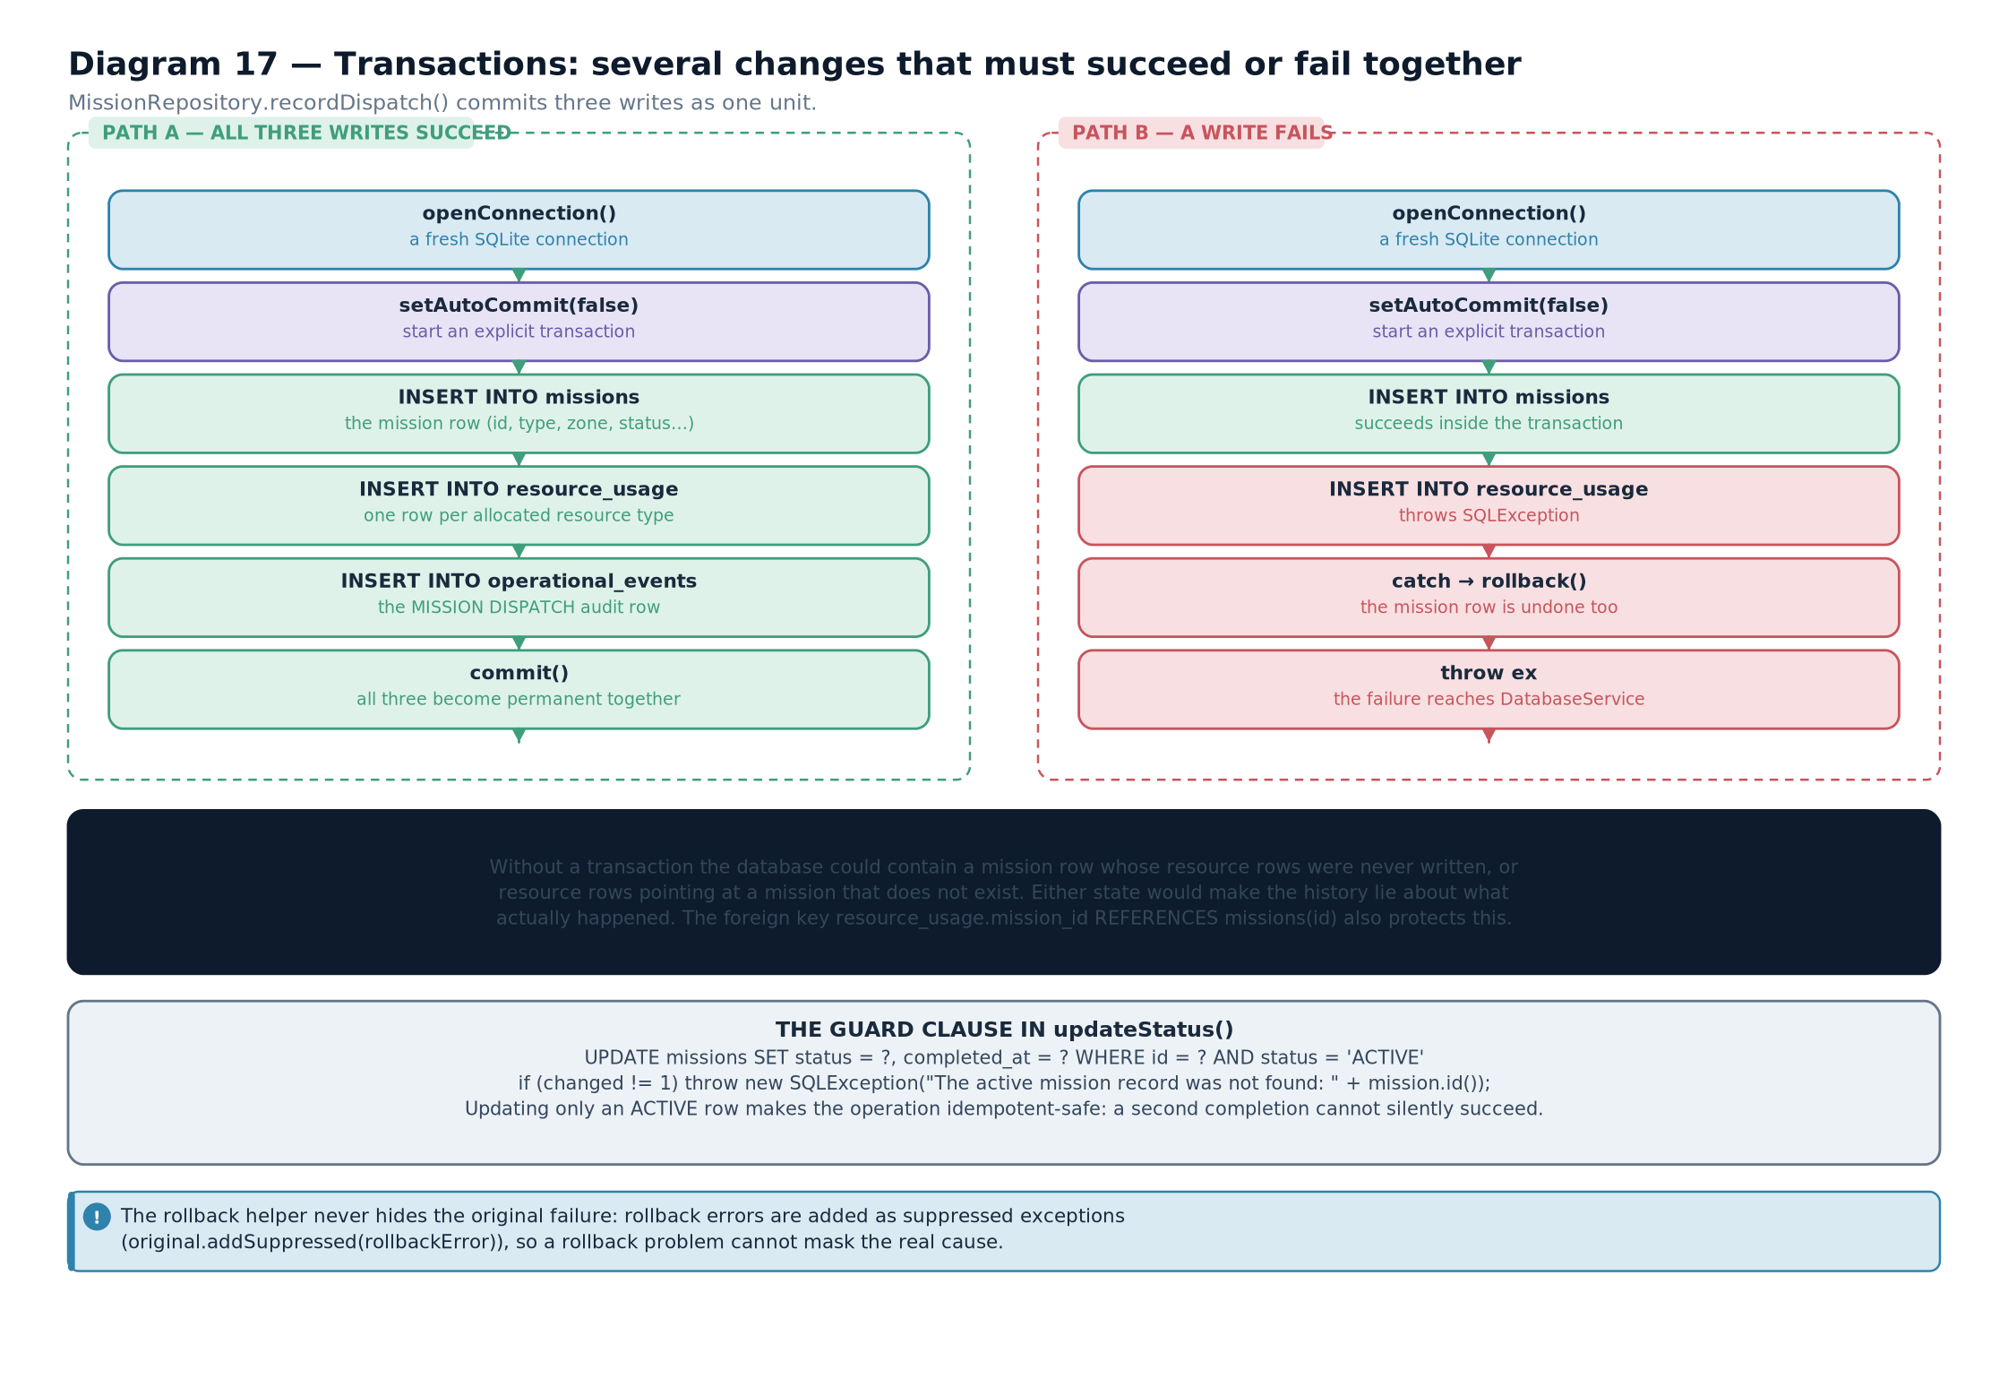

13.2 The four guarantees
Transactions are described by four properties, known by the acronym ACID. Each is worth understanding in concrete terms rather than as a slogan.
Property | Means | In this project
Atomicity | All operations take effect, or none do | A dispatch writes a mission, deducts resources and logs an event — or writes nothing
Consistency | The database moves from one valid state to another | NOT NULL and type constraints hold at commit time
Isolation | Concurrent transactions do not see each other's partial work | The database work runs on a single thread, so there is one writer
Durability | Once committed, the change survives a crash | SQLite flushes the committed transaction to the database file

13.3 Controlling a transaction in JDBC
By default a connection is in autocommit mode: each statement is committed immediately as its own transaction. Turning autocommit off gives you control.
connection.setAutoCommit(false);
// begin: nothing commits until you say so

try
{

// ... statement 1

// ... statement 2

// ... statement 3

connection.commit();
// all three become visible together

}
catch
(
SQLException
ex) {
connection.rollback();
// undo everything since setAutoCommit(false)

throw
ex;
}
finally
{
connection.setAutoCommit(true);
// restore the default for the next caller

}
illustrative — the standard transaction skeletonCORE CONCEPTNotice the shape: turn autocommit off, do the work in a try, commit at the end of the try, roll back in the catch, and restore autocommit in a finally. The finally matters when the connection comes from a pool and will be reused by someone who does not expect an open transaction.
COMMON MISTAKEForgetting to roll back, or forgetting to restore autocommit. Both leave the connection in an unexpected state. A missing rollback means a later commit could persist work that was supposed to be discarded; a missing restore means the next user of a pooled connection accidentally joins your transaction. BasinWatch avoids the first problem by rolling back in the catch block and the second by closing the connection afterwards rather than pooling it.

13.4 How BasinWatch records a dispatch
The dispatch path is the project's one genuine multi-statement operation, and it is where the transaction is used.
public

void
recordDispatch(
ResponseMission
mission,
ZoneSnapshot
zone,

Map
<
ResourceType
,
Integer
> allocation,
Instant
timestamp) {
enqueue(() -> {

try
(
Connection
connection = database.openConnection()) {
connection.setAutoCommit(false);
// begin the transaction

try
{
missions.insert(connection, mission, timestamp);
// 1. the mission row

for
(
Map.Entry
<
ResourceType
,
Integer
> entry : allocation.entrySet()) {
resourceUsage.insert(connection, mission.id(), entry.getKey(),
entry.getValue(), timestamp);
// 2. one row per resource

}
operationalEvents.insert(connection, timestamp, "
DISPATCH
", zone.id(),
mission.type().label() + " allocated to " + zone.name());
// 3. the audit event

connection.commit();
// all three take effect together

}
catch
(
SQLException
ex) {
connection.rollback();
// none of them take effect

throw
ex;
}
}
catch
(
SQLException
ex) {
statusReporter.accept("
Could
not
record
dispatch: " + ex.getMessage());
}
});
}
from BasinWatch, db/DatabaseService.java — one transaction, three kinds of write.VISUAL WALKTHROUGHFollow the three numbered writes in that method. If the third throws, the rollback undoes the first two — so the database never contains a mission with no audit event, or resource deductions with no mission. That is what atomicity buys, and it is why the transaction boundary is drawn around all three rather than around each one.

13.5 Why the writes share one connection
This is the detail that most often goes wrong in student implementations, and it explains the package-private overloads from Chapter 2.
// Each repository can open its own connection — fine for a single write

public

void
insert(
ResponseMission
mission,
Instant
timestamp)
throws

SQLException
{

try
(
Connection
connection = database.openConnection()) {
insert(connection, mission, timestamp);
}
}
// ...but a transaction must span ONE connection, so a shared overload is needed

void
insert(
Connection
connection,
ResponseMission
mission,
Instant
timestamp)

throws

SQLException
{

try
(
PreparedStatement
statement = connection.prepareStatement(
INSERT_SQL
)) {
statement.setString(1, mission.id());

// ... bind the rest, then executeUpdate()

}
}
from BasinWatch, db/MissionRepository.java — the two overloads and why both exist.IMPORTANT DISTINCTIONA transaction belongs to a connection, not to a statement. Calling commit() on one connection has no effect on work done on another. So if three repositories each opened their own connection, three separate transactions would exist and atomicity would be lost entirely — the code would look correct and silently not be. Passing one connection through every write is the mechanism that makes the transaction real.

13.6 Isolation, and why it is simple here
Isolation is the property that governs what one transaction can see of another's uncommitted work. Real systems offer several isolation levels, trading consistency against concurrency, and reasoning about them is one of the harder parts of database engineering.
BasinWatch sidesteps the whole problem in one design decision: all database work runs on a single dedicated thread. There is exactly one writer, so there is never a second transaction to interfere.
private

void
enqueue(
DatabaseOperation
operation) {

if
(!available) {

return
;
// database disabled: silently do nothing

}

try
{
executor.submit(() -> {

try
{
operation.run();
}
catch
(
SQLException
ex) {
statusReporter.accept("
Database
operation failed: " + ex.getMessage());
}
catch
(
RuntimeException
ex) {
statusReporter.accept("
Unexpected
database error: " + ex);
}
});
}
catch
(
RejectedExecutionException
ex) {
statusReporter.accept("
Database
queue is full; operation dropped.");
}
}
from BasinWatch, db/DatabaseService.java — one single-threaded executor is the whole concurrency policy. That method is worth reading closely, because it is where several chapters meet.
The executor is single-threaded. Every database operation runs one after another on "basin-database". No two transactions are ever concurrent, so no isolation anomaly is possible and no locking policy is needed.
An unavailable database is a no-op, not an error. The early return means every call site can invoke recordSensor or recordDispatch without checking availability first. The optional subsystem is optional at the call site too.
Failures are reported, not thrown. A database failure cannot propagate into the event processing path, because the work happens on a different thread. It is reported through the status listener and the application continues.
A full queue drops the operation rather than blocking. RejectedExecutionException is caught and reported. For an optional history feature, dropping a record is better than stalling the sensor pipeline.
CONNECTION TO ANOTHER CONCEPTCompare this with the resource allocator in Chapter 3. That used a synchronized block to make an in-memory reservation atomic. Here the database provides atomicity through a transaction. Two different mechanisms, one shared goal: never let a partially complete change be observable.
EXAM TIPA likely question is "give an example from your project where a transaction is needed, and explain what would go wrong without it." The dispatch path is the ideal answer: without a transaction, a failure after the mission insert would leave a running mission with resources that were never deducted, so the resource board would be permanently wrong and the audit trail would not explain it. Naming the three writes and the failure point is what makes the answer convincing.
- A transaction groups several operations so that all of them take effect or none do.
- The ACID properties are atomicity, consistency, isolation and durability.
- JDBC connections are in autocommit mode by default; setAutoCommit(false) begins a transaction you control.
- The standard skeleton is: disable autocommit, work in a try, commit, roll back in the catch, restore autocommit in a finally.
- A transaction belongs to a connection, so every statement in it must use that same connection.
- BasinWatch's dispatch records a mission, its resource usage and an audit event in one transaction.
- All database work runs on one single-threaded executor, so isolation anomalies cannot arise and no locking policy is needed.
- A database failure is reported to the status listener rather than propagated into event processing.
- ACID — atomicity, consistency, isolation, durability.
- Commit — making a transaction's changes permanent and visible.
- Rollback — discarding a transaction's changes as though they never happened.
- Autocommit — the default mode in which each statement is its own transaction.
- Isolation level — the degree to which concurrent transactions are prevented from seeing each other's partial work.

How BasinWatch Uses JDBC and SQLite
The database architecture, the schema, the repositories, and a complete trace of a history record from an accepted observation to a table cell.

14.1 The four classes that make up the database layer
The whole database subsystem is four kinds of class, each with one responsibility.
Class | Responsibility | Knows about | Does not know about
DatabaseManager | Hold the URL and hand out connections | The driver, the URL | Tables, SQL, the domain
DatabaseInitializer | Create the tables and indexes if absent | The schema | Anything else
DatabaseService | Own the worker thread, wrap operations in transactions, report failures | Repositories, the status listener | Swing, files, SQL text
*Repository (four) | Turn domain values into SQL and rows back into domain values | Its own table and its SQL | Threads, transactions, other repositories
Table 14.1 — The four responsibilities of the database layer.Diagram 18 — Database data flow. An accepted observation travels from the engine, through the database service's queue, onto the worker thread, into the repository, through a prepared statement into SQLite. A history read travels the reverse path as a future whose callback returns to the event-dispatch thread.
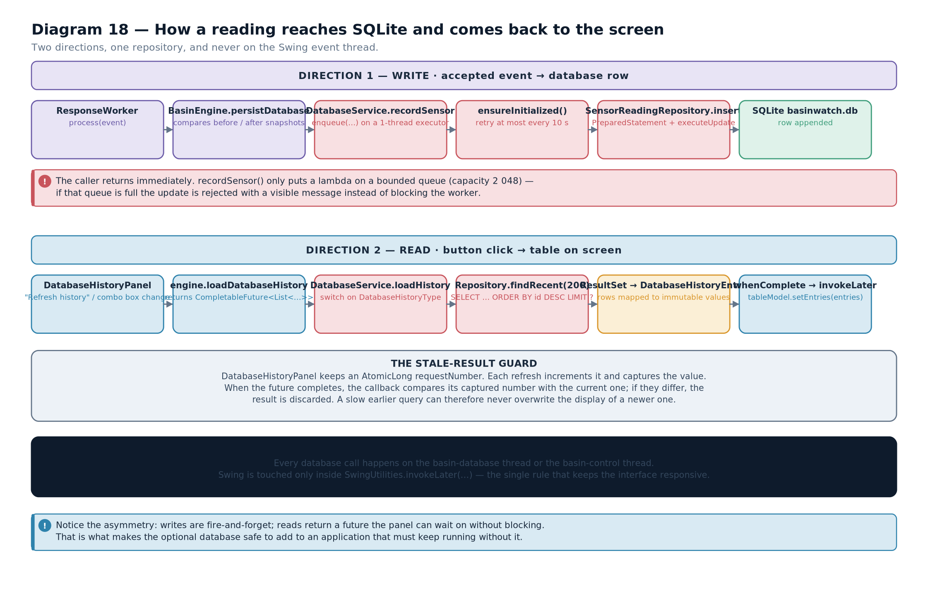

14.2 The schema
Four tables hold the history. Each corresponds to one kind of thing the application does.
CREATE

TABLE

IF

NOT

EXISTS
sensor_readings (
id
INTEGER

PRIMARY

KEY

AUTOINCREMENT
,
reading_tick
INTEGER

NOT

NULL
,
station_id
TEXT

NOT

NULL
,
zone_id
TEXT

NOT

NULL
,
rainfall_mm
REAL

NOT

NULL
,
rise_cm
REAL

NOT

NULL
,
water_level_m
REAL

NOT

NULL
,
risk_level
TEXT

NOT

NULL
,
risk_escalated
INTEGER

NOT

NULL
,
recorded_at
TEXT

NOT

NULL

);
CREATE

TABLE

IF

NOT

EXISTS
missions (
id
TEXT

PRIMARY

KEY
,
mission_type
TEXT

NOT

NULL
,
zone_id
TEXT

NOT

NULL
,
started_tick
INTEGER

NOT

NULL
,
completes_at_tick
INTEGER

NOT

NULL
,
status
TEXT

NOT

NULL
,
recorded_at
TEXT

NOT

NULL

);
CREATE

TABLE

IF

NOT

EXISTS
resource_usage (
id
INTEGER

PRIMARY

KEY

AUTOINCREMENT
,
mission_id
TEXT

NOT

NULL
,
resource_type
TEXT

NOT

NULL
,
quantity
INTEGER

NOT

NULL
,
recorded_at
TEXT

NOT

NULL

);
CREATE

TABLE

IF

NOT

EXISTS
operational_events (
id
INTEGER

PRIMARY

KEY

AUTOINCREMENT
,
occurred_at
TEXT

NOT

NULL
,
event_type
TEXT

NOT

NULL
,
zone_id
TEXT
,
detail
TEXT

NOT

NULL

);
from BasinWatch, db/DatabaseInitializer.java — the four tables.Diagram 19 — The database schema. Four tables and the relationships between them. Missions and resource usage are linked by mission id; sensor readings and operational events carry a zone id that names a zone in the model. Every table carries a timestamp so history can be ordered.
Three design decisions are visible in the schema.
Every table has a timestamp. History is only useful if it can be ordered and filtered by time, and recorded_at is stored as ISO-8601 text so that string ordering matches chronological ordering — the same choice the log file makes.
missions.id is the primary key and is text. The application already generates identifiers such as M-0007, so the database uses them rather than inventing a second identity. This is what lets resource_usage.mission_id refer to a mission.
operational_events.zone_id is the one nullable column. Not every event belongs to a zone — a global warning does not — and NOT NULL would force a meaningless value.
RELATED TECHNIQUE — NOT USED IN BASINWATCHThe schema declares the mission relationship with a plain column rather than a FOREIGN KEY ... REFERENCES constraint. That is a deliberate simplification: SQLite enforces foreign keys only when PRAGMA foreign_keys = ON is set for the connection, so a constraint written in the schema could be silently ignored. A production schema would enable the pragma and declare the constraint, so that deleting a mission could not orphan its resource rows. BasinWatch's single-writer design means the application itself maintains the relationship.
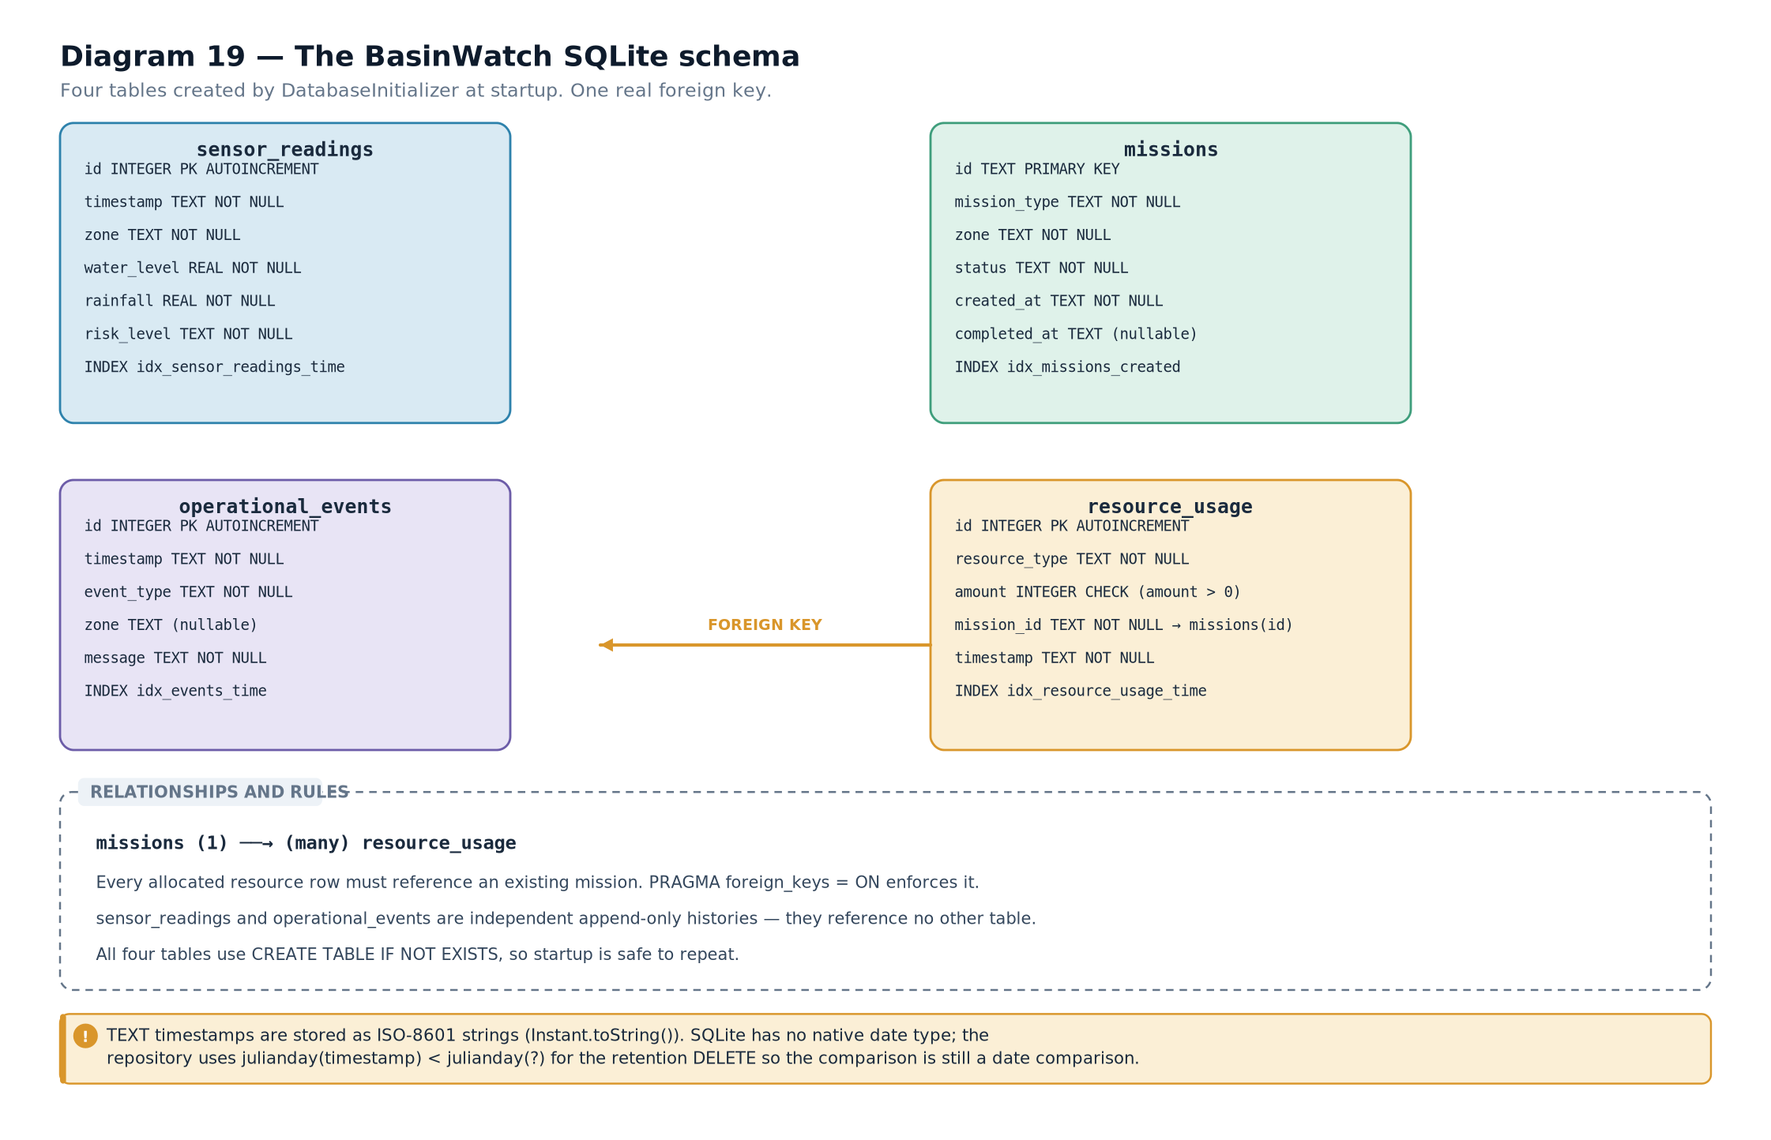

14.3 Initialisation, and why it is idempotent
The initialiser runs at start-up and must be safe to run every time.
public

void
initialise()
throws

SQLException
{

try
(
Connection
connection = database.openConnection();

Statement
statement = connection.createStatement()) {

for
(
String
ddl :
SCHEMA
) {
statement.execute(ddl);
// every statement uses IF NOT EXISTS

}
}
}
from BasinWatch, db/DatabaseInitializer.java — creating the schema is idempotent. The IF NOT EXISTS clause in every CREATE is what makes this safe. Without it, the second launch of the application would fail with "table already exists". With it, the first launch creates the tables and every later launch does nothing. This is the simplest possible migration strategy, and it is appropriate for a project with one schema version.
IMPORTANT DISTINCTIONStatement is used here, not PreparedStatement. That is correct and deliberate: these are fixed DDL statements with no parameters, so there is nothing to bind and nothing to inject. It is a useful example of the one case where Statement is the right choice — and it shows that "always use PreparedStatement" is really "always use it when there are values".

14.4 Tracing a reading from the sensor to the table
This is the central trace of the chapter. Follow one observation all the way to a stored row.
- The feed encodes it. SensorFeed builds a SensorReading and writes reading.encode() plus a line separator into the PipedWriter.
- The intake parses it. SensorIntake reads the line and calls SensorReading.parse(line), which validates the field count and ranges.
- The intake queues it. eventBuffer.put(event) hands it to the workers; the call blocks if the buffer is full.
- A worker processes it. One of the three ResponseWorker threads takes the event and calls model.process(event), which applies the reading to the zone and returns activity messages.
- The worker fans out. The engine appends to the journal, submits to the archive worker, and — if the reading was accepted and changed the zone — calls database.recordSensor(...).
- The service queues it. recordSensor calls enqueue, which submits a lambda to the single-threaded executor and returns immediately.
- The worker thread runs it. The lambda opens a connection, and SensorReadingRepository.insert prepares the nine-placeholder statement and binds every value.
- SQLite executes it. The driver sends the statement and the bound values; the database inserts the row and commits it, because autocommit is on.
- If it was a risk escalation, a second insert follows. An operational_events row is written with the type RISK ESCALATION.
- A failure is reported, not thrown. Any SQLException is caught by enqueue's lambda and passed to the status listener, which posts it to the interface.
BASINWATCH IN PRACTICEStep five is where the acceptance test lives, and it is worth seeing exactly. The engine writes to the database only when the model actually changed:
if
(event
instanceof

SensorReading
reading) {

ZoneSnapshot
zone = model.zone(reading.zoneId());

boolean
riskEscalated = zone.risk().rank() > previousRiskRank;
database.recordSensor(reading, zone,
Instant
.now(), riskEscalated);
}
Listing 14.1 — from BasinWatch, engine/BasinEngine.java This is why Chapter 2's stale-reading guard matters. A reading older than the last one applied is rejected by BasinZone.apply, the model does not change, and no row is written. Without that guard, a duplicate or out-of-order observation would appear in the history as though it had taken effect.

14.5 Reading history back into the interface
The read path is the reverse, and it uses a future so the interface never blocks.
public

CompletableFuture
<
List
<
DatabaseHistoryEntry
>> loadHistory(
int
limit) {

if
(!available) {

return
CompletableFuture.completedFuture(List.of());
// optional means empty, not error

}

CompletableFuture
<
List
<
DatabaseHistoryEntry
>> future =
new

CompletableFuture
<>();
enqueue(() -> future.complete(history.loadRecent(limit)));

return
future;
}
from BasinWatch, db/DatabaseService.java — a read returns a future; an unavailable database returns an empty list. Two details are worth naming. When the database is unavailable the future is completed immediately with an empty list, so the caller's callback runs normally and simply shows no history. And the actual query runs on the database thread, so the future completes on that thread — which is why the interface's callback must hop back to the event-dispatch thread.
public

List
<
DatabaseHistoryEntry
> loadRecent(
int

limit
)
throws

SQLException
{

String
sql = """

SELECT
occurred_at
AS
at, event_type
AS
type, zone_id
AS
zone, detail
AS
detail

FROM
operational_events

ORDER

BY
occurred_at
DESC

LIMIT
?
""";

// ... prepare, bind limit, iterate the result set, map each row

}

14.6 Why the database is optional
The final question about this layer is the most important one: why does the application work without it?
Diagram 20 — Database failure isolation. How a database failure is contained. The exception is caught on the database worker thread, converted into a status message, and posted to the interface. The sensor pipeline, the model, the files and the interface all continue unaffected.
Four mechanisms together produce that isolation, and each was a decision.
Availability is a boolean, checked once. DatabaseManager.isAvailable catches the exception and returns false, so the rest of the code tests a value rather than handling a failure.
Every write is a queued lambda. Because the work happens on another thread, an exception there cannot propagate into the caller's stack.
The queue wrapper catches everything. enqueue catches both SQLException and RuntimeException and routes them to the status listener.
A read on an unavailable database returns an empty list. The interface's code path is identical in both cases, so no branch is needed at the call site.
CORE CONCEPTThis is the design pattern worth taking away from Part III, and it generalises well beyond databases: an optional subsystem should be detectable, isolated, and silent-on-absence. Detectable through a boolean or a capability query. Isolated by running on its own thread so failures cannot propagate. Silent-on-absence by returning a sensible empty result rather than raising an error the caller must anticipate.
EXAM TIPIf asked "what happens if the database is unavailable?", the complete answer has four parts: the application still starts, because availability is checked rather than assumed; the history panel shows an empty list and a status message; all writes become no-ops; and the file layer is entirely unaffected, so the log, archive, snapshot and reports are still produced. Answering with only the first part is the usual mistake.
- The database layer has four responsibilities: connection management, schema creation, service coordination, and per-table SQL.
- Four tables hold readings, missions, resource usage and operational events; every one carries a timestamp.
- Schema creation is idempotent through CREATE TABLE IF NOT EXISTS, so it is safe on every launch.
- Fixed DDL statements use Statement; everything with values uses PreparedStatement.
- A reading reaches the database only when the model actually changed, which is why the stale-reading guard matters.
- Reads return CompletableFutures so the interface never blocks on a query.
- The database is optional because availability is a boolean, writes are queued and isolated on their own thread, and reads on an unavailable database return an empty list.
- An optional subsystem should be detectable, isolated and silent on absence.
- Repository — a class that owns the SQL for one table and maps rows to and from domain objects.
- Idempotent — safe to perform more than once with the same result.
- DDL — data definition language: statements such as CREATE TABLE.
- Single-threaded executor — an executor with one worker, serialising all submitted tasks.
- Capability query — asking whether an optional subsystem is available rather than assuming it is.
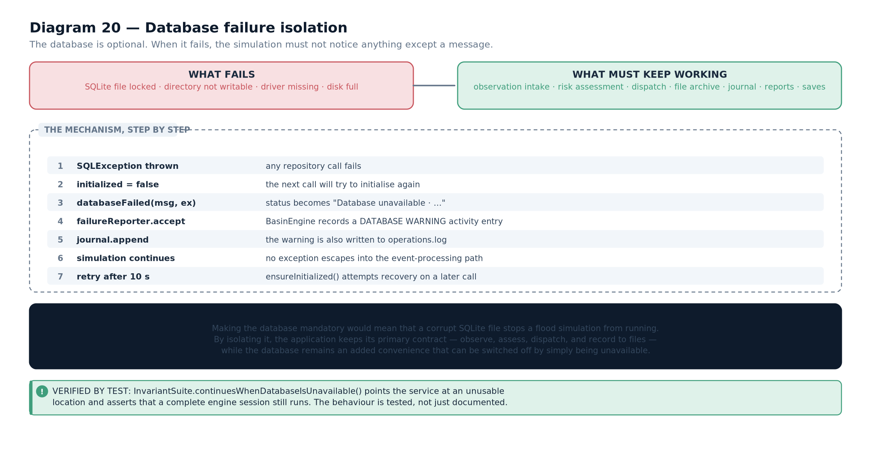

Swing and the User Interface

Swing Fundamentals and Event-Driven Programming
Containers, components, layouts, listeners and events — and the lecture-note login application explained line by line.

15.1 What makes a program event-driven?
A procedural program runs from top to bottom: it reads input, computes, prints output, and exits. A graphical program does none of that. It starts, builds a window, and then waits. Everything that happens afterwards happens because something triggered it — a click, a key press, a timer, a window being resized.
The structure that makes this work is a loop that never ends and a set of callbacks that the loop invokes. In Swing, that loop lives on a dedicated thread called the event-dispatch thread, and every listener you register runs on it.
DEFINITIONEvent-driven programming — a style in which the program declares handlers for events and then waits, letting the framework invoke the appropriate handler when each event occurs, rather than controlling the sequence of execution itself.
CORE CONCEPTThree consequences follow from the event-driven model, and they explain almost every Swing rule in this chapter.
- You do not control the order of execution. The user does.
- All event handling and all painting happen on one thread. So any long operation inside a handler freezes the entire interface.
- Components must be updated from that thread. Touching a Swing component from another thread is unsafe.

15.2 Containers and components
Swing's class hierarchy separates things that hold other things from things that display something.
Category | Base class | Examples | Role
Top-level container | JFrame, JDialog | JFrame | A real operating-system window with a title bar and close button
Intermediate container | JPanel, JScrollPane, JSplitPane | JPanel, JScrollPane | Groups and arranges other components; invisible itself
Simple component | JComponent | JButton, JLabel, JTable, JComboBox, JSlider | Displays something or accepts input
Table 15.1 — The three categories of Swing class.IMPORTANT DISTINCTIONA JFrame is a window; a JPanel is not. You cannot add a JPanel to another window's title bar, and a JPanel has no close button. Confusing the two is behind a large share of beginner layout problems: the top-level container is the window, and everything else is arranged inside its content pane.
Diagram 21 — The Swing component tree. A JFrame containing a toolbar, a central split pane, and a status bar. The split pane holds the map panel on the left and a tabbed panel on the right. Each node is a real component class.
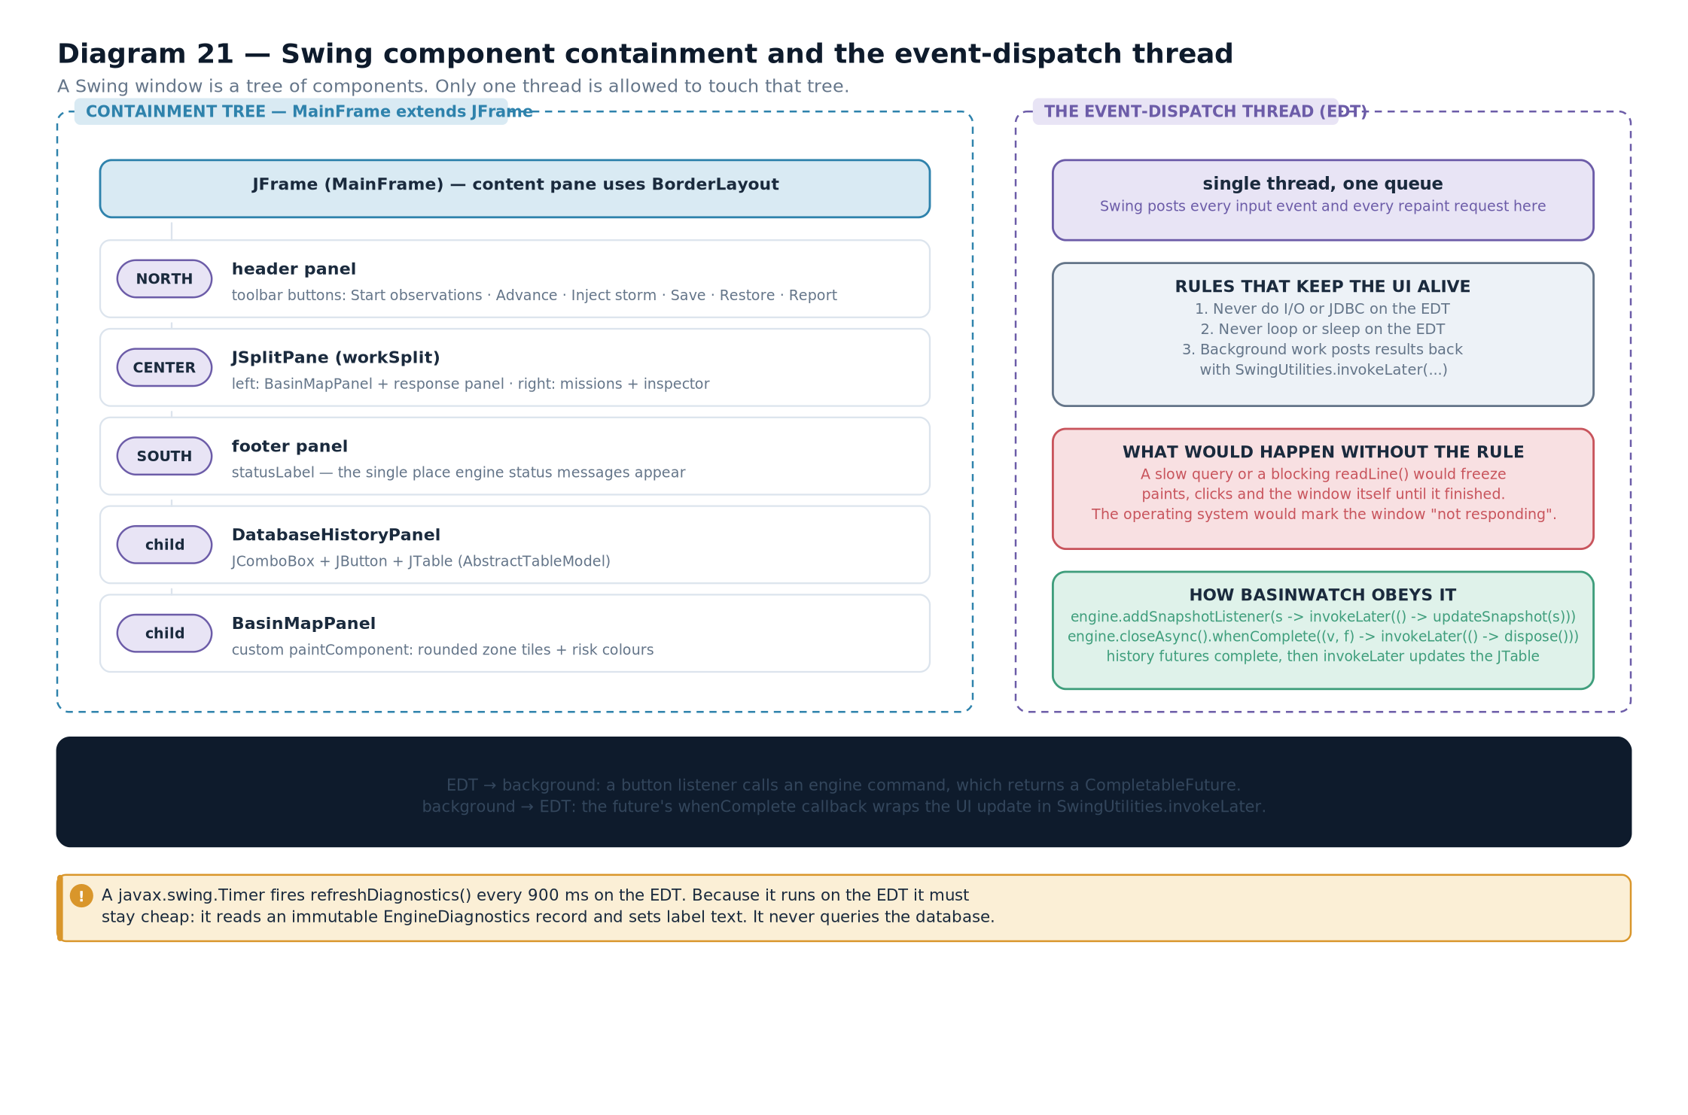

15.3 Layout managers
Swing does not use absolute coordinates. Instead, each container has a layout manager that decides where its children go. This is why a Swing window resizes sensibly rather than leaving controls stranded.
Layout | Arrangement | Best for | Characteristic
BorderLayout | Five regions: NORTH, SOUTH, EAST, WEST, CENTER | The overall frame — toolbar on top, status bar at the bottom, content in the centre | CENTER takes all remaining space; the other four take their preferred size
FlowLayout | Left to right, wrapping to the next line | A row of buttons or controls | The default for JPanel
GridLayout | A fixed grid of equal-sized cells | A keypad, or a uniform form | Every cell is the same size
BoxLayout | A single row or column | Stacking controls vertically | Use Box.createVerticalStrut for spacing
GridBagLayout | A grid with per-component constraints | Complex forms that must align precisely | Powerful and verbose; needs a GridBagConstraints per component
Table 15.2 — The common layout managers.BASINWATCH IN PRACTICEBasinWatch's main frame uses BorderLayout for the window and nested containers inside it, which is the standard composition:
setLayout(
new

BorderLayout
(8, 8));
add(buildToolbar(),
BorderLayout
.NORTH);
add(buildStatusBar(),
BorderLayout
.SOUTH);
JSplitPane
split =
new

JSplitPane
(
JSplitPane
.HORIZONTAL,
mapPanel, rightPanel);
split.setResizeWeight(0.45);
add(split,
BorderLayout
.CENTER);
Listing 15.1 — from BasinWatch, app/MainFrame.java Read the composition: the window is a border layout, the toolbar and status bar take the fixed north and south regions, and the split pane fills the centre. The split pane divides the centre horizontally, giving 45 per cent of extra space to the map when the window is resized.

15.4 Events and listeners
An event is an object describing something that happened. A listener is an object that wants to be told. Registering a listener connects the two.
Listener interface | Method | Triggered by | Event object carries
ActionListener | actionPerformed(ActionEvent) | A button click, a menu item, pressing Enter in a field | The source component and an action command string
MouseListener | mouseClicked, mousePressed, mouseReleased, mouseEntered, mouseExited | Mouse activity over a component | The x/y position and which button
MouseMotionListener | mouseMoved, mouseDragged | Movement, with no click | The x/y position
KeyListener | keyTyped, keyPressed, keyReleased | Keyboard input when the component has focus | The key code and character
WindowListener | windowClosing, windowClosed, … | Window lifecycle | The window and its new state
ChangeListener | stateChanged(ChangeEvent) | A slider or tab selection changing | The source component
ListSelectionListener | valueChanged(ListSelectionEvent) | A row or list item being selected | Whether the change is still adjusting
Table 15.3 — The listeners you meet most often.Diagram 22 — Swing event handling flow. The user's click is delivered to the event-dispatch thread, which dispatches it to every listener registered on the source component. The listener runs its handler on that same thread. Painting is also requested through the same thread, so the handler must return quickly.
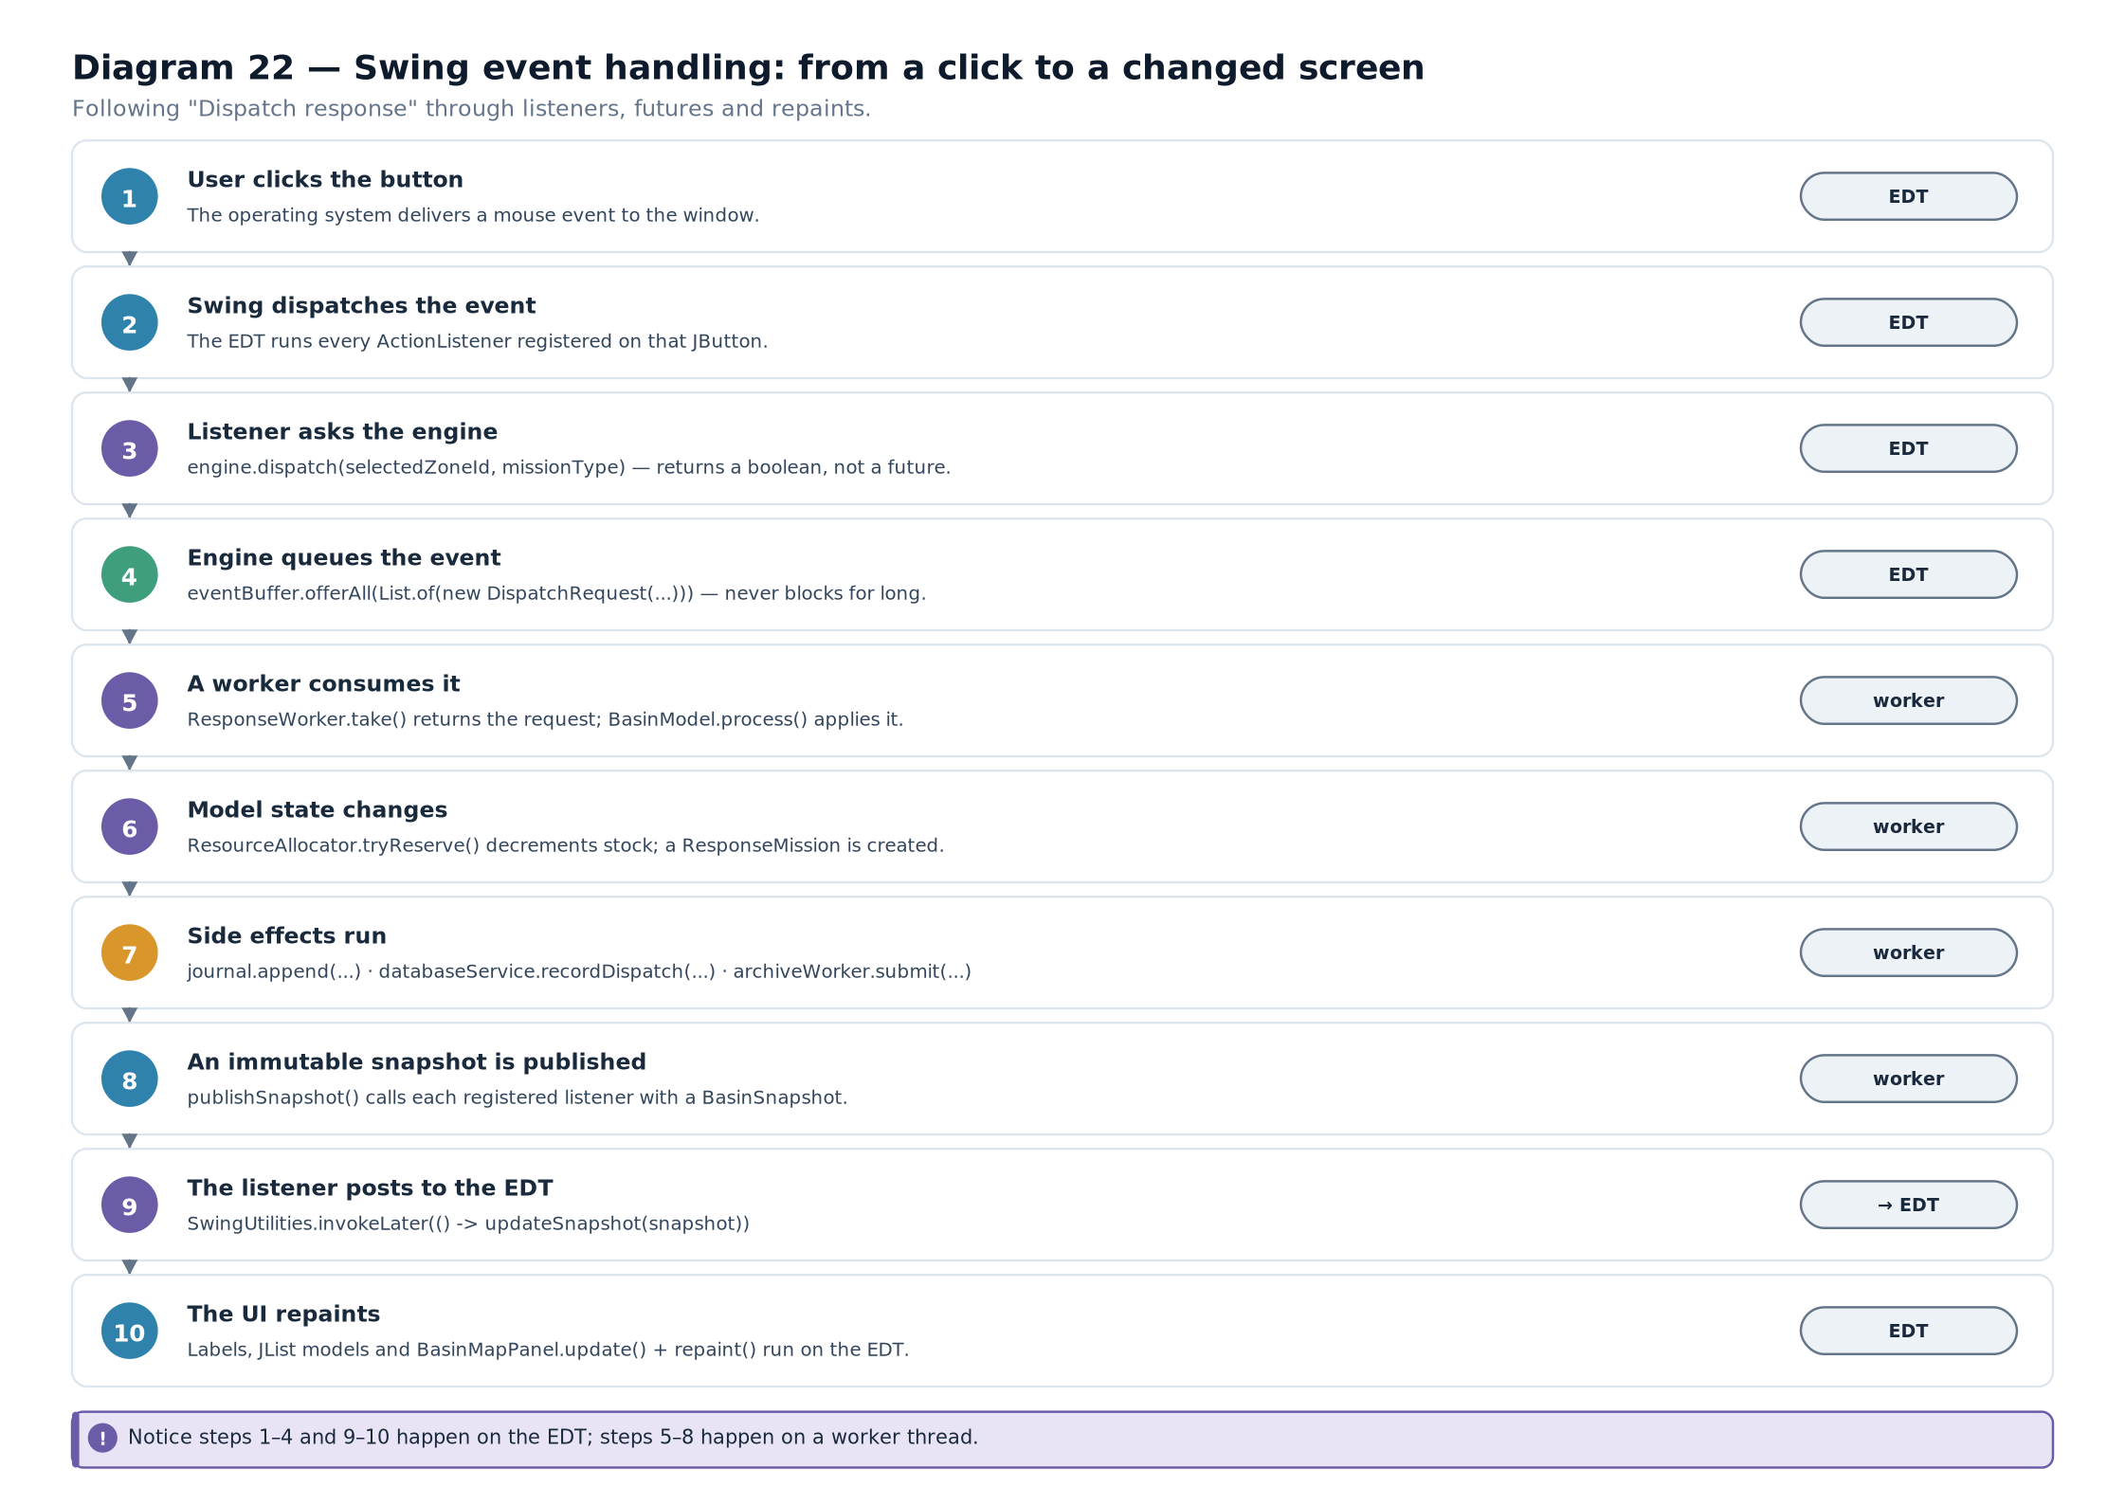

15.5 The three ways to write a listener
Java gives you several idioms for the same thing, and each is appropriate in a different situation.
// (1) A separate named class — best when the handler is substantial or reused

final

class

ExportHandler

implements

ActionListener
{

private

final

BasinEngine
engine;

ExportHandler
(
BasinEngine
engine) { this.engine = engine; }

@Override

public

void
actionPerformed(
ActionEvent
event) {
engine.exportReport();
}
}
button.addActionListener(
new

ExportHandler
(engine));
// (2) An anonymous inner class — the classic style in older Swing code

button.addActionListener(
new

ActionListener
() {

@Override

public

void
actionPerformed(
ActionEvent
event) {
engine.exportReport();
}
});
// (3) A lambda — correct when the interface has one abstract method

button.addActionListener(event -> engine.exportReport());
// (4) A method reference — when the handler is already a method

button.addActionListener(
this
::onExportRequested);
illustrative — four listener idiomsCORE CONCEPTAll four compile to the same thing. A lambda works because ActionListener is a functional interface: it declares exactly one abstract method, so the compiler can infer the implementation. This is why Swing code written after Java 8 is markedly shorter than older examples, and why the anonymous-class form you may see in lecture notes is now mostly historical.

15.6 The lecture-note login application
The lecture notes contain a Swing login screen. It is a small program, but it demonstrates most of the fundamentals at once, so it is worth walking through carefully.
Diagram 23 — The lecture-note login application. The login frame: a username field, a password field, a login button and a status label, arranged in a grid inside a border layout. The annotated flow shows the button's ActionListener reading both fields and comparing them against the expected credentials.
import
javax.swing.*;
import
java.awt.*;
public

class

LoginApplication
{

private

final

JFrame
frame =
new

JFrame
("
Login
");

private

final

JTextField
usernameField =
new

JTextField
(16);

private

final

JPasswordField
passwordField =
new

JPasswordField
(16);

private

final

JButton
loginButton =
new

JButton
("
Login
");

private

final

JLabel
statusLabel =
new

JLabel
("
Enter
your credentials",
SwingConstants.CENTER
);

public

LoginApplication
() {

JPanel
form =
new

JPanel
(
new

GridLayout
(2, 2, 8, 8));
form.add(
new

JLabel
("
Username
:"));
form.add(usernameField);
form.add(
new

JLabel
("
Password
:"));
form.add(passwordField);

JPanel
content =
new

JPanel
(
new

BorderLayout
(8, 8));
content.setBorder(BorderFactory.createEmptyBorder(12, 12, 12, 12));
content.add(form,
BorderLayout.CENTER
);
content.add(loginButton,
BorderLayout.SOUTH
);
content.add(statusLabel,
BorderLayout.NORTH
);

loginButton.addActionListener(event -> attemptLogin());

frame.setContentPane(content);
frame.setDefaultCloseOperation(
JFrame.EXIT_ON_CLOSE
);
frame.pack();
frame.setLocationRelativeTo(null);
// centre on screen

frame.setVisible(true);
}

private

void
attemptLogin() {

String
username = usernameField.getText().trim();

char
[] password = passwordField.getPassword();

if
(username.isEmpty() || password.length == 0) {
statusLabel.setText("
Both
fields are required.");

return
;
}

if
("admin".equals(username) && "secret".equals(
new

String
(password))) {
statusLabel.setText("
Welcome
, " + username + ".");
}
else
{
statusLabel.setText("
Incorrect
username or password.");
passwordField.setText("");
// clear the password on failure

}
}

public

static

void
main(
String
[] args) {
SwingUtilities.invokeLater(
LoginApplication
::
new
);
}
}
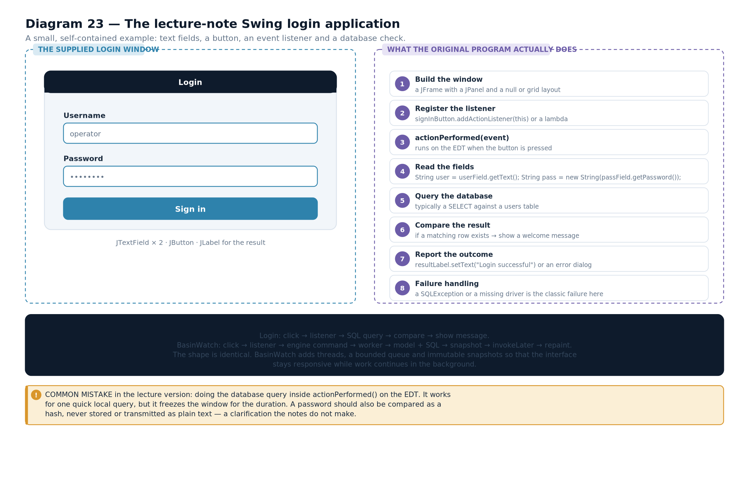

15.7 What the login program actually does
It builds a component tree. A GridLayout panel holds two label and field pairs. That panel sits in the centre of a border layout, with the button below and the status label above. Nothing is positioned by coordinates.
It registers one listener. The button's action listener calls attemptLogin(). That is the only connection between the user and the logic.
It validates before comparing. An empty username or password produces a specific message, which is more useful than "incorrect credentials". This is the same validate-at-the-boundary habit as SensorReading.parse.
It reads the password as a char[], not a String. That is not stylistic. JPasswordField.getPassword() returns a character array precisely so that the caller can overwrite it when finished. A String is immutable and its contents may persist in memory until garbage collection, so a password held in a String is readable from a memory dump for longer than necessary.
It clears the password on failure. A small detail with a real security purpose: the credential is not left on screen for someone walking past.
It starts on the event-dispatch thread. main does nothing but schedule the constructor with SwingUtilities.invokeLater. Every component is therefore created on the EDT, which is the rule.
TECHNICAL CLARIFICATIONThis program checks a hard-coded credential in the client. That is fine for a demonstration of Swing mechanics and unacceptable for a real system, for three reasons. The password appears in the compiled code. There is no hashing, so anyone reading the class file learns the credential. And any check performed in the user interface can be bypassed by anyone who can run different code. A real login compares a hash of the submitted password against a stored hash, and it does so on a server the user does not control. The lecture example is a UI exercise, not a security pattern — and saying so is part of understanding it.
COMMON MISTAKECalling new LoginApplication() directly from main instead of through SwingUtilities.invokeLater. It often appears to work, because the components happen to be created before the window is shown. But Swing's internals assume single-threaded access, and creating components off the EDT can produce intermittent, hard-to-reproduce failures in layout or painting. The fix is one line, and it is not optional.

15.8 Custom painting
When a component must draw something Swing does not provide — a schematic map, for instance — you override paintComponent.
@Override

protected

void
paintComponent(
Graphics
graphics) {
super.paintComponent(graphics);
// always first: clears and paints the background

Graphics2D
g = (
Graphics2D
) graphics;
g.setRenderingHint(
RenderingHints.KEY_ANTIALIASING
,

RenderingHints.VALUE_ANTIALIAS_ON
);

for
(
ZoneSnapshot
zone : snapshot.zones()) {

Point
centre = positionOf(zone.id());
g.setColor(colourFor(zone.risk()));
g.fillOval(centre.x -
RADIUS
, centre.y -
RADIUS
,
RADIUS
* 2,
RADIUS
* 2);
g.setColor(
Color.WHITE
);
g.drawString(zone.id(), centre.x - 12, centre.y + 4);
}
}
from BasinWatch, app/BasinMapPanel.java — custom painting, condensed. Three rules govern paintComponent, and all three matter.
Call super.paintComponent first. It clears the component's area. Without it, previous frames are never erased and the drawing smears as the component is repainted.
Never perform slow work inside it. Painting runs on the event-dispatch thread, and it runs whenever the window is uncovered, resized or asked to repaint. Reading a file or running a query here would freeze the interface repeatedly.
Never call repaint() from inside it. That requests another paint, which requests another repaint, producing an unresponsive loop. To change what is drawn, change the data and then call repaint() from elsewhere.
CONNECTION TO ANOTHER CONCEPTThis is why the engine publishes immutable snapshots. The paint method reads snapshot on the event-dispatch thread while workers may be mutating the model on other threads. Because the snapshot is an immutable copy, the paint method sees a consistent picture with no locking at all.
EXAM TIPA very common question asks why a long-running task in an ActionListener freezes the interface. The complete answer: the handler runs on the event-dispatch thread, and that same thread is responsible for delivering subsequent events and performing all painting. While the handler is busy, neither can happen, so the window appears frozen even though the application is running. The fix is to move the work to a background thread and post the result back — the subject of Chapter 16.
- Swing is event-driven: the program declares handlers and then waits for the framework to call them.
- Components fall into top-level containers, intermediate containers and simple components.
- Layout is managed by a layout manager per container; BorderLayout for the frame with nested layouts inside it is the standard composition.
- Events are dispatched to registered listeners, and all event handling runs on the event-dispatch thread.
- A listener can be a named class, an anonymous class, a lambda or a method reference; lambdas work because the listener interfaces are functional.
- The lecture-note login application validates input, reads the password as a char array, clears it on failure, and starts on the EDT.
- Custom painting goes in paintComponent, must call super first, must be fast, and must never call repaint.
- A hard-coded credential check in a UI is a demonstration of mechanics, not a security design.
- Event-dispatch thread (EDT) — the single thread that runs Swing event handling and painting.
- Listener — an object registered to be notified when a particular event occurs.
- Functional interface — an interface with exactly one abstract method, so a lambda can implement it.
- Layout manager — the object that decides where a container's children are placed.
- paintComponent — the method overridden to draw a custom component.

Connecting Application Logic, JDBC and Swing
From a click to a command, through a background thread and a database query, back to a visible table — and the one thread rule that governs all of it.

16.1 The problem this chapter solves
Chapter 15 established that all Swing work happens on the event-dispatch thread. Chapter 12 established that a database query is a blocking operation. Put those two facts together and you have a conflict: running the query in a listener freezes the window.
This chapter is about resolving that conflict without introducing a worse one. The solution has four parts, and each is a rule rather than a trick.
- A listener does not do the work. It asks the engine for an operation and returns.
- Slow work happens on a background thread. The engine's executors own those threads.
- The result is delivered as a future. A callback runs when the value arrives.
- The callback posts to the EDT before touching any component. Every time, without exception.

16.2 Step one: the listener asks, and returns
BasinWatch's listeners are short by design. Each one translates a user gesture into an engine call and nothing else.
startButton.addActionListener(event -> {

if
(engine.isRunning()) {
engine.pause();
}
else
{
engine.start();
}
refreshControlStates();
});

stepButton.addActionListener(event -> engine.step());
stormButton.addActionListener(event -> engine.injectStorm(1.35, 0.42));
reportButton.addActionListener(event -> engine.exportReport());
saveButton.addActionListener(event -> chooseAndSave());
refreshHistoryButton.addActionListener(event -> historyPanel.reload());
from BasinWatch, app/MainFrame.java and app/DatabaseHistoryPanel.java — six listeners, all of them short. None of those handlers opens a file, runs a query or waits for anything. That is the point. A listener that returns quickly cannot freeze the interface, and the method names read like the operations the user is actually performing.

16.3 Step two: the engine runs the work elsewhere
The engine decides which thread performs an operation. Several executors and named threads are involved, and each exists for a reason.
Thread | Created by | Runs | Why it is separate
"event-dispatch" | Swing | Event handling and painting | Swing requires it
"basin-sensor-feed" | SensorFeed extends Thread | The emission loop and its timed sleep | It must be interruptible and joinable
"basin-sensor-intake" | The engine, from a Runnable | Reading and validating pipe lines | It blocks on readLine()
"basin-response-1..3" | A fixed thread pool | Applying events to the model | Processing is concurrent and CPU-bound
"basin-sensor-archive" | A single-thread executor | Appending typed records to the archive | Disk writes must be serialised
"basin-control" | A single-thread executor | Save, restore and report generation | Only one control operation at a time
"basin-database" | A single-thread executor | All JDBC work | One writer, so no isolation anomalies
Table 16.1 — The threads in the application and why each is separate.VISUAL WALKTHROUGHCount the threads and note that only one of them may touch Swing. Every other row in that table describes work that would freeze the window if it ran on the event-dispatch thread — a blocking read, a disk write, a database round trip, a computation over hundreds of events.

16.4 Step three: the result arrives as a future
An operation that produces a result returns a CompletableFuture. The caller attaches a callback and carries on.
public

CompletableFuture
<
Path
> exportReport() {

return
CompletableFuture.supplyAsync(() -> {

try
{

BasinSnapshot
snapshot = model.snapshot();

Path
report = ReportWriter.write(AppPaths.reportsDirectory(), snapshot);
publishStatus("
Report
written to " + report.getFileName());

return
report;
}
catch
(
IOException
ex) {
publishStatus("
Could
not write the report: " + ex.getMessage());

throw

new

CompletionException
(ex);
}
}, controlExecutor);
}
from BasinWatch, engine/BasinEngine.java — the work is supplied to an executor; the caller gets a future. Three properties of that method are the pattern.
The work is a supplier submitted to a named executor. supplyAsync(..., controlExecutor) runs on "basin-control", not on the caller's thread and not on the common pool.
Failures are converted. IOException is checked, and a supplier cannot throw it, so it is wrapped in CompletionException. The future then completes exceptionally, and any whenComplete callback can inspect the cause.
The status is published from the worker thread. publishStatus is called inside the supplier, so it runs on the control thread. The listener that receives it must hop to the EDT — which brings us to step four.

16.5 Step four: the callback posts to the EDT
This is the rule that everything else depends on.
// Registering a listener: the engine may call it from ANY thread

engine.addStatusListener(message ->
SwingUtilities.invokeLater(() -> statusLabel.setText(message)));
// Attaching a callback to a future: it runs on the completing thread

engine.loadHistory(200).whenComplete((entries, failure) ->
SwingUtilities.invokeLater(() -> {

if
(failure != null) {
historyStatus.setText("
History
unavailable: " + failure.getMessage());

return
;
}
historyTableModel.setEntries(entries);
historyStatus.setText(entries.size() + " entries loaded.");
}));
from BasinWatch, app/MainFrame.java and app/DatabaseHistoryPanel.java — every callback hops to the EDT.CORE CONCEPTNotice that SwingUtilities.invokeLater appears in both places, and in exactly the same position: wrapping the entire body that touches a component. That is the rule stated precisely. It is not enough to call it somewhere in the method — the component access must be inside the lambda that is posted.
IMPORTANT DISTINCTIONinvokeLater and invokeAndWait are different, and one of them is dangerous. invokeLater queues the runnable on the EDT and returns immediately — the calling thread continues. invokeAndWait queues it and blocks until the EDT has run it, which is a deadlock if you call it from the EDT. BasinWatch uses invokeLater exclusively.

16.6 The complete path, from click to table cell
Now the two halves of the book can be joined. Here is the whole path for one user action: pressing "Refresh" in the history panel.
Diagram 24 — The complete path from a click to a table cell. Fourteen numbered steps crossing four threads: the event-dispatch thread dispatches the click, the database thread runs the query and completes the future, and the callback posts back to the event-dispatch thread to update the table model.
- The user clicks Refresh. The operating system delivers a mouse event to the window.
- The EDT dispatches it. Swing calls the ActionListener registered on that button.
- The listener calls one method. historyPanel.reload() — and returns immediately.
- reload asks the engine for a future. engine.loadHistory(200) returns a CompletableFuture at once.
- The engine checks availability. If the database is unavailable it returns an already-completed future holding an empty list, so no error path is needed.
- The engine enqueues the query. A lambda is submitted to the single-threaded database executor.
- The database thread opens a connection. DatabaseManager.openConnection() on basin-database.
- The repository prepares and binds. A PreparedStatement with one placeholder for the limit.
- SQLite executes. The query is planned and the matching rows are returned in descending time order.
- The rows are mapped to objects. Each row becomes a DatabaseHistoryEntry, inside the result-set loop.
- The future completes on the database thread. future.complete(entries) runs the whenComplete callback on that same thread.
- The callback posts to the EDT. SwingUtilities.invokeLater queues a runnable.
- The EDT runs the runnable. The table model's entries are replaced and the status label is updated.
- Swing repaints. The table asks its model for the new row count and redraws only the visible cells.
VISUAL WALKTHROUGHFollow the thread changes in that list: EDT, then database thread, then EDT again. Steps one to four are EDT. Steps five to eleven are the database thread. Steps twelve to fourteen are EDT again. The two invokeLater boundaries are the only places the two threads touch.
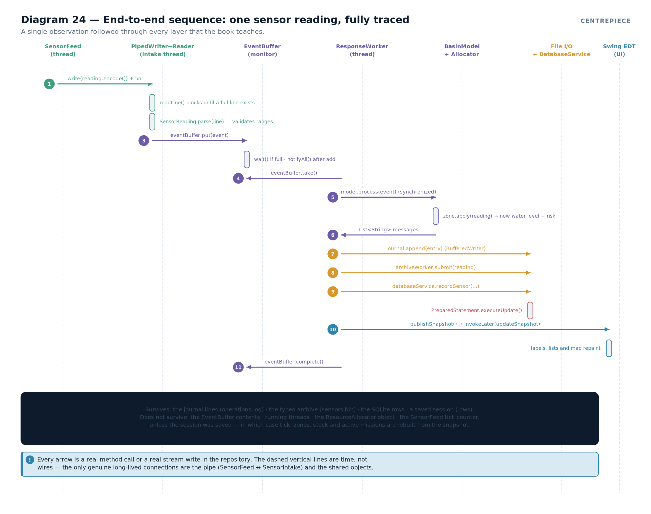

16.7 Why the table model matters
A JTable does not store data. It asks a TableModel for it, and the model is where the application's data lives.
final

class

HistoryTableModel

extends

AbstractTableModel
{

private

static

final

String
[]
COLUMNS
= {"
Time
", "
Type
", "
Zone
", "
Detail
"};

private

List
<
DatabaseHistoryEntry
> entries = List.of();

void
setEntries(
List
<
DatabaseHistoryEntry
> entries) {
this.entries = List.copyOf(entries);
// defensive copy, immutable

fireTableDataChanged();
// tell the table to ask again

}

@Override

public

int
getRowCount() {
return
entries.size(); }

@Override

public

int
getColumnCount() {
return
COLUMNS.length; }

@Override

public

String
getColumnName(
int
column) {
return

COLUMNS
[column]; }

@Override

public

Object
getValueAt(
int
row,
int
column) {

DatabaseHistoryEntry
entry = entries.get(row);

return

switch
(column) {

case
0 -> entry.at();

case
1 -> entry.type();

case
2 -> entry.zoneId() == null ? "\u2014" : entry.zoneId();

default
-> entry.detail();
};
}
}
from BasinWatch, app/DatabaseHistoryPanel.java — a table model over immutable rows. Three things in that class are worth noting.
The model holds the data, and the table renders it. Replacing the entries and calling fireTableDataChanged() is what makes the table update. Without the notification, the table would keep displaying stale rows, because it has no way to know the model changed.
setEntries takes an immutable copy. The list came from the database thread; copying it removes any possibility of concurrent modification while the EDT is reading.
The nullable zone is handled in the view. operational_events.zone_id is nullable by design, and the model renders null as a dash rather than the text "null".
CONNECTION TO ANOTHER CONCEPTCompare this with the login application in Chapter 15. That program put its logic directly in a private method of the frame class. BasinWatch puts the logic in the engine and gives the panel only a table model. Both are Swing programs; the difference is that one is a demonstration of mechanics and the other is an application with a persistence layer behind it. Neither is wrong — but the second is what you need when the data comes from a database.
RELATED TECHNIQUE — NOT USED IN BASINWATCHSome applications use SwingWorker instead of futures. It is a JDK class with doInBackground() on a worker thread and process() and done() on the EDT, and it solves the same problem. BasinWatch does not use it, for one reason: the engine must work without a user interface, so its operations cannot depend on a Swing type. Returning CompletableFuture keeps the engine independent of Swing, and the interface chooses how to consume the result. If you are asked which is better, the honest answer is that SwingWorker is more convenient inside a UI and CompletableFuture is more flexible outside one.
EXAM TIPThe highest-value question in this part is "trace the path of a user action that reads from the database." Answer it as a thread journey, not a class list: the EDT handles the click, the call returns a future immediately, the query runs on the database thread, the future completes there, and the callback posts back to the EDT to update the model. Mention invokeLater explicitly, and mention that the interface never blocks.
- A listener must return quickly, so it asks the engine for an operation rather than performing one.
- The engine owns several executors and named threads, each with a specific job.
- Operations that produce a result return CompletableFutures, so the caller never blocks.
- Any code touching a Swing component must be wrapped in SwingUtilities.invokeLater, including callbacks from futures.
- invokeLater queues and returns; invokeAndWait blocks and can deadlock if called from the EDT.
- A complete click-to-table path crosses the EDT, the database thread, and the EDT again.
- A JTable renders whatever its TableModel provides, and the model must call fireTableDataChanged to trigger an update.
- The engine returns futures rather than using SwingWorker, so that it remains independent of Swing.
- invokeLater — queueing a runnable to run on the event-dispatch thread, without waiting.
- CompletionException — the wrapper used when a checked exception must be thrown from an asynchronous supplier.
- TableModel — the object supplying data to a JTable.
- fireTableDataChanged — the notification that tells a table its model's contents have changed.
- Thread confinement — the rule that a particular object may only be accessed from one thread; Swing components are confined to the EDT.

Configuration and Related Techniques

Maven, pom.xml and Project Dependencies
How a Java project declares what it needs, how the build turns source into a runnable artefact, and why the JDBC driver is on the classpath at all.

17.1 The problem a build tool solves
Compiling a single file is easy: javac Hello.java. Compiling a project is not. A real project has hundreds of source files, depends on third-party libraries, needs those libraries' own dependencies, must be compiled in the right order, and must be packaged into something distributable. Doing all of that by hand does not scale.
A build tool automates four things: resolving dependencies, compiling, testing, and packaging. Maven is one such tool, and it is the one BasinWatch uses.
DEFINITIONBuild tool — a program that reads a project description, downloads and resolves the libraries the project depends on, compiles the sources in the correct order, runs tests, and produces a packaged artefact.
Diagram 25 — The Maven build workflow. The pom.xml declares coordinates, dependencies and plugins. Maven resolves the dependency tree from a repository into the local cache, compiles the sources against that classpath, runs the tests, and packages the result. The shade plugin then merges the dependency classes into one runnable jar.
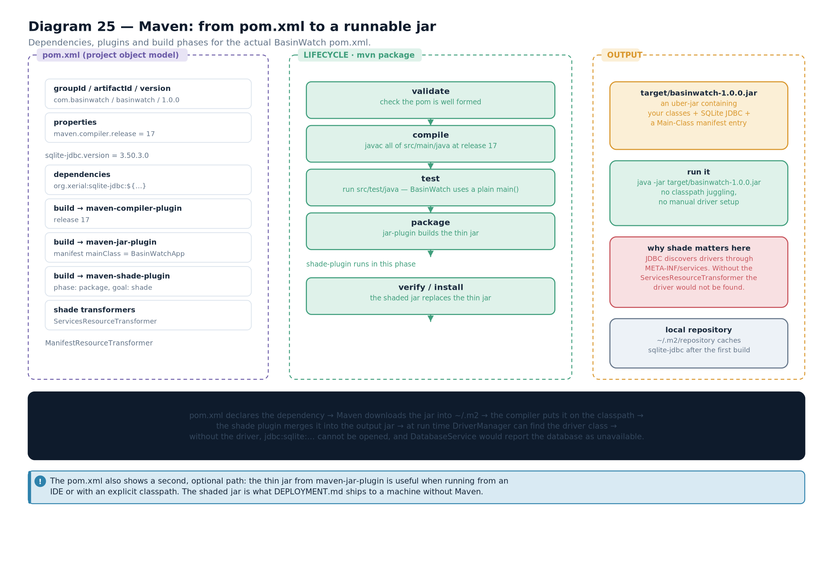

17.2 Coordinates: how a dependency is named
Maven identifies every library by three values, and it identifies your project the same way.
Coordinate | Meaning | BasinWatch's project | The SQLite driver
groupId | The organisation or namespace | com.basinwatch | org.xerial
artifactId | The project or library name | basinwatch | sqlite-jdbc
version | The release identifier | 1.0.0 | 3.50.3.0
Table 17.1 — Maven coordinates, for this project and for its one dependency.CORE CONCEPTThose three values are the complete address of a jar in a repository. Given org.xerial:sqlite-jdbc:3.50.3.0, Maven can find, download and cache the exact file — and it does the same for every library that library itself needs. That transitive resolution is the main reason build tools replaced hand-managed jars.

17.3 The pom.xml, section by section
The Project Object Model is the project's description. BasinWatch's is short, and every section has a purpose.
<?xml version="1.0" encoding="UTF-8"?>
<project xmlns="http://maven.apache.org/POM/4.0.0"
xmlns:xsi="http://www.w3.org/2001/XMLSchema-instance"
xsi:schemaLocation="http://maven.apache.org/POM/4.0.0
https://maven.apache.org/xsd/maven-4.0.0.xsd">
<modelVersion>4.0.0</modelVersion>

<groupId>com.basinwatch</groupId>
<artifactId>basinwatch</artifactId>
<version>1.0.0</version>
<name>BasinWatch</name>
<description>Offline floodplain operations console and planning simulation</description>

<properties>
<project.build.sourceEncoding>UTF-8</project.build.sourceEncoding>
<maven.compiler.release>17</maven.compiler.release>
<sqlite-jdbc.version>3.50.3.0</sqlite-jdbc.version>
</properties>

<dependencies>
<dependency>
<groupId>org.xerial</groupId>
<artifactId>sqlite-jdbc</artifactId>
<version>${sqlite-jdbc.version}</version>
</dependency>
</dependencies>
<!-- build section follows -->
</project>
from BasinWatch, pom.xml — coordinates, properties and the single dependency. Three things are worth pointing out.
There is exactly one dependency. The project uses only the JDK, Swing and the SQLite driver. Everything else — streams, threads, collections, futures — is standard library. A short dependency list is a real advantage: fewer things to update, fewer vulnerabilities, fewer surprises.
The version is a property, not a literal. <sqlite-jdbc.version> is declared once in <properties> and referenced as ${sqlite-jdbc.version}. Upgrading the driver means changing one line.
The source encoding is declared. UTF-8 is stated explicitly, so the compiler reads the source files the same way on every machine. This is the build-file equivalent of the explicit charsets in Chapter 5 — the same discipline applied to a different artefact.

17.4 Plugins and the build lifecycle
Maven's build is a fixed sequence of phases. Running a later phase runs every earlier one.
Phase | What happens | Plugins involved
validate | The project description is checked | Core
compile | Sources in src/main/java are compiled to target/classes | maven-compiler-plugin
test | Tests in src/test/java are compiled and run | maven-surefire-plugin
package | Compiled classes are packaged into a jar in target/ | maven-jar-plugin, then maven-shade-plugin
verify | Additional checks run | Any verification plugin
install | The artefact is copied into the local repository | Core
deploy | The artefact is uploaded to a remote repository | Core
Table 17.2 — The Maven lifecycle phases and what each produces. So mvn package compiles, tests and packages. The commands you will actually type are short.
mvn compile # compile only
mvn test # compile and run the test suite
mvn package # compile, test, and produce target/basinwatch-1.0.0.jar
mvn clean package # delete target/ first, then do all of the above
mvn dependency:tree # print the resolved dependency tree

17.5 Where the JDBC driver comes from
Chapter 11 asked why the driver is on the classpath and answered "a Maven dependency". Here is the mechanism.
- Declared. pom.xml names org.xerial:sqlite-jdbc:3.50.3.0.
- Resolved. Maven downloads the jar from a repository into the local cache, typically ~/.m2/repository.
- Added to the compile classpath. The compiler can now resolve any driver-specific types referenced in the source.
- Added to the runtime classpath. When the program runs, the jar is on the class path, so org.sqlite.JDBC is loadable.
- Discovered automatically. The jar contains META-INF/services/java.sql.Driver, so the JDK registers the driver without any code.
- Selected by URL. DriverManager.getConnection("jdbc:sqlite:…") asks each registered driver whether it accepts the URL; the SQLite driver says yes.
COMMON MISTAKEForgetting that the driver must be on the runtime classpath, not just the compile classpath. This is the classic cause of SQLException: No suitable driver found in a program that compiles perfectly. The dependency is present when the compiler runs and absent when the program runs — usually because the jar was built without it, which is the next section's subject.

17.6 Packaging a runnable jar
A plain jar contains only your own compiled classes. Run it and the driver is missing. Maven's shade plugin solves this by producing an "uber jar": your classes plus the dependency classes, merged into one file.
<plugin>
<groupId>org.apache.maven.plugins</groupId>
<artifactId>maven-shade-plugin</artifactId>
<version>3.6.0</version>
<executions>
<execution>
<phase>package</phase>
<goals><goal>shade</goal></goals>
<configuration>
<createDependencyReducedPom>false</createDependencyReducedPom>
<transformers>
<!-- CRITICAL: merge META-INF/services files from every jar -->
<transformer implementation="org.apache.maven.plugins.shade.resource.ServicesResourceTransformer"/>
<transformer implementation="org.apache.maven.plugins.shade.resource.ManifestResourceTransformer">
<mainClass>com.basinwatch.app.BasinWatchApp</mainClass>
</transformer>
</transformers>
</configuration>
</execution>
</executions>
</plugin>
from BasinWatch, pom.xml — the shade plugin and the transformer that matters.CORE CONCEPTThe ServicesResourceTransformer is not optional. Without it, the shading process would keep only one META-INF/services/java.sql.Driver file and discard the others. The merged jar would then contain the SQLite driver's classes but no registration, and the application would fail with "No suitable driver found" — even though the driver is physically inside the jar. This is one of the most confusing failures in Java packaging, and the transformer is the fix.
The ManifestResourceTransformer sets Main-Class in the jar's manifest, which is what makes java -jar basinwatch-1.0.0.jar start the application instead of printing an error.
VISUAL WALKTHROUGHDiagram 25 shows both jars Maven produces. The thin jar in target/ contains only the project's own classes and is not runnable alone. The shaded jar contains the project plus the driver's classes plus the merged service files, and it is the artefact you distribute.

17.7 Why this matters to the rest of the book
The build file is not administrative overhead. It is the answer to three questions the other chapters raise.
- Why does the JDBC code compile? Because java.sql is in the JDK and the driver is on the compile classpath.
- Why does the JDBC code run? Because the driver is on the runtime classpath and registers itself through a service file.
- Why does the application start with one command? Because the shade plugin merged everything into one jar and set Main-Class.
Remove any one of those and the application stops working, even though no Java source changed. That is the lesson of this chapter: the build is part of the program.
EXAM TIPA likely question is "how does your application get its database driver?" The complete answer has three parts: it is declared as a Maven dependency with groupId, artifactId and version; Maven resolves it and places it on the classpath; and the driver registers itself through META-INF/services, which the shade plugin must be configured to merge. That last clause is what distinguishes an answer that has read the pom from one that has not.
- A build tool resolves dependencies, compiles, tests and packages; Maven is the one this project uses.
- Every library is identified by groupId, artifactId and version, and Maven resolves their transitive dependencies automatically.
- The pom.xml declares coordinates, properties, dependencies and build plugins.
- BasinWatch has exactly one dependency — the SQLite JDBC driver — because everything else is in the JDK.
- Maven's lifecycle is a fixed sequence of phases, and a later phase runs every earlier one.
- The JDBC driver reaches the runtime classpath as a Maven dependency and registers itself through a service file.
- The shade plugin builds an uber jar containing the dependency classes, and its ServicesResourceTransformer is required for driver registration to survive.
- The build configuration is part of the program: change it and the application's behaviour changes without any Java source changing.
- pom.xml — the Project Object Model, Maven's description of a project.
- Coordinate — the groupId, artifactId and version triple identifying a library.
- Transitive dependency — a library required by a library you depend on directly.
- Build lifecycle — Maven's ordered sequence of phases.
- Uber jar — a jar containing a project's classes plus all its dependencies' classes.
- ServicesResourceTransformer — the shade transformer that merges service provider files so driver registration survives packaging.

XML, Schemas, Namespaces, Annotations and JavaBeans
Structured text, the rules that constrain it, and the two ways Java records metadata about code — with a clear statement of what this project does and does not use.

18.1 XML: a tree of labelled text
XML is a way of writing structured data as text. Everything in it is either an element with a name, or text inside an element. Elements nest, forming a tree.
<?xml version="1.0" encoding="UTF-8"?>
<basin name="Northreach" revision="3">
<zone id="UPR" waterLevelMeters="3.62">
<name>Upper Reach</name>
<residents>18</residents>
</zone>
<zone id="MIL" waterLevelMeters="2.71">
<name>Middle Basin</name>
<residents>42</residents>
</zone>
</basin>
Term | Meaning | In the example
Element | A labelled node with a start tag and an end tag | <zone>…</zone>
Attribute | A name-value pair inside a start tag | id="UPR"
Text content | Characters between tags | Upper Reach
Root element | The single outermost element | <basin>
Well-formed | Every tag closed, correctly nested, one root, quoted attributes | The example is well-formed
Valid | Well-formed and conforming to a schema | A separate question — see below
illustrative — the same zone data the project holds in Java, expressed as XMLTable 18.1 — XML terminology.IMPORTANT DISTINCTIONWell-formed and valid are different things. A document is well-formed if it follows XML's syntax rules: tags match, nesting is correct, there is exactly one root. It is valid if it also conforms to a schema that says which elements may appear, in what order, with what types. Every valid document is well-formed; a well-formed document need not be valid.

18.2 Namespaces
A namespace is a prefix that qualifies element and attribute names, so that two vocabularies can be mixed in one document without collision.
Diagram 26 — Namespaces, schemas and validation. A document declaring two namespaces, each bound to a URI that identifies a vocabulary. A schema in the xsd namespace describes the elements and types allowed in the document namespace. Validation checks the document against that description.
<project xmlns="http://maven.apache.org/POM/4.0.0"
xmlns:xsi="http://www.w3.org/2001/XMLSchema-instance"
xsi:schemaLocation="http://maven.apache.org/POM/4.0.0
https://maven.apache.org/xsd/maven-4.0.0.xsd">
<modelVersion>4.0.0</modelVersion>
</project>
from BasinWatch, pom.xml — the namespace declarations at the top of the file you already met. That header is worth decoding, because it is the same pattern everywhere.
xmlns="http://maven.apache.org/POM/4.0.0" declares the default namespace. Every unprefixed element — project, modelVersion, dependencies — belongs to it.
xmlns:xsi="…XMLSchema-instance" binds the prefix xsi to the XML Schema instance namespace, which defines two attributes used for validation: schemaLocation and noNamespaceSchemaLocation.
xsi:schemaLocation pairs a namespace URI with the URL of the schema that describes it. A validating parser can therefore find the schema and check the document.
CORE CONCEPTA namespace URI is an identifier, not an address. http://maven.apache.org/POM/4.0.0 does not have to be fetchable. Its purpose is to be a globally unique string that everyone agrees means the same vocabulary. That is why the same URI appears unchanged in every Maven project, and why it is a common examination point.
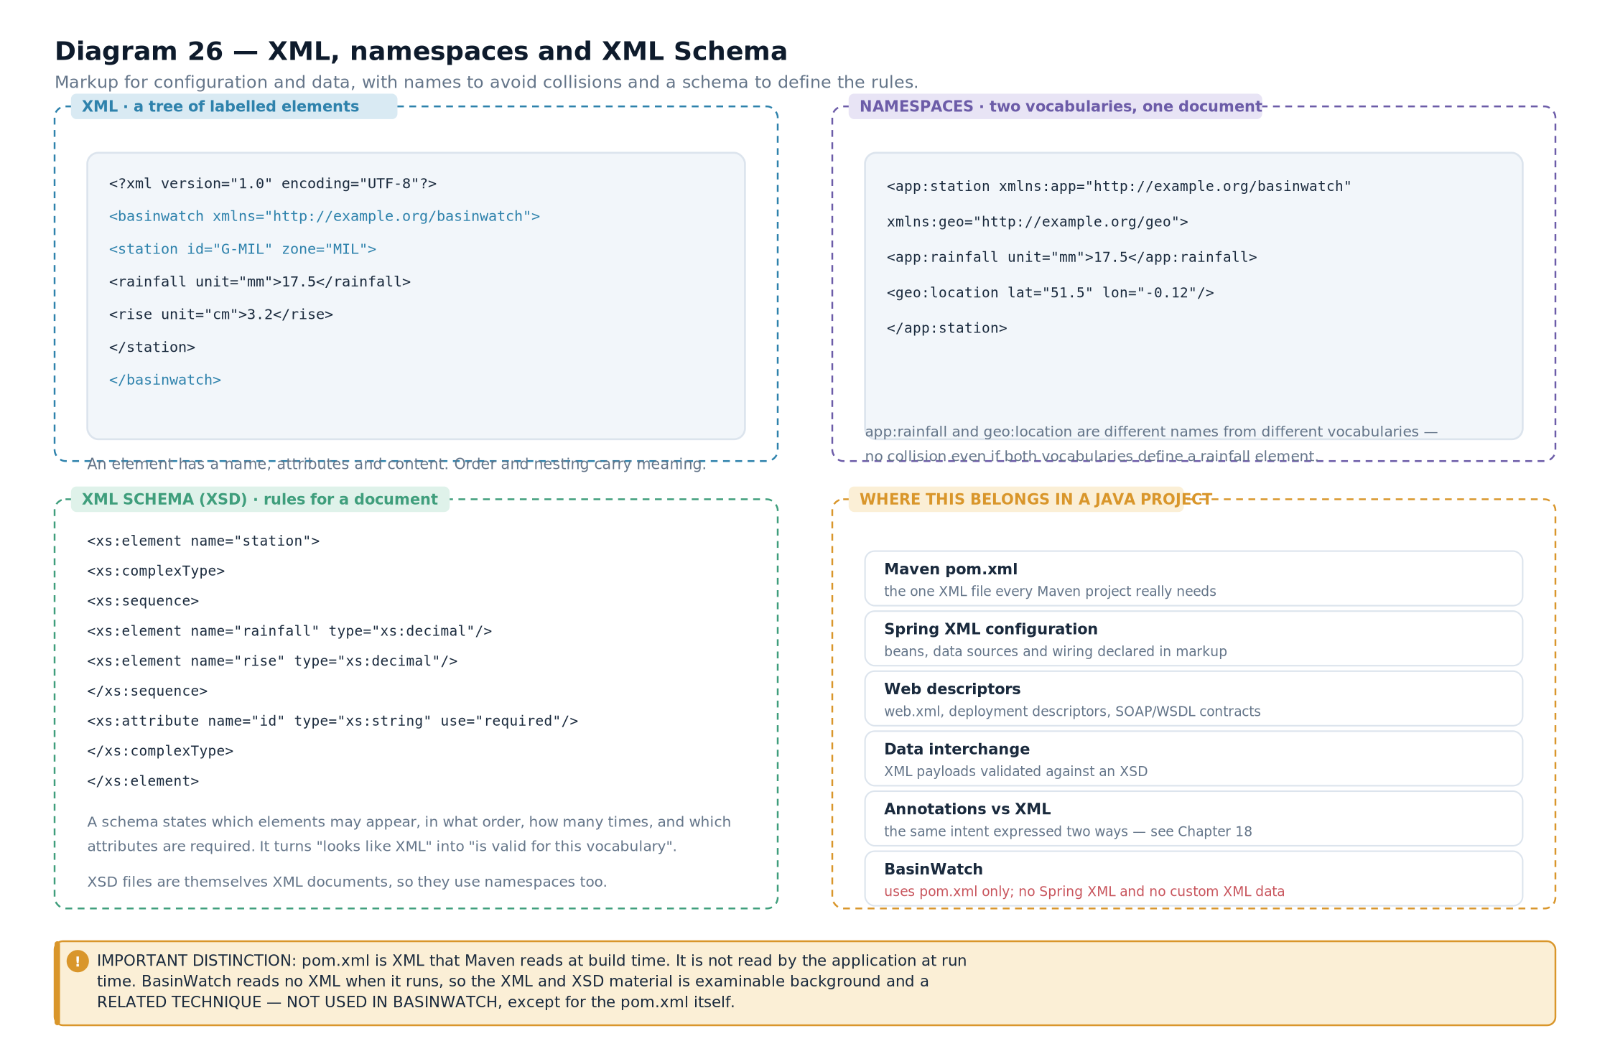

18.3 XML Schema
A schema is itself an XML document that describes which elements and attributes another XML document may contain. Two schema languages exist: DTD and XSD. XSD is the modern one and the one the syllabus material covers.
<?xml version="1.0" encoding="UTF-8"?>
<xs:schema xmlns:xs="http://www.w3.org/2001/XMLSchema">
<xs:element name="basin">
<xs:complexType>
<xs:sequence>
<xs:element name="zone" maxOccurs="unbounded">
<xs:complexType>
<xs:sequence>
<xs:element name="name" type="xs:string"/>
<xs:element name="residents" type="xs:nonNegativeInteger"/>
</xs:sequence>
<xs:attribute name="id" type="xs:string" use="required"/>
<xs:attribute name="waterLevelMeters" type="xs:decimal" use="required"/>
</xs:complexType>
</xs:element>
</xs:sequence>
<xs:attribute name="name" type="xs:string"/>
</xs:complexType>
</xs:element>
</xs:schema>
illustrative — a schema describing the basin document A schema buys you four things, and each corresponds to something you would otherwise have to check in code.
Schema feature | What it constrains | Java equivalent
Element and attribute declarations | Which names may appear | The fields of a class
type | What values are allowed | The declared type of a field
use="required" | Whether something must be present | A constructor that rejects null
maxOccurs="unbounded" | How many times something may repeat | A List field
xs:sequence | The required order of children | The parameter order of a constructor
xs:nonNegativeInteger | A value range | A range check in a compact constructor
Table 18.2 — What a schema expresses, and the Java construct that expresses the same idea.CONNECTION TO ANOTHER CONCEPTThat comparison is the useful way to think about schemas. A schema is validation declared outside the program, in a language a validator can read. BasinWatch does the same work in Java: SensorReading's compact constructor rejects out-of-range values, SessionSnapshot.validate re-checks restored state, and the database's NOT NULL constraints reject missing columns. Three mechanisms, one purpose.
RELATED TECHNIQUE — NOT USED IN BASINWATCHBasinWatch does not read or write any XML of its own. Its only XML file is pom.xml, which Maven reads. The project has no configuration XML, no schema, and no XML parser on its classpath. The XML material in this chapter is syllabus content and ecosystem knowledge — it is what you need to understand the build file and to recognise the technique when you meet it in a framework. It is not part of the application's runtime design, and saying so is more honest than inventing a use for it.

18.4 Annotations
An annotation is metadata attached to a declaration. It does not change what the code does by itself; it records information that a compiler or a framework can read.
@Override

// read by the compiler

public

String
toString() {
return
name; }
@Deprecated

// read by the compiler and by tools

public

void
oldDispatch() { }
@FunctionalInterface

// read by the compiler

public

interface

BasinEvent
{
/* ... */
}
@SuppressWarnings
("unchecked")
// read by the compiler

void
copy(
List
<?> source) { }
// An annotation with members — this is the shape frameworks use

@Retention
(
RetentionPolicy.RUNTIME
)
@Target
(
ElementType.TYPE
)
public

@interface

Component
{

String
value()
default
"";
}
Retention | Available at | Used for
SOURCE | Compile time only; not in the class file | @Override, @SuppressWarnings
CLASS | In the class file, but not readable at runtime by default | Some build-tool and analysis annotations
RUNTIME | In the class file and readable by reflection at runtime | Framework annotations such as @Component, @Autowired
illustrative — standard annotations and one framework-style annotationTable 18.3 — The three retention policies, and why the third is the one frameworks need.CORE CONCEPTThat table explains why annotations matter to frameworks. If an annotation's retention is RUNTIME, a framework can discover it by reflection and act on it — that is the entire mechanism behind Spring's component scanning, JPA's entity mapping and JUnit's test discovery. Without runtime retention, an annotation is only a message to the compiler.
BASINWATCH IN PRACTICEBasinWatch uses standard annotations only, and each one is doing exactly what its retention promises:
@Override

public

String
toString() { ... }
// SOURCE — compiler checks the signature

@FunctionalInterface

public interface

BasinEvent
{ ... }
// SOURCE — compiler enforces one method

@SuppressWarnings
(
"unchecked"
) ...
// SOURCE — silences one warning
Listing 18.1 — from BasinWatch — standard annotations, no framework annotations. There is no @Component, no @Autowired and no @Entity anywhere in the project, because there is no framework to read them.

18.5 POJO, JavaBean and the wiring they enable
Chapter 2 introduced the distinction. Here is why it exists, which is the part that matters when you meet a framework.
Diagram 27 — Hand-written wiring versus framework wiring. Left: BasinWatch constructs its services explicitly, passing each dependency through a constructor. Right: a framework scans annotated classes, instantiates JavaBeans reflectively, and injects dependencies by matching types. Both produce the same object graph.
Aspect | BasinWatch (hand-written wiring) | A framework such as Spring
How objects are created | Explicit new calls in constructors | Reflection, driven by annotations or XML
How dependencies arrive | Constructor arguments | Injected fields, setters or constructors
What the classes must look like | Anything; records and final classes are fine | Usually a JavaBean: no-argument constructor and setters, or an annotated constructor
Where the wiring lives | In the source, readable with the class | In annotations plus the framework's scan configuration
Compile-time safety | A missing dependency is a compile error | A missing bean is a runtime error
Discoverability | Follow the constructor | Search for the annotation
Table 18.4 — Two ways to assemble an object graph.RELATED TECHNIQUE — NOT USED IN BASINWATCHBasinWatch wires by hand. BasinEngine constructs the DatabaseService, which constructs the DatabaseManager and passes it to each repository's constructor. That is constructor injection, performed manually and visibly. It is a legitimate choice for an application of this size: there are six packages and roughly two dozen classes, so a framework would add a dependency, a start-up scan and a class of runtime errors in exchange for saving perhaps thirty lines. A larger application with hundreds of components would make the opposite trade, which is the subject of Chapter 19.
EXAM TIPIf asked "what is the difference between a POJO and a JavaBean?", give the convention first — no-argument constructor, private fields, public accessors, often Serializable — and then the reason: a framework needs to instantiate and populate the object without knowing anything about it. Adding the reason is what turns a definition into an explanation. Then note that every JavaBean is a POJO but not the reverse, and that a record can never be a JavaBean.
- XML represents structured data as a tree of elements, attributes and text.
- A document is well-formed if it follows XML syntax; it is valid if it also conforms to a schema.
- A namespace URI is a unique identifier for a vocabulary, not necessarily a fetchable address.
- An XSD schema declares which elements and attributes may appear, in what order and with what types.
- An annotation is metadata; its retention policy determines whether it is available at runtime.
- Runtime retention is what allows frameworks to discover annotations by reflection.
- BasinWatch uses standard annotations only, and contains no XML of its own beyond pom.xml.
- A JavaBean's conventions exist so a framework can instantiate and populate it reflectively; BasinWatch instead wires its objects by hand.
- Well-formed — following XML's syntax rules.
- Valid — well-formed and conforming to a schema.
- Namespace — a URI-qualified vocabulary that prevents name collisions in a document.
- XSD — XML Schema Definition, a schema language written in XML itself.
- Annotation retention — how long an annotation survives: source, class or runtime.
- Reflection — inspecting and using classes and members at runtime, which is how frameworks read annotations.
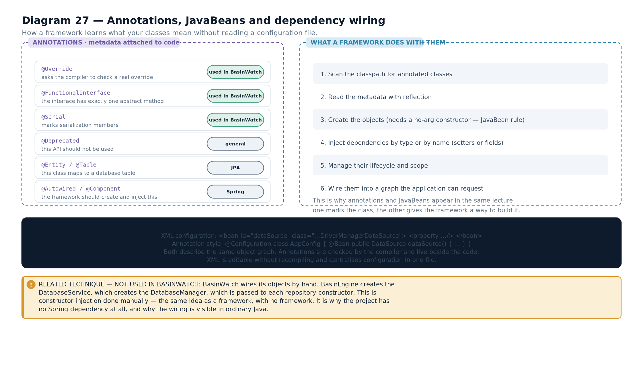

Raw JDBC versus Spring JdbcTemplate
The repetitive pattern that raw JDBC forces you to write, the abstraction that removes it, and an honest comparison with what this project actually does.

19.1 The repetition in raw JDBC
Look back at any repository method in Chapter 12 and count the lines that are about the query rather than about the resource handling.
public

List
<
DatabaseHistoryEntry
> loadRecent(
int
limit)
throws

SQLException
{

String
sql = "
SELECT
...
FROM
operational_events
ORDER
BY occurred_at
DESC

LIMIT
?";

ArrayList
<
DatabaseHistoryEntry
> entries =
new

ArrayList
<>();

try
(
Connection
connection = database.openConnection()) {
// boilerplate

try
(
PreparedStatement
statement = connection.prepareStatement(sql)) {
// boilerplate

statement.setInt(1, limit);
// the actual work

try
(
ResultSet
rows = statement.executeQuery()) {
// boilerplate

while
(rows.next()) {
// boilerplate

entries.add(
new

DatabaseHistoryEntry
(
// the actual work

DatabaseHistoryType.valueOf(rows.getString("event_type")),
rows.getString("zone_id"),
rows.getString("detail"),
Instant.parse(rows.getString("occurred_at"))));
}
}
}
}

return
List.copyOf(entries);
}
from BasinWatch, db/OperationalEventRepository.java — three lines of intent inside ten lines of resource handling. The structure is identical in every method: open a connection, prepare a statement, bind parameters, execute, iterate, close everything. Only the SQL and the row mapping change. That is the definition of code that wants to be abstracted.
CORE CONCEPTRepetition like this is not merely ugly — it is a source of bugs. Every place that must remember to close a connection is a place that might forget. Every place that must bind parameters in the right order is a place that might get the order wrong. Raw JDBC in BasinWatch is safe because it is written carefully in a handful of repository classes; in a larger codebase, the same pattern repeated two hundred times would not stay safe.

19.2 What Spring JdbcTemplate does
Spring's JdbcTemplate is a thin wrapper over the JDBC interfaces you already know. It performs exactly the steps in that method, and asks you to supply only the two things that vary: the SQL, and the code that turns a row into an object.
// ---- the same query, with JdbcTemplate ----

String
sql = "
SELECT
occurred_at, event_type, zone_id, detail "
+ "
FROM
operational_events
ORDER
BY occurred_at
DESC

LIMIT
?";
List
<
DatabaseHistoryEntry
> entries = jdbcTemplate.query(sql,
(rows, rowNumber) ->
new

DatabaseHistoryEntry
(
DatabaseHistoryType.valueOf(rows.getString("event_type")),
rows.getString("zone_id"),
rows.getString("detail"),
Instant.parse(rows.getString("occurred_at"))),
limit);
lecture-note style — the same query expressed with Spring JdbcTemplate Compare the two listings. The intent is identical and the SQL is identical. What has disappeared is every line about connections, statements, result sets and closing — because JdbcTemplate does all of it. The lambda in the middle is the RowMapper: given a row, produce an object.
Raw JDBC step | Who does it with JdbcTemplate | What you still supply
Obtain a connection | JdbcTemplate, from its DataSource | Nothing
Prepare the statement | JdbcTemplate | The SQL text with ? placeholders
Bind parameters | JdbcTemplate, from the argument list | The values, in order
Execute | JdbcTemplate | Nothing
Iterate the result set | JdbcTemplate | The RowMapper lambda
Close the result set, statement and connection | JdbcTemplate | Nothing
Translate SQLException | JdbcTemplate, into a DataAccessException hierarchy | Nothing

19.3 The DataSource, and DriverManagerDataSource
JdbcTemplate does not call DriverManager itself. It asks a DataSource for connections.
DEFINITIONDataSource — an interface representing a source of database connections. Code asks it for a connection; how that connection is created — a direct call, a pool, a JNDI lookup — is the DataSource's business.
// ---- a DataSource configured by hand, as the lecture notes show ----

@Bean

public

DataSource
dataSource() {

DriverManagerDataSource
dataSource =
new

DriverManagerDataSource
();
dataSource.setDriverClassName("
org.sqlite.JDBC
");
dataSource.setUrl("jdbc:sqlite:data/basinwatch.db");

return
dataSource;
}
@Bean

public

JdbcTemplate
jdbcTemplate(
DataSource
dataSource) {

return

new

JdbcTemplate
(dataSource);
}
lecture-note style — DriverManagerDataSource and JdbcTemplate declared as beans DriverManagerDataSource is a simple DataSource implementation that creates a brand-new connection on every call and never pools them. It is useful for teaching and for tests, and it is not what you would use in a production application — there you would use a pooling implementation such as HikariCP, because opening a physical connection per query is expensive.
TECHNICAL CLARIFICATIONThe lecture material configures these as Spring beans, using either @Bean methods in a configuration class or XML <bean> elements. Both are the same idea expressed two ways: a container creates and holds the objects, and injects them where needed. The DriverManagerDataSource class itself lives in org.springframework.jdbc.datasource and is a teaching-friendly convenience rather than a production choice — its own documentation says so.
RELATED TECHNIQUE — NOT USED IN BASINWATCHBasinWatch does not use JdbcTemplate, Spring, or a DataSource. It calls DriverManager.getConnection directly inside DatabaseManager and passes a Connection to each repository. That is raw JDBC. Nothing in this chapter should be read as a description of the project's implementation — it is the alternative approach the syllabus teaches, presented so you can compare it with what the project does.

19.4 Side by side
Diagram 28 — Raw JDBC and Spring JdbcTemplate. Left: the project's raw path, where the application opens a connection through DriverManager and manages every resource itself. Right: the JdbcTemplate path, where a DataSource supplies connections and the template manages resources, leaving only SQL and row mapping to the application.
Question | Raw JDBC (BasinWatch) | Spring JdbcTemplate
Who opens the connection? | DatabaseManager.openConnection() | The DataSource behind the template
Who closes it? | try-with-resources in each repository method | JdbcTemplate
Who binds parameters? | Typed setters, written by hand | JdbcTemplate, from the argument list
Who maps rows? | A loop inside the method | The RowMapper you supply
Exception type | SQLException | DataAccessException
Transactions | setAutoCommit(false) and commit() written by hand | @Transactional or a TransactionTemplate
Extra dependencies | The driver only | Spring Core, Spring JDBC, plus the driver
Lines per query | Roughly fifteen | Roughly five
Compile-time checking of the SQL | None | None
Used in BasinWatch? | Yes | No
Table 19.2 — The two approaches compared, with the project's actual choice stated.CORE CONCEPTTwo conclusions follow from that table, and both are worth holding together.
JdbcTemplate is not a replacement for JDBC. It is a class that calls the same Connection, PreparedStatement and ResultSet interfaces you studied in Chapter 12. Everything you learned about parameter binding, result-set iteration and transactions still applies — you have simply delegated the resource handling.
Neither approach is wrong. For an application with one database and a dozen queries, raw JDBC in a few repository classes is perfectly reasonable and keeps the dependency list to one jar. For an application with hundreds of queries, pooling, declarative transactions and several data sources, the framework earns its place.
EXAM TIPA very likely question is "why does Spring JdbcTemplate not eliminate the need for JDBC?" The answer is that it is built on JDBC: it obtains connections from a DataSource, creates PreparedStatements, binds parameters, iterates ResultSets and closes everything — all through the same java.sql interfaces. It removes repetition, not the underlying protocol. Saying that plainly is usually worth full marks.
- Raw JDBC forces the same resource-handling structure into every method, with only the SQL and row mapping varying.
- JdbcTemplate performs that structure for you and asks only for the SQL and a RowMapper.
- A DataSource supplies connections; JdbcTemplate never calls DriverManager directly.
- DriverManagerDataSource creates a new connection per call and does not pool; it is for teaching and tests.
- JdbcTemplate translates SQLException into Spring's DataAccessException hierarchy.
- JdbcTemplate is built on the same java.sql interfaces, so it removes repetition rather than JDBC itself.
- BasinWatch uses raw JDBC exclusively; the JdbcTemplate material is a taught alternative, not a description of the project.
- JdbcTemplate — a Spring class that executes SQL and manages JDBC resources, leaving SQL and row mapping to the caller.
- RowMapper — a callback that converts one result-set row into an object.
- DataSource — an abstraction representing a source of database connections.
- DriverManagerDataSource — a simple non-pooling DataSource implementation.
- DataAccessException — Spring's unchecked exception hierarchy for data access failures.
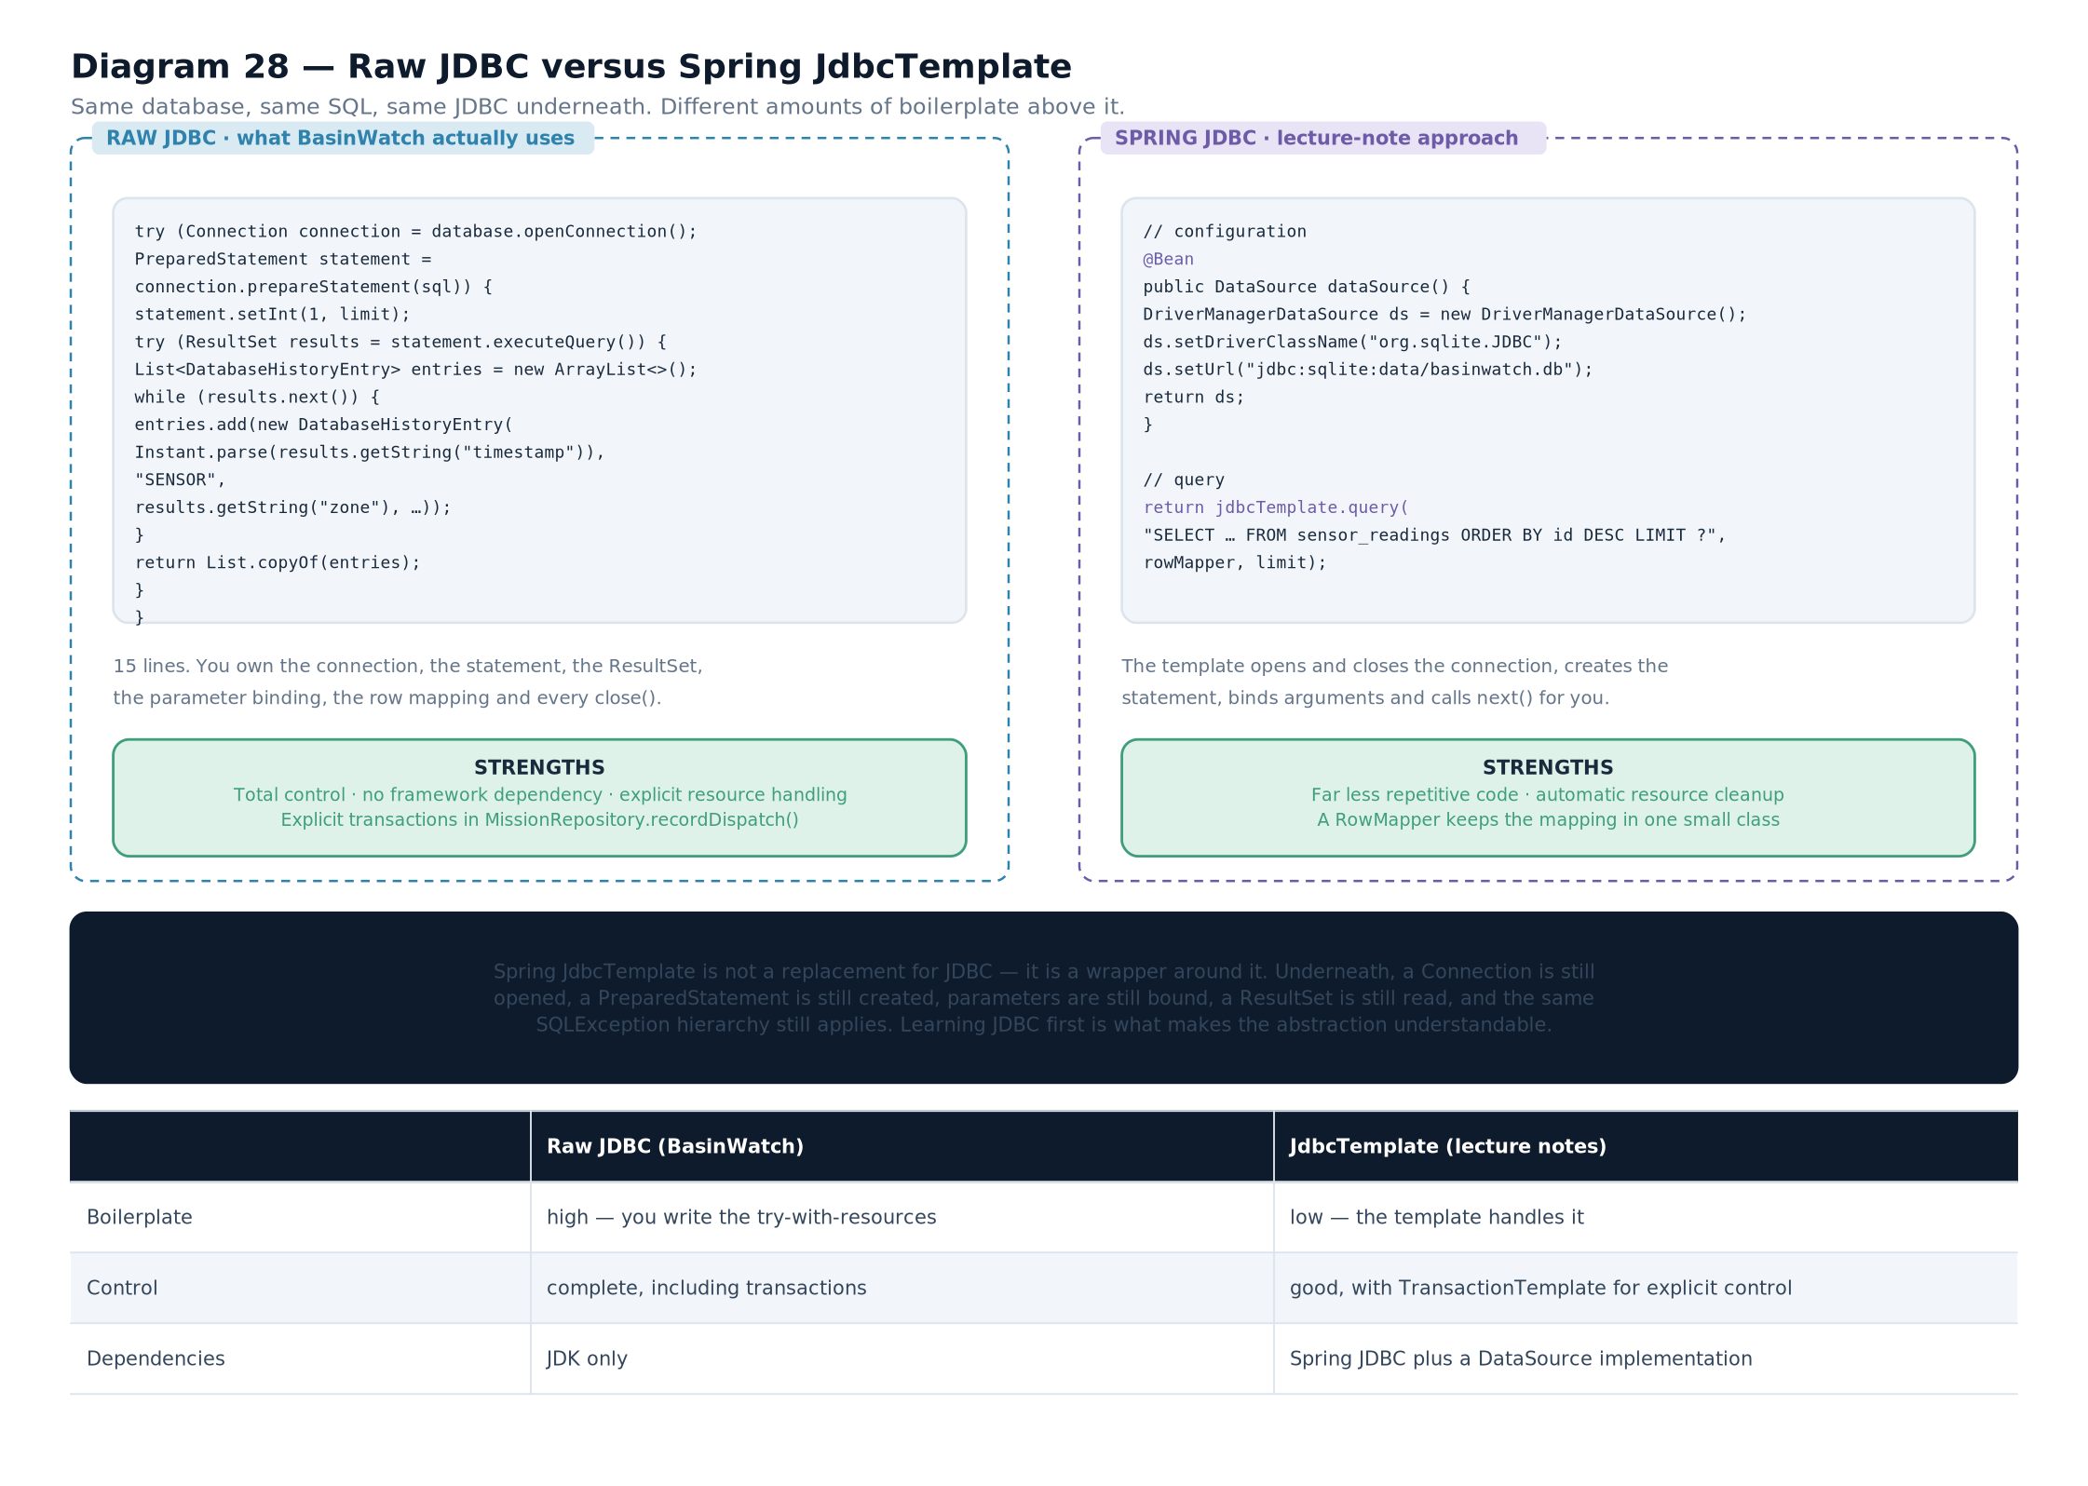

Putting Everything Together

End-to-End BasinWatch Architecture Walkthrough
Four scenarios traced through every layer, each following a genuinely different route. This is the integrative centerpiece of the book.

20.1 Why four scenarios and not one
It is tempting to trace a single "typical" request through the system and declare the architecture explained. That would be misleading, because BasinWatch has four genuinely different data paths and forcing them into one diagram would misrepresent at least three of them.
Scenario | Origin | Threads crossed | Persists to | Visible result
A — an observation | Sensor feed thread | Feed, intake, worker, database | Log, archive, database | Map colour and activity timeline
B — a dispatch | Operator click | EDT, worker, control, database | Log, database (transaction) | Resource board and mission list
C — save and restore | Operator click, then next launch | EDT, control | Session snapshot file | The whole restored model
D — a history read | Operator click | EDT, database, EDT | Nothing — it is a read | A populated history table
Table 20.1 — The four scenarios and how each differs.CORE CONCEPTRead the table's second and third columns together. Scenario A is the only one that starts without a user. Scenario D is the only one that writes nothing. Scenario B is the only one that needs a transaction. Scenario C is the only one whose result is visible on a later run. Those differences are why one trace would not be enough.
Diagram 24 — The full sequence diagram, with all four scenarios. Repeated from Diagram 24 in Chapter 16 so the trace can be read beside the scenarios. The complete sequence across the operator, the event-dispatch thread, the engine, the sensor path, the workers, the file layer, the database thread and the SQLite file. Scenarios A, B, C and D are marked so you can follow each separately.

20.2 Scenario A: an observation, fully traced
This is the system's heartbeat. Nothing is clicked; the application produces its own data.
- 1. The feed loop wakes. SensorFeed.run is in its timed loop on basin-sensor-feed. It increments the shared tick counter and begins a new interval.
- 2. Six readings are generated. For each of the six zones, a SensorReading is constructed with randomised rainfall and rise values within the configured bounds. The compact constructor validates the ranges as it is built.
- 3. Each reading is encoded and written. reading.encode() produces a pipe-delimited line such as READ|214|MIL-ST-2|MIL|12.400|3.100, which is written into the PipedWriter along with a line separator.
- 4. The pipe transfers and applies back-pressure. Characters move into the pipe's 8,192-character buffer. If intake has fallen behind and the buffer is full, the feed's write blocks here — the producer waits rather than overrunning memory.
- 5. Intake reads a line. On basin-sensor-intake, SensorIntake.run is blocked in source.readLine(). It wakes, receives the line, and returns it without the terminator.
- 6. The record is parsed and validated. SensorReading.parse splits on the pipe character and checks that there are exactly six fields beginning with READ. A malformed line is reported and skipped; the loop continues.
- 7. The event is queued. eventBuffer.put(event) adds it to the bounded deque. If the buffer is full, this call waits on the monitor; if it is closed, the method returns false and intake stops.
- 8. A worker takes it. One of the three ResponseWorker threads is waiting in eventBuffer.take(). It wakes, removes the event, and calls model.process(event).
- 9. The model applies it. applyReading finds the zone, calls BasinZone.apply(reading), and — crucially — receives false if the reading is stale. The risk level is recomputed from the new water level.
- 10. Escalation is detected. The new risk rank is compared with the previous one. If it increased, the activity message is prefixed with “Risk increased:” and a boolean is prepared for the database.
- 11. Activity is recorded and the snapshot is published. An ActivityEntry is added to the model's ring buffer, and model.snapshot() produces a new immutable BasinSnapshot.
- 12. The listener chain fires. BasinEngine calls every snapshot listener on the worker thread. Each listener's first action is SwingUtilities.invokeLater.
- 13. The EDT updates the interface. The map panel's snapshot field is replaced and repaint() is requested; the activity list and labels are updated. The zone's circle changes colour.
- 14. Persistence runs in parallel. The engine appends each activity message to the journal, submits the reading to the archive worker, and — only if the model changed — calls database.recordSensor(...).
- 15. The database thread writes. On basin-database, the repository prepares the nine-placeholder insert, binds every value, and executes it. If the risk escalated, a second row is written to operational_events.
VISUAL WALKTHROUGHFollow the thread changes in Scenario A: feed, intake, worker, then EDT and database in parallel. Steps one to three are the feed thread. Steps five to seven are intake. Steps eight to twelve are a worker. Steps thirteen and fifteen happen concurrently on two different threads. Only step thirteen touches Swing.
BASINWATCH IN PRACTICEStep nine is worth pausing on, because it is where the architecture earns its keep. The model decides whether a reading counts, and everything downstream obeys that decision:
// BasinZone.apply returns false for a stale reading

boolean
changed = zone.apply(reading);
if
(!changed) {{

// no activity entry, no archive record, no database row

return
;
}}
One boolean, decided in the domain, determines whether three separate persistence mechanisms write anything at all. That is what "the model is the source of truth" means in practice.

20.3 Scenario B: a dispatch, and its transaction
This scenario starts with a person and ends with a changed resource board. It is also the only scenario that needs a database transaction.
- 1. The operator selects a mission type and a zone, then clicks Dispatch. Two combo boxes and a button, all on the EDT.
- 2. The listener calls the engine. engine.dispatch(zoneId, missionType) — one call, returning immediately.
- 3. The engine submits the work. The request is submitted to basin-control and the caller receives a CompletableFuture.
- 4. The control thread reserves resources. ResourceAllocator.tryReserve(requirements) runs under the allocator's monitor: it checks every requirement, and only if all are satisfied does it decrement any of them.
- 5. A failed reservation stops here. If any resource is short, the method returns false, no state changes, and the future completes with a message the interface displays. Nothing is persisted, because nothing happened.
- 6. A successful reservation creates a mission. BasinModel constructs a ResponseMission with an identifier, a start tick and a completion tick derived from the mission type's duration.
- 7. The model publishes a new snapshot. The resource board now shows the deduction and the mission list shows the new operation. The listener chain posts both to the EDT.
- 8. Persistence begins. The engine appends an ALLOCATED entry to the journal and calls database.recordDispatch(...).
- 9. The database transaction opens. On basin-database, a connection is obtained and setAutoCommit(false) is called.
- 10. Three writes execute on that one connection. The mission row, one resource-usage row per required resource, and an audit event — all through package-private repository overloads that accept the shared connection.
- 11. The transaction commits. All three rows become visible together, or none of them does.
- 12. A failure rolls back. If any of the three throws, rollback() discards all of them, and the status listener reports the failure to the interface.
- 13. Completion is scheduled. In the model, the mission's completion tick is in the future. When the tick arrives, a later pulse completes the mission, releases the resources, and records a second transaction.
VISUAL WALKTHROUGHNotice step four and step eleven are the same idea implemented twice. Step four makes an in-memory change atomic using a monitor; step eleven makes a database change atomic using a transaction. Both exist to prevent a partially completed change from being observable. Chapter 13 makes this comparison explicitly.
COMMON MISTAKEA common wrong design puts the resource reservation after the database write. Then a failed reservation leaves a mission row claiming resources that were never deducted, and the history contradicts the live state. The order matters: reserve first, because the in-memory reservation is the decision, and the database records the decision.

20.4 Scenario C: save, exit, and restore
This scenario is the only one whose result is visible on a later run, and it is the reason the snapshot format is versioned and validated.
- 1. The operator clicks Save. On the EDT, the listener opens a file chooser and obtains a target path.
- 2. The listener calls the engine. engine.save(target), returning a future.
- 3. The control thread takes a snapshot. model.snapshot() produces an immutable BasinSnapshot while holding the model's monitor, so the copy is consistent.
- 4. The snapshot is converted to a DTO. SessionSnapshot.from(snapshot) copies zones, resources, missions and recent activity into serializable plain classes.
- 5. A temporary file is written. SnapshotStore.save opens name.bws.tmp, writes the format version, then serializes the DTO.
- 6. The temporary file is moved into place. Files.move(..., ATOMIC_MOVE) replaces the real file in one step, so an interrupted save cannot corrupt an existing snapshot.
- 7. The status is reported. The future completes with the path, and the callback posts the message to the EDT.
- 8. Later, the application exits cleanly. closeEngine() stops the feed, closes the pipe, joins intake, drains the archive queue, flushes the journal, and writes last-session.bws automatically.
- 9. On the next launch, the engine checks for a restore point. It looks for last-session.bws in the saves directory.
- 10. Four gates are applied on load. The file size is bounded, an ObjectInputFilter approves only com.basinwatch, java.lang, java.util and java.time classes, the format version is compared, and the DTO is validated.
- 11. The model is rebuilt. Zones are restored with their water levels, the resource allocator is refilled, missions are reinstated with their remaining durations, and the activity ring buffer is repopulated.
- 12. The interface shows the restored state. The map, the resource board, the mission list and the activity timeline all reflect the saved session, and the tick counter resumes.
VISUAL WALKTHROUGHCount the differences between the save path and the restore path. Saving is straightforward: copy, convert, write, move. Restoring is defensive: four gates before a single value is trusted. That asymmetry is deliberate and it is the single most important thing to understand about serialization in an application — writing is your own data, reading is unverified input.

20.5 Scenario D: a history read
This scenario writes nothing. It is the shortest of the four, and it is the one that most directly connects JDBC to Swing.
- 1. The operator clicks Refresh. Delivered to the EDT and dispatched to the button's listener.
- 2. The listener calls historyPanel.reload() and returns. Nothing blocks.
- 3. The panel asks the engine. engine.loadHistory(200) returns a future immediately.
- 4. Availability is checked. If the database is unavailable, an already-completed future holding an empty list is returned and steps five to eight are skipped.
- 5. The query is enqueued. A lambda is submitted to basin-database.
- 6. The repository prepares and binds. One placeholder for the limit, bound with setInt(1, limit).
- 7. SQLite executes and returns rows. The index on operational_events serves the descending time order.
- 8. Rows are mapped and the future completes. Each row becomes a DatabaseHistoryEntry; future.complete(entries) runs the callback on the database thread.
- 9. The callback posts to the EDT. SwingUtilities.invokeLater.
- 10. The table model is updated. setEntries(entries) copies the list and calls fireTableDataChanged().
- 11. The table repaints. It asks the model for the row count and redraws the visible rows.

20.6 Where the four scenarios differ, and why that matters
Placing the four traces side by side shows the architecture's real shape more clearly than any single diagram.
 | A — observation | B — dispatch | C — save/restore | D — history read
Initiated by | A timer | A click | A click, then a later launch | A click
First thread | Feed | EDT | EDT | EDT
Crosses the pipe? | Yes | No | No | No
Needs a transaction? | No — single-row inserts | Yes — three related writes | No | No — read only
Writes files? | Log and archive | Log | Snapshot | No
Writes the database? | Yes, if the model changed | Yes, transactionally | No | No
Result visible immediately? | Yes, on the map | Yes, on the resource board | No — on the next launch | Yes, in the table
Can fail silently? | Yes — a malformed record is skipped | No — a failed reservation is reported | No — a failed save is reported | Yes — an unavailable database shows empty history

20.7 The dependency graph
Finally, the static picture: who depends on whom. Dependencies point one way, and that direction is what makes the layers testable and replaceable.
Diagram 4 — The component dependency graph, revisited. Repeated from Diagram 4 in Chapter 3, now read as a design argument. Arrows point from a component to what it depends on. The app package depends on the engine, the engine depends on the domain, io and db packages, and none of those depends back on the app. The domain depends on nothing.
Three properties of that graph are worth naming.
The domain is at the bottom and depends on nothing. No file, no database, no Swing. That is why the model can be tested in a unit test with no setup at all, and why the same model could be driven by a different interface.
There are no cycles. Nothing the engine depends on depends on the engine. A cycle would make the layers impossible to test in isolation and impossible to replace.
The interface is at the top and depends on the engine, not the reverse. The engine has no import of javax.swing anywhere, which is what allows the whole application to run headless in a test.
CONNECTION TO ANOTHER CONCEPTThis chapter has traced four paths through that graph. If you can redraw Diagram 4 from memory, name the thread for each box, and describe one scenario that crosses it, you can answer almost any architecture question about this application.
EXAM TIPIn a viva, the strongest thing you can do is offer to trace a scenario and then choose the one that best matches the question. If the question is about persistence, trace C. If it is about transactions, trace B. If it is about threading, trace A. If it is about the interface and the database together, trace D. Choosing the scenario is itself evidence that you understand the architecture.
- Four genuinely different paths exist: an observation, a dispatch, a save-and-restore, and a history read.
- Scenario A crosses the pipe and fans out to three persistence mechanisms, but writes to the database only when the model changed.
- Scenario B is the only transactional path, and it reserves resources before recording anything.
- Scenario C is defensive on the way in and straightforward on the way out, because reading is unverified input.
- Scenario D writes nothing and is the clearest example of the JDBC-to-Swing path.
- The dependency graph is acyclic, with the domain at the bottom and the interface at the top.
- The engine has no dependency on Swing, which is what makes the application testable without a window.
- Fan-out — one decision causing several independent downstream operations.
- Restore point — a saved state the application checks for at start-up.
- Acyclic dependency graph — a component graph with no cycles, so each layer can be tested and replaced independently.
- Source of truth — the single component whose decision everything else obeys; here, the domain model.

Final Integration Exercise
A guided walkthrough of the real code, the eight questions that turn knowledge of parts into an explanation of the whole, and where every syllabus concept lives.

21.1 How to use this chapter
This is not a summary. It is an exercise. Read the guided walkthrough below, then answer the eight questions from memory, using the code as a reference only to check yourself. If you can answer all eight about any class in the project, you can explain the application.

21.2 Guided walkthrough: following one class completely
Take SensorIntake. It is a small class — a single run method — but it sits at the junction of streams, threads, validation and queueing, so it is the ideal subject for the exercise.
public

final

class

SensorIntake

implements

Runnable
{

private

final

BufferedReader
source;

private

final

EventBuffer
buffer;

private

final

Consumer
<
String
> warningReporter;

private

final

Consumer
<
String
> statusReporter;

public

SensorIntake
(
BufferedReader
source,
EventBuffer
buffer,

Consumer
<
String
> warningReporter,
Consumer
<
String
> statusReporter) {
this.source = source;
this.buffer = buffer;
this.warningReporter = warningReporter;
this.statusReporter = statusReporter;
}

@Override

public

void
run() {
statusReporter.accept("
Sensor
intake online");

try
(source) {

String
line;

while
((line = source.readLine()) != null) {

BasinEvent
event;

try
{

if
(line.startsWith("
PULSE
|")) {
event =
new

SimulationPulse
(Long.parseLong(line.substring(6)));
}
else
{
event = SensorReading.parse(line);
}
}
catch
(
IllegalArgumentException
ex) {
warningReporter.accept("
Discarded
malformed sensor
record
: " + ex.getMessage());

continue
;
}

if
(!buffer.put(event)) {
warningReporter.accept("
Event
buffer closed; intake stopping.");

break
;
}
}
}
catch
(
IOException
ex) {
warningReporter.accept("
Sensor
intake ended with an I/O error: " + ex.getMessage());
}
catch
(
InterruptedException
ex) {
Thread.currentThread().interrupt();
}
finally
{
statusReporter.accept("
Sensor
intake offline");
}
}
}
from BasinWatch, engine/SensorIntake.java — the complete class, unedited. Now apply the eight questions to it.

1. Why is this class needed?
Because reading and validating the observation stream is a distinct job with its own failure modes. It blocks on input, it must tolerate malformed data without stopping, and it must hand off to a queue that can be full. Putting that in SensorFeed would make the producer responsible for the consumer's timing; putting it in the workers would make every worker re-validate the same stream. As its own task, it can be reasoned about — and tested — alone.

2. How does it communicate with other classes?
Through four constructor arguments, each a narrow contract. A BufferedReader (a stream), an EventBuffer (a queue), and two Consumer<String> callbacks (events). It has no reference to the feed, the model, the engine or any interface class. That is why it can be tested by handing it a StringReader and a fresh buffer.

3. Which data does it receive?
Lines of text, one per event. Each line is either a pipe-delimited observation beginning with READ|, or a pulse beginning with PULSE|. It receives nothing else — no objects, no configuration, no state.

4. Does it use a stream, an event, a method call, or a database query?
All three of the first, and none of the last. A stream supplies the characters. A method call performs the parse, which validates. An event — a callback — reports warnings and status, and the queue hand-off is a fourth mechanism, condition waiting. There is no database interaction at all, which is correct: persistence is a decision for the engine, made after the model has processed the event.

5. How does its result affect the application?
Indirectly and only through the queue. For every accepted line it places one event in the buffer; a worker then takes it. For every rejected line it produces a warning and continues. It never returns a value, because it is a long-running task rather than a function — its effect is the stream of events it delivers.

6. What survives application shutdown?
Nothing that this class owns. The buffer's contents are drained and processed before shutdown; the pipe is closed; the reader is closed by try-with-resources. The durable record is created by the engine — a journal line, an archive record and possibly a database row — none of which this class touches. That separation is deliberate.

7. What happens if the relevant operation fails?
Three distinct outcomes, and the differences are the design.
- A malformed line produces a warning and the loop continues. One bad record cannot stop the stream.
- An IOException ends the loop and reports. The channel is broken; there is nothing left to read.
- A closed buffer makes put return false, so intake reports and stops cleanly rather than waiting forever for a consumer that will never come.

8. Which design alternative is taught in the lecture notes?
Reading from a file with FileReader and a BufferedReader in a main method. That is the same read loop with a different source and no threading. The lecture version demonstrates the stream API; this version demonstrates what changes when the source is another thread and the consumer is concurrent — which is why the try-with-resources, the two failure categories and the closed-buffer check all matter.
CORE CONCEPTNotice what those eight answers produced between them. They covered streams, threads, queues, callbacks, validation, exception strategy, persistence boundaries and the relationship to the lecture material — for one small class. That is the exercise's purpose: the same eight questions work on BasinZone, on SensorReadingRepository, on SnapshotStore and on DatabaseHistoryPanel.

21.3 Where every syllabus concept lives
This table is the book's index of concepts against their homes in the system. Use it to check coverage and to find the example for a topic you are revising.
Syllabus concept | Where it is taught | Where it lives in BasinWatch
Classes, objects, encapsulation | Ch. 2 | BasinZone — private state, package-private behaviour
Interfaces | Ch. 2 | BasinEvent, implemented by three records
Polymorphism | Ch. 2 | BasinModel.process pattern matching
Inheritance | Ch. 2 | SensorFeed extends Thread, Swing panels
Enums | Ch. 2 | RiskLevel, MissionType, ResourceType
Records | Ch. 2 | SensorReading, ZoneSnapshot, DatabaseHistoryEntry
POJO versus JavaBean | Ch. 2, 18 | Records and serializable DTOs; no framework beans
Threads and Runnable | Ch. 3, 7 | SensorFeed, SensorIntake, three workers
Synchronization and monitors | Ch. 3 | ResourceAllocator.tryReserve, BasinModel.process
wait / notifyAll | Ch. 3, 7 | EventBuffer.put and take
Producer–consumer | Ch. 3, 7 | Feed produces, intake consumes, workers process
Interruption and joining | Ch. 7 | closeEngine shutdown sequence
Byte streams | Ch. 4, 6 | Sensor archive via DataOutputStream
Character streams | Ch. 4, 5 | Journal, reports, and the pipe
FileInputStream / FileOutputStream | Ch. 5 | The classic API, contrasted with Files.newXxx
FileReader / FileWriter | Ch. 5 | The classic character API, contrasted with Files.newBufferedReader
ByteArrayInputStream / ByteArrayOutputStream | Ch. 7 | Demonstrated as the in-memory case
Piped streams | Ch. 7 | PipedWriter / PipedReader between feed and intake
Buffered streams | Ch. 6 | Every file stream in the project is wrapped
DataInputStream / DataOutputStream | Ch. 6 | SensorArchive
Serialization | Ch. 8 | SnapshotStore with ObjectOutputStream
Deserialization safety | Ch. 8 | Size bound, class filter, version check, validation
File metadata and exceptions | Ch. 5 | SaveCatalog.list, EOFException handling
JDBC architecture | Ch. 11 | DatabaseManager and the driver
Driver types | Ch. 11 | SQLite's pure-Java type 4 driver
Connection | Ch. 12 | DatabaseManager.openConnection
Statement | Ch. 12 | DatabaseInitializer DDL
PreparedStatement | Ch. 12 | Every repository insert and query
CallableStatement | Ch. 12 | Taught; not used — no stored procedures
ResultSet | Ch. 12 | OperationalEventRepository.loadRecent
CRUD | Ch. 12 | Insert, select and update; delete is deliberately absent
Transactions | Ch. 13 | DatabaseService.recordDispatch
SQLException handling | Ch. 12, 14 | Caught in enqueue, reported to the UI
Swing components and layouts | Ch. 15 | MainFrame, BasinMapPanel
Events and listeners | Ch. 15 | Action listeners throughout the frame
Custom painting | Ch. 15 | BasinMapPanel.paintComponent
Event-dispatch thread | Ch. 15, 16 | Every listener and every invokeLater call
JDBC to Swing | Ch. 16 | DatabaseHistoryPanel and its table model
Maven and pom.xml | Ch. 17 | pom.xml and the shade plugin
XML and namespaces | Ch. 18 | pom.xml header; taught, not otherwise used
XML Schema | Ch. 18 | Taught; not used in the project
Annotations | Ch. 18 | @Override, @FunctionalInterface, @SuppressWarnings
JavaBeans | Ch. 18 | Taught; the project wires by hand
Spring JdbcTemplate | Ch. 19 | Taught as an alternative; the project uses raw JDBC
DriverManagerDataSource | Ch. 19 | Taught; the project uses DriverManager directly

21.4 The eight questions
Work through these for a class of your choosing. If you can answer all eight without looking, you understand that class and its place in the system.
Exercise 1 · Why is this class needed?State the responsibility in one sentence, then say what would go wrong if the class did not exist. The second part is the one that shows understanding: “the model would have to validate input” or “the interface would have to know SQL” is a real answer; “it is a class that does X” is not.
Exercise 2 · How does it communicate with other classes?List the constructor arguments and the methods it calls on them. Name the mechanism for each — method call, stream, callback, queue, query. Note the classes it does not reference, because those absences are also design decisions.
Exercise 3 · Which data does it receive?Give the types and the shape. “A line of pipe-delimited text with six fields” is a better answer than “a string”, because it explains why the parse validates what it validates.
Exercise 4 · Does it use a stream, an event, a method call, or a database query?Answer with all that apply, and say why each is the right mechanism. If the answer is “none of them”, explain what mechanism it does use instead — an in-memory collection, a monitor, a future.
Exercise 5 · How does its result affect the application?Trace forward to the visible effect. A method that returns a boolean may ultimately change a colour on a map, and being able to say so is the difference between knowing a class and knowing a system.
Exercise 6 · What survives application shutdown?Answer for each artefact: nothing, an audit record, a typed measurement, or a restorable snapshot. Then say which component is responsible for writing it — it will rarely be the class you started with.
Exercise 7 · What happens if the relevant operation fails?Distinguish recoverable from unrecoverable, and reported from propagated. A class that skips a bad record and one that aborts the loop are making different assumptions about what failure means.
Exercise 8 · Which design alternative is taught in the lecture notes?Name the textbook version and say precisely what differs. “The lecture version reads a file in main; this version reads a pipe on a background thread” is the shape of a good answer, because it explains why the extra machinery exists.

21.5 Three design alternatives worth being able to argue
An examiner who wants to know whether you understand a design will ask what you would do differently. These are the three most likely, with both sides of the argument.
Choice in BasinWatch | The alternative | Argument for the alternative | Argument for what the project does
Raw JDBC with hand-written repositories | Spring JdbcTemplate with a DataSource | Less boilerplate per query; declarative transactions; pooling available | One dependency instead of four; the JDBC mechanics remain visible; appropriate for a dozen queries
One file per artefact, no database by default | Store everything in the database | One mechanism, one query language, consistent access | The application works with no database at all; the log is readable without tooling; the snapshot restores state that a row store would need replay for
Hand-written constructor wiring | A dependency-injection framework | Wiring is declarative; large graphs become manageable; lifecycles are managed | Wiring is visible in the source; a missing dependency is a compile error rather than a runtime one; no scanning, no reflection, no framework start-up
Table 21.2 — Three design choices, and the case for each side.CORE CONCEPTThe point of that table is not that one column is right. It is that a design choice can be defended with reasons. In a viva, saying “I used raw JDBC because the project has one database and a dozen queries, and adding Spring would add four dependencies to save perhaps forty lines” is a far stronger answer than “the lecture notes used JDBC”.

21.6 What you should now be able to do
- Draw the architecture from memory, with the layers, the threads and the two persistence columns.
- Name the mechanism for any interaction in the system: method call, monitor, stream, queue, callback or query.
- Trace four scenarios end to end, saying which thread runs each step.
- Choose a stream for a task and justify the layers, including the charset and the buffering.
- Explain why serialization needs four defences, and name them.
- Write a parameterized query with correct 1-based binding and complete resource handling, and say why binding beats concatenation.
- Say what a transaction guarantees and identify the one place the project needs one.
- Keep the event-dispatch thread free, and explain what happens when you do not.
- Explain how the JDBC driver reaches the classpath, and why the shade transformer matters.
- Distinguish raw JDBC from JdbcTemplate without claiming the project uses both.
- Answer the eight questions about any class in the project.
CONNECTION TO ANOTHER CONCEPTThe revision section that follows turns each of those capabilities into comparison tables, viva questions and tracing exercises. Work through Chapter 21 first; then use the revision material to check what you missed.
- The eight questions — purpose, communication, data received, mechanism, effect, survival, failure, and the lecture alternative — explain any class in the system.
- Every syllabus concept has a home in the project; Table 21.1 maps all of them.
- The three most defensible design alternatives are raw JDBC versus JdbcTemplate, files versus a database, and hand wiring versus a DI framework.
- A design choice is worth defending with reasons, not with a reference to the lecture notes.
- Design alternative — a different but defensible way of achieving the same requirement.
- Traceability — the ability to follow a piece of data from its origin to its visible effect.
- Responsibility — the single job a class exists to do.

Comparison Tables and Chapter Summaries
The twelve comparisons that carry the most marks, followed by a one-page summary of every chapter in the book.

R.1The twelve essential comparisons
Each of these is a question an examiner can ask directly. Learn the table, but more importantly learn the axis of each comparison — that is what the question is really testing.

1. Byte streams versus character streams
 | Byte stream | Character stream
Roots | InputStream, OutputStream | Reader, Writer
Unit | 8-bit byte | 16-bit character
Encoding | None | A charset converts characters to bytes
Line methods | None | readLine(), newLine()
Use for | Binary data, typed values, serialized objects | Text a human will read
Project example | SensorArchive, SnapshotStore | OperationalJournal, ReportWriter

2. The file and memory stream classes
Purpose | Byte input | Byte output | Character input | Character output
A file | FileInputStream | FileOutputStream | FileReader | FileWriter
Memory | ByteArrayInputStream | ByteArrayOutputStream | StringReader | StringWriter
Another thread | PipedInputStream | PipedOutputStream | PipedReader | PipedWriter
Adding a capability | FilterInputStream | FilterOutputStream | FilterReader | FilterWriter

3. Buffered versus unbuffered streams
 | Unbuffered | Buffered
Reads per 8 KB | One system call per read() | One system call per buffer refill
Line methods | Not available | readLine() and newLine()
flush() matters? | No — data goes straight out | Yes — data may sit in the array
Risk if not closed | Minor | Silent data loss of buffered content
Project use | Never used alone for files | Every file stream in the project

4. Data streams versus object serialization
 | DataInputStream / DataOutputStream | ObjectInputStream / ObjectOutputStream
What is written | Primitives and strings, in a fixed order | An object graph, with class descriptors
Format defined by | You — the sequence of calls | The JDK
Readable if the class changes? | Only if the order is unchanged | Yes, with an explicit serialVersionUID
Constructor called on read? | Not applicable | No — which is why validation must be explicit
Security concern | Low — no classes are named in the stream | High — the stream names classes to instantiate
Project example | SensorArchive | SnapshotStore

5. The six communication mechanisms
Mechanism | Direction | Blocks? | Crosses threads? | Project example
Method call | two-way | briefly | no | model.process(event)
Monitor | two-way | on the lock | yes | ResourceAllocator.tryReserve
Stream | one-way | when full or empty | usually | The pipe; all file access
Queue | one-way | when full or empty | yes | EventBuffer
Callback | inverted | no | may arrive anywhere | Snapshot, status and database listeners
Database operation | request/response | yes unless offloaded | yes | Writes queued, reads as futures

6. File persistence versus database persistence
 | File | Database
Structure | Whatever format you invent | Tables, columns and declared types
Selective read | Read and filter everything | WHERE plus an index
Aggregation | Application code | SQL aggregate functions
Concurrency | Effectively one writer | Locking and isolation levels
Atomic multi-part change | Write to a temporary file and rename | A transaction
Readable without tooling | Yes, for text formats | No — needs a client
Restores full application state | Yes, via a snapshot | Only by replaying or reconstructing
Project use | Log, archive, snapshot, reports | Optional history in SQLite

7. Statement, PreparedStatement and CallableStatement
 | Statement | PreparedStatement | CallableStatement
Values | Concatenated into the SQL text | Bound with typed setters | Bound as input or registered as output
Pre-parsed | No | Yes | Yes
Injection-safe | No | Yes | Yes
Reusable efficiently | No | Yes | Yes
Project use | Schema DDL in DatabaseInitializer | Every repository method | Not used — no stored procedures

8. The four JDBC driver types
Type | Approach | Status today
1 — JDBC–ODBC bridge | Native ODBC driver called through Java | Removed from the JDK
2 — Native-API | Calls the vendor's native client library | Rarely used; needs native libraries
3 — Network protocol | Talks to a middleware server | Largely converged with type 4
4 — Thin driver | Pure Java, speaks the database protocol directly | The modern default; SQLite's driver is type 4

9. Execution methods and their results
Method | Returns | Use for
executeQuery() | ResultSet | SELECT
executeUpdate() | int — rows affected | INSERT, UPDATE, DELETE, DDL
execute() | boolean — is a ResultSet available | When the kind of statement is unknown
executeBatch() | int[] — counts per statement | Bulk operations

10. Raw JDBC versus Spring JdbcTemplate
 | Raw JDBC | JdbcTemplate
Connection handling | Written by hand | Delegated to the template
Resource closing | try-with-resources at every site | Automatic
Parameter binding | Typed setters, hand-written | From the argument list
Row mapping | A loop in the method | A RowMapper lambda
Exceptions | SQLException (checked) | DataAccessException (unchecked)
Dependencies | The driver only | Spring Core, Spring JDBC, the driver
Used in BasinWatch? | Yes | No

11. POJO versus JavaBean
 | POJO | JavaBean
Convention | None | No-argument constructor, private fields, public get/set accessors
Serializable | Not required | Conventionally yes
Can be a record? | Yes | No — records have no no-argument constructor or setters
Purpose of the convention | None needed | Allows a framework to create and populate by reflection
Project example | SensorReading, ZoneSnapshot | None — no framework is used

12. Swing event handling essentials
Concept | Meaning | Project example
Event-dispatch thread | The single thread for events and painting | Every listener in MainFrame
Listener | An object registered to receive an event | ActionListener on each button
Functional interface | One abstract method, so a lambda works | ActionListener, Runnable
Layout manager | Decides where children go | BorderLayout and JSplitPane
Custom painting | Override paintComponent | BasinMapPanel
Off-EDT hand-off | SwingUtilities.invokeLater | Every engine callback
Table model | Supplies data to a JTable | HistoryTableModel

R.2One-page chapter summaries
Each entry is the smallest complete statement of what a chapter established. If any line is not familiar, that is the chapter to reread.
Ch. | In one paragraph
1 | BasinWatch is a single-process offline floodplain console in six layers: operator and interface, engine commands, domain and engine, sensor input path, file persistence, and an optional JDBC layer. Six threads do background work and publish immutable snapshots to the event-dispatch thread. Technologies meet at exactly two boundaries: the accepted event and the published snapshot.
2 | Encapsulation is enforced with access modifiers; one interface unifies three event types; polymorphism is expressed as pattern matching; inheritance is used only where a framework contract requires it; enums carry their own data; records provide validated immutable values; a JavaBean adds conventions a framework needs and a record cannot have.
3 | Components communicate in six distinct ways: method call, shared object under a monitor, stream, queue with condition waiting, listener callback, and database operation. Each has different blocking and threading behaviour. A method call must never block on external work; condition waits must be loops that hold the monitor and use notifyAll.
4 | A stream is an ordered one-directional sequence consumed incrementally. Four abstract roots: InputStream, OutputStream, Reader, Writer. Bytes preserve data exactly; characters pass through a charset and are right for text. read() returns int so that -1 can mean end of stream.
5 | A Path names a file; only a stream reads it. Opening for output truncates unless append is requested. A complete write is create, open, write, flush, close; a complete read is check, open with an explicit charset, loop on readLine() != null, close. flush() pushes data onward; close() flushes and releases.
6 | A buffer turns many small operations into few large ones. Wrapper classes add one capability each by taking another stream in their constructor. readLine() exists only on BufferedReader. Data streams write primitives in a fixed order that is the schema, so the read order must match exactly; a usable binary format has a magic number, a version and self-describing strings.
7 | Byte-array streams use the whole stream API with no device. A pipe is a matched writer/reader pair with a bounded buffer, intended for two threads; it provides back-pressure and a natural end-of-stream signal. Shutdown order is stop the producer, close the writer, join the consumer, close the queue.
8 | Serialization writes an object graph; deserialization reconstructs it without calling constructors. transient and static fields are skipped; an explicit serialVersionUID prevents unrelated recompiles from invalidating saves. Because constructors are bypassed, a reader needs four defences: bound the size, filter the classes, check the version, validate the result. BasinWatch writes to a temporary file and moves it into place.
9 | Four file mechanisms answer four questions: the log records what happened, the archive records exact measurements, the snapshot restores state, the report communicates. All paths derive from AppPaths. None of the four can substitute for another, because the format determines which questions the file can answer.
10 | Data lives in memory, in files, or in a database; the decisive difference is selective access through indexes. BasinWatch uses all three because different questions need different mechanisms. A table declares columns, types and constraints; an index makes a query fast; JDBC is the interface layer that lets Java talk to any database.
11 | JDBC splits into fixed interfaces in java.sql and a vendor driver that implements them. A driver recognises URLs, opens connections, translates calls and translates results back. There are four driver types; the pure-Java thin driver is the modern default. BasinWatch builds its URL in one place and reports availability as a boolean.
12 | A query involves a Connection, a Statement and possibly a ResultSet, all closed. PreparedStatement is the default: safer against injection, pre-parsed and reusable. Placeholders are 1-based and each needs a typed setter. executeQuery returns rows, executeUpdate returns a count. Map rows into your own objects inside the loop.
13 | A transaction groups operations so all take effect or none do; the ACID properties are atomicity, consistency, isolation and durability. JDBC is in autocommit mode by default; setAutoCommit(false) begins a transaction you control. A transaction belongs to a connection, so every statement in it must share that connection. BasinWatch records a dispatch in one transaction, and runs all database work on one thread so isolation anomalies cannot arise.
14 | Four classes form the database layer: connection management, schema creation, service coordination, and per-table SQL. Four tables carry readings, missions, resource usage and events, each with a timestamp. Schema creation is idempotent. The database is optional because availability is a boolean, writes are queued on their own thread, and reads on an unavailable database return an empty list.
15 | Swing is event-driven: handlers are declared and the framework calls them. Components are containers or simple components, arranged by layout managers. All event handling and painting run on the event-dispatch thread, which is why a slow handler freezes the window. The lecture-note login application validates input, reads the password as a char array and starts on the EDT; its hard-coded credential is a UI exercise, not a security design.
16 | A listener asks the engine and returns; slow work runs on a background thread; the result arrives as a future; and the callback posts to the EDT before touching any component. A complete click-to-table path crosses the EDT, the database thread and the EDT again. A JTable renders whatever its TableModel supplies, and the model must fire a change event.
17 | A build tool resolves dependencies, compiles, tests and packages. Maven identifies libraries by groupId, artifactId and version. BasinWatch has exactly one dependency. The driver reaches the runtime classpath as a Maven dependency and registers itself through a service file, which the shade plugin's ServicesResourceTransformer must preserve in the uber jar.
18 | XML is a tree of elements, attributes and text; a document is well-formed if it follows the syntax and valid if it conforms to a schema. A namespace URI is an identifier, not an address. Annotations are metadata whose retention policy decides whether a framework can read them at runtime. A JavaBean's conventions exist so a framework can instantiate and populate it reflectively; BasinWatch wires by hand instead.
19 | Raw JDBC forces the same resource handling into every method; JdbcTemplate performs it for you and asks only for SQL and a RowMapper. A DataSource supplies connections; DriverManagerDataSource does not pool and is for teaching and tests. JdbcTemplate is built on the same java.sql interfaces, so it removes repetition rather than JDBC. BasinWatch uses raw JDBC only.
20 | Four scenarios take genuinely different routes: an observation crosses the pipe and fans out to three persistence mechanisms; a dispatch is the only transactional path; a save-and-restore is defensive on the way in; a history read writes nothing. The dependency graph is acyclic, with the domain at the bottom and the interface at the top.
21 | Eight questions explain any class: purpose, communication, data received, mechanism, effect, survival, failure, and the lecture alternative. Every syllabus concept has a home in the project, and the three most defensible design alternatives are raw JDBC versus JdbcTemplate, files versus a database, and hand wiring versus a dependency-injection framework.

Viva and Theory Questions
Fifty questions with answers, grouped from definitions through mechanisms to integration. The last group is the one that separates understanding from memorisation.

V.1Definitions and distinctions

V.2Mechanisms and code

V.3Integration and architecture

Programming and Tracing Exercises
Thirty exercises in four groups: predicting output, repairing code, tracing data through the system, and interpreting the architecture. Answers are given so you can check yourself, but attempt each one first.

E.1Output prediction
try (ByteArrayOutputStream buffer = new ByteArrayOutputStream();
DataOutputStream out = new DataOutputStream(buffer)) {
out.writeInt(4);
out.writeUTF("AB");
out.writeDouble(1.0);
out.flush();
System.out.println(buffer.size());
}
String line;
int count = 0;
try (BufferedReader reader = new BufferedReader(new StringReader("a\nb\nc"))) {
while ((line = reader.readLine()) != null) {
count++;
}
}
System.out.println(count);
PipedWriter writer = new PipedWriter();
PipedReader reader = new PipedReader(writer);
writer.write("hello");
writer.close();
System.out.println(reader.read());
System.out.println((char) reader.read());
System.out.println(Math.min(8.0, Math.max(0.0, 5.0 + (10.0 * 0.0014 + 4.0 / 100.0) * 0.58)));
ObjectInputFilter filter = info -> {
Class
type = info.serialClass();
if (type == null) return ObjectInputFilter.Status.ALLOWED;
return type.getName().startsWith("com.basinwatch.")
? ObjectInputFilter.Status.ALLOWED
: ObjectInputFilter.Status.REJECTED;
};
System.out.println(filter.checkInput(new ObjectInputFilter.FilterInfo() {
public Class
serialClass() { return java.util.ArrayList.class; }
public long arrayLength() { return 0; }
public long depth() { return 0; }
public long references() { return 0; }
public long streamBytes() { return 0; }
}));
connection.setAutoCommit(false);
try (PreparedStatement a = connection.prepareStatement("INSERT ...");
PreparedStatement b = connection.prepareStatement("UPDATE ...")) {
a.executeUpdate();
b.executeUpdate();
connection.commit();
}
try (PreparedStatement ps = connection.prepareStatement(
"SELECT zone_id FROM sensor_readings LIMIT ?")) {
ps.setString(1, "10");
try (ResultSet rows = ps.executeQuery()) {
while (rows.next()) {
System.out.println(rows.getString(1));
}
}
}

E.2Debugging and repair
public String readFirstLine(Path path) {
BufferedReader reader = new BufferedReader(new FileReader(path));
return reader.readLine();
}
public String readFirstLine(Path path) throws IOException {
try (BufferedReader reader = Files.newBufferedReader(path, StandardCharsets.UTF_8)) {
return reader.readLine();
}
}
String line = reader.readLine();
while (line != null) {
process(line);
line = reader.readLine();
}
String line;
while ((line = reader.readLine()) != null) {
process(line);
}
public synchronized BasinEvent take() {
if (events.isEmpty()) {
wait();
}
return events.removeFirst();
}
public synchronized BasinEvent take() throws InterruptedException {
while (events.isEmpty() && !closed) {
waitingConsumers++;
try {
wait();
} finally {
waitingConsumers--;
}
}
if (events.isEmpty()) {
return null; // closed and drained
}
BasinEvent event = events.removeFirst();
notifyAll();
return event;
}
public void close() throws IOException {
eventBuffer.close();
feedWriter.close();
sensorFeed.requestStop();
}
String sql = "SELECT * FROM operational_events WHERE zone_id = '"
+ zoneId + "' ORDER BY occurred_at DESC";
String sql = "SELECT occurred_at, event_type, zone_id, detail "
+ "FROM operational_events WHERE zone_id = ? "
+ "ORDER BY occurred_at DESC";
try (PreparedStatement ps = connection.prepareStatement(sql)) {
ps.setString(1, zoneId);
try (ResultSet rows = ps.executeQuery()) { ... }
}
public void record(Connection a, ResponseMission mission) throws SQLException {
try (Connection b = database.openConnection()) {
b.setAutoCommit(false);
missions.insert(b, mission, Instant.now());
resourceUsage.insert(b, mission.id(), ResourceType.PUMP, 1, Instant.now());
b.commit();
}
}
engine.addSnapshotListener(snapshot -> {
mapPanel.setSnapshot(snapshot);
mapPanel.repaint();
});
engine.addSnapshotListener(snapshot ->
SwingUtilities.invokeLater(() -> {
mapPanel.setSnapshot(snapshot);
mapPanel.repaint();
}));
void setEntries(List<DatabaseHistoryEntry> entries) {
this.entries = entries;
}
void setEntries(List<DatabaseHistoryEntry> entries) {
this.entries = List.copyOf(entries);
fireTableDataChanged();
}

E.3Tracing and data flow
Exercise 16 · Trace a malformed record.A line arrives from the pipe reading READ|abc|MIL-ST-2|MIL|12.4|3.1. Describe every consequence.
Answer. SensorReading.parse splits the line into six fields and finds the READ marker, so the field-count check passes. Long.parseLong("abc") then throws NumberFormatException, which the method catches and rethrows as IllegalArgumentException. SensorIntake catches that, reports a warning through the warning consumer, and executes continue. The event never enters the buffer, no worker sees it, no activity is recorded, no archive record is written, no database row exists. The intake loop continues with the next line.Exercise 17 · Trace a stale reading.Zone MIL has already applied a reading with tick 214. A duplicate arrives with tick 214. Describe every consequence.
Answer. BasinZone.apply compares reading.tick() <= lastReadingTick and returns false without changing any field. The model produces no activity message, so the journal writes nothing for it; the engine's changed test fails, so no archive record and no database row are written. The interface is unchanged. The only trace is that the intake accepted and queued an event that the model declined — which is correct, because the intake's job is to validate the format, not the ordering.Exercise 18 · Trace a dispatch that fails its reservation.The operator requests a pump deployment for zone NOR, but all four pumps are already committed. Describe every consequence.
Answer. ResourceAllocator.tryReserve checks every requirement and finds PUMP unavailable, so it returns false having changed nothing — no resource was partially deducted. BasinModel does not create a mission, no snapshot changes, and the interface's resource board is unchanged. The engine reports a failure message, which the listener posts to the event-dispatch thread and the status bar displays. Nothing is written to the log or the database, because nothing happened. This is the all-or-nothing property in action.Exercise 19 · Trace a dispatch whose third database write fails.In recordDispatch, the mission insert succeeds, the resource rows succeed, and the audit event insert throws SQLException. Describe every consequence.
Answer. The catch block calls connection.rollback(), which discards the mission row and the resource-usage rows as well. The exception is then rethrown and caught by the outer catch, which reports it through the status listener. The database therefore contains none of the three writes, so it agrees with the in-memory model, which did record the dispatch. That divergence is a real limitation worth naming honestly: the interface and the log show the dispatch, the database does not, and the status message is what tells the operator. A production system would reconcile on the next start.Exercise 20 · Trace a session restore with a truncated file.The file last-session.bws is 2,000 bytes but was truncated mid-object. Describe every consequence.
Answer. The size gate passes, because 2,000 bytes is below the 4 MB bound. The class filter approves the classes it sees. The version check passes, because the header was written first and is intact. readObject then throws EOFException — a subclass of IOException — because the stream ends inside an object. The load fails, the exception propagates to the caller, and the engine reports it. The application starts with a fresh model rather than a corrupt one, which is the correct outcome: a partial session is worse than none.Exercise 21 · Trace a history read when the database file is deleted between launches.Describe the sequence from start-up to an empty history table.
Answer. DatabaseManager.isAvailable calls openConnection, and because SQLite creates a missing database file on demand, the connection succeeds — so availability is actually true, and the initialiser recreates the four empty tables. loadHistory therefore returns an empty list from a real query rather than from the unavailable branch. The table shows no rows and the status reports zero entries. The distinction matters: an empty database and an unavailable database produce the same visible result through different code paths.Exercise 22 · Trace a shutdown during a save.The operator clicks Save and immediately closes the window. Describe what survives.

E.4Architecture interpretation

High-Yield Revision, Glossary and Reference
The material to read the night before an examination: essential definitions, the classes and signatures worth memorising, the mistakes that cost marks, a glossary, and the source coverage matrix.

G.1Twenty-five definitions to know exactly
Term | Definition
Stream | An ordered, one-directional sequence of data with a source or destination, consumed or produced incrementally.
Byte stream | A stream carrying 8-bit units with no interpretation applied.
Character stream | A stream carrying 16-bit characters converted through a charset.
Charset | The reversible mapping between characters and bytes, such as UTF-8.
Filter stream | A stream that wraps another stream and adds one capability.
Buffering | An intermediate array that turns many small operations into few large ones.
Serialization | Converting an object graph into a byte sequence including class descriptors.
Deserialization | Reconstructing an object graph from such a byte sequence, without invoking constructors.
transient | A modifier excluding a field from serialization.
serialVersionUID | The explicit version identity of a serializable class.
Pipe | A matched writer/reader pair with a bounded buffer, used between two threads.
Back-pressure | A bounded channel making a fast producer wait rather than buffer without limit.
Monitor | The lock associated with an object, entered by synchronized.
Condition wait | A wait() inside a loop that re-tests a predicate while holding a monitor.
Producer–consumer | A pattern in which one thread produces items into a shared channel and another consumes them.
Database table | A named collection of rows sharing the same columns and types.
Primary key | The column or columns uniquely identifying each row.
Index | An auxiliary structure that speeds up lookups on particular columns.
JDBC | The standard Java API for relational database access, comprising interfaces plus a driver mechanism.
JDBC driver | The vendor-supplied implementation that translates JDBC calls into a database's protocol.
PreparedStatement | A pre-parsed SQL statement with numbered placeholders filled by typed setters.
ResultSet | A cursor over the rows a query returned, positioned before the first row initially.
Transaction | A group of database operations that all take effect or none do.
ACID | Atomicity, consistency, isolation and durability — the four transaction guarantees.
Event-dispatch thread | The single thread on which Swing performs event handling and painting.

G.2Classes and method signatures worth memorising
Class | Key methods | Notes
InputStream | read(), read(byte[]), close() | read() returns int; -1 means end
OutputStream | write(int), write(byte[]), flush(), close() | Abstract
Reader | read(), read(char[]), close() | No readLine() here
Writer | write(int), write(String), flush(), close() | Abstract
BufferedReader | readLine() | Returns null at end
BufferedWriter | newLine() | Platform line separator
DataOutputStream | writeInt (4), writeLong (8), writeDouble (8), writeUTF (2+n) | Big-endian; the order is the schema
ObjectOutputStream | writeObject(Object) | Requires Serializable
ObjectInputStream | readObject(), setObjectInputFilter(...) | Constructors are not called
Files | newBufferedReader, newBufferedWriter, newInputStream, newOutputStream, size, move, createDirectories | Prefer these to the classic classes
DriverManager | getConnection(String url) | Selects a registered driver
Connection | prepareStatement, createStatement, setAutoCommit, commit, rollback, close | A transaction belongs to a connection
PreparedStatement | setInt, setLong, setDouble, setString, executeQuery, executeUpdate | Placeholders are 1-based
ResultSet | next(), getString, getInt, getDouble, close | Cursor starts before the first row
SwingUtilities | invokeLater(Runnable) | The only safe way to touch Swing from another thread
CompletableFuture | supplyAsync, whenComplete, completedFuture | The callback runs on the completing thread

G.3Ten mistakes that cost marks
- Concatenating values into SQL. Use PreparedStatement with placeholders. Always.
- Assuming deserialization validates. It bypasses constructors, so the rules you wrote in them do not run. Validate the restored state explicitly.
- Forgetting the append flag. Opening a file for output truncates it. A journal that should grow will silently restart.
- Omitting the charset. The platform default differs between machines, so a file written on one may be unreadable on another.
- Mixing up the end-of-stream signals. read() returns -1; readLine() returns null.
- Using wait() in an if. It must be a loop, because a woken thread is not guaranteed its condition holds.
- Confusing wait() with sleep(). wait() releases the monitor; sleep() does not.
- Returning a ResultSet from a method that closes its connection. Map rows into your own objects before leaving the block.
- Touching Swing from a background thread. Wrap the whole component-accessing body in invokeLater.
- Spreading several statements across different connections and calling it a transaction. A transaction belongs to one connection.

G.4Glossary
Term | Meaning
ACID | Atomicity, consistency, isolation, durability — the four transaction guarantees.
Aggregate root | The single object that owns a group of related state and enforces its invariants; here, BasinModel.
Annotation | Metadata attached to a declaration; its retention policy determines whether it survives to runtime.
Append mode | Opening an output stream so new writes follow existing content.
Atomic move | Replacing a file in a single step, so no partial state is ever observable.
Audit trail | An ordered record of what happened, for later inspection.
Autocommit | The JDBC default in which each statement is its own transaction.
Back-pressure | A bounded channel making a fast producer wait rather than buffer without limit.
Bean (JavaBean) | A POJO following the conventions a framework needs: no-argument constructor, private fields, public accessors.
Bounded buffer | A queue with a maximum size that makes producers wait when full.
Build lifecycle | Maven's ordered sequence of phases, where a later phase runs every earlier one.
Byte stream | A stream of 8-bit units with no interpretation applied.
Callback | A function supplied to be invoked later, typically on another thread.
Charset | The reversible mapping between characters and bytes.
Commit | Making a transaction's changes permanent and visible.
Condition wait | A wait() inside a loop that re-tests a predicate while holding a monitor.
Constructor injection | Supplying an object's dependencies as constructor arguments.
Coordinate (Maven) | The groupId, artifactId and version triple identifying a library.
DataAccessException | Spring's unchecked exception hierarchy for data access failures.
DataSource | An abstraction representing a source of database connections.
DDL | Data definition language: statements such as CREATE TABLE.
Decorator pattern | Adding behaviour by wrapping an object in another of the same interface.
Deserialization | Reconstructing an object graph from bytes, without invoking constructors.
Durability | The property that a committed change survives a failure.
EDT (event-dispatch thread) | The single thread on which Swing handles events and paints.
Encapsulation | Keeping state private so behaviour is the only route in.
Enum | A type whose values come from a fixed, closed set; may carry data.
Fan-out | One decision causing several independent downstream operations.
Filter stream | A stream that wraps another stream and adds one capability.
Fire-and-forget | A call that queues work and returns immediately, reporting failure out of band.
Flush | Forcing buffered data out to the destination without closing.
Idempotent | Safe to perform more than once with the same result.
Index (database) | An auxiliary structure speeding up lookups on particular columns.
Inversion of control | A component declaring interest and being called, rather than polling.
Isolation | The property that concurrent transactions do not see each other's partial work.
JDBC | The standard Java API for relational database access.
JdbcTemplate | A Spring class that executes SQL and manages JDBC resources, leaving SQL and row mapping to the caller.
Layout manager | The object deciding where a container's children are placed.
Magic number | A constant at the start of a file identifying its format.
Metadata (file) | Information about a file — name, size, modification time — as opposed to its contents.
Monitor | The lock associated with an object, entered by synchronized.
Namespace (XML) | A URI-qualified vocabulary that prevents name collisions in a document.
ObjectInputFilter | A hook approving or rejecting each class a deserialization stream tries to construct.
Pattern matching | Testing and binding an object's type in one expression.
Pipe | A matched writer/reader pair with a bounded buffer, used between two threads.
Placeholder | The ? in a prepared statement, replaced by a bound value.
POJO | A Plain Old Java Object: any ordinary class with no framework convention.
Primary key | The column or columns uniquely identifying each row.
Producer–consumer | A pattern in which one thread produces into a shared channel and another consumes.
Record | A class declaring immutable data, with a compiler-generated constructor and accessors.
Reflection | Inspecting and using classes and members at runtime.
Repository | A class owning the SQL for one table and mapping rows to and from domain objects.
ResultSet cursor | The position marker over a query's rows, starting before the first.
Rollback | Discarding a transaction's changes as though they never happened.
RowMapper | A callback converting one result-set row into an object.
Serialization | Converting an object graph into bytes including class descriptors.
serialVersionUID | The explicit version identity of a serializable class.
Service provider file | META-INF/services/java.sql.Driver, which lets a driver register itself automatically.
Snapshot (immutable) | A value object copied out of the model so another thread can read it safely.
SQL injection | An attack in which user input becomes part of a statement's structure.
SQLState | The standard five-character error code carried by a SQLException.
Stale guard | A check that rejects input older than the state already applied.
Stream | An ordered, one-directional sequence of data, consumed incrementally.
Thin driver | A pure-Java type 4 JDBC driver needing no native code.
Thread confinement | The rule that an object may only be accessed from one thread.
Transaction | A group of database operations that all take effect or none do.
Transient | A modifier excluding a field from serialization.
try-with-resources | A statement that closes every declared resource automatically, in reverse order.
Uber jar | A jar containing a project's classes plus all its dependencies' classes.
Well-formed (XML) | Following XML's syntax rules, as distinct from conforming to a schema.
XSD | XML Schema Definition, a schema language written in XML itself.

G.5Key workflows on one page
READ A TEXT FILE
Path -> Files.newBufferedReader(path, UTF_8) -> loop on readLine() != null -> close (try-with-resources)

WRITE A TEXT FILE
Path -> createDirectories(parent) -> Files.newBufferedWriter(path, UTF_8[, CREATE, APPEND])
-> write -> flush -> close

READ TYPED RECORDS
Files.newInputStream -> BufferedInputStream -> DataInputStream
-> readLong, readUTF, readDouble, ... until EOFException

WRITE TYPED RECORDS
Files.newOutputStream -> BufferedOutputStream -> DataOutputStream
-> writeLong, writeUTF, writeDouble, ... -> flush -> close

SERIALIZE AN OBJECT GRAPH
ObjectOutputStream( BufferedOutputStream( Files.newOutputStream(temp) )
-> writeInt(version) -> writeObject(snapshot) -> flush -> close -> atomic move into place

DESERIALIZE SAFELY
check size -> ObjectInputStream -> setObjectInputFilter -> readInt(version)
-> readObject -> cast -> validate

PIPE BETWEEN THREADS
PipedWriter w = new PipedWriter(); PipedReader r = new PipedReader(w, 8192);
feed thread writes + flush; intake thread reads readLine() until null; writer.close() ends the loop

BOUNDED QUEUE
producer: synchronized put -> while (full && !closed) wait(); add; notifyAll();
consumer: synchronized take -> while (empty && !closed) wait(); remove; notifyAll();

SHUTDOWN ORDER
stop producer -> close writer -> join consumer -> close queue -> drain archive -> flush journal -> save

JDBC QUERY
DriverManager.getConnection(url) -> prepareStatement(sql) -> setX(1..n)
-> executeQuery() -> while (rows.next()) map row -> close rows, statement, connection

JDBC UPDATE
... -> executeUpdate() -> inspect the returned row count -> close

JDBC TRANSACTION
setAutoCommit(false) -> statement 1 -> statement 2 -> commit()
catch: rollback() finally: setAutoCommit(true)

SWING OFF-THREAD UPDATE
worker thread -> SwingUtilities.invokeLater(() -> { update components; repaint(); })

SWING TABLE UPDATE
model.setEntries(List.copyOf(rows)) -> fireTableDataChanged()

G.6Source coverage matrix
Every topic area from the source lecture material, mapped to where it is taught and whether it is verified against the project's code.
Source topic | Book chapter | Project evidence | Status
Java I/O package overview | 4 | Every stream in the io package | Verified
InputStream / OutputStream | 4 | Basis of SensorArchive | Verified
FileInputStream / FileOutputStream | 5 | Contrasted with Files.newXxx | Verified (modern form used)
Reader / Writer | 4 | OperationalJournal, ReportWriter | Verified
FileReader / FileWriter | 5 | Contrasted with the modern API | Verified (modern form used)
Buffered streams | 6 | Every file stream is buffered | Verified
DataInputStream / DataOutputStream | 6 | SensorArchive | Verified
ByteArrayInputStream / ByteArrayOutputStream | 7 | Illustrative example | Taught; not used
PipedInputStream / PipedOutputStream | 7 | Character variants used instead | Related
PipedReader / PipedWriter | 7 | SensorFeed to SensorIntake | Verified
File handling and metadata | 5, 9 | AppPaths, SaveCatalog | Verified
Exceptions and resource management | 4, 5 | try-with-resources, suppressed exceptions | Verified
Object serialization | 8 | SnapshotStore | Verified
Threading and the producer–consumer model | 3, 7 | Feed, intake, buffer, workers | Verified
JDBC fundamentals | 10, 11 | DatabaseManager | Verified
JDBC architecture and drivers | 11 | SQLite type 4 driver | Verified
Connection | 12 | DatabaseManager.openConnection | Verified
Statement | 12 | Schema DDL in DatabaseInitializer | Verified
PreparedStatement | 12 | Every repository method | Verified
CallableStatement | 12 | No stored procedures exist | Taught; not used
ResultSet and CRUD | 12 | All four repositories | Verified
SQL parameters | 12 | Nine-placeholder insert | Verified
Transactions | 13 | recordDispatch | Verified
SQLException and cleanup | 12, 14 | enqueue catches and reports | Verified
Spring JdbcTemplate | 19 | Not used | Taught as alternative
DriverManagerDataSource | 19 | Not used; DriverManager used directly | Taught as alternative
Maven and pom.xml | 17 | pom.xml with one dependency | Verified
Dependency management | 17 | sqlite-jdbc version property | Verified
XML and namespaces | 18 | pom.xml header only | Verified (build file only)
XML Schema | 18 | Not used | Taught; not used
Annotations | 18 | @Override, @FunctionalInterface, @SuppressWarnings | Verified
POJO versus JavaBean | 2, 18 | Records and DTOs; no beans | Verified
Swing components and layouts | 15 | MainFrame, BasinMapPanel | Verified
Event handling | 15 | Action listeners throughout | Verified
The login application | 15 | Walked through as lecture material | Lecture-note style
Swing and JDBC together | 16 | DatabaseHistoryPanel | Verified

G.7The final visual summary
One diagram to hold in mind: the whole system, the concepts that make each part work, and the two boundaries where the technologies meet.
Diagram 29 — The complete Java system, revisited. The architecture from Diagram 1 with the syllabus concepts annotated onto each layer, plus the two interaction boundaries and the build that puts the driver on the classpath.
- Architecture first. Name the layers, the threads and the two boundaries before any API.
- Three properties describe every stream. Direction, unit, and source or destination.
- Four defences protect deserialization. Size, filter, version, validation.
- One rule governs Swing. Only the event-dispatch thread touches components.
- One connection owns a transaction. Everything inside it must share that connection.
- Two persistence mechanisms, two questions. A file records; a database answers.
- Explain connections, not definitions. That is what this book has been for.

