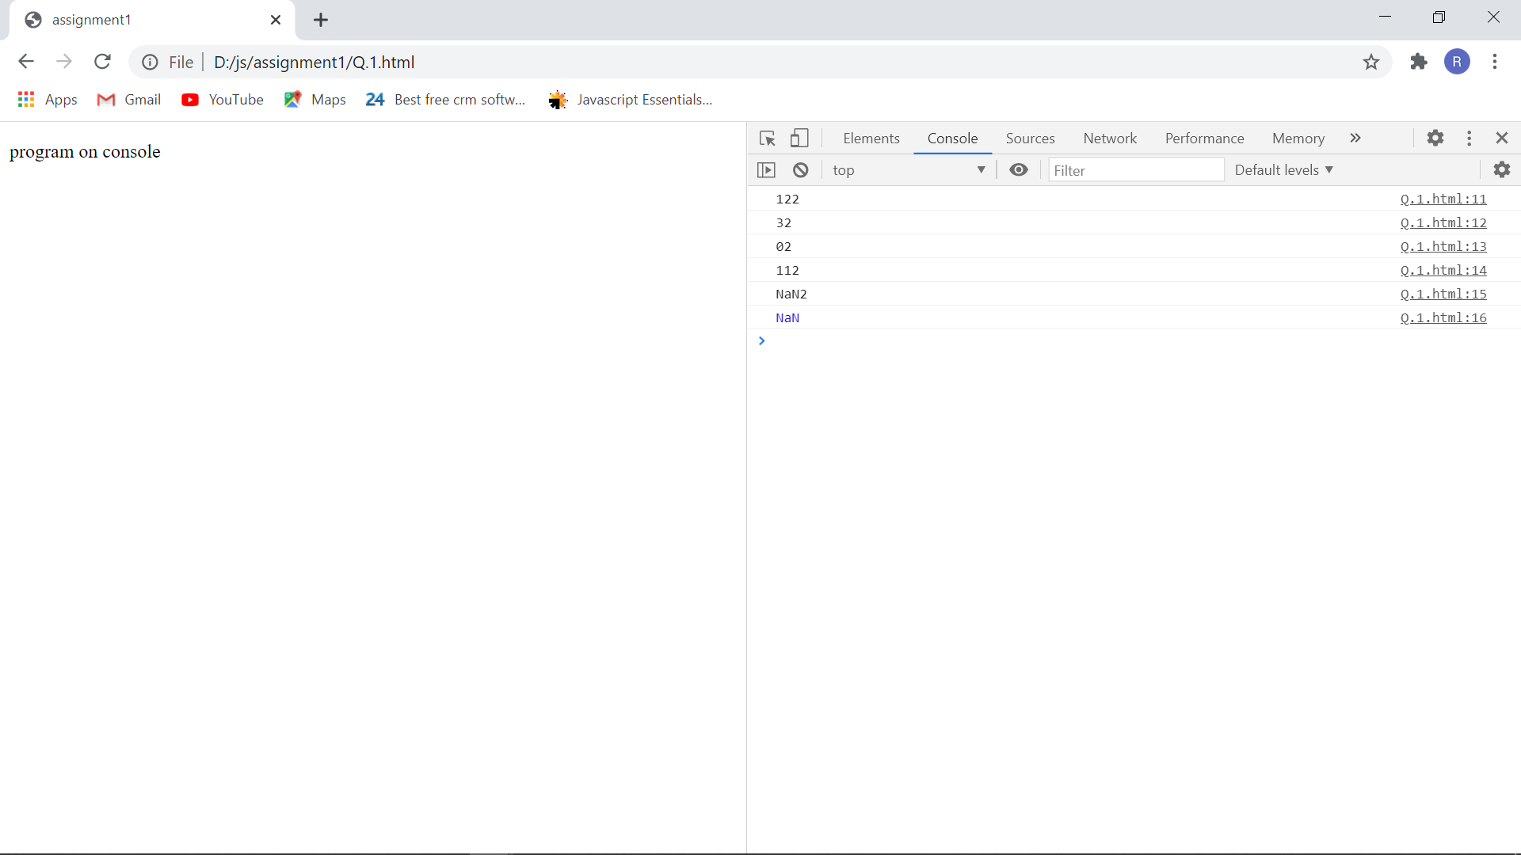

console.log(1 + "2" + "2");

Ans

We get 122

Take individual number as 1 is number while both 2 is character or just a symbol is predicted.

        console.log(1 + +"2" + "2");

Ans

1++”2”=3

And “2” =2

Hence, we get 32 as here first two is treated as number and addition operation performed of first two number and print last one as it is.

        console.log(1 + -"1" + "2");

Ans

1+-‘’1”=0

”2”

Hence, we get 02 as here first two is treated as number and subtraction operation performed of first two number and print last one as it is.

   console.log(+"1" + "1" + "2");

Ans

We get 112 , as console treated all as character or symbol.

        console.log("A" - "B" + "2");

Ans

We get NaN2

Not a number and 2 is a symbol

        console.log("A" - "B" + 2);

Ans

We get NAN