Step : When I Enter Username and Password
Time : 2026-03-16 08:06:43
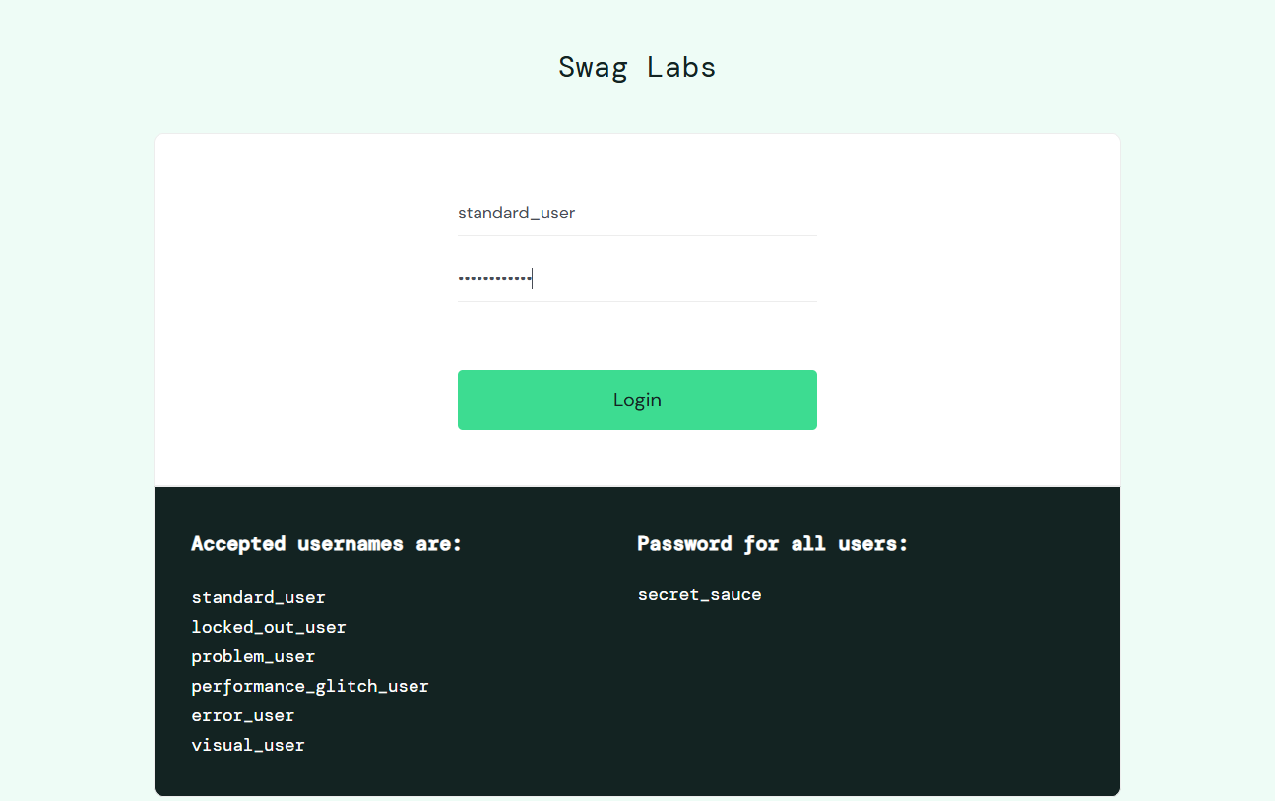
Step : And I click on login button
Time : 2026-03-16 08:06:45
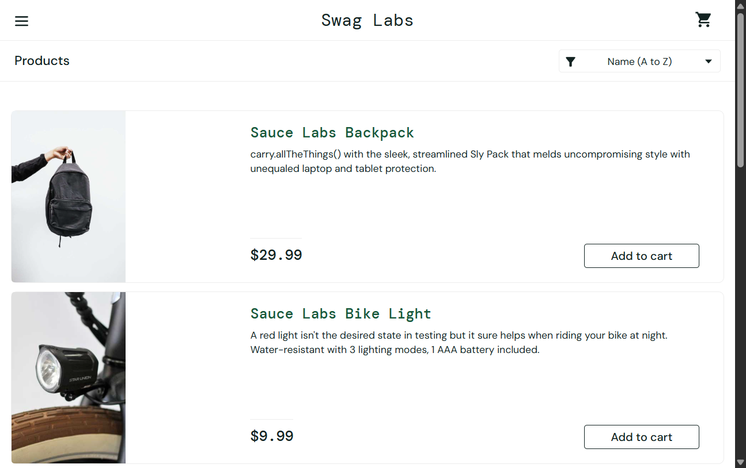
Step : I verify SwagLabs home page
Time : 2026-03-16 08:06:45

Step : And I get all product names
Time : 2026-03-16 08:06:46


