Step : When I Enter Username and Password
Time : 2026-03-15 22:27:52
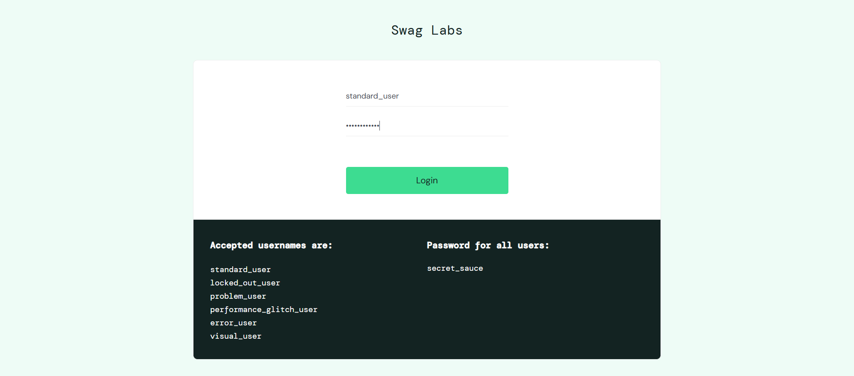
Step : And I click on login button
Time : 2026-03-15 22:27:54
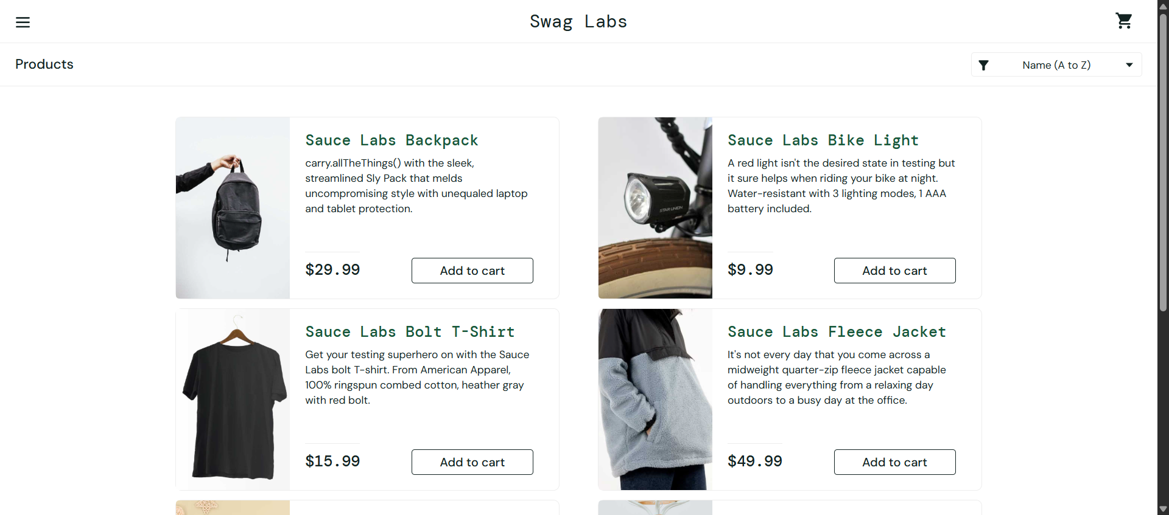
Step : I verify SwagLabs home page
Time : 2026-03-15 22:27:55


