Rishabh Bhatia

Output:

Introduction page with sliders

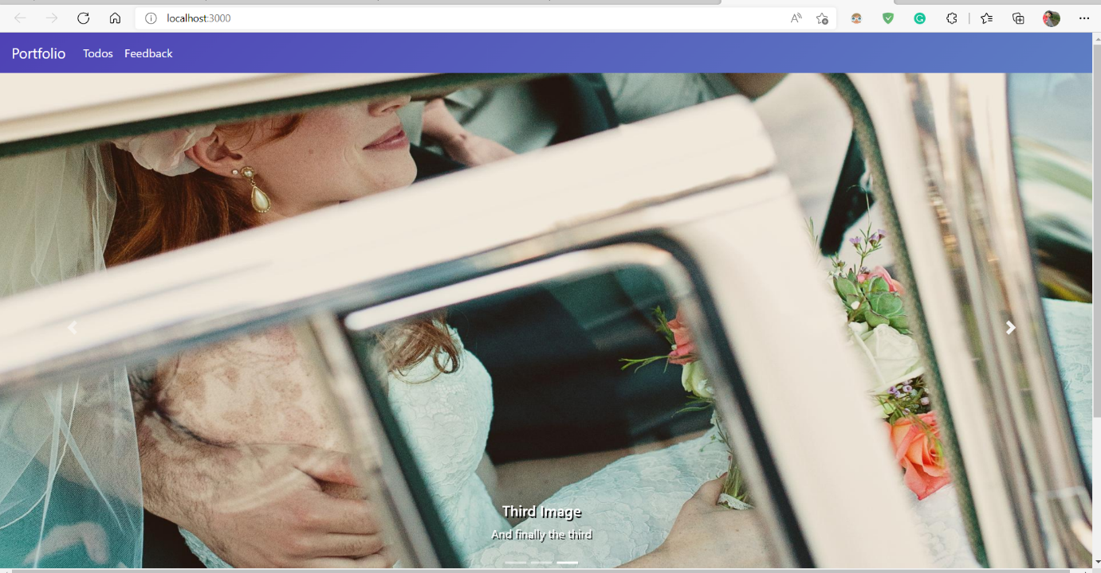

Feedback page: printing vales on submit