GoIbibo Cab Booking Automation
Project presentation document for the Pytest POM suite and the BDD Behave suite
Project 1  Pytest + Selenium + Page Object Model  Code-driven regression suite with Allure, pytest-html, logs, and screenshots. | Project 2  Behave BDD + Selenium  Business-readable Gherkin suite with 8 scenarios, step-level Allure logs, screenshots, and negative outcome files.

Main idea
Both projects automate the same GoIbibo cab-booking domain. The first project proves the flow using Pytest and POM. The second project rebuilds it as BDD so the same testing intent is readable as Given-When-Then scenarios.

Prepared by: Rishabh Chauhan | Date: 23 May 2026

Executive Overview
This document explains two Selenium automation projects built around GoIbibo cab booking. The Pytest project uses a Page Object Model structure for code-focused automation. The BDD project uses Behave feature files so the same business flow can be read by testers, trainers, and evaluators without opening Python first.
Area | Pytest POM Project | BDD Project
Main purpose | Automate GoIbibo cab search, filters, cab selection, passenger details, negative checks, and screenshots. | Express the same domain as Gherkin scenarios, with one full UPI QR end-to-end flow and seven supporting scenarios.
Framework | Pytest with Selenium WebDriver and Allure Pytest. | Behave with Selenium WebDriver and Allure Behave.
Design pattern | Page Object Model: test files call reusable page methods. | BDD layering: feature files -> step definitions -> page objects -> locators.
Evidence generated | Allure results, pytest HTML report, logs, and screenshots. | Allure report, Behave JSON/text report, HTML report, JUnit XML, logs, screenshots, and negative outcome JSON files.
End point of main flow | Stops after cab selection and anonymous passenger details are filled. | Continues to payment, selects UPI, clicks Generate/View QR, verifies QR display, and stops before real payment.

Project 1: Pytest POM Cab Automation
Local folder: C:\Users\risha\PyCharmMiscProject\CapstoneProject\GoIbiboAutomationProject
The first project is a Pytest suite written around Page Object Model classes. The test file stays readable while the browser actions are kept inside page methods such as opening the Cabs page, selecting cities, applying filters, choosing a cab, and filling passenger details.

Structure And Responsibilities
Folder/File | Role
tests/test_cab_booking.py | Contains the positive, negative, parameterized, and end-to-end Pytest cases.
pages/base_page.py | Shared Selenium helpers for waits, safe clicks, text checks, screenshots, and page loading.
pages/cab_booking_page.py | Main Page Object for GoIbibo Cabs: popup cleanup, city selection, search, filters, cab selection, and passenger details.
conftest.py | Pytest fixture setup for Chrome WebDriver lifecycle.
pytest.ini | Default execution options for Allure results, pytest HTML report, and test discovery.
utils/logger.py | Central logging helper used during execution.
reports, screenshots, logs | Stores HTML reports, visual proof, and execution log files.

Workflow
- Open the GoIbibo Cabs URL directly and clear popups.
- Select pickup city and destination city through stable visible text and input fallback logic.
- Apply pickup time, search cabs, and wait for result cards.
- Apply cab type filters such as Hatchback, Sedan, and SUV on different journeys.
- Select an available cab and fill anonymous passenger details.
- For negative tests, record what happened and pass the case if the application stays controlled.
Run: cd C:\Users\risha\PyCharmMiscProject\CapstoneProject\GoIbiboAutomationProject
Run: pytest
Open reports: allure serve allure-results OR open reports\report.html

Pytest Test Coverage
Test | Type | What It Verifies
Cabs page opens directly | Positive | URL or page source confirms the Cabs page is available.
Pickup city can be selected | Positive | Delhi appears in visible text or input value after selection.
Pickup and destination can be selected | Positive | Delhi and Agra are both retained in the form.
Search results display | Positive | Cab cards or SELECT CAB actions become visible.
Booking flow until passenger details | Positive | Cab selection opens details page and anonymous data is entered.
Parameterized city/filter journeys | Positive | Delhi-Agra Hatchback, Mumbai-Pune Sedan, Bangalore-Mysore SUV with visible results and AC observation.
Same pickup/drop handling | Negative | Checks how the app behaves for invalid same-route input and records observation.
Empty pickup handling | Negative | Checks that a search without pickup is blocked or safely handled.
End-to-end until passenger details | E2E | Full search, cab selection, and anonymous passenger details entry.

Important Functions
Function/Helper | Purpose
open_cabs_page_directly() | Loads https://www.goibibo.com/cars/, waits for the page, refreshes once if needed, closes popups, and captures a screenshot.
dismiss_popups() | Uses generic close, X, skip, later, and not-now locators so popups do not break tests.
select_city(field_name, city_name) | Clicks From or To, types the city with a reliable input strategy, then selects the matching suggestion.
search_cabs() | Clicks SEARCH CABS using exact and case-insensitive fallback XPath locators.
select_cab_type_filter(cab_type) | Applies filters like Hatchback, Sedan, and SUV from the listing page.
select_first_available_cab() | Clicks the first visible SELECT CAB button after results are loaded.
fill_passenger_details() | Enters anonymous name, mobile number, and email on the cab review/details page.
cab_results_are_visible() | Assertion helper that checks whether result cards or SELECT CAB buttons exist.

Locator Strategy
Locator Example | Why It Was Used
//button[contains(translate(normalize-space(.), 'ABCDEFGHIJKLMNOPQRSTUVWXYZ', 'abcdefghijklmnopqrstuvwxyz'), 'search')] | Search button text may vary in case or surrounding whitespace, so the XPath normalizes it.
//input[contains(translate(@placeholder, 'ABCDEFGHIJKLMNOPQRSTUVWXYZ', 'abcdefghijklmnopqrstuvwxyz'), 'pickup')] | City inputs are located by meaning instead of brittle screen position.
//button[contains(translate(normalize-space(.), 'ABCDEFGHIJKLMNOPQRSTUVWXYZ', 'abcdefghijklmnopqrstuvwxyz'), 'select cab')] | Works even when SELECT CAB text is inside button spans.
[aria-label*='close' i], [class*='close' i] | Popup close buttons often change class names, so generic close selectors are safer.
//input[@type='email'] | Email field has a reliable semantic attribute on the passenger details page.

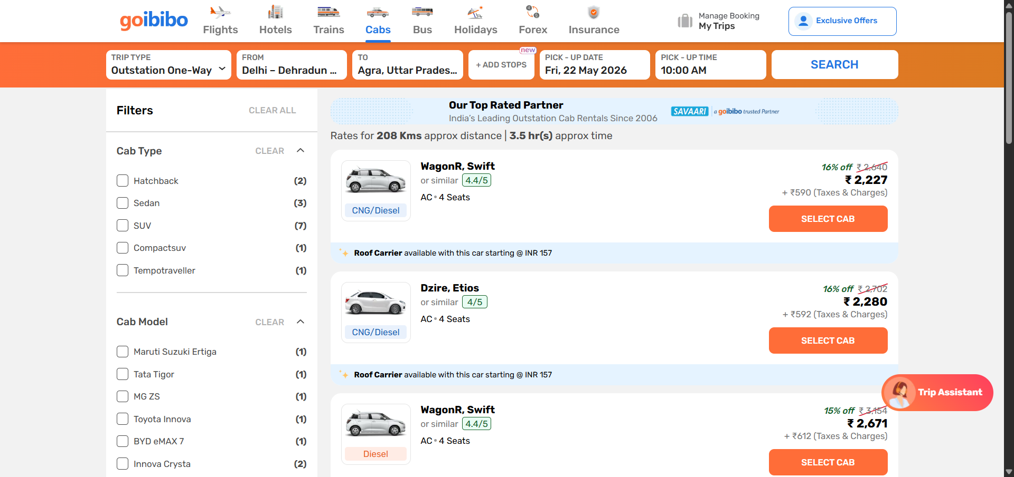
Pytest evidence: E2E flow reached cab results and displayed selectable cab cards.
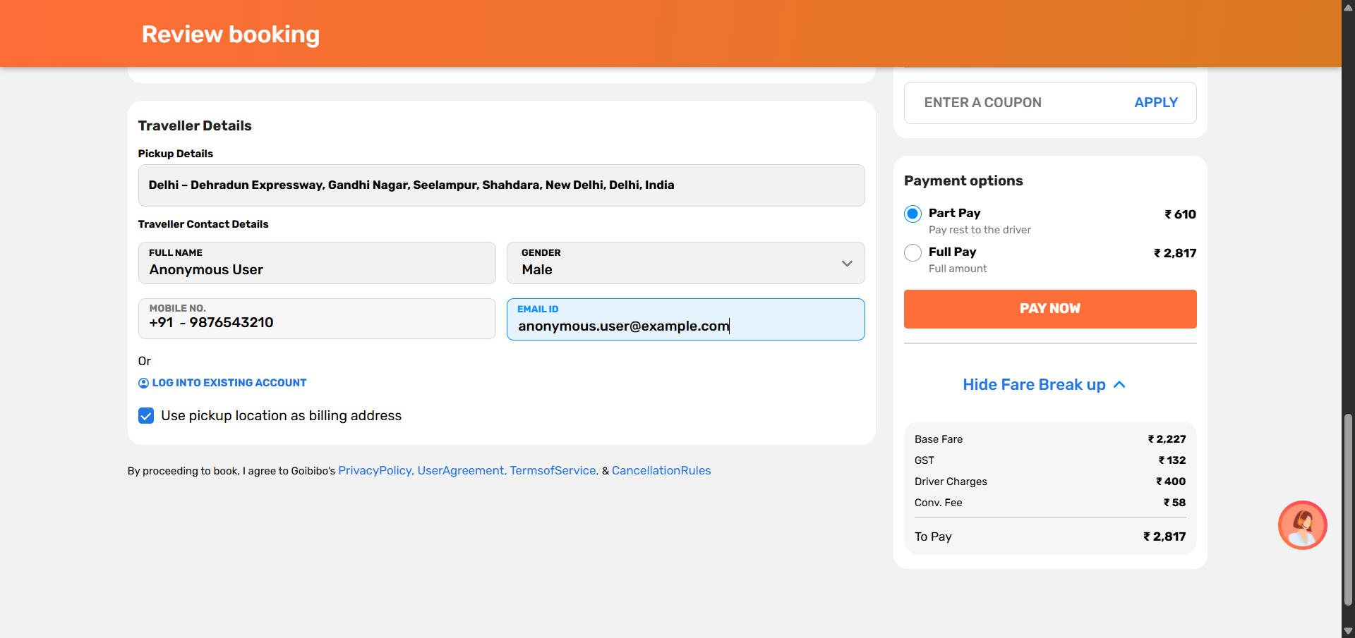
Pytest evidence: anonymous passenger details were filled after selecting a cab.

Project 2: BDD Cab Automation
Local folder: C:\Users\risha\PyCharmMiscProject\BDDproject\BDDcabsGoIbibo_NEW
The second project converts the same cab-booking automation into BDD. The important difference is that test intent is written in feature files using Given, When, Then steps. Python step definitions then call page objects to perform the real Selenium work.
Current run result
The latest saved Behave run shows 3 features passed, 8 scenarios passed, and 58 steps passed with 0 failures. The suite also attaches Execution log text and screenshots to every Allure step.

Structure And Responsibilities
Folder/File | Role
features/*.feature | Readable BDD scenarios for E2E, positive filter coverage, and negative validation.
features/steps/goibibo_cab_steps.py | Maps each Gherkin step to Python methods.
features/environment.py | Behave hooks for driver setup, logs, screenshots after every step, Allure attachments, and negative outcome files.
locators/cab_locators.py | Central XPath and CSS locators for home, listing, review, and payment pages.
pages/*.py | Page objects for home/search, results, review, booking helpers, and payment.
utils/*.py | Config reader, driver factory, waits, logger, report writer, and test data helpers.
scripts/run_all_reports.py | Runs Behave and generates all report outputs.
reports/* | Allure, Behave, HTML, JUnit, logs, screenshots, and negative outcome evidence.

BDD Scenario Coverage
Scenario | Type | Route/Filter | End Point
Delhi to Agra UPI QR flow | E2E | Hatchback + CNG, WagonR/Swift preference | UPI QR request displayed; no payment completed.
Delhi to Agra | Positive | Sedan + Diesel, Dzire/Etios preference | Cab review page.
Mumbai to Pune | Positive | SUV + Diesel, Ertiga/Innova preference | Cab review page.
Bangalore to Mysuru | Positive | Electric, BYD E6/EV preference | Cab review page.
Jaipur to Ajmer | Positive | Petrol + Innova Crysta preference | Cab review page.
Delhi to Chandigarh | Positive | Sedan with AC listing check | Cab review page.
Missing drop city | Negative | Pickup selected, drop city blank | Listing must not open; outcome JSON recorded.
Typed but unselected invalid drop | Negative | Invalid text Atlantis Nowhere | Listing must not open; outcome JSON recorded.

BDD Workflow
- Feature files describe the business journey in plain English.
- Step definitions read the scenario data table and call page object methods.
- Page objects interact with GoIbibo using centralized locators and explicit waits.
- Positive filter scenarios select a cab after applying filters and stop at the review page.
- The E2E scenario fills anonymous traveller details, opens payment, selects UPI, generates/views QR, and stops before real payment.
- Negative scenarios pass by design when invalid search behavior is observed and documented.
Run: cd C:\Users\risha\PyCharmMiscProject\BDDproject\BDDcabsGoIbibo_NEW
Run all reports: python scripts\run_all_reports.py
Open Allure report: allure open reports\allure-report

BDD Locator Strategy
Page | Locator Examples | Reason
Home | //h1[normalize-space()='Book Online Cab']; input[placeholder*='Pickup']; input[placeholder*='Drop'] | Validates the correct page and targets search fields semantically.
Listing | //*[contains(., 'Filters')]; //button[contains(normalize-space(.), 'SELECT CAB')] | Confirms listing page loaded and finds selectable cab cards.
Review | //*[contains(normalize-space(.), 'Review booking')]; //input[@label='FULL NAME']; //button[contains(., 'PAY NOW')] | Verifies review page and fills traveller details by field labels.
Payment | UPI Options text, Generate/View QR button, QR modal text, UPI QR image | Checks payment screen without completing real transaction.

BDD Assertions
- Results are displayed when Filters and at least one SELECT CAB button are visible.
- Applied filters are checked against listing observations and saved into the report evidence.
- Review page is verified by URL, review heading, and traveller detail sections.
- Anonymous details are verified after filling pickup location, full name, mobile, and email.
- UPI QR is verified by QR modal text or QR image after Generate/View QR is clicked.
- No real payment is completed because success or booking-confirmation text must not appear.
- Negative tests assert that invalid searches do not open the listing or review page.
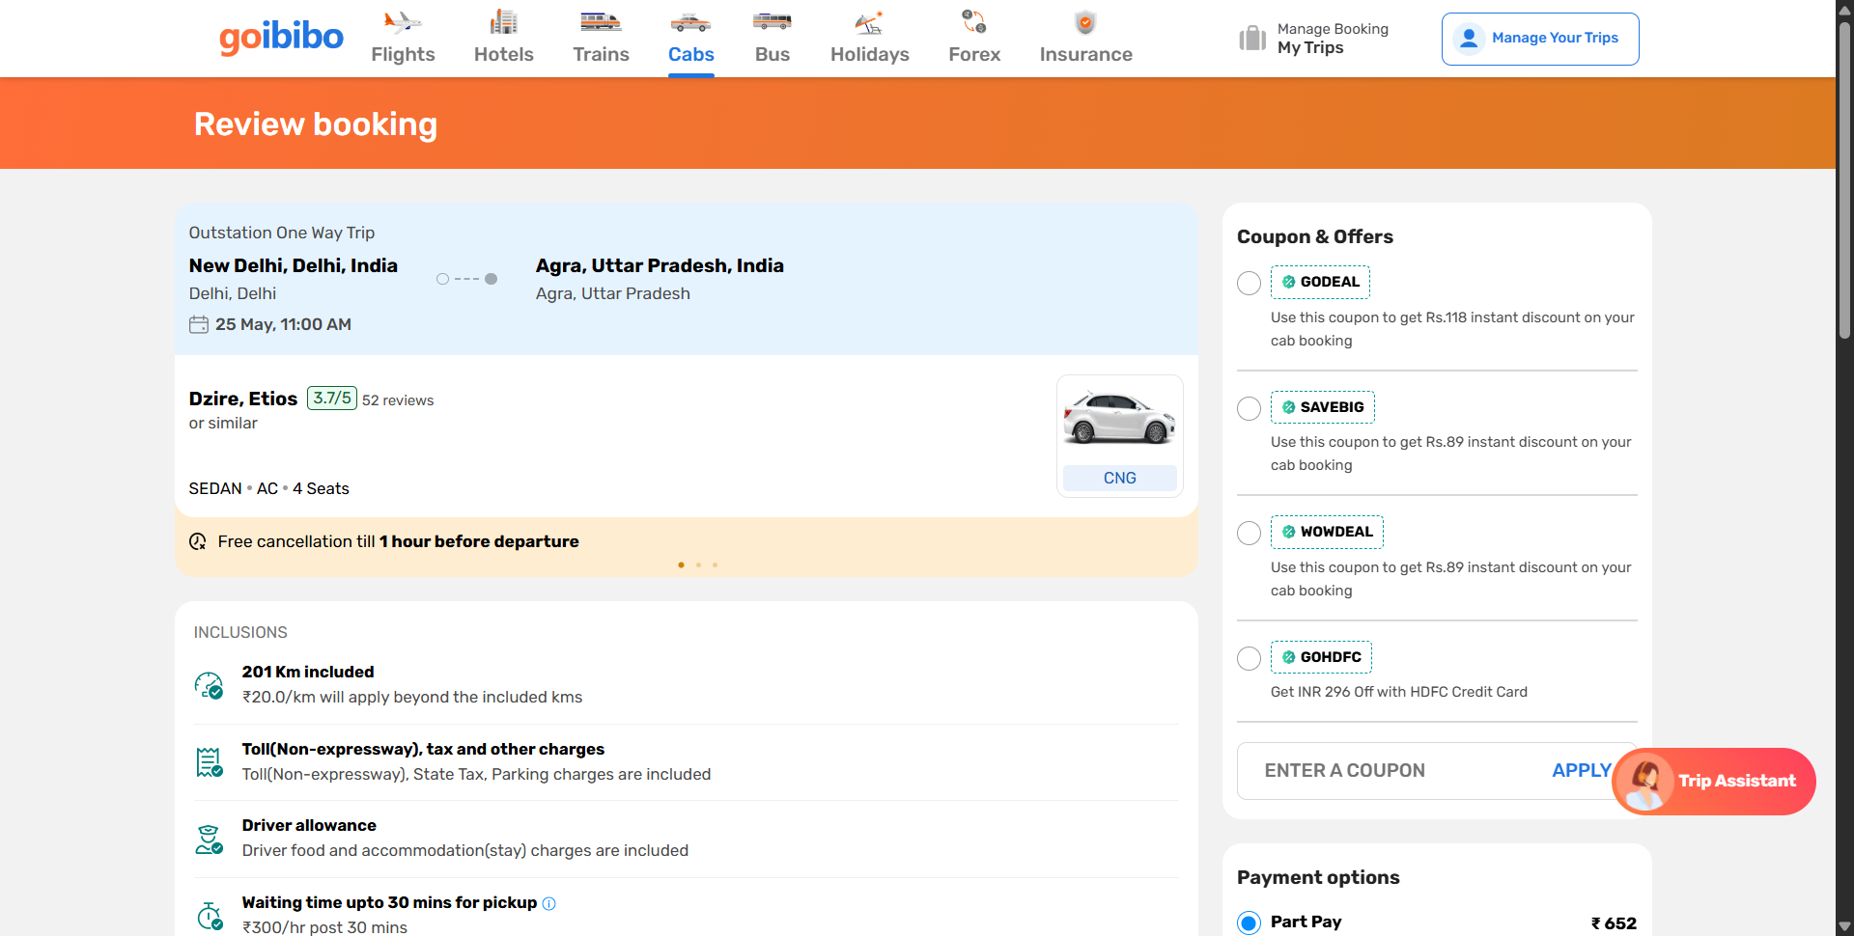
BDD evidence: positive Sedan/Diesel filter scenario selected a cab and reached the review page.
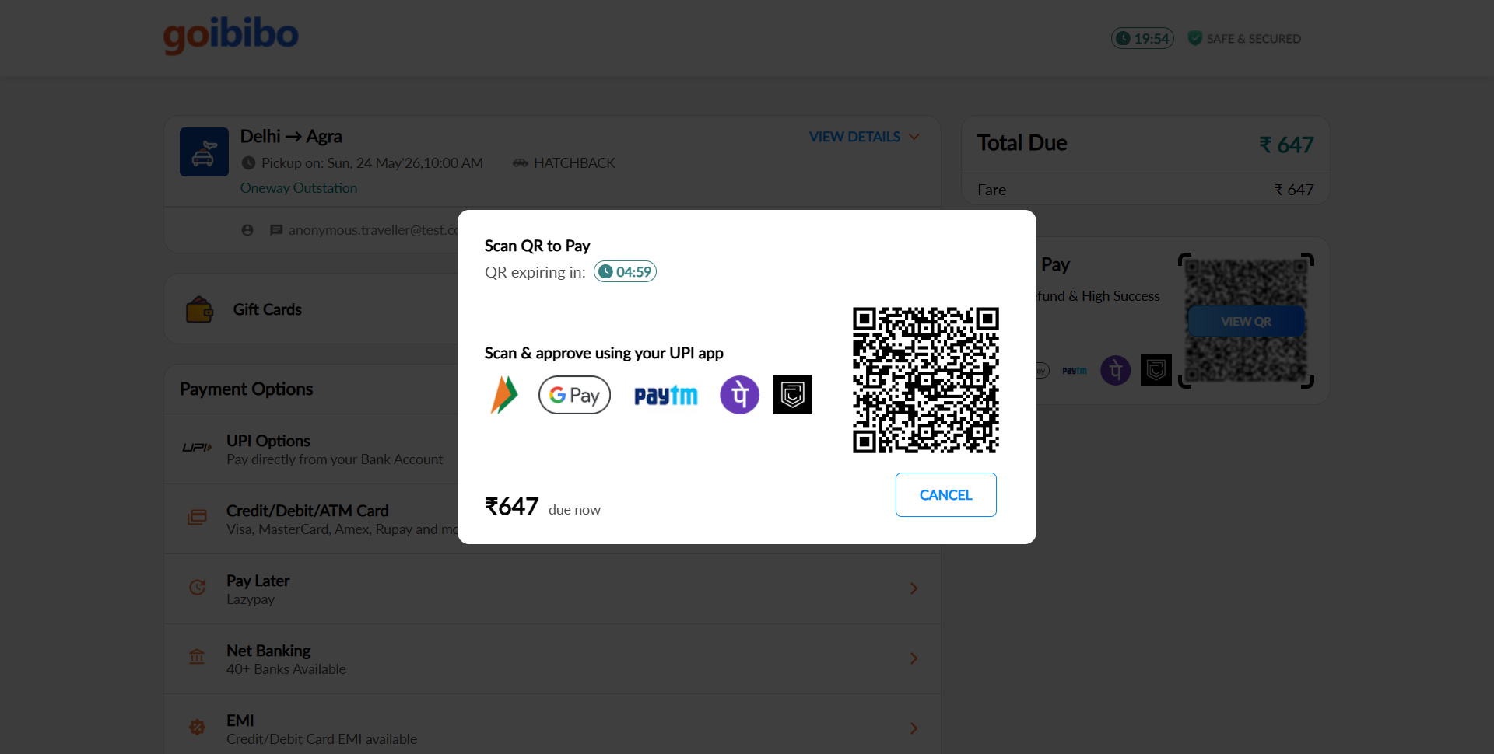
BDD evidence: the E2E scenario reached the UPI QR payment request and stopped safely.
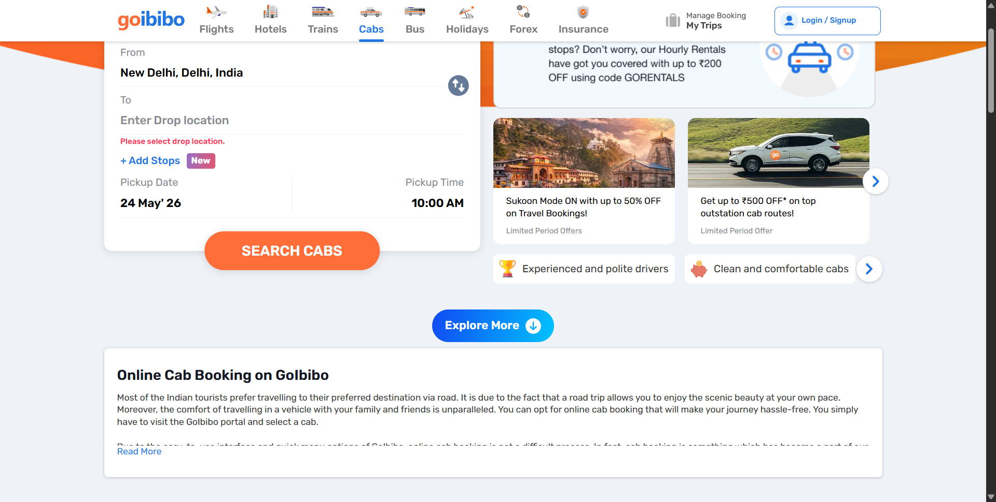
BDD evidence: negative missing-drop-city case was recorded while the listing stayed blocked.

Reports And Evidence
Evidence Type | Pytest POM | BDD Behave
Allure | allure-results and generated Allure report for test steps, screenshots, and status. | reports/allure-results and reports/allure-report with step Execution log and screenshots for every step.
HTML | reports/report.html from pytest-html. | reports/html/index.html from the BDD report flow.
Logs | logs/test_execution.log records browser actions and screenshots. | reports/logs/behave-console.log plus timestamped run logs.
Screenshots | screenshots/*.png for each major test stage. | reports/screenshots/*.png after each step and final scenario state.
Machine-readable outputs | Allure JSON files generated under allure-results. | Behave JSON, JUnit XML, Allure JSON, and negative outcome JSON.

Allure Report Screenshots
These screenshots are taken from the generated Allure report folders. They show pass status, test totals, and the BDD step-level execution evidence.
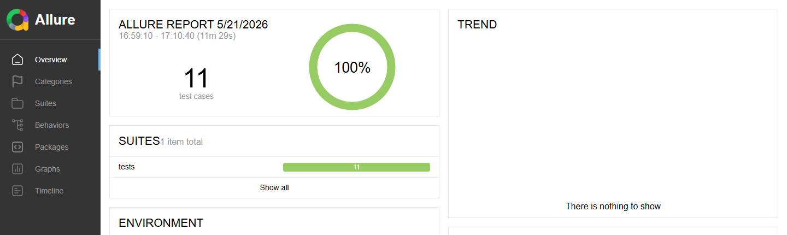
Allure evidence: Pytest POM report shows 11 test cases with 100% pass status.
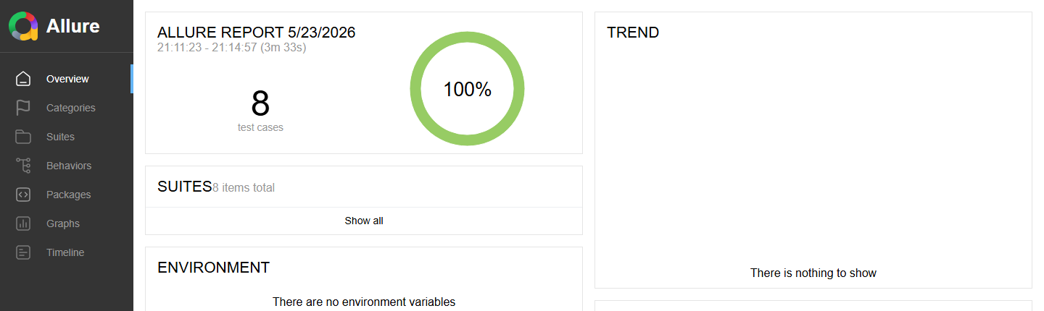
Allure evidence: BDD report shows 8 scenarios with 100% pass status.
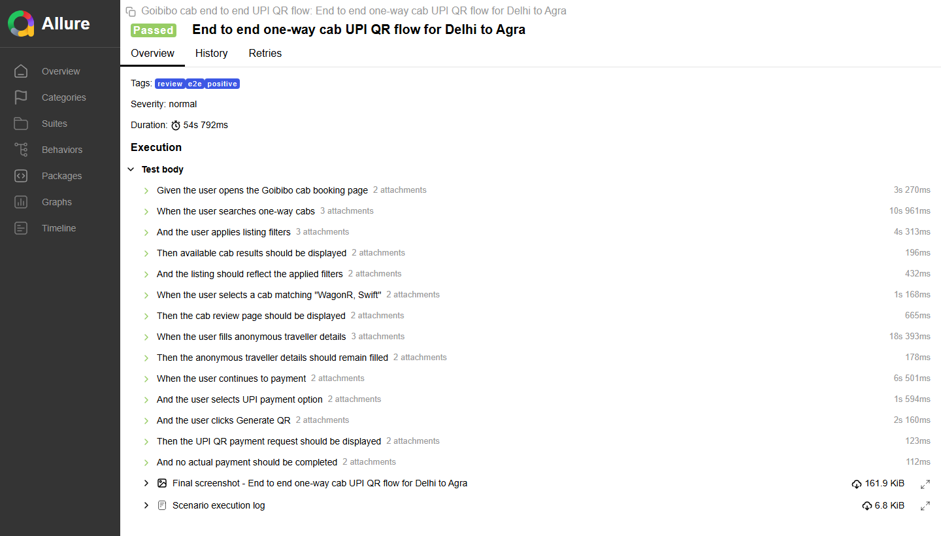
Allure evidence: BDD E2E scenario detail shows passed steps with execution log and screenshot attachments.

Issues Faced And Fixes
Issue | Fix Applied
GoIbibo popups interrupted clicks. | Added reusable popup cleanup using Escape, generic close selectors, X buttons, skip/later/not-now text, and repeated cleanup loops.
City fields and suggestions were dynamic. | Used visible-label clicks, placeholder-based input locators, JavaScript fallback, controlled typing, and suggestion matching.
Some text and locator casing changed across screens. | Used normalize-space and translate in XPath for whitespace-tolerant and case-insensitive matching.
BDD report initially lacked logs inside Allure. | Added Behave hooks that attach an Execution log after every step, step screenshots, final scenario logs, and negative outcome JSON.
Positive filter tests originally stopped at filter selection. | Updated BDD positive tests to select a cab after filters and end at the review page.
Payment must not be completed during automation. | E2E stops at UPI QR request and explicitly checks that no booking/payment success state is reached.

Conclusion
The Pytest project proves automation strength through reusable page objects and parameterized tests. The BDD project adds structured Gherkin scenarios and a deeper end-to-end checkout checkpoint.

