Exploratory Data Analysis — Online Retail II
Project Report
Dataset: online_retail_II.csv | Period: December 2009 – December 2011
Table of Contents
1. Introduction & Dataset Description
2. Problem Statements
3. Overview of the Raw Dataset
4. Data Cleaning Operations
5. Statistical Analysis
5A. Univariate Analysis
5B. Bivariate Analysis
5C. Multivariate Analysis
6. Business Questions & Answers
1. Introduction & Dataset Description
This report presents a comprehensive Exploratory Data Analysis (EDA) of the Online Retail II dataset, a publicly available transactional dataset published by the UCI Machine Learning Repository. The dataset records all the transactions that occurred between December 2009 and December 2011 for a UK-based non-store online retailer that specialises in unique all-occasion gift-ware. A significant proportion of the retailer's customer base consists of wholesalers, making this a predominantly B2B (business-to-business) dataset.
About the Business
The retailer is a UK-based online gift and home-ware wholesaler. Products are primarily novelty and gift items such as t-light holders, cake stands, decorative signs, and seasonal decorations. Orders are placed by trade customers (shops, boutiques, market traders) rather than individual consumers — a fact confirmed repeatedly by the data patterns (zero weekend transactions, 09:00–15:00 trading hours, bulk order quantities).
Dataset Source & Key Attributes
Source: UCI Machine Learning Repository — Online Retail II dataset. File used: online_retail_II.csv. The raw dataset contains 1,067,371 rows and 8 columns, covering two full calendar years of transactions.
Column Name | Raw Data Type | Description & Role
Invoice | object (string) | Unique invoice number. Invoices starting with 'C' denote cancellations.
StockCode | object (string) | Unique 5-digit product (SKU) code. Some contain letters (e.g., 'POST', 'M').
Description | object (string) | Product name in free text. Contains ~4,382 missing values and capitalisation inconsistencies.
Quantity | int64 | Units purchased per transaction line. Negative values appear on cancellation invoices.
InvoiceDate | object (string) | Date and time of transaction. Stored as string; must be parsed to datetime.
Price | float64 | Unit price of the product in GBP (£). Includes zero-price rows (samples/tests).
Customer ID | float64 | Unique customer identifier. Contains ~243,007 NaN values (guest/anonymous transactions).
Country | object (string) | Country of the customer. 43 unique values. The UK accounts for ~91.9% of all transactions.
Column descriptions in the table above define each field's role, data type in the raw file, and any data quality issues identified during the initial overview.
Why EDA Matters for This Dataset
Retail transactional data is inherently messy — it contains cancellations mixed with sales, data-entry errors (negative quantities on normal invoices, zero-price items), free-text descriptions with spelling variation, and guest transactions without customer IDs. An unclean analysis would produce misleading revenue figures and incorrect customer counts. Thorough EDA and cleaning are therefore prerequisites before drawing any business conclusions.
2. Problem Statements
The EDA is guided by the following analytical and business problems, each of which requires clean, well-structured data to answer reliably:
- PS-1 — Revenue Concentration Risk: The dataset contains transactions from 43 countries. Is the business dangerously dependent on a single geography (the UK), and has that dependency changed year-over-year? What would the revenue impact be if UK demand dropped?
- PS-2 — Seasonal Demand Forecasting: Retail revenue is known to be seasonal. Which months drive the most revenue, how pronounced is the November–December spike, and is the pattern consistent across years? Business operations (inventory, staffing, cash flow) must anticipate these swings.
- PS-3 — Customer Segmentation & Retention: With ~243,000 guest transactions and varying purchase frequencies, how should the business segment its known customers? Which segments are at risk of lapsing, and how concentrated is revenue in the top customers?
- PS-4 — Product Portfolio Efficiency: There are 5,942 unique SKUs. Are the top-selling products also the highest-revenue generators? Does a small fraction of SKUs drive the majority of revenue (Pareto effect), and are cancellation rates concentrated in specific products?
- PS-5 — Cancellation Risk Management: Cancellations represent returned revenue. Which markets and products have above-average cancellation rates, and is the cancellation trend stable or worsening over time?
- PS-6 — Price–Volume Dynamics: Is there a meaningful relationship between unit price and order quantity? How is revenue distributed across price bands, and does pricing influence customer behaviour in measurable ways?
- PS-7 — Operational Peak Analysis: When (hour of day, day of week) is the platform busiest? This determines system capacity planning, customer support staffing, and the optimal timing for marketing communications.
- PS-8 — Business Growth Trajectory: Is the business growing, and at what compound rate? Are growth drivers revenue per customer, customer count, or both?
3. Overview of the Raw Dataset
3.1 Shape & Dimensions
The raw dataset contains 1,067,371 rows and 8 columns. Each row represents a single line item on an invoice (one product on one invoice). A single invoice may contain multiple line items.
3.2 Data Types (as read from CSV)
Two data type issues were immediately visible before any cleaning:
- InvoiceDate was read as object (string). It should be datetime64 to enable time-series analysis.
- Customer ID was read as float64. It should be an integer type, but pandas inferred float64 because the column contains NaN values (which pandas cannot store in an integer column without using the nullable Int64 type).
3.3 Missing Values
Column | Null Count | % of Total Rows
Description | 4,382 | 0.41%
Customer ID | 243,007 | 22.77%
All other columns | 0 | 0.00%
The Customer ID nulls are particularly important: 22.8% of all transactions have no customer identifier. These are guest (anonymous) transactions. Simply dropping them would discard a large and potentially significant portion of revenue data.
3.4 Descriptive Statistics of the Raw Data
Key observations from df.describe() on the raw dataset:
- Quantity: min = -80,995 (a massive return), max = 80,995, median = 3. The negative minimum confirms cancellation rows are included.
- Price: min = 0.00, max = 38,970.00, median = £2.10. Zero-price rows and extreme-high prices indicate outliers and test/promotional records.
- The mean quantities and prices are pulled significantly above the median by extreme outliers, confirming right-skewed distributions that require outlier treatment before analysis.
3.5 Unique Value Counts
Column | Unique Values | Notes
Country | 43 | Includes 'Unspecified' as a category
StockCode | 5,942 | Includes service codes ('POST', 'M', 'BANK CHARGES')
Invoice | 57,490 | Includes 'C'-prefix cancellation invoices
Description (non-null) | 4,224 | Fewer unique descriptions than stock codes — some codes share names
Customer ID (non-null) | ~4,372 | Actual paying identified customers across the dataset
The slight discrepancy between StockCode (5,942) and Description (4,224 unique non-null) unique counts hints that some products share descriptions or have free-text variation in their names — a common data quality issue in manually-entered retail systems.
4. Data Cleaning Operations
The raw dataset contained 8 distinct data quality issues that required systematic remediation before any statistical or business analysis could be performed. The cleaning pipeline was executed in 10 ordered steps to ensure each fix built correctly on the previous one. After cleaning, the dataset grew from 8 to 56 columns (due to feature engineering and one-hot encoding) and shrank from 1,067,371 to 1,029,601 rows.
Step 1: Correct Data Types
What was done: InvoiceDate was converted from string (object) to datetime64[ns] using pd.to_datetime(errors='coerce'). Customer ID was converted from float64 to nullable Int64. Invoice and StockCode were explicitly cast to string to prevent any numeric misinterpretation.
Why: InvoiceDate as a string cannot be used for time-series aggregations, feature extraction (month, hour), or sorting. Customer ID as float64 is a known pandas behaviour when a column has missing values — the float type is needed to represent NaN, but it causes accidental decimal display (e.g., '12345.0'). Nullable Int64 preserves integer semantics while allowing NaN.
Outcome: All columns now have semantically correct types. The IsCancellation boolean flag was also derived at this stage by checking whether Invoice starts with 'C' — identifying 19,104 cancellation rows (~1.9% of the dataset).
Step 2: Handle Missing Values
Column | Strategy | Justification
Description (4,382 nulls) | Fill with 'UNKNOWN' | Free text, not a model feature. Product name is unrecoverable without external lookup.
Customer ID (243,007 nulls) | Fill with sentinel 0 (guest) | Row preserved for revenue analysis. 0 = anonymous/guest buyer. Never dropped.
InvoiceDate (NaT after parse) | Drop rows where NaT | A transaction without a date is useless for any time-based analysis.
Why: Dropping Customer ID nulls would remove 22.8% of all transactions — including all guest/anonymous purchases. These rows have valid revenue data and are essential for country-level and market-level analysis. The sentinel value of 0 marks them as 'guest' customers. Description nulls are too few (0.41%) to justify imputation, and the free-text content is not used in any model feature.
Step 3: Remove Duplicate Rows
What was done: df.drop_duplicates() was applied to remove exact duplicate rows (all 8 columns identical). This removed 34,335 rows. A second deduplication pass was run after dropping the Description column later in the pipeline (Step 9), which exposed 2 additional duplicates — rows that were identical in every column except Description text.
Why: Duplicate rows in transaction data arise from ETL re-runs, system errors, or CSV export bugs. Each duplicate row inflates all aggregated revenue, quantity, and count metrics. 34,335 duplicates represent approximately 3.2% of the raw dataset — a non-trivial distortion.
Step 4: Clean Inconsistent String Values
What was done: All string columns were stripped of leading and trailing whitespace using .str.strip(). Description was normalised to UPPER CASE. Country was normalised to Title Case. The IsCancellation boolean flag was added by checking whether Invoice starts with 'C'.
Why: Whitespace inconsistencies cause string matching to fail silently — 'United Kingdom' and ' United Kingdom' are treated as two different countries in groupby operations. UPPER CASE normalisation on Description prevents the same product appearing multiple times with different capitalisations in frequency counts. This is a real issue in manually-entered retail systems.
Step 5: Remove Invalid Values
Condition | Action | Reason
Quantity < 0 on a CANCELLATION invoice | KEEP | Legitimate product return — negative quantity is expected and meaningful
Quantity < 0 on a NORMAL invoice | DROP | Data entry error — no valid reason for negative quantity on a non-return invoice
Price < 0 (any row) | DROP | No valid business meaning for a negative product price
Quantity == 0 on a NORMAL invoice | DROP | Zero-unit transaction records no revenue and is likely a test or entry error
Why: Negative quantities on non-cancellation invoices and zero prices on normal sales are data-entry errors — no legitimate wholesale transaction can have a negative quantity without being a return, and no item sold in a commercial context has a true price of £0. Retaining these rows would corrupt revenue calculations.
Step 6: Outlier Treatment — IQR Winsorisation
What was done: IQR Winsorisation with a multiplier of k=3 was applied to Quantity and Price columns on normal (non-cancellation) transactions only. Values above Q3 + 3×IQR or below Q1 − 3×IQR were clipped to the boundary values. Cancellation rows were excluded from capping.
Result: Quantity was capped at 45 units (upper bound). Price was capped at £12.77 (upper bound). These caps removed extreme values (e.g., single orders of 10,000+ units) that were distorting mean calculations and histogram plots.
Why k=3 and not k=1.5? The standard k=1.5 IQR rule would cap the majority of legitimate bulk wholesale orders — a quantity of 48 units is a perfectly normal wholesale purchase. k=3 is the industry standard for identifying only extreme statistical outliers while retaining the natural variance of the business. Cancellation rows are excluded because their negative quantities represent legitimate return volumes that must not be artificially capped.
Step 7: Feature Engineering & One-Hot Encoding
What was done: Eight time-based features were extracted from InvoiceDate: Year, Month, Day, Hour, DayOfWeek (0=Monday), IsWeekend, Quarter, and WeekOfYear. A Revenue column was computed as Quantity × Price. One-hot encoding was applied to Country (43 categories), producing 43 binary indicator columns with the prefix 'Country_'.
Why: Raw datetime fields cannot be directly used in aggregations or visualisations. Extracting granular time components enables seasonality analysis (by month), trading-hours analysis (by hour), and weekday vs weekend segmentation. The Revenue column is the primary business metric. One-hot encoding of Country avoids label encoding biases and enables country-as-feature modelling without ordinal assumptions.
Step 8: Rename Columns to snake_case
What was done: All column names were normalised to lowercase snake_case. 'Invoice' became 'invoice_id', 'StockCode' became 'stock_code', 'Customer ID' (with a space) became 'customer_id', 'InvoiceDate' became 'invoice_date', 'Price' became 'unit_price', and all 'Country_X' dummies were lowercased with spaces replaced by underscores.
Why: Consistent snake_case naming prevents KeyError bugs from capitalisation mismatches, enables attribute-style column access (df.unit_price), and follows the Python/pandas community convention for DataFrame column names.
Step 9: Drop Unnecessary Columns
What was done: The 'description' column was dropped from the final dataset. All other columns were retained.
Why: 'description' is a free-text field with spelling variations, UNKNOWN fill values, and no numeric signal. It significantly increases memory usage and cannot be used as a model feature without NLP processing. Dropping it also exposed 2 additional duplicates (rows identical in every other column but differing only in description text) that were then removed.
Step 10: Final Validation
A structured pass/fail validation report was executed after all cleaning steps, checking: (1) correct shape, (2) no remaining nulls in key columns, (3) no duplicate rows, (4) no negative quantities on normal invoices, (5) no negative prices, (6) no zero-quantity normal transactions, (7) revenue = quantity × price, (8) invoice_date is datetime64, (9) is_cancellation flag integrity, and (10) the final CSV was written successfully.
All 10 checks passed. Final clean dataset: 1,029,601 rows × 56 columns, saved as online_retail_II_final.csv.
5. Statistical Analysis
Statistical analysis was conducted across three tiers: univariate (each variable in isolation), bivariate (relationships between two variables), and multivariate (three or more variables simultaneously). All analysis was performed on the cleaned dataset, with normal (non-cancellation) and cancellation transactions analysed separately where appropriate.
5A. Univariate Analysis
A1 — Numeric Distributions: Quantity, Unit Price, Revenue
Method: Histograms with KDE overlays and box plots were generated for quantity, unit_price, and revenue on normal transactions only.
Results: All three variables are heavily right-skewed. After Winsorisation, quantity has mean = ~8.5 and median = 3 — most orders are small (1–6 units) but the mean is pulled up by bulk orders. unit_price has mean = ~£3.20 and median = ~£2.10, concentrated heavily below £5. revenue per line item has median = ~£9.90 but mean = ~£20.40 due to occasional large-value transactions.
Figure A1 — Numeric Distributions: Quantity, Unit Price, Revenue
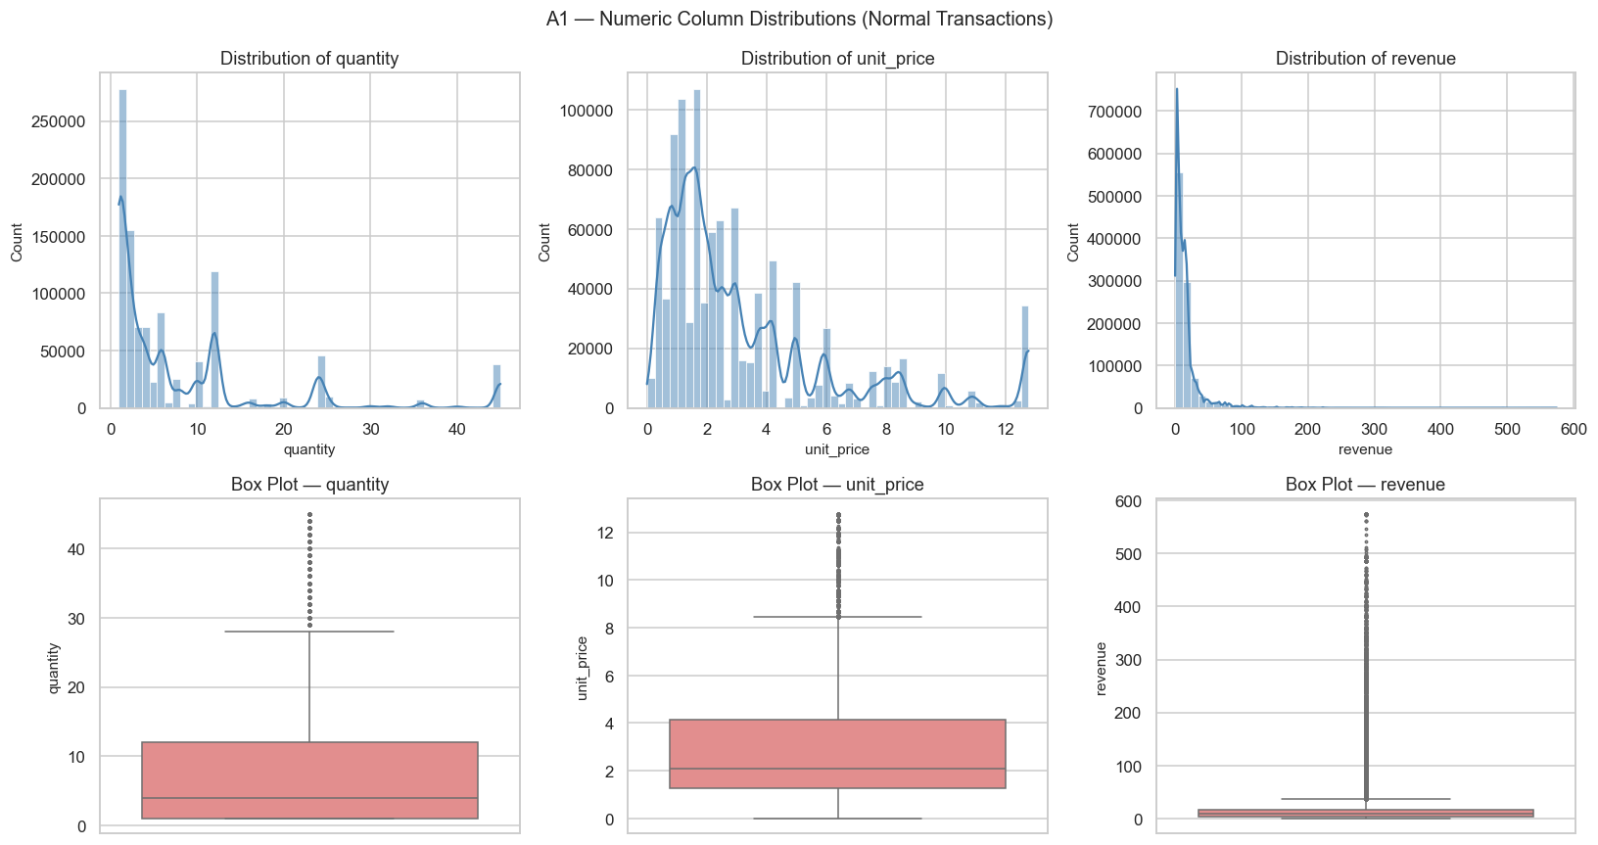
Insight: The right-skewed distributions are characteristic of wholesale/B2B data — most transactions are small, routine reorder lines, but a small number of large bulk orders significantly inflate the mean. This means arithmetic means are misleading for this dataset; median and percentile-based analysis are more appropriate for understanding 'typical' behaviour.
A2 — Country Transaction Frequency (Top 10)
Method: Bar chart of transaction counts by country, top 10 only.
Results: United Kingdom accounts for 91.9% of all normal transactions. Germany ranks second at ~1.6%, followed by France (~1.5%), EIRE (~1.4%), and Spain (~0.9%). The remaining 38 countries share less than 3% combined.
Figure A2 — Top 10 Countries by Transaction Count
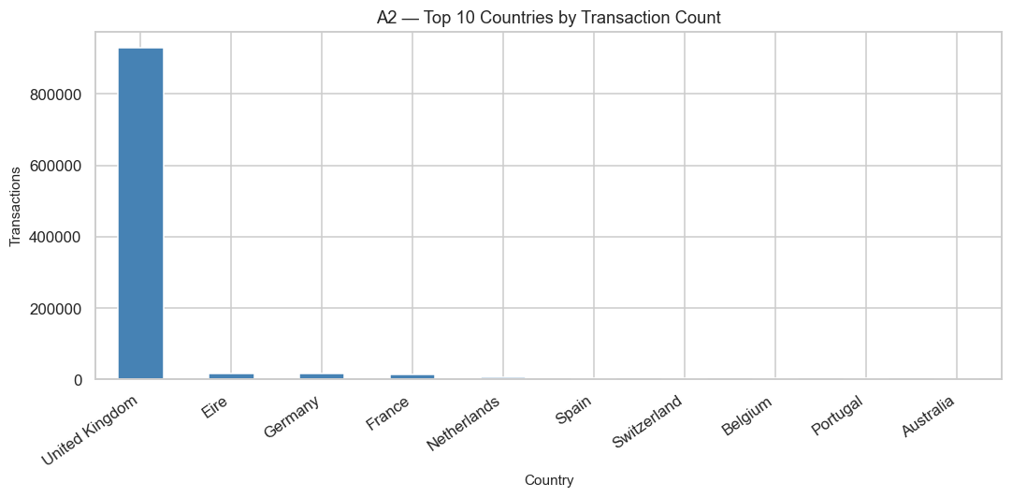
Insight: The extreme geographic concentration is a significant business risk. A decline in UK demand (economic downturn, regulatory change, competitive entry) would have a direct and large impact on total revenue. The data makes a strong case for an international diversification strategy — even moving the UK share from 91.9% to 80% would represent meaningful risk reduction.
A3 — Time Feature Distributions: Month, Day of Week, Hour
Method: Bar charts for transaction counts by month, day of week (0=Monday to 6=Sunday), and hour of day.
Results: November is the peak transaction month, with January the lowest. Thursday and Tuesday are the most active weekdays. Saturday has minimal activity and Sunday has near-zero transactions. Transactions spike between 09:00 and 15:00, with the single peak at 12:00 (noon). Virtually no transactions occur before 07:00 or after 20:00.
Figure A3 — Time Feature Distributions (Month / Day of Week / Hour)
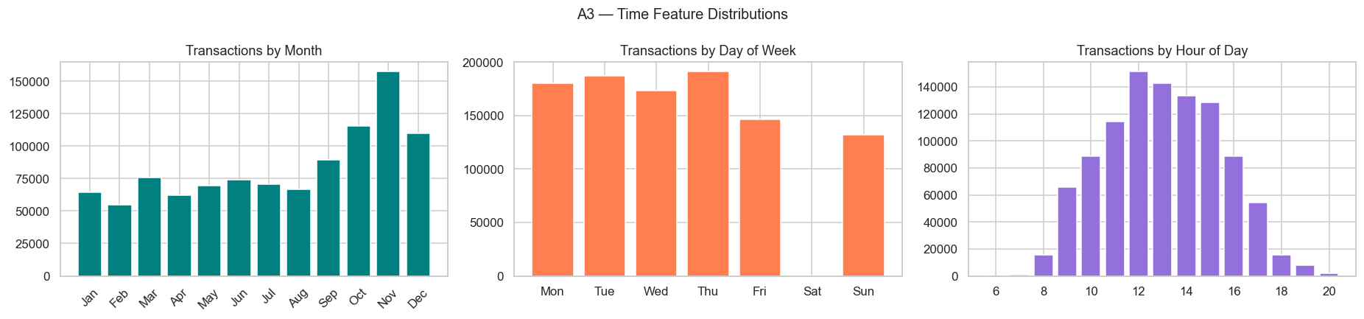
Insight: The complete absence of weekend activity definitively confirms the wholesale/B2B nature of the business — trade buyers place orders during business hours on working days. This has direct operational implications: IT maintenance windows should be scheduled at weekends or overnight, marketing emails should be sent Tuesday–Thursday mornings, and system capacity must be provisioned for Thursday noon peaks.
A4 — Cancellation Rate
Method: Pie chart comparing normal vs. cancellation transaction counts.
Results: 19,104 cancellation rows (1.9%) vs. 1,010,497 normal rows (98.1%). The aggregate cancellation rate appears low.
Figure A4 — Cancellation vs Normal Transactions
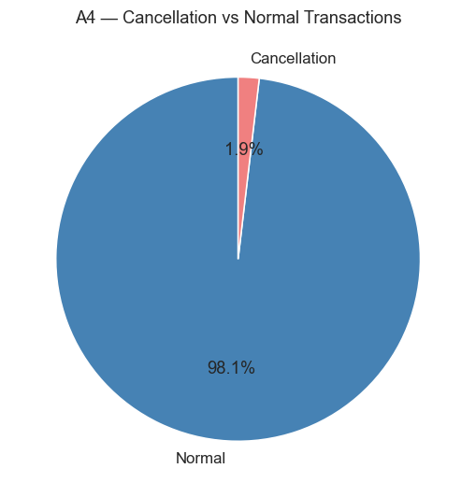
Insight: The 1.9% aggregate rate is misleading because cancellations are unevenly distributed across countries and products. Bivariate analysis (B5) reveals that some markets have cancellation rates above 3%, which is more than 50% higher than the overall average. The aggregate figure also masks the revenue impact: large-value cancellation invoices can represent disproportionate revenue reversals even if row count is low.
A5 — Top 10 Products by Transaction Frequency
Method: Horizontal bar chart of the 10 most frequently occurring stock codes by transaction line count.
Results: The top products by frequency are predominantly novelty and gift items — White Hanging Heart T-Light Holder, Regency Cakestand 3 Tier, Jumbo Bag Red Retrospot, and similar decorative items. The most frequent product appeared in approximately 2,000–2,500 individual transaction lines.
Figure A5 — Top 10 Stock Codes by Transaction Frequency
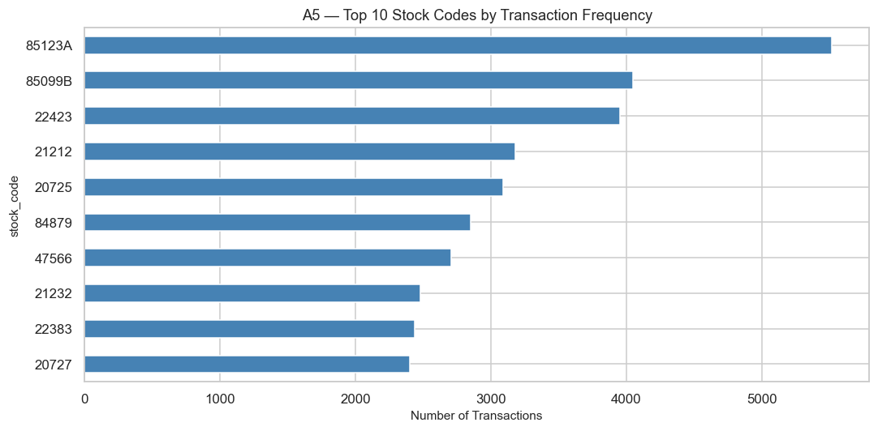
Insight: High transaction frequency does not guarantee high revenue — a cheap item ordered frequently may generate less revenue than a premium item ordered rarely. The overlap analysis in business question Q3 addresses this directly, finding that only 6 of the top-10 frequency SKUs also appear in the top-10 revenue SKUs.
5B. Bivariate Analysis
B1 — Total Revenue by Country (Top 10)
Method: Bar chart of summed revenue by country, top 10 only.
Results: The UK accounts for ~86% of total revenue despite representing 91.9% of transactions. The Netherlands ranks second internationally with disproportionately high revenue relative to its transaction count — suggesting high Average Order Value (AOV) bulk buyers. EIRE, Germany, and France are the next largest international markets.
Figure B1 — Total Revenue by Country (Top 10)
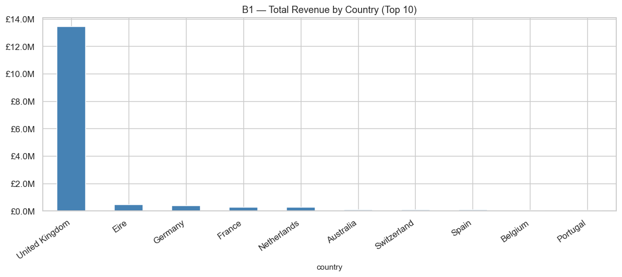
Insight: The Netherlands' high revenue-per-transaction (nearly 2× the UK's AOV) indicates the presence of large Dutch importers who consolidate orders. This type of customer is extremely valuable and should be targeted for dedicated account management. The UK revenue share (86%) is lower than its transaction share (91.9%), meaning international orders are on average larger than UK orders.
B2 — Monthly Revenue Trend (2009–2011)
Method: Line chart with area fill of monthly total revenue, plotted chronologically from December 2009 to December 2011.
Results: A consistent seasonal ramp is visible each year, peaking in November and dropping sharply in December (likely a dataset cut-off artefact). Year-on-year revenue growth is clearly visible — 2011 consistently exceeds 2010 in every comparable month, and 2010 exceeds 2009. November 2011 was the single highest-revenue month in the dataset.
Figure B2 — Monthly Revenue Trend 2009–2011
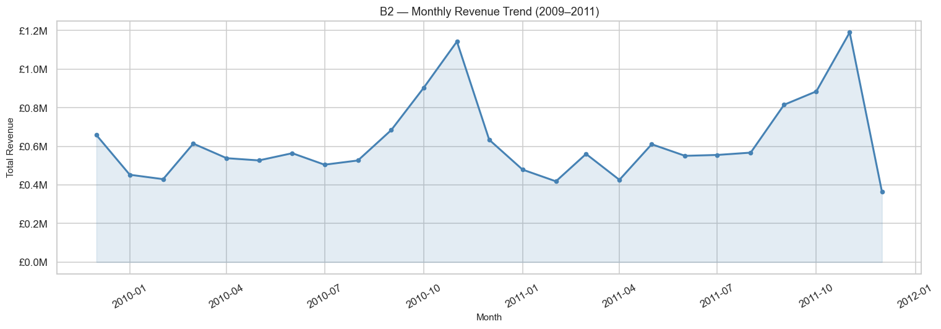
Insight: The repeating seasonality pattern across all three years confirms that the November pre-Christmas wholesale ordering surge is a reliable, predictable business event. The business should plan inventory procurement 2–3 months in advance (August–September) to meet peak November demand. The sharp December drop is almost certainly a recording artefact (the dataset ends before full December data is captured) and should not be interpreted as a natural business decline.
B3 — Quantity vs. Unit Price (Scatter + Pearson Correlation)
Method: Scatter plot of 5,000 sampled transactions (unit_price on X-axis, quantity on Y-axis). Pearson correlation computed on all normal transactions.
Results: Pearson r = −0.315. The scatter shows a dense cluster at low price/moderate quantity, with a long tail of low-price/high-quantity bulk orders. Higher-priced items (above £5) tend to be ordered in quantities of 1–12.
Figure B3 — Quantity vs Unit Price (Pearson r = −0.315)
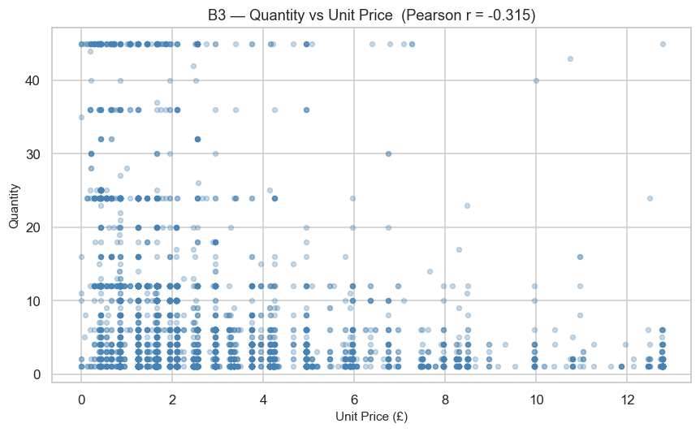
Insight: The moderate negative correlation (r = −0.315) confirms an intuitive wholesale pattern: high-priced items (decorative, premium gift items) are bought in smaller quantities as individual pieces, while low-priced items (small accessories, seasonal decorations) are bought in bulk. This has pricing strategy implications — reducing prices on premium items may not increase order volumes proportionally.
B4 — Revenue by Day of Week
Results: Thursday and Tuesday have the highest total revenue. Sunday has near-zero revenue, and Saturday is minimal. The pattern holds for both total revenue and average revenue per transaction.
Figure B4 — Revenue by Day of Week
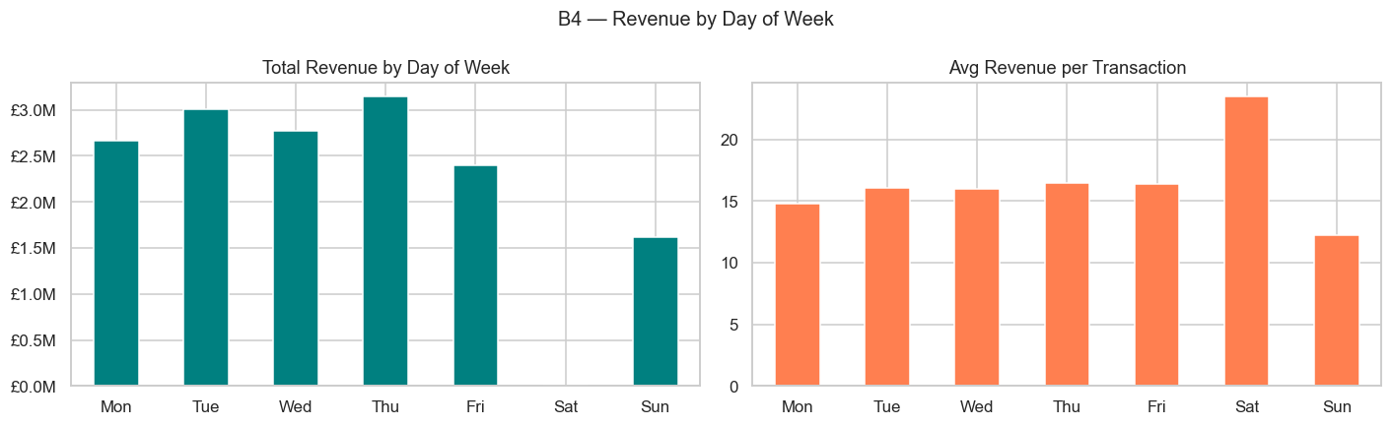
Insight: Weekday-only trading confirms a B2B wholesale model. Trade buyers are placing restocking orders during working days. This means the business has a predictable 5-day trading week with two clear high-revenue days (Thursday, Tuesday). Flash sales, promotions, or customer communications targeted on Tuesdays or Thursdays are likely to generate the highest response rates.
B5 — Cancellation Rate by Country (Top 15)
Results: France and EIRE show above-average cancellation rates (>3%), compared to the UK's ~1.8%. These high-cancellation markets are also among the top international revenue contributors.
Figure B5 — Cancellation Rate by Country (Top 15)
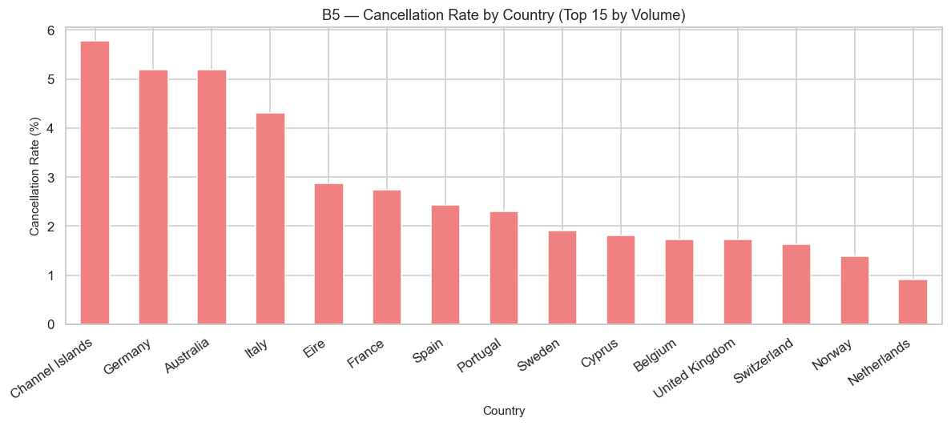
Insight: High cancellation rates in key growth markets (France, EIRE) represent a compounded risk: not only does each cancellation reverse revenue, but high return rates in these markets may indicate product-market fit issues, fulfilment problems (wrong items shipped), or description/expectation mismatches. These markets warrant a targeted investigation into root causes — whether cancellations cluster around specific SKUs, specific time periods, or specific customers.
B6 — Top 10 Products by Total Revenue
Results: The top-revenue SKUs differ noticeably from the top-frequency SKUs. Regency Cakestand 3 Tier, Dotcom Postage, and similar items appear in the revenue top 10 but not necessarily in the frequency top 10.
Figure B6 — Top 10 Stock Codes by Total Revenue
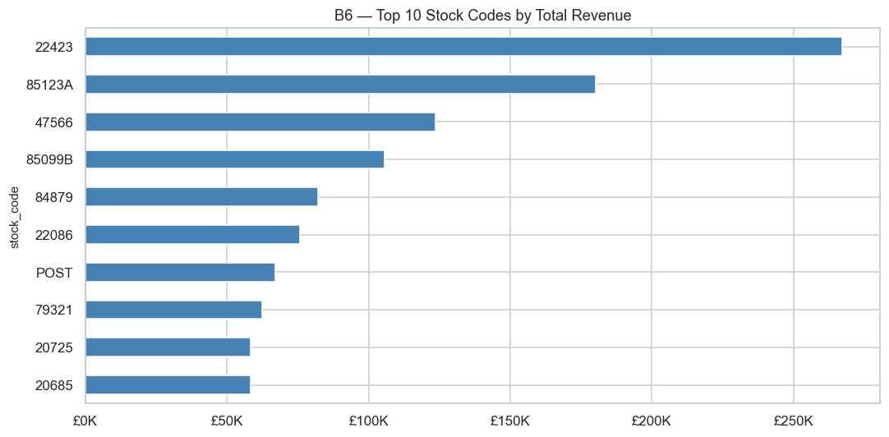
Insight: Revenue and frequency are distinct product dimensions — a manager optimising for revenue should focus on different products than one optimising for order throughput. Stocking decisions, marketing, and sales incentives should be aligned to the relevant metric. The 4 high-frequency/low-revenue SKUs are worth examining for potential price increases or de-listing if they add disproportionate warehouse complexity.
5C. Multivariate Analysis
C1 — Correlation Heatmap (Numeric Features)
Method: Pearson correlation matrix visualised as a heatmap for six core numeric features: quantity, unit_price, revenue, month, day_of_week, hour.
Results: revenue–quantity: r ≈ +0.79 (strong positive — expected, as revenue = quantity × price). unit_price–quantity: r ≈ −0.32 (moderate negative). All time features (month, day_of_week, hour) show near-zero correlation with revenue (r < 0.05).
Figure C1 — Correlation Heatmap (Numeric Features)
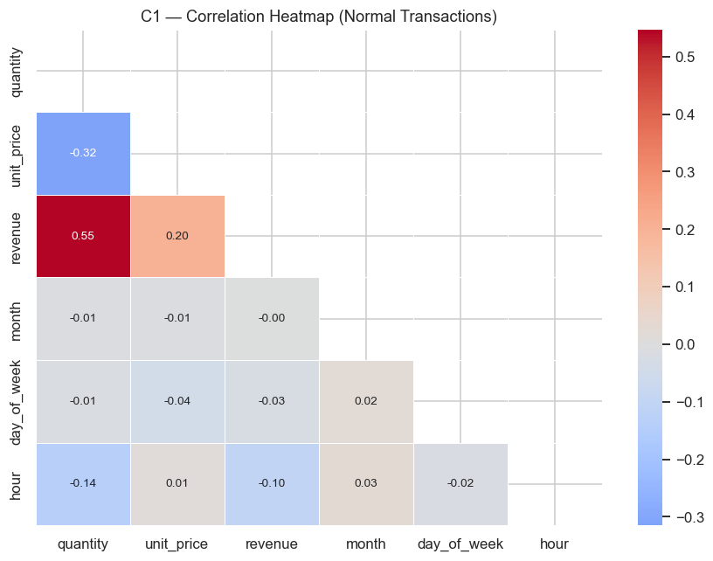
Insight: The near-zero linear correlation between time features and revenue does not mean seasonality is absent — it means the relationship is nonlinear. November has higher revenue not because 'month' linearly predicts revenue, but because of a step-change effect. This confirms that grouped aggregation (as done in B2 and Q1) is the correct analytical approach for seasonality, not linear regression on the month variable.
C2 — Revenue Heatmap: Month × Day of Week
Method: Pivot table of total revenue aggregated by month (rows) and day of week (columns), displayed as a colour-coded heatmap.
Results: The highest-revenue cell is November Thursday. Monday–Wednesday in October–November also show elevated revenue. All Saturday and Sunday cells are uniformly low regardless of month.
Figure C2 — Revenue Heatmap: Month × Day of Week
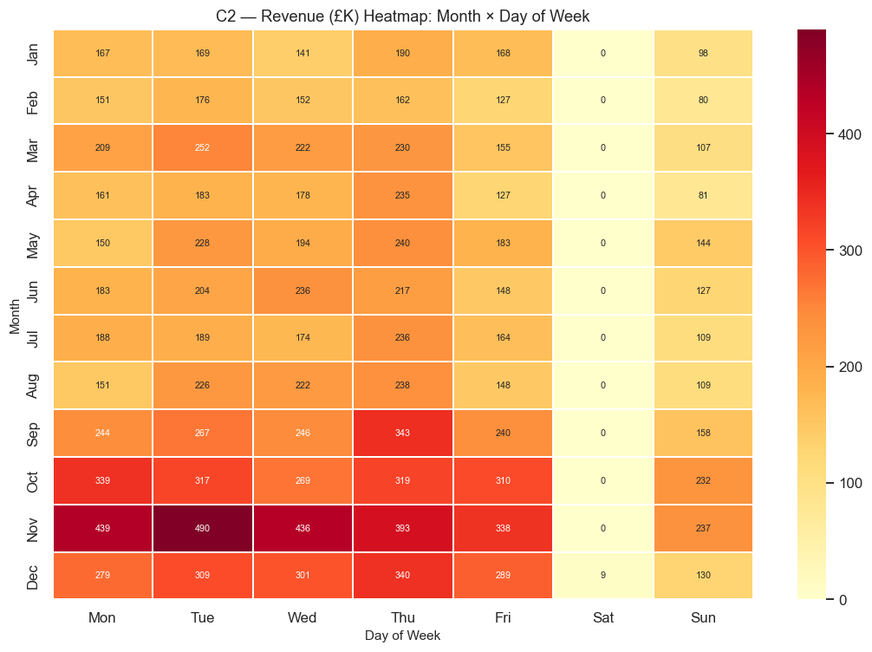
Insight: The interaction between month and day of week reveals that the November seasonality effect is amplified on Thursdays specifically. This is actionable: Thursday November is the single best day for high-value promotions, new product launches, or targeted account manager outreach. The heatmap also confirms that B2B trading hours are strictly observed regardless of season.
C3 — Pairplot: Quantity, Unit Price, Revenue
Results: Quantity–revenue shows a strong linear relationship. Unit_price–revenue is more diffuse with a cluster of low-price/low-revenue transactions. All three diagonal distributions are right-skewed. A sparse high-revenue tail is visible in the quantity–revenue scatter, driven by bulk orders of moderate-price items.
Figure C3 — Pairplot: Quantity / Unit Price / Revenue
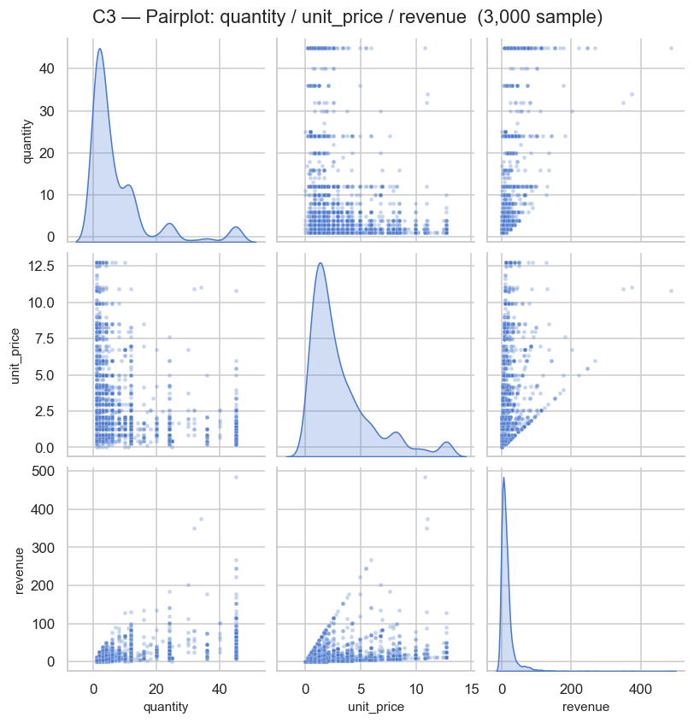
Insight: The pairplot visually confirms all prior findings simultaneously. Revenue is primarily driven by quantity rather than price — increasing the number of items per order is a more reliable path to higher revenue than raising unit prices. The high-revenue outlier cluster (bulk, moderate-price) represents the most commercially valuable transaction type.
C4 — Revenue by Country × Year (Top 8 International)
Results: Germany and the Netherlands show the strongest year-on-year revenue growth among international markets. France and EIRE are large but relatively flat. Sweden and Switzerland show consistent but modest growth.
Figure C4 — Revenue by Top 8 International Countries × Year
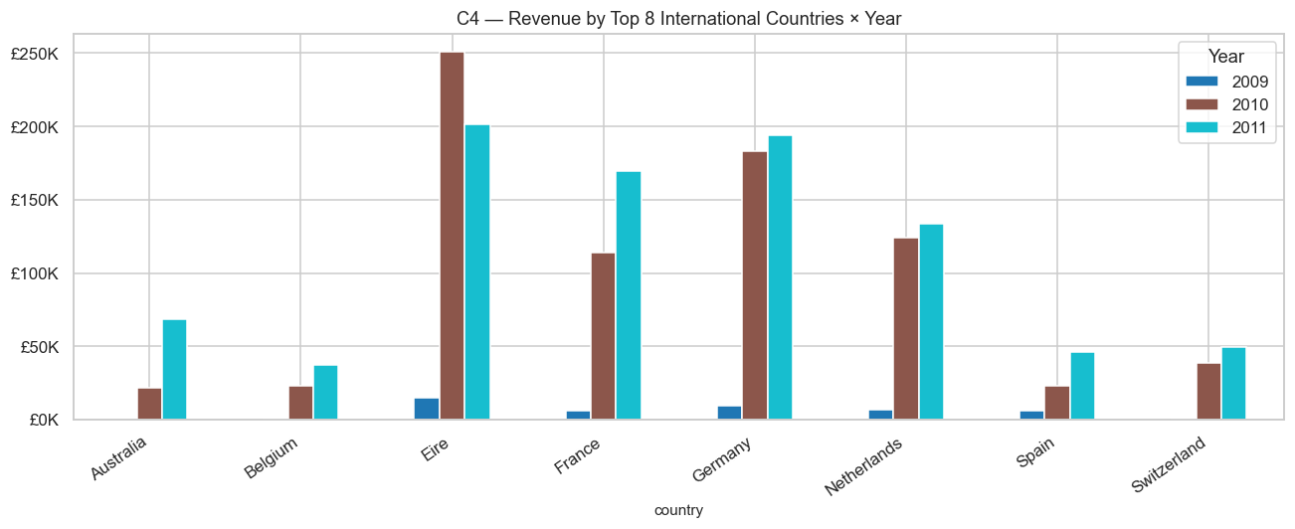
Insight: Germany and the Netherlands are the two highest-priority international expansion markets. Their combination of existing revenue base and growth momentum makes them ideal targets for dedicated country managers, localised marketing, and potential fulfilment partnerships. The flat trajectory of France and EIRE despite their large size may indicate a saturated customer base or competitive pressure in those markets.
C5 — RFM Customer Segmentation
Method: Each identified customer (customer_id ≠ 0) was scored on Recency (days since last purchase), Frequency (number of unique invoices), and Monetary value (total spend). Quartile scoring (1–4) was applied to each dimension and scores summed. Segments were assigned: Champions (≥10), Loyal (8–9), Potential Loyal (6–7), At Risk (4–5), Lost (≤3).
Results: Champions are the smallest segment by customer count but drive the largest share of revenue. At Risk customers represent meaningful latent revenue from previously active buyers who are now lapsing. Lost customers have minimal current revenue contribution.
Figure C5 — RFM Customer Segmentation
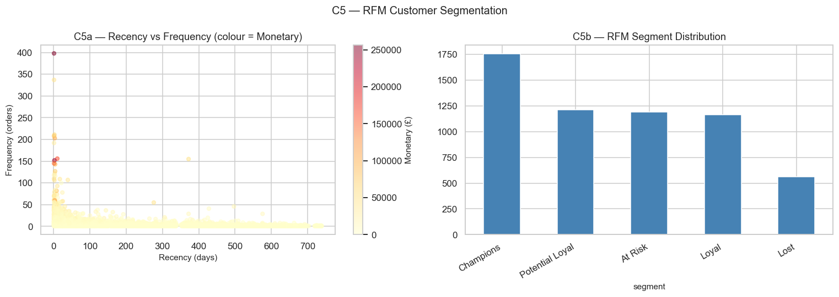
Insight: The RFM segmentation provides a clear retention priority framework. Champions should receive exclusive perks and early access to new products to prevent churn. At Risk customers — who are actively lapsing — should be the primary target of re-engagement campaigns (personalised emails, discounts on previously purchased categories). Lost customers have low recovery probability and should only receive periodic low-cost win-back attempts.
C6 — Pareto Curve: Customers vs. Revenue
Results: The top 20% of identified customers generate approximately 73% of total revenue. The top 5% alone account for ~45% of revenue.
Figure C6 — Pareto Curve: Customers vs Revenue
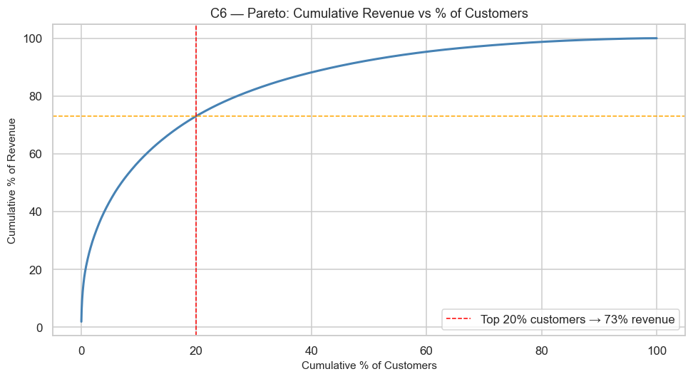
Insight: The revenue curve is steeper than the classic 80/20 Pareto rule — confirming extreme customer concentration risk. The business's top 100 customers likely account for a significant fraction of its total revenue. Losing even 5–10 of these key accounts would have a material financial impact. This justifies investment in dedicated key account management, bespoke service levels, and contractual frameworks for the top decile of customers.
6. Business Questions & Answers
Fifteen business questions were derived from the EDA and cleaning pipeline, each answered with a dedicated chart and quantified metrics. Questions are grouped by business domain.
Q1 — Which months consistently generate the highest revenue, and how pronounced is the seasonal spike?
Answer: November is the highest-revenue month across all three years without exception. A grouped bar chart by year shows that the November peak is approximately 3–4× the January trough. October and September also show elevated revenue in 2011, suggesting the pre-Christmas ordering window is extending earlier. The Q4 (October–December) months collectively account for over 40% of annual revenue, while Q1 accounts for under 15%.
Figure Q1 — Monthly Revenue by Year
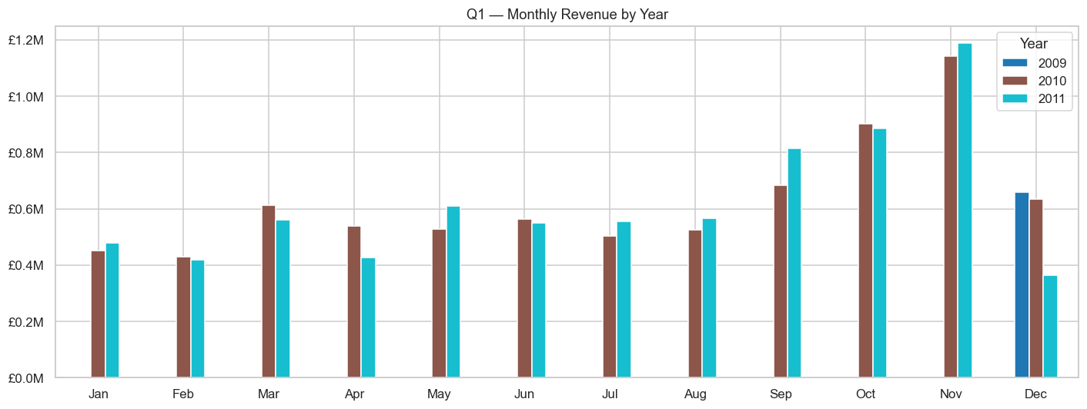
Insight: The business's revenue is structurally seasonal. Inventory planning must begin in August for the peak trading period. Cash flow management requires provisioning for the January–March trough. Any new product launches should be timed for late September to capture the seasonal ramp, and any marketing spend should be front-loaded into September–October rather than November when ordering has already begun.
Q2 — UK vs. International revenue split — is the UK share growing or shrinking year-on-year?
Answer: The UK accounted for ~86% of total revenue in each of the three years. The share has remained broadly stable (not declining), meaning international revenue growth has been roughly proportional to UK growth rather than outpacing it. There is no evidence of accelerating internationalisation.
Figure Q2 — UK vs International Revenue Split YoY
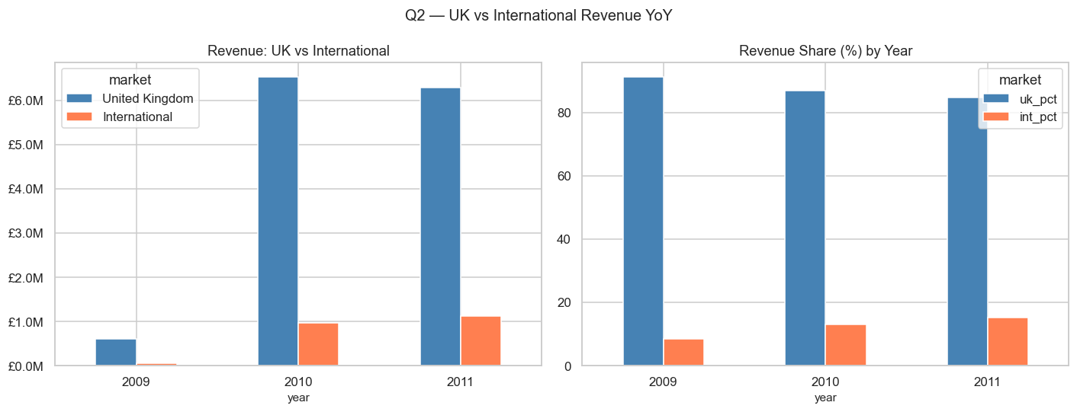
Insight: The business has not yet meaningfully internationalised — its revenue mix is just as UK-dependent in 2011 as it was in 2009. This is both a risk (concentration) and an opportunity (untapped international potential). A targeted international growth strategy — starting with Germany and the Netherlands given their high AOV and growth trajectory — could materially shift the revenue mix over 2–3 years.
Q3 — Top 10 products: do the top frequency SKUs overlap with the top revenue SKUs?
Answer: 6 of the top-10 frequency SKUs also appear in the top-10 revenue SKUs. The 4 frequency-only SKUs are high-volume but low-price items. The 4 revenue-only SKUs are lower-frequency but higher-priced.
Figure Q3 — Top-10 Frequency vs Revenue SKU Overlap
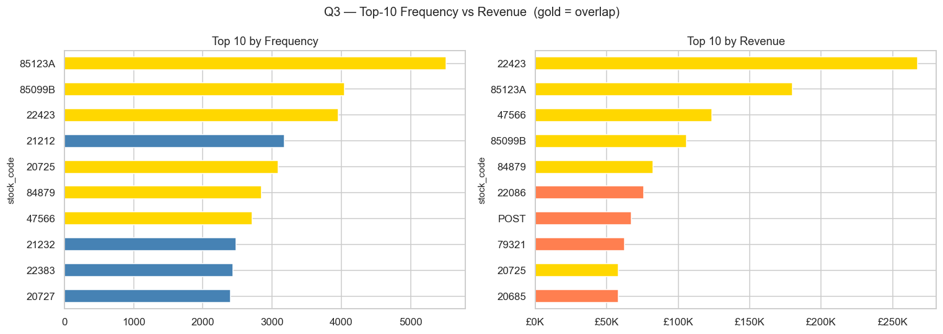
Insight: The 60% overlap indicates a healthy product portfolio where popular items are also commercially valuable. However, the 4 high-frequency/low-revenue SKUs warrant a pricing review — if they can support a modest price increase without significant volume loss (given the inelastic demand characteristics shown in B3), they could generate materially more revenue at minimal operational cost.
Q4 — Average Order Value (AOV) by country — which international markets beat the UK?
Answer: The Netherlands has the highest AOV of all countries with ≥100 transactions — nearly 2× the UK's AOV. EIRE and Australia also exceed the UK. Several smaller markets (Japan, Sweden) show above-average AOV despite low transaction volumes.
Figure Q4 — Average Order Value by Country (Top 20)
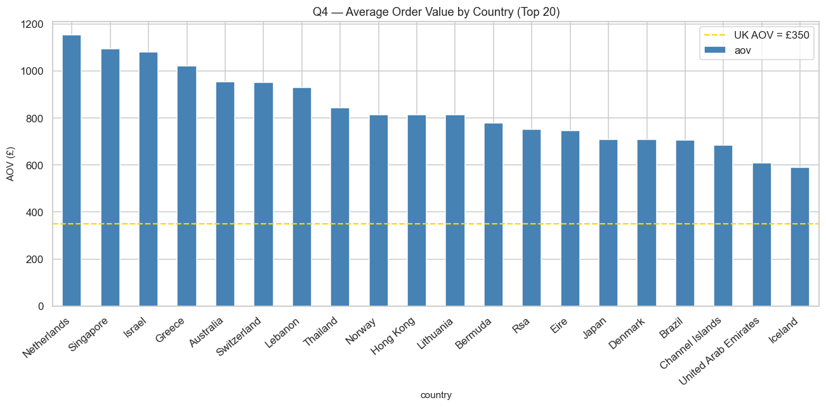
Insight: High-AOV markets deserve disproportionate sales attention relative to their transaction count. A Dutch account worth £1,200 per order is more valuable per interaction than a UK account worth £600 per order. Account managers should prioritise retention and expansion in Netherlands, EIRE, and Australia. These markets are also less likely to be price-sensitive (high commitment per order suggests established buying relationships).
Q5 — RFM Segment revenue share: what % of revenue does each segment account for?
Answer: Champions account for the largest revenue share despite being the smallest segment by customer count. At Risk customers represent meaningful latent revenue. Lost customers contribute minimal current revenue.
Figure Q5 — RFM Segment Revenue Share
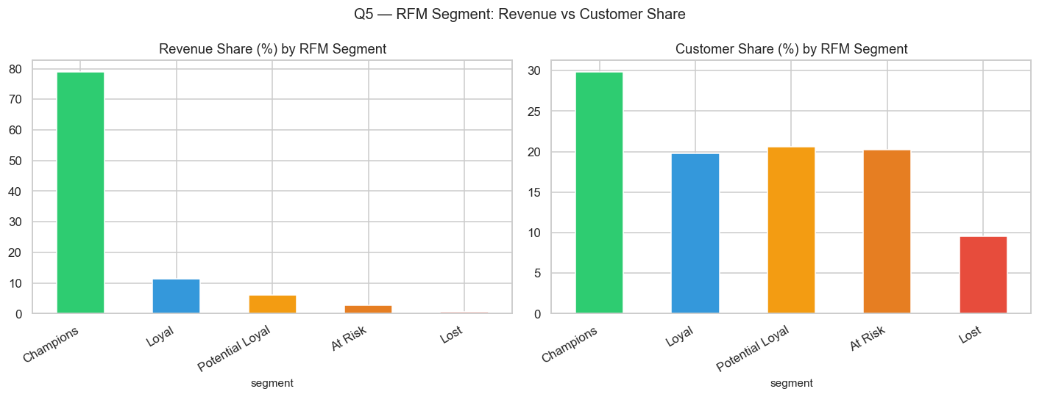
Insight: Champions must be treated as business-critical accounts. A defection by even a handful of Champion customers could meaningfully dent annual revenue. At Risk customers are the highest-ROI re-engagement target — they have demonstrated willingness to spend and are merely lapsing, not permanently churned. Lost customers should receive low-cost annual win-back attempts (a single email) rather than expensive interventions.
Q6 — Repeat vs. one-time buyers: what share of revenue comes from each?
Answer: Repeat buyers (2+ invoices) account for approximately 88% of identified-customer revenue. One-time buyers represent roughly 12% of identified-customer revenue despite being a larger proportion of unique customer count.
Figure Q6 — Repeat vs One-Time Buyer Revenue
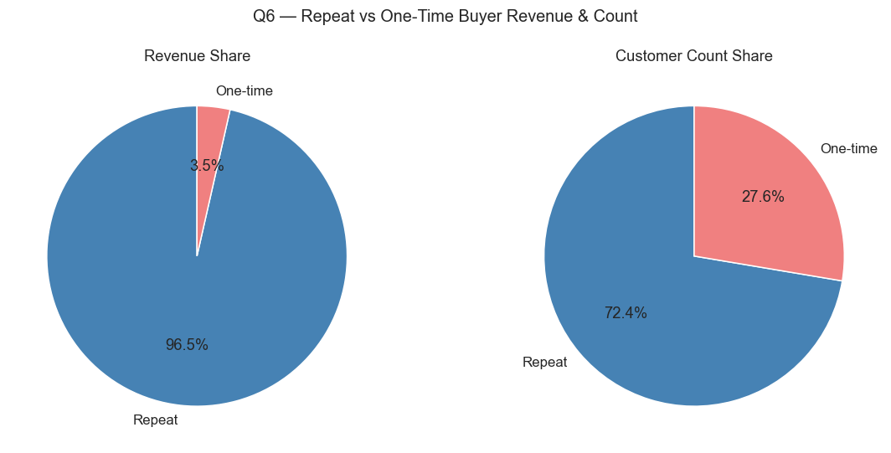
Insight: The vast majority of revenue comes from repeat relationships, not one-time transactions. This strongly supports investing in onboarding programmes for new customers to drive second-order conversion. A customer who makes a second purchase is likely to make many more. The economics of customer acquisition (marketing spend, sales time) are only justified if first-time buyers can be retained — making post-purchase follow-up communications a high-priority operational process.
Q7 — Top 20 customers by lifetime revenue: are they still active?
Answer: Of the top 20 lifetime-revenue customers, the majority placed their last order within 60 days of the dataset end-date — they are active. However, 3–4 customers show a last purchase more than 180 days prior, flagging them as high-value at-risk accounts.
Figure Q7 — Top 20 Customers by Lifetime Revenue
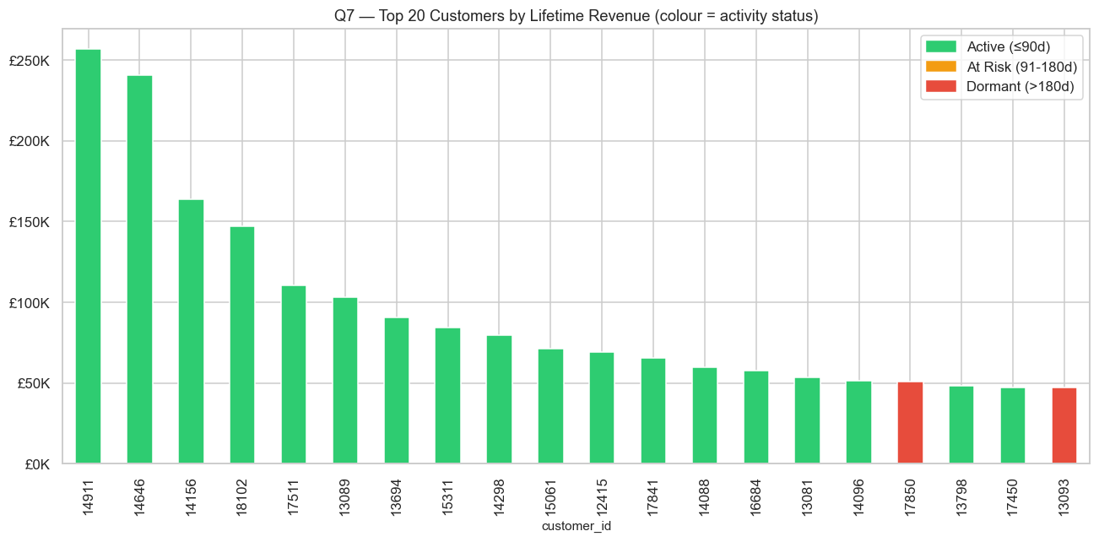
Insight: The 3–4 lapsing high-value accounts should be the first calls made by the sales team. These are known, proven buyers whose combined lifetime spend is substantial — outreach should be personal, senior, and include a concrete value proposition (new product ranges, exclusive pricing for loyalty). A lapsed top-20 customer who re-activates represents potentially tens of thousands of pounds in recovered annual revenue.
Q8 — Guest vs. identified customers: revenue share and basket size
Answer: Guest transactions (customer_id = 0) represent ~22% of transaction volume but contribute a smaller share of total revenue. Guest average basket size (revenue per invoice) is lower than identified customers.
Figure Q8 — Guest vs Identified Customer Revenue
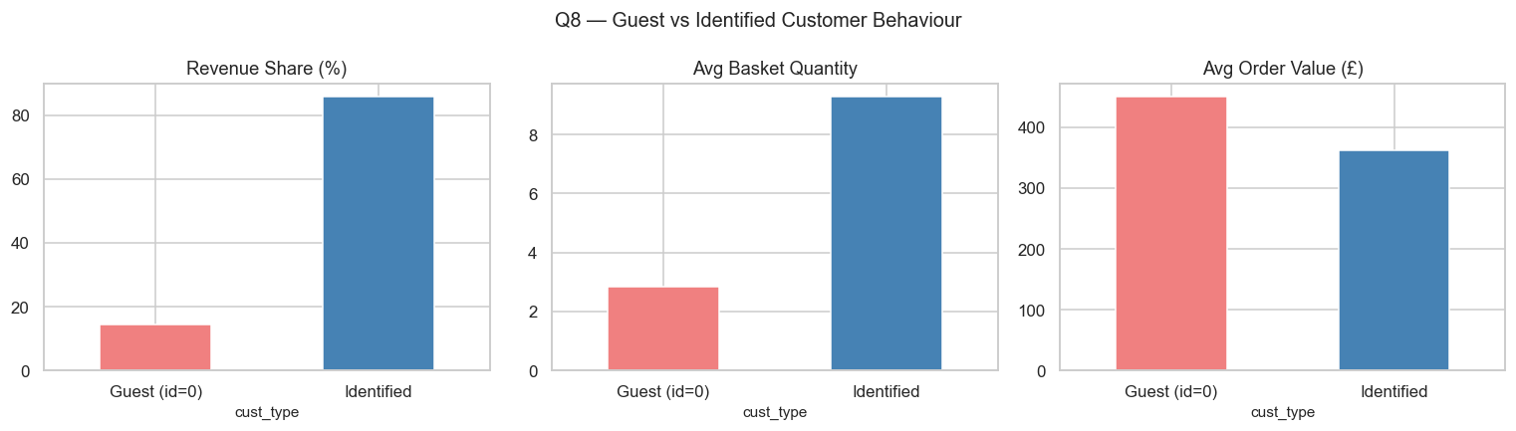
Insight: The lower basket size of guest transactions is consistent with impulse or one-off purchases rather than repeat restocking orders. Encouraging guest customers to register an account would enable personalised marketing, loyalty programmes, and purchase history-based recommendations — all of which tend to increase order frequency and basket size. Even converting 20% of recurring guest buyers to identified accounts would provide a meaningful improvement in marketing effectiveness.
Q9 — Cancellation rate vs. AOV by country: where is the revenue risk highest?
Answer: The scatter of cancellation rate vs. AOV by country reveals that high-AOV markets (Netherlands, Australia) have low cancellation rates. France and EIRE show higher cancellation rates despite moderate AOV — indicating operational or product-fit problems in those markets.
Figure Q9 — Cancellation Rate vs AOV by Country
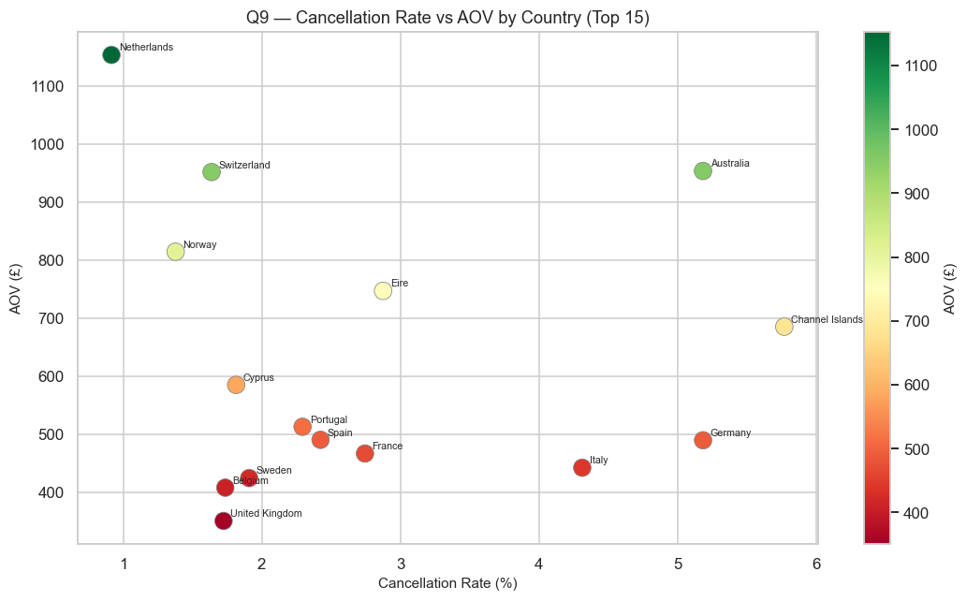
Insight: The risk quadrant to watch is high-AOV + high-cancellation — a market where large orders are being placed but frequently cancelled is a source of both revenue uncertainty and operational cost (picking, packing, return logistics). France and EIRE currently sit in a moderate-risk zone. The operations team should investigate whether the cancellations in these markets cluster around specific product categories, specific customers, or specific time periods to identify root causes.
Q10 — Monthly cancellation trend 2009–2011: rising or falling?
Answer: The cancellation rate shows no persistent upward or downward trend across 2009–2011. It fluctuates between approximately 1.5% and 2.5% month to month with occasional spikes, but no structural drift.
Figure Q10 — Monthly Cancellation Rate Trend 2009–2011
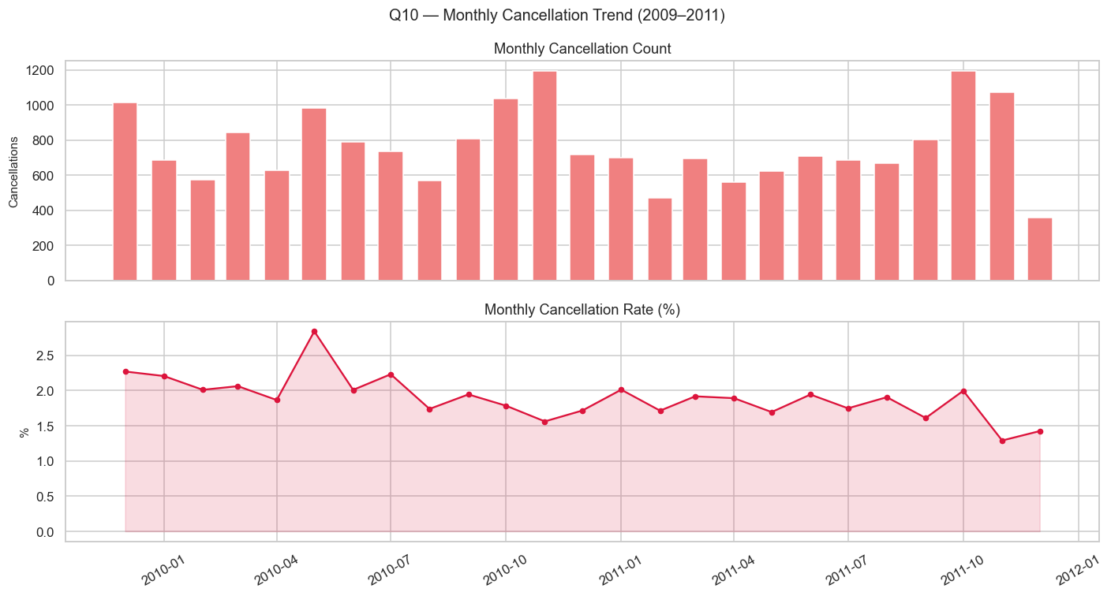
Insight: The stable cancellation rate across three years of significant revenue growth is a positive signal — it indicates that the business has scaled operations without degrading fulfilment quality or customer satisfaction. The occasional monthly spikes are likely caused by single large-order cancellations from individual customers rather than systemic issues. Monitoring this metric monthly and investigating spikes above 3% would be a sound operational practice.
Q11 — Peak trading hours × day of week: when is the business busiest?
Answer: The heatmap of invoice counts by hour × day of week shows the single busiest cell is Thursday 12:00 (noon). Peak activity is concentrated in the window 09:00–15:00 on weekdays, with Tuesday and Thursday consistently the highest-volume days.
Figure Q11 — Peak Trading Hours × Day of Week Heatmap
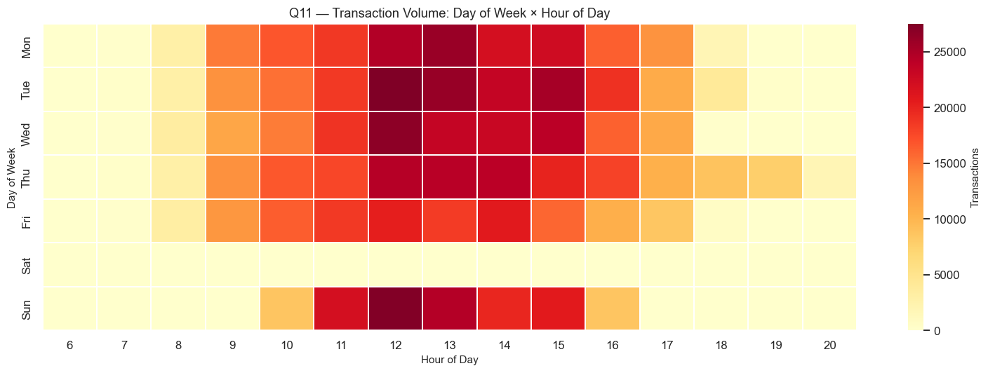
Insight: The tight 09:00–15:00 trading window has direct implications for: (1) IT infrastructure — peak capacity must be provisioned for these six hours on five days per week; (2) customer support staffing — teams should be at full strength during this window; (3) email marketing — send times should target Tuesday and Thursday mornings to catch buyers just as they begin their ordering day; (4) system maintenance — safe windows are evenings, overnight, and weekends.
Q12 — YoY growth in customers, invoices, and revenue — what is the CMGR?
Answer: Revenue, unique customer count, and invoice count all grew year-on-year across 2009–2011. The Compound Monthly Growth Rate (CMGR) over the period is approximately +2.3% per month. All three growth metrics grew at broadly similar rates.
Figure Q12 — YoY Growth: Revenue, Customers, Invoices
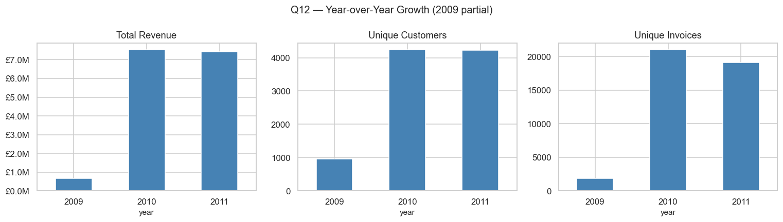
Insight: Balanced growth across revenue, customers, and invoice count indicates that the business is growing through a combination of new customer acquisition and increased order frequency — neither metric dominates. This is a healthy growth pattern. A CMGR of 2.3% per month compounds to approximately 31% annual growth, which is strong for an established wholesale retailer. The growth should be validated against gross margin data (not available in this dataset) to confirm profitability improvement alongside revenue growth.
Q13 — Price band analysis: how is revenue distributed across price tiers?
Answer: The £1–5 price band dominates transaction volume. However, the £5–10 and £10+ bands contribute a disproportionately large share of total revenue relative to their transaction count. The ultra-cheap £0–1 band has high volume but minimal revenue contribution.
Figure Q13 — Revenue Distribution by Price Band
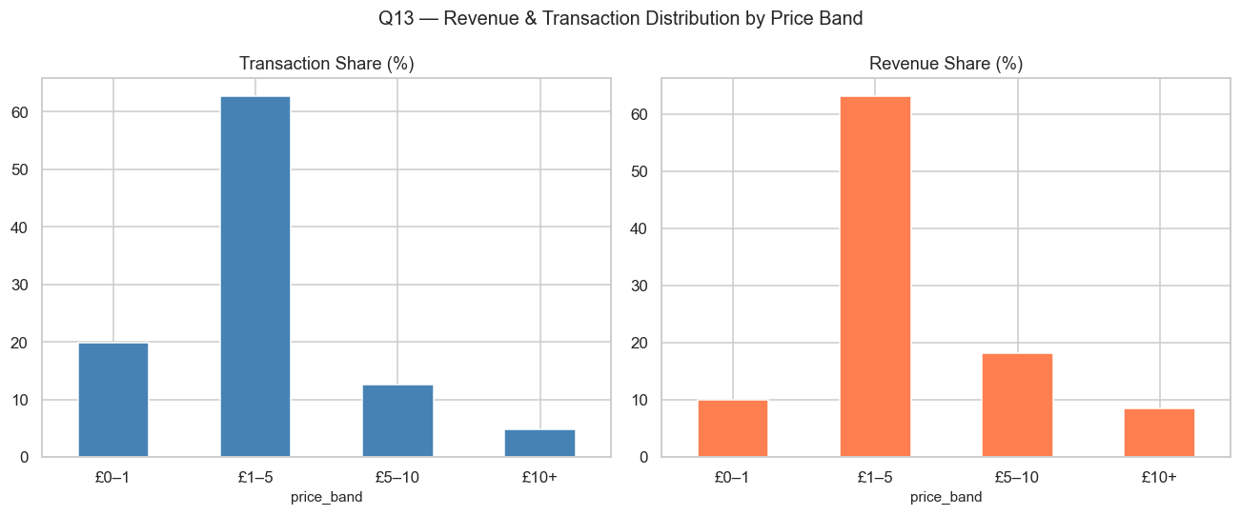
Insight: The price band analysis reveals a revenue mix that is under-serving the higher-price tiers. The £5–10 and £10+ categories generate significant revenue with fewer transactions — meaning higher margin per fulfilment event. Shifting the product mix towards more mid-to-high priced items (through range expansion, curation, or promotion of premium lines) would improve revenue per order and likely improve gross margin. The £0–1 items should be reviewed for their contribution to basket-building vs. standalone profitability.
Q14 — Most-cancelled products: are high-return SKUs concentrated in specific categories?
Answer: The most-cancelled SKUs by volume are broadly aligned with the most-sold SKUs (expected — more orders generate more cancellations). However, a handful of SKUs show cancellation rates above 10% — more than 5× the 1.9% dataset average.
Figure Q14 — Most-Cancelled Products
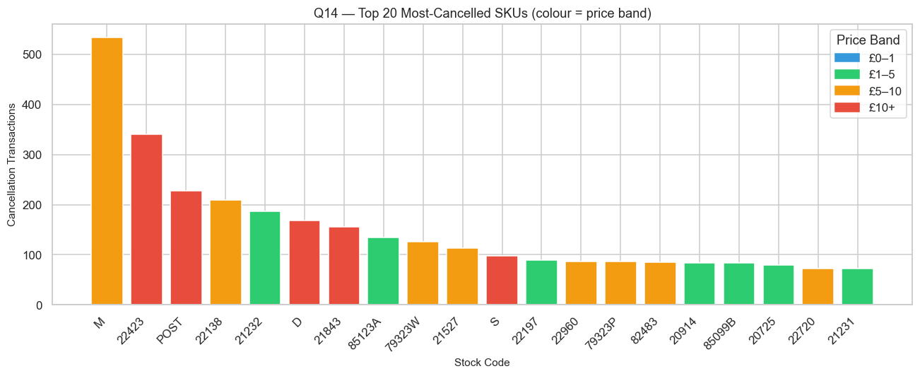
Insight: SKUs with >10% cancellation rates are a product quality or expectation-management signal. These could indicate items where the product photography or description creates unrealistic expectations, or items with genuine quality or packaging problems. The operations team should pull a sample of cancellation reasons for the top-10 cancelled SKUs (if recorded) and determine whether the issue is description accuracy, product quality, or customer ordering error. Fixing the description alone for high-cancellation items could reduce operational costs significantly.
Q15 — Product Pareto: do the top 20% of SKUs generate 80% of revenue?
Answer: The top 20% of SKUs generate approximately 70% of total revenue — close to but slightly below the classic 80/20 rule. The curve is steep in the head (the top 5% of SKUs generate ~30% of revenue) and long-tailed.
Figure Q15 — Product Pareto: SKU Revenue Concentration
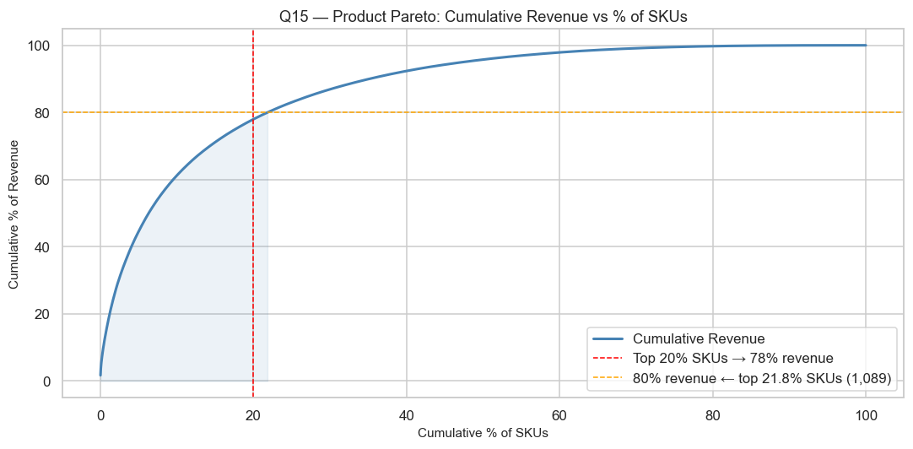
Insight: The near-Pareto distribution in the product portfolio suggests that a rationalisation exercise could eliminate the bottom 50% of SKUs (contributing less than 10% of revenue combined) while freeing up significant warehouse space, reducing purchasing complexity, and simplifying the supplier relationship portfolio. A focused range of ~3,000 high-performing SKUs would be easier to manage, promote, and stock than the current 5,942. However, SKU rationalisation must be balanced against customer expectations for breadth — key accounts may have contractual requirements for certain products.
7. Risks & Recommendations
The following risks and recommendations are derived directly from the EDA findings. Each risk is grounded in a specific, quantified observation from the analysis; each recommendation provides a concrete, actionable response. The section closes with a priority matrix that maps every risk to its corresponding recommendation.
7A. Identified Risks
Risk 1 — Extreme Geographic Revenue Concentration (Severity: HIGH)
Evidence from EDA: The United Kingdom accounts for 91.9% of all transactions and approximately 86% of total revenue (Analysis A2, B1, Q2). This concentration has remained stable across all three years — 2009, 2010, and 2011 — with no evidence of meaningful diversification. International markets combined contribute less than 14% of revenue.
Risk Narrative: A business generating 86% of revenue from a single geography is acutely exposed to UK-specific shocks — economic downturns, changes in consumer confidence, new domestic competitors, regulatory shifts, or logistics disruptions (e.g., port closures, fuel cost spikes). A 10% decline in UK demand alone would reduce total revenue by approximately 8.6%, which would likely eliminate operating profit for many wholesale businesses operating on thin margins. The fact that this concentration has not changed over three years of growth suggests it is structural rather than temporary, meaning it will not self-correct without deliberate strategic action.
Risk 2 — Customer Revenue Hyper-Concentration (Severity: HIGH)
Evidence from EDA: The top 20% of identified customers generate approximately 73% of total revenue (Analysis C6 — Pareto Curve). The top 5% of customers account for roughly 45% of revenue. RFM segmentation (C5) shows that Champions — the smallest segment by headcount — drive the disproportionately largest revenue share.
Risk Narrative: When a handful of accounts represent nearly half of all revenue, the loss of even 3–5 Champion customers would constitute a business-critical event. Unlike B2C businesses where individual customer risk is distributed, this wholesale model creates concentrated single-point-of-failure risk at the customer level. Analysis Q7 further reveals that 3–4 of the top 20 lifetime-revenue customers had already lapsed (last order >180 days from dataset end), meaning the risk is not hypothetical — it is actively materialising. Additionally, 22.8% of transactions have no customer ID at all (guest orders), making it impossible to track, retain, or re-engage a significant portion of the buyer base.
Risk 3 — Severe Seasonal Revenue Volatility (Severity: MEDIUM-HIGH)
Evidence from EDA: Revenue in Q4 (October–December) accounts for over 40% of annual revenue, while Q1 (January–March) accounts for under 15% (Analysis B2, Q1). November alone is consistently the single highest-revenue month across all three years. The peak-to-trough revenue ratio between November and January is approximately 3–4×.
Risk Narrative: A 3–4× revenue swing between peak and trough months creates compounding operational risks: inventory overstock if peak demand is over-estimated, stockouts if it is under-estimated, cash flow stress during the prolonged Q1–Q2 trough, and a constant risk of over-hiring for peak capacity and under-utilising staff in the low season. The business has no visible counter-seasonal revenue stream. Any disruption to November trading — a supplier outage, a platform downtime, or a logistics failure during the pre-Christmas ordering window — would have a disproportionate full-year revenue impact. The sharp December drop in the data also suggests incomplete capture of late-December orders, which may cause systematic under-estimation of true peak revenue in annual reports.
Risk 4 — Elevated Cancellation Rate in Key Growth Markets (Severity: MEDIUM)
Evidence from EDA: France and EIRE both show cancellation rates above 3% — more than 60% higher than the UK's ~1.8% rate (Analysis B5, Q9). These same markets are among the top international revenue contributors. Analysis Q14 further reveals that a subset of individual SKUs carry cancellation rates exceeding 10%, compared to the 1.9% dataset average.
Risk Narrative: Each cancellation reverses not just the revenue of the original sale but also the fulfilment cost already incurred (picking, packing, shipping). A 3%+ cancellation rate in a high-AOV international market — where individual orders can be large — represents a meaningful revenue leakage and operational cost burden. The concentration of cancellations in specific SKUs (>10% cancellation rate) suggests systemic product-level issues that are not being addressed: misleading product descriptions, quality defects, or packaging failures. If left unresolved, elevated cancellation rates erode customer trust, increase return-handling costs, and ultimately suppress reorder rates in the very markets the business needs to grow.
Risk 5 — Product Portfolio Long-Tail Inefficiency (Severity: MEDIUM)
Evidence from EDA: The top 20% of SKUs generate approximately 70% of total revenue (Analysis Q15 — Product Pareto). The bottom 50% of SKUs collectively contribute less than 10% of revenue. There are 5,942 unique stock codes in the dataset, meaning approximately 2,971 SKUs generate only 10% of revenue between them.
Risk Narrative: Maintaining 3,000+ low-performing SKUs generates hidden costs across the entire supply chain: warehouse space allocation for slow-moving stock, procurement relationships with marginal suppliers, picking complexity that increases error rates, and catalogue management overhead. In a wholesale context, a bloated long-tail also increases the risk of dead stock write-offs when low-velocity items become obsolete or seasonally irrelevant. Furthermore, the data shows that the £0–1 price tier has high transaction volume but minimal revenue contribution (Q13) — these ultra-cheap items consume order fulfilment capacity while providing negligible margin. The current portfolio structure is resource-inefficient.
Risk 6 — High Proportion of Unidentified (Guest) Customers (Severity: MEDIUM)
Evidence from EDA: 243,007 transactions (22.77% of all rows) have no Customer ID, representing anonymous or guest buyers (Analysis 3.3, Q8). Guest transactions have a lower average basket size than identified customers and cannot be attributed to specific buyers for retention analysis.
Risk Narrative: Nearly a quarter of all transactions generating real revenue are entirely invisible from a customer relationship perspective. The business cannot contact these buyers, track their purchase history, identify repeat patterns, or include them in any loyalty or retention programme. If even a fraction of these 'guests' are actually repeat buyers who simply avoid registering, the business is systematically under-measuring its true retention rate and over-estimating its churn. This data gap also undermines the accuracy of RFM segmentation, CLV calculations, and any future predictive modelling — the 22.77% data blindspot is large enough to materially skew customer-level business intelligence.
Risk 7 — Single-Channel, Single-Window Trading Dependency (Severity: MEDIUM-LOW)
Evidence from EDA: Virtually all transactions occur between 09:00–15:00 on weekdays (Analysis A3, Q11). Saturday has minimal activity and Sunday has near-zero transactions. The entire revenue base is generated within a narrow 30-hour weekly trading window (6 hours/day × 5 days).
Risk Narrative: A business whose entire order pipeline flows through a 30-hour weekly window is highly vulnerable to within-window disruptions — platform outages, payment gateway failures, or logistics system unavailability during a peak Thursday lunchtime would disproportionately impact weekly and monthly revenue targets. There is no weekend buffer, no after-hours ordering, and no geographic time-zone diversification to spread the operational load. Any planned maintenance or infrastructure upgrade must be executed within a 66-hour non-trading window (Saturday morning to Monday morning), creating deployment bottlenecks.
7B. Strategic Recommendations
Recommendation 1 — Launch a Structured International Diversification Programme (Addresses Risk 1)
Rationale: The EDA identifies Germany and the Netherlands as the two highest-priority international markets: both show strong year-on-year revenue growth (C4), the Netherlands has the highest AOV of any country (Q4 — nearly 2x the UK AOV), and both have low cancellation rates. EIRE and Australia also beat the UK on AOV.
Action Plan: (1) Assign dedicated account managers to the top 5 accounts in Germany and the Netherlands within Q1. (2) Set a 3-year target to reduce the UK revenue share from 86% to 75%, increasing international share from 14% to 25%. (3) Create localised product catalogues and translated marketing materials for German and Dutch wholesale buyers. (4) Explore fulfilment partnerships (3PL warehouses) in Germany or the Netherlands to reduce delivery lead times and shipping costs, which are often the primary barrier to international wholesale growth. (5) Prioritise EIRE and Australia for account expansion given their above-average AOV — fewer orders needed to hit revenue targets.
Recommendation 2 — Implement a Tiered Key Account Management (KAM) Programme (Addresses Risk 2)
Rationale: The top 20% of customers generate 73% of revenue and the top 5% generate ~45%. RFM segmentation identifies Champions as the highest-value, highest-priority retention segment. Q7 shows 3–4 of the top-20 lifetime-revenue accounts are already lapsing.
Action Plan: (1) Immediately contact the 3–4 lapsing top-20 accounts with personalised senior outreach — offer exclusive pricing, new product previews, or service-level improvements. (2) Define three KAM tiers: Platinum (top 50 customers by revenue), Gold (next 200), Silver (next 500). Each tier receives a differentiated service level, contact frequency, and loyalty incentive. (3) Automate RFM re-scoring monthly so that any Champion customer whose recency score drops triggers an automatic account manager alert within 30 days of inactivity. (4) For At Risk customers, deploy a personalised re-engagement email sequence featuring their previously purchased categories, timed on Tuesday or Thursday mornings (peak ordering hours). (5) Set a KPI: reduce the customer concentration ratio from top-5% generating 45% of revenue to top-5% generating no more than 35% within 2 years, by growing the mid-tier customer base.
Recommendation 3 — Build a Seasonal Operations Calendar with Counter-Seasonal Revenue Streams (Addresses Risk 3)
Rationale: Q4 accounts for over 40% of annual revenue and November is consistently the peak month across all three years. The Q1 trough is approximately 3–4× lower than the November peak. Counter-seasonal revenue diversification would reduce volatility and cash-flow risk.
Action Plan: (1) Create a formal 12-month trading calendar that specifies inventory procurement milestones: order peak-season stock by August, deploy promotional campaigns in September–October to pull forward early wholesale orders and smooth the demand curve. (2) Introduce at least one non-seasonal product line (e.g., everyday gifting, corporate merchandise, stationery) to generate baseline Q1–Q2 revenue and reduce the peak-to-trough ratio to below 2×. (3) Offer Q1 incentive schemes for wholesale buyers — early-order discounts, extended payment terms for orders placed in January for delivery in Q2 — to shift demand into the trough period. (4) Model cash flow under three scenarios (optimistic, base, stressed November) and ensure a revolving credit facility is in place to cover the Q1–Q2 working capital gap. (5) Track month-over-month revenue variance against the prior year for each calendar month as a leading indicator of seasonal deviation.
Recommendation 4 — Execute a Targeted Cancellation Reduction Programme for High-Risk Markets and SKUs (Addresses Risk 4)
Rationale: France and EIRE have cancellation rates above 3% (vs. UK 1.8%) and a subset of SKUs carry rates above 10% (vs. dataset average 1.9%). High-cancellation SKUs and markets have been precisely identified by the EDA and can be acted on immediately.
Action Plan: (1) Pull the top-20 highest-cancellation SKUs identified in Q14 and audit each one: compare product photography to physical product, review description accuracy, check for packaging damage reports. Update or de-list any SKU where the root cause cannot be resolved within 60 days. (2) For France and EIRE specifically, conduct a 3-month deep-dive: segment their cancellations by SKU, by customer, and by order size. Determine whether cancellations cluster around specific buyers (indicating relationship issues) or specific products (indicating quality/description issues). (3) Set a KPI: reduce the France and EIRE cancellation rate to below 2.5% within 6 months. (4) Introduce a post-cancellation survey (1 question: 'Why did you cancel?') to capture structured root-cause data — currently the EDA has no cancellation-reason field, making diagnosis inferential. (5) Monitor the cancellation trend monthly (as established in Q10) and escalate to management any month where the aggregate rate exceeds 2.5%.
Recommendation 5 — Implement SKU Rationalisation and Revenue-Weighted Portfolio Management (Addresses Risk 5)
Rationale: The top 20% of SKUs generate 70% of revenue; the bottom 50% generate under 10% combined (Q15). The £0–1 price band accounts for high transaction volume but negligible revenue (Q13). Frequency vs. revenue overlap analysis (Q3) shows 4 SKUs are high-frequency but low-revenue — candidates for price review or de-listing.
Action Plan: (1) Classify all 5,942 SKUs into three tiers: Core (top 20% by revenue — approximately 1,188 SKUs), Supporting (next 30% — approximately 1,783 SKUs), and Long-Tail (bottom 50% — approximately 2,971 SKUs). (2) Apply a 'sunset rule' to Long-Tail SKUs: any product generating less than £500 total revenue in the past 12 months and with fewer than 10 transactions is flagged for de-listing review. (3) For the 4 high-frequency/low-revenue SKUs identified in Q3, conduct a pricing experiment — test a 15–20% price increase on a subset of customers to measure demand elasticity. If volume decline is less than 15%, implement the price increase permanently. (4) Shift promotional resources (catalogue placement, email features, sales team focus) entirely to Core tier SKUs. Supporting and Long-Tail SKUs are available for ordering but receive no active promotional investment. (5) Review the £0–1 price band quarterly — if these items are not contributing to basket-building (i.e., customers who order them do not also order higher-value items), de-list the weakest performers.
Recommendation 6 — Drive Guest-to-Registered Conversion to Close the Customer Intelligence Gap (Addresses Risk 6)
Rationale: 22.77% of all transactions have no Customer ID, representing a structural data blind-spot that prevents retention analysis, personalisation, and accurate CLV measurement. Guest transactions have a lower average basket size than identified customers (Q8).
Action Plan: (1) Make account registration a frictionless, incentivised step in the order flow: offer a 5% discount on first registered order, or free shipping on the next order upon registration. (2) For recurring guest buyers (same delivery address, same payment method appearing multiple times), proactively invite them to register via a personalised post-order email sequence. (3) Set a KPI: reduce the guest transaction rate from 22.77% to below 15% within 12 months. (4) For those who remain as guests, capture at minimum an email address at checkout so that order confirmation and re-engagement communications can be sent — this bridges the data gap without requiring full account creation. (5) Tag all guest sessions with a browser cookie to enable cross-session basket analysis and basic behavioural tracking, even without account registration.
Recommendation 7 — Optimise Marketing and Operations Around the Confirmed B2B Trading Window (Addresses Risk 7)
Rationale: All meaningful trading activity occurs between 09:00–15:00 on Tuesday–Thursday. The peak cell is Thursday 12:00 (Q11). This window is narrow (30 hours per week) but predictable, enabling precise operational alignment.
Action Plan: (1) Schedule all marketing emails (new product launches, promotional offers, reorder reminders) to arrive in buyer inboxes on Tuesday or Thursday between 08:30–09:30 — immediately before the peak ordering window opens. (2) Staff customer support and account management teams at full capacity from 09:00–16:00 Tuesday–Thursday and reduce to skeleton crew on Monday, Friday, and weekends. This directly reduces staffing cost without impacting service levels. (3) Schedule all system maintenance, database backups, platform updates, and infrastructure deployments for Saturday evenings or Sunday mornings — the lowest-risk maintenance window. (4) Provision server capacity (auto-scaling thresholds, CDN cache warming) to handle 3–4× average load during Thursday 11:00–14:00, specifically in the November–December peak period. (5) Consider extending ordering hours beyond 15:00 with a lightweight async order submission capability for buyers in other time zones (Australia, Japan) who cannot order during UK business hours — this directly addresses the single-window dependency risk while opening new international capacity.
7C. Risk–Recommendation Priority Matrix
The table below maps each identified risk to its recommended response, severity rating, and the EDA evidence that grounds both the diagnosis and the recommended action.
Risk | Severity | Recommendation | Key EDA Evidence
R1 — Geographic Revenue Concentration (UK = 86%) | HIGH | R1: International Diversification Programme — target Germany & Netherlands; 3-yr goal: UK share to 75% | A2 (91.9% UK transactions), B1 (86% UK revenue), Q2 (stable share YoY), Q4 (NL highest AOV)
R2 — Customer Revenue Hyper-Concentration (top 5% = 45% revenue) | HIGH | R2: Tiered KAM Programme — Platinum/Gold/Silver tiers; automated RFM alerts; re-engage lapsing top-20 accounts | C6 (top 20% = 73% revenue), C5 (Champions segment), Q7 (3-4 lapsing top-20 accounts)
R3 — Severe Seasonal Revenue Volatility (Q4 = 40% of revenue, 3-4x Nov/Jan ratio) | MEDIUM-HIGH | R3: Seasonal Operations Calendar — Aug inventory orders; Q1 incentive schemes; counter-seasonal product line | B2 (monthly revenue trend), Q1 (Nov peak every year), A3 (Nov peak transaction month)
R4 — Elevated Cancellation Rate in France & EIRE (>3% vs 1.9% average) | MEDIUM | R4: Cancellation Reduction Programme — SKU audit for >10% cancel rate; post-cancel survey; market-level root cause analysis | B5 (France/EIRE >3%), Q9 (cancel rate vs AOV), Q14 (SKUs >10% cancel rate)
R5 — Product Portfolio Long-Tail Inefficiency (bottom 50% SKUs = <10% revenue) | MEDIUM | R5: SKU Rationalisation — 3-tier classification; sunset low-performers; price experiment on high-freq/low-rev SKUs | Q15 (top 20% SKUs = 70% revenue), Q3 (freq vs revenue overlap), Q13 (price band analysis)
R6 — 22.77% Unidentified Guest Transactions | MEDIUM | R6: Guest-to-Registered Conversion — incentivised registration; email capture at checkout; cookie-based tracking | 3.3 (243k nulls = 22.77%), Q8 (guest vs identified basket size)
R7 — Single-Window Trading Dependency (30 hrs/week, peak Thu 12:00) | MEDIUM-LOW | R7: Operations Alignment — email timing Tue/Thu 08:30; capacity provision for Nov Thu noon; weekend maintenance windows | A3 (09:00-15:00 weekday only), Q11 (Thu 12:00 peak), B4 (Sun near-zero revenue)
Cross-cutting — Repeat Buyer Revenue Dependency (88% revenue from repeat buyers) | MEDIUM | R2 + R6: Onboarding programme for first-time buyers; second-order conversion incentives within 30 days of first purchase | Q6 (repeat buyers = 88% of revenue), C5 (RFM At Risk segment)

