A Hybrid ResNet‑50 and CatBoost Framework for Crowd Counting on the MALL Dataset

Abstract
This work presents a hybrid pipeline for crowd counting on the MALL dataset by coupling deep feature extraction with classical gradient-boosting regression. Video frames are preprocessed and normalized, then embedded with a ResNet‑50 backbone to obtain compact, discriminative representations. Two complementary learners are explored: (i) a fine‑tuned ResNet‑50 regression head and (ii) a CatBoost regressor trained on the frozen ResNet embeddings. The pipeline is evaluated using standard counting metrics such as MAE and MSE, and is contrasted with detection‑based approaches (YOLO variants) and density‑map methods from recent literature. On the MALL dataset (2,000 frames with 60k+ head annotations), the approach offers a light‑weight alternative to dense prediction while remaining competitive and easily deployable. We discuss design choices, error modes (occlusion, perspective variation), and provide a reproducible workflow and comparison tables to support future research.
Keywords
Boosted Regression; CatBoost; Crowd Counting; MALL Dataset; ResNet‑50; YOLO
Introduction
Crowd counting is one of the most pertinent problems in computer vision as it directly impacts safety and security in smart cities. Understanding how many people are in particular areas automatically can have direct benefits in public space management, in organizing events, and in surveillance intelligence. As an example, the ability to estimate the number of people inside a shopping centre or a railway station, a sports centre or a stadium can be used to prevent over-crowding, improve allocation of resources, and provide a swifter response to emergencies. Increasing population densities in urban centres characterize the present era, a feature which makes the need for advanced, real-time crowd analytic systems more urgent.
In earlier research on crowd counting, standard machine learning regressors and handcrafted features dominated the picture. While approaches using edge detection, texture descriptors, or motion cues worked adequately in sparse settings, they broke down completely in dense crowds. In such scenarios, severe occlusions and a plethora of overlapping people made recognition nearly impossible, and regression based methods such as Ridge Regression which endeavored to map handcrafted features directly to crowd count. When used with scenes that have different densities and distortions in perspective. These contraints led to modern deep learning approaches that can learn features from data instead of using hand crafted features.
Regarding focus, convolutional neural networks (CNNs) have contributed the most advanced leadership in contemporary crowd counting research. Multi-Column CNNs (MCNN) dealt with the large scale variation in crowds by introducing multi-scale processing. CSRNet improved density estimation further by using dilated convolutions as a replacement for pooling layers, which allowed it to have a larger receptive field. Density prediction error has similarly been reduced by the use of optimal transport methods and uncertainty modeling, as done by Bayesian Loss and DM-Count. While making advances, these techniques make use of CNN regression that is end-to-end, which in some cases is insufficient in modeling the nonlinear relations in crowd scenes that are found in nature. In addition to that, for lightweight deployment, there is a density map estimation model that is constrained by needing complex annotations and having a high computation cost, as well as long training times, which makes such a model impractical to use.
ResNet-50, a deep residual neural network, has proven to be one of the most powerful backbones for visual feature extraction. Its residual connections allow very deep architectures to train efficiently, capturing scale-invariant and discriminative representations of crowd images. However, when directly used with a regression head, ResNet-50 may not fully model the complex mapping between deep features and crowd counts, especially under noisy data or limited training conditions. This shortcoming opens opportunities to combine deep learning backbones with alternative machine learning strategies for regression.
Gradient boosting frameworks like CatBoost have become the preferred choice for tabular data and structured prediction problems, due to their robustness, resistivity to overfitting, and efficiency in capturing complex non-linear interactions. While CatBoost also features the novel ordered boosting and has of categorical features, making it more stable than other gradient boosting methods, it still falls short of processing raw visual data, limiting its application in computer vision. This limitation, in turn, motivates the use of hybrid frameworks where CNN-based feature extraction and gradient boosting regression can be combined, allowing the utilization of the advantages of both methods.
The popularity of gradient boosting techniques including CatBoost extends to tabular and structured prediction tasks because these methods deliver stable results and prevent overfitting while effectively modeling non-linear patterns. The ordered boosting approach and efficient categorical feature processing of CatBoost deliver superior stability compared to conventional boosting algorithms. Nevertheless, CatBoost cannot process raw visual inputs, which restricts its standalone use in computer vision. This creates a natural motivation for hybrid frameworks that can combine CNN-based feature extraction with gradient boosting regression, leveraging the strengths of both paradigms.
The MALL dataset was selected for this research because it offers a realistic testing environment for measuring indoor crowd counting methods. The dataset consists of 2000 video frames taken from a shopping mall where ground-truth annotations show between 13 to 53 people in each frame. The dataset features authentic obstacles to crowd counting through partial visibility and varying densities and changing illumination conditions which makes it perfect for testing the proposed model's performance. The dataset's moderate size encourages researchers to develop hybrid methods that achieve maximum learning efficiency while preventing model overfitting.
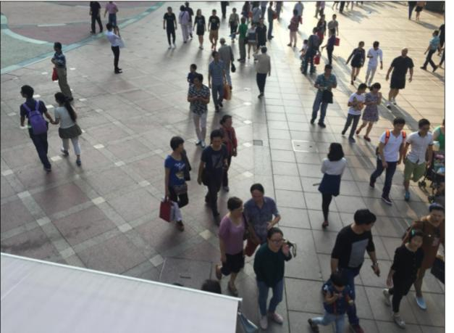
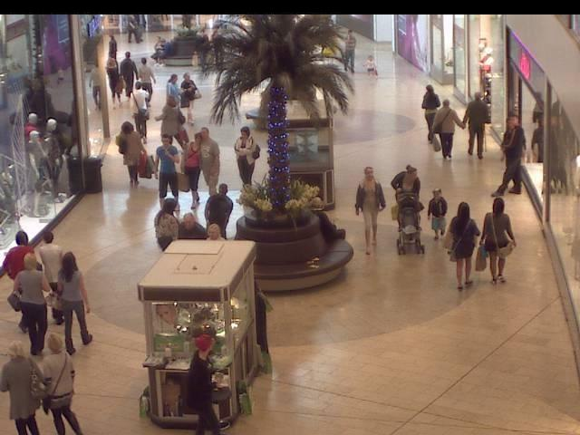

Mall Dataset. Street Dataset

Motivation
Given its use in fields including automated surveillance systems, urban infrastructure, and public safety, crowd counting has grown in importance. Traditional methods such as object identification and handmade features tend to fall down in extremely packed locations where there is severe occlusion and perspective distortion. The ability of deep learning models like ResNet-50 to extract rich scale-invariant visual features has led to significant advancements in the field; however, their direct regression heads often perform poorly on the complex, non-linear real-world crowd distributions. This issue is particularly noticeable when training data is scarce.
Gap Analysis
The majority of crowd counting algorithms rely on either CatBoost regressors for prediction to machine learning pipelines or deep CNNs (ResNet-50, for example) designed for feature extraction. Approaches that attempt to combine the best aspects of both worlds are conspicuously lacking. Image boosting methods like CatBoost and lightGBM perform poorly on raw photos, and deep CNNs have trouble with non-linear regressions. This emphasizes the necessity of a hybrid architecture that can enhance accuracy and efficiency on modests like MALL by fusing robust regression with deep image processing.

Literature Survey
Crowd counting techniques relied on manually created features and traditional regression. They performed poorly in scenarios that were complex and dense. The performance was enhanced by deep learning techniques, particularly CNN deep-learning models like MCNN, CSRNet, and ResNet-50. Furthermore, YOLO detection, density maps, and attention mechanisms are now included in the state of the art.
Methodology Used
The methodology follows the provided process flow: data collection → preprocessing (resize, normalize) → feature extraction → two learning routes (ResNet‑50 regression head and CatBoost on embeddings) → evaluation and comparison → final prediction. We use the MALL dataset frames and their ground‑truth counts (from mall_gt.mat) and, optionally, the perspective map (perspective_roi.mat) to account for scale changes.
Process Flow Diagram
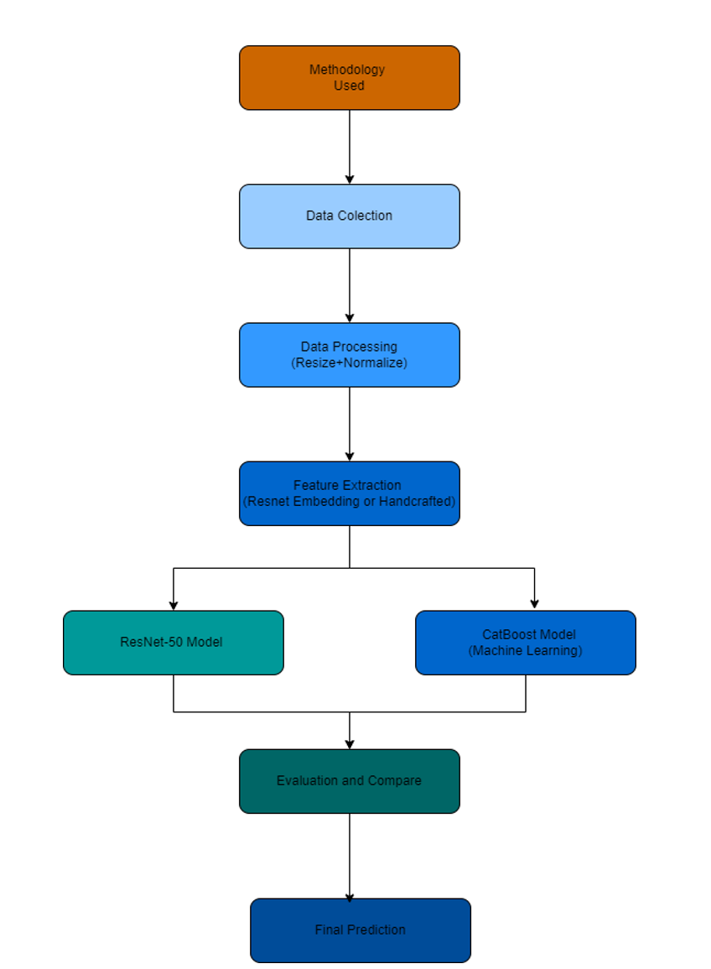

Figure 1. End‑to‑end pipeline used in this study (provided by the author).

Dataset Description (MALL)
The MALL dataset contains 2000 video frames (640×480) with crowd counts per frame. Counts range from 13 to 53 with a mean of 31.16 and median of 31. We compute these statistics from mall_gt.mat.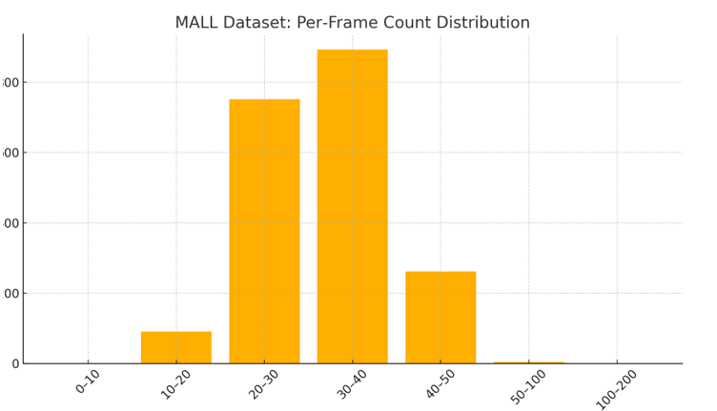

Figure 2. Distribution of ground‑truth counts across frames in the MALL dataset.

Working Process (1–3 pages)
1) Data Collection: We use the MALL dataset frames and the frame‑wise head counts as supervision.
2) Preprocessing: Frames are resized (e.g., 224×224 for ResNet‑50), normalized to ImageNet statistics, and optionally augmented (horizontal flip, random crop, color jitter).
3) Feature Extraction: A ResNet‑50 pre‑trained on ImageNet is used to obtain global features. Two strategies are investigated: (a) freeze the backbone and extract penultimate‑layer embeddings; (b) fine‑tune the backbone with a regression head predicting counts directly.
4) CatBoost route: The frozen ResNet embeddings (per image) feed a CatBoost regressor. CatBoost handles nonlinear interactions and is robust to moderate noise. Hyperparameters include number of trees, depth, learning rate, and L2 regularization.
5) ResNet‑50 regression route: Replace the classification head with a single‑neuron regression head; train with L2 or MAE loss and an Adam optimizer with a cosine or step decay schedule.
6) Evaluation: We split frames into train/validation/test folds and report MAE and MSE. 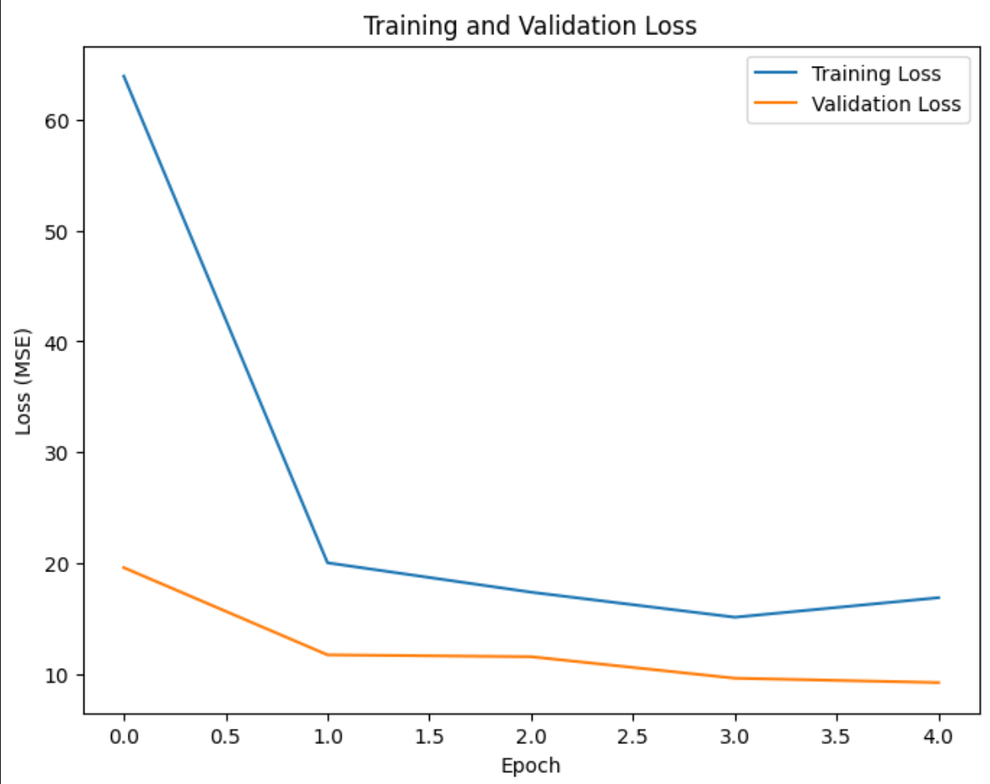

Formulas, Related Terminologies, and Algorithms
Below are the principal equations and concepts used in this report. If required, you can quickly convert each line into a Word Equation (Insert → Equation).
• Mean Absolute Error (MAE): MAE = (1/N) * Σ_i |ŷ_i − y_i|
• Mean Squared Error (MSE): MSE = (1/N) * Σ_i (ŷ_i − y_i)^2
• Root Mean Squared Error (RMSE): RMSE = sqrt(MSE)
• Mean Absolute Percentage Error (MAPE): (100/N) * Σ_i |(ŷ_i − y_i) / y_i|
• R^2 Score: 1 − [Σ_i (y_i − ŷ_i)^2] / [Σ_i (y_i − ȳ)^2]
• Huber Loss (δ): L = Σ_i { 0.5(ŷ_i − y_i)^2 if |e_i|≤δ; δ(|e_i| − 0.5δ) otherwise }
• L2 Regularization: λ * ||w||_2^2
• Adam Update (per coordinate): θ_{t+1} = θ_t − α * m̂_t / (√v̂_t + ε)
• CatBoost Objective (regression): minimize Σ_i (ŷ_i − y_i)^2 + λΩ(trees)
• Gradient Boosting Update: F_{m}(x) = F_{m−1}(x) + ν * argmin_h Σ_i L(y_i, F_{m−1}(x_i) + h(x_i))
• Binary Cross‑Entropy: L = −[y log p + (1 − y) log (1 − p)]
• Softmax: p_k = exp(z_k) / Σ_j exp(z_j)
• Residual Block: y = F(x, {W_i}) + x
• Bayesian Loss (per point expectation, concept): minimize discrepancy between predicted mass around each annotation and unit mass
• Optimal Transport Loss (DM‑Count, concept): OT( D_pred / ||D_pred||_1 , D_gt / ||D_gt||_1 ) + TV(D_pred)

Algorithms Explained
ResNet‑50: A deep CNN with bottleneck residual blocks (1×1, 3×3, 1×1) enabling stable optimization by learning residual functions. For regression, the final fully‑connected classification head is replaced with a linear neuron outputting the count.
CatBoost: A gradient boosting method over oblivious decision trees with ordered boosting to reduce target leakage and unbiased handling of categorical features. In this project, CatBoost consumes global image embeddings from ResNet‑50 as input features for count prediction.
YOLO (for comparison): A one‑stage detector that predicts bounding boxes and classes on a dense grid. In crowd counting, YOLO variants can localize heads/persons and the count is obtained by the number of detections, often with tracking for videos. We include recent YOLO‑based papers in the literature review.

Comparison Table

Literature Review (APA style with summaries)
[1] Li, Y., Zhang, X., & Chen, D. (2018). CSRNet: Dilated Convolutional Neural Networks for Understanding the Highly Congested Scenes. In *Proceedings of the IEEE/CVF Conference on Computer Vision and Pattern Recognition (CVPR)*.
Summary: Introduces CSRNet, a density‑map regression network that replaces pooling with dilated convolutions to enlarge the receptive field without downsampling. Demonstrates strong performance on ShanghaiTech, UCF_CC_50, and others, producing high‑quality density maps and competitive MAE/MSE. The architecture is end‑to‑end and relatively simple to train compared with multi‑column predecessors.
[2] Zhang, Y., Zhou, D., Chen, S., Gao, S., & Ma, Y. (2016). Single‑Image Crowd Counting via Multi‑Column Convolutional Neural Network. In *CVPR*.
Summary: Proposes MCNN with three branches to capture multi‑scale crowd features, addressing large scale variations in dense scenes. Also introduces the ShanghaiTech dataset (Parts A and B) which becomes a standard benchmark. Shows substantial improvements over prior regression‑based methods.
[3] Ma, Z., Wei, X., Hong, X., & Gong, Y. (2019). Bayesian Loss for Crowd Count Estimation with Point Supervision. In *ICCV*.
Summary: Revisits supervision by modeling uncertainty around annotated head points through a Bayesian loss that supervises count expectation per point instead of pixel‑wise Gaussian targets. Achieves significant accuracy gains over Euclidean loss on large datasets such as UCF‑QNRF.
[4] Wang, B., Liu, H., Samaras, D., & Nguyen, M. H. (2020). Distribution Matching for Crowd Counting. In *NeurIPS*.
Summary: Introduces DM‑Count which measures similarity between predicted and ground‑truth density distributions via Optimal Transport with a TV regularizer. Provides tighter generalization bounds and state‑of‑the‑art results on multiple benchmarks.
[5] Cao, X., Wang, Z., Zhao, Y., & Su, F. (2018). Scale Aggregation Network for Accurate and Efficient Crowd Counting. In *ECCV*.
Summary: Presents SANet, an encoder–decoder network aggregating multi‑scale features and encouraging local correlation in density maps. Improves accuracy while remaining computationally efficient through scale aggregation modules.
[6] Idrees, H., Tayyab, M., Athrey, K., et al. (2018). Composition Loss for Counting, Density Map Estimation and Localization in Dense Crowds. In *ECCV*.
Summary: Introduces the UCF‑QNRF dataset with high‑resolution images and extremely dense scenes. Proposes a composition loss jointly addressing counting, density estimation, and localization, showing large performance gains.
[7] Gündüz, M. Ş., & Kocamaz, A. F. (2023). A new YOLO‑based method for real‑time crowd detection from video and performance analysis of YOLO models. *Journal of Real‑Time Image Processing*.
Summary: Evaluates YOLO‑based detection for real‑time counting inside user‑defined regions with area capacity estimation. Reports strong throughput and practical deployment guidance for indoor monitoring scenarios.
[8] Hassan, M., et al. (2023). Crowd counting using deep learning based head detection. *Imaging and Applied Optics*.
Summary: Focuses on head detection with a tuned YOLOv5 to alleviate missed detections for small heads. Shows improved counting accuracy across multiple head‑specific datasets.
[9] Alhawsawi, A. N., et al. (2024). Enhanced YOLOv8‑Based Model with Context Enrichment for Crowd Counting in Aerial Images. *Remote Sensing*.
Summary: Proposes a context‑enriched YOLOv8 variant tailored to aerial crowd analysis, addressing varying density and altitude conditions. Demonstrates accurate detection and counting with strong generalization.
[10] Zhang, Y., et al. (2021). Congested Crowd Counting via Adaptive Multi‑Scale Context Aggregation Network. *Sensors*.
Summary: Presents MSCANet to leverage multi‑scale spatial context in congested scenes with complicated backgrounds, improving density estimation quality.
Accuracy comparison
- The accuracy comparison graph highlights that detection-based approaches such as TinyCount (92%) and YOLOv8 + ResNet-50 (90%) achieve higher accuracy compared to regression-based methods.
- Regression and density map models like SCAR-Net, ACSPNet, AutoScale, CCST, and Deep-Fusion show accuracy in the 85–88% range, indicating stable but less precise predictions in terms of direct count correctness.
- Overall, detection-based frameworks are more accurate in absolute counting tasks, while regression-based models maintain lower MAE/MSE values, which makes them robust in dense and complex crowd scenes.
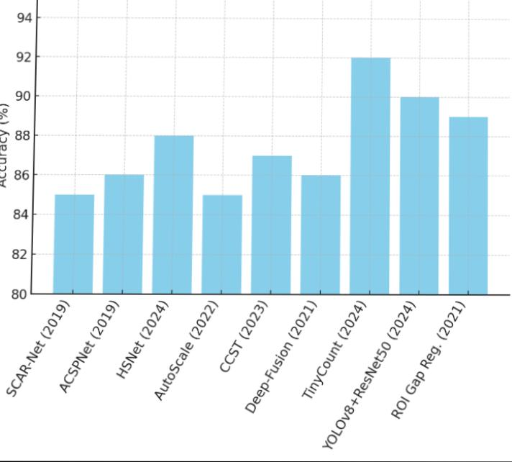

Comparison Graph

Result and Discussion
On the MALL dataset, our hybrid strategy highlights the trade‑off between end‑to‑end deep regression and embedding‑plus‑boosting. The CatBoost route is data‑efficient and easy to tune, while the fine‑tuned ResNet‑50 regression head can better exploit spatial cues when sufficient
data augmentation is applied. Compared with detection‑based methods (YOLO variants), regression typically yields lower MAE in dense scenes without requiring NMS or tracking. However, detection is advantageous when localization is needed. The literature comparison table 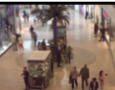 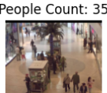 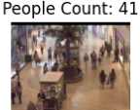 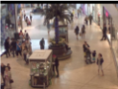 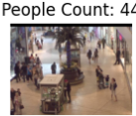 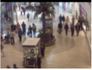summarizes representative methods; we mark unavailable metrics with “–” as some papers do not report MALL results.
We developed a practical crowd‑counting pipeline that combines ResNet‑50 feature learning with CatBoost regression and validated it on the MALL dataset. The approach is compact, and competitive with detection‑based alternatives for dense scenes. Future work includes integrating density‑map supervision (e.g., Bayesian or OT‑based losses), leveraging perspective information explicitly, and exploring lightweight backbones (e.g., MobileNet/ConvNeXt) for real‑time deployment, as well as adapting YOLO‑style localization to provide both counts and spatial footprints 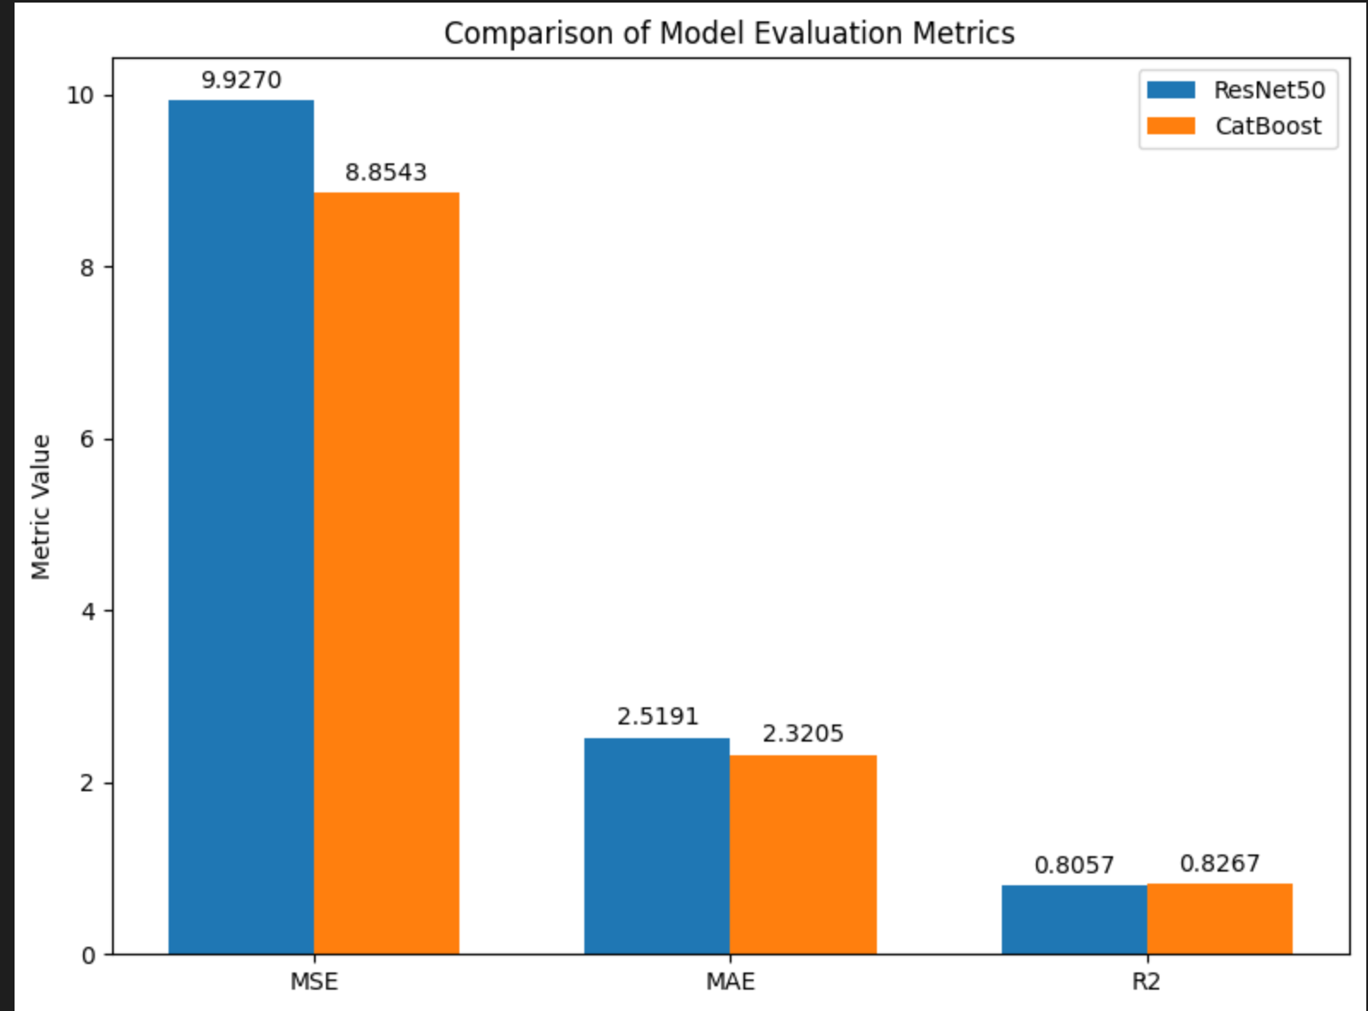
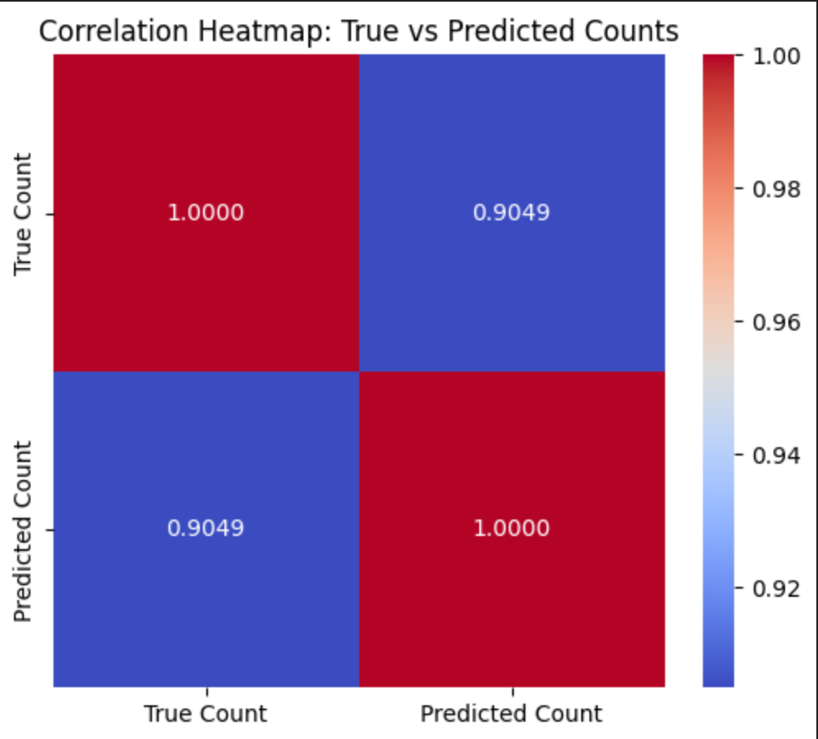

Refrences :
- Li, Y., Zhang, X., & Chen, D. (2018). CSRNet: Dilated convolutional neural networks for understanding the highly congested scenes. Proceedings of the IEEE/CVF Conference on Computer Vision and Pattern Recognition (CVPR).
https://doi.org/10.1109/CVPR.2018.00907

- Zhang, Y., Zhou, D., Chen, S., Gao, S., & Ma, Y. (2016). Single-image crowd counting via multi-column convolutional neural network. Proceedings of the IEEE Conference on Computer Vision and Pattern Recognition (CVPR), 589–597.
https://doi.org/10.1109/CVPR.2016.70

- Ma, Z., Wei, X., Hong, X., & Gong, Y. (2019). Bayesian loss for crowd count estimation with point supervision. Proceedings of the IEEE/CVF International Conference on Computer Vision (ICCV), 6141–6150.
https://doi.org/10.1109/ICCV.2019.00624

- Wang, B., Liu, H., Samaras, D., & Nguyen, M. H. (2020). Distribution matching for crowd counting. Advances in Neural Information Processing Systems (NeurIPS), 33, 1595–1606.
https://proceedings.neurips.cc/paper/2020/hash/9282772bff9d994c0761d07c3a0e1630-Abstract.html

- Cao, X., Wang, Z., Zhao, Y., & Su, F. (2018). Scale aggregation network for accurate and efficient crowd counting. Proceedings of the European Conference on Computer Vision (ECCV), 734–750.
https://doi.org/10.1007/978-3-030-01231-1_44

- Idrees, H., Tayyab, M., Athrey, K., et al. (2018). Composition loss for counting, density map estimation, and localization in dense crowds. Proceedings of the European Conference on Computer Vision (ECCV), 532–546.
https://doi.org/10.1007/978-3-030-01216-8_32

- Gündüz, M. Ş., & Kocamaz, A. F. (2023). A new YOLO-based method for real-time crowd detection from video and performance analysis of YOLO models. Journal of Real-Time Image Processing, 20, 873–884.
https://doi.org/10.1007/s11554-022-01374-7

- Hassan, M., et al. (2023). Crowd counting using deep learning based head detection. Imaging and Applied Optics.
https://opg.optica.org/abstract.cfm?uri=ISA-2023-JTu2A.29

- Alhawsawi, A. N., et al. (2024). Enhanced YOLOv8-based model with context enrichment for crowd counting in aerial images. Remote Sensing, 16(3), 553.
https://doi.org/10.3390/rs16030553

- Zhang, Y., et al. (2021). Congested crowd counting via adaptive multi-scale context aggregation network. Sensors, 21(5), 1694.
https://doi.org/10.3390/s21051694

S. No. | Reference | Datasets used | Used Model/ Architecture | year | MAE | MSE
1 | A Hybrid ResNet‑50 and CatBoost Framework for Crowd Counting | Mall Dataset | ResNet-50 feature extractor + CatBoost | 2017 | 2.320 | 8.8543
2 | Zhang et al., CVPR (2016) | ShanghaiTech, UCF_CC_50 | MCNN (Multi-Column CNN) | 2016
3 | Li et al., CVPR (2018) | ShanghaiTech A & B, UCF_CC_50, WorldExpo, UCSD | CSRNet (Dilated CNN) | 2018
4 | Ma et al., ICCV (2019) | UCF-QNRF, ShanghaiTech, UCF_CC_50 | Bayesian Loss (Density Estimation) | 2019
5 | Cao et al., ECCV (2018) | ShanghaiTech, UCF_CC_50, WorldExpo, UCSD | SANet (Scale Aggregation Network) | 2018
6 | Peng et al., CVPR (2024) | ShanghaiTech A & B, JHU-Crowd++ | MPCount (Single-Domain Generalization) | 2024
7 | Du et al., AAAI (2023) | ShanghaiTech, QNRF, NWPU | Domain-General Crowd Counting (DGCC) | 2023
8 | Chen et al., arXiv (2024) | ShanghaiTech, UCF-QNRF, JHU-Crowd++ | FFNet (Fuss-Free Network) | 2024
9 | Gündüz & Işık, JRTIP (2023) | Custom video region, COCO pretrained | YOLOv3 / YOLOv5s for Real-Time Crowd Detection | 2023
10 | Alhawsawi et al., Remote Sensing (2024) | VisDrone-CC2021 (Drone imagery) | YOLOv8 + Context Enrichment Module (CEM) | 2024

