Circular Linked List
Input

#include <iostream>
using namespace std;

// Cicular Linked List

struct Linkedlist
{
int data;
struct Linkedlist * next;
};

typedef struct Linkedlist node;
node * head = NULL;

void insertEnd()
{
node * temp = new node;
cout << "Enter data: " << endl;
cin >> temp->data;
temp->next = head->next;
head->next = temp;
head = temp;
}

void create()
{

if (head == NULL)
{
head = new node;
cout << "Enter data: " << endl;
cin >> head->data;
head->next = head;
}
else
{
insertEnd();
}
}

void display()
{
node * disp = head->next;
do {
cout << disp->data << endl;
disp = disp->next;

} while(disp != head->next);
}

void insertBeginning()
{
node * beg = new node;
cout << "Enter data: " << endl;
cin >> beg->data;
beg->next = head->next;
head->next = beg;
}

void insertMiddle()
{
int num,ref;
cout << "Enter data: " << endl;
cin >> num;
cout << "Enter the number after which input must be added: " << endl;
cin >> ref;
node * loopPointer = head->next;
while( loopPointer->data != ref)
{
loopPointer = loopPointer->next;
}
node * temporaryNode = new node;
temporaryNode->data = num;
temporaryNode->next = loopPointer->next;
loopPointer->next = temporaryNode;
}

void deleteEnd()
{
node * temp = head;
if (head->next == head)
{
delete head;
head = NULL;
}

else{
node * ptr = head->next;
while(ptr->next!=head)
{
ptr = ptr->next;
}
ptr->next = head->next;
delete head;
head = ptr;
}
}

void deleteBeginning()
{
node * tempPointer = head->next;
head->next = head->next->next;
delete tempPointer;
}

void deleteMiddle()
{
int num;
cout << "Enter data to delete: "<< endl;
cin >> num;
node * temporaryPointer = head->next;
node * temporaryPointer2 = NULL;
while(temporaryPointer->next->data != num)
{
temporaryPointer = temporaryPointer->next;
}
temporaryPointer2 = temporaryPointer->next;
temporaryPointer->next = temporaryPointer2->next;
delete temporaryPointer2;

}

void Search()
{
int num, count = 1;
cout << "Enter the data to search for: " << endl;
cin >> num;
node * temporaryPointer = head->next;
if (head->data == num)
{
cout << "The required element was found at the end of the list" << endl;
}
else{
while(temporaryPointer!= head && temporaryPointer->data != num)
{
count++;
temporaryPointer = temporaryPointer->next;
}
if (temporaryPointer!= head)
cout << "The required data was found at position " << count << endl;
else
cout << "Node not found!!" << endl;

}
}

int main()
{
int menu;
cout << "1. Create node" << endl;
cout << "2. Display items" << endl;
cout << "3. Add node at beginning" << endl;
cout << "4. Add node in the middle" << endl;
cout << "5. Delete last node" << endl;
cout << "6. Delete first node" << endl;
cout << "7. Delete middle node" << endl;
cout << "8. Search" << endl;
cout << "15.Exit" << endl;
do{
cout << "Enter menu item: " << endl;
cin >> menu;
switch(menu)
{
case 1:
create();
break;
case 2:
display();
break;
case 3:
insertBeginning();
break;
case 4:
insertMiddle();
break;
case 5:
deleteEnd();
break;
case 6:
deleteBeginning();
break;
case 7:
deleteMiddle();
break;
case 8:
Search();
break;
default:
break;
}} while(menu != 15);
return 0;
}

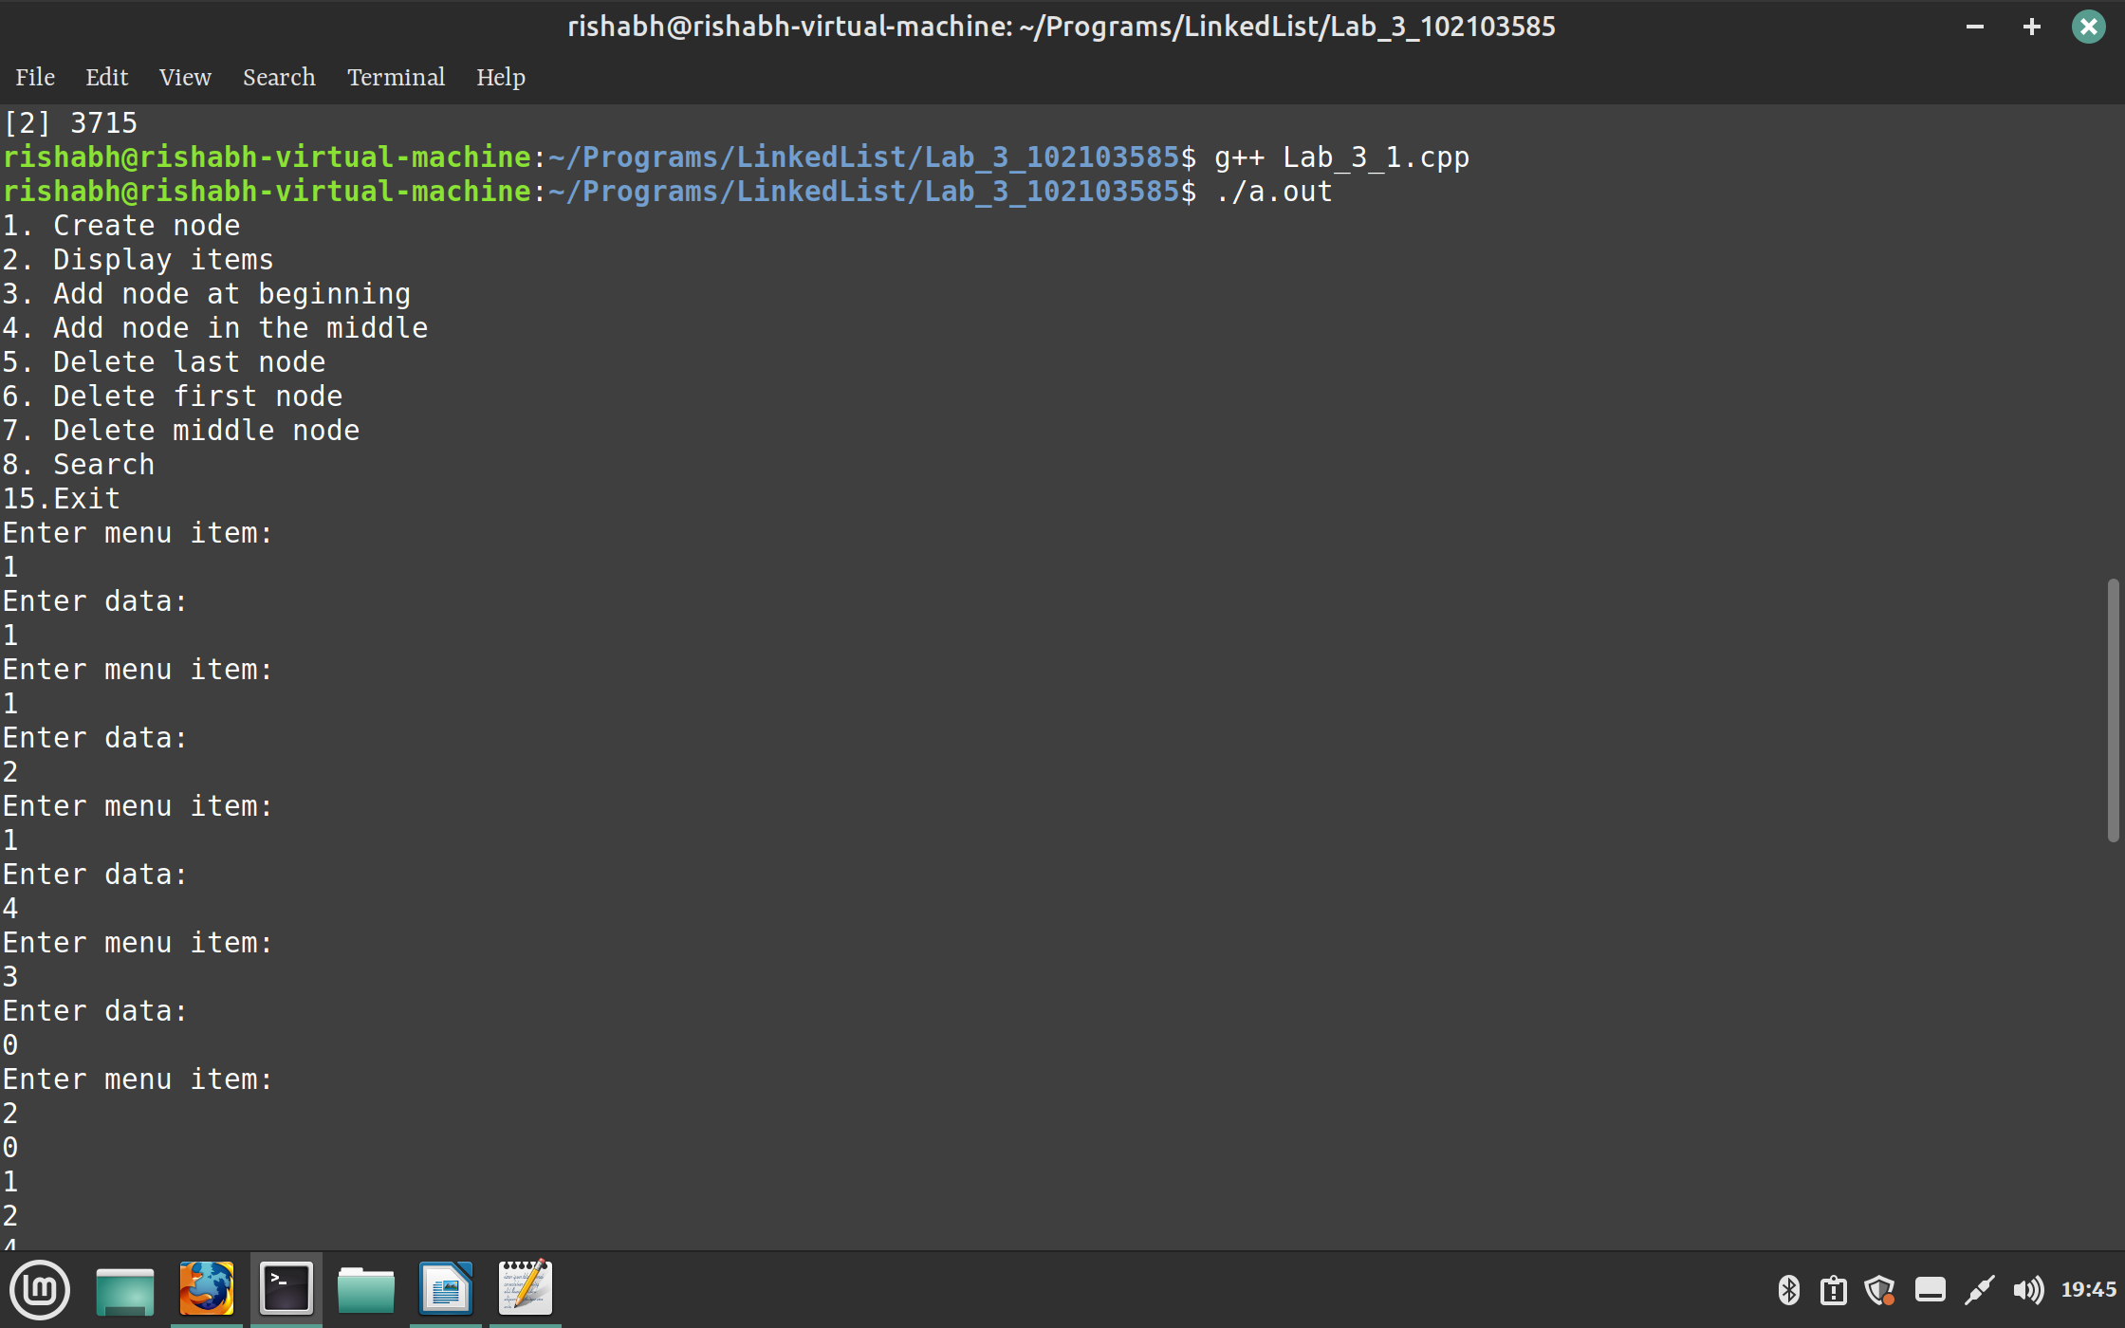
Output

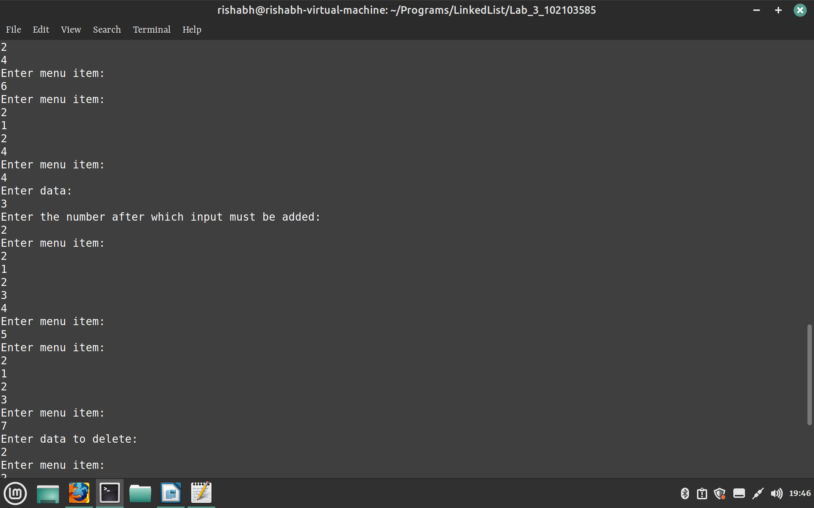

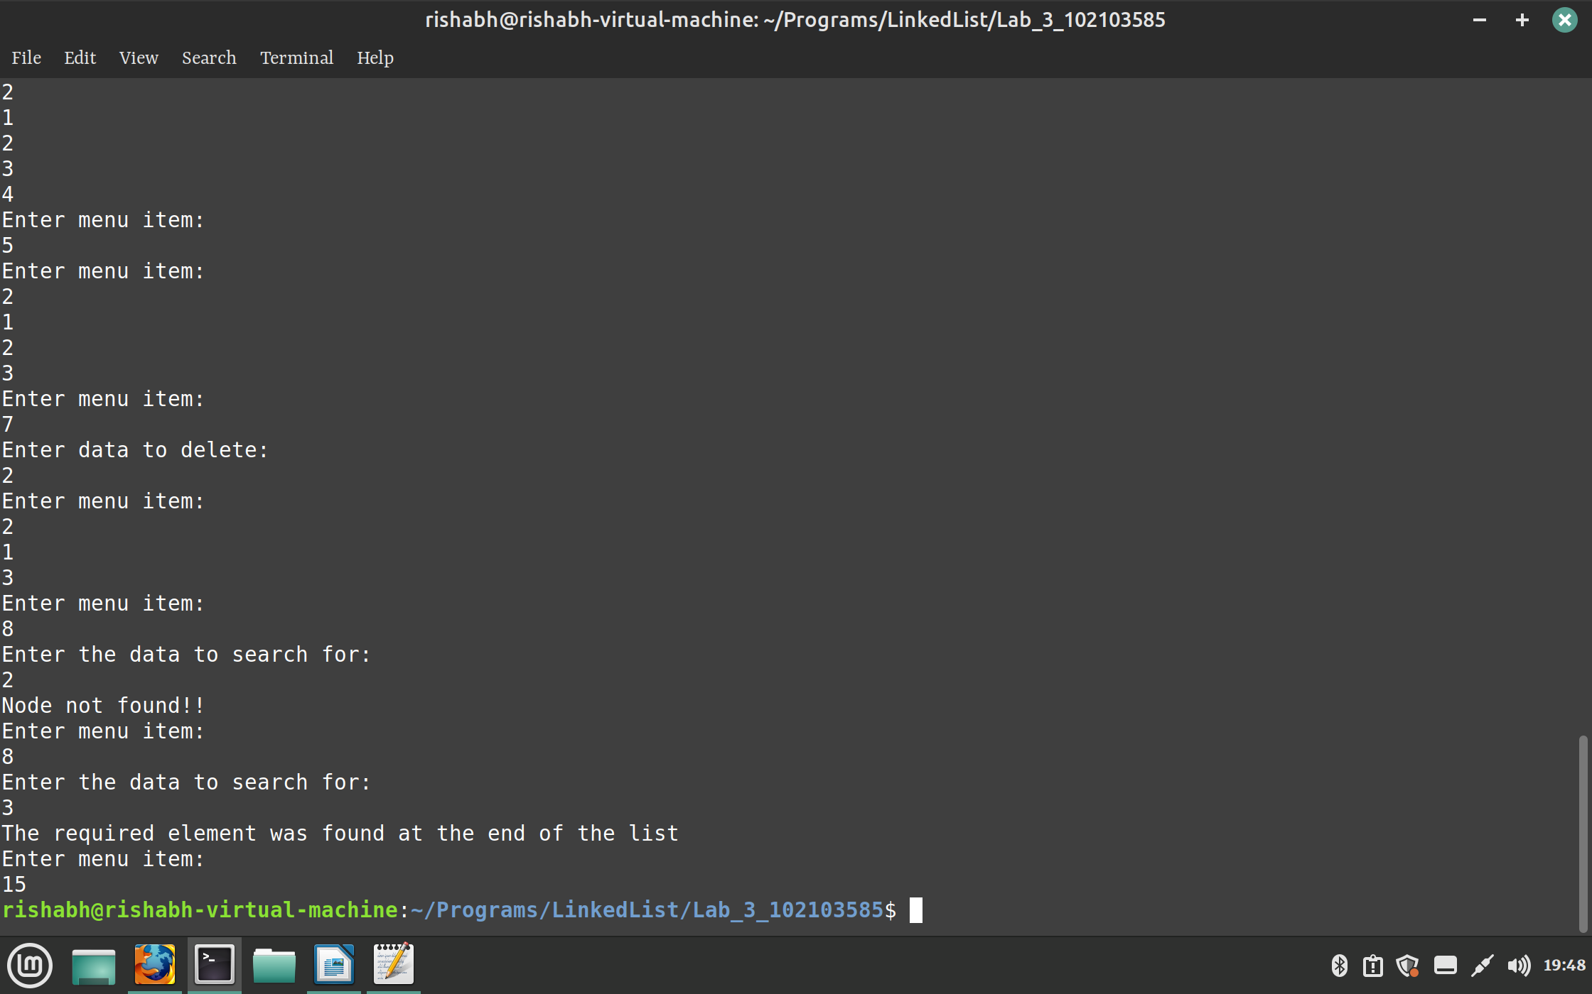
Doubly Linked List
Input

#include <iostream>
using namespace std;

//Double Linked List

struct DLL
{
int data;
struct DLL * next;
struct DLL * prev;
};

typedef struct DLL node;
node * head = NULL, * temp = NULL;

void insertEnd()
{
temp->next = new node;
temp->next->prev = temp;
temp->next->next = NULL;
temp = temp->next;
cout << "Enter the data: " << endl;
cin >> temp->data;
}

void create()
{
if (head == NULL)
{
head = new node;
head->prev = NULL;
head->next = NULL;
cout << "Enter the data: "<< endl;
cin >> head->data;
temp = head;
}
else
{
insertEnd();
}
}

void display()
{
node * disp = head;
while(disp != NULL)
{
cout << disp->data << endl;
disp = disp->next;
}
}

void insertBeginning()
{
if (head != NULL)
{
node * ptr = new node;
ptr->next = head;
cout << "Enter data: " << endl;
cin >> ptr->data;
ptr->prev = NULL;
head->prev = ptr;
head = ptr;
}
else
{
create();
}

}

void insertMiddle()
{
if(head != NULL)
{
int ref;
cout << "Enter the number after which new node must be added: " << endl;
cin >> ref;
node * ptr = head;
while(ptr->data != ref)
{
ptr = ptr->next;
}
node * add = new node;
cout << "Enter the data: " << endl;
cin >> add->data;
add->prev = ptr;
add->next = ptr->next;
add->next->prev = add;
ptr->next = add;
}
else
create();
}

void deleteBeg()
{
head = head->next;
delete head->prev;
head->prev = NULL;
}

void deleteOther(int pos)
{
int counter = 1;
node * ptr = head;
while (ptr != NULL && counter != pos - 1)
{
counter++;
ptr = ptr->next;
}
if (ptr == NULL)
{
cout << "Node does not exist!!" << endl;
}
else
{
if (ptr->next->next != NULL)
{
ptr->next = ptr->next->next;
delete ptr->next->prev;
ptr->next->prev = ptr;
cout << "Successfully deleted!" << endl;
}
else
{
delete ptr->next;
ptr->next = NULL;
}

}

}

void deleteNode()
{
int pos;
cout << "Enter the position of the node you want to delete: " << endl;
cin >> pos;
if (pos == 1)
deleteBeg();
else
deleteOther(pos);
}

void searchNode()
{
int item, count = 1;
cout << "Enter the the value you want to search for: " << endl;
cin >> item;
node * ptr = head;
while (ptr != NULL && ptr->data != item)
{
ptr = ptr->next;
count++;
}
if (ptr == NULL)
cout << "Specified node was not found!" << endl;
else
{
cout << "The required node was found at postion " << count << endl;
}
}

int main()
{
int menu = 1;
cout << "1.Create node" << endl;
cout << "2.Display List"<< endl;
cout << "3.Insert in beginning" << endl;
cout << "4.Insert in the middle" << endl;
cout << "5.Delete Node" << endl;
cout << "6.Search for a node" << endl;
cout << "0. Exit" << endl;
while(menu != 0)
{

switch(menu)
{
case 1:
create();
break;
case 2:
display();
break;
case 3:
insertBeginning();
break;
case 4:
insertMiddle();
break;
case 5:
deleteNode();
break;
case 6:
searchNode();
break;
default:
break;
}
cin >> menu;
}
return 0;
}

Output:

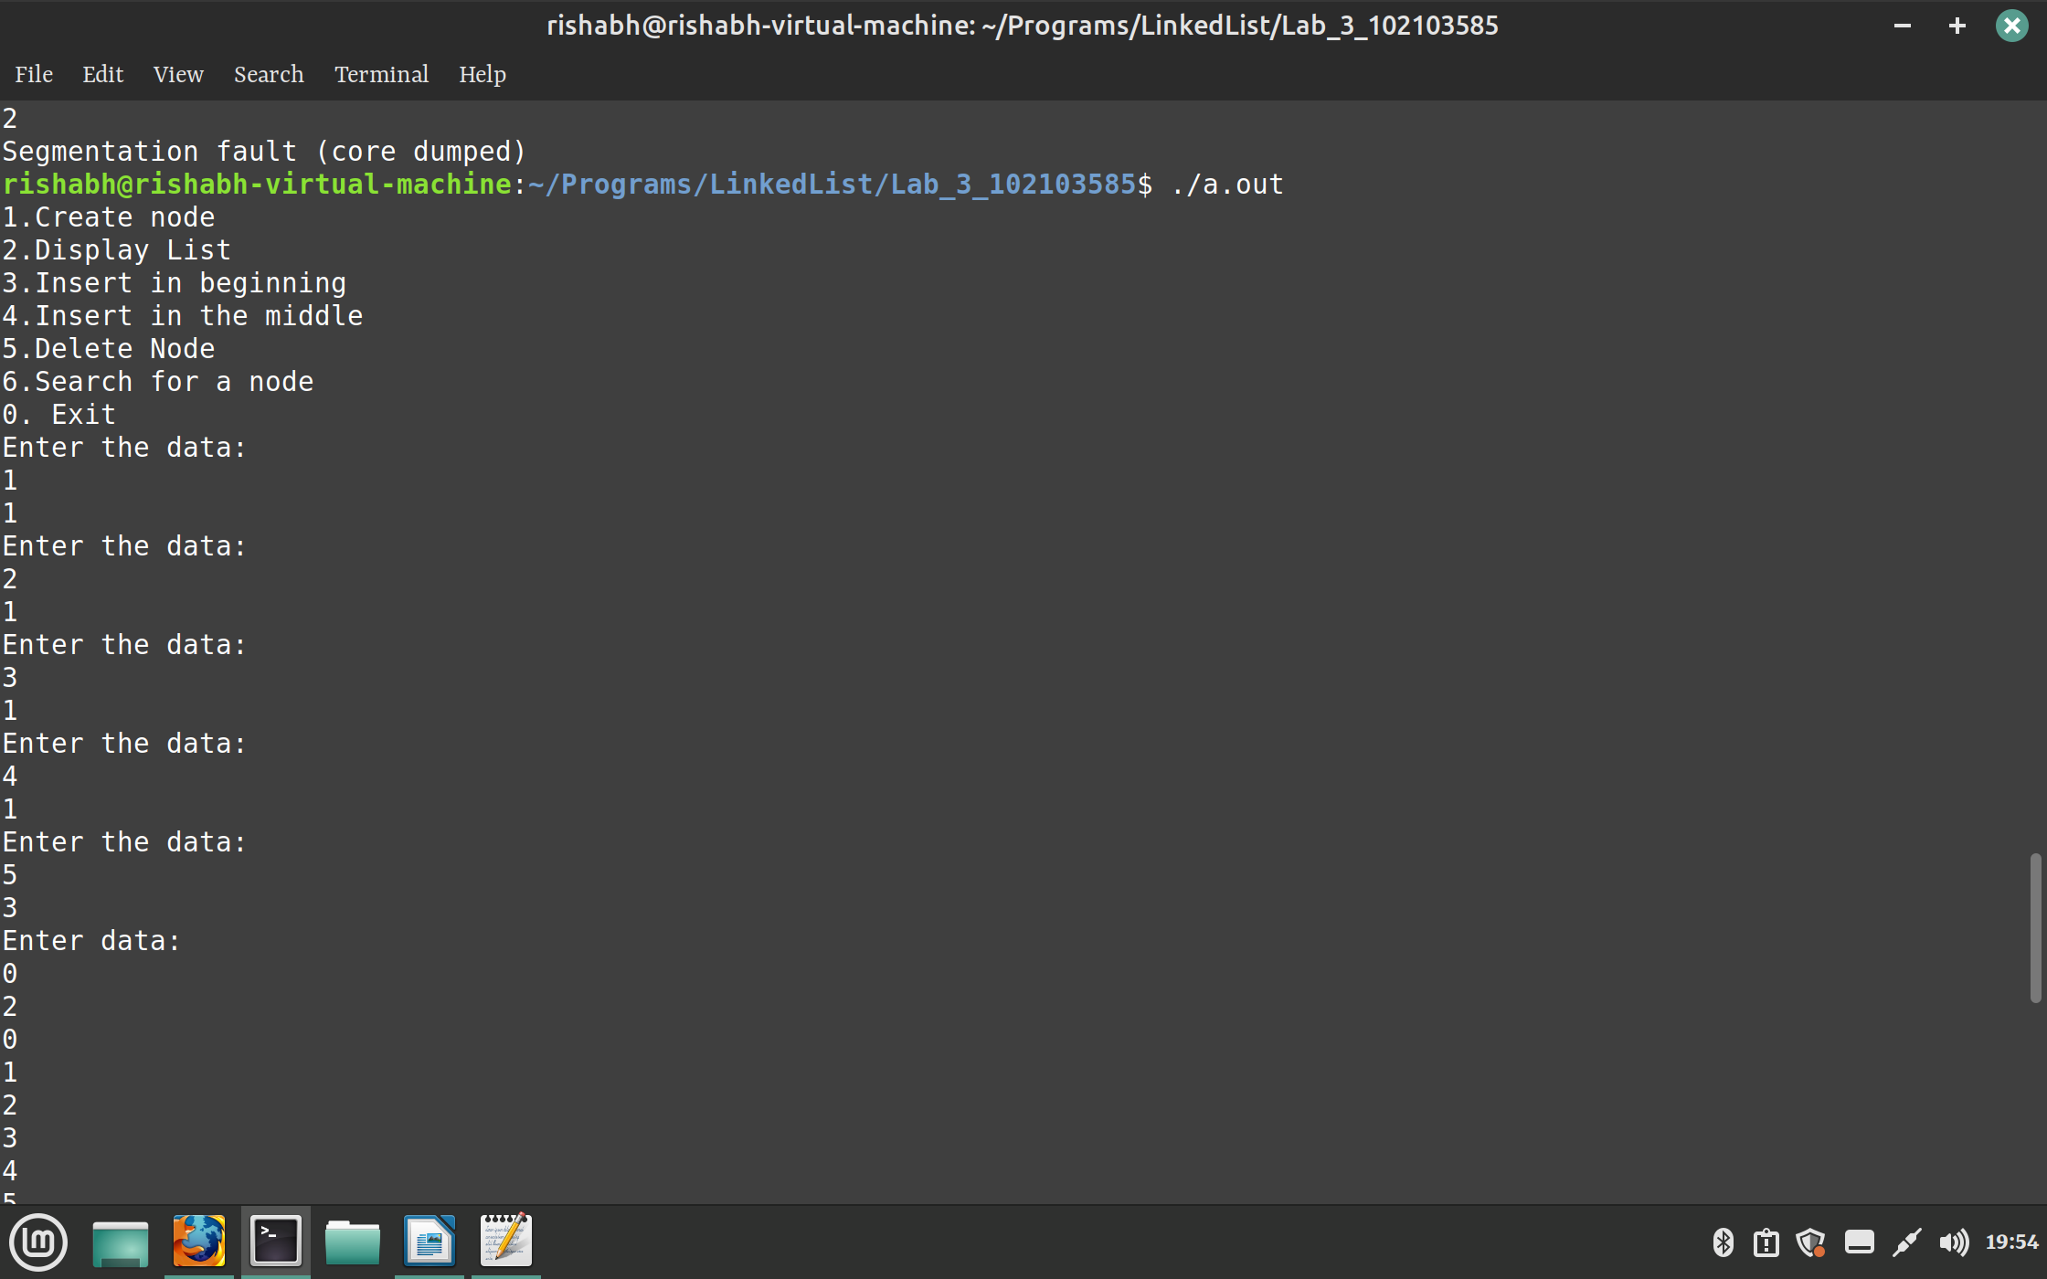
llllllllllllllll

