**EXPERIMENT**

**DESIGN A LDR SENSING BOX**

**CIRCUIT DIAGRAM:**

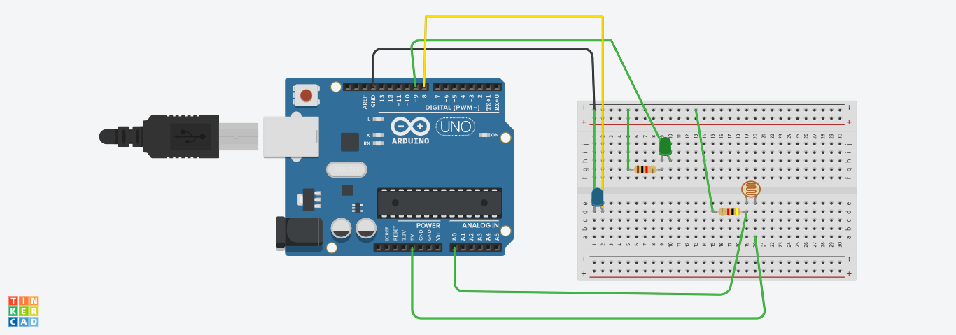**THEORY:**

**CONCEPT USED:**

* **KIRCHOFF’S VOLTAGE LAW**
* **KIRCHOFF’S CURRENT LAW**
* **ELECTROMAGNETIC RADIATION**
* **PHOTO CONDUCTIVITY**

**LEARNING & OBSERVATION:**

* **CONNECTIONS IN BREADBOARD AND WIRING**
* **USE OF MULTIMETER FOR CONTINUITY**
* **HOW TO CONTROL ARDUINO & ITS CODING**
* **PHOTO CONDUCTIVITY PRINCIPLE**
* **LIGHT SENSING DEVICES**

**OBSERVATIONS:**

* **CONTROL OF LEDS ON THERMAL SENSING**
* **RELATION BETWEEN SOFTWARE AND HARDWARE**
* **AUTOMATION OF A DEVICE USING A LDR**

**PROBLEMS AND TROUBLESHOOTING:**

* **TO SELECT THE RIGHT PORT AND TYPE OF ARDUINO**
* **TO CHECK THE LOOSE CONNECTIONS**
* **TO CHECK THE CONTINUITY OF CIRCUIT**
* **TO CHECK THE FLOW OF CURRENT**
* **TO CHECK THE CONNECTIONS ACCORDING TO THE CODES**
* **TO CONNECT THE RIGHT PINS IN THEIR RESPECTIVE PINMODES ACCORDING TO THE CODES**

**PRECAUTIONS:**

* **HANDLE THE COMPONENTS CAREFULLY**
* **AVOID CONNECTING ARDUINO TILL THE CIRCUIT IS COMPLETE**
* **CONNECT THE LEDs WITH A RESISTANCE TO AVOID DAMAGE**
* **DON’T PLUG THE COMPONENTS INTO UNKNOWN CIRCUITS AND MODES**

**SUBMITTED BY:**

**NAME: RISHABH GUPTA**

**UID : 19BCS3792**

**COURSE: BE-CSE(BD1(B))**