Mark Price Flow:
- The Pricing Server transmits Mark Price data for all symbols, which are stored in the latestMarkPrices cache on the server.
- At the Esper Engine, upon receiving the Mark Price data, a validation check is performed to ensure mark price is not 0.
- This validation may result in a discrepancy between the count of unique symbols in the Compliance Unique Symbols database query and the unique symbols count in the SymbolData window in Esper.
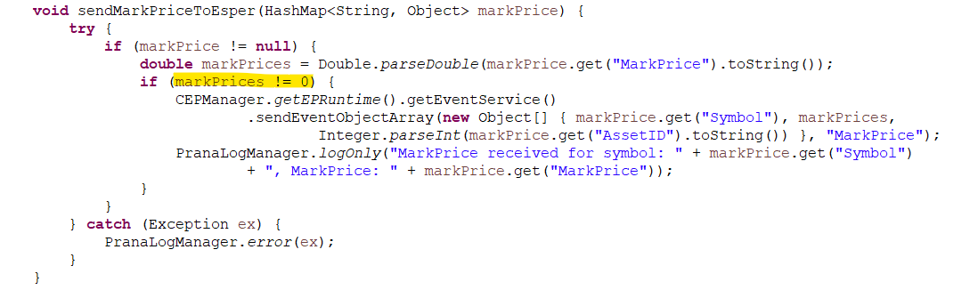

LiveFeed Flow:
- The Pricing Server transmits LiveFeed data for all symbols, which are stored in the _pricingCache cache on the server.
- At the Esper Engine, upon receiving the LiveFeed data, a validation is applied to ensure selectedfeedPX is not 0 or AskPrice is not 0 or BidPrice is not 0.
- This validation may also lead to a difference in the count of unique symbols between the Compliance Unique Symbols database query and the SymbolData window in Esper.
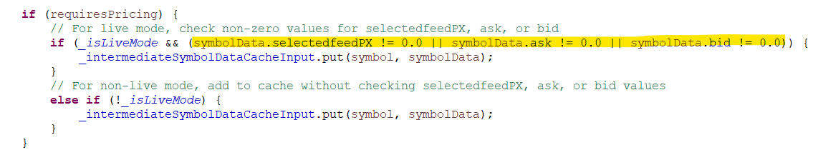

Left Outer Join in Row Calculation:
- When using a left outer join, there will always be at least one output event for each event in the stream on the left side of the join clause. For instance, in the left outer join example below, an output is generated for every event in the RfidEvent stream, even if no matching event is found in the OrderList stream:
- SELECT *
FROM RfidEvent#time(30 sec) AS rfid
LEFT OUTER JOIN
OrderList#length(10000) AS orderlist
ON rfid.itemId = orderlist.itemId
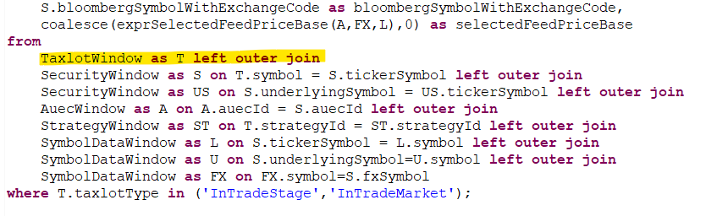

Post Taxlots Sent to Esper from EXPNL:
- The EXPNL server sends post-taxlot data to the Esper engine, including allocated post-taxlots, unallocated post-taxlots, transactions, and post-dated transactions. The presence of unallocated post-taxlots in the database can result in a discrepancy between the taxlot count in the Compliance Taxlots database query and the taxlot count in the Taxlot window within Esper.
