Experiment 2 – Rishabh Shah

J058 – B. Tech Data Science (IV SEM)

1.

void setup()

{

pinMode(13, OUTPUT);

}

void loop()

{

for (int i=0;i<255;i++)

{

analogWrite(13,i);

delay(10);

}

for (int i=255;i>0;i--)

{

analogWrite(13,i);

delay(10);

}

}

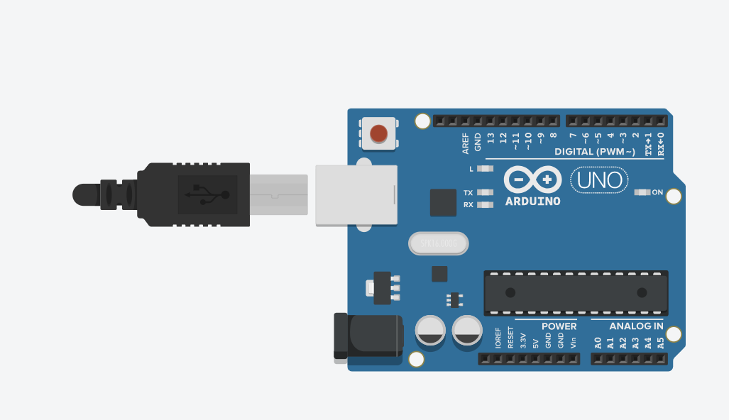

2.

void setup()

{

pinMode(9, OUTPUT);

pinMode(10, OUTPUT);

}

void loop()

{

for (int i=0; i<255; i++){

analogWrite(9, 255-i);

analogWrite(10,i);

delay(10);

}

for (int i=255; i>0; i--){

analogWrite(9, 255-i);

analogWrite(10, i);

delay(10);

}

}

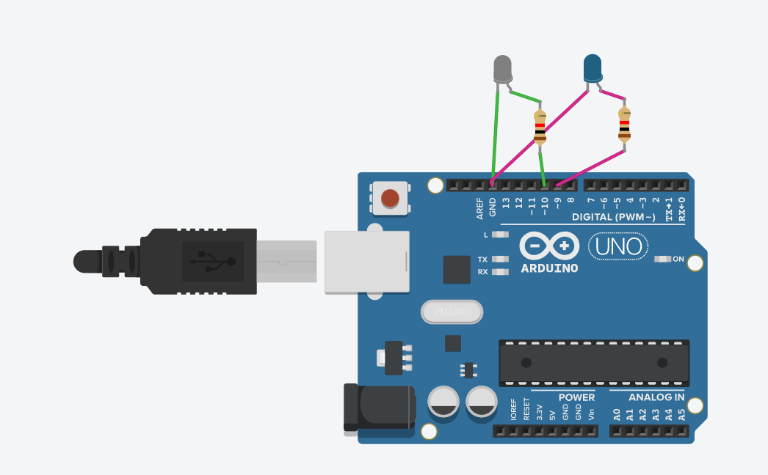

3.

void setup()

{

pinMode(A0, INPUT);

Serial.begin(9600);

}

void loop()

{

int read = analogRead(A0);

Serial.println(read);

delay(10);

}

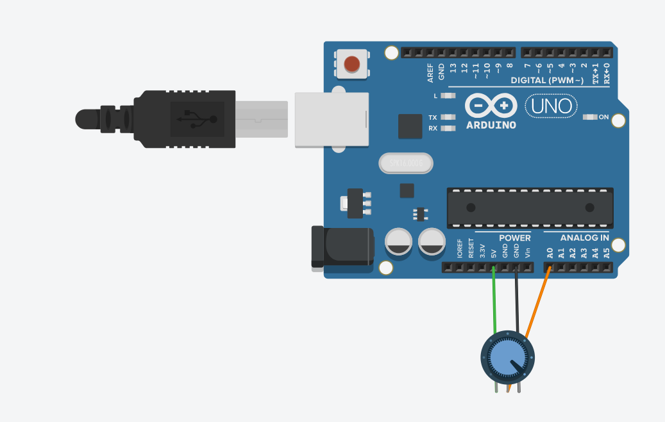

4.

int read = 0;

void setup()

{

pinMode(A0, INPUT);

pinMode(10, OUTPUT);

Serial.begin(9600);

}

void loop()

{

read = analogRead(A0);

if(read>512)

{

digitalWrite(10,HIGH);

Serial.println(read);

}

else

{

digitalWrite(10,LOW);

Serial.println(read);

}

delay(10);

}

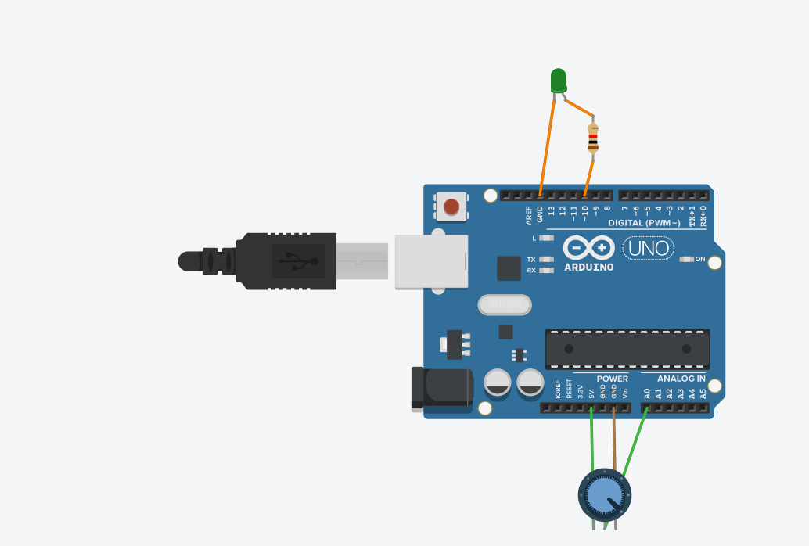

5.

const int P= A0;

void setup()

{

pinMode(P,INPUT);

pinMode(9,OUTPUT);

Serial.begin(9600);

}

void loop()

{

int a = analogRead(P);

int y = map(a,0,1023,0,255);

analogWrite(9,y);

Serial.println(a);

Serial.println(y);

delay(1000);

}

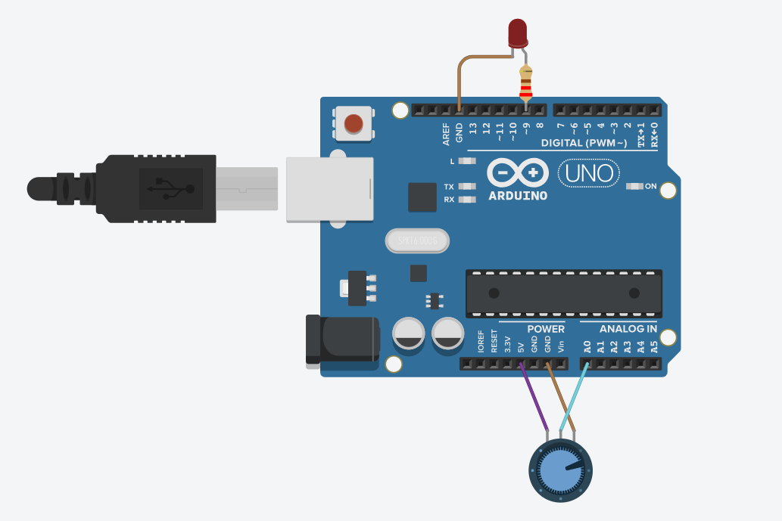

6.

int buttonState = 0;

void setup()

{

pinMode(2, INPUT);

pinMode(12, OUTPUT);

pinMode(11, OUTPUT);

pinMode(10, OUTPUT);

pinMode(9, OUTPUT);

}

void loop()

{

buttonState = digitalRead(2);

if (buttonState == HIGH)

{

// turn LEDs on

digitalWrite(12, HIGH);

digitalWrite(11, HIGH);

digitalWrite(10, HIGH);

digitalWrite(9, HIGH);

}

else

{

// turn LEDs off

digitalWrite(12, LOW);

digitalWrite(11, LOW);

digitalWrite(10, LOW);

digitalWrite(9, LOW);

}

delay(10);

}

