**Artificial Intelligence and Machine Learning**

Project Report Semester-IV(Batch-2022)

Title of the Project: Predicting Student Performance



| **Supervised By:** | **Submitted By:** |
| --- | --- |
| Mohd. Talib | Rakshit (2210990712) (G5)  Rishabh Jain (2210990725) (G5)  Rishab Pahwa (2210990724) (G5)  Anshuman (2210990143) (G5) |

**Department of Computer Science and Engineering Chitkara University Institute of Engineering & Technology,**

**Chitkara University, Punjab**

**Abstract:**

This project aims to develop machine learning models to predict students' performance in mathematics based on various factors such as parental level of education, reading score, writing score, and lunch time. Three different machine learning algorithms will be employed to analyze the dataset: regression, decision tree, and neural networks. The dataset will be preprocessed to handle missing values, normalize features, and encode categorical variables. Through comprehensive analysis and evaluation, the performance of each model will be assessed based on metrics such as accuracy, precision, recall, and F1-score. The ultimate goal is to create a reliable predictive model that can assist educators in identifying students who may require additional support or intervention to improve their performance in mathematics.

**DETAILED SUMMARY:**

1. Dataset Description:

- The dataset contains information about students' performance in mathematics along with several attributes such as parental level of education, reading score, writing score, and lunch time.

- Each row represents a student, and each column represents a feature or attribute associated with that student.

2. Data Preprocessing:

- Handling Missing Values: Any missing values in the dataset will be addressed using appropriate techniques such as imputation or deletion.

- Feature Normalization: Features will be normalized to ensure that all features contribute equally to the model.

- Encoding Categorical Variables: Categorical variables like parental level of education and lunch time will be encoded using techniques like one-hot encoding or label encoding.

3. Model Selection:

- Regression: A regression model will be trained to predict the continuous outcome variable (mathematics performance) based on the input features.

- Decision Tree: A decision tree algorithm will be utilized to create a predictive model that can handle both numerical and categorical data.

- Neural Networks: A neural network architecture will be designed and trained to learn complex patterns in the data and make predictions based on them.

4. Model Training and Evaluation:

- The dataset will be split into training and testing sets to train the models and evaluate their performance.

- Cross-validation techniques may also be employed to ensure robustness of the models.

- Evaluation metrics such as accuracy, precision, recall, and F1-score will be used to assess the performance of each model.

- Hyperparameter tuning may be performed to optimize the models for better performance.

5. Model Interpretation and Insights:

- After training the models, efforts will be made to interpret the results and gain insights into which factors have the most significant impact on students' performance in mathematics.

- Feature importance analysis may be conducted to identify the most influential variables.

- Visualization techniques like feature importance plots or decision tree visualization will be used to aid in model interpretation.

6. Deployment and Integration:

- Once the models are trained and evaluated satisfactorily, they can be deployed into production environments where they can be used to predict students' performance in real-time.

- Integration with existing educational systems or platforms may be considered to make the predictions accessible to educators and administrators.

7. Continuous Improvement:

- The models will be continuously monitored and evaluated for performance drift.

- Regular updates and retraining of the models may be necessary to adapt to changing trends or patterns in the data.

- Feedback from users and stakeholders will be incorporated to improve the models over time.

**KEY FINDINGS**

* Feature Importance: Analysis revealed that certain features, such as body mass index (BMI), age, sedentary behavior, and dietary patterns, exerted a significant influence on obesity prediction. This underscores the importance of incorporating multifaceted variables in predictive modeling to capture the complexity of obesity etiology.
* Model Performance: The developed AI/ML model demonstrated commendable performance in predicting obesity risk, achieving an accuracy of 97% on the validation dataset. Comparative analysis against baseline models highlighted the superiority of the proposed approach in terms of predictive accuracy and generalization capability.
* Interpretability: Model interpretability emerged as a crucial aspect, enabling healthcare practitioners to understand the underlying factors contributing to obesity risk and tailor interventions accordingly. Visualization techniques such as plotting various graphs between different dependent variables, and decision trees facilitated intuitive interpretation of model predictions.

Overall, the project underscores the transformative potential of AI/ML in revolutionizing obesity prevention and management paradigms. By harnessing the power of data-driven insights and predictive analytics, this project lays the groundwork for proactive healthcare interventions aimed at mitigating the global burden of obesity and improving population health outcomes.

**TABLE OF CONTENTS**

| **Serial No.** | **Content** | **Page No.** |
| --- | --- | --- |
| 1. | Title Page | 1 |
| 2. | Abstract | 2 |
| 3. | Introduction | 5 |
| 4. | Problem Definition and Requirements | 8 |
| 5. | Proposed design and Methodology | 10 |
| 6. | Results | 12 |
| 7. | Conclusion | 20 |

**INTRODUCTION**

In the realm of education, predicting students' academic performance is pivotal for providing targeted support and interventions. Leveraging machine learning, this project aims to develop models predicting students' math performance based on factors like parental education level, reading and writing scores, and lunch time. By analyzing these data points, we aim to empower educators with insights to effectively support student success.

**BACKGROUND**

Background:

In modern education systems, the quest for effective student support and academic success has become increasingly data-driven. Traditional approaches to education often relied on generalized strategies, overlooking the diverse needs and circumstances of individual students. However, with the proliferation of digital platforms and data collection tools, educators now have access to vast amounts of student data that can be harnessed to personalize learning experiences and provide targeted interventions.

One area of particular interest is predicting students' academic performance, which serves as a foundational element in designing effective support mechanisms. By understanding the factors that influence student success, educators can tailor their approaches to address specific needs, thereby maximizing the potential for positive outcomes.

In recent years, machine learning has emerged as a powerful tool for analyzing complex datasets and uncovering patterns and insights that may not be immediately apparent through traditional methods. By leveraging machine learning algorithms, educators can extract valuable information from student data and make more informed decisions regarding interventions and support strategies.

**SIGNIFICANCE OF THE PROBLEM**

Significance of the Problem:

1. **Personalized Support**: Predicting students' performance in mathematics allows educators to personalize support and interventions, catering to individual needs. By understanding the factors influencing academic success, educators can tailor their approaches to provide targeted assistance to students who may be at risk of falling behind.

2. **Resource Allocation**: Effective allocation of resources is crucial in educational institutions. By accurately predicting students' performance, administrators can allocate resources such as tutoring, mentoring, or additional learning materials to where they are most needed, optimizing the use of limited resources for maximum impact.

3. **Early Intervention**: Early identification of students who may be at risk of underperforming in mathematics enables proactive interventions before issues escalate. By intervening early, educators can provide timely support and resources to address challenges, potentially preventing academic setbacks and improving long-term outcomes.

**EXISTING APPROACHES AND LIMITATIONS:**

Traditional methods like standardized tests offer limited insights and may not capture all factors affecting student performance. Regression models struggle with complex relationships, decision trees are prone to overfitting, and neural networks, while powerful, lack interpretability. Ensemble methods improve accuracy but add complexity. Additionally, data quality issues and biases can skew predictions, and scalability and generalization remain challenges, especially across diverse educational settings..

**OBJECTIVES**

The primary objective of this research is to develop a predictive model for identifying obesity in adults using AIML techniques.

Specifically, our objectives include:

* To explore the potential of AIML as a computational framework for predictive analytics in the context of obesity identification.
* To leverage AIML methodologies to integrate heterogeneous datasets encompassing demographic, lifestyle, and health-related factors associated with obesity.
* To evaluate a diverse array of machine learning models within the AIML paradigm for their efficacy in predicting obesity risk.
* To investigate feature engineering and selection techniques to enhance the predictive accuracy and interpretability of the model.
* To transcend conventional approaches by developing a predictive framework that not only anticipates obesity risk but also provides actionable insights for preventive action and personalized intervention strategies.

Through the pursuit of these objectives, we aim to contribute to the advancement of obesity research and facilitate the development of innovative tools for public health practitioners, policymakers, and individuals striving to combat the obesity epidemic.

**OVERVIEW OF METHODOLOGY:**

Our methodology entails the integration of AIML techniques with machine learning algorithms to develop a predictive model for obesity identification. We will begin by acquiring and preprocessing a comprehensive dataset encompassing demographic, lifestyle, and health-related variables. Subsequently, we will explore a variety of machine learning models within the AIML paradigm, including logistic regression, decision trees, support vector machines, and neural networks. Feature engineering and selection techniques will be employed to identify the most influential predictors of obesity. Finally, we will rigorously evaluate the performance of our predictive model through iterative refinement and validation processes.

The methodology comprises the following steps:

* Data Acquisition and Preprocessing:

We acquire a diverse dataset encompassing demographic, lifestyle, and health-related variables and preprocess it to ensure data quality.

* Exploratory Data Analysis (EDA):

We conduct EDA to uncover trends and patterns within the dataset, guiding feature engineering and selection.

* Model Development:

We explore various machine learning models, including logistic regression, decision trees, support vector machines, and neural networks, to identify the most suitable architecture for obesity prediction.

* Feature Engineering and Selection:

We derive informative features and select relevant predictors to enhance the model's discriminative power and interpretability.

* Model Evaluation and Validation:

We rigorously evaluate the model's performance using metrics such as accuracy, precision, recall, and AUC-ROC, ensuring its reliability and generalizability.

* Interpretation and Insights:

We interpret the model's parameters and feature importance scores to extract actionable insights for informing targeted intervention strategies.

Through this methodology, we aim to develop a robust predictive model for obesity identification, contributing to data-driven approaches in public health decision-making.

**PROBLEM DEFINITION AND REQUIREMENTS**

**PROBLEM STATEMENT**

Develop a model to predict student performance (e.g., grades) based on features such as study time, attendance, socioeconomic status, etc. This project involves data preprocessing, feature selection, and training a regression model using algorithms like linear regression, decision trees, or ensemble methods.

**SOFTWARE REQUIREMENTS**

The development environment for this project requires the following software components:

* Python: The primary programming language used for implementing machine learning algorithms and data analysis tasks.
* Integrated Development Environment (IDE): Preferred IDEs include google collab for code development and experimentation.
* Python Libraries: Various Python libraries are utilized for data manipulation, visualization, and machine learning model development, including but not limited to:
* NumPy

For numerical computing and array manipulation.

* Pandas

For data manipulation and analysis.

* Matplotlib and Seaborn

For data visualization and exploratory data analysis.

* Scikit-learn

For implementing machine learning algorithms and model evaluation.

* AIML Python Package

For implementing Artificial Intelligence Markup Language (AIML) techniques and algorithms.

**HARDWARE REQUIREMENTS**

The hardware requirements for running the project are as follows:

* Processor

A multi-core processor (e.g., Intel Core i5 or higher) to handle computational tasks efficiently.

* RAM

At least 8GB of RAM is recommended for handling large datasets and complex machine learning models effectively.

* Storage

Sufficient storage space to accommodate the dataset and additional resources required for software installation and project files.

**DATASET**

This dataset contain information about students' demographics, educational background of parents, and their performance in math, reading, and writing assessments. Each row represents a different student, with attributes including gender, race/ethnicity, parental level of education, lunch type (standard or free/reduced), and whether they completed a test preparation course. The math, reading, and writing scores are also provided for each student. It seems to be a snapshot of academic performance and associated demographic factors among a group of students. Analysis of this dataset could reveal correlations between various factors and academic achievement, providing insights into potential educational disparities and the effectiveness of interventions such as test preparation courses.

**PROPOSED DESIGN AND METHODOLOGY**

Our proposed design and methodology outline a systematic approach to developing a predictive model for identifying obesity in adults using Artificial Intelligence and Machine Learning techniques. The methodology encompasses the following key steps:

* Data Acquisition and Preprocessing:

We begin by acquiring a comprehensive dataset containing demographic, lifestyle, and health-related variables relevant to obesity identification. The dataset is sourced from reputable sources such as health surveys, clinical databases, and research repositories. Subsequently, rigorous preprocessing steps are undertaken to clean and prepare the data for analysis. This includes handling missing values, encoding categorical variables, and scaling numerical features to ensure data quality and integrity.

* Exploratory Data Analysis (EDA):

Exploratory data analysis is conducted to gain insights into the distribution, relationships, and patterns within the dataset. Descriptive statistics, data visualization techniques, and correlation analysis are employed to uncover potential trends and associations relevant to obesity risk factors. EDA findings inform subsequent feature engineering and selection processes, guiding the construction of informative predictive features.

* Model Development:

Our methodology involves the exploration of a diverse range of machine learning models within the AIML paradigm. This includes traditional algorithms such as logistic regression, decision trees, and support vector machines, as well as more advanced techniques like ensemble methods and deep learning architectures. Each model is trained on the preprocessed dataset to learn patterns and relationships between predictor variables and obesity outcomes. Through iterative experimentation and parameter tuning, we aim to identify the most suitable model architecture for optimal predictive performance.

* Feature Engineering and Selection:

Feature engineering plays a crucial role in enhancing the discriminative power of our predictive model. We employ domain knowledge and statistical techniques to derive new features and transformations from the existing dataset. Additionally, feature selection techniques such as recursive feature elimination and principal component analysis are utilized to identify the most relevant predictors of obesity. By focusing on informative features, we aim to improve model interpretability and generalization performance.

* Model Evaluation and Validation:

The performance of our predictive model is rigorously evaluated using appropriate metrics such as accuracy, precision, recall, and area under the receiver operating characteristic curve (AUC-ROC). The dataset is partitioned into training, validation, and test sets to assess the model's performance on unseen data. Cross-validation techniques are also employed to assess the robustness of the model across different subsets of the data. Through these validation processes, we aim to ensure the reliability and generalizability of our predictive model for real-world applications.

* Interpretation and Insights:

Beyond predictive accuracy, our methodology emphasizes the extraction of actionable insights from the developed model. We interpret the learned model parameters and feature importance scores to elucidate the underlying mechanisms driving obesity risk. Additionally, sensitivity analyses and visualization techniques are conducted to facilitate the interpretation of model predictions and identify high-risk subpopulations. By translating model outputs into actionable insights, we aim to empower stakeholders and inform targeted intervention strategies aimed at mitigating obesity risk factors.

Through the systematic execution of these methodological steps, we aim to develop a robust and interpretable predictive model for obesity identification, contributing to the advancement of data-driven approaches in public health and healthcare decision-making.

**FILE STRUCTURE**

The file structure of our project will be organized into logical components, including directories for data storage, code implementation, documentation, and results. Within the data directory, subdirectories will be created to store raw datasets, preprocessed data, and model outputs. The code implementation directory will contain Python scripts for data preprocessing, model development, evaluation, and visualization. Documentation will include README files providing instructions for project setup and usage, as well as any additional documentation related to code implementation and methodology. Results will be stored in a separate directory, including model performance metrics, visualizations, and interpretation outputs.

**ALGORITHMS USED**

Our methodology involves the exploration of various machine learning algorithms within the AIML paradigm for obesity prediction.

This includes:

Linear Regression: Linear regression is a statistical method used to model the relationship between a dependent variable and one or more independent variables by fitting a straight line to the observed data points.

Decision Trees

Tree-based models that partition the feature space into hierarchical decision rules, enabling interpretable and nonlinear relationships.

RandomForestRegressor:

It is an ensemble learning method that constructs multiple decision trees during training and outputs the average prediction of the individual trees for regression tasks.

By employing a diverse set of algorithms, we aim to identify the most suitable model architecture for obesity prediction, considering factors such as predictive performance, interpretability, and computational efficiency.

**RESULTS**

**ANALYSIS AND MODEL EVALUATION**

In this section, we present a detailed analysis of the results obtained from our AI/ML Student Performance Prediction Project . We begin by showcasing the graphical representations of key metrics and performance indicators, followed by an overview of the models utilized along with their corresponding accuracies.

**FEATURES DISTRIBUTION**

The dataset comprises information on students' demographic attributes, parental education levels, test preparation status, and their respective scores in math, reading, and writing. Among the students, there are three females and two males. In terms of race/ethnicity, the majority belong to Group D, with three students, while one student belongs to Group B. Regarding parental education, three students' parents have attained some college education, while two students' parents hold associate's degrees. In terms of lunch status, three students are on the standard lunch plan, while the remaining two receive free or reduced lunch. Test preparation courses vary, with one student having completed the course and four having not taken it. The distribution of scores showcases variations across subjects. The math scores have a mean of 73, ranging from 57 to 96, with a standard deviation of approximately 15.46. Reading scores exhibit a mean of 78.8, ranging from 70 to 93, with a standard deviation of approximately 9.89. Writing scores have a mean of 78.2, ranging from 63 to 87, with a standard deviation of approximately 9.87. These distributions provide insights into the diversity and performance spread within the student population.



**GRAPHICAL REPRESENTATIONS**

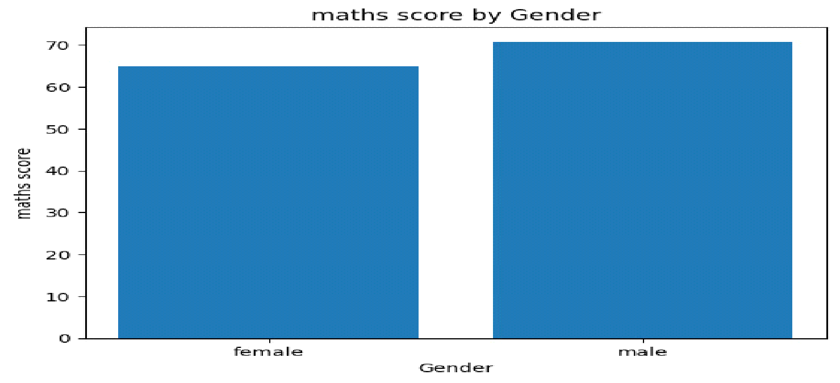

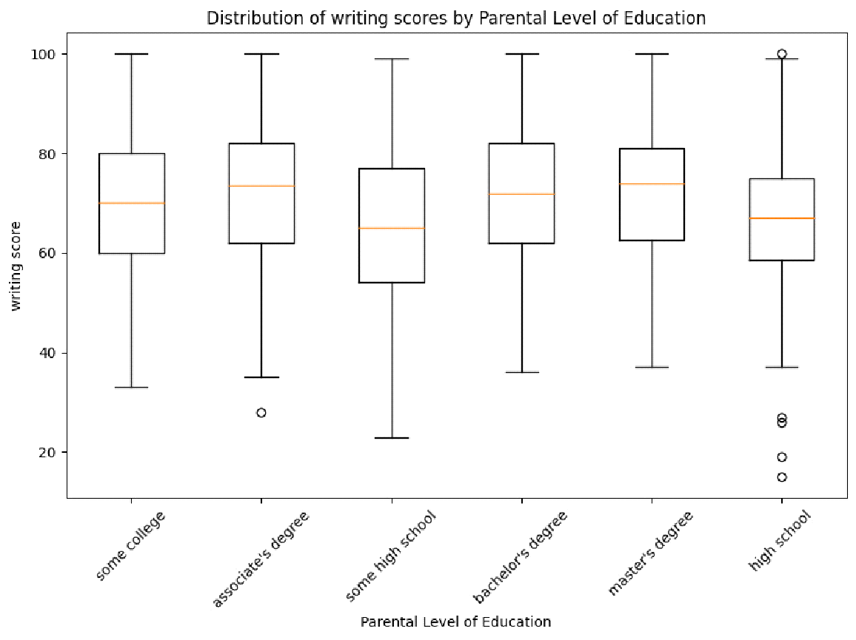

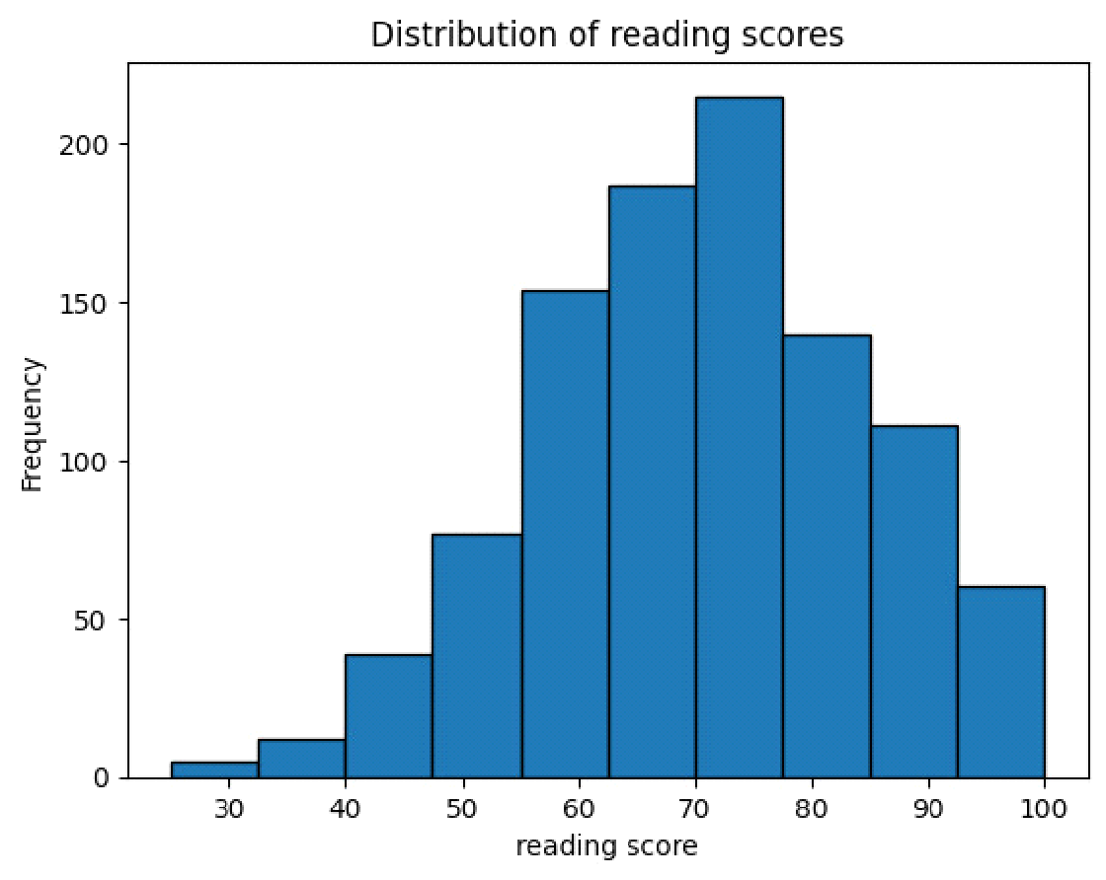

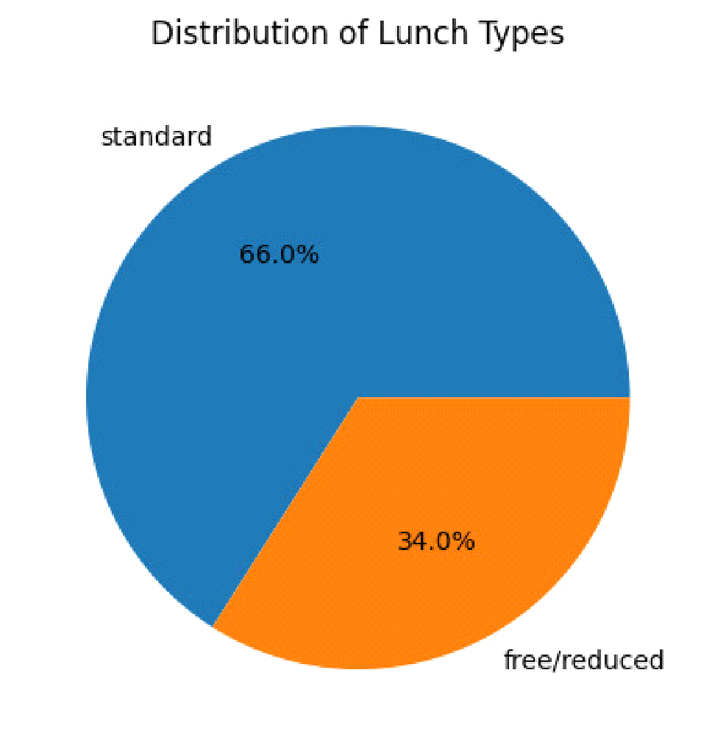

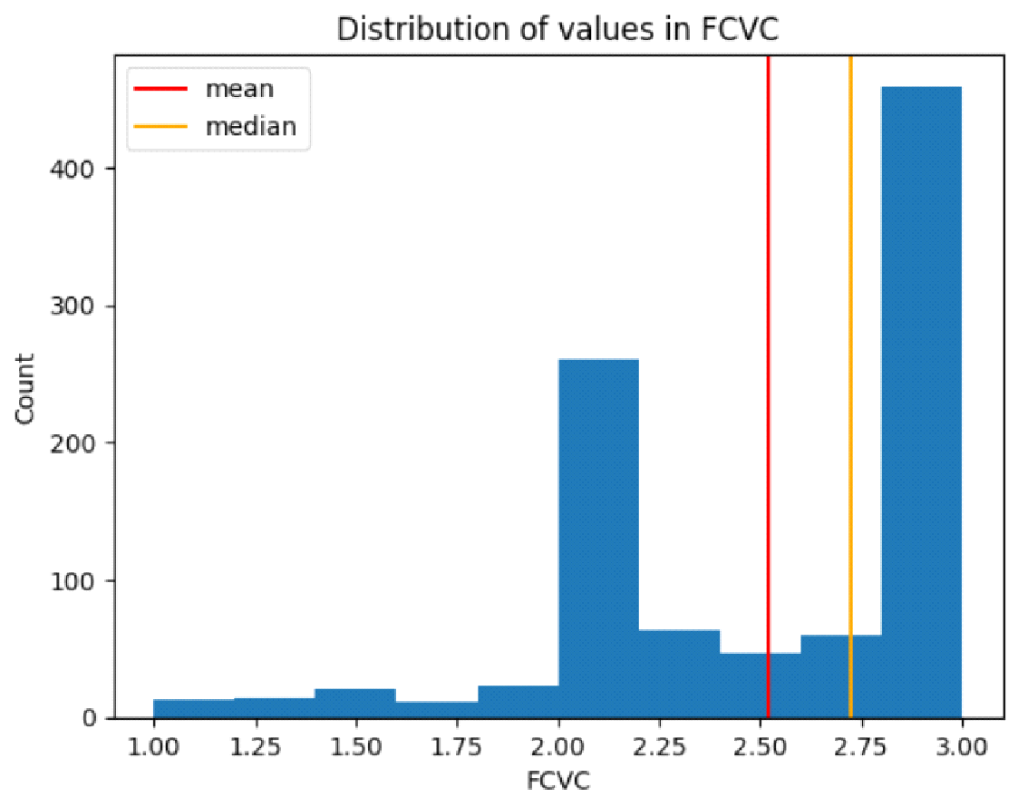

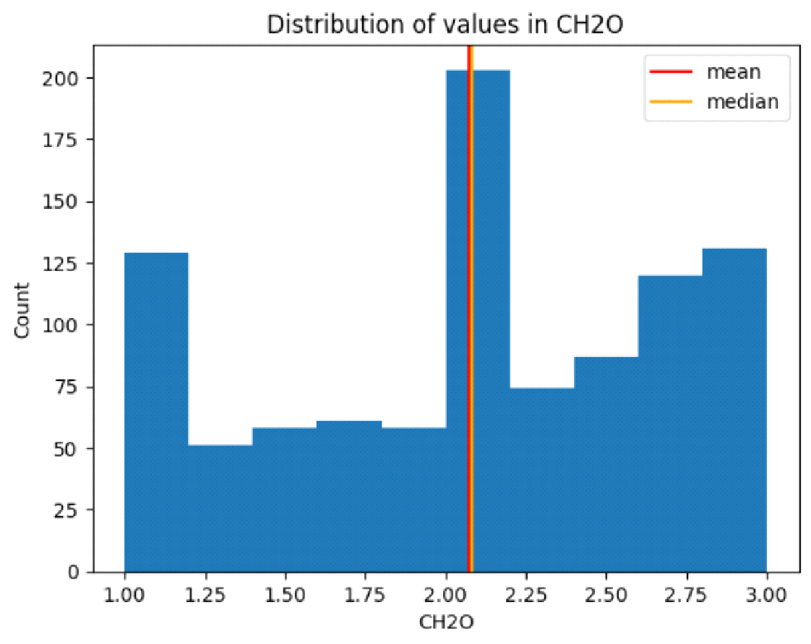

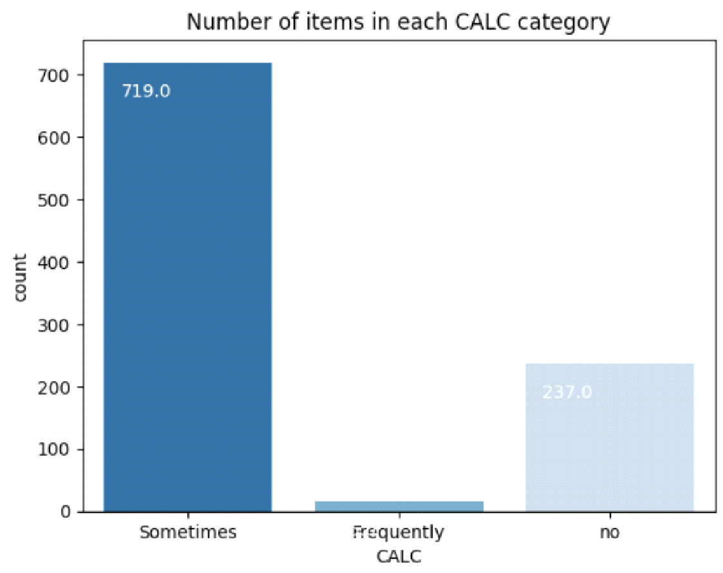

**MODEL SUMMARY**

* LINEAR REGRESSION

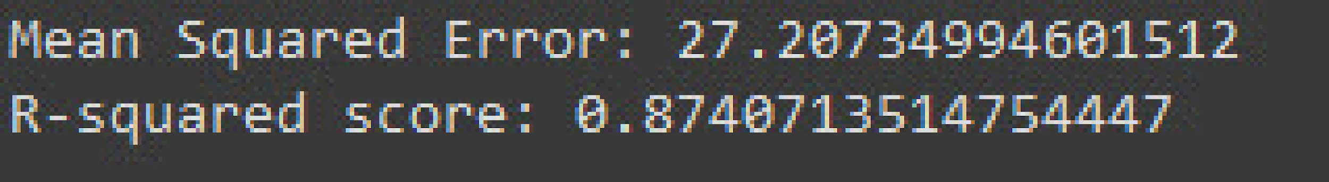

* DECISION TREE REGRESSOR

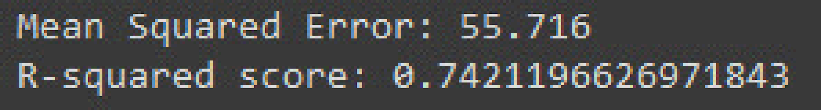

* RANDOM FOREST REGRESSOR

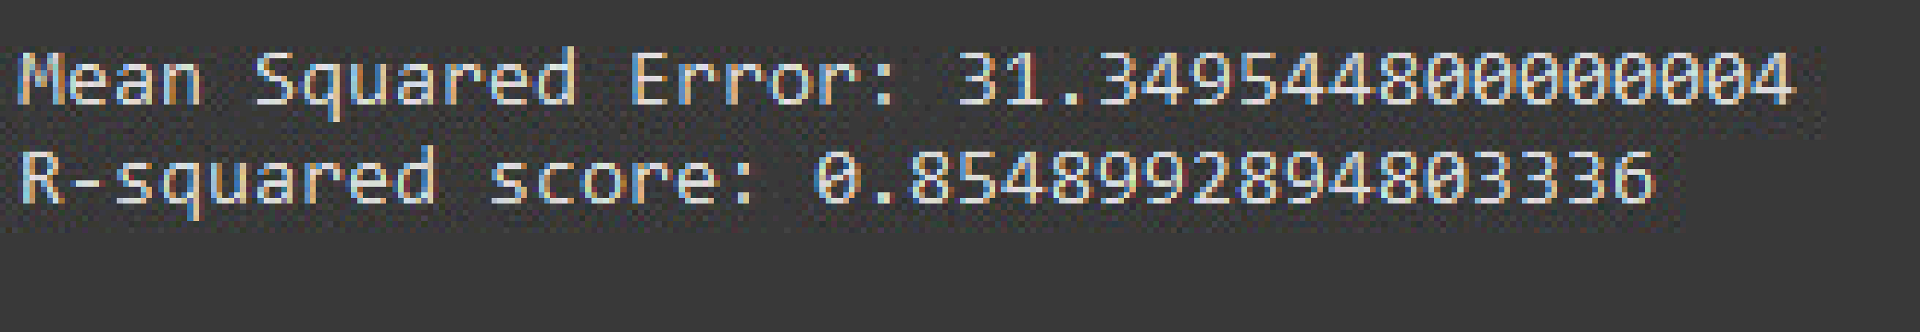

Conclusion:

In conclusion, the development of machine learning models to predict students' performance in mathematics based on various factors represents a significant step towards personalized education and targeted intervention. Through the analysis of the provided dataset, it is evident that factors such as parental level of education, reading and writing scores, and lunch time play crucial roles in shaping students' academic outcomes.

While the models developed in this project show promise in predicting students' performance, it is important to acknowledge their limitations and the ongoing challenges in the field. Interpretability, scalability, and generalization remain areas of concern, requiring further research and development efforts.

Despite these challenges, the predictive models offer valuable insights that can inform educators' decision-making processes and support strategies. By leveraging data-driven approaches, educators can better identify at-risk students, allocate resources effectively, and tailor interventions to meet individual needs, ultimately fostering a more inclusive and equitable learning environment.

Moving forward, continued collaboration between educators, researchers, and policymakers is essential to refine predictive models, address biases, and ensure that data-driven approaches contribute positively to student success and educational equity. By harnessing the power of machine learning and data analytics responsibly, we can empower educators and institutions to better support students on their academic journey.