Report

Intelligent Logistics Route Planner using Heuristic Search

Problem Id: 11

Name : Pranjal Negi
University Roll number : 2028801
Section : L
Name : Rishabh Jakhmola
University Roll number : 2028821
Section : L
Name : Ishwar Singh Jethi
University Roll number : 2028731
Section : L

- Problem Description:
This project is about designing an intelligent system to find the best route using the A* (A-Star) search algorithm. In this, we represent a delivery network as a graph with several locations (nodes). The route between these locations is considered an edge, and there is a cost associated with this edge, which is called the road distance (cost of travel).
Each of these locations has an associated value, which is called the Euclidean distance to the goal. This value acts as a heuristic, which is an estimation of the distance to reach the destination.
The A* algorithm uses these two values in the following formula to find the shortest and most efficient path:
f(n) = g(n) + h(n)
g(n) = actual cost from start node to current node
h(n) = estimated cost from current node to goal
The application of this concept in real life can be observed in many areas, like delivery services. Organizations like FedEx and Amazon use these techniques to reduce fuel costs and deliver their packages in the most efficient manner. Similarly, Google Maps and other GPS-based apps use these algorithms to find the most efficient route to reach the destination in the least time.
This project can be helpful for us to understand the decision-making process of intelligent systems in real-life scenarios.

Steps of Implementation:
Data Collection
Final Output (Optimal Path + Cost)
Testing and Evaluation
Selection of the desired search strategy
Calculation of heuristic values using the latitudes and longitudes

- Data Collection:
The dataset containing information about different cities along with their latitude and longitude coordinates is collected from kaggle.
This dataset forms the foundation of the project and is used to represent real-world locations. The data is stored in a structured format (CSV file) and later used to construct the graph.
Node |  | Place | Latitude | Longitude | Heuristic_to_Agra | Connected_Node | Road_Distance_km | Actual_Distance_to_Agra_km
N1 | Delhi |  | 28.6139 | 77.209 | 180 | Noida | 25 | 178.060539
N1 | Delhi |  | 28.6139 | 77.209 | 180 | Gurugram | 30 | 178.060539
N1 | Delhi |  | 28.6139 | 77.209 | 180 | Ghaziabad | 20 | 178.060539
N1 | Delhi |  | 28.6139 | 77.209 | 180 | Sonipat | 45 | 178.060539
N2 | Noida |  | 28.5355 | 77.391 | 165 | Greater Noida | 20 | 162.8154503
N2 | Noida |  | 28.5355 | 77.391 | 165 | Aligarh | 120 | 162.8154503
N3 | Ghaziabad |  | 28.6692 | 77.4538 | 170 | Meerut | 50 | 174.6646464
N3 | Ghaziabad |  | 28.6692 | 77.4538 | 170 | Hapur | 35 | 174.6646464
N7 | Meerut |  | 29.9845 | 77.7064 | 210 | Muzaffarnagar | 65 | 203.1852567
N8 | Muzaffarnagar |  | 29.4727 | 77.7085 | 260 | Roorkee | 60 | 256.9818425

- Calculation of Heuristic Values using Latitudes and Longitudes:
The heuristic function is calculated using a modified version of the Euclidean distance to estimate the distance between two cities based on their geographic coordinates.
The formula used is:
d = R × √[(Δlat)² + (cos(lat_avg) × Δlon)²]
Where:
  - R=6371 km (radius of the Earth)
  - Δlat=lat2−lat1 ​
  - Δlon=lon2−lon1
  - latavg=(lat1+lat2)/2
  - All latitude and longitude values are converted into radians
This formula improves accuracy by adjusting longitude differences using the cosine of the average latitude, accounting for the curvature of the Earth. The computed value serves as an estimate of the remaining distance to the goal node.
- Selection of the Desired Search Strategy:
The A* search algorithm is selected as the search strategy due to its efficiency in finding the shortest path.
It uses the evaluation function:
f(n) = g(n) + h(n)
where:
  - g(n) = actual cost from start node to current node
  - h(n) = heuristic estimate to goal
This combination allows the algorithm to explore the most promising paths first, reducing unnecessary computations.
- Testing and Evaluation:
The implemented algorithm is tested by selecting different cities as starting where goal node remains the same,
Multiple test cases are executed to verify the correctness and robustness of the system. The generated estimated cost is checked by calculating the accuracy of the algorithm using the actual real cost to the goal node. This step helps in validating both the heuristic function and the working of the algorithm.
- Visualization
We visualized A* results using bar graphs for heuristic vs actual distance, error plots, and network graphs using NetworkX to show the shortest path.
- Final Output (Optimal Path + Cost):
The final step produces the optimal path between the selected cities along with the total distance (cost).
The output clearly displays the sequence of cities forming the shortest route and the corresponding total travel distance, demonstrating the effectiveness of the algorithm.
- Expected Modules/ Libraries to be used :
- pandas is a powerful data analysis library used for handling structured data.
In this project, it is used to read the dataset (CSV file), store city data in dataframes, and perform data cleaning and manipulation efficiently.
- heapq
heapq is a built-in Python module used to implement a priority queue using a heap data structure.
In the A* search algorithm, it is used to always select the node with the lowest function value, ensuring efficient pathfinding.
- collections
collections is a module that provides specialized data structures like defaultdict, deque, and Counter.
In this project, defaultdict is used to represent the graph (nodes and edges), making it easier to store and access neighbors of each city.
- matplotlib
matplotlib is a plotting library used for data visualization.
It is used to visually represent the graph or display the optimal path between cities, making the results easier to understand.

- Required topics from the subject:

1. Graph
A graph is a data structure consisting of nodes (locations) and edges (roads) connecting them. It is used to represent real-world networks like maps. In this project, the graph models delivery routes.

2. Weighted Graph
A weighted graph assigns a cost (weight) to each edge, such as distance or time. These weights help determine the shortest or most efficient path. In your project, road distance acts as the weight.

3. Nodes and Edges
Nodes represent locations or cities, while edges represent the paths between them. Each edge connects two nodes and may have a weight. Together, they form the structure of the graph.

4. A* (A-Star) Algorithm
A* is a search algorithm used to find the optimal path between two nodes. It combines actual cost and estimated cost using f(n) = g(n) + h(n). It is efficient and guarantees the shortest path if the heuristic is valid.

5. Heuristic Function
A heuristic is an estimated cost from a node to the goal. It helps guide the algorithm toward the destination faster. In this project, we used Euclidean distance is used as the heuristic.

6. Euclidean Distance
In this project, we used a modified Euclidean distance formula using latitude and longitude as the heuristic. It provides a realistic estimate of distance between cities by considering Earth’s curvature.
- The formula used is:
d = R × √[(Δlat)² + (cos(lat_avg) × Δlon)²]
Where:
  - R=6371 km (radius of the Earth)
  - Δlat=lat2−lat1 ​
  - Δlon=lon2−lon1
  - latavg=(lat1+lat2)/2
  - All latitude and longitude values are converted into radians

7. Cost Function (f(n))
The cost function in A* is defined as f(n) = g(n) + h(n). Here, g(n) is the actual cost from the start node, and h(n) is the estimated cost to the goal. The algorithm selects the node with the lowest function cost.
8. Priority Queue
A priority queue is an abstract data type where each element is associated with a specific "priority" value. Unlike a standard queue that follows a first-in-first-out (FIFO) principle, a priority queue processes and removes elements based on their priority levels.
RESULT ANALYSIS:
OUTPUT SUMMARY TABLE:
S.No. | Input City | Shortest Path | Actual Distance | Heuristic Distance | Error | Accuracy
1 | Muzaffarnagar | Muzaffarnagar → Meerut → Ghaziabad → Delhi → Noida → Aligarh → Mathura → Agra | 395 km | 260 km | 135 km | 65.82%
2 | Delhi | Delhi → Noida → Aligarh → Mathura → Agra | 260 km | 350 km | 90 km | 65.38%
3 | Roorkee | Roorkee → Muzaffarnagar → Meerut → Ghaziabad → Delhi → Noida → Aligarh → Mathura → Agra | 455 km | 290 km | 165 km | 63.74%
4 | Jaipur | Jaipur → Agra | 240 km | 240 km | 0 km | 100.00%
5 | Dehradun | Dehradun → Haridwar → Roorkee → Muzaffarnagar → Meerut → Ghaziabad → Delhi → Noida → Aligarh → Mathura → Agra | 540 km | 330 km | 210 km | 61.11%
6 | Khatima | Invalid start city | — | — | — | —
The A* Search algorithm was tested using different starting cities, while the destination city was fixed as Agra. For each input city, the algorithm calculated the shortest path, actual road distance, heuristic value, error, and accuracy.
The valid input cities tested were Muzaffarnagar, Delhi, Roorkee, Jaipur, and Dehradun. The highest accuracy was obtained for Jaipur, where the accuracy was 100.00%. This happened because the actual distance and heuristic distance were both 240 km, so the error was 0 km.
The lowest accuracy among valid inputs was obtained for Dehradun, with an accuracy of 61.11%. This is because the actual route distance was 540 km, while the heuristic value was only 330 km, giving an error of 210 km.

The average accuracy of all valid test cases is 71.21%.
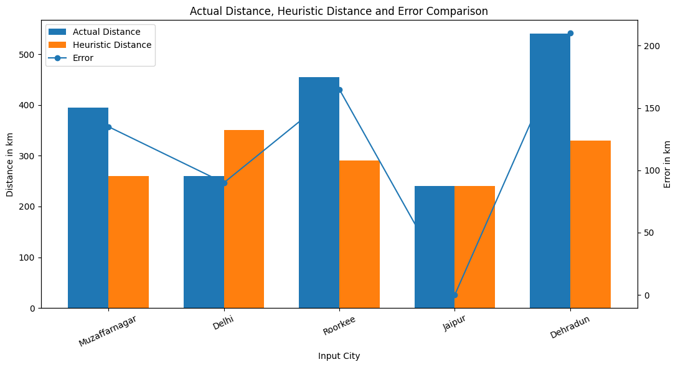
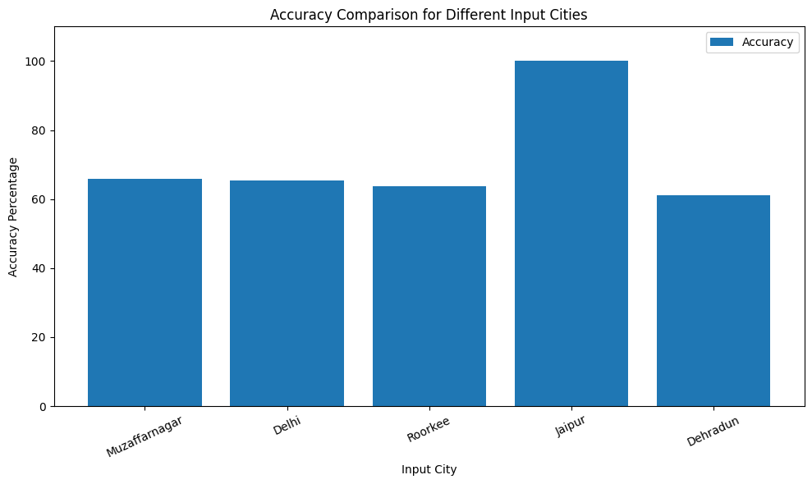

- Platform Required:
- Jupyter Notebook
It provides us an interactive environment that allows writing and executing code in cells. It is useful for step-by-step execution, visualization, and testing algorithms like A*.
- Books and Link Sources:
- Artificial Intelligence : A Modern Approach - Stuart Russell & Peter Norvig
A standard textbook covering A* search, intelligent agents, and problem-solving techniques in AI.
- Introduction to Artificial Intelligence – Eugene Charniak
Explains fundamental AI concepts including search algorithms and heuristics.
- https://www.kaggle.com/datasets/rishabhjakhmolaa/a-algorithm-having-places-to-goal-node
Used for obtaining datasets containing city names, latitude, and longitude values.
- https://www.geeksforgeeks.org/dsa/a-search-algorithm/
Simple explanation of A* algorithm with examples and code.

