19BDS0021

Rishabh Johri

CSE3054 : Data Mining EPJ Review 1

Topic: Hybrid model based on Apriori Algorithm

Aim : Developing a novel association rule mining algorithm by incorporating

new measures of interestingness

ABSTRACT:

Apriori algorithm is the most basic yet widely used frequent pattern mining algorithm. Apriori algorithm uses two interestingness measures : Support , Confidence. My endeavor is to improve and modify this algorithm by incorporating some novel interestingness measures that are based on profit.

The following defects of the association rules mining methods exist: (1) Many traditional association methods generate a lot of rules, and most of them are not relevant or even rules of error. (2) Do not consider users characteristics and their changes, but users characteristics and subjectivity tend to affect relevance of several events. (3) Online trading data and user evaluation data are extremely sparse (i.e., data sparseness) due to surge of current online trading. (4) The too low threshold values of support and confidence can produce the combination explosion, but, because of data sparseness, low support rules may provide some novel knowledge that users are interested in. (5) At present some literature simply combines kinds of interestingness evaluation to measure, but this does not take rationality of various interestingness evaluation methods into account.

Incorporating new interestingness measures to apriori algorithm will solve these disadvantages.

Rough Approach :

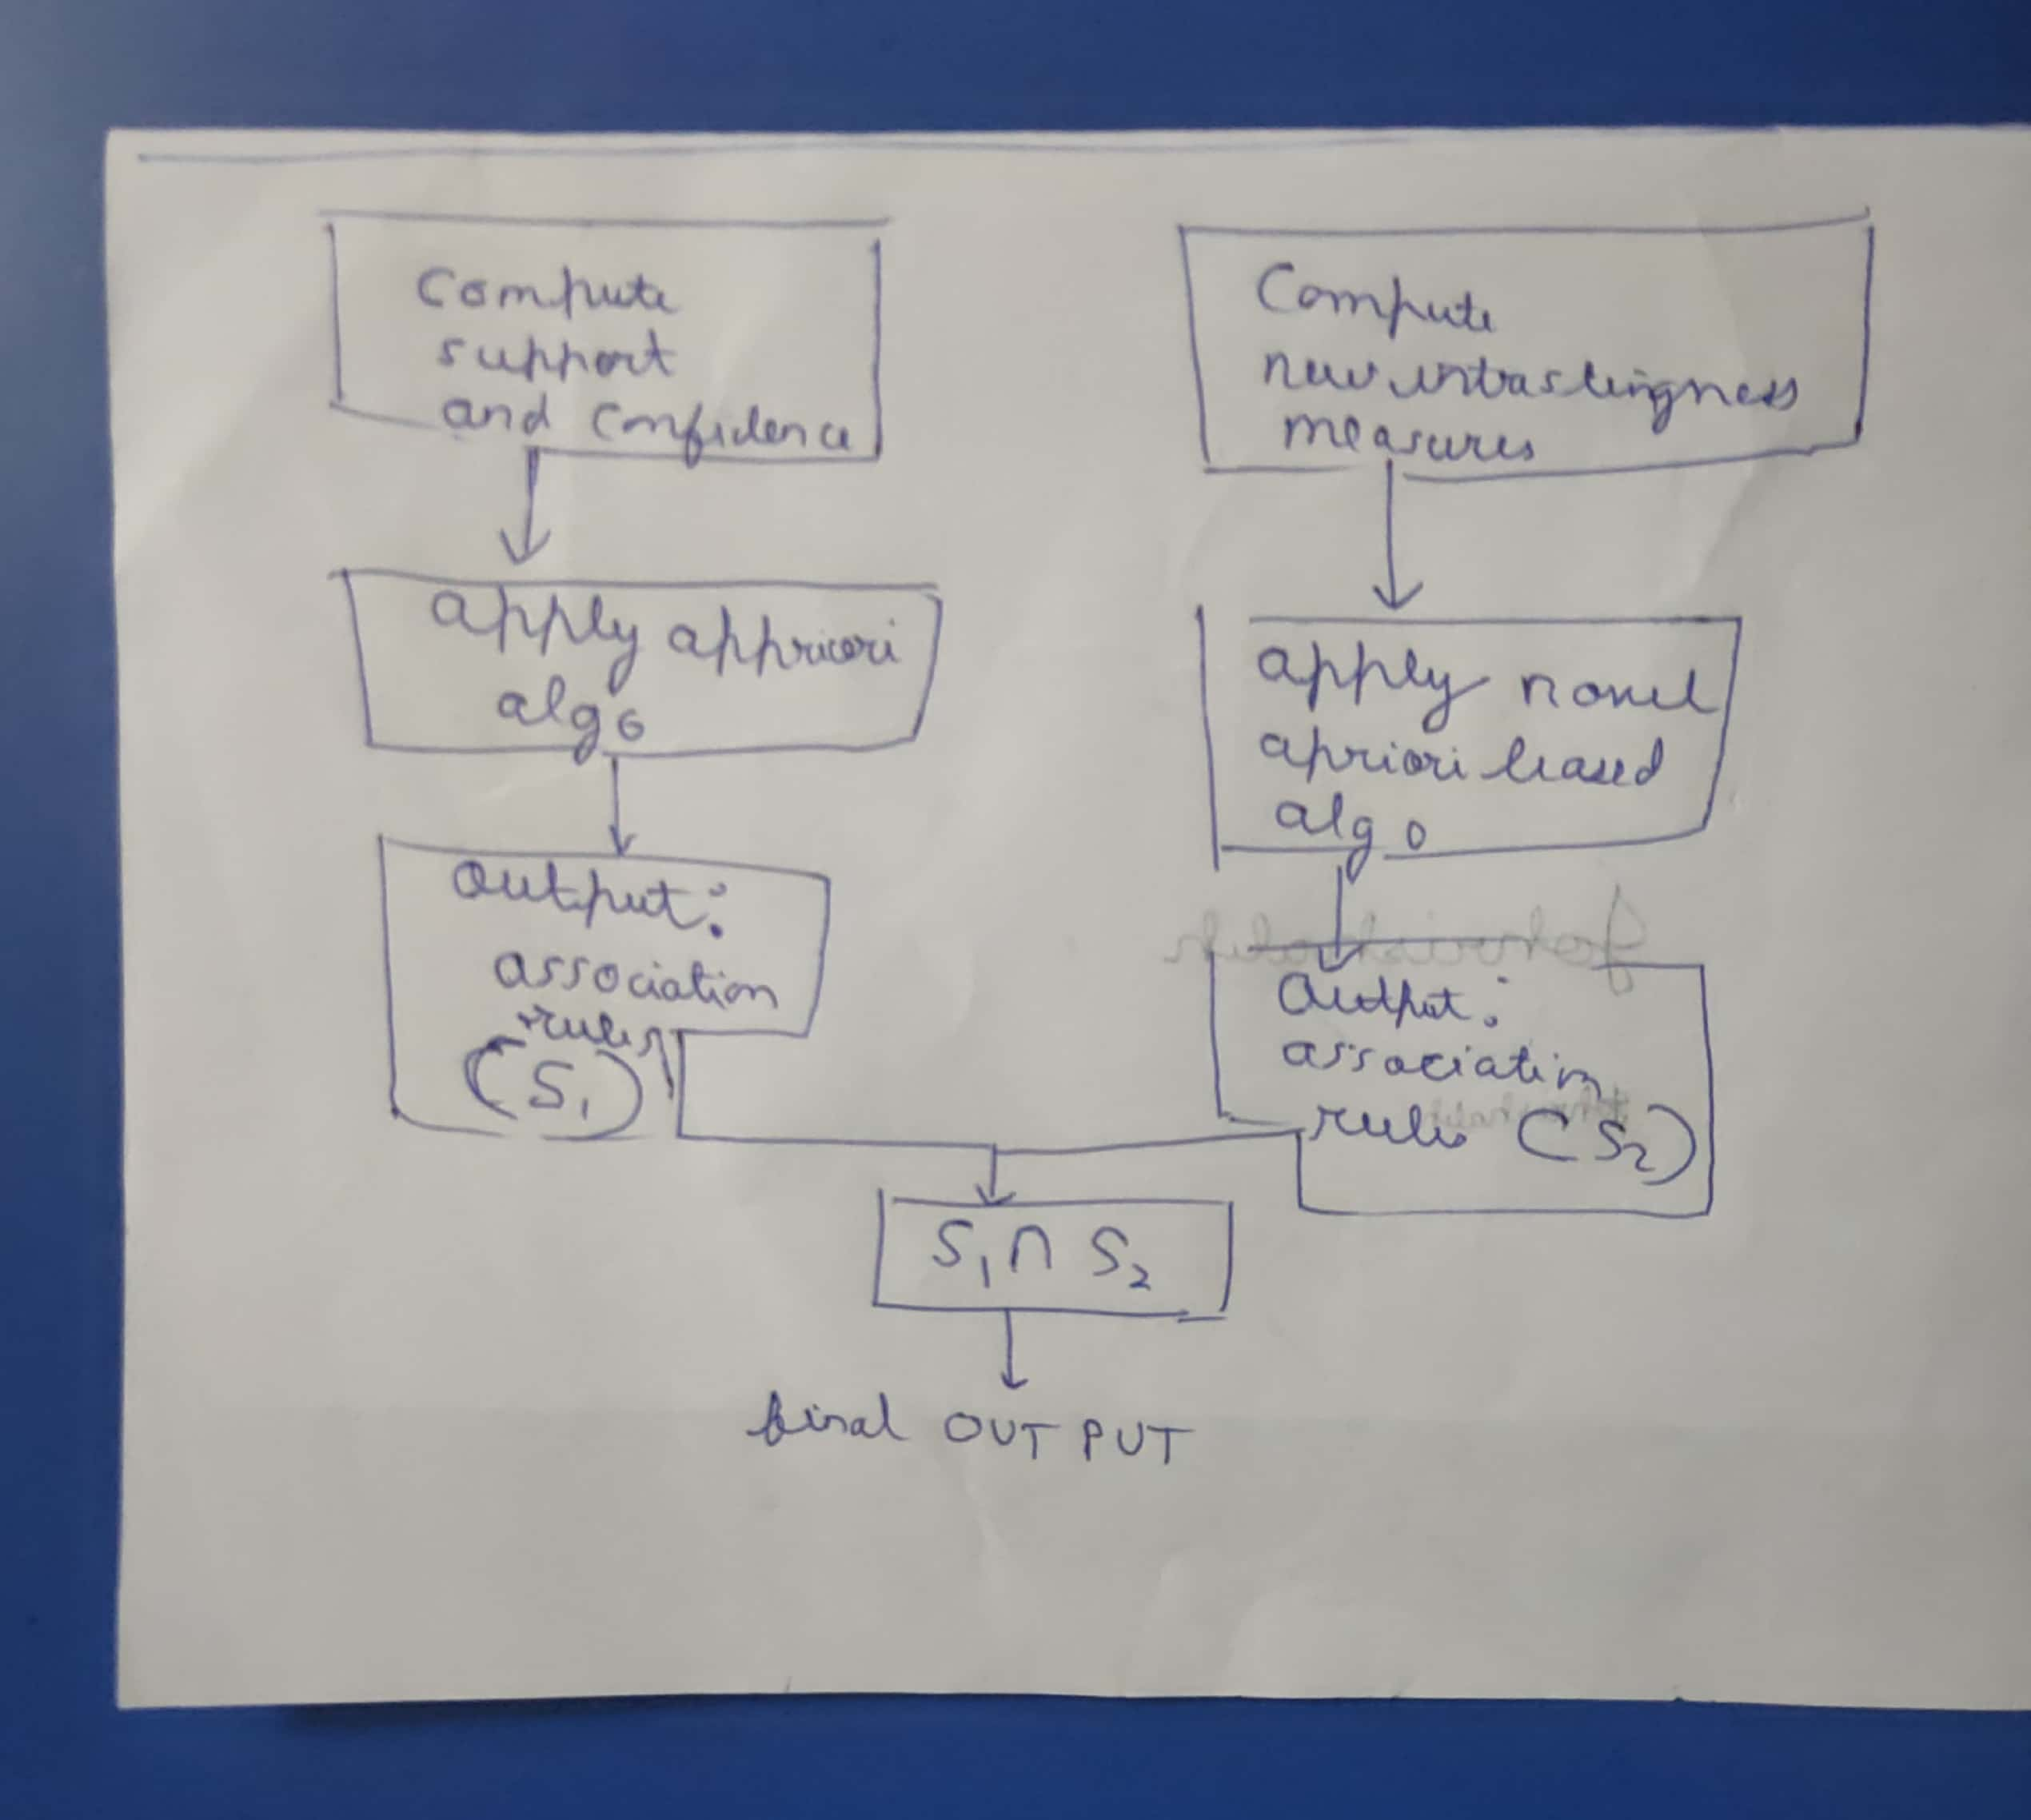

Base paper:

<https://www.hindawi.com/journals/ddns/2015/868634/>

References:

1. P. N. Tan, M. Steinbach, and V. Kumar, *Introduction to Data Mining*, Pearson—Addison-Wesley, Boston, Mass, USA, 1st edition, 2005.
2. J. H. Fowler and M. Laver, “A tournament of party decision rules,” *Journal of Conflict Resolution*, vol. 52, no. 1, pp. 68–92, 2008.View at: [Publisher Site](https://doi.org/10.1177/0022002707308598) | [Google Scholar](https://scholar.google.com/scholar_lookup?title=A%20tournament%20of%20party%20decision%20rules&author=J.%20H.%20Fowler%20&author=M.%20Laver&publication_year=2008)
3. R. Agrawal and R. Srikant, “Fast algorithms for mining association rules,” in *Proceedings of the 20th International Conference on Very Large Data Bases (VLDB '94)*, pp. 487–499, 1994.View at: [Google Scholar](https://scholar.google.com/scholar_lookup?title=Fast%20algorithms%20for%20mining%20association%20rules&author=R.%20Agrawal%20&author=R.%20Srikant)
4. R. Srikant and R. Agrawal, “Mining generalized association rules,” in *Proceedings of the 21st International Conference on Very Large Data Bases*, pp. 407–418, Zurich, Switzerland, 1995.View at: [Google Scholar](https://scholar.google.com/scholar_lookup?title=Mining%20generalized%20association%20rules&author=R.%20Srikant%20&author=R.%20Agrawal)
5. M.-C. Tseng, W.-Y. Lin, and R. Jeng, “Incremental maintenance of generalized association rules under taxonomy evolution,” *Journal of Information Science*, vol. 34, no. 2, pp. 174–195, 2008.View at: [Publisher Site](https://doi.org/10.1177/0165551507082271) | [Google Scholar](https://scholar.google.com/scholar_lookup?title=Incremental%20maintenance%20of%20generalized%20association%20rules%20under%20taxonomy%20evolution&author=M.-C.%20Tseng&author=W.-Y.%20Lin&author=&author=R.%20Jeng&publication_year=2008)