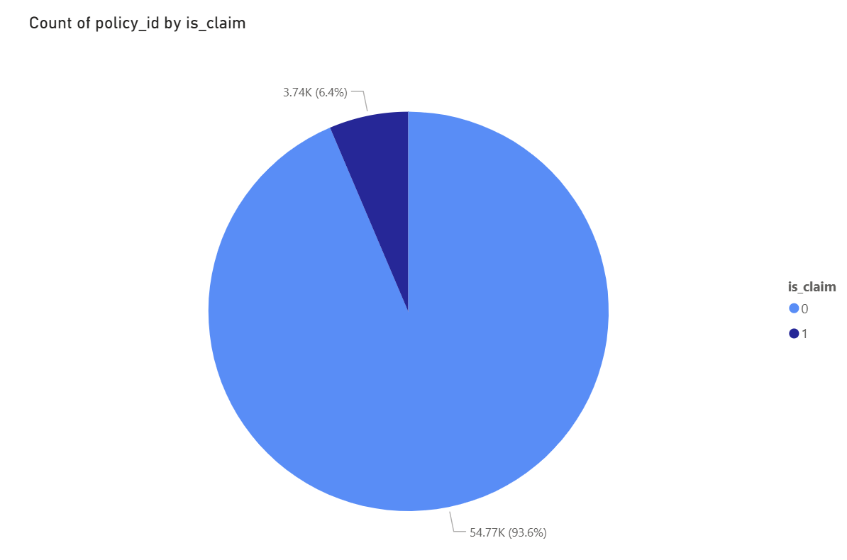

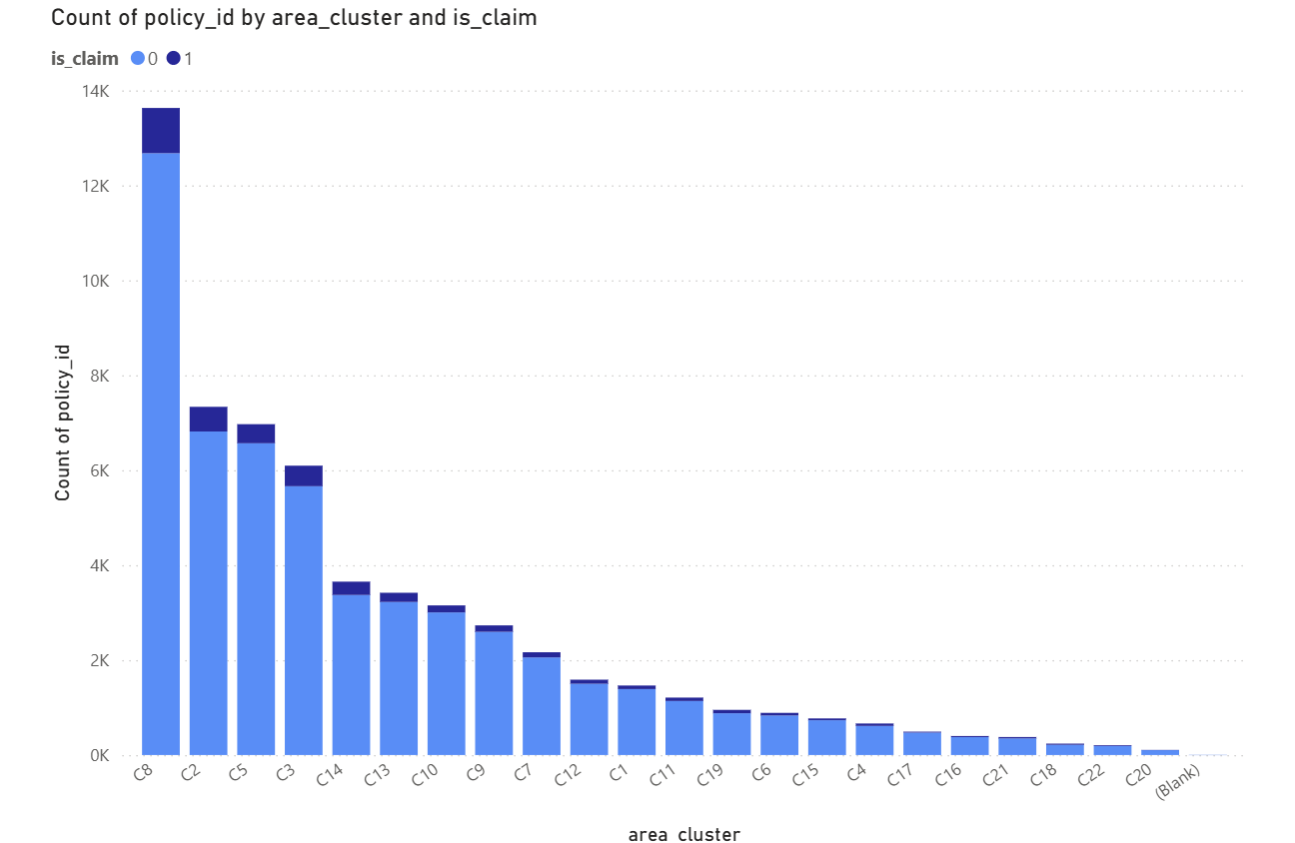

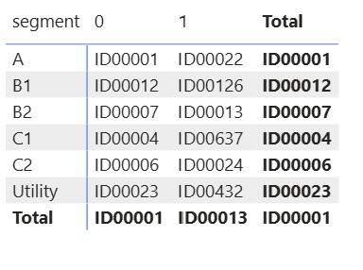

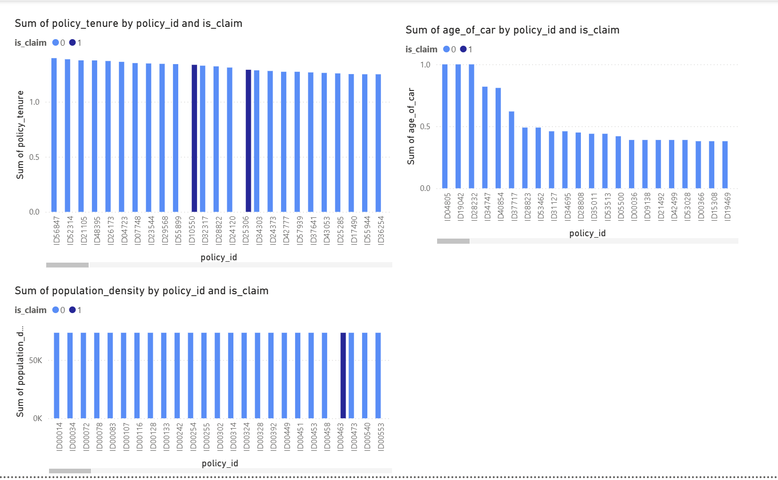

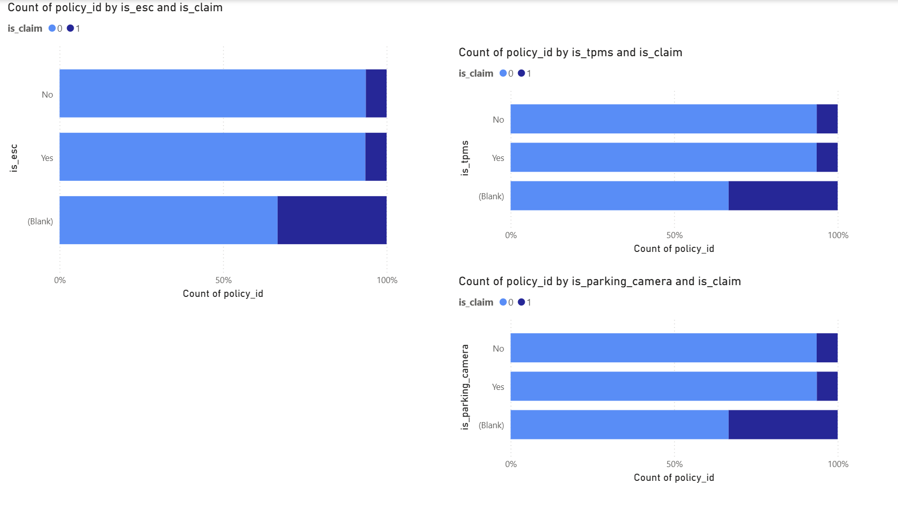

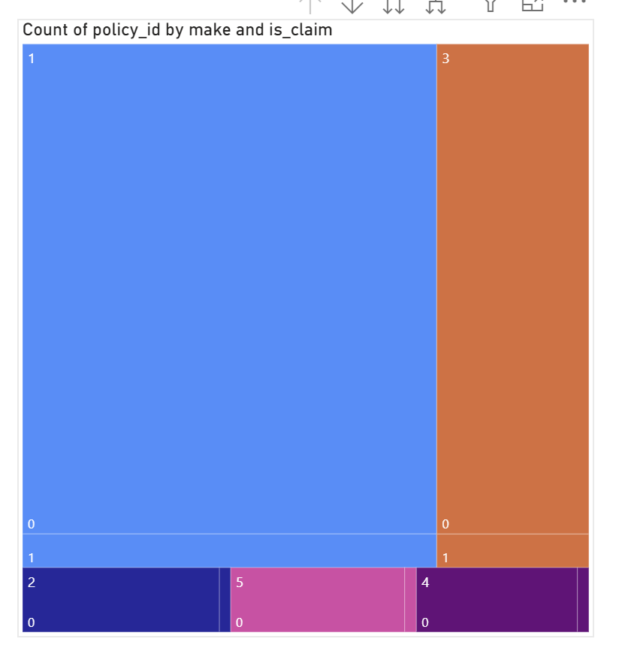

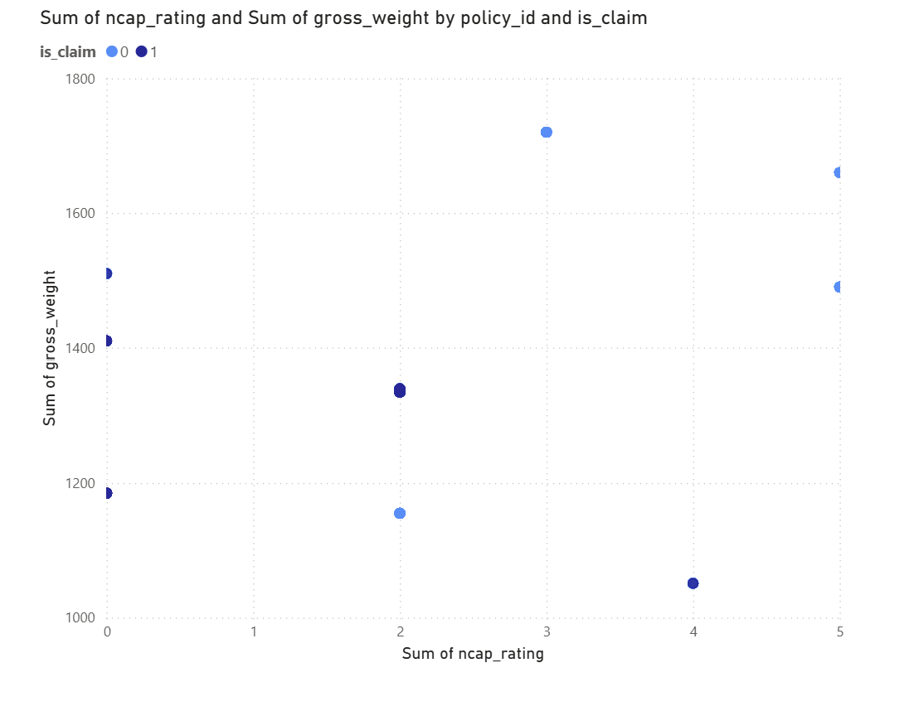

**📄 Task 2.1 – Power BI Visualization Report**

**✅ Objective**

To analyze policyholder and vehicle data using **Power BI**, identify patterns that influence insurance claims, and provide **data-driven recommendations** for targeting the right customer segments for marketing campaigns.

**🔧 Methodology / Steps Followed**

**1. Data Import**

* Imported three datasets into Power BI:
  + Policy features.xlsx
  + Car features.xlsx
  + Insurance claim.xlsx

**2. Data Preparation (Power Query Editor)**

* Merged the datasets using policy_id (Inner Joins)
  + Policy + Claim → Policy_Claim
  + Policy_Claim + Car → Final_Data
* Cleaned the data:
  + Removed rows with blank or null policy_id
  + Corrected data types (text, decimal, boolean)
  + Renamed and organized columns

**3. Visualizations Created in Power BI**

Built charts using Final_Data to explore claim behavior and correlations.

**📊 Visual Insights**

**🥧 1. Claim Distribution (Pie Chart)**

Only **6.4%** of policies led to a claim → **high class imbalance**  
✅ Most policyholders are **low-risk**.

**📍 2. Claims by Area Cluster (Bar Chart)**

**C8, C2, and C5** had the highest number of claims.  
⚠️ These **high-risk zones** should be evaluated before targeting.

**🧱 3. Segment vs Claim (Matrix)**

Segments **B1 and Utility** show relatively more claims.  
🚫 Consider these **riskier car segments**.

**⏳ 4. Policy Tenure, Car Age, Population Density (Bar Charts)**

* Claims observed across all policy tenures
* Slightly more claims for **newer cars**
* **Densely populated areas** show more claim activity  
  📌 Environment and usage may influence risk.

**🚘 5. Safety Features (Stacked Bars)**

Cars with features like **ESC, TPMS, and parking cameras** have **fewer claims**.  
✅ Use these as **positive indicators** for low-risk targeting.

**🌳 6. Make-wise Claims (Tree Map)**

Certain **car makes** dominate claim volume.  
🛑 High-claim brands should be **flagged for review**.

**⚖️ 7. NCAP Rating vs Gross Weight (Scatter Plot)**

No clear correlation between safety rating and claim rate.  
🔍 **Multiple variables** should be used to assess risk, not just NCAP rating.

**🎯 Recommendations for Marketing Team**

Based on the analysis, here are **data-driven approaches** to target the ideal customer group:

**✅ Target Low-Risk Segments**

* Focus on segments like **A, B2, and C2** (lower claims observed)
* Prioritize **customers with safety features** (ESC, TPMS, parking cameras)
* Target vehicles with **higher NCAP ratings + lower historical claim counts**

**⚠️ Avoid High-Risk Zones**

* Deprioritize area clusters with **high claim frequencies** (e.g., C8, C2)
* Evaluate **Utility and B1 segment** cars more strictly

**📍 Geo & Demographic-Based Filters**

* Customers in **low population density** areas are safer bets
* Consider policy tenure and **car age mix** for better targeting

**✅ Final Notes**

* **Power BI** was used to manipulate and visualize the data effectively.
* Each visual was backed by direct data-driven **insights**.
* The findings guide marketing to **target low-risk policyholders** while **avoiding loss-heavy segments**.