HTML – CSS Assignment

Question1: How are inline and block elements different from each other?
Solution1:Inline element are those elements which take only that much of space which they wanted basically inline element does not line break and block elements are those which take full width of a page and always takes with a new line it does have the line break before and after the element.
Inline elements are:
- anchor <a> tag
- emphasis <em> tag
- image <img> tag
- span<span>tag
Block elements are:
- Heading tags <h1> to <h6>
- List (Ordered, Unordered, Description and List Item) tags <ol> , <ul> ,<dl> , <li>
- Pre-formatted text tag <pre>
- Blockquote tag <blockquote>
- Div tag<div>
Question2: Explain the difference between visibility:hidden and display:none
Solution2: Display:none and visibility: hidden are used to restrict the tag to be visible on the page.They have the same purpose but there is one difference display:none means tag will not be visible on the page nor it will consume any space on the web page.Moreover,visibility:hidden will do the same as display:none but it will consume the space on the web page.
Question3: Explain the clear and float properties.
Solution3:
=>Float:Float is used for changing the position of the text.We change change the position to left ,right,none,inherit.
1.Left:If we write float:left then image will be floated to left . 2.Right:If we float:right then image will be floated to right . 3.None:In this case image won’t move any of its position.It will simply comes after the text.It is bydefault property of the image. 4.Inherit:In this case image will inherit float value from its parent.

=>Clear:Clear property is used after the float property as clear property must match with the float property.It is used for positioning as well.But it takes float property into consideration while moving the image.
1.none - Allows floating elements on both sides. This is default
2.left - No floating elements allowed on the left side
3.right- No floating elements allowed on the right side
4.both - No floating elements allowed on either the left or the right side
5.inherit - The element inherits the clear value of its parent
Question4: Explain difference between absolute, relative,fixed and static.
Solution4:
Static,fixed,relative,absolute are used for the property position.These are used to make change in the position of the element.
Static:It is the by default position of the element it just means that the element will flow into the page as it normally would.There is no such significance of the static position.
Relative:It is used to change the position of the element.By relative it means we should provide other positioning attributes (top, left, bottom or right).If we are using relative and we are not providing any positioning attribute then it will act as static.
Eg : If position:relative ,top=10px.Then it will move down from the top to 10px.
Absolute:It is same as that of relative but there is one difference that is in this the position is relative to its parent tag.If there is no parent tag then it will act as relative position.
Fixed:Fixed positioned element will stay right where it is when the page is scrolled that is when the page is scrolled then element also keep moving with the page.

Question5: Write the HTML code to create a table in which there are 4 columns( ID , Employee Name, Designation, Department) and at least 6 rows. Also do some styling to it.
Solution5:
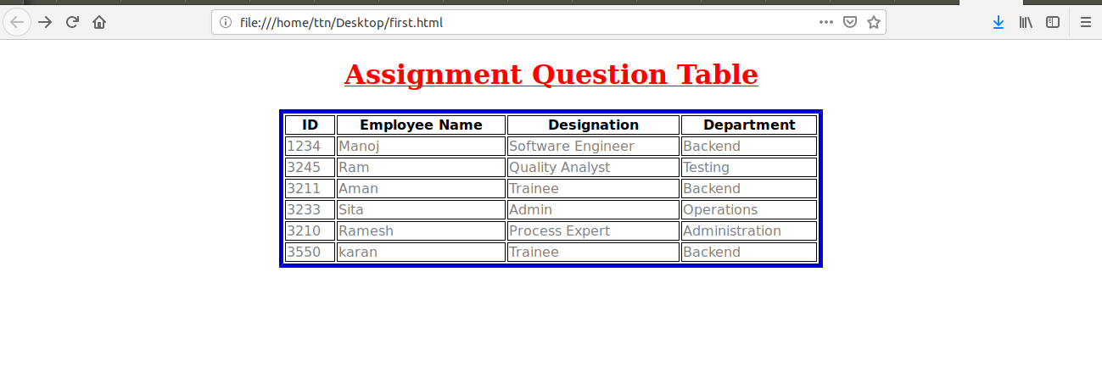
This is a responsive page .For making it responsive I have used media query.

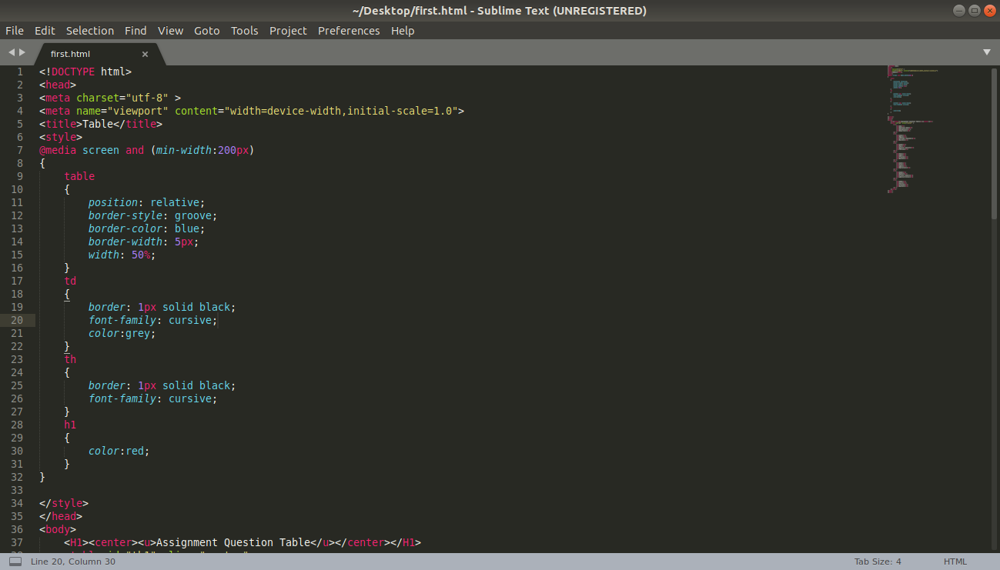
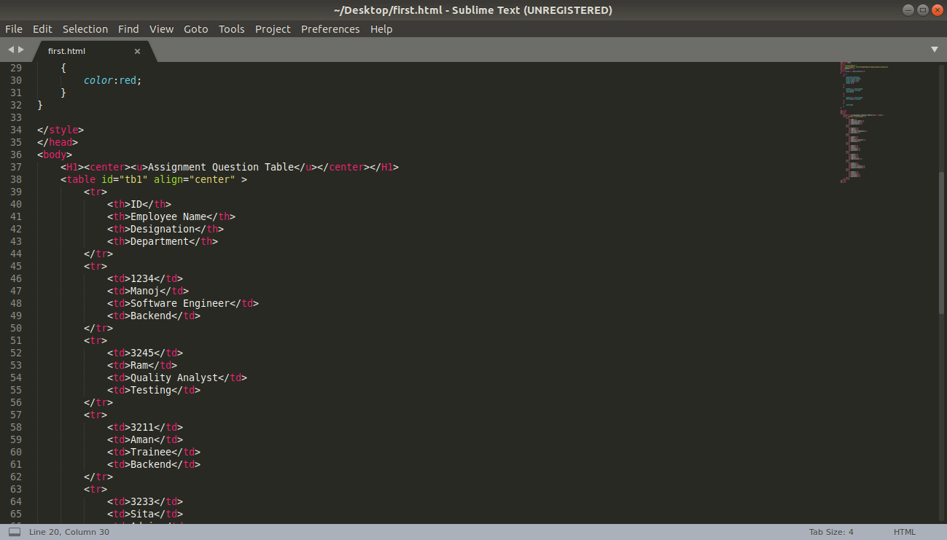

Question6: Why do we use meta tags?
Solution6: Meta means data about data.In html meta tags are used to provide information on the web brower about the html document.Meta tags also improve search engine optimization of the web page.They are placed in head tag.
Few other uses of meta tags are:
1.Responsiveness:It also used for making web page responsive.eg:<meta name =”viewport” content=”width=device-width,initial-scale=1.0”>.
2.Author of the page:It provide name of the person who created the web page.eg:<meta name =”viewport” content=”width=device-width,initial-scale=1.0”>.
3.Search engine optimization:It increases chances of your page to appear on the top of the browser.eg:<meta name=”keywords” content=”HTML,CSS,XML,XHTML,javaScript”>.

Question7: Explain box model.
Solution7:The box model is css layout and design .It wraps every element around it.It consists of: margins, borders, padding, and the actual content.
Margin:It is the outer most layer in the box model.It is transparent and not visible by default.
Padding:Padding is simply width from the text that is if we provide padding to the content then it will be measure from the text to the border.
Border:It goes around padding and content.
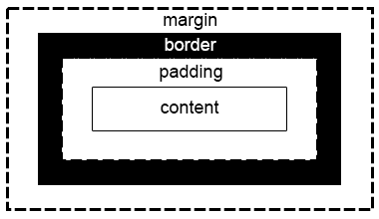
Content:It is the area having all the content.

Question8: What are the different types of CSS Selectors?
Solution8:CSS Selectors are used to provide styling to the elements.By using selector we can apply style to the group of elements.There are 5 types of the css selectors:
1.Element selector:When we want to apply style to any tag then it is used.For eg:
<style>
h1
{
text-align:center;
color:blue;
}
</style>
2.Class selector:When we want to apply style using class selector in this we provide every element with the class name and then apply styling to that class .In CSS we have to provide “ . ” and then class name to provide styling.
For eg:
<style>
.rishabh
{
text-align:center;
color:blue;
}
</style>
<body>
<h1 class=”rishabh”>hello</h1>
</body>
3.ID selector:When we want to apply style using id selector in this we provide every element with the id and then apply styling to that class .In CSS we have to provide “ # ” and then id name to provide styling.Ids must be unique.
For eg:
<style>
#rishabh
{
text-align:center;
color:blue;
}
</style>
<body>
<h1 id=”rishabh”>hello</h1>
</body>
4.Class Selector for specific element:This is used when two or more elements are having same class and we want to apply different styling to both of then.
<style>
h1.rishabh
{
color:blue;
}
h2.rishabh
{
color:yello;
}
</style>
<body>
<h1 class=”rishabh”>hello</h1>
<h2 class=”rishabh”>hello</h1>
</body>
5.Group selector:When we want to apply same styling to the group of elements. For eg: if we want to provide same styling to h1,h2 tags then we have to do this.
<style>
h1,h2
{
color:blue;
}
</style>
<body>
<h1>hello</h1>
<h2>hello</h1>
</body>
Question9: Define Doctype.
Solution9:Doctype must be first line in the html document.Doctype tells the browser about the version in which html page is written.Doctype declaration syntax is:
<!DOCTYPE html>
Note:Doctype is case insensitive.
Doctype is not an html tag it is just the declaration that tells the version.If we don’nt provide declaration of doctype then it will not give error.<!DOCTYPE html> tells the browser that we have used html5 as the version of the html page.
Question10: Explain 5 HTML5 semantic tags.
Solution:Semantic tags are the tags which clearly describe its usage by its name.Like for eg <footer> tag it is the tag which is used to place text at the bottom of the document or the section.As its name says it all footer means at the bottom.That is why it is one of the semantic tag.
5 HTML5 semantic tags are:
1.<Header>:This tag is used to place text on the top of the document or the section.
2.<Footer>:This tag is used to place text in the bottom of the document or the section.
3.<Section>:This tag is to split the document into different space called section.
4.<figcaption>:This tag is used for providing image description.If we don’t use figcaption then description might not align with the image we have to write whole new css for aliging the description.
5.<Figure>: Figure tag is responsible for achieving the figcaption tag benefits. Figure tag is used to display image on the screen with by default positioning.
Question11: Create HTML for web-page.jpg (check resources, highest weightage for answers)
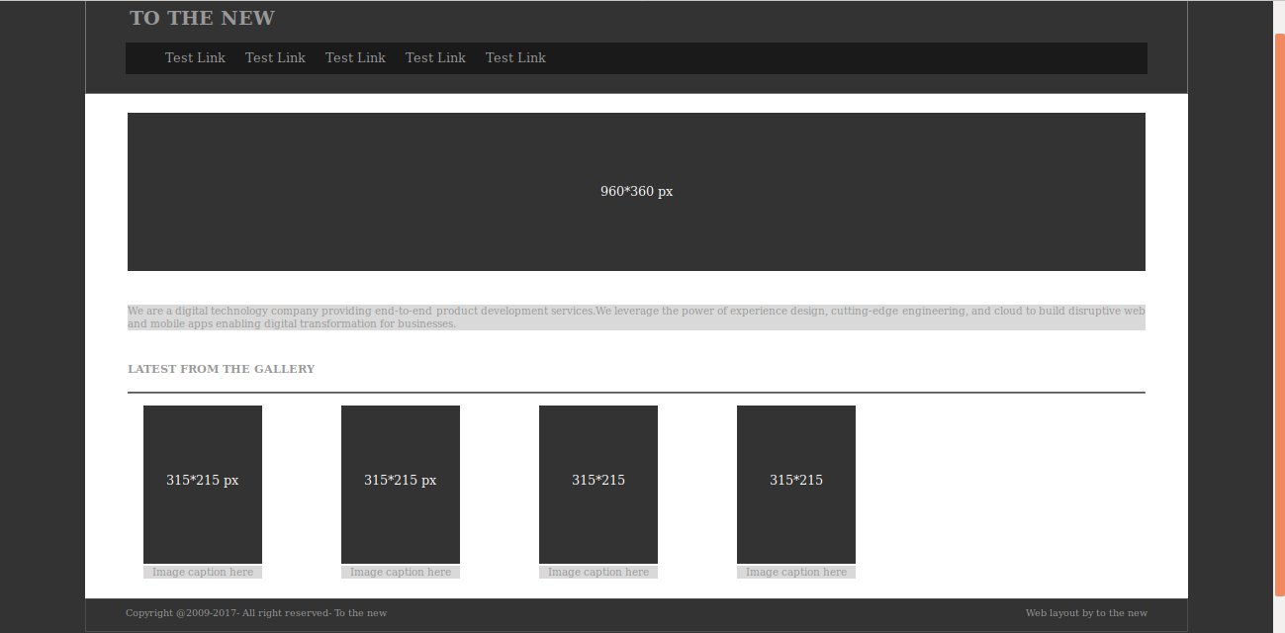
Solution11:

<!DOCTYPE html>
<html>
<head>
<title>sample</title>
<style>
.main
{
margin: 0 100px 50px 100px;

}
body
{
background-color: #333333;
}
.head
{
border-style: solid;
border-width: 1px;
height: 150px;
border-color: #737373;
}
h2
{
position: relative;
left: 55px;
top:30px;
}
.nav
{

margin: 0 50px 50px 50px;
height: 40px;
background-color: #1a1a1a;
}
a
{
text-decoration: none;
color: #999999;
margin: 10px;
position: relative;
top:10px;
}
header
{
position: relative;
top:-40px;
}
.mid
{
border-style: solid;
background-color: white;
border-color: white;
}
.b
{
background-color: #333333;
margin: 20px 50px 50px 50px;
height: 200px;
}
#a
{
position: relative;
top:90px;
color:white;
}
.content
{
margin: -40px 50px 50px 50px;
background-color: #d9d9d9;
color: #999999;
}
#c
{
font-size: 13px;
text-align: justify;

}
h3
{
text-align: left;
margin: -30px 50px 50px 50px;
font-size: 14px;
color: #999999;
}
hr
{
margin: -30px 50px 0 50px;
}
#gal
{
margin-top: 15px;
margin-left: 20px;
height: 240px;
}
.b1
{
float: left;
margin: 0 50px 50px 50px;
height: 200px;
width: 150px;
background-color: #333333;
}
.b2
{
float: left;
margin: 0 50px 50px 50px;
height: 200px;
width: 150px;
background-color: #333333;
}
.b3
{
float: left;
margin: 0 50px 50px 50px;
height: 200px;
width: 150px;
background-color: #333333;
}
.b4
{
float: left;
margin: 0 50px 50px 50px;
height: 200px;
width: 150px;
background-color: #333333;
}
#t1,#t2,#t3,#t4
{
position: relative;
top:69px;
color:white;
}
#t11,#t22,#t33,#t44
{
font-size: 13px;
position: relative;
top: 150px;
background-color: #d9d9d9;
color: #999999;
}
.foot
{
height: 40px;
border-style: solid;
border-color: #4d4d4d;
border-width: 1px;
}
#foot1
{
margin: 0 50px 50px 50px;
margin-top: 10px;
color: #999999;
font-size: 12px;
}
#foot2
{

margin: 0 50px 50px 50px;
float:right;
margin-top: -65px;
color: #999999;
font-size: 12px;
}
</style>
</head>
<body>
<div class="main">
<div class="head">
<header>
<div>
<a href="#"><h2>TO THE NEW</h2></a>
</div>
<div class="nav">
<nav >
<ul class="nav-bar">
<a href="#">Test Link</a>
<a href="#">Test Link</a>
<a href="#">Test Link</a>
<a href="#">Test Link</a>
<a href="#">Test Link</a>
</ul>
</nav>
</div><br>
</header>
</div>
<div class="mid">
<center>
<div class="b">
<p id=a>960*360 px</p>
</div>
<br>
<div class="content">
<p id=c>We are a digital technology company providing end-to-end product development services.We leverage the power of experience design, cutting-edge engineering, and cloud to build disruptive web and mobile apps enabling digital transformation for businesses.
</p>
</div>
<br>
<h3>
LATEST FROM THE GALLERY
</h3>
<hr>
<div id="gal">
<div class="b1">
<p id=t1>315*215 px</p>
<p id=t11>Image caption here</p>
</div>
<div class="b2">
<p id=t2>315*215 px</p>
<p id=t22>Image caption here</p>
</div>
<div class="b3">
<p id=t3>315*215</p>
<p id=t33>Image caption here</p>
</div>
<div class="b4">
<p id=t4>315*215</p>
<p id=t44>Image caption here</p>
</div>
</div>
</center>
</div>
<div class="foot">
<footer>
<p id=foot1>Copyright @2009-2017- All right reserved- To the new</p>
<p id=foot2>Web layout by to the new</p>
</footer>
</div>
</div>

</body>

</html>
Question12: Create HTML for form.png (check resources, highest weightage for answers)

Solution12:

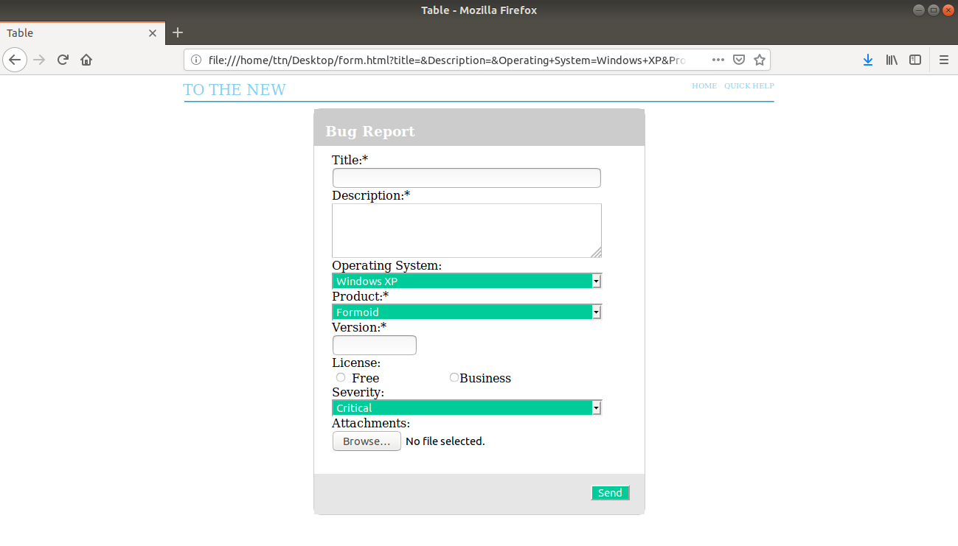

<!DOCTYPE html>
<head>
<meta charset="utf-8" >
<meta name="viewport" content="width=device-width,initial-scale=1.0">
<title>Table</title>
<style>

#main
{
width: 450px;
height: 550px;
margin: 0 auto;

}
#inside
{
width:100%;
height: 50px;
top:-10;
background-color: #cccccc;
display:inline-block;

}
#form1
{
border-style: solid;
border-radius: 10px;
height: 550px;
margin: 0 auto;
border-width: 1px;
border-color: #cccccc;
}
h3
{
color: white;
position: relative;
left: 15px;

}
#abc{
width: 800px;
margin: 0 auto;
}
#inside1
{
width: 400px;
margin: 0 auto;
height: 400px;
position: relative;
top:10px;
}
#len
{
width:350px;
}
#a
{
width: 367px;
background-color: #00cc99;
color: white;

}
#text2
{
width: 100px;
}
.select-selected:after {
position: absolute;
content: "";
top: 14px;
right: 10px;
width: 0;
height: 0;
border: 6px solid transparent;
border-color: #fff transparent transparent transparent;
}
#foot
{
width: 100%;
height: 55px;
position: relative;
top:45px;
background-color: #e6e6e6;
display:inline-block;

}
#snd
{
float:right;
margin: 15px 20px 0 0;
background-color:#00cc99;
color: white;
}
.button
{
color: white;
}

</style>
</head>
<body>
<div id="xyz" style="width: 1000px; padding-left: 240px;">
<div><span style="color: skyblue;float: left; padding-right:550px; font-size: 20px">TO THE NEW </span></div>
<div><span style="color: skyblue; float: left; padding-right:10px; font-size: 10px">HOME</a></span></div>
<div><span style="color: skyblue;float:left;font-size: 10px">QUICK HELP</span></div><br>
</div>
<div id="abc">
<hr style="color: skyblue; padding-right: 550px;">
<div id="main">
<form id="form1">
<div id="inside">
<h3>Bug Report</h3>
</div>
<div id="inside1">
Title:*<br>
<input type="text" name="title" id="len">
<br>
Description:*<br>
<textarea rows="4" cols="50" name="Description"></textarea>
<br>
Operating System:<br>
<select name="Operating System" id="a">
<option value="Windows XP">Windows XP</option>
<option value="saab">Saab</option>
<option value="fiat">Fiat</option>
<option value="audi">Audi</option>
</select><br>
Product:*<br>
<select name="Product" id="a">
<option value="Formoid">Formoid</option>
<option value="saab">Saab</option>
<option value="fiat">Fiat</option>
<option value="audi">Audi</option>
</select><br>
Version:*<br>
<input type="text" name="Version" id="text2">
<br>
License:<br>
<input type="radio" name="Free" > Free
<input type="radio" name="Business" style="margin: 0 0 0 90px;">Business<br>

Severity:<br>
<select name="Severity" id="a">
<option value="Critical">Critical</option>
<option value="saab">Saab</option>
<option value="fiat">Fiat</option>
<option value="audi">Audi</option>
</select><br>
Attachments:<br>
<input type="file" name="pic" accept="image/*">
<br>

</div>

<div id="foot">
<footer>
<input type="submit" value="Send" id="snd">
</footer>

</div>

</div>
</form>
</div>
</body>
</html>

