Jquery Assignment

Question1:Console "Hello Word" in document.ready function.

Solution1:

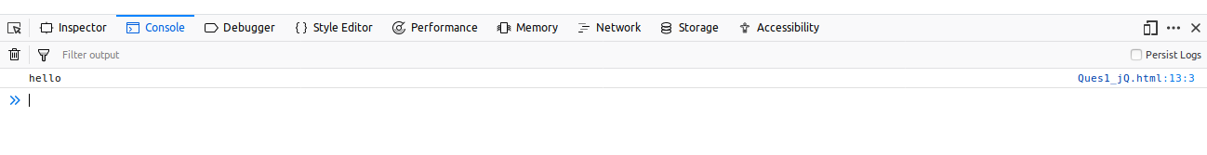

<!DOCTYPE html>
<head>
<meta charset="utf-8" >
<meta name="viewport" content="width=device-width,initial-scale=1.0">
<script src="https://ajax.googleapis.com/ajax/libs/jquery/3.3.1/jquery.min.js"></script>
<title>Table</title>
</style>
</head>
<body>
<script>
$(document).ready(function(){
console.log("hello");
});
</script>
</body>
</html>

Question2:Select a ID name "#test" and add class "load" when DOM is loaded

Solution2:
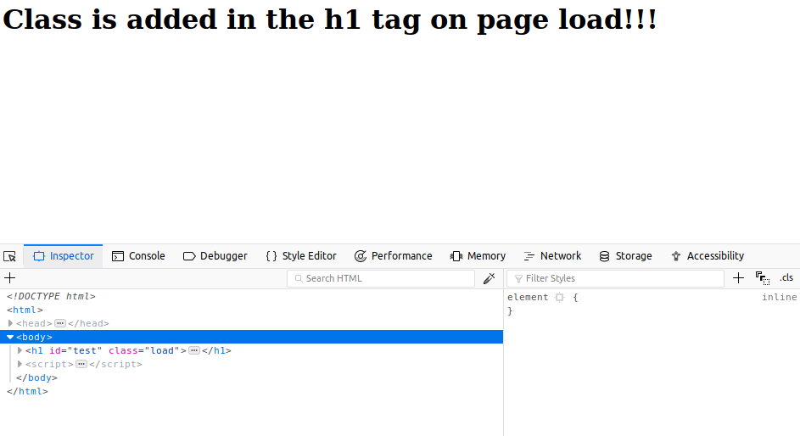

<!DOCTYPE html>
<head>
<meta charset="utf-8" >
<meta name="viewport" content="width=device-width,initial-scale=1.0">
<script src="https://ajax.googleapis.com/ajax/libs/jquery/3.3.1/jquery.min.js"></script>
<title>Table</title>
</head>
<body>
<h1 id="test">
Class is added in the h1 tag on page load!!!
</h1>
<script>
$(function(){
$("#test").attr('class', 'load');
});
</script>
</body>
</html>

Question3:Change the color of element which class name end with "-new"

Solution3:

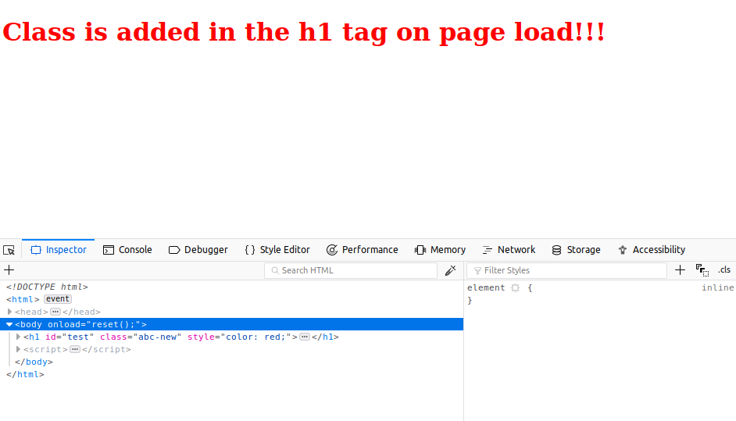

<!DOCTYPE html>
<head>
<meta charset="utf-8" >
<meta name="viewport" content="width=device-width,initial-scale=1.0">
<script src="https://ajax.googleapis.com/ajax/libs/jquery/3.3.1/jquery.min.js"></script>
<title>Table</title>
</head>
<body onload="reset();">
<h1 id="test">
Class is added in the h1 tag on page load!!!
</h1>
<script>
$(function(){
$("#test").attr('class', 'abc-new');
$("h1[class$=-new]").css("color","red");
});
</script>
</body>
</html>

Question4:Disable submit button using jquery attr method

Solution4:

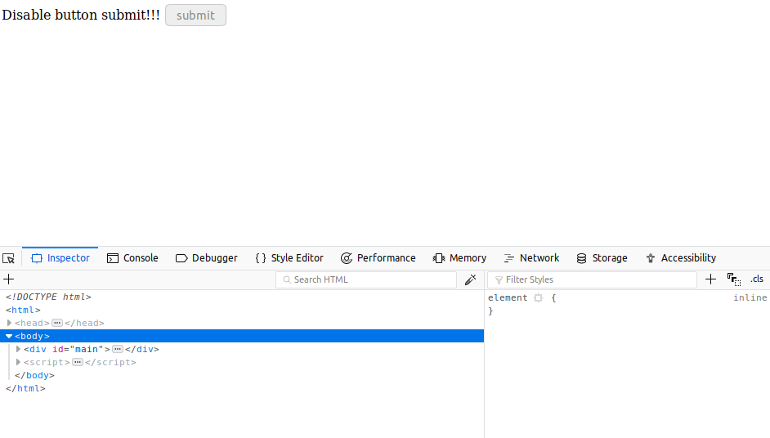

<!DOCTYPE html>
<head>
<meta charset="utf-8" >
<meta name="viewport" content="width=device-width,initial-scale=1.0">
<script src="https://ajax.googleapis.com/ajax/libs/jquery/3.3.1/jquery.min.js"></script>
<title>Table</title>
</head>
<body>
<div id="main">
Disable button submit!!!
<button type="submit">submit</button>
</div>
<script>
$(function(){
$("button").click(function()
{
$("button[type='submit']").attr("disabled","disabled");
});

});
</script>
</body>
</html>

Question5:Change the font size of ".target" which has parent element with id name "#main"

Solution5:

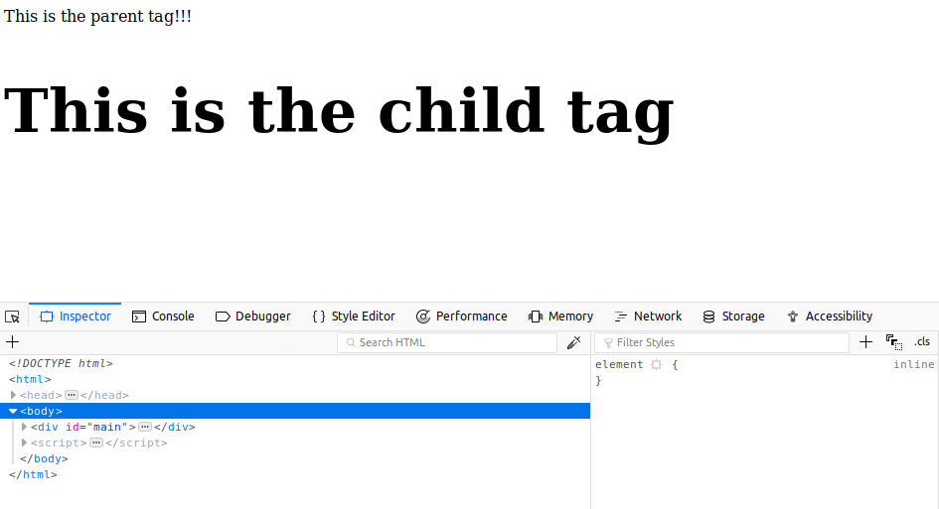

<!DOCTYPE html>
<head>
<meta charset="utf-8" >
<meta name="viewport" content="width=device-width,initial-scale=1.0">
<script src="https://ajax.googleapis.com/ajax/libs/jquery/3.3.1/jquery.min.js"></script>
<title>Table</title>
</head>
<body>
<div id="main">
This is the parent tag!!!
<h2 class="target">
This is the child tag
</h2>
</div>
<script>
$(function(){
$("#main >.target").css("font-size","60px");
});
</script>
</body>
</html>

Question6:After page load change the HTML of div element with "p" element

Solution6:
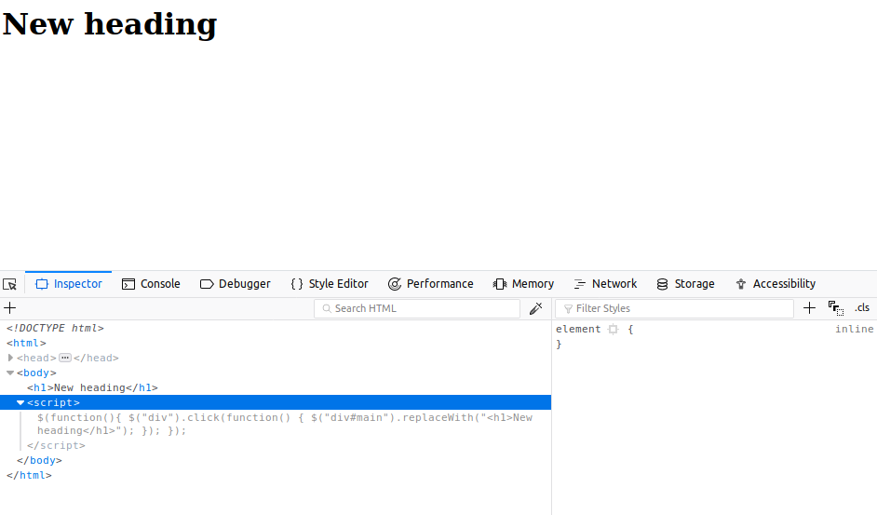

<!DOCTYPE html>
<head>
<meta charset="utf-8" >
<meta name="viewport" content="width=device-width,initial-scale=1.0">
<script src="https://ajax.googleapis.com/ajax/libs/jquery/3.3.1/jquery.min.js"></script>
<title>Table</title>
</head>
<body>
<div id="main">
Disable button submit!!!
</div>
<script>
$(function(){
$("div").click(function()
{
$("div#main").replaceWith("<h1>New heading</h1>");
});
});
</script>
</body>
</html>

Question7:Bind a click function to an "click" element and append next "click" next to it.

Solution7:

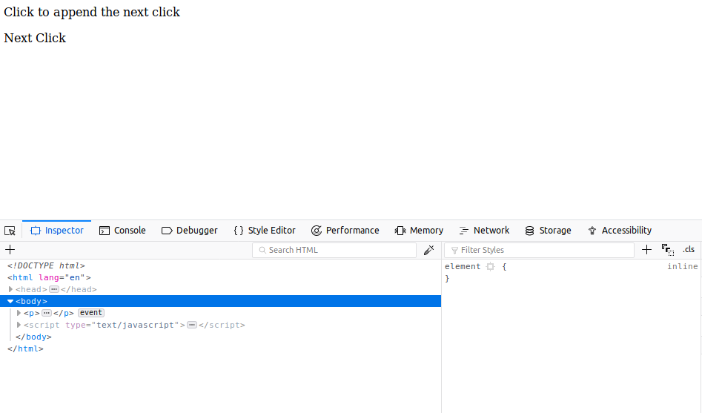
<!DOCTYPE html>
<html lang="en">
<head>
<title>table</title>
<script src="https://ajax.googleapis.com/ajax/libs/jquery/3.3.1/jquery.min.js"></script>
</head>
<body>
<p>Click to append the next click</p>
<script type="text/javascript">
$(function(){
$("p").on('click',function(){
$("p").append("<p> Next Click</p>");
})
});
</script>
</body>
</html>

Question8:Click event not working on element which added dynamicly or via script, make it work
using .on method

Solution8:

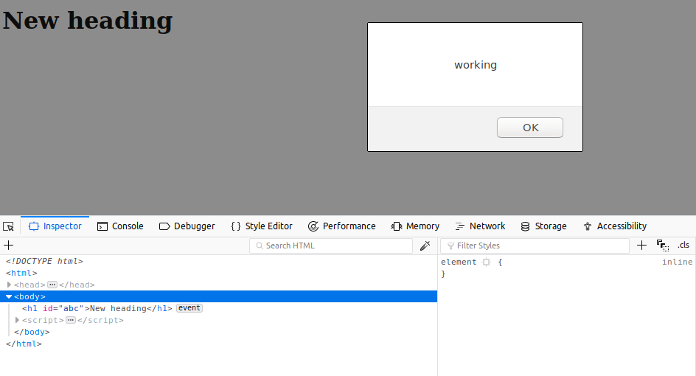

<!DOCTYPE html>
<head>
<meta charset="utf-8" >
<meta name="viewport" content="width=device-width,initial-scale=1.0">
<script src="https://ajax.googleapis.com/ajax/libs/jquery/3.3.1/jquery.min.js"></script>
<title>Table</title>
</head>
<body>
<div id="main">
Disable button submit!!!
</div>
<script>
$(function(){
$("div").click(function()
{
$("div#main").replaceWith("<h1>New heading</h1>");
$("h1").attr("id","abc");
$("#abc").on("click", function(){
alert("working");
});
});
});
</script>
</body>
</html>

Question9:Get dropdown selected value on onchanage event and append in div container
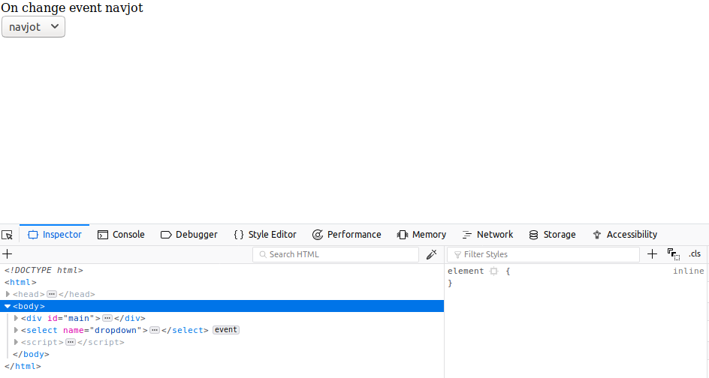
Solution9:

<!DOCTYPE html>
<head>
<meta charset="utf-8" >
<meta name="viewport" content="width=device-width,initial-scale=1.0">
<script src="https://ajax.googleapis.com/ajax/libs/jquery/3.3.1/jquery.min.js"></script>
<title>Table</title>
</head>
<body>
<div id="main">
On change event
</div>
<select name="dropdown">
<option value="rishabh">rishabh</option>
<option value="navjot">navjot</option>
<option value="harsh">harsh</option>
<option value="ayush">ayush</option>
</select>
<script>
$(function(){
$('select').on('change',function()
{
$("#main").append(this.value);
});
});
</script>
</body>
</html>

Question10:Create a dropdown menu using hover method in jquery

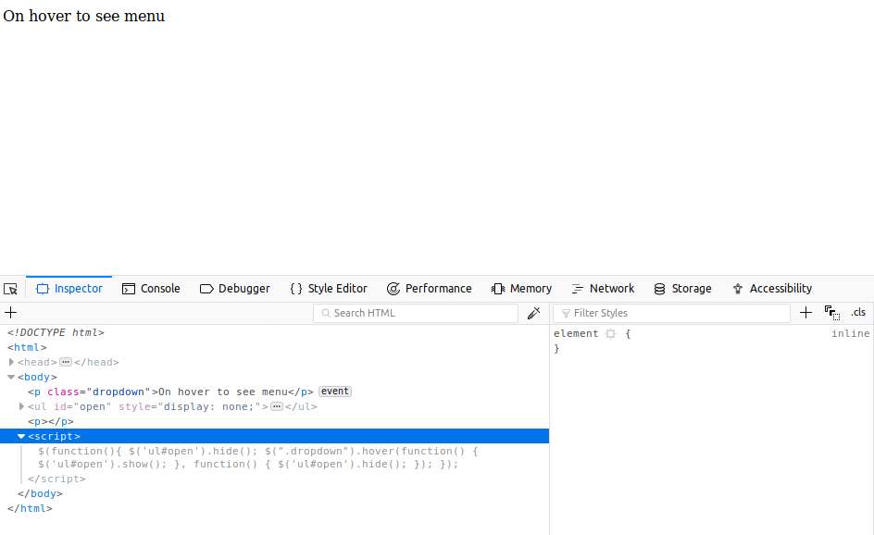
Solution10:
<!DOCTYPE html>
<head>
<meta charset="utf-8" >
<meta name="viewport" content="width=device-width,initial-scale=1.0">
<script src="https://ajax.googleapis.com/ajax/libs/jquery/3.3.1/jquery.min.js"></script>
<title>Table</title>
</head>
<body>
<p class="dropdown"> On hover to see menu
<ul id = "open">
<li>rishabh</li>
<li>navjot</li>
<li>harsh</li>
<li>ayush</li>
</ul>
</p>
<script>
$(function(){
$('ul#open').hide();
$(".dropdown").hover(function() {
$('ul#open').show();
},
function() {
$('ul#open').hide();
});
});
</script>

Question11:On clicking on "google" tag. It is taking us to google home page. Stop it from happening.

Solution11:
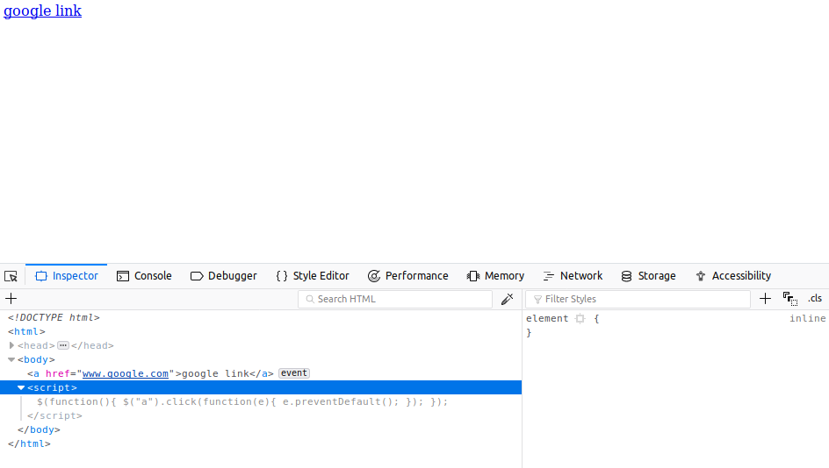

<!DOCTYPE html>
<head>
<meta charset="utf-8" >
<meta name="viewport" content="width=device-width,initial-scale=1.0">
<script src="https://ajax.googleapis.com/ajax/libs/jquery/3.3.1/jquery.min.js"></script>
<title>Table</title>
</head>
<body>
<a href="www.google.com">google link</a>
<script>
$(function(){
$("a").click(function(e){
e.preventDefault();
});
});
</script>
</body>
</html>

Question12:We have bind a click funtion to parent div but we want stop it from performing when user clicks on its child li

Solution12:
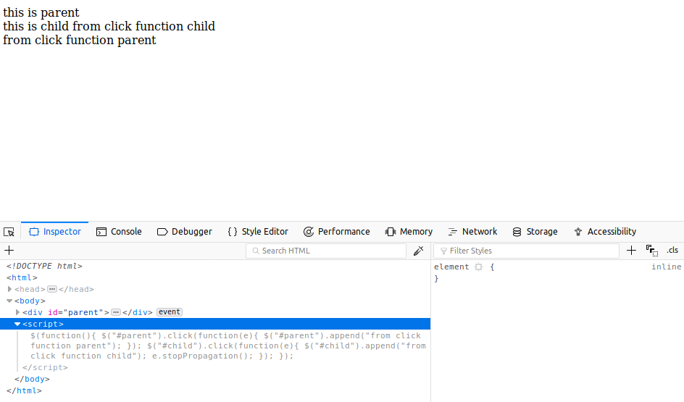
<!DOCTYPE html>
<head>
<meta charset="utf-8" >
<meta name="viewport" content="width=device-width,initial-scale=1.0">
<script src="https://ajax.googleapis.com/ajax/libs/jquery/3.3.1/jquery.min.js"></script>
<title>Table</title>
</head>
<body>
<div id="parent">
this is parent
<div id="child">
this is child
</div>
</div>
<script>
$(function(){
$("#parent").click(function(e){
$("#parent").append("from click function parent");
});
$("#child").click(function(e){
$("#child").append("from click function child");
e.stopPropagation();
});
});
</script>
</body>
</html>

Question13:Get the max height of elements using jquery each method

Solution13:
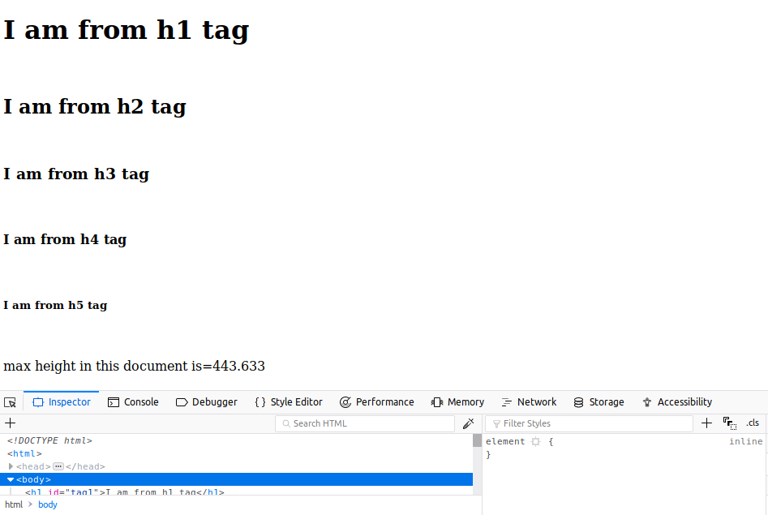

<!DOCTYPE html>
<head>
<meta charset="utf-8" >
<meta name="viewport" content="width=device-width,initial-scale=1.0">
<script src="https://ajax.googleapis.com/ajax/libs/jquery/3.3.1/jquery.min.js"></script>
<title>Table</title>
</head>
<body>

<h1 id="tag1">I am from h1 tag</h1><br>
<h2 id="tag2">I am from h2 tag</h2><br>
<h3 id="tag3">I am from h3 tag</h3><br>
<h4 id="tag4">I am from h4 tag</h4><br>
<h5 id="tag5">I am from h5 tag</h5><br>
<p id="abc">max height in this document is=</p>
<script>
$(function(){
var max=0;
$("body").each(function()
{
var height=$(this).height();
if(max<height)
{
max=height;
}
});
$("#abc").append(max);
});
</script>
</body>
</html>

Question14:Chagne color of every cell which has numberl larger than 10.
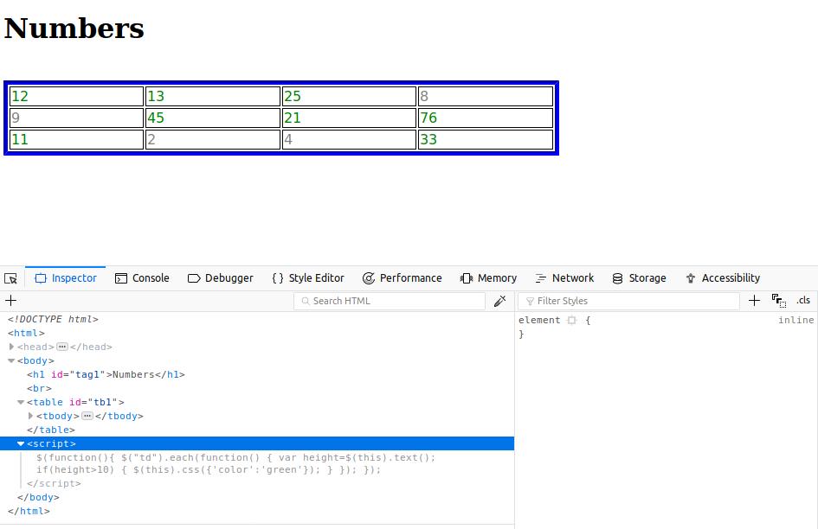
Solution14:

<!DOCTYPE html>
<head>
<meta charset="utf-8" >
<meta name="viewport" content="width=device-width,initial-scale=1.0">
<script src="https://ajax.googleapis.com/ajax/libs/jquery/3.3.1/jquery.min.js"></script>
<title>Table</title>
<style>
table
{
position: relative;
border-style: groove;
border-color: blue;
border-width: 5px;
width: 50%;
}
td
{
border: 1px solid black;
font-family: cursive;
color:grey;
}
th
{
border: 1px solid black;
font-family: cursive;
}
</style>
</head>
<body>

<h1 id="tag1">Numbers</h1><br>
<table id="tb1">
<tr>
<td>12</td>
<td>13</td>
<td>25</td>
<td>8</td>
</tr>
<tr>
<td>9</td>
<td>45</td>
<td>21</td>
<td>76</td>
</tr>
<tr>
<td>11</td>
<td>2</td>
<td>4</td>
<td>33</td>
</tr>
</table>
<script>
$(function(){
$("td").each(function()
{
var height=$(this).text();
if(height>10)
{
$(this).css({'color':'green'});
}
});
});
</script>
</body>
</html>

Question15:Retrive the data from server using ajax get call

Solution15:
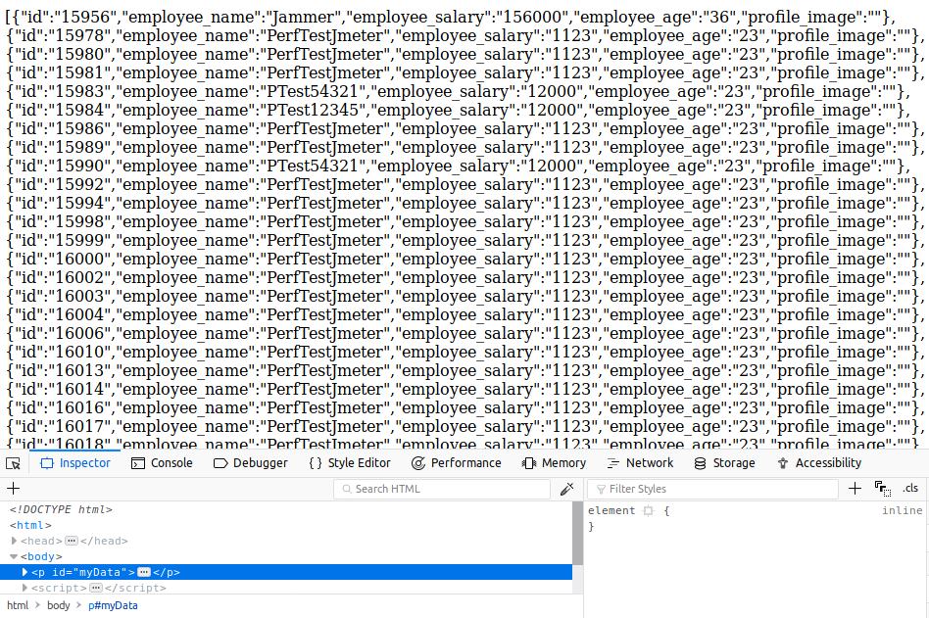
<!DOCTYPE html>
<head>
<meta charset="utf-8" >
<meta name="viewport" content="width=device-width,initial-scale=1.0">
<script src="https://ajax.googleapis.com/ajax/libs/jquery/3.3.1/jquery.min.js"></script>
<title>Table</title>

</head>
<body>

<p id="myData"></p>
<script>
$(function(){
$.ajax({
type:'GET',
url: 'http://dummy.restapiexample.com/api/v1/employees',
success: function(data){
console.log(data);
$("#myData").html(data);
}
})
});

</script>
</body>
</html>

Question16:Add cross button on row and bind click function which make a delete request to server, after success event remove the row from dom

Solution16:

Question17:Create a image array and in div create a slide show to animate images of delay of 500ms.
Solution17:
<!DOCTYPE html>
<html lang="en">
<head>
<title>Table</title>
</head>

<body>
<div id="slider">hover to slideshow<img id="slide-img"></div>
<script src="https://ajax.googleapis.com/ajax/libs/jquery/3.3.1/jquery.min.js"></script>
<script>
$(document).ready(function () {
var imageArray = ["https://images.pexels.com/photos/814499/pexels-photo-814499.jpeg?auto=compress&cs=tinysrgb&dpr=1&w=500",
"https://ak.picdn.net/assets/cms/14c40a5a7a7f50788cf9e346071ab49ad1201b12-17d705f0349ed08f5387b39c7644054a59affe52-LOHP_vector_module_shutterstock_307324316-min.jpg",
"https://i.pinimg.com/originals/5a/e5/8f/5ae58f5036997cfd4636917403c3c951.jpg"]
$("#slider").hover(function () {
var image = $("#slide-img");
image.animate(500, function () {
var random = imageArray[Math.floor(Math.random() * imageArray.length)];
image.attr("src", random);
$("#slider").html(image);
})
})
});
</script>
</body>
</html>

