Assignment On Java -2

1. Create Java classes having suitable attributes for Library management system.Use OOPs concepts in your design.Also try to use interfaces and abstract classes.
Solution1:
This is a design !Not the implementation part I have shown only the function that book,librarian,student will have.
interface Common
{
void issueBook();
void updateStudentRecord();
void getBookFromStudent();
}
class Book
{
public int bookId;
public String bookName;
public String author;
public int price;
public Book() {
}
Book(int bookId, String bookName, String author, int price)
{
this.bookId=bookId;
this.bookName=bookName;
this.author=author;
this.price=price;
}
}
class Librarian extends Book implements Common
{
public boolean addBook(Book book)
{
//for adding the book into the library
return true;
}
public boolean addStudent(Student student)
{
//this will add student into the library record
return true;
}
public boolean deleteStudent(Student student)
{
//this will delete student from the library
return true;
}
public void updateStudentRecord()
{
//update student record;
}
public boolean search(int bookId)
{
//search for book in the libarary
return true;
}
public void issueBook()
{
}
public void getBookFromStudent()
{
}
public void getMemberdetail(Student s)
{
}
}
class Student
{
public String name;
public int rollNumber;
public String Course;
Student(String name,int rollno,String Course)
{
this.name=name;
this.rollNumber=rollno;
this.Course=Course;
}
public void search()
{
//search for book;
}
}
public class Library {
public static void main(String[] args) {
Book book=new Book(101,"java programming","rishabh",200);
Student student=new Student("ram",3064,"BCA");
}
}
2. WAP to sorting string without using string Methods?
Solution2:
public class Sorting_String {
public static void main(String[] args) {
String string="rishabh is my name";
char[] character=new char[string.length()];
for(int i=0;i<string.length();i++)
{
character[i]=string.charAt(i);
}
for(int i=0;i<character.length-1;i++)
{
if(!(character[i]==' '))
{
for(int j=i+1;j<character.length;j++)
{
if(character[j]==' ')
{
continue;
}
else if(character[i]>character[j])
{
char temp;
temp=character[i];
character[i]=character[j];
character[j]=temp;
}
}
}
}
for (int i=0;i<character.length;i++)
{
System.out.print(character[i]);
}
}
}
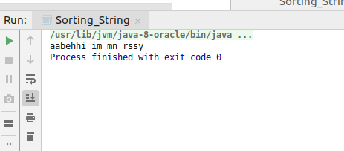

3. WAP to produce NoClassDefFoundError and ClassNotFoundException exception.
Solution3:
//Class not found exception:It is the checked exception.
public class Exception_Error {
public static void main(String[] args)
{
Class.forName("excep");
}
}
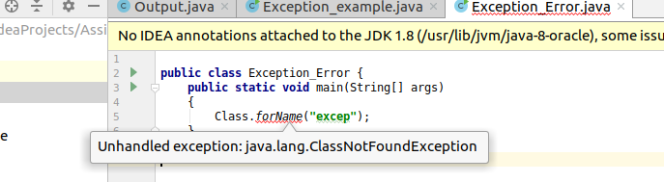
//NoClassDefFoundError:
I have deleted the BOI class file from production and after running the program again this error occured.!
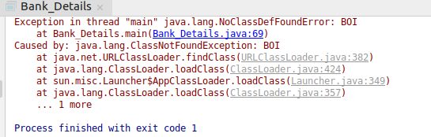

4. WAP to create singleton class.
Solution4:
class Demo
{
int demo_id;
private static Demo t=new Demo();
private Demo()
{
demo_id=101;
}
public static Demo getDemo()
{
return t;
}
}
public class Singleton
{
public static void main(String[] args) {
Demo d=Demo.getDemo();
System.out.println("object d="+d.demo_id);
Demo d1=Demo.getDemo();
System.out.println("object d1="+d1.demo_id);
d1.demo_id=206;
System.out.println("after change object d1="+d1.demo_id);
System.out.println("after change object d="+d.demo_id);
}
}
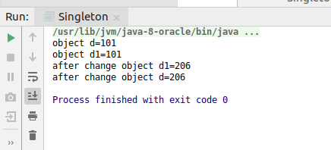

5. WAP to show object cloning in java using cloneable and copy constructor both.
Solution5:
Copy constructor:
class Thing
{
private int id;
private String name;
public Thing(int id,String name)
{
this.id=id;
this.name=name;
}
public Thing(Thing obj)
{
this.id=obj.id;
this.name=obj.name;
}
@Override
public String toString() {
return "Thing{" +
"id=" + id +
", name='" + name + '\'' +
'}';
}
}
public class Cloning {
public static void main(String[] args) {
Thing obj1=new Thing(101,"rishabh");
Thing cloneobj=new Thing(obj1);
System.out.println("object="+obj1);
System.out.println("cloneobject="+cloneobj);
}
}
clone method:
class Thing implements Cloneable
{
private int id;
private String name;
public Thing(int id,String name)
{
this.id=id;
this.name=name;
}
@Override
public String toString() {
return "Thing{" +
"id=" + id +
", name='" + name + '\'' +
'}';
}
public Object clone()throws CloneNotSupportedException{
return super.clone();
}
}
public class Cloning {
public static void main(String[] args)throws CloneNotSupportedException {
Thing obj1=new Thing(101,"rishabh");
Thing cloneobj=(Thing)obj1.clone();
System.out.println("object="+obj1);
System.out.println("cloneobject="+cloneobj);
}
}
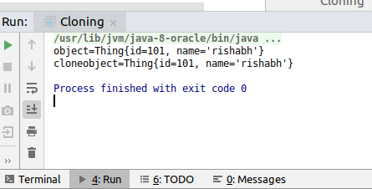

6. WAP showing try, multi-catch and finally blocks.
Solution6:
import java.util.Scanner;
public class Exception_example
{
public static void main(String[] args) {
int i=0;
Scanner sc=new Scanner(System.in);
System.out.println("enter the number=");
i=sc.nextInt();
try
{
System.out.println(i/0);
}
catch(ArithmeticException e)
{
e.printStackTrace();
}
catch (Exception e)
{
e.printStackTrace();
}
finally {
System.out.println("finally");
}
}
}
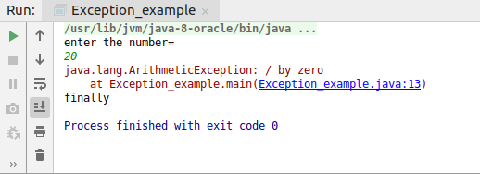
7. WAP to convert seconds into days, hours, minutes and seconds.
Solution7:
import java.util.Scanner;
public class Time {
public static void main(String[] args) {
int days,hours,min;
Scanner enter=new Scanner(System.in);
System.out.println("Enter the seconds=");
int sec=enter.nextInt();
days=sec/(24*3600);
sec=sec-days*(3600*24);
hours=sec/3600;
sec=sec-hours*3600;
min= sec / 60;
sec=sec-min*60;
System.out.println("days="+days);
System.out.println("hours="+hours);
System.out.println("minutes="+min);
System.out.println("seconds="+sec);
}
}

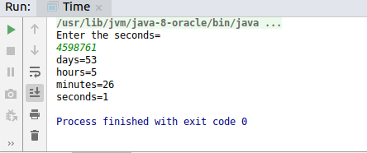

8. WAP to read words from the keyboard until the word done is entered. For each word except done, report whether its first character is equal to its last character. For the required loop, use a
a)while statement
b)do-while statement
Solution8:
Do while loop:
import java.util.*;
import java.util.Scanner;
public class Read_Word {
public static void main(String[] args) {
Scanner sc=new Scanner(System.in);
String word;
do
{
System.out.println("Enter the word");
word = sc.next();
word=word.toLowerCase();
if(word.charAt(0)==word.charAt(word.length()-1))
{
System.out.println("This word is having both first and last character equal="+word);
}
}while(!word.equals("done"));
}
}
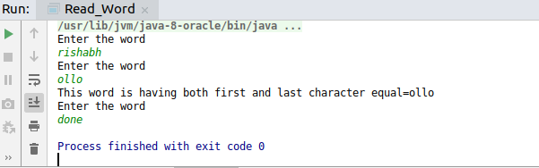
While loop:
import java.util.*;
import java.util.Scanner;
public class Read_Word {
public static void main(String[] args) {
Scanner sc=new Scanner(System.in);
String word="";
while(!word.equals("done"))
{
System.out.println("Enter the word");
word = sc.next();
word=word.toLowerCase();
if(word.charAt(0)==word.charAt(word.length()-1))
{
System.out.println("This word is having both first and last character equal="+word);
}
}
}
}
9. Design classes having attributes for furniture where there are wooden chairs and tables, metal chairs and tables. There are stress and fire tests for each products.
Solution9:
interface FireStressTest {
void FireTest();
void StressTest(int weight, String typeOfFurniture);
}
class wooden implements FireStressTest {
@Override
public void FireTest() {
System.out.println("wooden chair not passed FireTest");
}
@Override
public void StressTest(int weight, String typeOfFurniture) {
if (typeOfFurniture.equals("chair")) {
if (weight > 2000) {
System.out.println("wooden furniture not passed the stesstest");
} else {
System.out.println("passed the stesstest");
}
} else if (typeOfFurniture.equals("table")) {
if (weight > 5000) {
System.out.println("wooden table not passed the stesstest");
} else {
System.out.println("passed the stesstest");
}
}
}
}
class Metal implements FireStressTest {
@Override
public void FireTest() {
System.out.println(" Metal passed FireTest");
}
@Override
public void StressTest(int weight, String typeOfFurniture) {
if (typeOfFurniture.equals("chair")) {
if (weight > 10000) {
System.out.println("metal chair not passed the stesstest");
} else {
System.out.println("passed the stesstest");
}
} else if (typeOfFurniture.equals("table")) {
if (weight > 15000) {
System.out.println("metal table not passed the stesstest");
} else {
System.out.println("passed the stesstest");
}
}
}
}
public class Furniture {
public static void main(String[] args) {
Metal metalfurniture = new Metal();
metalfurniture.FireTest();
metalfurniture.StressTest(23000, "chair");
wooden furniture = new wooden();
furniture.FireTest();
furniture.StressTest(900, "table");
}
}
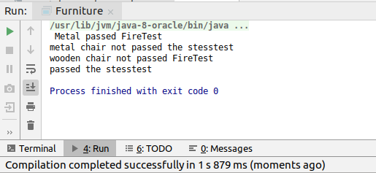
10. Design classes having attributes and method(only skeleton) for a coffee shop. There are three different actors in our scenario and i have listed the different actions they do also below
* Customer
- Pays the cash to the cashier and places his order, get a token number back
- Waits for the intimation that order for his token is ready
- Upon intimation/notification he collects the coffee and enjoys his drink
( Assumption: Customer waits till the coffee is done, he wont timeout and cancel the order. Customer always likes the drink served. Exceptions like he not liking his coffee, he getting wrong coffee are not considered to keep the design simple.)
* Cashier
- Takes an order and payment from the customer
- Upon payment, creates an order and places it into the order queue
- Intimates the customer that he has to wait for his token and gives him his token
( Assumption: Token returned to the customer is the order id. Order queue is unlimited. With a simple modification, we can design for a limited queue size)
* Barista
- Gets the next order from the queue
- Prepares the coffee
- Places the coffee in the completed order queue
- Places a notification that order for token is ready
Solution10:
This is only the class design functions are not working !It is just a design.
import java.util.*;
class Order {
int orderId;
float price;

public Order(int orderId, float price) {
this.orderId = orderId;
this.price = price;
}
public int getOrderId() {
return orderId;
}

}
class Cashier {
static int count=0;
static Queue<Integer> orderIdList=new PriorityQueue<>() ;
static Queue<Integer> completedorderIdList=new PriorityQueue<>();
public int PaymentGenerateToken (int pay,String orderItem) {
boolean paymentReceived;
if(pay>0)//it will also check if the item order price is same as that of the payment then it will provide orderid
{
int orderId = ++count;
paymentReceived=true;
orderIdList.add(orderId);
new Barista().orderPreparation(orderId,orderItem);
return orderId;
}
else
{
paymentReceived=false;
}
return 0;
}

}
class Barista extends Cashier {

public void orderPreparation(int id,String Item) {
completedorderIdList.add(id)

if(orderIdList.remove(id))
{
System.out.println("Notification on screen : order prepared" + id);
}
}
}
class Customer {
public int order() {
System.out.println("please give your order and cash");
Scanner sc=new Scanner(System.in);
String item=sc.next();
int pay=sc.nextInt();//user will give the payment
return new Cashier().PaymentGenerateToken(pay,item);
}

}
public class Coffee {
public static void main(String[] args) {
Customer customer = new Customer();
int orderId= customer.order();
}
}
11. Convert the following code so that it uses nested while statements instead of for statements:
int s = 0;
int t = 1;
for (int i = 0; i < 10; i++)
{
s = s + i;
for (int j = i; j > 0; j−−)
{
t = t * (j - i);
}
s = s * t;
System.out.println("T is " + t);
}
System.out.println("S is " + s);
Solution11:
import java.util.*;
import java.util.Scanner;
public class Read_Word {
public static void main(String[] args) {
int s = 0,i=0;
int t = 1;
while(i<10)
{
s=s+i;
int j=i;
while(j>0)
{
t=t*(j-i);
j--;
}
s=s*t;
i++;
System.out.println("T is " + t);
}
System.out.println("S is " + s);
}
}

12.What will be the output on new Child(); ?
class Parent extends Grandparent {
{
System.out.println("instance - parent");
}
public Parent() {
System.out.println("constructor - parent");
}
static {
System.out.println("static - parent");
}
}
class Grandparent {
static {
System.out.println("static - grandparent");
}
{
System.out.println("instance - grandparent");
}
public Grandparent() {
System.out.println("constructor - grandparent");
}
}
class Child extends Parent {
public Child() {
System.out.println("constructor - child");
}
static {
System.out.println("static - child");
}
{
System.out.println("instance - child");
}
}
Solution:
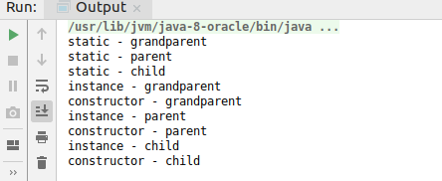

Q13. Create a custom exception that do not have any stack trace.
Solution13:
import java.sql.SQLOutput;
import java.util.Scanner;
class Custom_Exception extends RuntimeException
{
Custom_Exception(String s)
{
super(s);
}
@Override
public synchronized Throwable fillInStackTrace() {
return null;
}
}
public class Exception_example
{
public static void main(String[] args) {
int number;
Scanner sc=new Scanner(System.in);
System.out.println("enter the number=");
number=sc.nextInt();
if(number>100)
{
throw new Custom_Exception("you have entered number greater than 100");
}
else
{
System.out.println("thank you");
}
}
}
