Database Assignment

Question1:Create Database

Solution1:

Question2:Design Schema
Solution2:
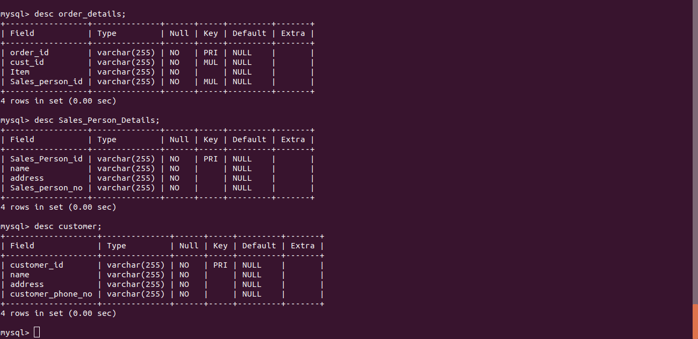
Question3:Create tables
Solution3:
Question4:Insert sample data
Solution4:
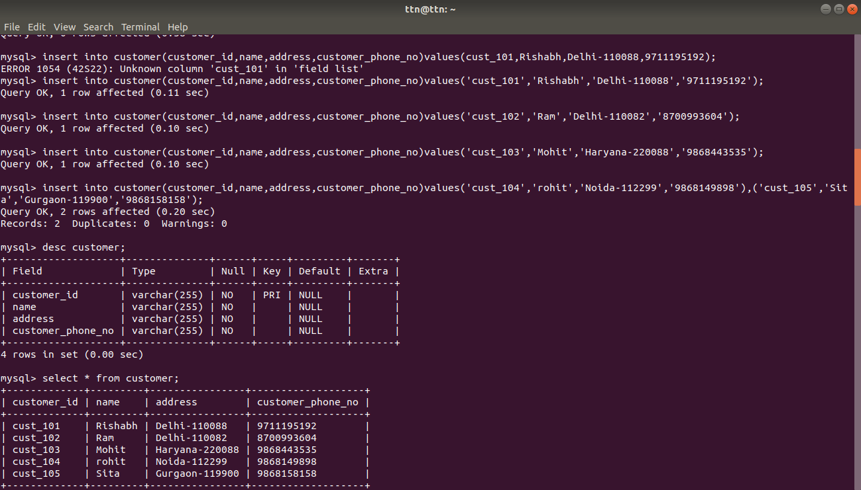
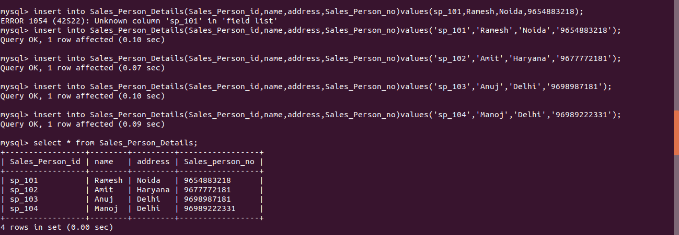
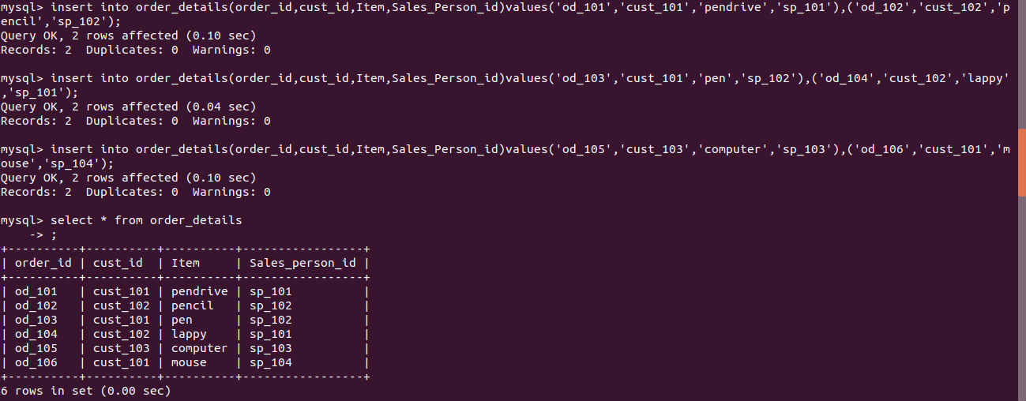
Question5:Find the sales person have multiple orders.

Solution5:
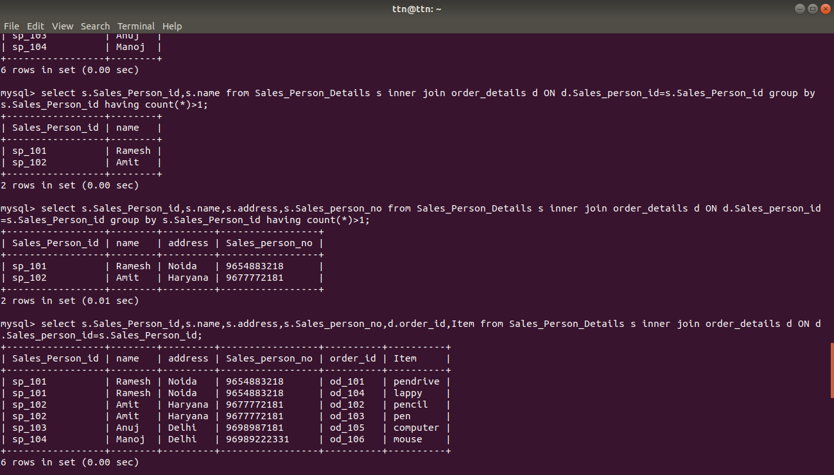

Question6:Find the all sales person details along with order details.

Solution6:
Question7:Create index

Solution7:
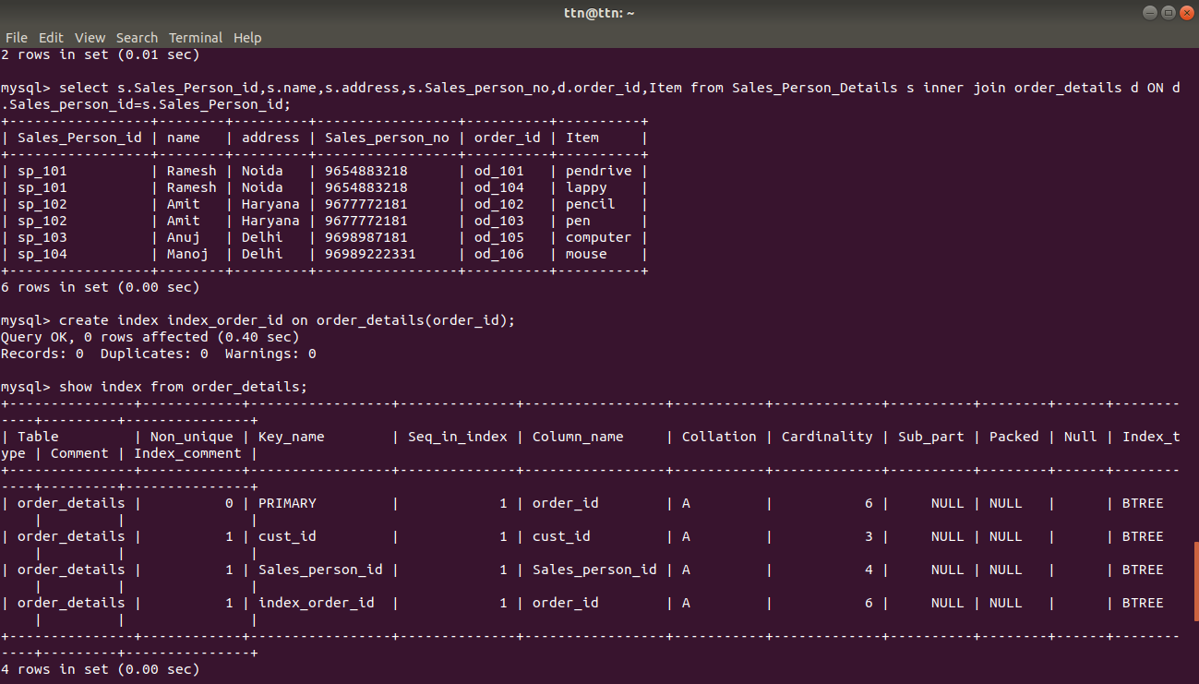

Question8:How to show index on a table

Solution8:
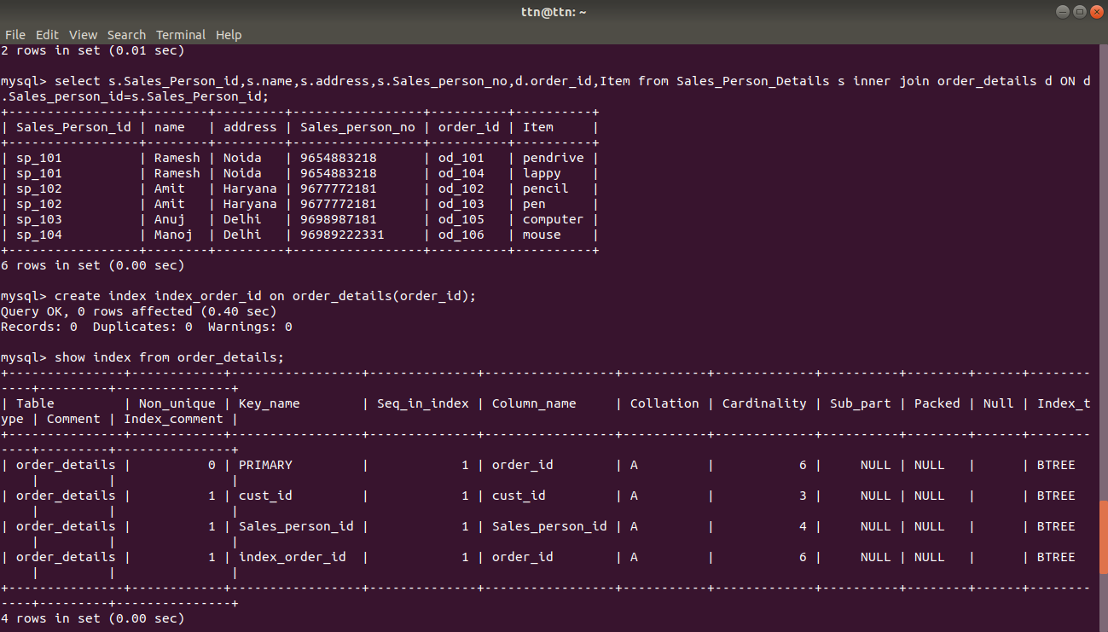

Question9:Find the order number, sale person name, along with the customer to whom that order belongs to.

Solution9:
