Javascript Assignment

Question1:Prompt for amount, interest rate and no. of years and calculate simple interest.

Solution1:
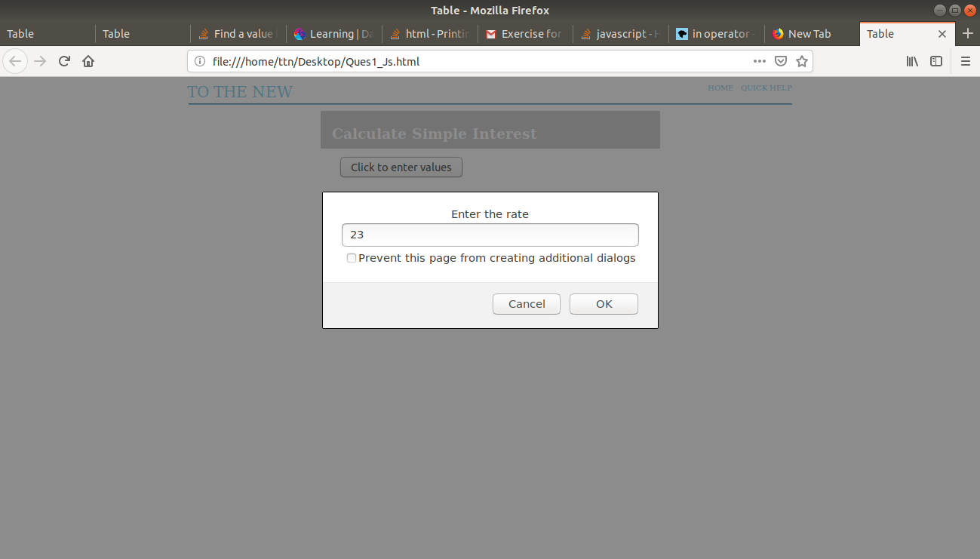

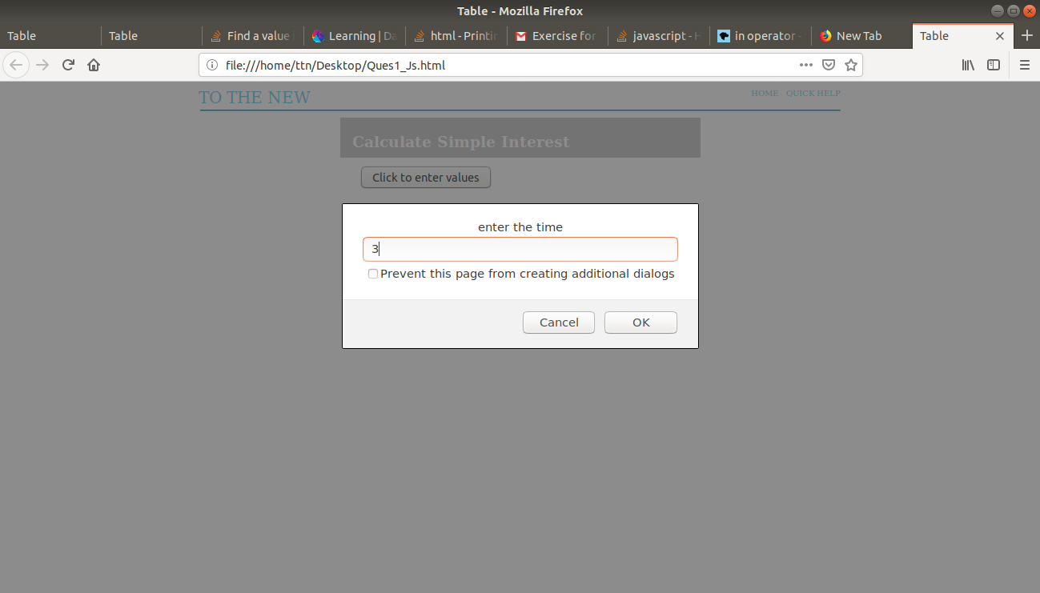

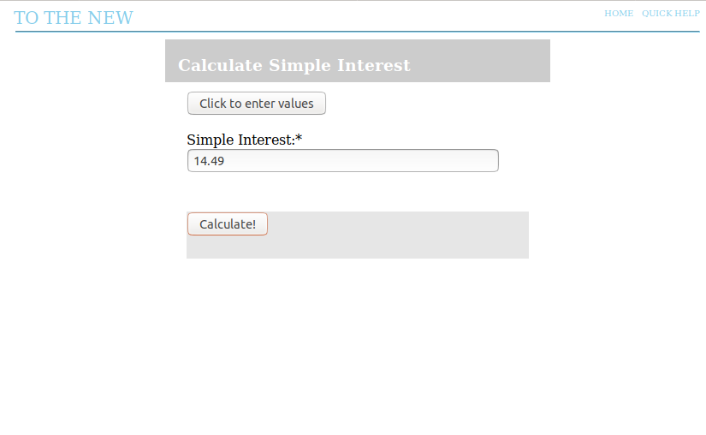

<!DOCTYPE html>
<head>
<meta charset="utf-8" >
<meta name="viewport" content="width=device-width,initial-scale=1.0">
<title>Table</title>
<style>

#main
{
width: 450px;
height: 550px;
margin: 0 auto;

}
#inside
{
width:100%;
height: 50px;
top:-10;
background-color: #cccccc;
display:inline-block;

}
#form1
{
border-style: solid;
border-radius: 10px;
height: 550px;
margin: 0 auto;
border-width: 1px;
border-color: #cccccc;
}
h3
{
color: white;
position: relative;
left: 15px;

}
#abc{
width: 800px;
margin: 0 auto;
}
#inside1
{
width: 400px;
margin: 0 auto;
height: 400px;
position: relative;
top:10px;
}
#len
{
width:350px;
autocomplete:off;
}
#len1
{
width:350px;
}#len2
{
width:350px;
}
#a
{
width: 367px;
background-color: #00cc99;
color: white;

}
#text2
{
width: 100px;
}

#foot
{
width: 100%;
height: 55px;
position: relative;
top:45px;
background-color: #e6e6e6;
display:inline-block;

}

.button
{
color: white;
}

</style>
<script type="text/javascript">
var p,r,t;
function CalSimpleInterest() {
var result=document.getElementById("len");
result.value=p*r*t/100;
}
function get_t()
{
p=prompt("Enter the amount");
if(p!=null && !isNaN(p))
{
r=prompt("Enter the rate");
if(r!=null)
{
t=prompt("enter the time");
if(t!=null)
alert("you have entered all three values now click on calculate");
else
alert("you have not entered all the values or you have entered string");
}
else
{
alert("you have not entered all the values or you have entered string");
}
}
else
{
alert("you have not entered all the values or you have entered string");
}
}
</script>
</head>
<body onload="form1.reset();">
<div id="xyz" style="width: 1000px; padding-left: 240px;">
<div><span style="color: skyblue;float: left; padding-right:550px; font-size: 20px">TO THE NEW </span></div>
<div><span style="color: skyblue; float: left; padding-right:10px; font-size: 10px">HOME</a></span></div>
<div><span style="color: skyblue;float:left;font-size: 10px">QUICK HELP</span></div><br>
</div>
<div id="abc">
<hr style="color: skyblue; padding-right: 550px;">
<div id="main">
<form name="form1">
<div id="inside">
<h3>Calculate Simple Interest</h3>
</div>
<div id="inside1">
<button type="button" onclick='get_t();'>Click to enter values</button>
<br>
<br>
Simple Interest:*<br>
<input type="text" id="len" >
<br>
<div id="foot">
<footer>
<button type="button" onclick='CalSimpleInterest();'>Calculate!</button>
</footer>
</div>
</div>
</form>
</div>
</body>
</html>

Question2:Is palindrome string?

Solution2:
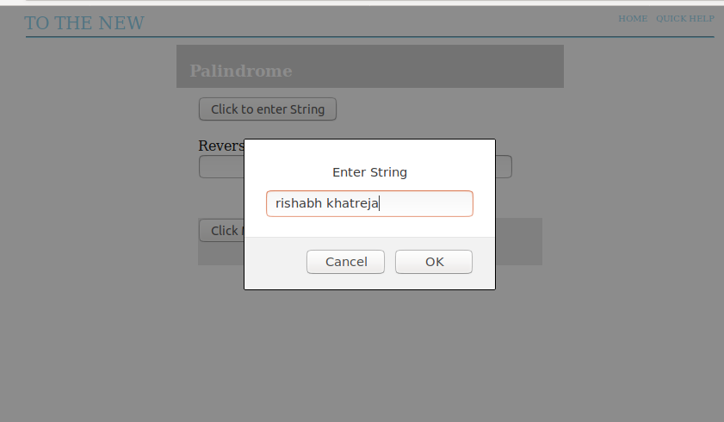

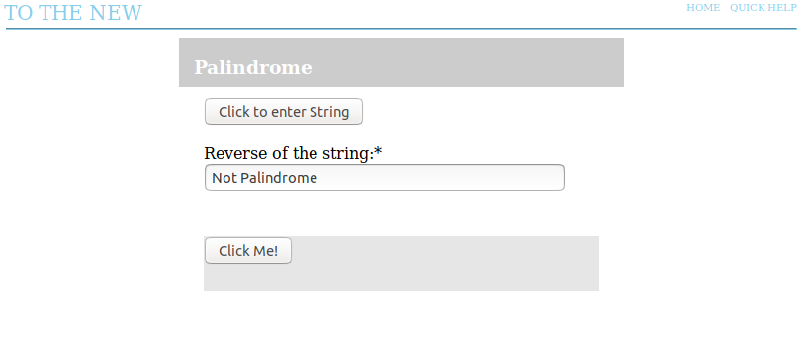
<!DOCTYPE html>
<head>
<meta charset="utf-8" >
<meta name="viewport" content="width=device-width,initial-scale=1.0">
<title>Table</title>
<style>

#main
{
width: 450px;
height: 550px;
margin: 0 auto;

}
#inside
{
width:100%;
height: 50px;
top:-10;
background-color: #cccccc;
display:inline-block;

}
#form1
{
border-style: solid;
border-radius: 10px;
height: 550px;
margin: 0 auto;
border-width: 1px;
border-color: #cccccc;
}
h3
{
color: white;
position: relative;
left: 15px;

}
#abc{
width: 800px;
margin: 0 auto;
}
#inside1
{
width: 400px;
margin: 0 auto;
height: 400px;
position: relative;
top:10px;
}
#len
{
width:350px;
}
#len1
{
width:350px;
}#len2
{
width:350px;
}
#a
{
width: 367px;
background-color: #00cc99;
color: white;

}
#text2
{
width: 100px;
}
.select-selected:after {
position: absolute;
content: "";
top: 14px;
right: 10px;
width: 0;
height: 0;
border: 6px solid transparent;
border-color: #fff transparent transparent transparent;
}
#foot
{
width: 100%;
height: 55px;
position: relative;
top:45px;
background-color: #e6e6e6;
display:inline-block;

}
#snd
{
float:right;
margin: 15px 20px 0 0;
background-color:#00cc99;
color: white;
}
.button
{
color: white;
}

</style>
<script type="text/javascript">
var p,i=0,j=0,k=0;
function CalSimpleInterest() {
var result=document.getElementById("len");
j=p.length-1;
k=0;
for(i=0;i<p.length/2;i++)
{
if(p.charAt(i)==p.charAt(j))
{
j--;
continue;
}
else
{
k=1;
break;
}
}
if(k==1)
result.value="Not Palindrome";
else
result.value="Palindrome";
}
function get_t()
{
p=prompt("Enter String");
}
</script>
</head>
<body onload="form1.reset();">
<div id="xyz" style="width: 1000px; padding-left: 240px;">
<div><span style="color: skyblue;float: left; padding-right:550px; font-size: 20px">TO THE NEW </span></div>
<div><span style="color: skyblue; float: left; padding-right:10px; font-size: 10px">HOME</a></span></div>
<div><span style="color: skyblue;float:left;font-size: 10px">QUICK HELP</span></div><br>
</div>
<div id="abc">
<hr style="color: skyblue; padding-right: 550px;">
<div id="main">
<form name="form1">
<div id="inside">
<h3>Palindrome</h3>
</div>
<div id="inside1">
<button type="button" onclick='get_t();'>Click to enter String</button>
<br>
Reverse of the string:*<br>
<input type="text" id="len" >
<br>
<div id="foot">
<footer>
<button type="button" onclick='CalSimpleInterest();''>Click Me!</button>
</footer>

</div>
</div>
</form>
</div>
</body>
</html>

Question3:Area of circle

Solution3:

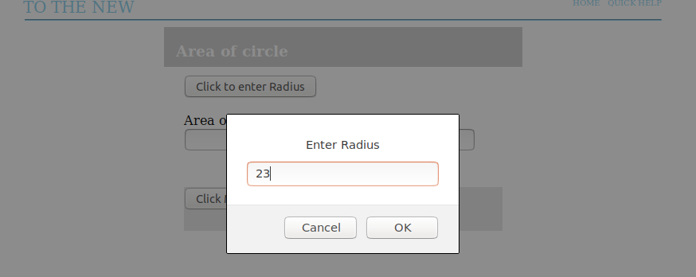

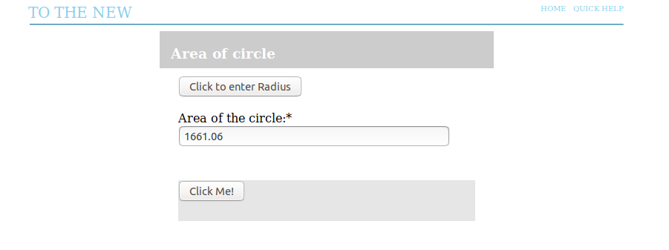

<!DOCTYPE html>
<head>
<meta charset="utf-8" >
<meta name="viewport" content="width=device-width,initial-scale=1.0">
<title>Table</title>
<style>

#main
{
width: 450px;
height: 550px;
margin: 0 auto;

}
#inside
{
width:100%;
height: 50px;
top:-10;
background-color: #cccccc;
display:inline-block;

}
#form1
{
border-style: solid;
border-radius: 10px;
height: 550px;
margin: 0 auto;
border-width: 1px;
border-color: #cccccc;
}
h3
{
color: white;
position: relative;
left: 15px;

}
#abc{
width: 800px;
margin: 0 auto;
}
#inside1
{
width: 400px;
margin: 0 auto;
height: 400px;
position: relative;
top:10px;
}
#len
{
width:350px;
}
#len1
{
width:350px;
}#len2
{
width:350px;
}
#a
{
width: 367px;
background-color: #00cc99;
color: white;

}
#text2
{
width: 100px;
}
.select-selected:after {
position: absolute;
content: "";
top: 14px;
right: 10px;
width: 0;
height: 0;
border: 6px solid transparent;
border-color: #fff transparent transparent transparent;
}
#foot
{
width: 100%;
height: 55px;
position: relative;
top:45px;
background-color: #e6e6e6;
display:inline-block;

}
#snd
{
float:right;
margin: 15px 20px 0 0;
background-color:#00cc99;
color: white;
}
.button
{
color: white;
}

</style>
<script type="text/javascript">
var p,area;
function CalSimpleInterest() {
var result=document.getElementById("len");
area=3.14*p*p;
result.value=area;
}
function get_t()
{
p=prompt("Enter Radius");
if(isNaN(p))
{
alert("please enter the number not string");
}
}
</script>
</head>
<body onload="form1.reset();">
<div id="xyz" style="width: 1000px; padding-left: 240px;">
<div><span style="color: skyblue;float: left; padding-right:550px; font-size: 20px">TO THE NEW </span></div>
<div><span style="color: skyblue; float: left; padding-right:10px; font-size: 10px">HOME</a></span></div>
<div><span style="color: skyblue;float:left;font-size: 10px">QUICK HELP</span></div><br>
</div>
<div id="abc">
<hr style="color: skyblue; padding-right: 550px;">
<div id="main">
<form name="form1">
<div id="inside">
<h3>Area of circle</h3>
</div>
<div id="inside1">
<button type="button" onclick='get_t();'>Click to enter Radius</button>
<br>
Area of the circle:*<br>
<input type="text" id="len" >
<br>
<div id="foot">
<footer>
<button type="button" onclick='CalSimpleInterest();''>Click Me!</button>
</footer>

</div>
</div>
</form>
</div>
</body>
</html>

Question4:Copy information of one object to another and log it to console.

Solution4:

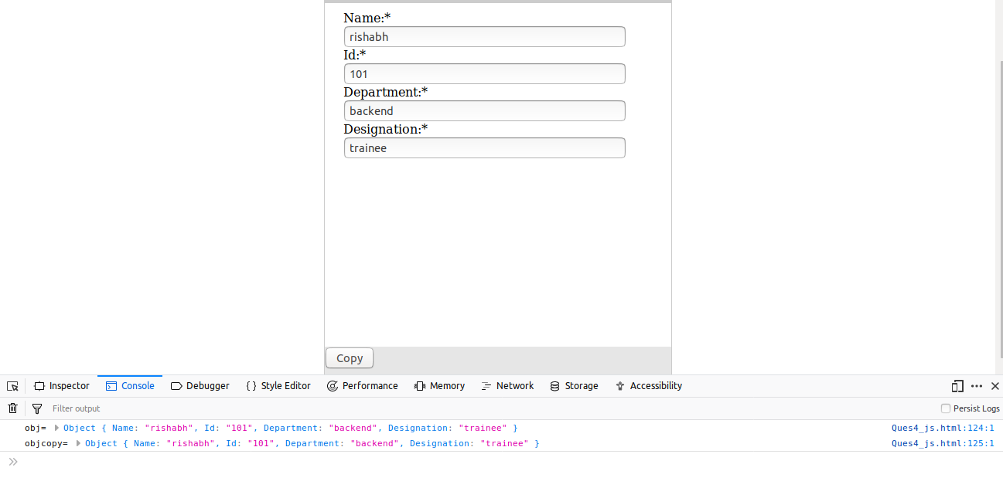

<!DOCTYPE html>
<head>
<meta charset="utf-8" >
<meta name="viewport" content="width=device-width,initial-scale=1.0">
<title>Table</title>
<style>

#main
{
width: 450px;
height: 550px;
margin: 0 auto;

}
#inside
{
width:100%;
height: 50px;
top:-10;
background-color: #cccccc;
display:inline-block;

}
#form1
{
border-style: solid;
border-radius: 10px;
height: 550px;
margin: 0 auto;
border-width: 1px;
border-color: #cccccc;
}
h3
{
color: white;
position: relative;
left: 15px;

}
#abc{
width: 800px;
margin: 0 auto;
}
#inside1
{
width: 400px;
margin: 0 auto;
height: 400px;
position: relative;
top:10px;
}
#len
{
width:350px;
}
#len1
{
width:350px;
}
#len2
{
width:350px;
}
#len3
{
width:350px;
}
#a
{
width: 367px;
background-color: #00cc99;
color: white;

}
#text2
{
width: 100px;
}
.select-selected:after {
position: absolute;
content: "";
top: 14px;
right: 10px;
width: 0;
height: 0;
border: 6px solid transparent;
border-color: #fff transparent transparent transparent;
}
#foot
{
width: 100%;
height: 55px;
position: relative;
top:45px;
background-color: #e6e6e6;
display:inline-block;

}
#snd
{
float:right;
margin: 15px 20px 0 0;
background-color:#00cc99;
color: white;
}
.button
{
color: white;
}

</style>
<script type="text/javascript">

function CalSimpleInterest() {
var obj = new Object();
var objcopy = new Object();
obj.Name=document.getElementById("len").value;
obj.Id=document.getElementById("len1").value;
obj.Department=document.getElementById("len2").value;
obj.Designation=document.getElementById("len3").value;
for(keys in obj) {
objcopy[keys] = obj[keys];
}
console.log("obj=",obj);
console.log("objcopy=",objcopy);
}
</script>
</head>
<body onload="form1.reset();">
<div id="xyz" style="width: 1000px; padding-left: 240px;">
<div><span style="color: skyblue;float: left; padding-right:550px; font-size: 20px">TO THE NEW </span></div>
<div><span style="color: skyblue; float: left; padding-right:10px; font-size: 10px">HOME</a></span></div>
<div><span style="color: skyblue;float:left;font-size: 10px">QUICK HELP</span></div><br>
</div>
<div id="abc">
<hr style="color: skyblue; padding-right: 550px;">
<div id="main">
<form id="form1">
<div id="inside">
<h3>Copy one object to another</h3>
</div>
<div id="inside1">
Name:*<br>
<input type="text" name="title" id="len" required="Name">
<br>
Id:*<br>
<input type="text" name="title" id="len1" required="Id">
<br>
Department:*<br>
<input type="text" name="title" id="len2" required="Department">
<br>
Designation:*<br>
<input type="text" name="title" id="len3" required="Designation">
<br>
</div>

<div id="foot">
<footer>
<button type="button" onclick='CalSimpleInterest();'>Copy</button>
</footer>

</div>

</div>
</form>
</div>
</body>
</html>

Question5:create a list of objects of Employee with info as follow :

a.Name, age, salary ,DOB.

Solution a.

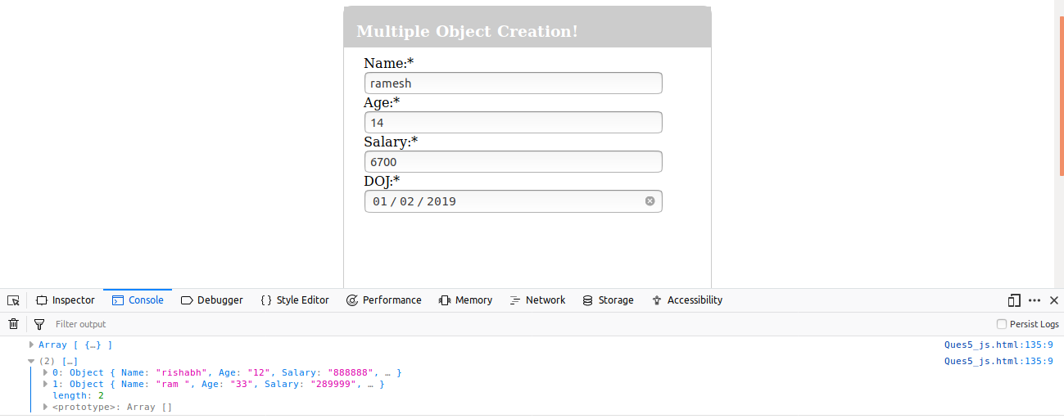

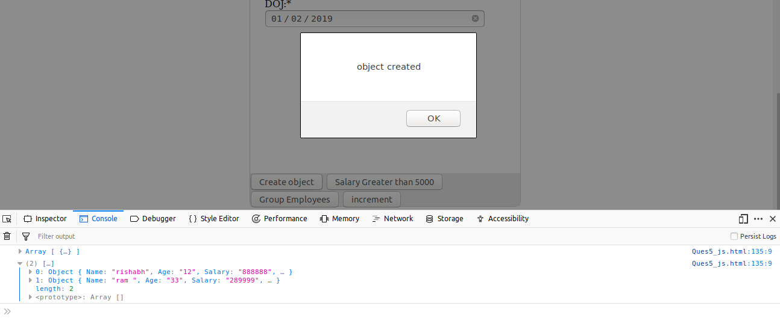
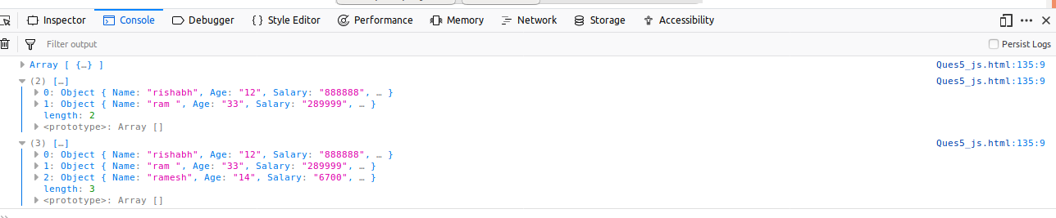
function Create() {
var obj = new Object();
obj.Name=document.getElementById("len").value;
if(isNaN(obj.Name))
{
obj.Age=document.getElementById("len1").value;
if(!isNaN(obj.Age) && obj.Age > 0 && obj.Age < 100)
{
obj.Salary=document.getElementById("len2").value;
if(!isNaN(obj.Salary))
{
obj.DOJ=document.getElementById("len3").value;
ob[i]=obj;
i++;
alert("object created");
console.log(ob);
form1.reset();
}
else
{
alert("please enter the valid Salary");
}
}
else
{
alert("please enter the valid Age");
}
}
else
{
alert("please enter the valid name");
}

}

b.filter all employees with salary greater than 5000

solution b:

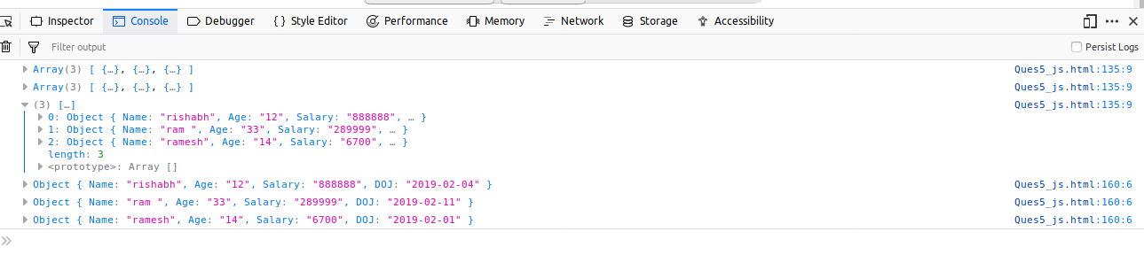

function Greater()
{
for(var j=0;j<ob.length;j++)
{
if(ob[j].Salary>5000)
{
console.log(ob[j]);
}
}
}
c.group employee on the basis of their age

solution c:
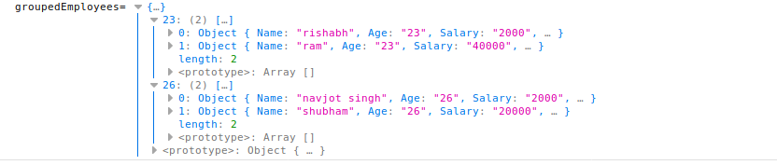
function Group()
{
var group=[];
var groupedEmployees={};
ob.forEach(function(list){
if(!group.includes(list.Age))group.push(list.Age)
for(let age of group)
{
if(!groupedEmployees[age])
{
groupedEmployees[age]=new Array();
}
for(let ob of Object.keys(list))
{
if(ob=="Age")
{
if(age===list[ob])
{
groupedEmployees[age].push(list);
}
}
}
}
});
console.log("groupedEmployees=",groupedEmployees);
}

d.fetch employees with salary less than 1000 and age greater than 20. Then give them an increment 5 times their salary.

solution d.

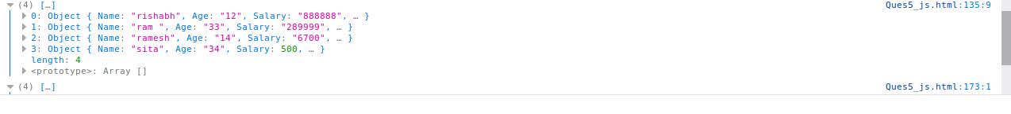
function increment()
{
for(var j=0;j<ob.length;j++)
{
if(ob[j].Salary<1000 && ob[j].Age>20)
{
ob[j].Salary=ob[j].Salary*5;
}
}
console.log(ob);
}

