GIT Assignment

Question1:Git Setup https://confluence.atlassian.

Solution1:

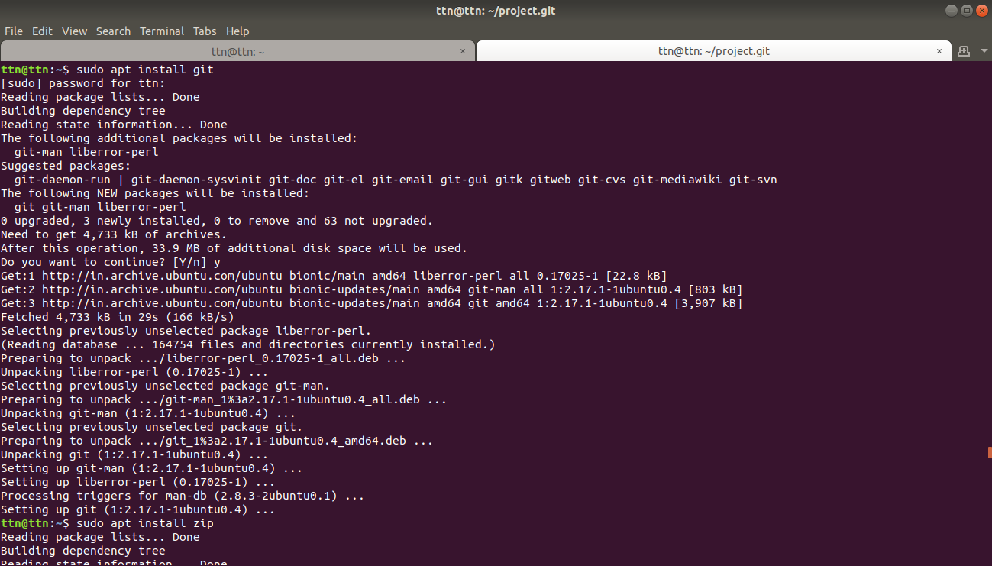
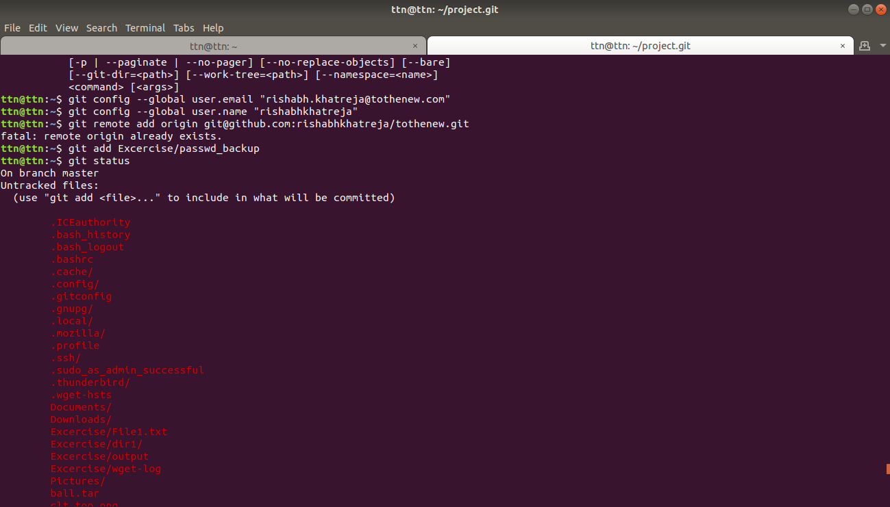

Question2:Initialize a Git Repository

Solution2:

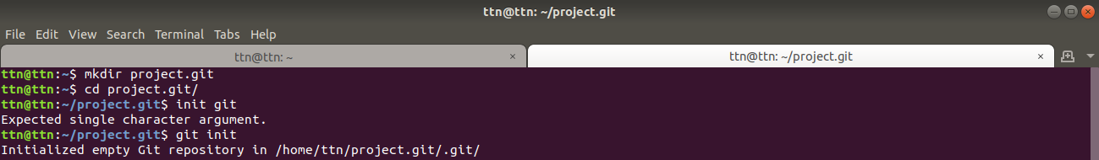

Question3:Add files to the repository

Solution3:
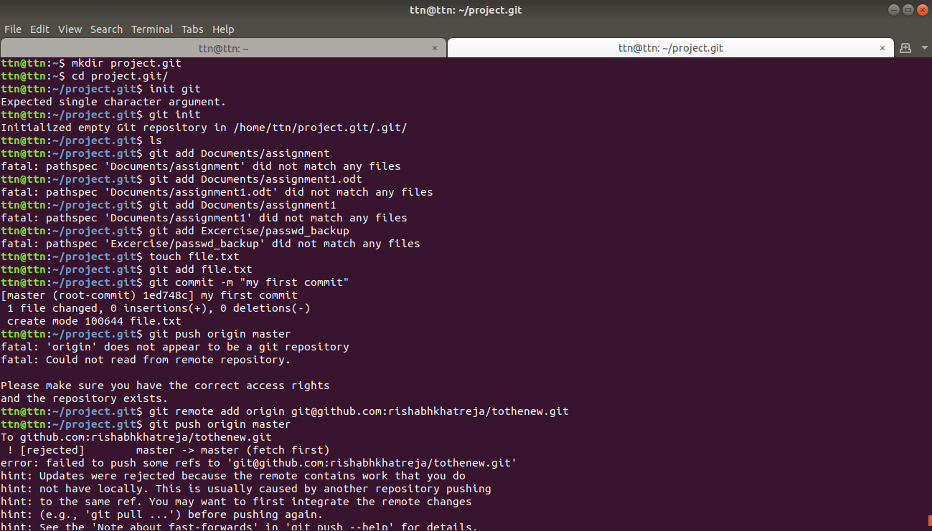
Question4:Unstage 1 file

Solution4:
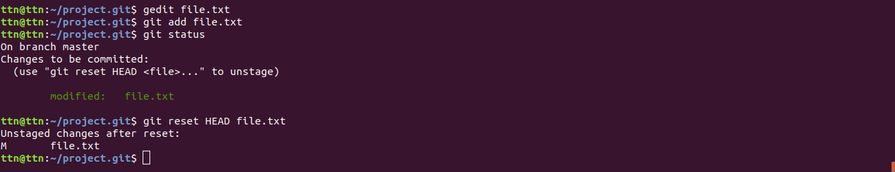

Question5:Commit the file

Solution5:

Question6:Add a remote

Solution6:
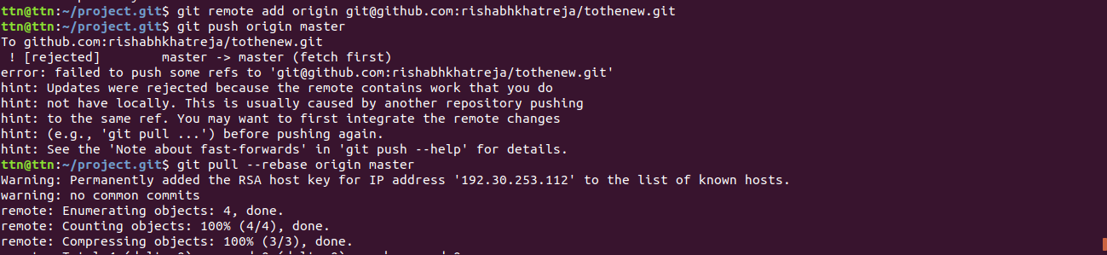

Question7:Undo changes to a particular file

Solution7:

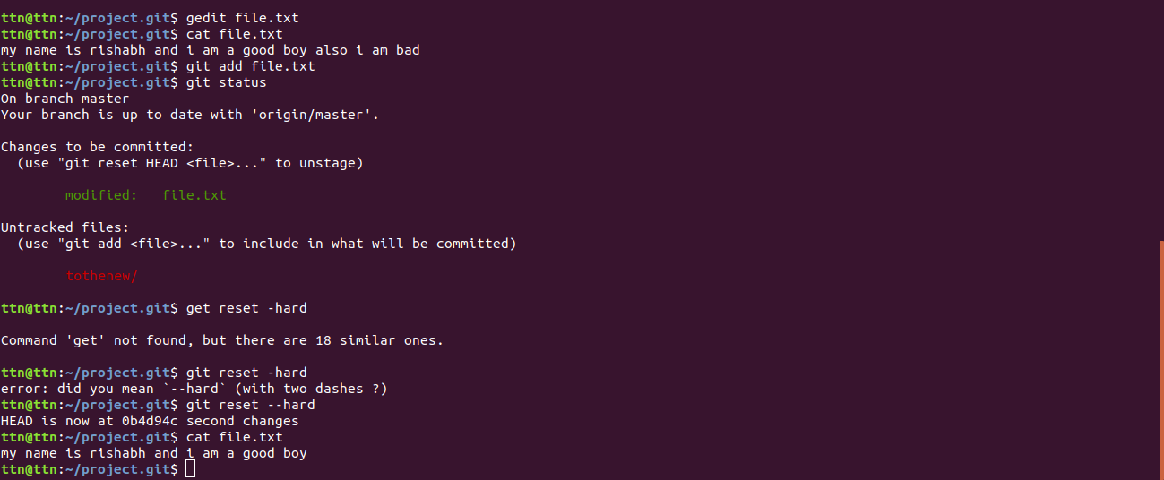

Question8:Push changes to Github

Solution8:
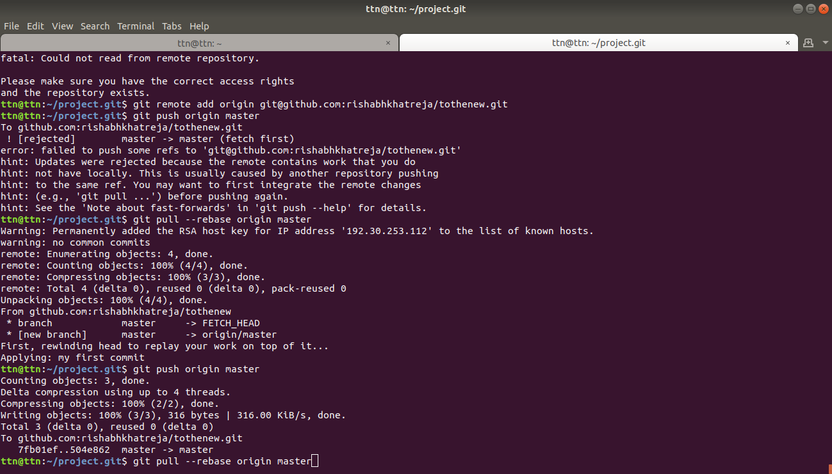

Question9:Clone the repository

Solution9:
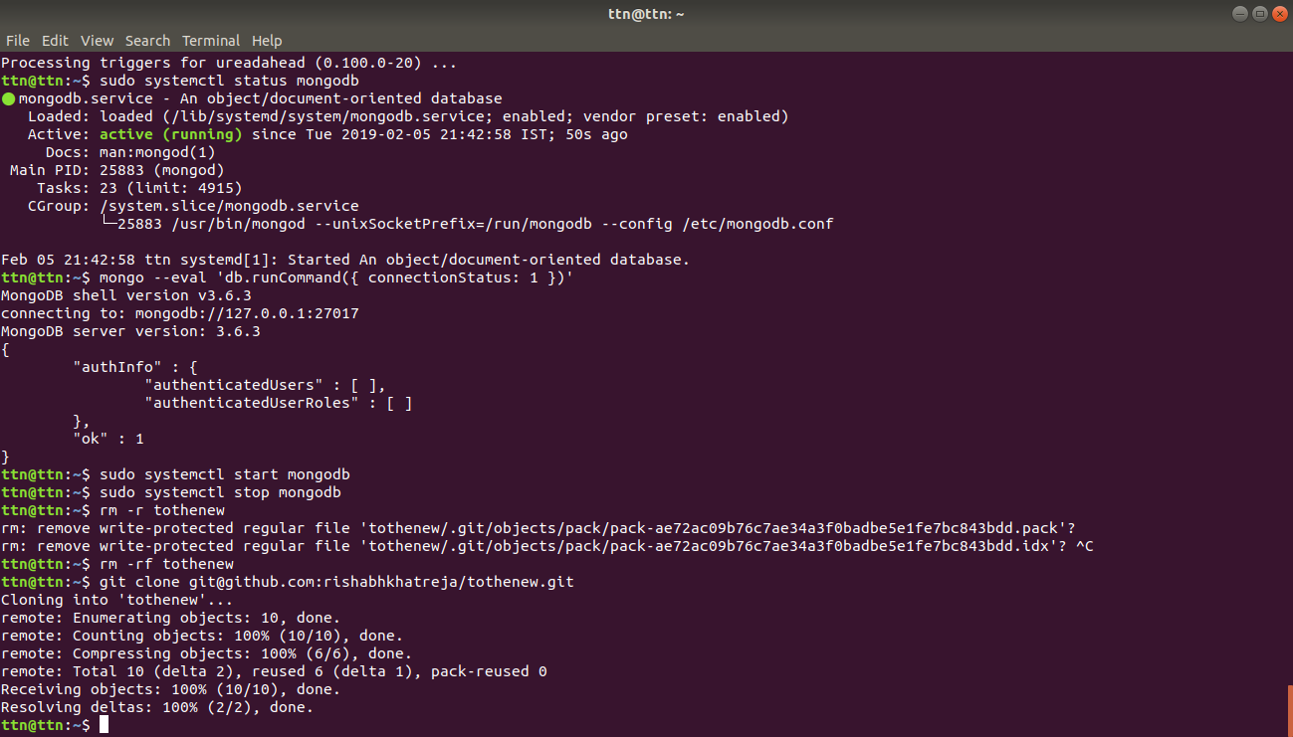

Question10:Add changes to one of the copies and pull the changes in the other.

Solution10:
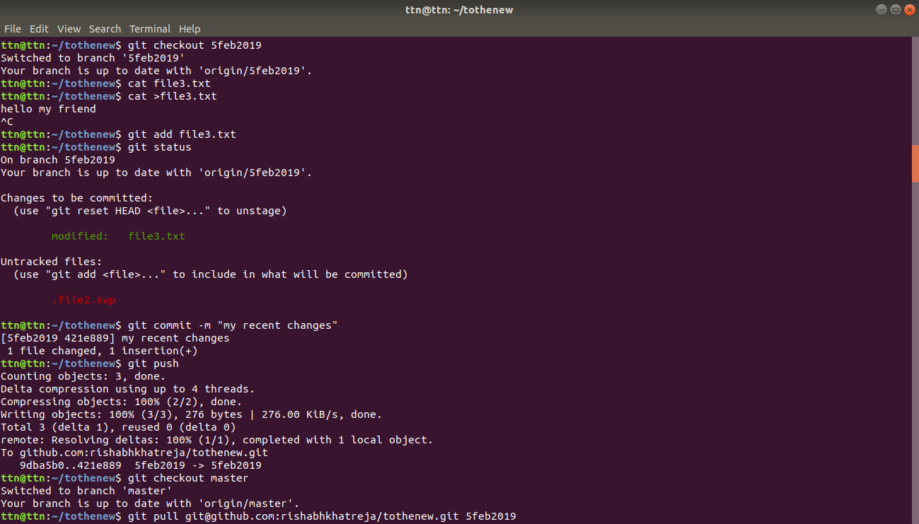
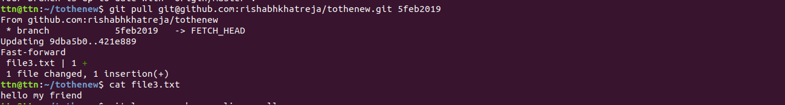

Question11:Check differences between a file and its staged version

Solution11:
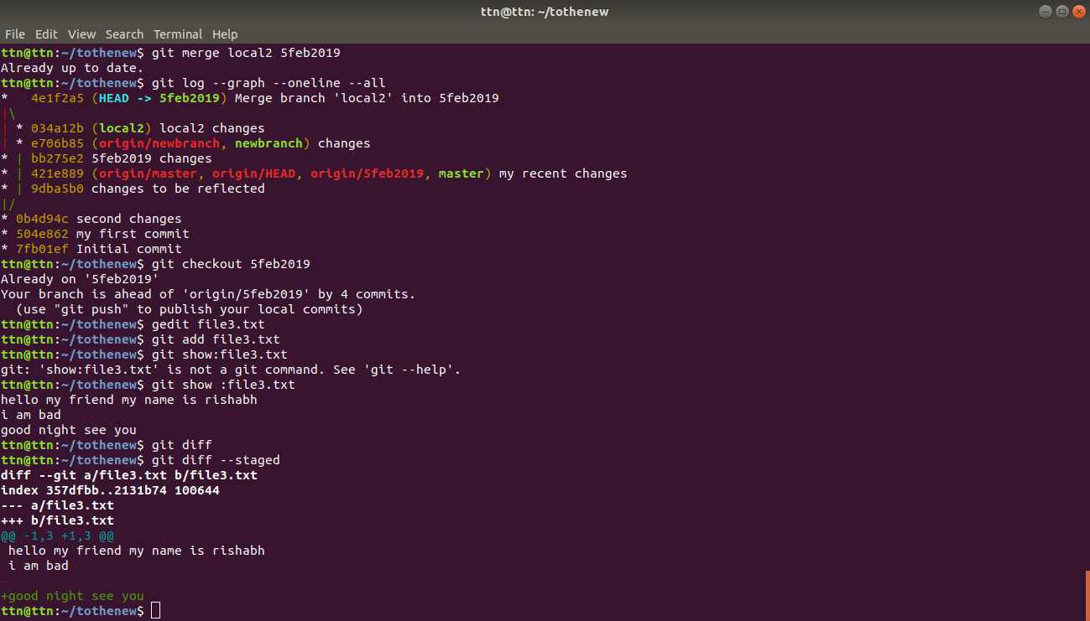
Question12:Ignore a few files to be checked in

Solution12:
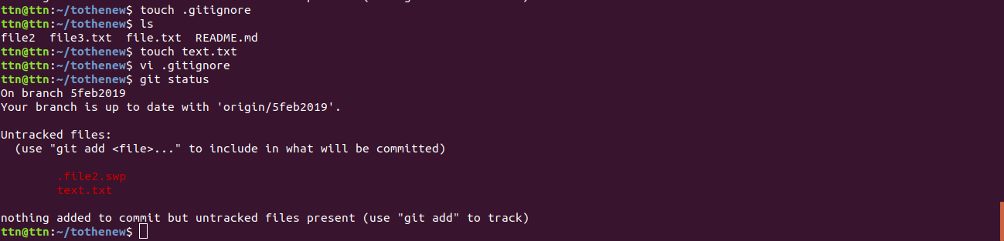

Question13:Create a new branch.

Solution13:
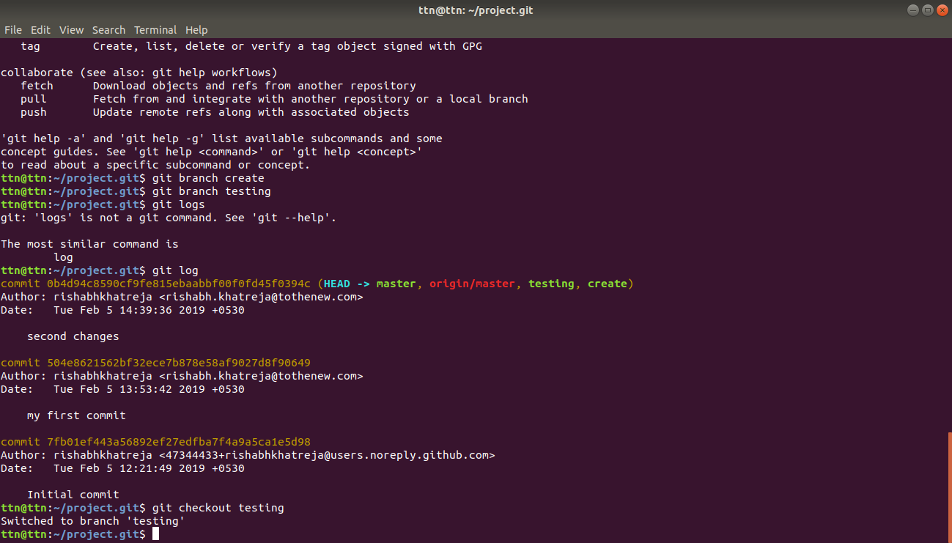

Question14:Diverge them with commits

Solution14:
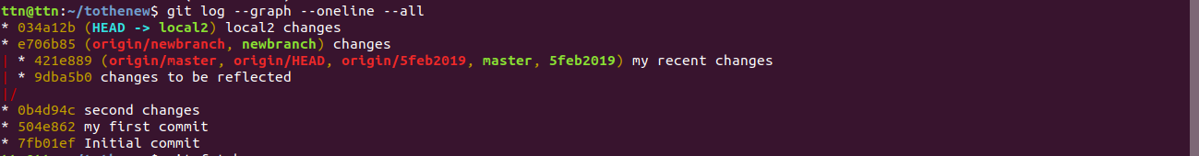

Question15:Edit the same file at the same line on both branches and commit

Solution15:

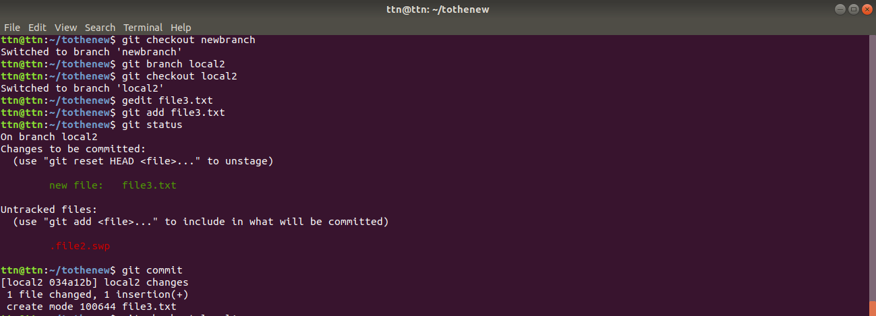

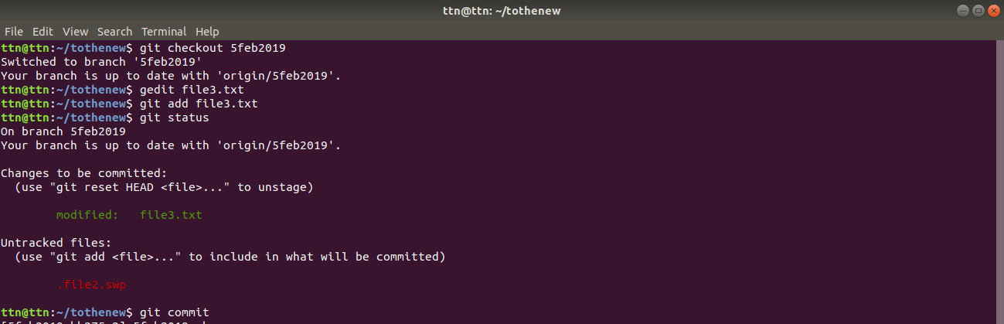

Question16:Try merging and resolve merge conflicts

Solution16:
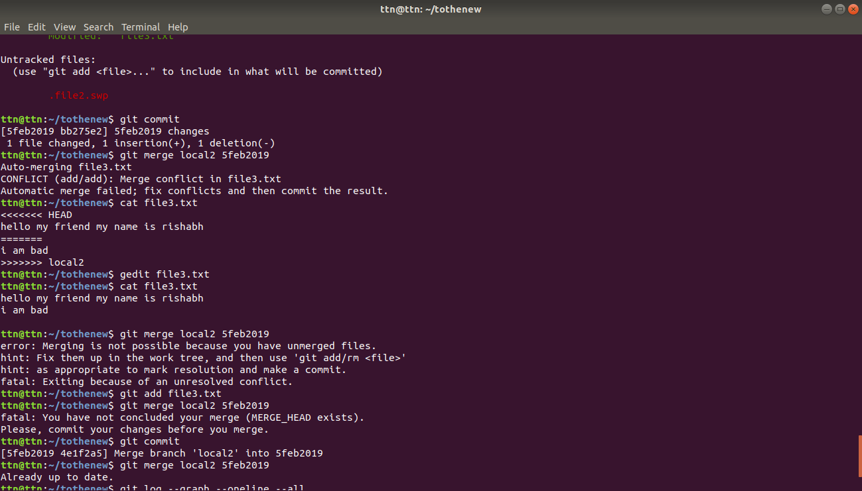
Question 17:Stash the changes and pop them

Solution17:
