Assignment On Threads

Question1:Create and Run a Thread using Runnable Interface and Thread class.
Solution1:
Using Thread Class:
class Mythread extends Thread
{
public void run()
{
System.out.println("new thread created");
}
}
public class ThreadCreationDemo
{
public static void main(String[] args) {
Mythread newThread=new Mythread();
newThread.start();
System.out.println("main thread");
}
}
Using Runnable Interface:
class Mythread implements Runnable
{
public void run()
{
System.out.println("new thread created");
}
}
public class ThreadCreationDemo
{
public static void main(String[] args) {
Thread newThread=new Thread(new Mythread());
newThread.start();
System.out.println("main thread");
}
}
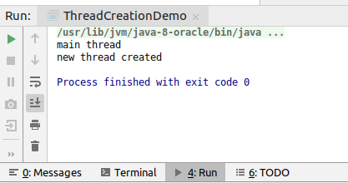

Question2:Use sleep and join methods with thread.
Solution2:
class DemoThread implements Runnable
{
public void run()
{
for(int i=0;i<5;i++)
{
System.out.println("from new thread"+i);
try {
Thread.sleep(2000l);
} catch (InterruptedException e) {
e.printStackTrace();
}
}
}
}
public class SleepJoin {
public static void main(String[] args) {
Thread newThread=new Thread(new DemoThread());
newThread.start();
for(int j=0;j<5;j++)
System.out.println("main thread"+j);
}
}
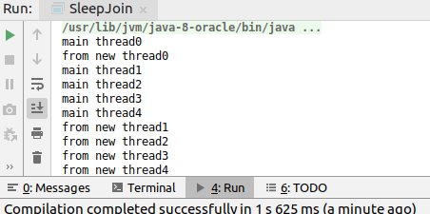

Join:
class SleepThread implements Runnable
{
public void run()
{
for(int i=0;i<5;i++)
{
System.out.println("from new thread"+i);
try {
Thread.sleep(2000l);
} catch (InterruptedException e) {
e.printStackTrace();
}
}
}
}
class joinThread implements Runnable
{
public void run()
{
for(int i=0;i<5;i++)
{
System.out.println("from join thread"+i);
try {
Thread.sleep(2000l);
} catch (InterruptedException e) {
e.printStackTrace();
}
}
}
}
public class SleepJoin {
public static void main(String[] args) {
Thread newThread=new Thread(new SleepThread());
newThread.start();
Thread newThread1=new Thread(new joinThread());
try
{
newThread.join();
}
catch (Exception e)
{
e.printStackTrace();
}
newThread1.start();
for(int j=0;j<5;j++)
System.out.println("main thread"+j);
}
}
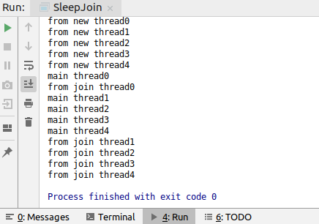

Question3:Use a singleThreadExecutor to submit multiple threads.
Solution3:
import java.util.concurrent.Executor;
import java.util.concurrent.ExecutorService;
import java.util.concurrent.Executors;
import java.util.concurrent.Future;
class myRunnable implements Runnable
{
String name;
myRunnable(String name)
{
this.name=name;
}
public void run()
{
System.out.println(Thread.currentThread().getName()+" has called this method and printed="+name);
}
}
public class ExcecutorBoot {
public static void main(String[] args) {
myRunnable[] jobs={new myRunnable("rishabh"),
new myRunnable("harsh"),
new myRunnable("mohit"),
new myRunnable("ram")};
ExecutorService service = Executors.newSingleThreadExecutor();
for (myRunnable object:jobs)
{
service.submit(object);
}
service.shutdown();
}
}
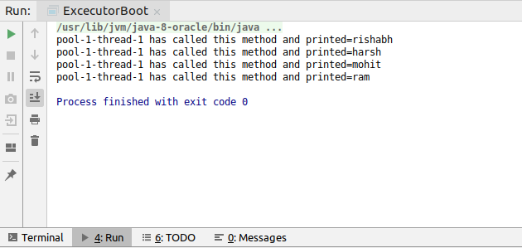

Question4:Try shutdown() and shutdownNow() and observe the difference.
Solution4:
ShutdownNow Example:
import java.util.concurrent.ExecutorService;
import java.util.concurrent.Executors;
class ThreadDemo implements Runnable
{
public void run()
{
System.out.println("thread executing this are is="+Thread.currentThread().getName());
try
{
Thread.sleep(3000);
}
catch (Exception e)
{
e.printStackTrace();
}
}
}
public class ShutDownNow {
public static void main(String[] args) {
ThreadDemo[] object={new ThreadDemo(),
new ThreadDemo(),
new ThreadDemo()};
ExecutorService service= Executors.newSingleThreadExecutor();
service.submit(object[0]);
service.submit(object[1]);
service.submit(object[2]);
service.shutdownNow();
}
}
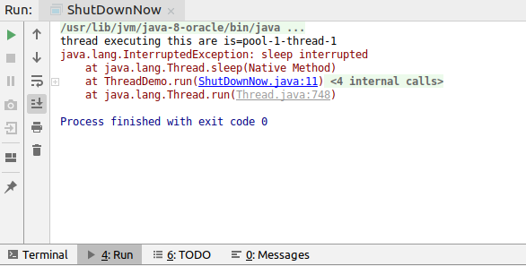

ShutDown:
import java.util.concurrent.ExecutorService;
import java.util.concurrent.Executors;
class ThreadDemo implements Runnable
{
public void run()
{
System.out.println("thread executing this are is="+Thread.currentThread().getName());
try
{
Thread.sleep(3000);
}
catch (Exception e)
{
e.printStackTrace();
}
}
}
public class ShutDownNow {
public static void main(String[] args) {
ThreadDemo[] object={new ThreadDemo(),
new ThreadDemo(),
new ThreadDemo()};
ExecutorService service= Executors.newSingleThreadExecutor();
service.submit(object[0]);
service.submit(object[1]);
service.submit(object[2]);
service.shutdown();
}
}
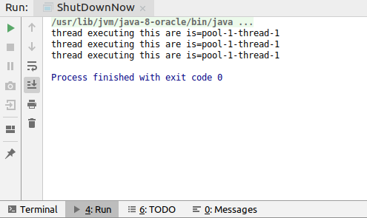

Question5:Use isShutDown() and isTerminate() with ExecutorService.

Solution5:

import java.util.Collection;
import java.util.List;
import java.util.concurrent.*;
class runnable implements Runnable
{
String name;
runnable(String name)
{
this.name=name;
}
public void run()
{
System.out.println(Thread.currentThread().getName()+" has called this method and printed="+name);
try
{
Thread.sleep(3000);
}
catch(Exception e)
{
e.printStackTrace();
}
}
}
public class IsShutDown {
public static void main(String[] args) {
runnable[] objects={new runnable("rishabh"),
new runnable("ram"),
new runnable("ramesh")};
ExecutorService service=Executors.newSingleThreadExecutor();
for (runnable object:objects) {
service.submit(object);
}
System.out.println(Thread.currentThread().getName());
service.shutdownNow();
System.out.println("Is shut down="+service.isShutdown());
System.out.println("Is terminated="+service.isTerminated());
}
}
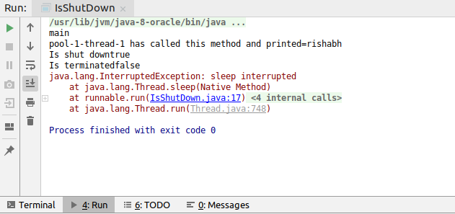

Question6:Return a Future from ExecutorService by using callable and use get(), isDone(), isCancelled() with the Future object to know the status of task submitted.

Solution6:

import java.util.concurrent.*;
class future implements Callable<Integer>
{
public Integer call()
{
try
{
Thread.sleep(3000);
}
catch (Exception e)
{
}
return 10;
}
}
public class FutureObject {
public static void main(String[] args) throws ExecutionException, InterruptedException {
future[] objects={new future(),new future()};
ExecutorService service= Executors.newSingleThreadExecutor();
Future value=null;
for (future eachOject:objects) {
value=service.submit(eachOject);
System.out.println("returned value by callable is ="+value.get());
}
service.shutdownNow();
System.out.println("Thread Is done ="+value.isDone());
System.out.println("Thread is cancelled ="+value.isCancelled());
}
}

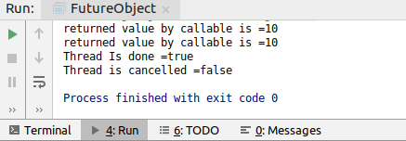

Question7:Submit List of tasks to ExecutorService and wait for the completion of all the tasks.
Solution7:

import java.util.concurrent.Executor;
import java.util.concurrent.ExecutorService;
import java.util.concurrent.Executors;
import java.util.concurrent.TimeUnit;
class Await implements Runnable
{
String name;
Await(String name)
{
this.name=name;
}
public void run()
{
System.out.println(Thread.currentThread().getName()+" has called this method and printed="+name);
try
{
Thread.sleep(1000L);
}
catch(Exception e)
{
e.printStackTrace();
}
}
}
public class WaitTillCompletion {
public static void main(String[] args) throws InterruptedException {
Await[] objects={new Await("rishabh"),new Await("ram"),new Await("ramesh"),new Await("mohit")};
ExecutorService service= Executors.newSingleThreadExecutor();
for (Await object:objects) {
service.submit(object);
}
service.shutdown();
service.awaitTermination(5000L, TimeUnit.MILLISECONDS);
if(service.isTerminated())
{
System.out.println("terminated");
}
else
{
System.out.println("still running");
}
}
}
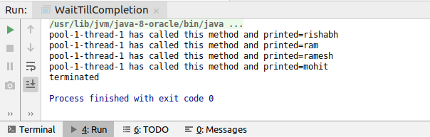

Question8:Schedule task using schedule(), scheduleAtFixedRate() and scheduleAtFixedDelay()
Solution8:
import java.util.concurrent.*;
class ScheduleDemo implements Callable<Integer>
{
public Integer call()
{
return 20;
}
}
public class Schedule {
public static void main(String[] args) throws ExecutionException, InterruptedException {
ScheduleDemo object=new ScheduleDemo();
ExecutorService service= Executors.newSingleThreadScheduledExecutor();
Future<Integer> submit = ((ScheduledExecutorService) service).schedule(object,3000l,TimeUnit.MILLISECONDS);
System.out.println(submit.get());
service.shutdown();
}
}

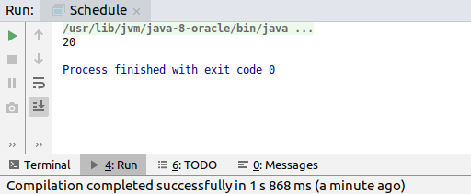

ScheduleDelay:

import java.util.concurrent.ExecutorService;
import java.util.concurrent.Executors;
import java.util.concurrent.ScheduledExecutorService;
import java.util.concurrent.TimeUnit;
class ScheduleFixedRateDemo implements Runnable
{
String name;
ScheduleFixedRateDemo(String name)
{
this.name=name;
}
public void run()
{
System.out.println("hello="+name);
}
}
public class ScheduleFixedRate {
public static void main(String[] args) throws InterruptedException {
ExecutorService service = Executors.newSingleThreadScheduledExecutor();
ScheduleFixedRateDemo[] objects = {new ScheduleFixedRateDemo("rishabh"),
new ScheduleFixedRateDemo("ram"),
new ScheduleFixedRateDemo("ramesh")};
for (ScheduleFixedRateDemo object : objects) {
((ScheduledExecutorService) service).scheduleWithFixedDelay(object, 0, 2000L, TimeUnit.MILLISECONDS);
}
service.awaitTermination(5000L,TimeUnit.MILLISECONDS);
service.shutdown();
}
}

ScheduleAtFixedRate:

import java.util.concurrent.ExecutorService;
import java.util.concurrent.Executors;
import java.util.concurrent.ScheduledExecutorService;
import java.util.concurrent.TimeUnit;
class ScheduleFixedRateDemo implements Runnable
{
String name;
ScheduleFixedRateDemo(String name)
{
this.name=name;
}
public void run()
{
try
{
Thread.sleep(2000L);
}
catch (Exception e)
{
e.printStackTrace();
}
System.out.println("hello="+name);
}
}
public class ScheduleFixedRate {
public static void main(String[] args) throws InterruptedException {
ExecutorService service = Executors.newSingleThreadScheduledExecutor();
ScheduleFixedRateDemo object = new ScheduleFixedRateDemo("rishabh");
((ScheduledExecutorService) service).scheduleAtFixedRate(object,0,1000L,TimeUnit.MILLISECONDS);
service.awaitTermination(6000L,TimeUnit.MILLISECONDS);
service.shutdown();
}
}

Question9:Increase concurrency with Thread pools using newCachedThreadPool() and newFixedThreadPool().

Solution9:
newCachedThreadPool:

import java.util.concurrent.ExecutorService;
import java.util.concurrent.Executors;
class CachedFixedDemo implements Runnable {
String name;
CachedFixedDemo(String name) {
this.name = name;
}
public void run() {
System.out.println(Thread.currentThread().getName() + " has called this method and printed=" + name);
}
}
public class CachedThreadAndFixedThread {
public static void main(String[] args) {
myRunnable[] jobs={new myRunnable("rishabh"),
new myRunnable("harsh"),
new myRunnable("mohit"),
new myRunnable("ram")};
ExecutorService service = Executors.newCachedThreadPool();
for (myRunnable object:jobs)
{
service.submit(object);
}
service.shutdown();
}
}
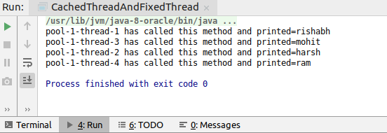

newFixedthreadPool:

import java.util.concurrent.ExecutorService;
import java.util.concurrent.Executors;
class CachedFixedDemo implements Runnable {
String name;
CachedFixedDemo(String name) {
this.name = name;
}
public void run() {
System.out.println(Thread.currentThread().getName() + " has called this method and printed=" + name);
}
}
public class CachedThreadAndFixedThread {
public static void main(String[] args) {
myRunnable[] jobs={new myRunnable("rishabh"),
new myRunnable("harsh"),
new myRunnable("mohit"),
new myRunnable("ram")};
ExecutorService service = Executors.newFixedThreadPool(2);
for (myRunnable object:jobs)
{
service.submit(object);
}
service.shutdown();
}
}
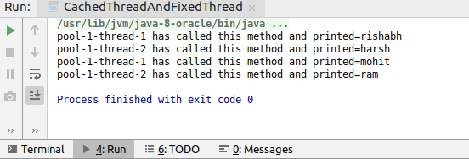

Question10:Use Synchronize method to enable synchronization between multiple threads trying to access method at same time.

Solution10:
class SyncronizedMethodDemo extends Thread
{
public synchronized void name(String name)
{
for(int i=0;i<10;i++)
{
System.out.println("good morning");
try
{
Thread.sleep(1000);
}
catch (Exception e)
{
e.printStackTrace();
}
System.out.println(name);
}
}
}
class Demo extends Thread
{
SyncronizedMethodDemo object;
String name;
Demo(SyncronizedMethodDemo object,String name)
{
this.object=object;
this.name=name;
}
public void run()
{
object.name(name);
}
}
public class SyncronizedMethod {
public static void main(String[] args) {
SyncronizedMethodDemo myThread=new SyncronizedMethodDemo();
Demo d=new Demo(myThread,"rishabh");
Demo d1=new Demo(myThread,"ram");
d.start();
d1.start();
}
}

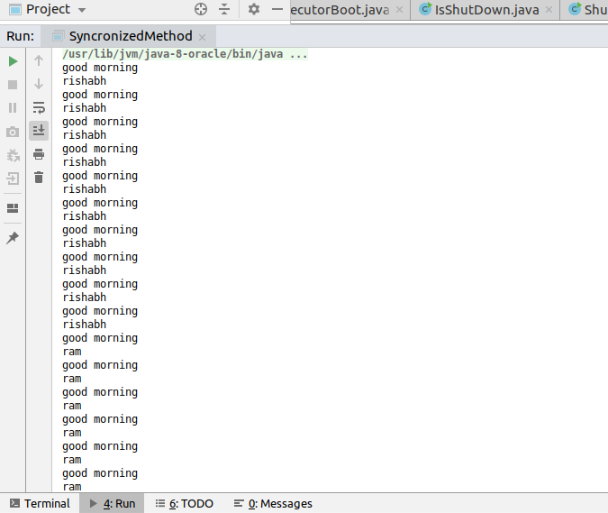

Question11:Use Synchronize block to enable synchronization between multiple threads trying to access method at same time.

Solution11:

import java.sql.SQLOutput;
class SyncronizedBlockDemo extends Thread
{
public void name(String name)
{
System.out.println("running thread is="+currentThread().getName());
synchronized(this)
{
for(int i=0;i<10;i++)
{
System.out.println("good morning");
try
{
Thread.sleep(1000);
}
catch (Exception e)
{
e.printStackTrace();
}
System.out.println(name);
}
}
}
}
class DemoBlock extends Thread
{
SyncronizedBlockDemo object;
String name;
DemoBlock(SyncronizedBlockDemo object,String name)
{
this.object=object;
this.name=name;
}
public void run()
{
object.name(name);
}
}
public class SynchronizedBlock {
public static void main(String[] args) {
SyncronizedBlockDemo myThread=new SyncronizedBlockDemo();
DemoBlock d=new DemoBlock(myThread,"rishabh");
DemoBlock d1=new DemoBlock(myThread,"ram");
d.start();
d1.start();
}
}
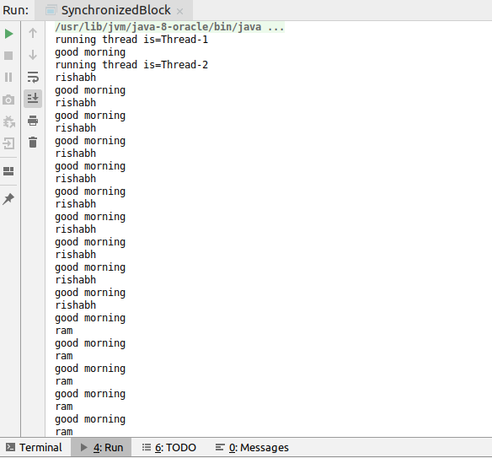

Question12:Use Atomic Classes instead of Synchronize method and blocks.

Solution12:
import java.util.concurrent.atomic.AtomicInteger;
public class Atomic {
AtomicInteger count = new AtomicInteger();
public void worker1() {
for (int i = 1; i <= 1000; i++) {
count.incrementAndGet();
}
}
public void worker2() {
for (int i = 1; i <= 1000; i++) {
count.incrementAndGet();
}
}
public static void main(String[] args) throws InterruptedException {
Atomic object = new Atomic();
Thread thread1 = new Thread(new Runnable() {
@Override
public void run() {
object.worker1();
}
});
Thread thread2 = new Thread(new Runnable() {
@Override
public void run() {
object.worker2();
}
});
thread1.start();
thread2.start();
thread1.join();
thread2.join();
System.out.println(object.count);
}
}
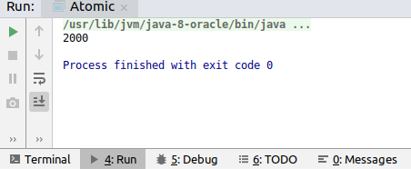

Question13:Coordinate 2 threads using wait() and notify().

Solution13:

class ThreadDemo1 implements Runnable
{
public void run()
{
synchronized (this)
{
System.out.println("executing");
System.out.println("giving notification");
this.notify();
}
}
}
public class WaitAndNotify {
public static void main(String[] args) throws InterruptedException {
ThreadDemo1 r1=new ThreadDemo1();
Thread thread=new Thread(r1);
thread.start();
synchronized (thread)
{
System.out.println("main thread calling wait method");
thread.wait();
System.out.println("main terminated");
}
}
}
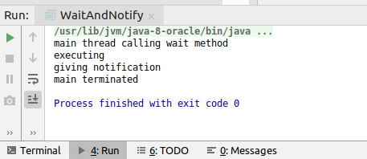

Question14:Coordinate mulitple threads using wait() and notifyAll()

Solution14:
public class WaitAndNotify {
public void Example1(){
synchronized (this) {
System.out.println("Started Example1");
try {
wait();
} catch (InterruptedException e) {
e.printStackTrace();
}
System.out.println("Example1 Completed");
}
}
public void Example2(){
synchronized (this) {
System.out.println("Started Example2");
try {
wait();
} catch (InterruptedException e) {
e.printStackTrace();
}
System.out.println("Example2 Completed");
}
}
public void Example3(){
synchronized (this) {
System.out.println("Started Example3");
try {
wait();
} catch (InterruptedException e) {
e.printStackTrace();
}
System.out.println("Example3 Completed");
}
}
public void Example4(){
synchronized (this) {
System.out.println("Started Example4");
System.out.println("Example4 Completed");
notifyAll();
}
}
public static void main(String[] args) {
WaitAndNotify demo = new WaitAndNotify();
new Thread(new Runnable() {
@Override
public void run() {
demo.Example1();
}
}).start();
new Thread(new Runnable() {
@Override
public void run() {
demo.Example2();
}
}).start();
new Thread(new Runnable() {
@Override
public void run() {
demo.Example3();
}
}).start();
new Thread(new Runnable() {
@Override
public void run() {
demo.Example4();
}
}).start();
}
}
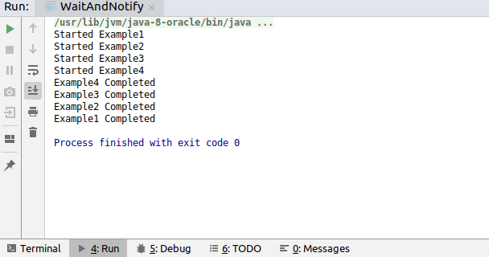

Question15:Use Reentract lock for coordinating 2 threads with signal(), signalAll() and wait().
Solution15:

Question16:Create a deadlock and Resolve it using tryLock().
Solution16:
import java.util.concurrent.locks.Lock;
import java.util.concurrent.locks.ReentrantLock;
public class DeadLock {
ReentrantLock lock1 = new ReentrantLock();
ReentrantLock lock2 = new ReentrantLock();
public void getLock(Lock lock1, Lock lock2){
boolean getLock1= lock1.tryLock();
boolean getLock2= lock2.tryLock();
if(getLock1 && getLock2){
return;
}
if(getLock1){
lock1.unlock();
}
if(getLock2){
lock2.unlock();
}
}
public void method1(){
getLock(lock1,lock2);
System.out.println("lock 1 method1 ");
System.out.println("lock 2 method2");
lock2.unlock();
lock1.unlock();
}
public void method2(){
getLock(lock2,lock1);
System.out.println("lock 1 method2");
System.out.println("lock 2 method2");
lock1.unlock();
lock2.unlock();
}
public static void main(String[] args) throws InterruptedException {
DeadLock demo=new DeadLock();
Thread thread1 = new Thread(new Runnable() {
@Override
public void run() {
demo.method1();
}
});
Thread thread2 = new Thread(new Runnable() {
@Override
public void run() {
demo.method2();
}
});
thread1.start();
thread2.start();
thread1.join();
thread2.join();
}
}
