Assignment on Collection

Question1:Write Java code to define List . Insert 5 floating point numbers in List, and using an iterator, find the sum of the numbers in List.
Solution1:
import java.util.*;
public class FloatSumUsingList {
public static void main(String[] args) {
float sum=0;
Scanner sc=new Scanner(System.in);
List<Float> Number=new ArrayList<>();
System.out.println("Enter 5 number in the list");
for(int i=0;i<5;i++)
{
Number.add(sc.nextFloat());
}
Iterator iterator = Number.iterator();
while (iterator.hasNext())
{
sum=sum+(float)iterator.next();
}
System.out.println("sum is="+sum);
}
}
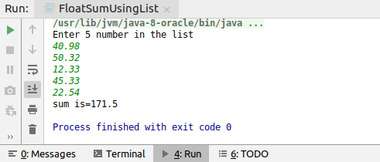

Question2:Write a method that takes a string and returns the number of unique characters in the string.

Solution2:
import java.util.HashSet;
import java.util.Scanner;
import java.util.Set;
public class Unique_Character {
public static void main(String[] args) {
Scanner sc=new Scanner(System.in);
String temp="my name is khan";
Set<Character> unique=new HashSet<>();
for (char charater:temp.toCharArray())
{
if(charater!=' ') {
unique.add(charater);
}
}
System.out.println(unique.toString());
}
}
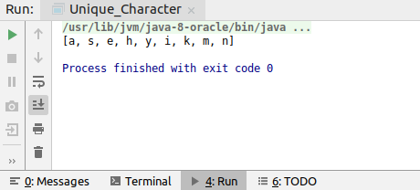

Question3:Write a method that takes a string and print the number of occurrence of each character characters in the string.

Solution 3:
import java.util.*;
public class FrequencyOfCharacter {
public static void main(String[] args) {
String temp="my name is khan but i m not a terrorist";
Map<Character,Integer> frequency=new LinkedHashMap<>();
for(int i=0;i<temp.length();i++)
{
if(temp.charAt(i)!=' ')
{
if(frequency.containsKey(temp.charAt(i)))
{
int k=frequency.get(temp.charAt(i));
k++;
frequency.put(temp.charAt(i),k);
}
else
{
frequency.put(temp.charAt(i),1);
}
}
}
System.out.println(frequency.toString());
}
}
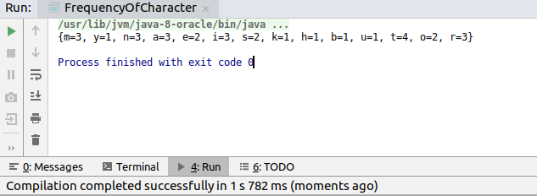

Question4:Write a program to sort Employee objects based on highest salary using Comparator. Employee class{ Double Age; Double Salary; String Name }

Solution4:
import java.util.ArrayList;
import java.util.Collections;
import java.util.Comparator;
import java.util.List;
class Age implements Comparator<SortObjectAge>
{
@Override
public int compare(SortObjectAge o1, SortObjectAge o2) {
if (o1.age < o2.age) return -1;
if (o1.age>o2.age) return 1;
else return 0;
}
}
public class SortObjectAge {
int age;
int salary;
String name;
@Override
public String toString() {
return "SortObjectAge{" +
"age=" + age +
", salary=" + salary +
", name='" + name + '\'' +
'}';
}
public SortObjectAge(String name, int salary, int age)
{
this.age=age;
this.salary=salary;
this.name=name;
}
public static void main(String[] args) {
SortObjectAge person1=new SortObjectAge("rishabh",200000,23);
SortObjectAge person2=new SortObjectAge("ram",500000,26);
SortObjectAge person3=new SortObjectAge("ramesh",100000,21);
SortObjectAge person4=new SortObjectAge("raju",800000,27);
List<SortObjectAge> person=new ArrayList<>();
Age age=new Age();
person.add(person1);
person.add(person2);
person.add(person3);
person.add(person4);
Collections.sort(person,age);
System.out.println(person.toString());
}
}
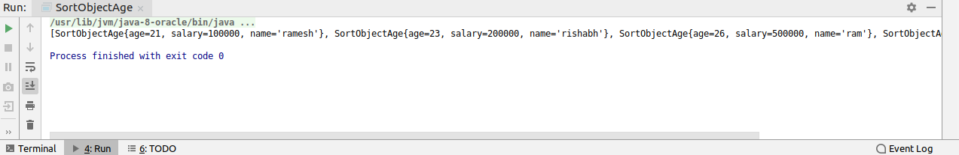

Question5:Write a program to sort the Student objects based on Score , if the score are same then sort on First Name . Class Student{ String Name; Double Score; Double Age}

Solution5:
import java.util.*;
class Sort implements Comparator<SortObjectMarks>
{
@Override
public int compare(SortObjectMarks o1, SortObjectMarks o2) {
if(o1.Score>o2.Score)
return 1;
if(o1.Score<o2.Score)
return -1;
else
return o1.Name.compareTo(o2.Name) ;
}
}
public class SortObjectMarks {
String Name;
double Score;
int age;
@Override
public String toString() {
return "SortObjectMarks{" +
"Name='" + Name + '\'' +
", Score=" + Score +
", age=" + age +
'}';
}
SortObjectMarks(String name, double score, int age)
{
this.Name=name;
this.Score=score;
this.age=age;
}
public static void main(String[] args) {
List<SortObjectMarks> list=new ArrayList<>();
list.add(new SortObjectMarks("rishabh",76.50,23));
list.add(new SortObjectMarks("ram",76.50,45));
list.add(new SortObjectMarks("ramesh",78.00,13));
list.add(new SortObjectMarks("sahil",42.00,33));
list.add(new SortObjectMarks("gaurav",33.50,53));
Sort sort=new Sort();
Collections.sort(list,sort);
System.out.println(list);
}
}

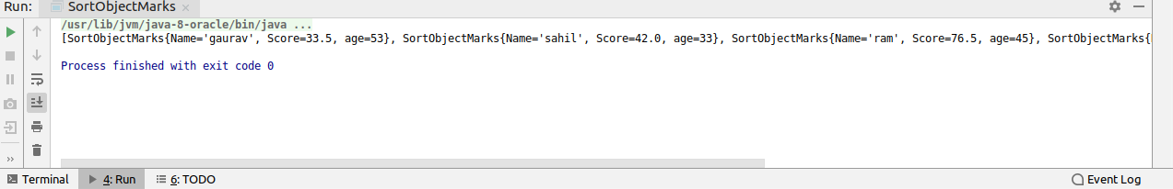

Question6:Print the elements of an array in the decreasing frequency if 2 numbers have same frequency then print the one which came first.

Solution6:

import java.util.*;
class myComparator implements Comparator<Map.Entry<Character, Integer>>
{
public int compare(Map.Entry<Character, Integer> o1,
Map.Entry<Character, Integer> o2)
{
return (o1.getValue()).compareTo(o2.getValue());
}
}
public class ArrayDecresing {
public static void main(String[] args) {
String temp = "my name is khan but i m not a terrorist";
Map<Character, Integer> frequency = new LinkedHashMap<>();
for (int i = 0; i < temp.length(); i++) {
if (temp.charAt(i) != ' ') {
if (frequency.containsKey(temp.charAt(i))) {
int k = frequency.get(temp.charAt(i));
k++;
frequency.put(temp.charAt(i), k);
} else {
frequency.put(temp.charAt(i), 1);
}
}
}
List<Map.Entry<Character, Integer>> list =
new LinkedList<Map.Entry<Character, Integer>>(frequency.entrySet());
myComparator obj=new myComparator();
Collections.sort(list, obj);
HashMap<Character, Integer> temp1 = new LinkedHashMap<Character, Integer>();
for (Map.Entry<Character, Integer> aa : list) {
temp1.put(aa.getKey(), aa.getValue());
}
System.out.println(temp1.toString());
}
}

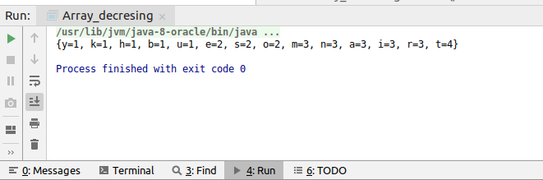
Question7:Design a Data Structure SpecialStack that supports all the stack operations like push(), pop(), isEmpty(), isFull() and an additional operation getMin() which should return minimum element from the SpecialStack. (Expected complexity O(1))

Solution7:

import java.text.SimpleDateFormat;
import java.util.*;
public class SpecialStack {
public static void main(String[] args) {
Scanner sc=new Scanner(System.in);
Stack<Integer> stack=new Stack<>();
Stack<Integer> temp=new Stack<>();
int i=1;
do
{
System.out.println("please enter your choice 1 for push 2 for pop 3 for min element 4 for display the stack 5 for exit");
i=sc.nextInt();
if(i==1)
{
System.out.println("please enter the number you want to push");
int element=sc.nextInt();
stack.push(element);
if(!temp.empty())
{
if(temp.peek()>=stack.peek())
{
temp.push(element);
}
}
else
{
temp.push(element);
}
}
else if(i==2)
{
if(!stack.empty())
{
if(stack.peek()==temp.peek())
{
temp.pop();
}
stack.pop();
}
else
{
System.out.println("stack is empty");
}
}
else if(i==3)
{
if(!stack.empty())
{
System.out.println("minimum element is"+temp.peek());
}
else
{
System.out.println("stack is empty");
}
}
else if(i==4)
{
System.out.println("stack"+stack);
System.out.println("temp"+temp);
}
}while(i<5 && i>=1);
}
}
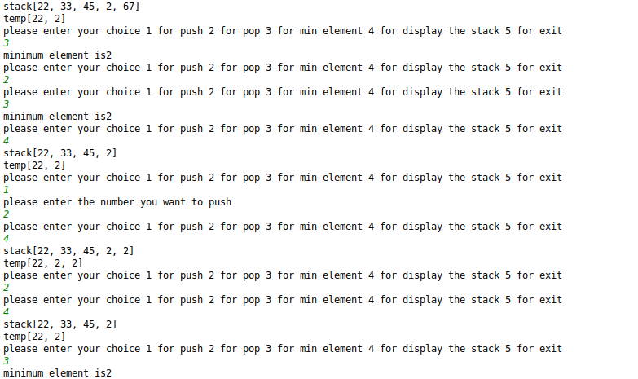

Question8:Write a program to format date as example "21-March-2016"

Solution8:
import java.text.SimpleDateFormat;
import java.util.Date;
public class DateFormat {
public static void main(String[] args) {
Date date=new Date();
SimpleDateFormat format=new SimpleDateFormat("dd-MMMMM-yyyy");
System.out.println(format.format(date));
}
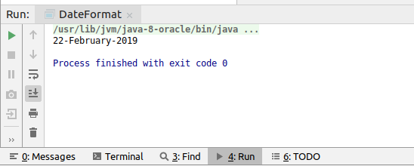
}

Question9:Write a program to display times in different country format.
Solution9:
import java.util.Date;
import java.util.Locale;
import java.text.DateFormat;
public class TimeDifferentCountryFormat {
public static void main(String[] args) {
Date d=new Date();
for (Locale l:
Locale.getAvailableLocales()) {
Locale country = new Locale( l.getLanguage() ,l.getCountry() );
DateFormat format = DateFormat.getDateInstance (DateFormat.MEDIUM, country);
System.out.println(format.format(d));
}
}
}
