LSTM : LONG TERM SHORT TERM MEMORY RNN

LSTM is a type of gated RNN. Commonly used gated recurrent neural network architectures is LSTM, which stands for a long short term memory. Consider our vanilla/normal recurrent neural network, now replace every hidden unit with something called an L STM cell and add another connection from every cell called the cell state and that's it this here is now our LSTM.

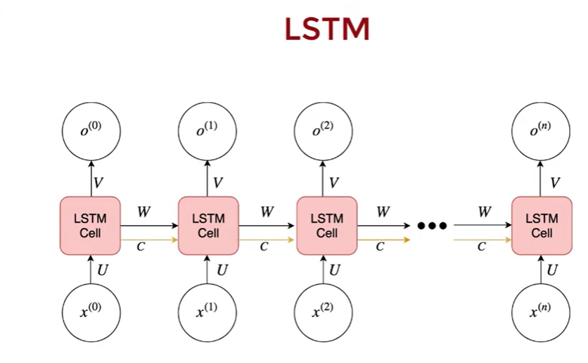

apart from the hidden state vector each LST M cell maintains a cell state vector and at each time step the next LS TM can choose to read from it right to it or reset the cell using an explicit gating mechanism.

Each unit has three gates of the same shape, think of each of these as binary gates.

The input gate controls whether the memory cell is updated, the forget gate controls if the memory cell is reset to 0 and the output gate controls whether the information of the current cell state is made visible,

They all have a sigmoid activation

1. Input Gate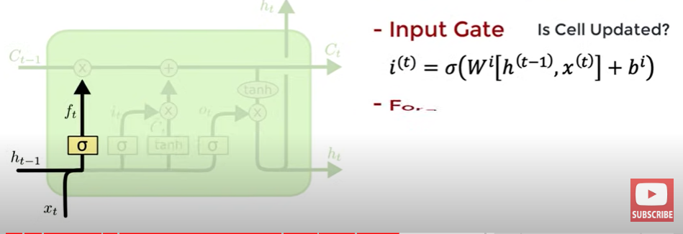
2. Forget Gate

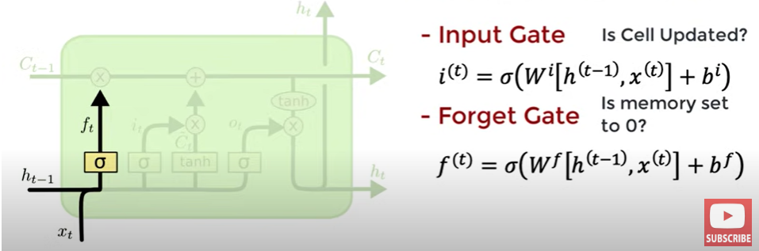

1. Output Gate

