How does it all work?

**3 Types of Investment Circles**

Circle 1 - Costs 0.1 Eth to enter

Circle 2 - Costs 0.5 Eth to enter

Circle 3 - Costs 1 eth to Enter

**A 2% fee is deducted on entry and paid to the owner eth addresses**

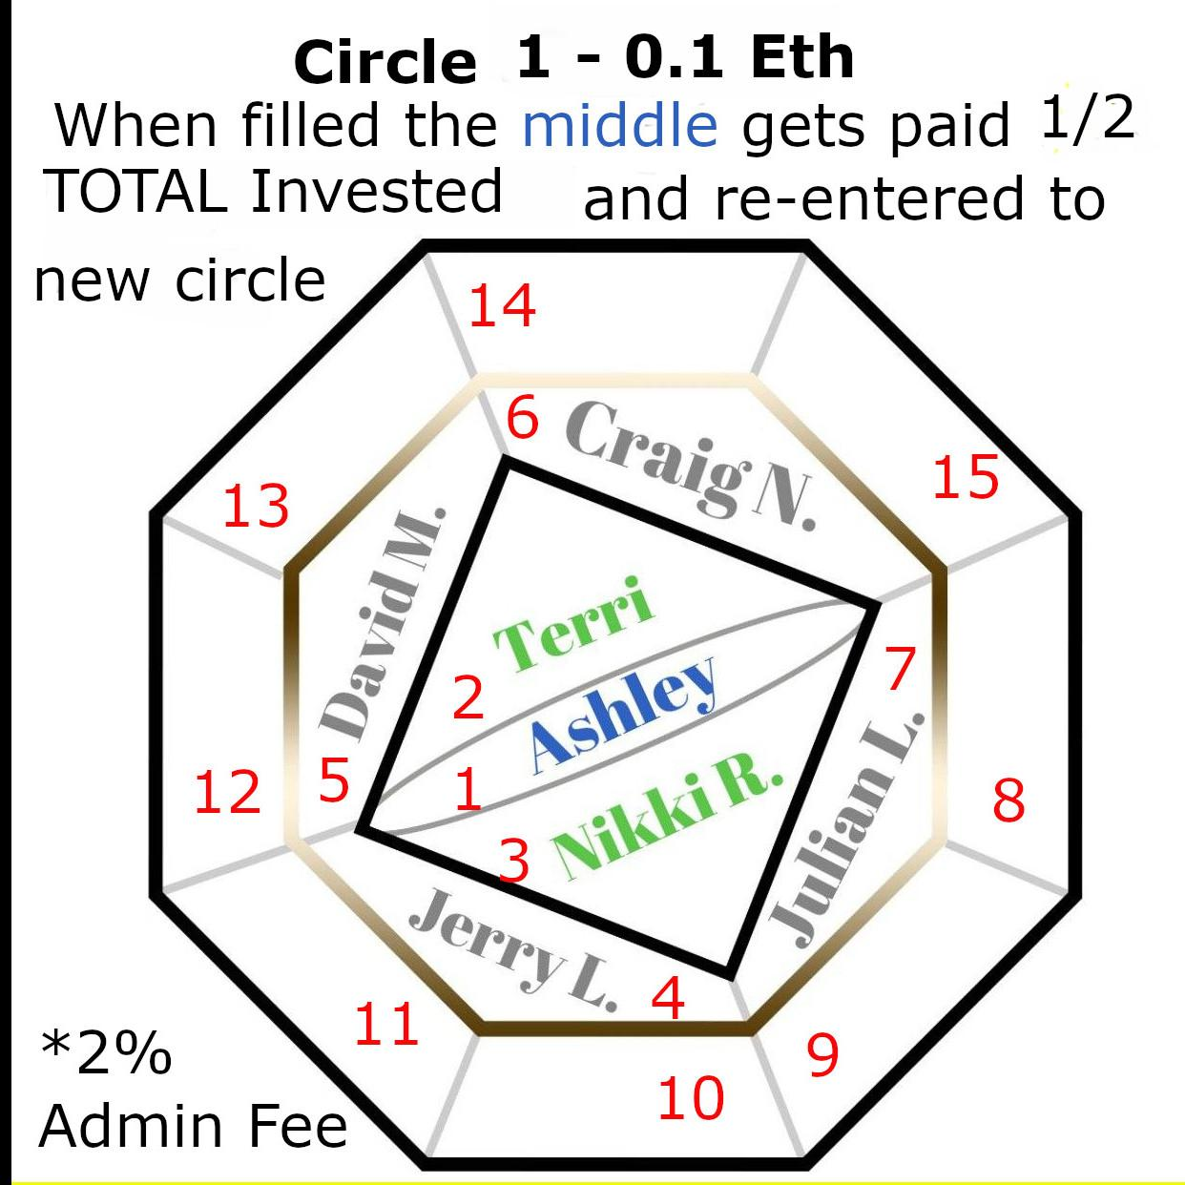

When The Circle is full Position 1 (water) gets paid 50% of the remaining eth after the admin fee has been deducted

The Circle Splits into 2 with 7 people in each

New people are added to the outer most position (highest number) of the circle that the referrer is currently a part of.

The outer positions are known as FIRE (position 8 to 15)

The next inner positions are known as WIND or AIR (position 4-7)

The next inner positions are known as EARTH (positions 2 and 3)

The final position is WATER (position 1)

The position 1 earns 50% of the total circle investment when the circle gets full

