**Design Document**

**BandAid**

**Introduction.**

BandAid is an innovative software solution designed to foster collaboration among musicians. Dubbed as the "Tinder for musicians," this platform offers a safe and intuitive space for artists to explore new genres, experiment with unfamiliar sounds, and collaborate on diverse musical projects. By enabling users to create profiles, search for potential collaborators using various filters, and interact seamlessly through an integrated chat feature, BandAid aims to simplify the collaborative process and maximize engagement and productivity for musicians.

**System Architecture.**

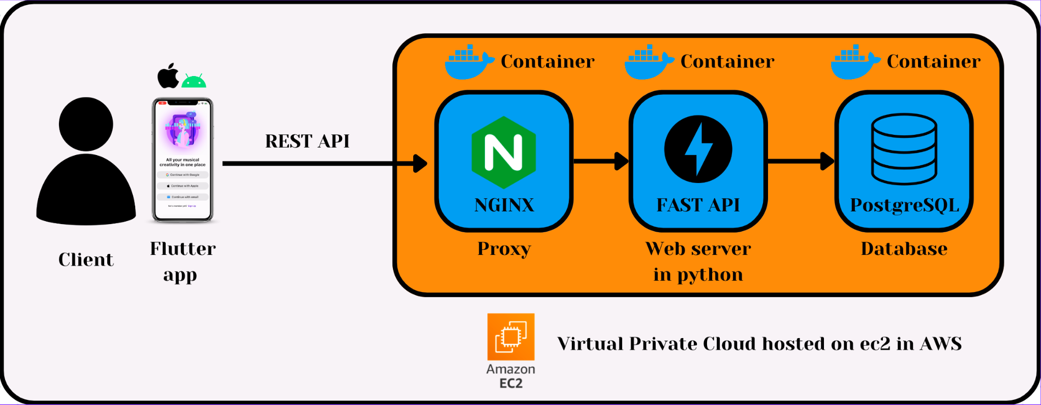

The project's system architecture is meticulously crafted to prioritize safety, sustainability, and future adaptability. BandAid stands as a versatile cross-platform mobile application developed using Flutter. It seamlessly interacts with a suite of cloud-hosted backend services via REST API calls. These requests traverse through an NGINX proxy server, ensuring heightened user privacy and efficient load balancing. They are then channeled to our Python-based FastAPI web server, which efficiently manages these requests by interfacing with our PostgreSQL database. All these integral services are encapsulated within Docker containers and reside on Amazon's EC2 virtual cloud, ensuring a robust and scalable infrastructure.

Expanding upon the architecture, our application offers an additional authentication pathway not depicted in the diagram. This alternative authentication flow leverages Google's OAuth 2.0, providing users with a streamlined and secure login experience through their Google accounts. This authentication enhancement ensures a more versatile and user-friendly access method, complementing the safety and convenience aspects of BandAid's architecture.

**Target Audience.**

BandAid is tailored to meet the needs of a wide range of musicians passionate about collaboration and the creation of musical groups. These individuals are actively involved in various aspects of music-making, spanning both online music production and in-person jam sessions. They are enthusiastic about finding like-minded collaborators to jointly craft music remotely or join forces for live performances in physical settings. The platform serves as a central hub for communication and interaction, fostering connections among musicians regardless of whether they are composing songs virtually or coming together for vibrant live music sessions. BandAid serves as a versatile solution, catering to the diverse preferences of musicians, promoting seamless engagement, and facilitating effortless connections for collaborative musical pursuits.

**Design Process and Ideation.**

Derived from the CS185 Winter 2023 project "[Bass Bros](https://docs.google.com/document/d/1R0nPMXhCWyE4NPFpWjka-Spc4eRv3QwEy_DI1pU0Bn4/edit#heading=h.mf327ky6ps6)," BandAid drew inspiration but underwent substantial modifications prompted by unforeseen implementation challenges and opportunities.

Noteworthy alterations encompassed various aspects:

* **Elimination of Online vs. In-person Collaboration Distinction:**

Technical uniformity across collaboration modes led to the removal of emphasizing this distinction.

* **Color Palette Adjustments:**

The color palette transitioned towards more commonly utilized schemes in mobile applications to enhance user familiarity and usability. Specific color choices may include softer tones or improved contrasts for better visual appeal and accessibility.

* **Filtering Options Removal (e.g., Distance):**

Certain filtering functionalities, such as distance-based filters, were omitted due to technical difficulties in implementation, ensuring a smoother user experience.

Retained Features:

* **Discrete Login Flow:**

Maintained based on positive user testing feedback, ensuring a streamlined login experience.

* **Minimalistic Design:**

Continued due to positive feedback, promoting an uncluttered interface for intuitive navigation.

* **Favorite Page Marking:**

Retained to enable users to mark and easily access their preferred content.

* **Infinite Scroller Layout for User Pages:**

Kept for its ability to allow continuous browsing without page reloads, ensuring a seamless and uninterrupted user experience while exploring profiles or content.

* **Integrated Chat Feature:**

Maintained to empower users to communicate and organize seamlessly within BandAid, eliminating the necessity to rely on external third-party applications.

**Team Meetings and Important Decisions.**

TODO: Here goes the common procedure for documenting routine scrum meetings. Maybe keep this part, maybe merge it with the previous one. Will need the team's input to decide.

**Installation Process.**

**So far:**

Clone the repository (pj-flutter-02) and change directories into a folder called "bandaid" (can be done by typing "cd pj-flutter-02/dev/bandaid" in the terminal).

For iOS:

Type the following instructions in the terminal (in order):

* "flutter pub get" to install all dependencies
* "flutter build ios" to build the application
* "flutter run" in the terminal to run the application on your device

If "flutter run" does not work, try running a file called "Runner.xcworkspace" (found in pj-flutter-02/dev/bandaid/ios) from Xcode. This should open up the application successfully.

For Android:

Type the following instructions in the terminal (in order):

* "flutter pub get" to install all dependencies
* "flutter run" in the terminal to run the application on your device

**In Future:**

Hopefully by downloading an executable of a build (at least for Android).

**User Manual & Interaction Flow.**

TODO: (all with minimalistic images-screenshots, preferably 1-2 rows at max per point)

* Register flow with images (both OAuth and native)
* Login flow with images (both OAuth and native)
* Profile options and exit session flow
* While logged in, find a collaborator flow
* Add to favorites and see all favorites flow
* Chatting flow