When Supply Chain Recovery Data Disagree: Measurement Validity and Event Reconstruction in Pharmaceutical Shortages

Abstract
Supply chain recovery studies increasingly use administrative records, but the dates in these records need not represent disruption onset or recovery. We examine how event-reconstruction choices affect measured pharmaceutical shortage persistence using 39 FDA archive captures on 38 dates (2019–2023), comprising 2,042 NDC-level listings under 298 FDA headings, and 958 ASHP resolved-shortage bulletins. Four reconstruction rules distinguish product-level records, drug-heading aggregation, archive-observed onset, and cross-system linkage. On a common cohort of 173 headings with a shared exit rule, one-year survival ranges from 0.79 to 0.84 across onset scenarios, yet four of the 20 longest-lasting shortages under recorded posting dates leave that group when onset is bounded by archival observations. Eleven additional headings have ambiguous resolution status and are excluded from persistence rankings. Reviewed consolidation of 11 duplicate-heading pairs increases stable top-20 membership from 16 to 18. Among 146 headings with any resolved NDC, 31 remain ambiguous at heading level. FDA resolution determinations and ASHP last-revision timestamps differ by a median of 395 days in the paired comparison, underscoring their non-equivalent administrative meanings. We provide a reproducible linkage and reconstruction workflow with explicit identity, spell, and timing uncertainty. The results show that aggregate persistence can remain stable while conclusions about individual long-lasting disruptions depend on administrative record definitions.
Keywords: drug shortages; supply chain resilience; recovery measurement; record linkage; administrative data; measurement validity

1. Introduction
When a supply chain is disrupted, the question that matters to operations is how long recovery takes. Resilience research has built its empirical base on that interval, the time to recover and the performance lost while recovering (Sheffi and Rice, 2005; Melnyk et al., 2014), and the field already recognises that the choice of recovery indicator is not neutral: different metrics can lead to different conclusions about performance and to different investment decisions (Behzadi et al., 2020; Ivanov, 2025). Those studies take the underlying event dates as given. Increasingly, however, recovery times are measured from administrative records rather than from firms' own operational data, and a register records what an agency did and when, not what happened in the supply chain and when. The date on which a shortage was posted is a reporting act; the date on which supply failed is the event. The two are usually close. The question this paper asks is when they are not, by how much, and whether it matters for the conclusions operations researchers and planners draw.
Pharmaceutical shortages are the right setting for the question. They are frequent, consequential and unusually well recorded: the United States maintains two public registers, the FDA Drug Shortage Database and the ASHP/University of Utah bulletins, both longitudinal and both widely used in shortage research (Fox et al., 2014; Yurukoglu et al., 2017; Tucker et al., 2020). The two registers apply different shortage definitions and serve different purposes, a distinction ASHP itself documents (American Society of Health-System Pharmacists [ASHP], 2014). Because the FDA register deletes resolved entries after a retention period, historical duration must be reconstructed from archived web captures, and the HHS/ASPE analysis of 2018 to 2023 shortages (Eastern Research Group [ERG], 2025) has shown how. That reconstruction involves choices about the unit of observation, when a spell begins, when it ends and what an absent listing means. These choices are rarely stated in the studies we reviewed, and their consequences have not, to our knowledge, been compared on a common cohort.
We make those choices explicit and measure their consequences. Four reconstruction rules, each defensible and each in use, are applied to the same archive: a product-level rule that takes recorded dates at face value, a drug-level rule anchored on recorded posting, a drug-level rule anchored on archival observation, and a hybrid that dates onset from ASHP and exit from FDA. The rules are compared on a common cohort with a shared exit definition, so that the only quantity varying is the one under study. We then ask the operations question directly: of the shortages a planner would prioritise as most persistent, how many survive careful reconstruction?
Three contributions follow. First, a measurement contribution: we quantify six mechanisms by which the FDA archive's recorded dates diverge from what it observed (inherited posting dates and duplicate headings across product listings, late-entering products, apparent re-use of shortage entries, irregular capture spacing, and the construct differences between FDA and ASHP) and state which are confirmed and which inferred. Second, a methodological contribution: a reproducible two-level record-linkage and event-reconstruction framework that carries identity confidence, spell-linkage confidence and observation intervals through to the results, released with its full audit trail. Third, an operations contribution: evidence that aggregate persistence estimates are robust to these choices while the identification of the longest-lasting shortages is not, together with a diagnostic that flags the unreliable cases from the archive alone.
The paper proceeds as follows. Section 2 locates the study in the literatures on recovery measurement, pharmaceutical shortage reconstruction and administrative record linkage. Section 3 describes the sources, the unit of analysis, the linkage protocol, the four reconstruction rules and the comparison design. Section 4 reports results. Section 5 discusses what is robust, what is not, and what follows for research and practice; Section 6 concludes.

2. Literature review

2.1 Measuring disruption and recovery in supply chains
Supply chain resilience research has converged on time-based constructs: time to detect, time to recover, and the area of the performance deficit between them (Sheffi and Rice, 2005; Melnyk et al., 2014; Bode and Macdonald, 2017; Hosseini et al., 2022; Ivanov, 2020). Measurement work within this tradition has shown that the construct is sensitive to how it is operationalised. Behzadi et al. (2020) review resilience metrics and demonstrate that alternative metrics can rank the same mitigation strategies differently; Ivanov (2025) shows that customer-facing indicators such as on-time delivery and operational indicators such as fill rate detect and date the same disruption differently, so that time to recover depends on the perspective adopted. Hosseini et al. (2022) argue for conceptualising and measuring resilience in an open-system context in which the boundary of what is measured shapes the result. These contributions concern the choice of indicator. The literature on how onset and restoration are dated in the records from which indicators are computed is thin. Where recovery times are drawn from administrative or secondary records such as regulatory filings, incident databases or trade press, the date carried in the record is a reporting milestone, not the event itself, and the gap between the two is seldom quantified. Performance-measurement scholarship in operations has long noted that measures inherit the properties of the systems that produce them (Neely, 2005; Melnyk et al., 2004), but this observation has not been carried into the resilience literature's treatment of recovery-time data. A systematic review of systems thinking in supply chains further emphasises interdependencies, feedback and the need to interpret resilience outcomes at the system level (Rana et al., 2026).

2.2 Pharmaceutical shortage measurement
Drug shortages are among the best-documented recurring disruptions in any supply chain, and the United States maintains two public registers: the FDA Drug Shortage Database, limited to products the agency determines to be in national shortage, and the ASHP/University of Utah bulletins, which record shortages affecting hospital practice. Clinical and economic studies have drawn on these registers to characterise shortage incidence, causes and policy determinants (Fox et al., 2014; Yurukoglu et al., 2017), and a scoping review covering two decades of that literature documents its scale (Tucker et al., 2020). In the duration studies we reviewed, the measure rests on the registers' own posting and resolution dates. Because the FDA list retains resolved entries only briefly, historical duration requires archival reconstruction. The HHS/ASPE analysis of 2018 to 2023 shortages (ERG, 2025) reconstructed shortage histories from archived FDA web pages, estimating resolution dates at the molecule, strength and dosage-form level with right-censoring and Kaplan–Meier methods, and documented both duplicated listings and the later addition of NDCs to existing entries. A recent Korean study applied machine learning to predict shortage duration and causes from 1,054 cases (Roe et al., 2026). These studies establish that archival reconstruction is feasible and that its inputs are imperfect. We are not aware of work that has asked how much the choice among defensible reconstruction rules changes the resulting measures, or that has compared the two U.S. registers' dating of the same events; the present study is positioned as a first such comparison rather than as a claim of priority.

2.3 Record linkage and event reconstruction in administrative data
Epidemiology and health-services research have developed a mature methodology for linking administrative records and reconstructing episodes from them (Harron et al., 2015). Three of its findings transfer directly. First, linkage error is systematic, not random: false matches, missed matches and non-representative linked samples each bias downstream estimates in characteristic directions, and the linked sample should be compared with the unlinked population by stratum rather than assumed equivalent (Harron, Dibben et al., 2017). Second, linkage quality should be evaluated and reported alongside results, with sensitivity analyses that vary the matching rule, because the analyst's matching choices are part of the measurement (Harron, Doidge et al., 2017). Third, the unit of record (a claim, a prescription, a package code) is rarely the unit of inference (a patient, an episode, a drug); onset and exit observed through periodic snapshots are interval-censored rather than point events; and an absent record is evidence of absence only when the recording system is known to be complete. Operations and supply chain research has adopted large-scale data analytics (Choi et al., 2018) but has imported less of this apparatus, and in particular has rarely reported identity confidence, spell-linkage confidence or observation intervals alongside its estimates.

2.4 Positioning
This study sits at the intersection of three gaps. Resilience measurement research has established that indicator choice changes conclusions (Behzadi et al., 2020; Ivanov, 2025), but takes event dates as given. Administrative record-linkage research has established that linkage and reconstruction choices introduce measurement uncertainty that must be reported (Harron, Dibben et al., 2017; Harron, Doidge et al., 2017), but we found no application of it to supply chain disruption records. FDA and ASHP document that their shortage definitions and reporting purposes differ (ASHP, 2014), but the consequences of linking their records and reading their timestamps as recovery events have not been quantified. The study takes the archival FDA reconstruction of the HHS/ASPE analysis (ERG, 2025) as its starting point, applies the record-linkage discipline to it and to ASHP, and asks an operations question: which conclusions about shortage persistence and priority are robust to the reconstruction choices a researcher or planner must make, and which are not. Its contribution is not the discovery that resilience metrics or administrative data are imperfect, which the literatures above document, but a quantified comparison of alternative administrative event reconstructions applied to a common pharmaceutical shortage cohort.

3. Methodology

3.1 Data sources
The study draws on three public sources that describe the same phenomenon, a pharmaceutical product being in shortage in the United States, from different administrative positions.
FDA Drug Shortages archive. The FDA Drug Shortage Database lists products the agency has determined to be in shortage, identified at package level by National Drug Code (NDC), with an initial posting date, the stated shortage reason, therapeutic category and a status (Current, Resolved, To Be Discontinued). Resolved entries are removed from the public list about six months after resolution (U.S. Food and Drug Administration [FDA], 2024), so the live database cannot support duration measurement. Following the archival method of the HHS/ASPE analysis (ERG, 2025), we use 39 archived captures of the database retrieved from the Internet Archive on 38 distinct dates from 29 December 2019 to 21 December 2023 (two captures on 30 October 2020 are treated as one observation). Capture spacing is uneven: one capture falls in December 2019, 16 in 2020, 10 in 2021, 2 in 2022 and 9 in 2023; the longest gaps are 308 days (30 November 2021 to 4 October 2022) and 184 days (14 May to 14 November 2023). From these captures a product-level episode file of 2,042 nine-digit NDCs with initial postings from 2018 through 2023 was reconstructed; each NDC carries its recorded initial posting, the first and last capture in which it appears, the number of captures in which it appears, and, where a capture marks it Resolved, the FDA-stated date of that update. This file was originally built as an external benchmark for a separate simulation study and is reused here with that provenance disclosed (Appendix B).
ASHP resolved-shortage bulletins. The American Society of Health-System Pharmacists, with the University of Utah Drug Information Service, maintains drug-level shortage bulletins. Its resolved list was extracted on 12 September 2026, yielding 958 bulletins created between 2015 and 2026, each with the date the bulletin was created and the date it was last revised. ASHP documents that the earliest date in a bulletin's history is the date the shortage was first posted, that a resolved bulletin is moved to the resolved list on a separate date, and that a recurring shortage receives a new bulletin (ASHP, n.d.). ASHP's shortage definition is hospital-impact based and broader than FDA's national-supply determination (ASHP, 2014).
FDA Orange Book and NDC Directory. The current Orange Book product file (September 2026 edition), the current NDC Directory and the NDC excluded-products file supply product identity (application number, applicant, dosage form, route, strength, marketing dates) used in record linkage and in the market-structure illustration of Appendix C. These are current files; where they are used to describe historical market participation the limitation is stated.

Table 1. Source characteristics
 | FDA Drug Shortage Database (live) | FDA archive (this study) | ASHP resolved bulletins
Shortage definition | National supply insufficient to meet demand, as determined by FDA | As FDA | Shortage affecting hospital or health-system practice, as assessed by ASHP/UUDIS
Unit of record | Package-level NDC under a drug heading | NDC episode, aggregated to drug heading | Drug-level bulletin
Onset date | Initial posting date of the drug heading, inherited by every NDC listed under it | As FDA; archive first sighting used to bracket observed entry | Bulletin creation date (earliest date in bulletin history)
Exit date | Date of Update marked Resolved, per NDC | As FDA, observed in the first capture that shows the mark; drug-level status by shared rule | Last revision date; transfer to the resolved list dated separately
Retention | Resolved listings removed after about six months | 38 Internet Archive captures, Dec 2019 to Dec 2023, spacing 4 to 308 days | Resolved bulletins retained indefinitely
Recurrence handling | Re-listing may reuse the existing heading and its posting date | Inferred from absence between captures | New bulletin for a recurring shortage
Coverage used | 2,042 NDC episodes, 298 headings, postings 2018 to 2023 | Same | 958 bulletins created 2015 to 2026; 479 active in the archive window
Main limitation for duration | Deletes its own history | Uneven capture spacing; entry unobserved for pre-archive postings | Last revision is a maintenance timestamp, not a recovery date

3.2 Unit of analysis
The unit of analysis is the drug-level shortage spell: a continuous period during which a drug, identified by its FDA generic heading, is listed in shortage. NDC rows are the raw material from which spells are reconstructed, never the unit of inference. The 2,042 NDC episodes belong to 298 drug headings (median 4 NDCs per drug, maximum 96), and in 181 of the 235 multi-NDC drugs every NDC carries an identical initial posting date. The posting is a property of the drug entry, inherited by every NDC listed under it, including NDCs added later. Treating NDC rows as independent observations therefore replicates one drug-level event many times (Section 4.4). Three levels are kept distinct throughout: the FDA administrative heading, which is the identifier the register uses and the unit of the primary analysis; the harmonized pharmaceutical identity, a reviewed grouping of headings that name the same ingredient and relevant formulation; and the shortage spell, a temporally distinct episode. Two headings for one medicine may be duplicate administrative records of one spell, separate spells, or different presentations, and are not merged on name alone (Section 4.6).

3.3 Record linkage
Linkage proceeds at two levels, each producing a recorded confidence.
Level 1: pharmaceutical identity. Every product name (FDA generic heading, ASHP bulletin title, Orange Book ingredient and dosage-form/route label, NDC Directory nonproprietary name) is parsed into an ingredient base, salt or ester, administration family, formulation, release characteristic, strength tokens, presentation markers and a combination-product flag. Two records are HIGH identity when ingredient, family, formulation and release agree and no presentation conflicts; MEDIUM when ingredient and family agree but formulation is unknown on one side; LOW when only the ingredient agrees or a presentation conflicts. Salt forms are recorded but never merged. Orange Book dosage-form/route labels (304 distinct strings) were harmonized to 179 equivalence groups through a two-level taxonomy (administration family; market-relevant formulation) in which 202 mappings were accepted as wording standardisation, 11 accepted conditionally, 11 revised to keep oral-liquid subtypes distinct and 80 held for review; every decision is recorded. Legacy INJECTABLE; INJECTION labels, which do not distinguish ready-to-use solutions from powders for reconstitution, were resolved per product row in a three-tier hierarchy: explicit dosage-form evidence from the NDC Directory (CONFIRMED), strength-pattern inference with verified exceptions for liquids expressed per container (PROVISIONAL), or UNRESOLVED. The strength rule was validated at 100% agreement for powders and 97.7% for solutions where both evidence types exist (Supplementary Table S1).
Level 2: spell identity. An ASHP bulletin and an FDA drug record are treated as describing the same shortage spell only when, in addition to Level-1 identity, the FDA entry falls within the ASHP spell (FDA posting within 90 days of ASHP creation, or FDA first sighting inside the bulletin's open period) and the FDA record shows no internal absence indicating recurrence. Pairs meeting both conditions with HIGH identity and an observed FDA entry are CONFIRMED; pairs with compatible timelines but left-censored FDA entry or MEDIUM identity are PROBABLE; pairs with several candidate presentations, FDA recurrence inside the bulletin, or an FDA resolution preceding ASHP creation are AMBIGUOUS. An FDA resolution is never attached to an ASHP bulletin merely because it is the first resolution after the bulletin's creation.

3.4 Reconstruction rules
Four rules reconstruct shortage spells from the same archive, each defensible on its face and each in use somewhere in the literature (Table 2).
Table 2. Reconstruction rules compared
Rule | Unit | Onset | Exit
R0 naive | NDC | recorded FDA initial posting | first archived Resolved mark; else censored at last sighting
R1 posting-anchored | drug | earliest recorded posting across the drug's NDCs | shared rule (3.5)
R2 archive-observed | drug | the interval between the last capture in which the drug is absent and the first in which it appears; its latest bound is capped at the FDA resolution date for spells posted and resolved within a single capture gap | shared rule (3.5)
R3 hybrid | drug | ASHP bulletin creation date | FDA Resolved decision date, with CONFIRMED same-spell linkage

R2 is eligible only for drugs whose recorded posting falls after the first capture and whose first sighting is not the first capture, so that the entry is bracketed by two observations. Drugs present at the first capture are left-censored and excluded from onset-anchored comparisons. R2 yields an onset interval, not a point; durations are therefore computed at both its earliest bound (the capture preceding first sighting) and its latest bound (first sighting, or the resolution date if earlier), and reported as sensitivity scenarios rather than as formal interval-censored estimates. R3 is reported as linkage coverage only, because the CONFIRMED subset is small and selectively matched.

3.5 Shared exit rule and status classification
To isolate the effect of onset reconstruction, R1 and R2 use one exit rule. A drug is RESOLVED when every NDC observed for it carries an FDA Resolved mark, with exit at the latest such date; AMBIGUOUS when some NDCs are marked Resolved and others are not; ONGOING when no NDC is resolved and the drug is present at the final capture; DISAPPEARED when no NDC is resolved and the drug's last sighting precedes the final capture. Disappearance is treated as censoring at the last verified observation, never as resolution, because FDA removes resolved listings after a retention period and a missed capture can produce the same pattern. AMBIGUOUS drugs are retained as a fourth status, reported alongside the analytical cohort and excluded only from survival summaries. The FDA resolution decision date (the agency's Date of Update marked Resolved) is recorded separately from the capture in which that mark was first observed, which bounds the observation lag.

3.6 Comparison design
The main comparison is R1 against R2 on the common set of drugs eligible under R2 with a decidable exit, so that the only quantity varying is the onset definition. For each scenario we report spells, events, Kaplan–Meier survival at 110, 180 and 365 days, the KM median where reached, and the share of spells whose observed duration exceeds one year; for ongoing drugs these are elapsed observation times, not completed recovery durations. The three scenarios use the same 173 subjects, the same 51 events and the same censoring rule; because onset shifts, the time-dependent risk sets differ, and the survival estimates are not independent across scenarios. The paired difference between R1 and R2 durations is the central exhibit (Figure 2), summarised by median, interquartile range and the count of drugs whose recorded posting exceeds the archive-supported onset by more than 365 days. Two secondary comparisons demonstrate, respectively, pseudoreplication under R0 (NDC rows and nominal events against drug-level spells and events for the same drugs) and the linkage coverage attainable under R3.
The operational consequence is assessed through ranking stability. Persistence rankings are analytical devices for testing sensitivity, not validated intervention priorities; a planner's list would weigh clinical criticality and substitutability as well. The 20 longest-lasting shortages are identified under R1, R2-earliest and R2-latest; the candidate universe is the common cohort, and each drug in the union of the three lists is classified DEFINITE (present in all three), or POSSIBLE (present in some). AMBIGUOUS-exit drugs lie outside the universe and are reported as UNRANKABLE. Rank agreement between scenarios is summarised by Spearman's ρ. Absolute changes in a drug's own duration are distinguished from relative changes in rank caused by movement of other drugs.

3.7 Reproducibility
All parsing, linkage and reconstruction steps are deterministic scripts with recorded input hashes and auditable decisions. For blind review, the code, derived files and audit trails are available through an anonymized supplementary package. The original archived FDA captures are not redistributed; their capture dates and provenance hashes are provided in Supplementary Table S2. The current FDA Orange Book and NDC Directory files can be retrieved from official FDA sources. AI-assisted tools supported rule development and code preparation; the author verified the analytical outputs.
4. Results

4.1 Cohort
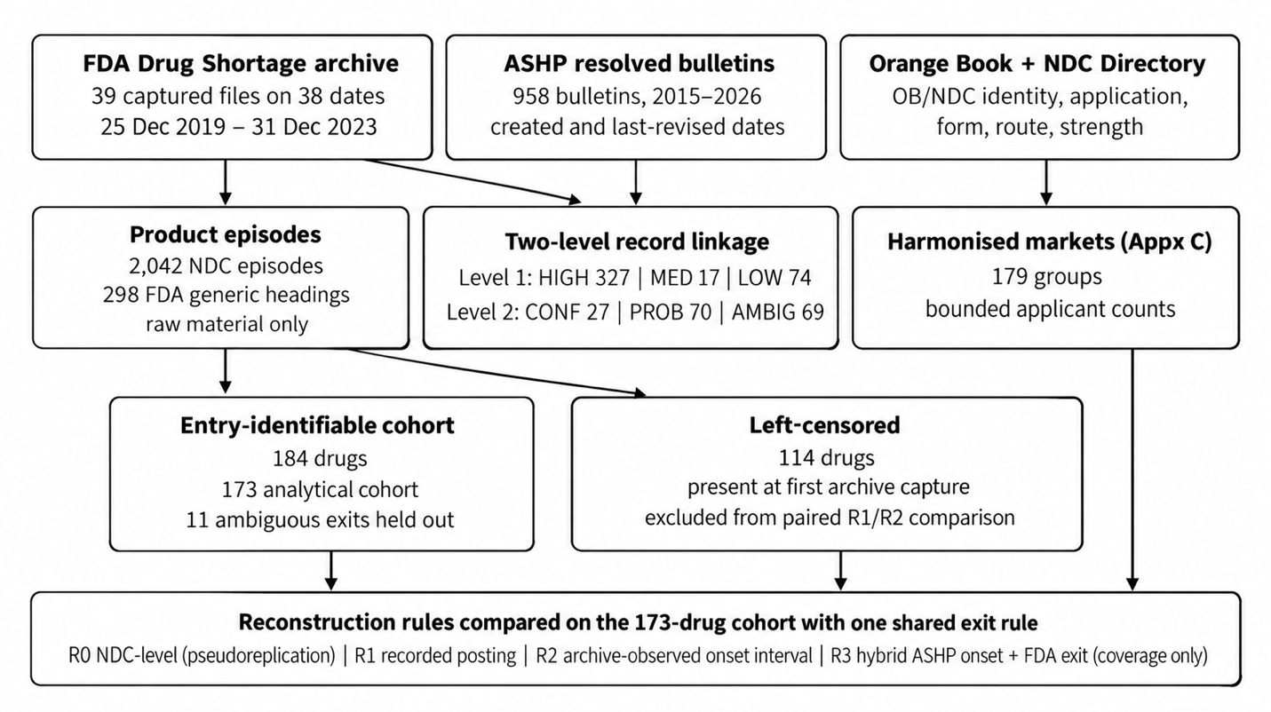
Figure 1. Sources, record linkage, cohort selection and reconstruction workflow.
The archive yields 298 drug headings. Of these, 114 were posted before the first capture and are left-censored at entry; 184 have an entry bracketed by two captures and form the entry-identifiable cohort (Table 3). Under the shared exit rule, 51 are resolved, 113 ongoing at the final capture, 9 disappeared without a Resolved mark, and 11 are ambiguous because some but not all of their NDCs carry a Resolved mark. The 173 drugs with a decidable exit form the analytical cohort for onset comparisons.
Table 3. Entry-identifiable cohort and analytical subset
Status under the shared exit rule | Drugs | Treatment
Resolved (every observed NDC marked Resolved) | 51 | survival event
Ongoing at final capture | 113 | right-censored
Disappeared without a Resolved mark | 9 | censored at last verified observation
Ambiguous exit (some NDCs resolved, others not) | 11 | separate status; excluded from survival summaries
Total entry-identifiable | 184

4.2 Discrepancy mechanisms
Six mechanisms separate what the archive records from what it observed (Table 4). Three are confirmed properties of the data; one is strongly indicated but inferred; two are properties of the sources themselves.
Table 4. Discrepancy mechanisms and prevalence
Mechanism | Evidence | Prevalence | Status
Inherited posting date, including duplicate headings | NDCs under one drug entry share the entry's initial posting; 11 reviewed pairs of headings name the same product and consolidate 298 administrative units to 287 | 181 of 235 multi-NDC drugs (77%) have one posting date for every NDC; 22 headings (7.4%) are reviewed duplicates | confirmed
Late-entering NDCs | NDC first appears in a later capture than its drug | 370 of 2,042 NDCs (18%); median lag 385 days, maximum 1,416 | confirmed
Approval after recorded posting | NDC's product approved, and first marketed, after the posting it inherited | 140 NDC episodes in 38 drugs | confirmed
Entry reuse | drug entry first observed more than a year after its recorded posting, no intervening capture shows it | 12 drugs posted after the archive begins (32 episodes); 103 of 1,251 post-archive episodes have a posting-to-observation gap over one year | inferred: consistent with re-listing under an original entry; missing captures could produce part of the pattern
Irregular observation | capture spacing | 38 captures; gaps of 308 and 184 days; 2 captures in 2022 | property of the archive
Construct non-overlap | ASHP bulletins active in the archive window with no FDA counterpart | 313 of 479 in-window ASHP bulletins have no FDA identity candidate | property of the sources

4.3 Paired onset differences
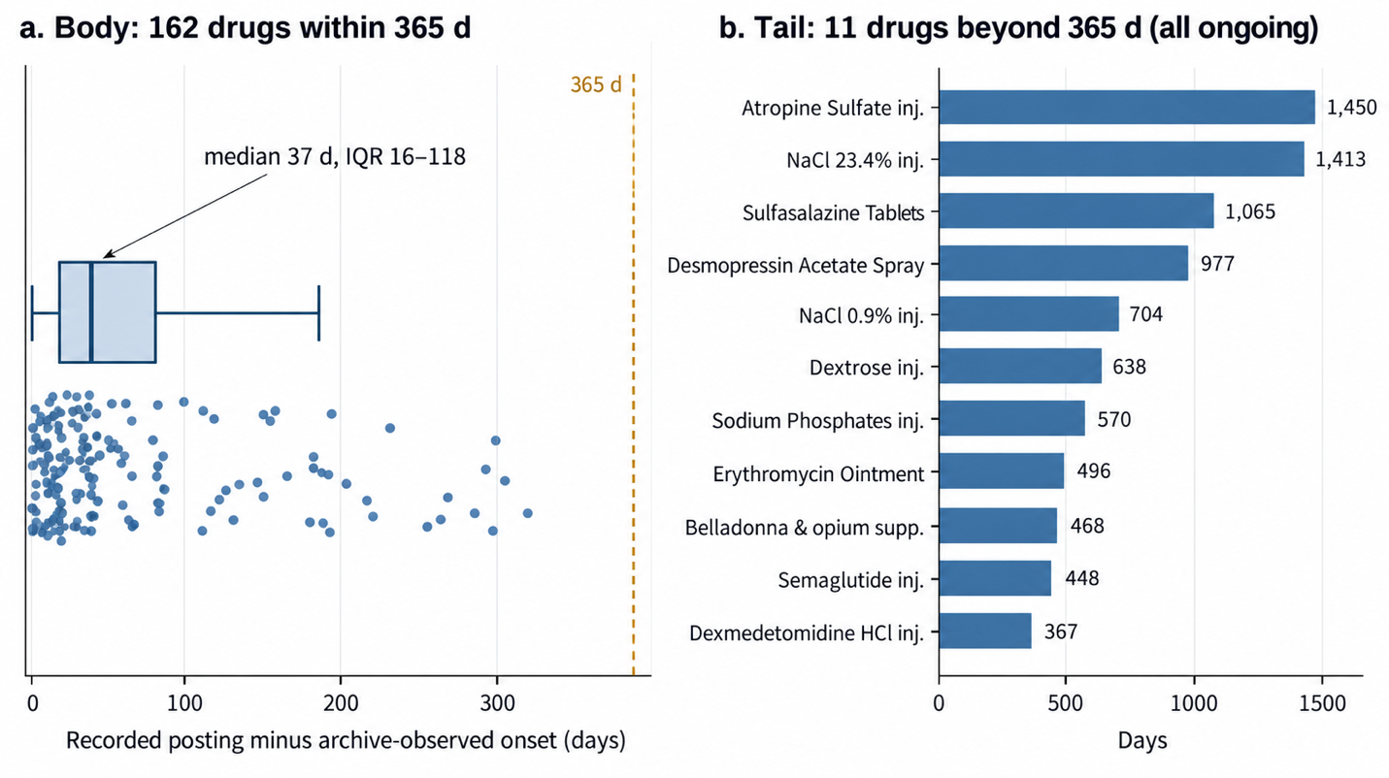
Figure 2. Recorded posting date minus archive-observed onset for the 173 common-cohort drugs. Panel a: 162 drugs within 365 days (jittered points with box: median 37 days, IQR 16 to 118). Panel b: the 11 drugs beyond 365 days, all ongoing shortages, so values are elapsed observation times.
For the 173 drugs in the analytical cohort, the recorded posting date precedes the latest archive-supported onset by a median of 37 days (IQR 16–118), and the entry bracket itself has a median width of 71 days (IQR 37–184, range 4–308). For most drugs, therefore, the recorded posting lies within one capture interval of the observed entry and the two rules agree to within the archive's resolution. The distribution has a long right tail: eleven drugs have recorded durations exceeding the archive-supported duration by more than 365 days, with a maximum discrepancy of 1,450 days (Figure 2). All eleven are ongoing shortages, so their recorded values are elapsed observation times rather than completed durations; for seven of them the recorded posting precedes even the earliest plausible onset by more than a year, the pattern consistent with re-listing under an existing entry. Three drugs were posted and resolved within a single capture gap and were first observed already resolved; for these the latest-onset bound is capped at the resolution date.

4.4 Common-cohort survival summaries
Table 5. Same 173 drugs, same exit rule, three onset definitions
Onset rule | Spells | Events | KM median | S(110) | S(180) | S(365) | Observed > 1 year
R1 recorded posting | 173 | 51 | not reached | 0.970 | 0.925 | 0.823 | 60.7%
R2 earliest plausible onset | 173 | 51 | not reached | 0.988 | 0.970 | 0.840 | 57.8%
R2 latest plausible onset | 173 | 51 | 916 d | 0.933 | 0.905 | 0.789 | 46.8%

Aggregate persistence is stable across onset definitions (Table 5): survival at one year ranges from 0.79 to 0.84, and the median is reached only under the latest-onset scenario. The share of spells observed to exceed one year moves more (47–61%) because it is sensitive to the small number of drugs with large posting discrepancies. The three scenarios share the same subjects, events and censoring rule by construction, while their time-dependent risk sets differ with the onset shift; Kaplan–Meier curves are given in Supplementary Figure S1.
Reconstructing at NDC level instead (R0) counts 1,037 rows and 224 nominal resolution events for these same 173 drugs and 51 events. Rows per drug have a median of 3 and a maximum of 60, and in 88 of the 129 multi-NDC drugs every row carries an identical duration and outcome. The NDC-level survival estimate at one year, 0.883, differs from the drug-level estimate, 0.823, not because the shortages differ but because the weighting does.

4.5 Resolution classification
Applying the shared exit rule to all 298 drugs reclassifies a fifth of the shortages that NDC-level coding would call resolved. Of 146 drugs with at least one NDC marked Resolved, 115 are resolved at drug level and 31 are ambiguous because other presentations remain listed. Of 152 drugs with no resolved NDC, 137 are ongoing and 15 disappeared from the archive without a Resolved mark (Table 6). The 31 ambiguous drugs here and the 11 in Table 3 have different denominators (all drugs versus the entry-identifiable cohort) and are not the same set.

Table 6. Resolution status: NDC-level coding against the drug-level shared rule (298 drugs)
NDC-level coding | Resolved | Ambiguous | Ongoing | Disappeared
Any NDC marked Resolved (146) | 115 | 31 | 0 | 0
No NDC marked Resolved (152) | 0 | 0 | 137 | 15

4.6 Ranking stability
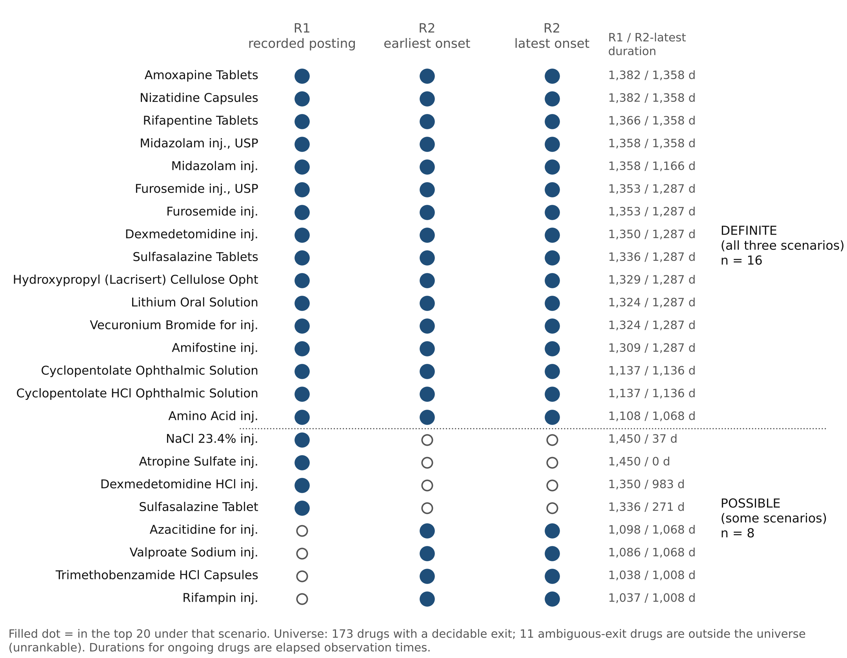
Figure 3. Top-20 persistence membership under three onset definitions. Filled dot: in the top 20 under that scenario. Universe: 173 drugs with a decidable exit; 11 ambiguous-exit drugs are outside the universe. Durations shown are R1 / R2-latest.
The 20 longest-lasting shortages were identified under each onset scenario within the 173-drug universe. The union of the three top-20 lists contains 24 drugs: 16 appear in all three (DEFINITE) and 8 in some (POSSIBLE); the 11 ambiguous-exit drugs lie outside the universe and are UNRANKABLE. Spearman rank correlation between R1 and R2 durations is 0.83 (latest onset) and 0.82 (earliest). Four drugs leave the top 20 when onset is taken from the archive rather than the recorded posting (atropine sulfate injection, 23.4% sodium chloride injection, dexmedetomidine injection and sulfasalazine tablets), each because its own recorded duration exceeds the archive-supported value by more than a year. Four drugs enter (azacitidine, rifampin injection, trimethobenzamide capsules and valproate sodium injection) by relative movement only: their own durations change by 18–30 days between scenarios, and they rise because the four above fall. Under the Orange Book point estimate, 4 of the R1 top-20 and 3 of the R2-latest top-20 are sole-source products (Appendix C).
As a sensitivity analysis, 11 reviewed pairs of duplicate FDA headings were consolidated into harmonized pharmaceutical identities, with shortage spells combined only where their observation windows overlapped. This reduced the number of administrative units from 298 to 287 and the analytical sample from 173 to 164, while preserving the shared resolution rule. Aggregate persistence estimates changed minimally, with one-year survival under recorded posting dates shifting from 0.823 to 0.821. The number of shortages consistently appearing in the top 20 increased from 16 to 18, and rank agreement between scenarios rose from 0.83 to 0.86. Only one of the four drugs displaced under archive-observed onset involved a duplicate heading; the two that remain displaced after harmonization, atropine sulfate injection and 23.4% sodium chloride injection, are the cases the posting-date diagnostic flags. These findings suggest that the principal ranking-stability result is not driven by duplicate administrative headings and that the primary heading-level estimate is conservative relative to the reviewed harmonization (Supplementary Table S3; crosswalk and adjudication decisions in the repository).

4.7 FDA–ASHP linkage
Of 958 ASHP resolved bulletins, 479 were active during the archive window and 166 have at least one FDA identity candidate; 418 bulletin-by-record pairs were evaluated (327 HIGH, 17 MEDIUM, 74 LOW identity). At spell level, 27 bulletins are CONFIRMED same-spell links (26 FDA drugs), 70 PROBABLE and 69 AMBIGUOUS, the last chiefly because a bulletin maps to several FDA presentations, an FDA resolution precedes the bulletin's creation (5), or the FDA record shows recurrence inside the bulletin (6) (Table 7). Among confirmed links, 11 have an FDA-determined resolution. Within the analytical cohort, 23 of 173 drugs have a confirmed ASHP link and 8 of those an event.
Table 7. FDA–ASHP record-linkage yield by stage
Stage / unit | Count | Interpretation
ASHP bulletins, full extract | 958 | Resolved-bulletin source records
ASHP bulletins overlapping FDA window | 479 | Temporal eligibility
Bulletins with any FDA identity candidate | 166 | Identity candidate coverage
Bulletin by FDA record candidate pairs | 418 | 327 HIGH; 17 MEDIUM; 74 LOW
Confirmed same-spell links | 27 | 26 distinct FDA headings; 11 FDA resolutions
Probable spell links | 70 | Not primary verified events
Ambiguous spell links | 69 | Excluded from confirmed links

On 125 paired spells where both entries are observable, ASHP bulletin creation and FDA posting differ by a median of 10 days, with 44 within 30 days and 68 within 90; disagreements beyond 90 days concentrate in fluid and dextrose products that ASHP lists by presentation. On 130 paired spells with an FDA Resolved determination, the bulletin's last revision falls a median of 395 days after it, with only 12 within 30 days (Table 8). Consistent with ASHP's documentation, which distinguishes bulletin update dates from the separate date of transfer to the resolved list (ASHP, n.d.), the last-revision timestamp is an update-history field and cannot be read as the date the shortage ended; 262 bulletins remain open for more than two years and 91 for more than four, spanning what the FDA archive records as resolve-and-recur cycles.
Table 8. Administrative dating differences on paired spells
Comparison | Pairs | Median gap | Within 30 d | Within 90 d
FDA posting − ASHP creation (onset) | 125 | 10 d | 44 | 68
FDA Resolved determination − ASHP last revision (exit) | 130 | −395 d (ASHP later) | 12 | 23

5. Discussion

5.1 What is robust and what is not
The central finding is a division, not a verdict. Aggregate persistence is robust: one-year survival moves within five percentage points across onset definitions, and the median recorded posting lies within one capture interval of the observed entry. A researcher estimating how long pharmaceutical shortages typically last from the FDA archive would reach much the same answer under any of the defensible rules. The identification of which shortages are most persistent is not robust in the same way. One in five of the longest-lasting shortages under the recorded-posting rule is displaced when onset is taken from observation, and every displaced case shares one signature: an ongoing shortage whose recorded posting precedes its first archival appearance by more than a year. That signature is detectable in advance, from the archive alone, without reference to any external source. The pattern parallels what Behzadi et al. (2020) and Ivanov (2025) report for resilience indicators, where aggregate assessments converge while rankings of alternatives diverge, and extends it one level down: here the divergence arises not from the indicator chosen but from how the dates feeding the indicator were reconstructed.
The mechanism is administrative rather than statistical. FDA posts shortages as drug entries and lists NDCs beneath them, and an NDC added to an entry inherits the entry's posting date; this is confirmed in the data. The second pattern, a drug entry first observed years after its recorded posting with no intervening capture showing it, is consistent with a recurring shortage being re-listed under its original entry, but missed captures could account for part of it, and the archive alone cannot settle which. Both behaviours would be sensible for the agency's purpose of telling clinicians what is short now, and both corrupt the posting date as a measure of when the current spell began. The HHS/ASPE analysis (ERG, 2025) noted the later addition of NDCs; the present results quantify it (18% of NDCs, median lag over a year) and identify the second pattern as a candidate mechanism affecting the drug level as well.

5.2 The exit side matters as much as the onset
Most attention in duration measurement falls on onset. The results show the exit is at least as consequential. A fifth of the drugs that NDC-level coding would call resolved have presentations still listed; whether those are "resolved" depends on a rule the analyst must choose and state. Disappearance from the archive, which a naive reconstruction treats as resolution, is indistinguishable from a missed capture or a retention-period removal. And the two national registers' exit timestamps diverge far more than their onset dates. ASHP's last bulletin revision falls a median of 395 days after the FDA's resolution determination. ASHP documents three distinct dates (last revision, transfer to the resolved list, and the underlying hospital-level recovery; ASHP, n.d.), and only the first is available in bulk; the 395-day figure therefore compares a maintenance timestamp with a regulatory determination and does not establish when hospital-level supply recovered. What it does establish is that these timestamps are not interchangeable recovery events, which is consistent with ASHP's own account of how its parameters differ from FDA's (ASHP, 2014). A study that used ASHP's last revision as a recovery date would measure something other than recovery.

5.3 Implications for operations research and practice
For researchers, the implication is procedural, and it is the one the record-linkage literature has drawn for health data (Harron, Doidge et al., 2017): recovery-time measures from administrative registers should report the unit of record and the unit of inference separately, state the onset and exit rules, carry an observation interval rather than a point where the data are periodic, report linkage confidence by stratum, and keep ambiguous dispositions visible rather than resolving them silently. The 11 ambiguous-exit drugs in this study are not noise to be cleaned; they are a finding about what the register can and cannot say. Where two registers cover the same events, their disagreement is itself informative and should be measured before either is used as ground truth. For resilience measurement more broadly, the results suggest that the sensitivity analyses Behzadi et al. (2020) recommend across indicators should be extended to the reconstruction of the event dates themselves.
For practitioners (hospital pharmacy, group purchasing organisations, public-health agencies that prioritise shortages for intervention) the implication is a diagnostic rather than a priority list. A posting date far older than any observed listing is a flag that the recorded duration describes an entry's history, not the current spell's. Four of the twenty shortages that would head a persistence-ranked list under the recorded dates carry that flag; the remaining sixteen are stable under every reconstruction tested. Persistence is one input to prioritisation among several, and the rankings here are analytical, not validated intervention priorities; but any prioritisation that depends on persistence should either exclude flagged cases or re-date them from observation.

5.4 Limitations
The archive is a sample of captures, not a complete record; 2022 is nearly unobserved, and the longest gap is 308 days. Entry intervals are reported as bounds, but the bounds are only as tight as the captures allow. Entry reuse is inferred from the absence of intermediate observations and is consistent with, but not proven by, the available evidence; the 38 archived captures themselves would be needed to distinguish it definitively from missed observation. The shared exit rule is one defensible choice among several; a presentation-level rule would classify differently. The ASHP–FDA linkage is conservative by design, and the 27 confirmed same-spell pairs are too few to support survival comparison; the hybrid rule is reported as coverage only. Market-structure measures in Appendix C derive from current Orange Book and NDC Directory files and have not been historically validated. The study is confined to the United States and to 2018–2023.

6. Conclusion
Aggregate measures of pharmaceutical shortage persistence are robust to reconstruction assumptions, but administrative posting-date artefacts can substantially alter the identification of the longest-lasting shortages. Explicit treatment of product aggregation, uncertain onset and ambiguous resolution, reporting each rather than resolving it silently, improves the reliability of supply-chain recovery measurement without requiring new data. The reconstruction framework, its rules and its audit trail are released for reuse; its central practical output is a single diagnostic, computable from the archive alone, that identifies the cases where recorded duration should not be trusted.

References
American Society of Health-System Pharmacists. (n.d.). Drug shortages FAQs. Retrieved October 23, 2026, from https://www.ashp.org/drug-shortages/current-shortages/drug-shortages-faqs
American Society of Health-System Pharmacists. (2014, August). FDA and ASHP shortage parameters. https://www.ashp.org/drug-shortages/current-shortages/fda-and-ashp-shortage-parameters
Behzadi, G., O'Sullivan, M. J., & Olsen, T. L. (2020). On metrics for supply chain resilience. European Journal of Operational Research, 287(1), 145–158. https://doi.org/10.1016/j.ejor.2020.04.040
Bode, C., & Macdonald, J. R. (2017). Stages of supply chain disruption response: Direct, constraining, and mediating factors for impact mitigation. Decision Sciences, 48(5), 836–874. https://doi.org/10.1111/deci.12245
Choi, T.-M., Wallace, S. W., & Wang, Y. (2018). Big data analytics in operations management. Production and Operations Management, 27(10), 1868–1883. https://doi.org/10.1111/poms.12838
Eastern Research Group, Inc. (2025). Analysis of drug shortages, 2018–2023. Office of the Assistant Secretary for Planning and Evaluation, U.S. Department of Health and Human Services. https://aspe.hhs.gov/reports/drug-shortages-2018-2023
Fox, E. R., Sweet, B. V., & Jensen, V. (2014). Drug shortages: A complex health care crisis. Mayo Clinic Proceedings, 89(3), 361–373. https://doi.org/10.1016/j.mayocp.2013.11.014
Harron, K., Dibben, C., Boyd, J., Hjern, A., Azimaee, M., Barreto, M. L., & Goldstein, H. (2017). Challenges in administrative data linkage for research. Big Data & Society, 4(2), Article 2053951717745678. https://doi.org/10.1177/2053951717745678
Harron, K., Goldstein, H., & Dibben, C. (Eds.). (2015). Methodological developments in data linkage. Wiley. https://doi.org/10.1002/9781119072454
Harron, K. L., Doidge, J. C., Knight, H. E., Gilbert, R. E., Goldstein, H., Cromwell, D. A., & van der Meulen, J. H. (2017). A guide to evaluating linkage quality for the analysis of linked data. International Journal of Epidemiology, 46(5), 1699–1710. https://doi.org/10.1093/ije/dyx177
Hosseini, S., Ivanov, D., & Blackhurst, J. (2022). Conceptualization and measurement of supply chain resilience in an open-system context. IEEE Transactions on Engineering Management, 69(6), 3111–3126. https://doi.org/10.1109/TEM.2020.3026465
Ivanov, D. (2020). Predicting the impacts of epidemic outbreaks on global supply chains: A simulation-based analysis on the coronavirus outbreak (COVID-19/SARS-CoV-2) case. Transportation Research Part E: Logistics and Transportation Review, 136, 101922. https://doi.org/10.1016/j.tre.2020.101922
Ivanov, D. (2025). When is the supply chain resilient? Customer and operational perspectives. International Journal of Production Research, 63(15), 5512–5527. https://doi.org/10.1080/00207543.2025.2454331
Melnyk, S. A., Closs, D. J., Griffis, S. E., Zobel, C. W., & Macdonald, J. R. (2014). Understanding supply chain resilience. Supply Chain Management Review. https://www.scmr.com/article/understanding_supply_chain_resilience
Melnyk, S. A., Stewart, D. M., & Swink, M. (2004). Metrics and performance measurement in operations management: Dealing with the metrics maze. Journal of Operations Management, 22(3), 209–218. https://doi.org/10.1016/j.jom.2004.01.004
Neely, A. (2005). The evolution of performance measurement research: Developments in the last decade and a research agenda for the next. International Journal of Operations & Production Management, 25(12), 1264–1277. https://doi.org/10.1108/01443570510633648
Rana, R., Sauser, B., Gligor, D., Prybutok, V., & Hiatt, B. (2026). A systematic review of systems thinking in supply chain research to manage complexity, resilience and sustainability. Systems Research and Behavioral Science, 43(2), 789–809. https://doi.org/10.1002/sres.3220
Roe, H. S., Ko, D. E., Nam, S. Y., Oh, J. E., Park, S. M., Lee, S. H., & Lee, J. H. (2026). Drug shortage in South Korea: Machine learning-based prediction models and analysis of duration and causal factors. Frontiers in Pharmacology, 16, 1608843. https://doi.org/10.3389/fphar.2025.1608843
Sheffi, Y., & Rice, J. B., Jr. (2005). A supply chain view of the resilient enterprise. MIT Sloan Management Review, 47(1), 41–48.
Tucker, E. L., Cao, Y., Fox, E. R., & Sweet, B. V. (2020). The drug shortage era: A scoping review of the literature 2001–2019. Clinical Pharmacology & Therapeutics, 108(6), 1150–1155. https://doi.org/10.1002/cpt.1934
U.S. Food and Drug Administration. (2024, December 18). Frequently asked questions about drug shortages. https://www.fda.gov/drugs/drug-shortages/frequently-asked-questions-about-drug-shortages
Yurukoglu, A., Liebman, E., & Ridley, D. B. (2017). The role of government reimbursement in drug shortages. American Economic Journal: Economic Policy, 9(2), 348–382. https://doi.org/10.1257/pol.20160035

Appendix A. Reconstruction rules
Let a drug heading h have NDC episodes i = 1..n, each with recorded posting p_i, first and last archive sighting f_i and l_i, and, where marked Resolved, an FDA resolution date r_i. Captures are c_1 < ... < c_38.
Shared exit rule (R1, R2). Status is RESOLVED if every i has r_i, with exit max r_i; AMBIGUOUS if some but not all have r_i; ONGOING if none has r_i and max l_i = c_38; DISAPPEARED if none has r_i and max l_i < c_38, censored at max l_i. AMBIGUOUS headings are reported but excluded from survival summaries.
R0. Unit = NDC episode. Onset p_i; exit r_i if present, else censored at l_i.
R1. Unit = heading. Onset min p_i; exit by the shared rule.
R2. Unit = heading. Eligible if min p_i ≥ c_1 and F = min f_i > c_1. Onset lies in (c_k, F] where c_k is the capture preceding F; earliest bound c_k; latest bound min(F, exit) for RESOLVED headings, F otherwise. Exit by the shared rule. Durations are computed at both bounds and reported as scenarios.
R3. Unit = heading linked to an ASHP bulletin at CONFIRMED spell confidence. Onset = bulletin creation; exit = FDA resolution by the shared rule. Reported as linkage coverage only.
Identity and spell confidence. Level-1 identity (HIGH, MEDIUM, LOW) from ingredient base, family, formulation, release and presentation agreement, salts never merged; Level-2 spell confidence (CONFIRMED, PROBABLE, AMBIGUOUS) requires the FDA entry inside the ASHP spell and no FDA recurrence within it. Full parsing vocabulary, the 304-label form/route map with reviewer decisions, and the legacy-injectable hierarchy are in Supplementary Material S1.
Duplicate headings. Candidate pairs by deterministic normalisation of ingredient phrase, family, formulation and release; classified MERGE, KEEP_SEPARATE or REVIEW on salt, strength, presentation, shared NDC and window overlap; 11 pairs approved on review; merged only where windows overlap (Supplementary Material S3).

Appendix B. Reproducibility and provenance
All scripts, audit outputs and reviewer decisions are at github.com/rishabhrana863/Shortage_Measurement_Validity (analysis baseline commit 0e57d57; supplementary provenance revision 541e3b0). The repository redistributes the derived episode file and the ASHP extract; it identifies the 38 archived FDA captures by Internet Archive URL and SHA-256 (Supplementary Table S2) without redistributing them; the current Orange Book, NDC Directory and NDC excluded-products files are downloaded from fda.gov and their hashes recorded in each audit's provenance.log. The episode file was first built as an external timescale benchmark for two simulation manuscripts by the author (Annals of Operations Research, ANOR-D-26-03489; Journal of Decision Systems, 262318073), which use only its Kaplan–Meier median and day-110 resolution share; all analyses here are new to this paper.

Appendix C. Market-structure illustration
For the 173-drug cohort, each heading's product was placed in a harmonized Orange Book market (ingredient; administration family and formulation; release) and the number of distinct applicants approved on or before the recorded posting was counted under three specifications: confirmed-formulation applicants only (lower bound), confirmed plus provisional (point), and point plus formulation-unresolved applicants in the same ingredient and family (upper bound). Under the point estimate, 4 of the 20 longest shortages by recorded posting and 3 of the 20 by archive-observed onset are sole-source (one approved applicant). These counts derive from current Orange Book and NDC Directory files and describe regulatory approval status, not historically observed market participation; they have not been validated against historical editions and are offered as illustration only.

