Mini Project Report

*On*

*“STOCK PRICE PREDICTION”*

*CSE 6th Semester Mini Project Report*

Session: 2022 – 2023

**

***Submitted To: Submitted By:***

*Prof SATVIK VATS Rishabh Rawat Assistant Professor Roll. No. : 2018634*

*Student ID: 20021600*

*CSE -E-6th-Sem*

**DEPARTMENT OF COMPUTER SCIENCE AND ENGINEERING**

**GRAPHIC ERA HILL UNVERSITY, DEHRADUN**



**CANDIDATE’S DECLARATION**

I hereby certify that the work which is being presented in the project report entitled **“Stock Price Prediction Using LSTM”** in partial fulfillment of the requirements for the award of the Degree of Bachelor of Technology in Computer Science and Engineeringof the Graphic Era (Hill University), Dehradun shall be carried out by the under the mentorship of **Satvik vats, Assistant Professor**, Department of Computer Science and Engineering, Graphic Era (Hill University),Dehradun.

Name : RISHABH RAWAT

Univ. Roll No: 2018634

**TABLE OF CONTENTS**

### INTRODUCTION

* 1. Introduction
  2. What is Stock Price?
  3. What is Stock Price Prediction?
  4. About Project

### REQUIREMENTS OF THE PROJECT

* 1. Hardware Requirements
  2. Software Requirements
  3. Libraries Used
  4. Sample Data Used

### METHODOLOGY

* 1. Regression Based Model
  2. Long Short Term Memory (LSTM) Model

1. **EXPERIMENTAL RESULTS**
2. **CONCLUSION**
3. **REFERENCES**

## **CHAPTER 1**

* 1. **Introduction**

A stock represents a share in the ownership of a company and constitutes a claim on part of the company's assets and earnings. There are two main types of stock: common and preferred. Holders of common stock exercise control by electing a board of directors and voting on corporate policy. Common shareholders are entitled to receive dividends and to participate in the appreciation of the company's assets. Preferred stock, on the other hand, does not come with voting rights, but it does typically have a higher claim on assets and earnings than the common shareholders.

The stock market is a place where stocks are bought and sold. It plays a crucial role in the economy, as it provides companies with access to capital and investors with the opportunity to earn returns on their investments. The stock market is also an important source of information about the performance of companies, as the demand for a company's stock can be a good indicator of how well the company is doing.

The stock market is a financial market where publicly traded companies' stocks (shares), bonds, and other securities are bought and sold. It is also known as the equity market or the stock exchange. The stock market provides companies with access to capital in exchange for giving investors a slice of ownership in the company. It also provides investors with the opportunity to earn returns on their investments in the form of capital appreciation (increase in the value of their investment) or dividends.

**1.2 Stock Price**

A stock price is the current price at which a particular stock is trading. It is the result of the forces of supply and demand in the market, with the price being driven up as demand increases and driven down as demand decreases. The stock price is an important indicator of a company's health, as it reflects the market's perception of the value of the company and its future prospects. The stock price is also a key factor in determining the value of a company's stock and its dividends.

There are many stock markets around the world, including the New York Stock Exchange (NYSE), the NASDAQ, and the London Stock Exchange (LSE). Stock markets operate through exchanges, which bring buyers and sellers together and facilitate the trading of securities. Trades on the stock market are typically made through brokers.

**1.3 Stock Price Prediction**

Stock price prediction is the act of trying to determine the future price of a stock. There are many approaches to stock price prediction, ranging from fundamental analysis, which looks at a company's financial statements and industry trends, to technical analysis, which uses past price and volume data to identify patterns and make predictions.

Stock price prediction is difficult and subject to significant uncertainty, as it is influenced by a wide range of factors, including economic conditions, investor sentiment, and company-specific events. As a result, stock price predictions should be viewed with caution and should not be relied upon as investment advice. It is important for investors to do their own research and carefully consider the risks and potential rewards before making any investment decisions.

**1.4 About Project**

The vital part of machine learning is the dataset used. The dataset should be as concrete as possible because a little change in the data can perpetuate massive changes in the outcome. In this project, supervised machine learning is employed on a dataset obtained from Yahoo Finance. This dataset comprises of following five variables: open, close, low, high and volume. Open, close, low and high are different bid prices for the stock at separate times with nearly direct names. The volume is the number of shares that passed from one owner to another during the time period. The model is then tested on the test data.

Regression and LSTM models are engaged for this conjecture separately. Regression involves minimizing error and LSTM contributes to remembering the data and results for the long run. Finally, the graphs for the fluctuation of prices with the dates (in case of Regression based model) and between actual and predicted price (for the LSTM based model) are plotted.

The rest of the report consists of following: Part 2 puts forward the two models used and the methods used in them in detail. Part 3 discusses the results produced with different plots for both the models in detail. Part 4 consists of conclusion and the last section involves the references.

## **CHAPTER 2**

#### **2.1 HARDWARE REQUIREMENTS**

Device Specifications

* + - Processor: Intel(R) Core(TM) i3 CPU @1.60GHz 1.80GHz
    - System: 64-bit Operating System, 32-bit Operating System , x64-based processor ,x86 based processor
    - Installed Ram: 8GB

Windows Specification

* Edition: Windows 10 Home
* Version: 2017
* OS Build: 19041.508

#### **SOFTWARE REQUIREMENTS**

* + - Language Used: Python (Latest Version)
    - IDE Used: Vs Code , Google Colab
    - For GUI: Streamlit
    - Anaconda prompt should be preinstalled(anaconda prompt is my preferred terminal)

#### **LIBRARIES USED**

* **Pandas :** This library helps to load the data frame in a 2D array format and has multiple functions to perform analysis tasks in one go.
* **Numpy :** Numpy arrays are very fast and can perform large computations in a very short time.
* **Matplotlib :** Matplotlib is easy to use and an amazing visualizing library in Python. It is built on NumPy arrays and designed to work with the broader SciPy stack and consists of several plots like line, bar, scatter, histogram, etc.
* **Keras:** Keras is an open-source deep learning library written in Python. It provides a high-level interface to design, build, and train deep neural networks. Keras is known for its simplicity, user-friendliness, and flexibility, making it popular among researchers and practitioners in the field of deep learning.
* **SKlear**n - It provides a wide range of tools and algorithms for various tasks in machine learning, including classification, regression, clustering, dimensionality reduction, and model selection.
  1. **Pre-Processing steps**
* Feature scaling – lstm is sentitive to feature scaling .sklearn comes with pre-built in functions like MinMaxScaler , StandardScaler.
* Train_test_spliting- 70% of the data is treated as training set and the rest 30% as test set.
* Validation_set- is kept separately which is used only after model has been trained.
  1. **Data_Collection**
* Used yahoo finance api ….which use stock symbol and return json file with metadatas and data
* Data is already well structured
* For my project ,I will be prediction stocks closing value and also for the next 30 days based on previous 100 days(i.e timesteps)

**CHAPTER 3**

Stock market prediction seems a complex problem because there are many factors that have yet to be addressed and it doesn’t seem statistical at first. But by proper use of machine learning techniques, one can relate previous data to the current data and train the machine to learn from it and make appropriate assumptions. Machine learning as such has many models but this paper focuses on two most important of them and made the predictions using them.

**3.1 Regression Based Model**

Regression is used for predicting continuous values through some given independent values. The project is based upon the use of linear regression algorithm for predicting correct values by minimizing the error function as given in Figure1. This operation is called gradient descent. Regression uses a given linear function for predicting continuous values:



Where, V is acontinuous value; K represents known independent values; and, a, b are coefficients.

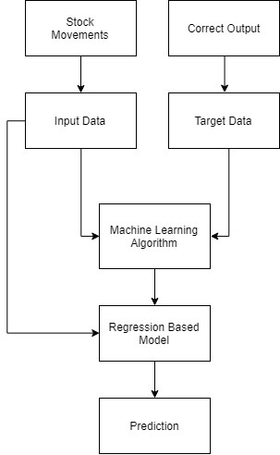Work was carried out on csv format of data through panda library and calculated the parameter which is to be predicted, the price of the stocks with respect to time. The data is divided into different train sets for cross validation to avoid over fitting. The test set is generally kept 20% of the whole dataset. Linear regression as given by the above equation is performed on the data and then predictions are made, which are plotted to show the results of the stock market prices vs time.

**Figure 1. Flow Chart for Regression Based Model**

**3.2 Long Short Term Memory (LSTM) Network Based Model**

LSTM is the advanced version of Recurrent-Neural Networks (RNN) where the information belonging to previous state persists. These are different from RNNs as they involve long term dependencies and RNNs works on finding the relationship between the recent and the current information. This indicates that the interval of information is relatively smaller than that to LSTM.

The main purpose behind using this model in stock market prediction is that the predictions depends on large amounts of data and are generally dependent on the long term history of the market. So LSTM regulates error by giving an aid to the RNNs through retaining information for older stages making the prediction more accurate.

Since stock market involves processing of huge data, the gradients with respect to the weight matrix may become very small and may degrade the learning rate of the system. This corresponds to the problem of Vanishing Gradient. LSTM prevents this from happening.

The LSTM consists of a remembering cell, input gate, output gate and a forget gate. The cell remembers the value for long term propagation and the gates regulate them.

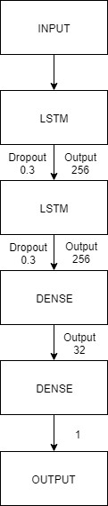In this report, a sequential model has been made which involves stacking two LSTM layers on top of each other with the output value of 256. The input to the layer is in the form of two layer and layer.

**Figure 2. LSTM Layers**

**CHAPTER 4**

### 4.1 Regression Based Model Results

The plot in figure3 is the result of application of linear regression algorithm on the dataset to predict varying prices with respect to the time.

### 

**Figure 3. Plot between Price and Date Using Regression**

### 4.2 LSTM Based Model Results

The above graph figure 3 is plot over the data having batch size 512 and 90 epochs. The prediction is shown by red line and the actual trend is shown by blue. The proximity of these two lines tells, how efficient the LSTM based model is. The prediction approximates real trend when a considerable amount of time has passed. The more the system is trained the greater the accuracy which will be attained.

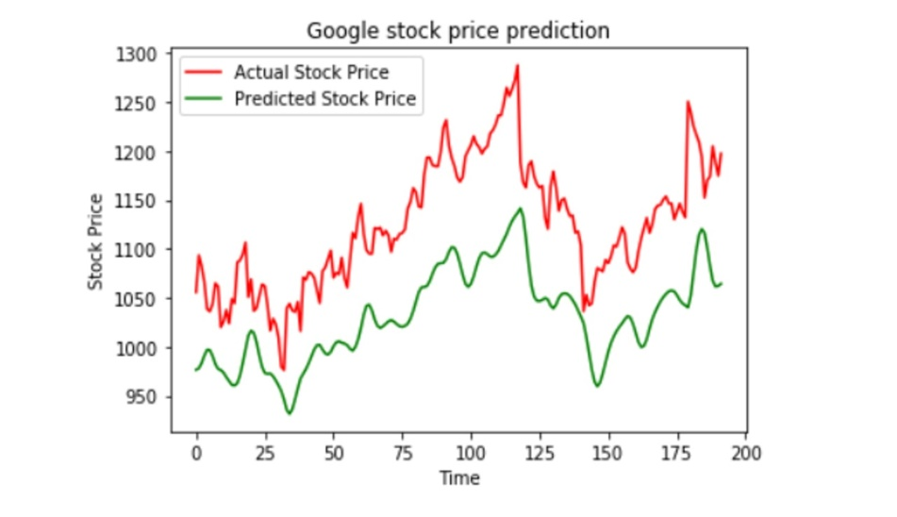

**Figure 4. Plot between Actual and Predicted Trend of LST**

**CHAPTER 5**

**CONCLUSION**

Two techniques have been utilized in this paper: LSTM and Regression, on the Yahoo finance dataset. Both the techniques have shown an improvement in the accuracy of predictions, thereby yielding positive results. Use of recently introduced machine learning techniques in the prediction of stocks have yielded promising results and thereby marked the use of them in profitable exchange schemes. It has led to the conclusion that it is possible to predict stock market with more accuracy and efficiency using machine learning techniques.

**FUTURE WORK**

In the future, the stock market prediction system can be further improved by utilizing a much bigger dataset than the one being utilized currently. This would help to increase the accuracy of our prediction models. Furthermore, other models of Machine Learning could also be studied to check for the accuracy rate resulted by them.

**CHAPTER 6**

[**https://github.com/rishabhrawat526/Stock-Price-Prediction-using-LSTM**](https://github.com/rishabhrawat526/Stock-Price-Prediction-using-LSTM)

**REFERENCES**

[1] <https://en.wikipedia.org/wiki/Stock_market_prediction>

[2]<https://www.geeksforgeeks.org/stock-price-prediction-using-machine-learning-python/>