**San Francisco Police Department Incident Reports Analysis**

**By**

**Rishabh Bansal**

# INTRODUCTION

The "Police Department Incident Reports" dataset that we have been provided is a collection of data from the San Francisco Police Department (SFPD) that documents incidents reported to the police. The data includes information such as the date, time, and location of each incident, as well as the type of crime that was reported.

This type of data is often used to understand the patterns and trends in crime in a given location, as well as to inform decisions about policing strategies, resource allocation, and community outreach programs. The data may also be used by researchers, journalists, and other stakeholders to shed light on the complex and often challenging issues surrounding crime and public safety.

It's important to note that crime data can be influenced by a variety of factors, including changes in law enforcement practices, the reporting of crime by the public, and the accuracy and completeness of the data itself. To obtain an accurate and comprehensive understanding of crime trends, it is necessary to carefully examine and interpret the data, taking into account the limitations and biases that may be present in the data and the methods used to collect and analyze it.

# ANALYSIS

Research Question 1

**The "crime rate trend" from 2018 to 2022 refers to the pattern of change in the frequency of criminal incidents over a specified period of time, in this case from 2018 to 2022. This question introduces the topic of crime trends and how they change over time.**

Understanding crime rate trends is important for law enforcement agencies, policymakers, and the general public, as it provides insight into the nature and extent of crime in a community and can inform the development of strategies to address crime and improve public safety. By analyzing crime rate trends, we can better understand the underlying causes of crime and develop targeted, evidencebased approaches to prevent and reduce crime in the future.

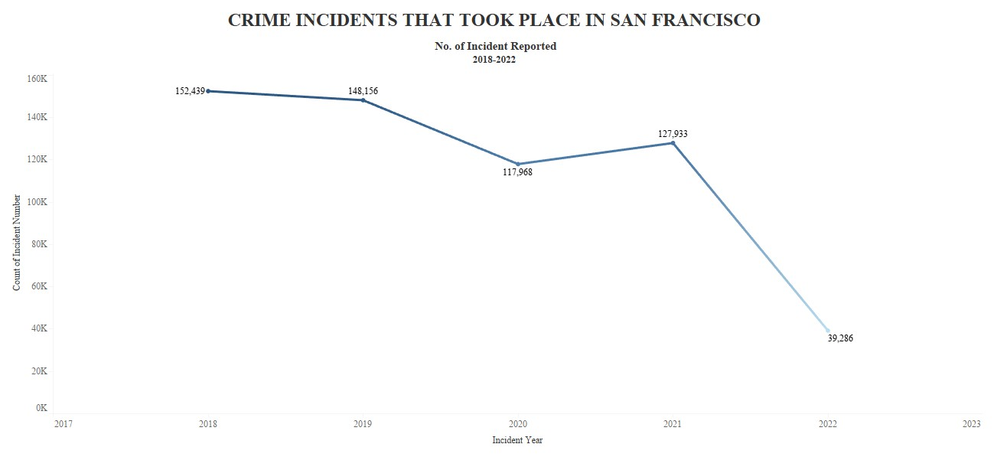

The crime trend in San Francisco is depicted in the graph, which reflects the complex and dynamic nature of crime and its underlying causes. As we can see from the fluctuations in crime rates over the years, the highest number of incidents was reported in 2018, followed by a gradual decline in the following two years, which could indicate the effectiveness of law enforcement efforts by the San Francisco Police Department. They also implemented new strategies and tactics that have been effective in reducing crime during this period. The rise in incidents reported in 2021 may reflect a number of factors, such as the COVID-19 pandemic has had a significant impact on the economy, leading to widespread job loss and financial insecurity, which could have motivated some individuals to engage in criminal activity, such as theft or robbery.

## Analysis and Findings

**The decline in incidents reported in 2022, following the COVID-19 outbreak, could be due to a variety of reasons such as-**

* **Reduced mobility:** With many people staying at home to avoid the spread of COVID-19, there has been a decrease in the number of opportunities for criminal activity to occur.
* **Economic factors:** The pandemic has led to widespread job losses and financial insecurity, which could have reduced the motivation for some types of crime, such as theft and robbery, that are driven by financial need.
* **Increased law enforcement:** In response to the pandemic, many police departments have increased their presence and efforts to prevent crime, which could have contributed to the decline in crime incidents.
* **Changes in criminal behavior:** The pandemic has had a significant impact on many aspects of daily life, and it is possible that some criminals have altered their behavior in response to the new circumstances.

### Research Question 2

**Which year observed the highest crime rate? How was the crime trend during day and night in that year?**

From our question 1 and graph, we have observed that the year 2018 had the highest crime rate from the data provided in the Police Department dataset. The crime rate trends at day and night can vary significantly depending on various factors such as location, population density, socio-economic status of the area, and local police presence, among others.

Larceny theft was the most observed crime in the year 2018 in the police department dataset of San Francisco dataset. We can also observe that the hour of the incident time is also late at night for larceny, theft, and most other incidents. It is a type of property crime that involves the unlawful taking of someone else's property without using force or violence. This type of crime can include theft of items such as cash, jewelry, electronics, and other personal property.

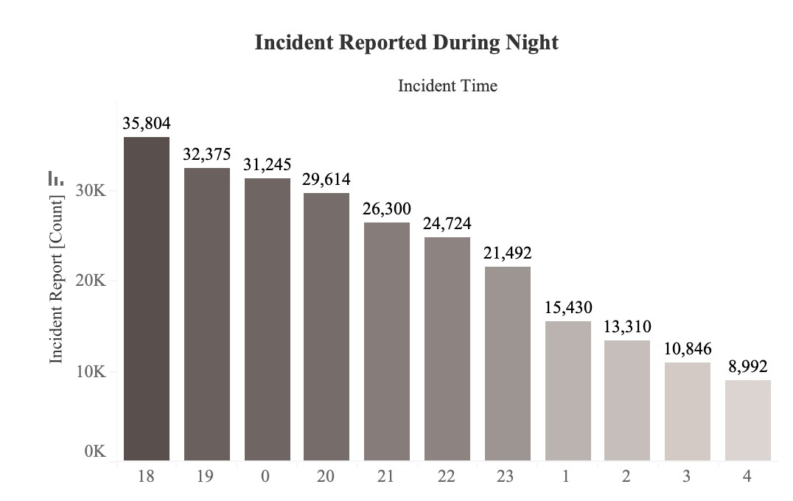

Moreover, crime rates can also vary depending on the day of the week. For example, crime rates may be higher on weekends when more people are out socializing. Given above is the graph of the larceny theft that happened during the day in 2018. As we can observe from the graph that in the wee hours of morning there are very few incidents of theft whereas it gradually increases every hour and the highest rate is reported in the peak afternoon hours at 12 pm.

The highest number of cases of theft are reported in the late hours of the day at 6 pm. Also, at night there is a higher number of thefts reported.

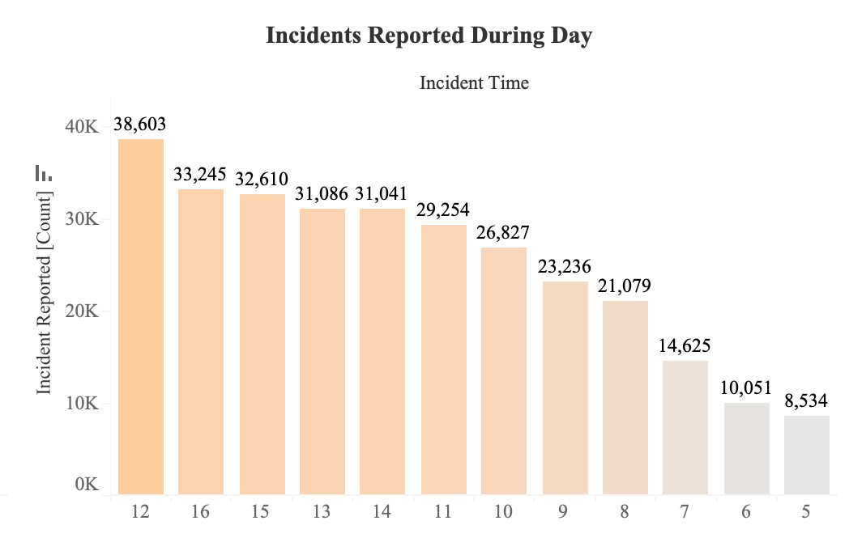

In general, crime rates tend to be higher at night, when visibility is reduced and there are fewer people on the streets. This is particularly true for crimes such as theft, robbery, and burglary, which are often committed under the cover of darkness. However, other crimes, such as assault, may occur more frequently during the day when people are more likely to be out and about.

## Analysis and Findings

To analyze the larceny theft crime rate, several factors need to be taken into consideration, such as

* **Location:** The larceny theft crime rate can vary greatly depending on the location. For example, urban areas may experience higher rates of larceny theft compared to rural areas.
* **Demographics:** The socio-economic status of an area can also play a role in the larceny theft crime rate. Areas with higher poverty rates and lower levels of education may have higher rates of property crime.
* **Law enforcement:** The presence of police and the level of enforcement in a specific area can also impact the larceny theft crime rate. If law enforcement is strong in an area, it can act as a deterrent for potential criminals.
* **Economic conditions:** Economic conditions can also play a role in the larceny theft crime rate. During times of economic hardship, crime rates, including property crime, may increase.
* **Preventive measures:** The presence of security measures such as alarm systems, cameras, and locks can also impact the larceny theft crime rate. If an area has a high number of homes and businesses with strong security measures, it may have a lower rate of larceny theft.

By analyzing these and other factors, it's possible to get a more accurate picture of the larceny theft crime rate in a specific area. This information can then be used to inform law enforcement strategies and to help prevent and reduce property crime.

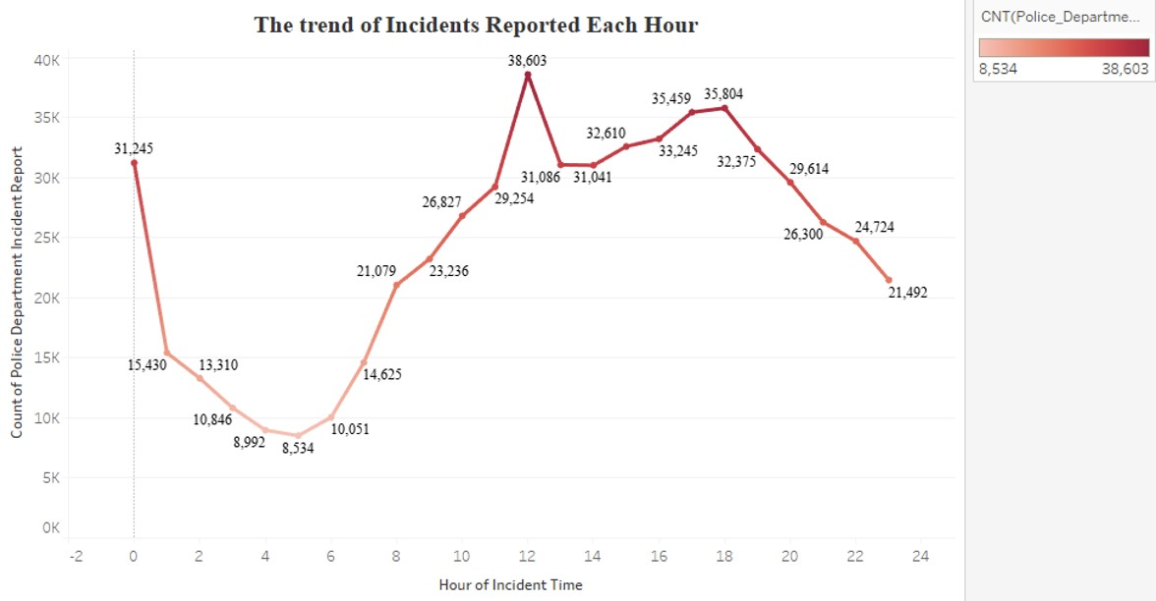

The above trend graph helps in better understanding the incident reported in each hour. This trend graph also points to the fact that the incidence rate increases in midnight and mid of the day to a greater extent.

It is important to note that crime rate trends can also change over time and can be influenced by many different factors such as demographics, economic conditions, and changes in law enforcement practices. Thus, it's essential to look at crime data on a case-bycase basis to get a more accurate picture of crime trends in a specific area.

### Research Question 3

**How has the police department of San Francisco been performing over the period of 5 years? A deep analysis of the top areas, the neighborhood, and the resolution of cases registered.**

In continuation to the previous parts where we analyzed several significant questions regarding **the number and trend of incidents, the reason for their occurrence, and the possible solutions or recommendations** for the San Francisco police department, we reached the final question of our analysis.

This part of the analysis involves how the department has been working in its capacity and how successful they have been in its efforts so far in controlling or handling the incidents.

To do this, we have created **three sub-analysis.** Putting them here as:

* **Analyzing the top districts of San Francisco in terms of the number of incidents reported.**
* **Narrowing the number of neighborhoods in each area and why they matter.**
* **Examining the resolution of cases based on their open and closed rates for each district.**

This sub-analysis will help us figure out the question in much detail and help us reflect upon the performance of the department.

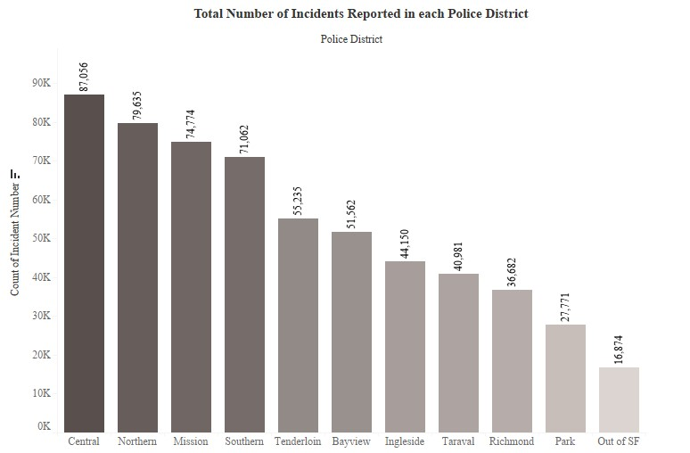

*Figure 1: Districts with the number of incidents reported*

**In figure 1**, we have created the bar graph using two major variables, “Number of incidents reported” and the “Districts”. Using the count function, we have sketched the plot. If you see, among the 10 districts and some operational areas outside San Francisco, the top five districts where the maximum number of incidents are happening are **“Central”, “Northern”, “Mission”, “Southern” and “Tenderloin”.**

The top 4 districts are very close to each other in terms of the number of incidents reported during the past 5 years. It can be easily concluded that due to some or other reasons these districts are the most prone to frequent crimes of all types.

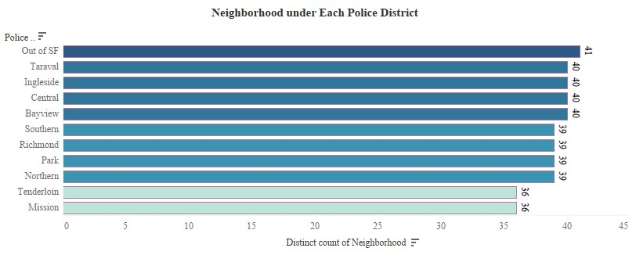

*Figure 2: Districts with the number of neighborhoods they cover*

Zeroing in on the neighborhood of each district, we have created another bar graph. Figure 2, gave us a striking set of information in terms of the **load and supervision that each district’s police department has,** with respect to the number of neighborhoods they are heading.

The district’s supervision over the count of neighborhoods gives us three ranges:

* **40 Neighborhoods:** Four districts under this category
* **39 Neighborhoods:** Another four districts under this category
* **36 neighborhoods:** Remaining two districts under this category

If you look closely, our top 5 districts from the first part of the analysis, are falling into each of these categories. While the top district i.e. **“Central”** falls under the first category, in spite of having a smaller number of neighborhoods, districts like **“Tenderloin and Mission”,** also are also on the list. Concluding that the size of districts and the population are not very strong factors for concluding the number of incidents occurring there.

This set of information is so crucial for the last part of the analysis. It provides a base for the analysis we are about to do next.

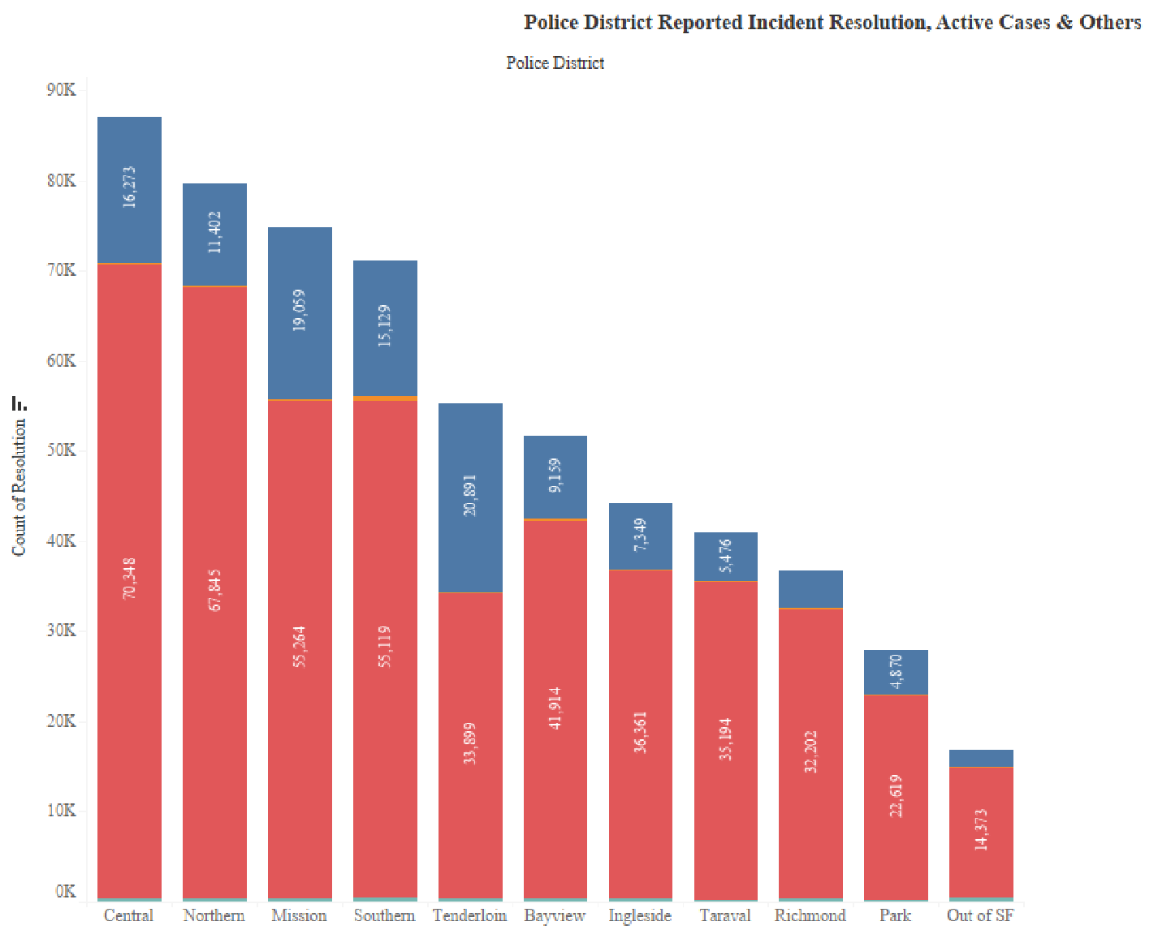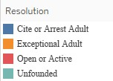

*Figure 3: Incident resolution (Active/Close/Others) based on their districts*

Coming to the most important element of our analysis. Figure 3, shows the **stack bar graph showing the current status of incidents and their resolution.** For this analysis, we have used 2 variables namely, **“Resolution” and “Districts”**. Using the count function, we have gotten the real number of the “Open or Active” and “Clear or Arrest Adult” cases.

|  |  |
| --- | --- |
| **Districts** | **Ratios (Open Vs Closed Cases)** |
| *Central* | *16273/70348 as* ***1 is to 4.32*** |
| *Northern* | *11402/67845 as* ***1 is to 5.93*** |
| *Mission* | *55264/19059 as 1 is to 3.89* |
| *Southern* | *55119/15129 as 1 is to 2.66* |
| *Tenderloin* | *33899/20891 as* ***1 is to 1.62*** |
| *Bayview* | *41914/9159 as 1 is to 2.18* |
| *Ingleside* | *36361/7349 as* ***1 is to 2.02*** |
| *Taraval* | *35194/5476 as* ***1 is to 6.39*** |
| *Richmond* | *32202/4101 as* ***1 is to 7.82*** |
| *Park* | *22619/4870 as* ***1 is to 2.14*** |

*Table 1: Incident resolution (Active/Close/Others) ratios district wise*

On the basis of the number of “Open” and “Closed” cases, we have done a resolution ratio analysis. If you see Table 1, you will see that the best district in terms of having a good rate of resolution is **“Tenderloin”** followed closely by **“Ingleside” and “Park”.** However, if you see the worst resolution ratios, you will find **“Richmond” and “Taraval” followed by “Northern” and “Central”.**

The surprising thing here is that a district like **“Tenderloin” has only 36 neighborhoods,** comparatively less than others. One reason for having more arrests over the incidents might be the **lesser size and population** of the entire district. However, on the other side, the **“Ingleside” district which is having 40+ neighborhoods,** is comparatively bigger in size and population and also has a secondbest resolution ratio. This analysis gives out the interpretation that **not only the demographic factors for personnel factors and the work culture and ethics of the police department** are also one of the strong reasons that impact the resolution.

On the other hand, if you see the districts with the worst resolution ratios, two of them namely **“Northern” and “Central”** even belong to the top five districts with the most incidents. The ratio where **only 1 in 6 cases are resulting in an arrest** creates an alarming situation for the safety of common people and the processing of complaints filed.

**Possible Reasons for the delay in Resolution:**

* **Shortage of Personnel:** It is recorded that the San Francisco police department was not getting ample budget and funds and because of that the police were facing staff shortages and delayed police academy classes.
* **Incomplete or Biases Reporting:** California has been one of the popular states prone to racial profiling. Because of this reason, the profiling done for the culprit is not apt. They lack a full record of the person leaving out important details. So, acting upon or making any decision on them gets delayed.

**Recommendations put forth for speedy Resolutions of Incidents:**

* **Proper Reporting:** From 2019 onwards, Law enforcement agencies made it obligatory to collect and report data that expands to proper details. Since the reform is new, it may take time to completely be followed.
* **Fund Allocation:** In December 2021, the funding to the police department was increased by the Mayor so that more staff can be employed and the shortage can be met.
* **Training Schools:** RIPA, the 16-member panel of policy experts has taken various measures and created policies regarding imparting proper training to the new staff and also helping them target implicit bias.

### Research question 4

**Forecast of the crime rate from the year 2022 to year 2024.**

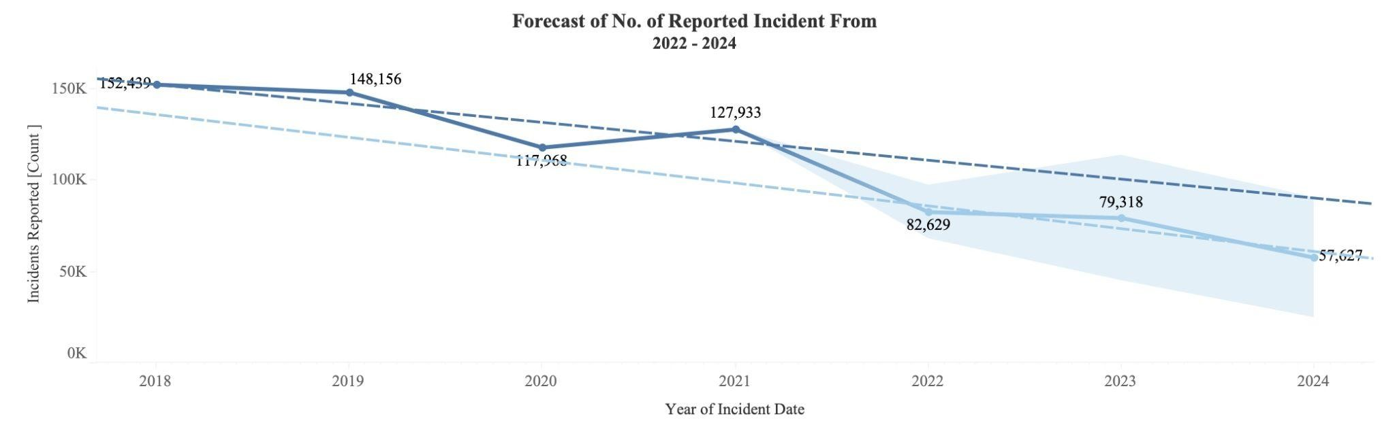

In question 2, we are going to forecast the crime rate from the year 2018 to the year 2022. Moreover, in the graph, we can see that the forecast is for 2 years after the year 2022 and the model is on yearly basis. To start with, we will need to use a filter on Police district data and select the top 5 districts that have the highest crime rate. Second, in order to count the crime rate, we will need to count the incident category with the months that the crimes happened. As for the forecasting model, in Tableau, we use the exponential smoothing model. Moreover, to make the model fit the prediction, I changed the trend into none and the season into multiplicative. Therefore, we can get the result below:

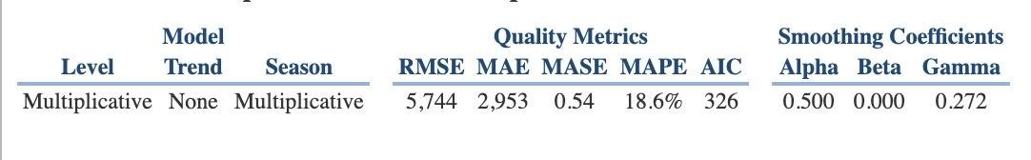

As we can see, the quality of the prediction is in the “OK” area, thus, we can say that this model is good for forecasting. Moreover, in this prediction, we use a 95% prediction interval, that is, the shadow we can see in the graph is based on a 95% confidence interval.

However, reducing crime in any city is a complex issue that requires a multifaceted approach. Therefore, the strategies that have been effective in lowering crime rates in other cities and could be considered for San Francisco:

* **Community policing:** Building strong relationships between the police and the community can increase trust and cooperation, leading to more effective law enforcement and reduced crime.
* **Targeted enforcement:** Focusing law enforcement efforts on the areas and types of crime that have the greatest impact can be more effective than spreading resources thinly across the entire city. In the forecast result, we can know that the area will be the Central district.
* **Crime prevention programs:** Programs that address the root causes of crime, such as poverty, drug addiction, and mental illness, can help to reduce criminal activity.
* **Improved public lighting:** Better lighting in high-crime areas can deter criminal activity and make it easier for the police to respond to incidents.
* **Youth programs:** Providing positive activities and opportunities for young people can help to steer them away from a life of crime.
* **Employment initiatives:** Creating job opportunities for those who may be at risk of involvement in criminal activity can help to reduce crime. Working with businesses and community organizations to address crime can leverage their resources and expertise to make a greater impact

With the strategy above, now we can understand what we should do to lower the crime rate for the next two years.

**REFERENCES:**

San Francisco Chronicle. (2022). California racial profiling: Police stops. Retrieved from https://www.sfchronicle.com/projects/2022/california-racial-profiling-police-stops/

SFGate. (2021). San Francisco 2021 crime data released. Retrieved from https://www.sfgate.com/bayarea/article/San-Francisco-2021crime-data-released-16807034.php

ABC7 News. (n.d.). SFPD budget: Defund the police department funding. Retrieved from https://abc7news.com/sfpd-budget-defundthe-police-department-funding/12321818/