**Navigating the Sneaker Resale Market: Insights and Predictions from a Comprehensive Analysis of Over 25 million transactions**

**BY**

Rishabh Bansal

# Abstract

This Capstone project, undertaken in collaboration with Arbit, aims to distill actionable insights from an extensive sneaker resale dataset comprising over 25 million transactions. My study concentrates on a quarter of this data, methodically randomized to ensure a representative sample of the entire dataset. The exploratory data analysis conducted as part of this project revealed significant factors that influence resale prices, such as brand prestige, collaboration status, and colorway. The key outcome of this analysis was the establishment of a reliable and robust predictive pricing model tailored for the Arbit platform, which aggregates real-time pricing data to assist users in making informed purchasing and selling decisions. This model is designed to trust the prices within the sneaker resale market, providing users with a comprehensive view of the current market dynamics. The model stands out for its emphasis on usability and accuracy, integrating trend analysis without the need for inventory management. Future work will include refining the model to enhance its forecasting capabilities further and exploring additional market segments to bolster the predictive analytics framework provided to Arbit users.

**Keywords:** Sneaker Resale Market, Predictive Analysis, Time series analysis, Brand Impact, Dashboards

TABLE OF CONTENTS

SECTIONS PAGE

Abstract 2

LIST OF TABLES 3

LIST OF FIGURES 4

Introduction 6

Data and Methodology 7

Descriptive Summary 9

Dashboard Visualizations 17

Prediction Model for Nike Resale Price using ARIMA 21

Prediction Model for Nike Resale Price using SARIMA 23

Comparative Evaluation of Prediction Models for Nike Resale Price 25

Prediction Model for Jordan Resale Price using ARIMA 30

Prediction Model for Jordan Resale Price using Holt-Winters 33

Comparative Evaluation of Prediction Models for Jordan Resale Price 35

Prediction Model for Adidas Resale Price using SARIMA 37

Comparative Evaluation of Prediction Models for Adidas Resale Price 39

Prediction Model for Converse Resale Price using SARIMA and Exponential Smoothing 40

Comparative Evaluation of Prediction Models for Converse Resale Price 43

Prediction Model for New Balance Resale Price using SARIMA and Exponential Smoothing 44

Comparative Evaluation of Prediction Models for New Balance Resale Price 47

References 48

# LIST OF TABLES

Table 1: Statistical Table for Numerical Variables

Table 2: Statistical Table for Categorical Variables

# LIST OF FIGURES

Figure 1: Sold Price Frequency Distribution

Figure 2: Number of Average Sales Over Time

Figure 3: Average Sold Price Trend Line on Different Platforms

Figure 4: Distribution of Resale Prices by Sneaker Brand

Figure 5-1: Average Sold Price Trend for Top 5 Brands in 2023

Figure 5-2: Average Number of Sales for Top 5 Brands in 2023

Figure 6: Average Sold Price for Top 5 Brands in Different Conditions

Figure 7: Sales Overview Dashboard

Figure 8: Collaborations and Brand Performance Dashboard

Figure 9: Price Variation and Smyce Dashboard

Figure 10: Decomposition plot of ARIMA model for brand Nike

Figure 11: ACF and PACF plots of ARIMA model for brand Nike

Figure 12: Decomposition plot of SARIMA model for brand Nike

Figure 13: ACF and PACF plots of SARIMA model for brand Nike

Figure 14: Forecast of ARIMA model on Nike for 2023

Figure 15: Forecast of ARIMA model on Nike for 2024

Figure 16: Forecast of SARIMA model on Nike for 2023

Figure 17: Forecast of SARIMA model on Nike for 2024

Figure 18: ARIMA Model Forecast vs Actual for Nike

Figure 19: SARIMA Forecast vs Actual for Nike

Figure 20: Decomposition plot for brand Jordan

Figure 21: ACF and PACF plots for brand Jordan

Figure 22: Residuals of Holt-Winters Model

Figure 23: Arima Monthly Forecast plot for brand Jordan

Figure 24: Holt-Winters Monthly Forecast for brand Jordan

Figure 25: ACF and PACF plots for brand Adidas

Figure 26: Decomposition graph for brand Adidas

Figure 27: Forecast of Adidas Sneakers Resale Price for 2024

Figure 28: Decomposition graph for brand Converse

Figure 29: ACF and PACF plots for brand Converse

Figure 30: Forecast of Converse Sneakers Resale Price

Figure 31: Decomposition graph for brand Converse

Figure 32: ACF and PACF plots for brand New Balance

Figure 33: Forecast of New balance Sneakers Resale Price

# Introduction

My analysis embarks on a journey through the dynamic world of sneaker resale, where fashion meets finance and consumer passions ignite bidding wars. Arbit, my sponsor, stands at the confluence of real-time market data and predictive analytics, offering a platform that equips both buyers and sellers with foresight in a market driven by trends and taste. My project is born from the vast sea of over 25 million transactions, each a story of supply, demand, and desire. Through careful stratification, we distilled this data to a manageable essence, representative of the whole yet agile for analysis. My aim was not merely to chart the past but to forecast the future, not just to observe the market but to provide a compass for its navigators.

My exploratory journey illuminated the diverse influences on resale value: the cachet of brands, the allure of colors, the clout of collaborations. These are the currents that shape the resale market, and my analysis sought to map their ebb and flow. The outcomes, captured in a suite of visualizations, serve as a beacon for decision-making, illuminating the path for Arbit's users.

As we progress, my gaze turns to predictive modeling, where algorithms divine patterns and project trends. This endeavor was not only an academic exercise but a practical tool, a synthesis of data and theory that culminates in actionable insights. In this report, we narrate My journey, from raw data to refined strategy, and invite you to follow the footprints I've charted in the bustling marketplace of sneaker resale.

# Data and Methodology

**Data Description**

My dataset was a rich tapestry of resale transactions from the sneaker market, meticulously compiled to provide a granular view of consumer behavior and market trends. The dataset includes the following variables:

SKU: A unique identifier for each sneaker model.

Condition: The condition of the sneaker at the time of sale, denoting if the item is new or used.

Size: The size of the sneaker, catering to a diverse demographic.

Gender: The gender classification of the sneaker design.

Sold_At: The sale timestamp, capturing the seasonality and timing of transactions.

Sold_Price: The final transaction price, reflecting the market's valuation of the sneaker.

Smyce: The platform on which the transaction took place.

Size_Value: A standardized numerical value representing the size of the sneaker.

Brand: The brand associated with the sneaker, a significant indicator of value.

Name: The model’s name, often carrying weight in the consumer's decision-making process.

Colorway: The color scheme of the sneaker, a factor in aesthetic appeal.

Color: The primary color, simplifying the colorway into a single dominant hue.

Silhouette: The model's silhouette, an essential aspect of sneaker identity.

RetailPrice: The manufacturer's suggested retail price, serving as a baseline for market comparison.

ReleaseDate: The date the sneaker was first available for purchase.

Is_Collab: Indicates whether the sneaker is a product of a collaboration.

Collaborator: The name of the collaborating entity, when applicable.

In addition, I introduced a Markup variable, created to analyze the profitability margin. It was computed by subtracting the retail price from the sold price, offering direct insight into the resale uplift.

**Analytical Approach**

My analytical journey begins with descriptive analytics, capturing the state of the market through various lenses—brand influence, collaboration impact, and the allure of colorways. I then transition to predictive analytics, aiming to forecast future price trends with regression analysis, factoring in historical price patterns and product attributes. Dashboard screens will visualize these insights, presenting the data through interactive and accessible means. My dashboards will display price distributions, identify brand rankings by volume, analyze collaboration premiums, and depict market growth trends.

# Descriptive Summary

My analysis encompasses a comprehensive exploration of a dataset related to footwear sales, focusing on various aspects such as condition, gender distribution, brand popularity, size value, collaboration with brands, and sales over time. The study utilizes numerous statistical and visual tools to uncover patterns and insights within the data.

The descriptive summary tables provide a detailed statistical and categorical breakdown of sneaker sales data, offering invaluable insights into the resale market. Table 1 focuses on pricing details, showing that out of nearly 6 million records, the average resale price of sneakers was $210.16, significantly higher than the average retail price of $145.51. This indicates a robust secondary market where sneakers can command a premium, largely due to factors like scarcity and demand. The standard deviation in sold prices was quite high at $254.21, suggesting a wide variation in the prices that sneakers are sold for, which could be influenced by factors like rarity, brand, and specific sneaker releases. The maximum sold price was an outlier at $108,000, indicating that certain sneakers are considered highly valuable collector's items.

|  |  |  |
| --- | --- | --- |
|  | **SOLD PRICE** | **RETAIL PRICE** |
| **count** | 5948377 | 5948377 |
| **mean** | 210.16 | 145.51 |
| **std** | 254.21 | 63.07 |
| **min** | 0.00 | 0.00 |
| **25%** | 118.00 | 110.00 |
| **50%** | 164.00 | 135.00 |
| **75%** | 239.00 | 180.00 |
| **max** | 108000.00 | 3450.00 |

***Table 1:*** *Statistical Table for Numerical Variables*

Table 2 provides categorical insights, highlighting that the most frequent condition of sneakers sold was 'new', which aligns with a strong consumer preference for mint-condition items. Most buyers are men, consistent with the known trend that male customers dominate the sneaker market. Interestingly, the most frequent sale date was November 24, 2023, which could correlate with special sale events like Black Friday, suggesting that these events significantly influence buying behavior. The most common sneaker sold was the Nike Dunk Low Retro White Black Panda, signifying its popularity and potential as a staple item for resellers to stock. The color white was the most prevalent among sneakers sold, which could indicate a market preference for neutral tones that are easier to style.

|  |  |  |  |  |  |  |  |  |  |  |  |  |
| --- | --- | --- | --- | --- | --- | --- | --- | --- | --- | --- | --- | --- |
|  | **CONDITION** | | **GENDER** | | | **SOLD_AT** | | **SMYCE** | **BRAND** | | **NAME** | |
| **count** | 5948377 | | 5948377 | | | 5948377 | | 5948377 | 5948377 | | 5948377 | |
| **unique** | 8 | | 8 | | | 5397815 | | 4 | 39 | | 67269 | |
| **top** | is_new | | men | | | 2023-11-24 00:00:00+00:00 | | stockx | Nike | | Nike Dunk Low Retro White Black Panda | |
| **freq** | 5661482 | | 4293473 | | | 1155 | | 4931507 | 2508534 | | 30581 | |
|  | | **COLORWAY** | | **COLOR** | **SILHOUETTE** | | **RELEASEDATE** | | | **COLLABORATOR** | | **SIZE VALUE** |
| **count** | | 5948377 | | 5948377 | 5948377 | | 5948377 | | | 5948377 | | 5948377 |
| **unique** | | 42556 | | 15 | 5460 | | 4501 | | | 83 | | 33 |
| **top** | | White/Black | | white | Air Jordan 1 | | 2021-03-10 | | | None | | 10 |
| **freq** | | 96535 | | 1915308 | 1058974 | | 83559 | | | 4980577 | | 554732 |

***Table 2:*** *Statistical Table for Categorical Variables*

For end users such as retailers, resellers, and marketers, these findings are crucial. The pricing data allows for better pricing strategies, considering the high variance in sold prices to maximize profits while remaining competitive. The categorical data emphasizes the importance of stocking new-condition sneakers and focusing on popular releases like the Nike Dunk Low. Moreover, marketers can leverage dates with high sales volumes to time their promotions and stock releases, while the preference for specific colors and models can guide inventory selection to match consumer demand. Understanding these patterns helps in optimizing sales approaches, stock levels, and marketing strategies to tap into the most lucrative segments of the market.

Then we use a histogram to provide visualization of the log-scaled distribution of sold prices for sneakers, offering a clear perspective on how prices are dispersed across the market. The logarithmic scale in Figure 1 helps to manage the wide range of prices and make the distribution of lower and higher-priced sneakers more interpretable. The mean sold price was marked at $210.41, significantly higher than the median sold price of $164.00. This suggests that while the average price was driven up by higher-priced sales, most sneakers are sold at a more moderate price point, with the median providing a better sense of the central tendency in a skewed distribution.

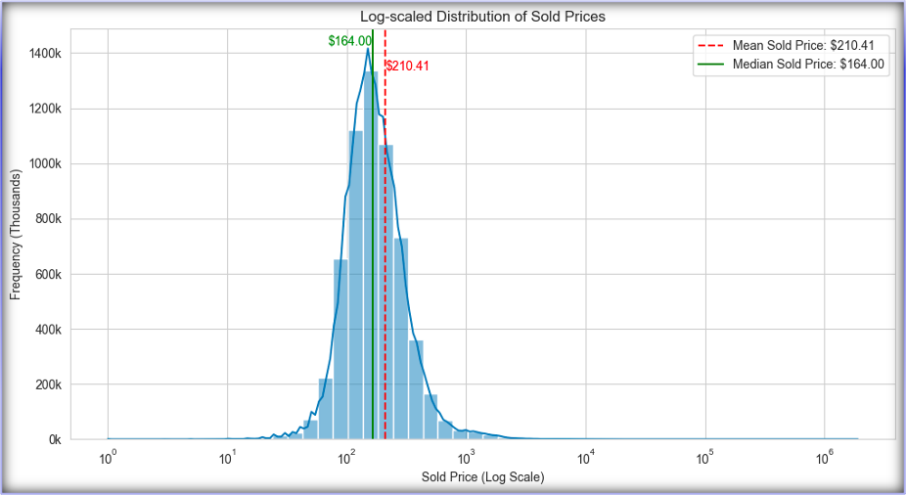

***Figure 1:*** *Sold Price Frequency Distribution*

The spread of the prices indicates that there's a substantial market for both commonly priced and high-end, luxury sneakers. The presence of sneakers with the sold prices in the higher logarithmic scale signifies a niche but financially substantial market for rare or limited-edition sneakers, which can be very profitable. For resellers, focusing on the median price point may result in more consistent sales, but the mean suggests there was also a significant opportunity in targeting the higher end of the market.

This visualization was crucial for businesses in making strategic decisions about which price segments to target. It implies that while the bulk of the market was at a lower price point, there's a non-negligible segment of the market that is willing to spend significantly more on sneakers. Businesses could use this information to segment their marketing efforts and inventory—maintaining a solid base of regularly priced items while also catering to the high-end market to maximize revenue.

We use two-line graphs to depict the monthly performance of sneaker sales across different platforms, with the first graph showing the volume of sales and the second indicating the average sale price over time.

In Figure 2, one platform distinctly outperforms the others in terms of sales volume, suggesting it is the preferred marketplace for sneaker transactions. This could be due to a variety of factors such as user trust, platform fees, ease of use, or shipping logistics. There's a visible pattern of peaks and troughs, which might correspond to seasonal trends, release dates of new sneakers, or special sale events. Businesses and individual resellers can use this information to anticipate when to increase their stock or when they might need to ramp up their marketing efforts.

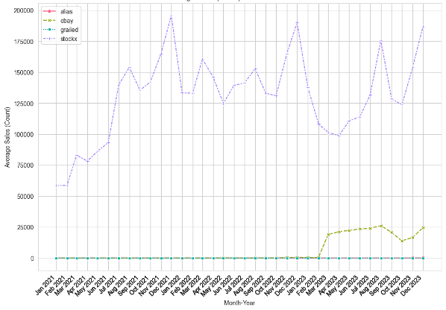

***Figure 2:*** *Number of Average Sales Over Time*

Figure 3 presents a more volatile scenario in terms of average sale price, with all platforms experiencing fluctuations. This could be influenced by the release of high-demand sneakers, market trends, or changes in consumer behavior. Notably, there's less disparity between platforms in terms of price than there was with volume, indicating that while consumers have a strong preference for where to buy, they are less sensitive to price differences across these platforms. This insight can be crucial for sellers in determining pricing strategies and for choosing the right platform to list different types of sneakers.

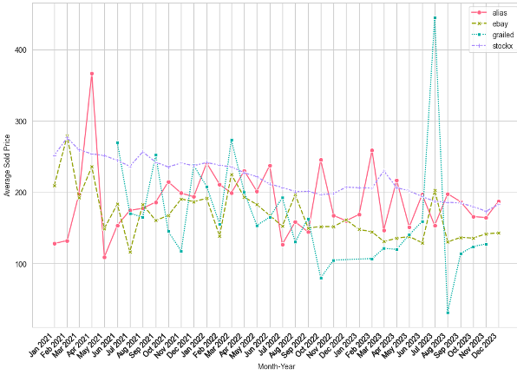

***Figure 3****: Average Sold Price Trend Line on Different Platforms*

Both graphs are critical for stakeholders in the sneaker market. The sales volume data can inform stock levels and help anticipate demand, while the pricing data can help set competitive prices. Together, they provide a multifaceted view of the market, allowing for a strategic approach to sales and marketing efforts. Understanding the reasons behind the patterns seen in these graphs could give sellers a competitive edge in the marketplace.

The box plot visually compares the resale prices across various sneaker brands on a logarithmic scale. This type of graph was particularly useful for showing the range and distribution of data, where the box represents the interquartile range (IQR), the line within the box shows the median, and the 'whiskers' extend to show the full range excluding outliers, which are plotted as individual points.

The plot reveals significant variation in resale prices among brands, with some brands showing a wider range of prices and others a more compact distribution. Brands with longer whiskers and more outliers, especially above the upper quartile, indicate that there are sneakers with exceptionally high resale values, possibly due to limited edition releases or collaborations that are highly coveted in the resale market. Conversely, brands with shorter whiskers and fewer outliers suggest a more uniform pricing strategy or a tighter control of the resale market.

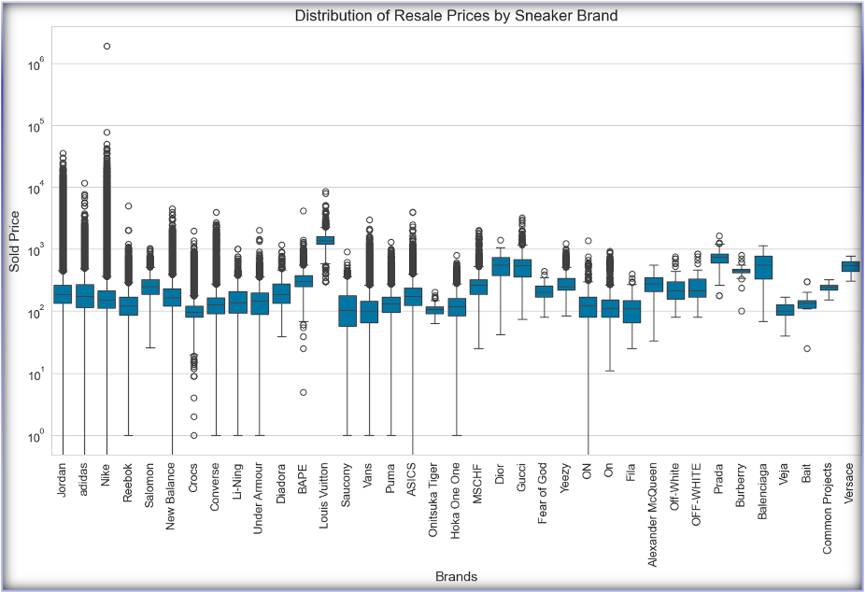

***Figure 4:*** *Distribution of Resale Prices by Sneaker Brand*

For stakeholders in the sneaker resale industry, this graph can provide strategic insights. Retailers and resellers can identify which brands tend to have a higher resale value and which are more consistently priced, informing their purchasing and pricing strategies. It can also highlight potential opportunities for investment in particular brands that may yield higher returns due to their variance in resale prices.

To provide a visual comparison of the average sold prices and sales volumes for the top five sneaker brands up until the year 2023, we use a pair of line charts.

Figure 5-1 illustrates the average sold prices, showing significant fluctuations over time for each brand. Jordan and Nike frequently hit higher price points, indicative of their premium product offerings and strong brand equity in the sneaker market. Converse, on the other hand, maintains a relatively stable and lower average sold price, which may reflect its position as a provider of more classic and widely accessible footwear. The spikes in the graph could represent the release of limited-edition models or collaborations that typically fetch higher prices. This information is valuable for resellers and retailers to identify the pricing trends of different brands and to adjust their sales and stocking strategies accordingly.

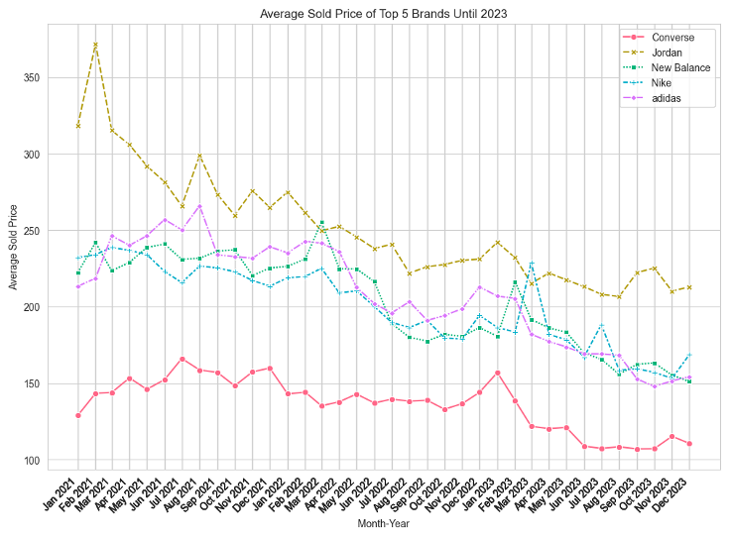

***Figure 5-1:*** *Average Sold Price Trend for Top 5 Brands in 2023*

Figure 5-2 depicts the average sales volume for these brands, with Nike and Jordan again leading the pack, reflecting their strong market presence and consumer demand. The peaks in sales volume may correspond to new release drops or seasonal sales, which are critical times for retailers to ensure they have sufficient stock to meet consumer demand. Converse shows the lowest variability and volume, which aligns with the pricing data, suggesting a stable but smaller market segment.

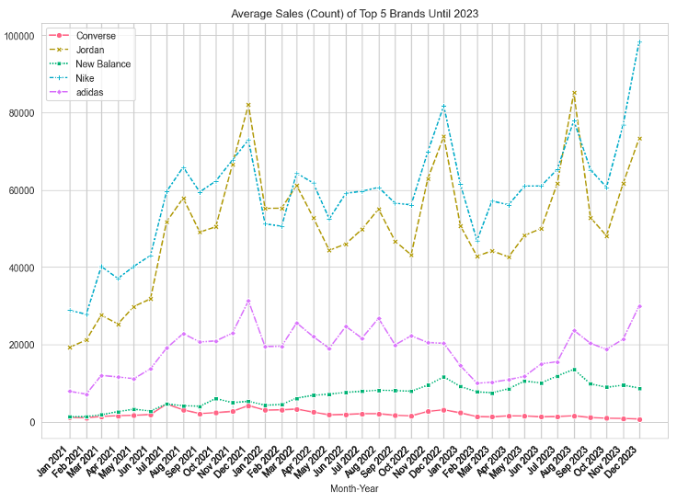

***Figure 5-2:*** *Average Number of Sales for Top 5 Brands in 2023*

These graphs are instrumental for market analysts and resellers in understanding not only the brand performance over time but also in making data-driven decisions about inventory management, pricing strategies, and marketing campaigns. Timing purchases to anticipate high-demand periods and setting competitive prices based on market trends can significantly impact profitability in the sneaker resale market.

Lastly, we use the bar graph in Figure 6 to illustrate the average sold prices of sneakers from various brands, segmented by the condition of the shoes. This visualization provides a clear comparison of how the condition affects the resale value across different brands like Converse, Jordan, New Balance, Nike, and Adidas. Brand new sneakers tend to fetch the highest prices across all brands, which is expected as consumers are willing to pay a premium for new, unworn items. As the condition descends from brand new to worn, there was a general decline in the average price sold. This trend was consistent across all the brands showcased, underscoring the importance of product condition in the resale market. Interestingly, certain conditions such as 'like new' or 'gently used' still command relatively high prices, which could indicate a market segment that values near-mint conditions at a discount from the new price.

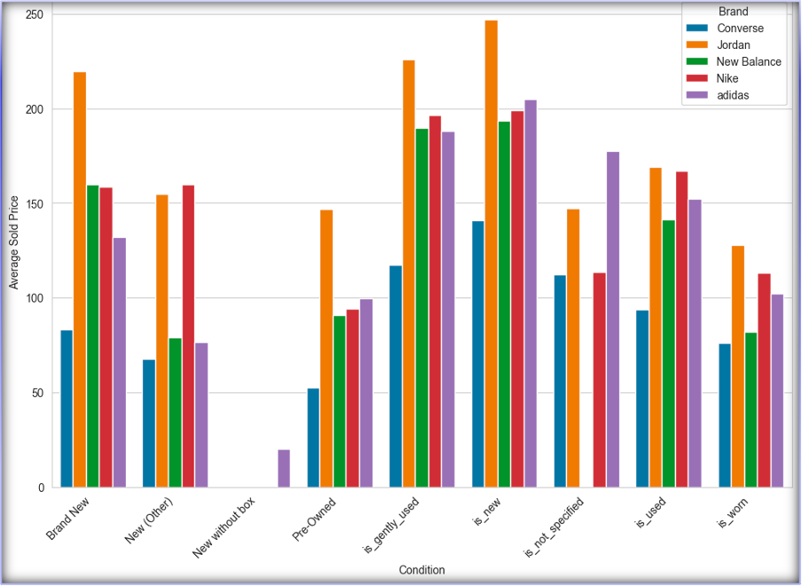

***Figure 6:*** *Average Sold Price for Top 5 Brands in Different Conditions*

This graph can serve as a key tool for resellers and retailers in setting pricing strategies based on the condition of the sneakers they are selling. It highlights the potential profitability in selling sneakers that are not brand new but still in excellent condition, as there appears to be a substantial market for such items. For consumers, it suggests that there is an opportunity to purchase sneakers at a reduced price if they are willing to consider products that are not brand new, providing options for different budget levels.

# Dashboard Visualizations

The series of dashboard visuals provided offers my comprehensive overview of the sneaker resale market, highlighting critical sales trends, customer demographics, color preferences, and the impact of collaborations on sales performance. These dashboards are designed to assist us in making informed decisions by providing a clear snapshot of the market's dynamics.

**Sales Overview Dashboard**

The Sales Overview Dashboard in Figure 7 presents a dynamic visual representation of the sneaker resale market, specifically tailored for resellers and market analysts to dissect sales trends within a designated timeframe. It highlights the comparative analysis between the average retail price of Adidas sneakers at $162.73 and their average resale price at $200.91, suggesting a profitable aftermarket for these products. The dashboard further segments the market into conditions of sale and buyer demographics, revealing a predominant trend of new sneakers sales and a significant male customer base, accounting for 94.97% and 83.41% respectively. With an impressive total of 795,893 sales, amounting to nearly $160 million, the dashboard underscores the robust nature of the Adidas sneaker resale industry.

In terms of product collaboration, the dashboard indicates a distinct consumer preference, as collaborative sneakers sell at an elevated average price of $246.33 compared to the $133.27 for standard releases. This data was pivotal for resellers who could capitalize on the higher demand for limited edition collaborations by adjusting their acquisition and sales strategies. Additionally, the dashboard provides a granular breakdown of sales by gender and shoe size, highlighting key trends such as the higher average sold price for men's size 9.5 sneakers. This information could be particularly useful for inventory management, allowing resellers to stock up on the most popular sizes to meet consumer demand.

Moreover, the sales trends over time, depicted through a line graph, offer insights into seasonal or periodic sales fluctuations, which can inform resellers of optimal times for stock preparation and marketing initiatives. The dashboard serves not only as a reflection of past and present market conditions but also as a prognostic tool, enabling resellers to anticipate future market movements and adapt their business strategies for maximum profitability in the sneaker resale market.

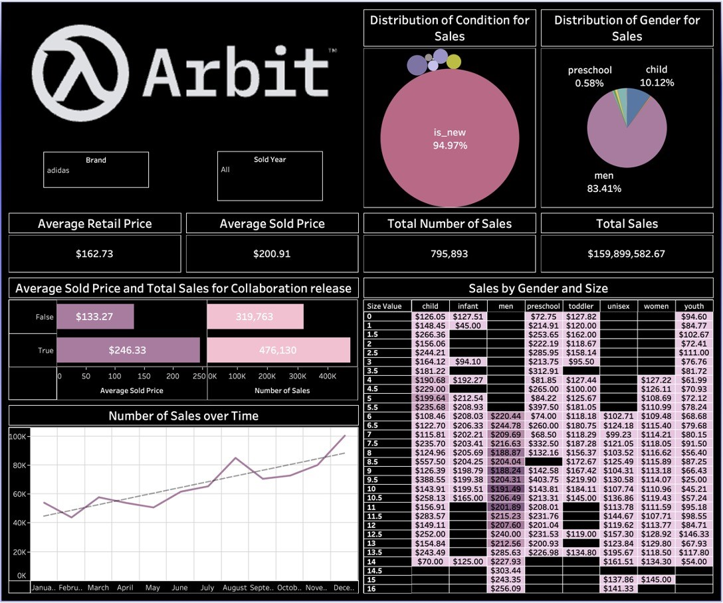

***Figure 7:*** *Sales Overview Dashboard*

**Collaborations and Brand Performance Dashboard**

The dashboard in Figure 8 was designed to provide a comprehensive overview of the sneaker resale market's performance, highlighting top-selling shoe models, most successful collaborations, and the leading brands both in terms of sales volume and price. The primary purpose of this dashboard was to inform stakeholders, such as resellers, brand managers, and market analysts, about the current market landscape, showcasing where the most significant sales numbers are concentrated, and which collaborations are yielding the highest returns. The visual also contrasts the top-selling brands by sales against the top-selling brands by average sold price, offering a clear depiction of market preferences and the premium pricing power of certain brands.

This dashboard serves as a critical tool in decision-making processes. For example, resellers can use the data to identify which shoe models and collaborations to prioritize in their inventories, given that certain names, such as Kanye West, drive high average sale prices, as indicated by the prominent placement and font size in the visual. The dashboard also highlights the substantial difference between the average retail price and resale price of top-selling shoes, suggesting room for significant markups in the resale market.

We can observe that brands like Nike and Jordan dominate the sales volume, while luxury brands such as Louis Vuitton command much higher average prices. This dichotomy can guide strategic positioning, either towards volume-based sales strategies or towards catering to a high-end market segment willing to pay premium prices for exclusive items.

In summary, the dashboard not only provides a snapshot of the current market status but also enables strategic planning for inventory management, pricing strategies, and marketing focus to capitalize on the most lucrative segments of the sneaker resale market.

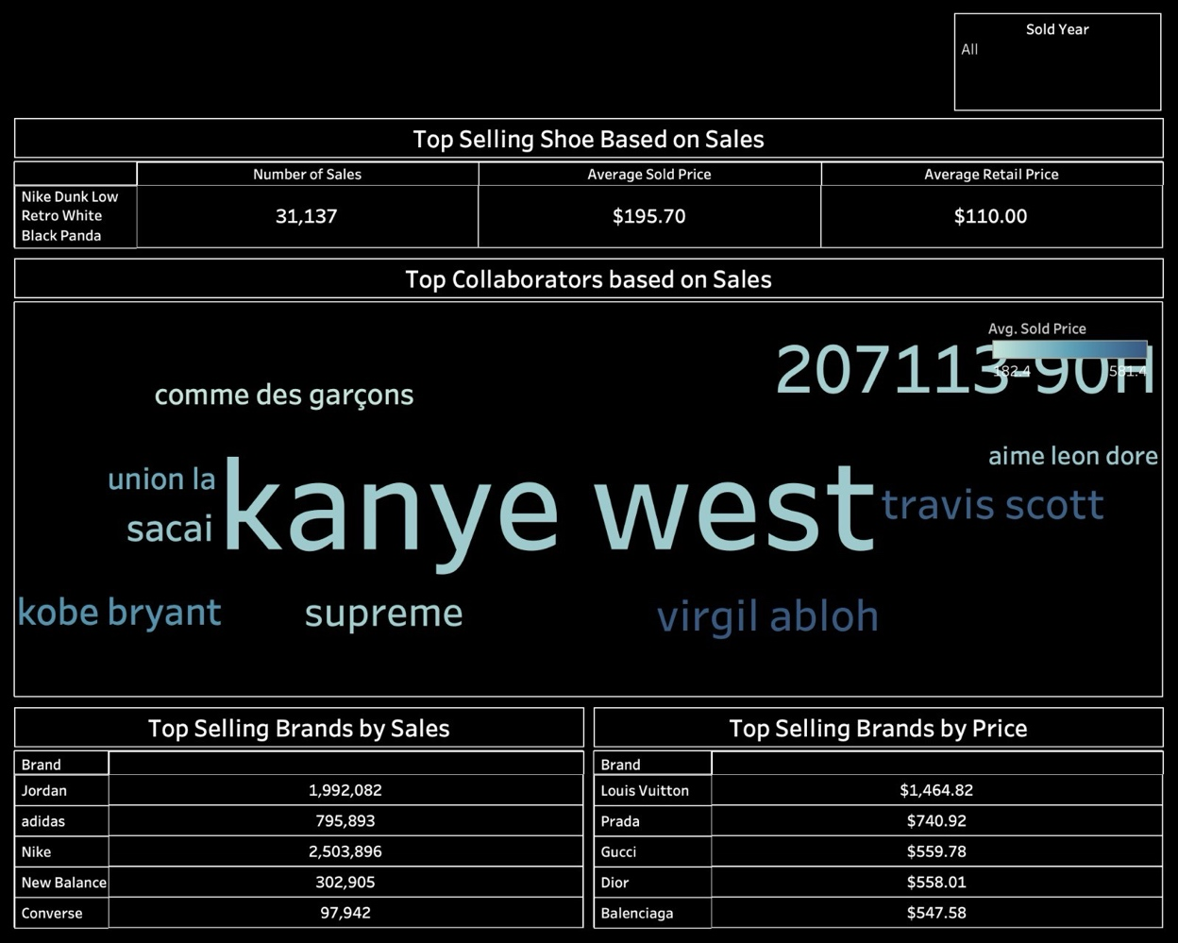

***Figure 8:*** *Collaborations and Brand Performance Dashboard*

**Price Variation and Smyce Dashboard**

The dashboard provided in Figure 9 was a color and gender-based sales analysis tool tailored for the Adidas brand within the sneaker resale market. Its primary purpose was to dissect and understand consumer preferences and sales performance across different colorways and gender segments. This dashboard aids us in crafting strategies that align with consumer buying patterns and preferences.

The color-based sales section of the dashboard gives a detailed insight into which colors sell the most and at what average price. It shows a significant market preference for black and white sneakers, with pink sneakers fetching the highest average sale price, indicating a niche but potentially lucrative market. This information is crucial for planning which color stocks to prioritize and could influence marketing campaigns that highlight certain colorways to drive sales.

On the other hand, the gender-based sold count graph offers a clear visualization of the quantity of sales attributed to different gender categories across various colors. This data was particularly useful for understanding demographic preferences and tailoring product offerings accordingly. For example, if a color was particularly popular among women, a reseller might decide to stock more of that color in sizes and styles that cater to women's preferences. Additionally, the dashboard can be used to identify potential gaps in the market. If a certain color was not selling well despite a significant stock, it may prompt a decision to reduce inventory or adjust pricing.

In summary, this dashboard is a strategic tool that translates complex sales data into actionable insights. By providing a clear visual representation of sales performance by color and gender, it enables us to optimize inventory, tailor marketing efforts, and ultimately target the most profitable segments of the market with greater precision.

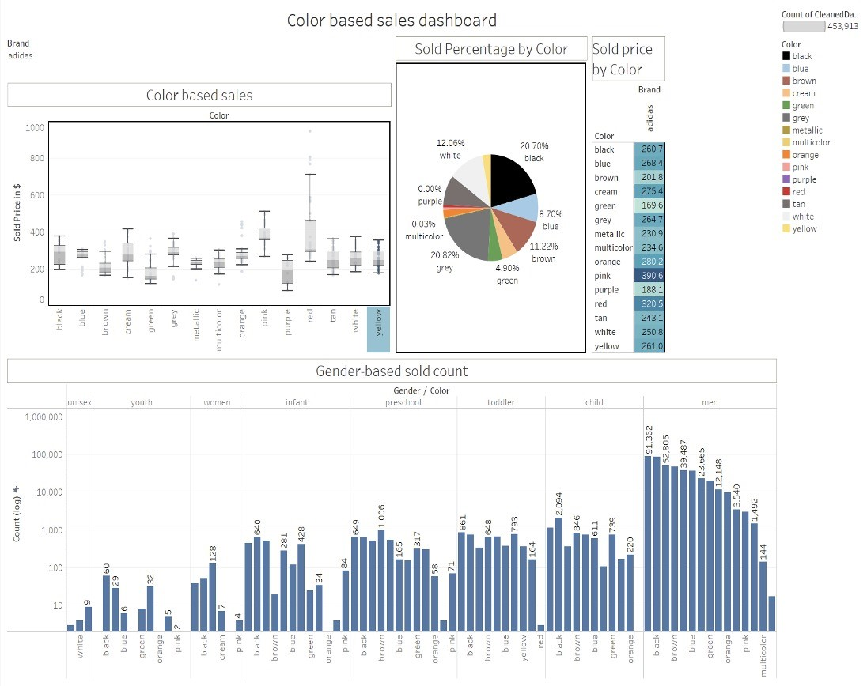

***Figure 9:*** *Price Variation and Smyce Dashboard*

# Prediction Model for Nike Resale Price using ARIMA

**ARIMA Model Training**

Training an Autoregressive Integrated Moving Average (ARIMA) model involves several steps: understanding the time series components, identifying model parameters, and estimating the model.

Using decomposition, we separate the observed Adidas sneaker sales data into trend, seasonal, and residual components. The observed component of the series reveals a clear cyclical behavior, superimposed on a downward trend. The trend component shows a continuous decrease over time, indicating a general decline in sneaker prices, potentially due to market saturation or evolving consumer preferences.

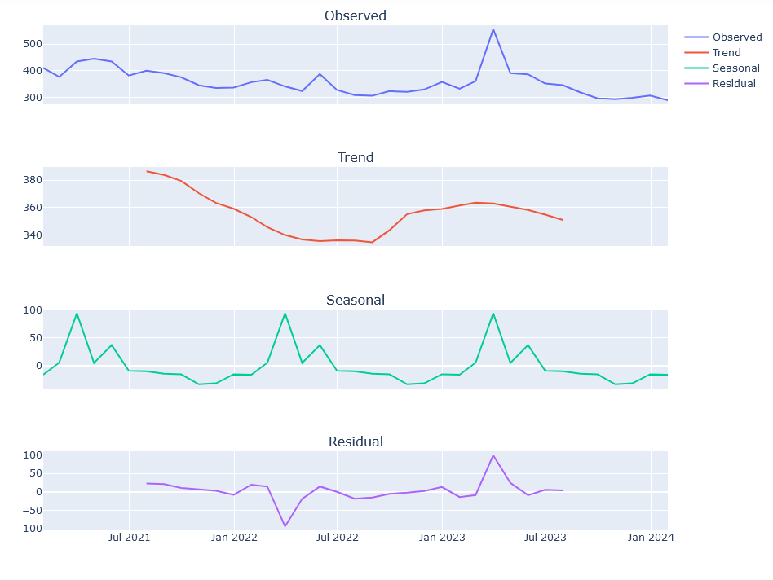***Figure 10:*** *Decomposition plot of ARIMA model for brand Nike*

The seasonal component highlights systematic, predictable fluctuations. Peaks likely correspond to the release of new sneaker models or seasonal sales, and troughs may represent off-peak periods. This cyclical nature is critical for specifying the seasonal orders of the ARIMA model.

The residual component represents what remains after the trend and seasonal components have been removed from the observed data. Ideally, these residuals should resemble white noise, indicating that the model has captured the systematic structure of the time series well.

The ACF and PACF plots guide the selection of the ARIMA model's parameters. The ACF shows a gradual decline in autocorrelations, while the PACF cuts off after the first lag. This suggests that a first-order autoregressive term is appropriate, and there's no need for additional differencing beyond the integrated component necessary to stabilize the mean of the series.

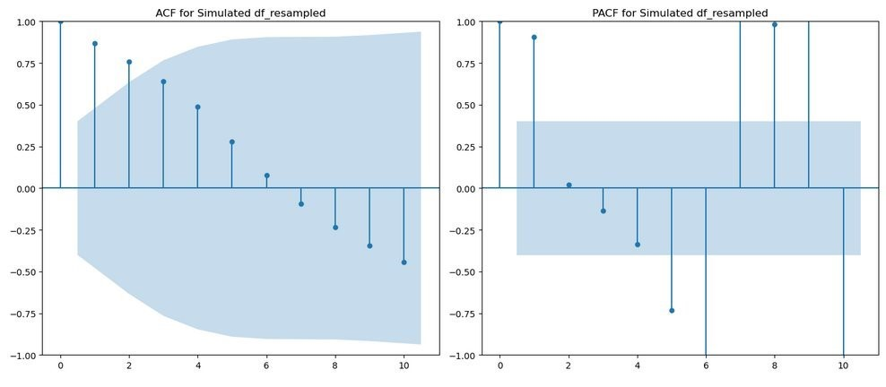***Figure 11:*** *ACF and PACF plots of ARIMA model for brand Nike*

**ARIMA Model Testing**

Testing an ARIMA model involves validating its predictive accuracy on unseen data and evaluating the residuals to ensure they meet certain statistical properties.

After training the ARIMA model on the historical data, we forecast future sneaker prices. The ACF of the residuals from this forecasting exercise should ideally show no significant correlations, implying that the model has successfully captured the information in the data.

Upon inspecting the residuals of my forecasts, the ACF and PACF plots do not exhibit significant spikes, which confirms that the residuals are uncorrelated and that the model does not omit valuable predictors. Moreover, residuals should scatter randomly around zero without any apparent patterns or systematic deviations, suggesting that the model's assumptions are valid.

# Prediction Model for Nike Resale Price using SARIMA

**SARIMA Model Training**

The Seasonal Autoregressive Integrated Moving Average (SARIMA) model is particularly well-suited for datasets with clear seasonal patterns, such as the Nike sneaker sale prices. The decomposition graph for the Nike brand (Figure 12) reveals distinct components of the time series data that influence the SARIMA model training process.

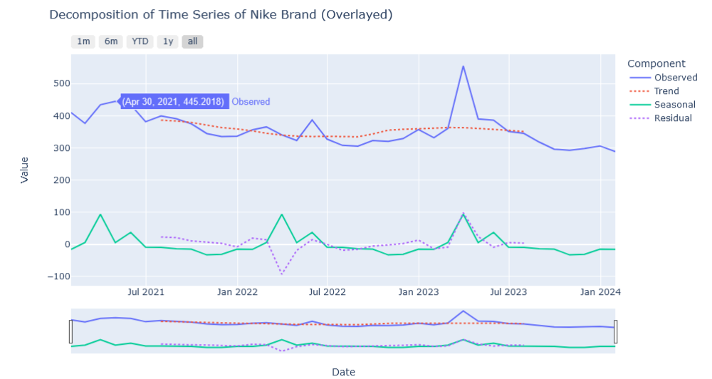***Figure 12:*** *Decomposition plot of SARIMA model for brand Nike*

The observed component shows periodic spikes in sales, which may correspond to seasonal launches or promotional events. The trend indicates a relatively stable, possibly slightly declining market over the observed period. This insight is crucial for determining the integrated (I) component of the SARIMA model, suggesting a need for differencing to achieve stationarity.

The seasonal component's clear pattern indicates the necessity of a seasonal (S) component in the model. These fluctuations are essential for setting the seasonal order of the SARIMA model to account for periodic changes in sneaker sales, which are likely tied to fashion trends and marketing cycles.

The residuals appear random and centered around zero, indicating that the decomposed trend and seasonal components have captured much of the time series' structure. For the residuals that do not exhibit any apparent pattern, the SARIMA model assumes that they are the noise of the process.

The ACF and PACF plots for the Nike brand (Figure 13) show the autocorrelation characteristics of the time series. The ACF plot displays significant autocorrelation at the initial lag, which tapers off quickly, suggesting that the series has a short memory. The PACF plot, with a significant spike at the first lag and a cutoff afterward, indicates that a first-order autoregressive term is sufficient for the AR component of the model.

***Figure 13:*** *ACF and PACF plots of SARIMA model for brand Nike*

**SARIMA Model Testing**

The performance of the SARIMA model is evaluated through out-of-sample testing, where the model's forecasts are compared against actual data not used in the training process.

The accuracy of the SARIMA model's forecasts for Nike sneaker sale prices is assessed using the same dataset. The model's effectiveness is evaluated based on its ability to predict unseen data points, considering the trend and seasonal patterns identified during the training phase.

The diagnostic checks on the model's residuals in the testing phase are essential to ensure the adequacy of the model fit. The ACF and PACF plots of the forecast residuals should show no significant autocorrelation, implying that the SARIMA model is capturing the time series data's dependencies effectively.

In comparison to other models, the SARIMA model's strength lies in its ability to incorporate both non-seasonal and seasonal dynamics observed in the decomposition graph. The autocorrelation behavior, as confirmed by the ACF and PACF plots, guides the specification of the autoregressive and moving average components, tailoring the model to the intricacies of Nike's sneaker sale price behavior.

# Comparative Evaluation of Prediction Models for Nike Resale Price

**ARIMA Model Evaluation**

The ARIMA model forecasts for Nike sneaker resale prices in both 2023 and 2024 indicate a flat line, suggesting a prediction that prices will hold steady at the most recent historical price level. This is a conservative forecast that does not account for the apparent declining trend in the historical data.

For 2023 (Figure 14):

The forecast suggests stability in the resale prices, as indicated by the solid red line within the confidence interval shaded in pink. The flat forecast may reflect an assumption that past patterns will continue into the future without significant change.

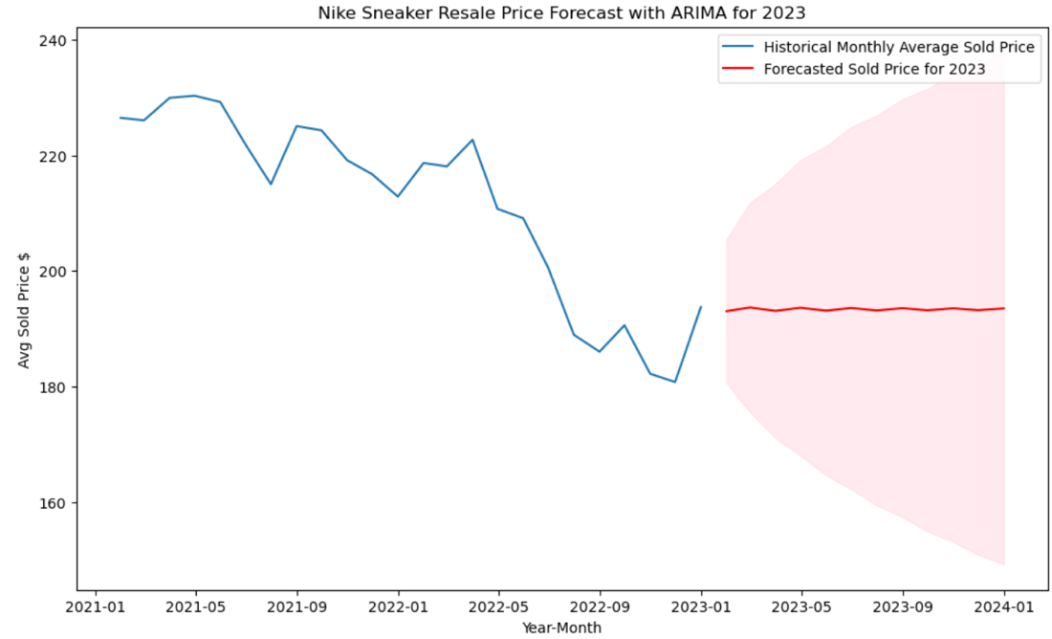

***Figure 14:*** *Forecast of ARIMA model on Nike for 2023*

For 2024 (Figure 15):

Similar to the forecast for 2023, the ARIMA model predicts a flat trend. The actual prices, however, display volatility, with a notable peak and subsequent drop. The model's forecast doesn't capture this movement, potentially underestimating market dynamics.

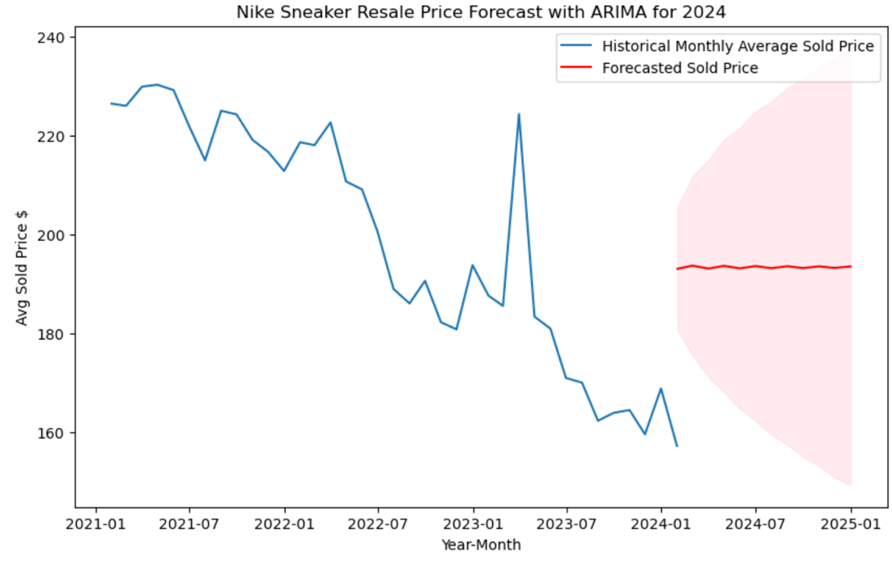

***Figure 15:*** *Forecast of ARIMA model on Nike for 2024*

The ARIMA model's RMSE for 2023 and 2024 forecasts remains consistent, suggesting that while the model's overall error rate does not significantly increase, it fails to account for the market's variability and potential for sudden price changes.

The ARIMA model's Root Mean Square Error (RMSE) stands at approximately 8.5, reflecting the average difference between the forecasted and actual values. While the RMSE indicates a relatively close fit, the inability to predict sudden market changes suggests a limitation in the model's design when facing volatile market dynamics.

**SARIMA Model Evaluation**

The SARIMA model accounts for both seasonality and the non-seasonal trends in the data, offering a more nuanced forecast.

For 2023 (Figure 16):

The SARIMA forecast acknowledges the declining trend in resale prices and adjusts its prediction accordingly. The wider confidence interval in 2023 indicates a higher level of uncertainty, reflecting potential market volatility that the model aims to capture.

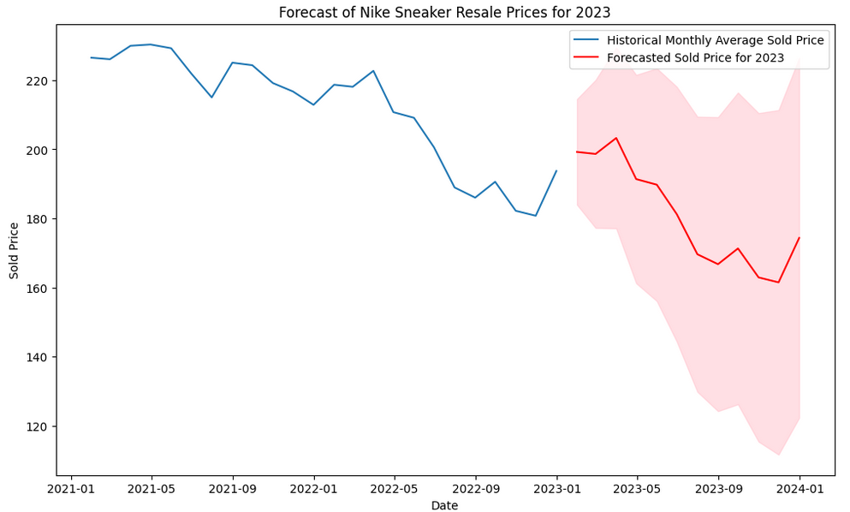

***Figure 16:*** *Forecast of SARIMA model on Nike for 2023*

For 2024 (Figure 17):

The forecast demonstrates a more responsive prediction to the historic spikes seen in the actual data, with the confidence interval capturing the potential variability. However, the SARIMA model's forecast overshoots the actual value around the peak in 2024, displaying a tendency to react to past volatility.

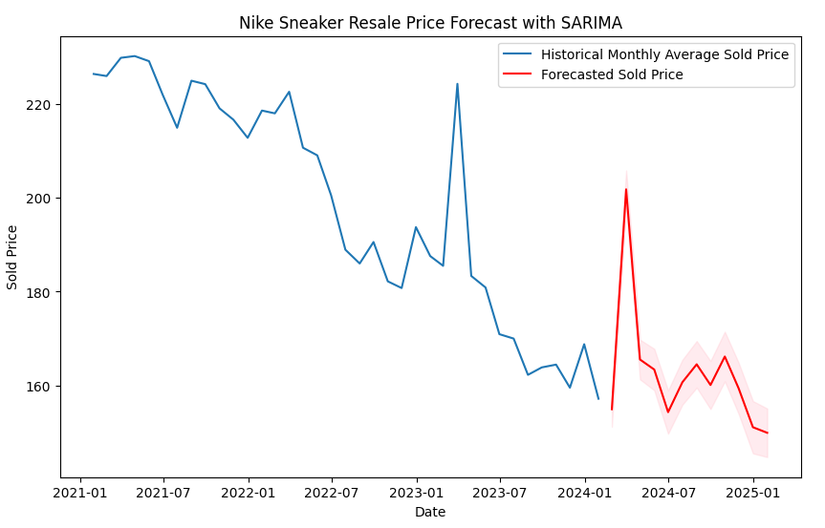

***Figure 17:*** *Forecast of SARIMA model on Nike for 2024*

The RMSE for the SARIMA model is slightly higher compared to the ARIMA model, suggesting that incorporating seasonality and trend does not necessarily translate to a lower error rate in this context.

**Comparative Analysis**

The ARIMA model (Figure 18) provides a more stable forecast across both years but at the cost of oversimplifying the future price trajectory. This could be misleading if stakeholders expect the model to indicate potential risk areas or opportunities based on price movements.

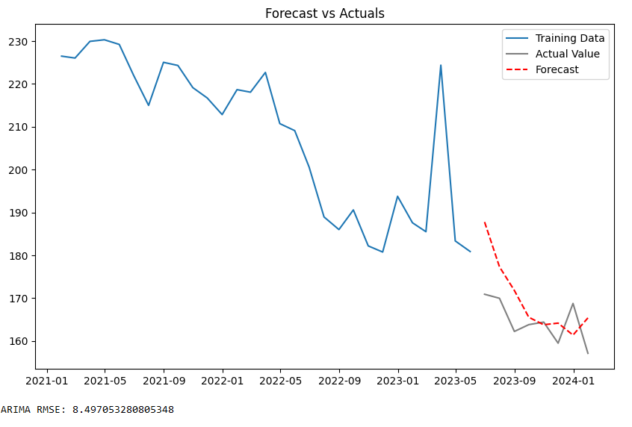

***Figure 18:*** *ARIMA Model Forecast vs Actual for Nike*

The SARIMA model (Figure 19) offers a more dynamic forecast that attempts to factor in seasonal variations and trends. However, the increased complexity does not result in a proportionate increase in accuracy, as the RMSE is marginally higher than ARIMA's.

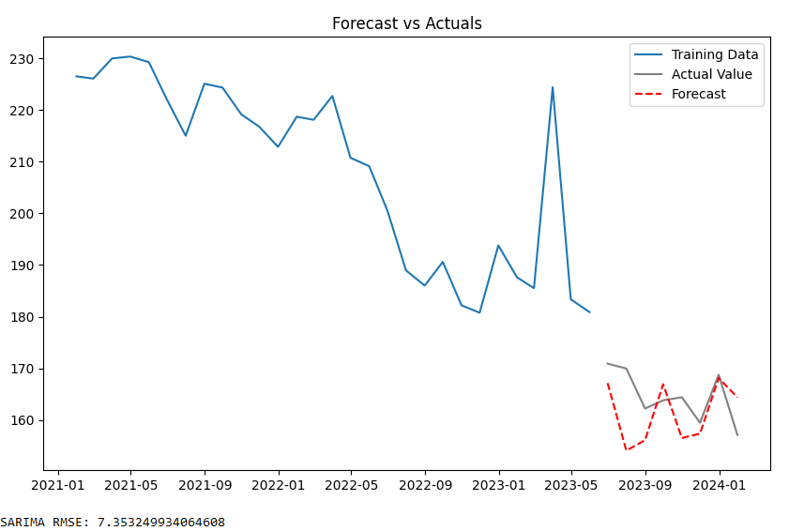

***Figure 19:*** *SARIMA Forecast vs Actual for Nike*

When comparing the models' performance, the choice between ARIMA and SARIMA should be made based on the stakeholder's need for stability versus responsiveness in forecasting. If the focus is on capturing broad trends and seasonality, SARIMA may be preferred despite its slightly higher RMSE. For applications where the smooth continuation of current price levels is assumed, ARIMA could be more appropriate.

# Prediction Model for Jordan Resale Price using ARIMA

Developing an ARIMA model for forecasting the Jordan brand sneaker resale prices involves analyzing both the decomposition of the time series into its components and the autocorrelation plots to inform the choice of ARIMA parameters.

**ARIMA Model Training**

As shown in Figure 19, the decomposition of the Jordan brand's resale prices allows us to break down the time series data into three main components: trend, seasonal, and residual.

***Figure 20:*** *Decomposition plot for brand Jordan*

Trend: The trend component shows a gradual decline over time, which is critical for the ARIMA model to capture. The negative slope of the trend suggests a decrease in prices that the model must account for, ensuring the long-term movements in prices are reflected in the forecasts.

Seasonal: The seasonal component is quite pronounced, displaying a pattern that repeats over a fixed period. This periodicity is crucial for setting the seasonal elements of the ARIMA model, which, in this case, may require a seasonal differencing to address the cyclic behavior apparent in the sneaker resale prices.

Residuals: The residuals should contain no discernible patterns if the trend and seasonal components are adequately modeled. The residual plot shows some fluctuation, indicating potential room for model improvement or the presence of additional variables not captured by the current model.

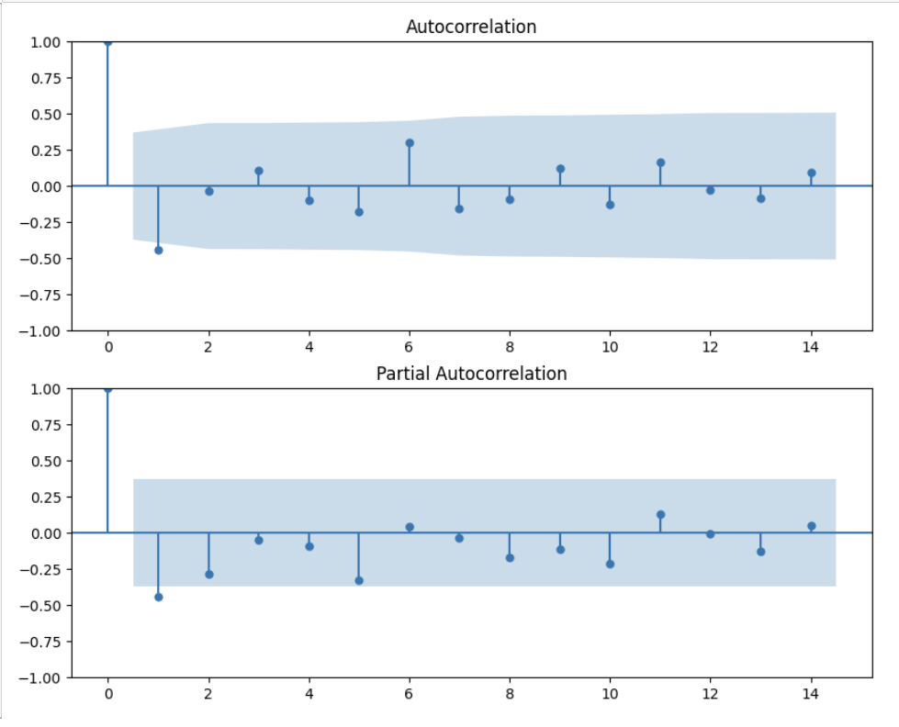

***Figure 21:*** *ACF and PACF plots for brand Jordan*

We applied an ARIMA (p=1, d=1, q=9) model to forecast the average sold price of products over time. This choice of parameters reflects the insights gained from examining the Autocorrelation Function (ACF) and Partial Autocorrelation Function (PACF) plots.

The parameter values (p=1, d=1, q=9) signify the following:

* p (autoregression order): 1, indicating that the model considers the immediately preceding value in the autoregressive component.
* d (differencing order): 1, suggesting that first-order differencing was applied to make the series stationery.
* q (moving average order): 9, implying that the model accounts for the last 9 lagged forecast errors in the moving average component.

This parameter selection aligns with the observed lack of significant autocorrelation in the ACF plot and the significant spike at lag 1 in the PACF plot. By incorporating these parameter values into the ARIMA model, we aimed to capture the underlying patterns in the data and make accurate predictions of the average product prices over time.

**ARIMA Model Testing**

After training, the model is subjected to rigorous testing to ensure its effectiveness in predicting future sneaker prices. The testing phase involves applying the trained ARIMA model to out-of-sample data, predicting prices beyond the timeframe used for training, and comparing these forecasts to actual observed prices to assess accuracy.

Performance metrics such as the Root Mean Square Error (RMSE) gauge the model's accuracy, with a lower RMSE indicating a better fit to the data. The model's forecasts are compared against the actual resale prices, examining whether the model successfully captures the downward trend and accounts for fluctuations suggested by the historical data.

Residual analysis is conducted to confirm that the model's assumptions hold and that the residuals display randomness, indicating a good fit. If systematic patterns are detected in the residuals, this would suggest the model could be further improved.

# Prediction Model for Jordan Resale Price using Holt-Winters

**Holt-Winters Model Training**

The Holt-Winters model is a triple exponential smoothing technique that accounts for level, trend, and seasonal variations within a time series. The training phase of the model involves calibrating these three components to the historical data.

Level: The model estimates the average level of the series, adjusting for any random variations.

Trend: The trend component is fitted to account for any increasing or decreasing patterns observed over time.

Seasonality: The seasonal component uses historical patterns to predict future fluctuations that repeat at regular intervals.

The residuals, which are the differences between the actual data and the model's fitted values, are crucial for assessing the model's fit. Residuals close to zero suggest a good fit, whereas large residuals may indicate a model misspecification or an opportunity for model refinement.

The residual plot shown in Figure 18 is used to assess the randomness of residuals post-model training. Ideally, the residuals should show no pattern, indicating that the model has captured all the systematic information in the data.

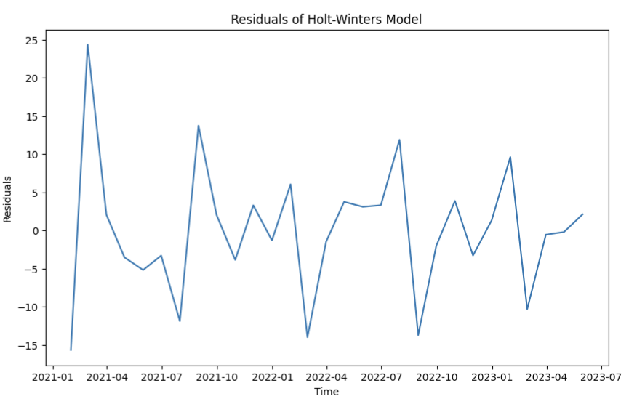

***Figure 22:*** *Residuals of Holt-Winters Model*

**Holt-Winters Model Testing**

Once the model has been trained, it is tested against unseen data to evaluate its predictive performance.

Out-of-Sample Forecasting: The model is used to generate forecasts for future periods not included in the training data.

Residual Checking: A new set of residuals is calculated by comparing the model's forecasts against the actual observed values. This step is crucial to ensure the model's predictive accuracy.

Model Performance Metrics: Metrics such as Mean Absolute Error (MAE), Mean Squared Error (MSE), or Root Mean Squared Error (RMSE) are used to quantify the model's forecast accuracy on the testing data set.

Diagnostic Checks: Additional diagnostic checks on the residuals, like the Ljung-Box test, may be used to check for autocorrelation in the residuals.

# Comparative Evaluation of Prediction Models for Jordan Resale Price

Upon examining the Autocorrelation Function (ACF) and Partial Autocorrelation Function (PACF) plots, we noticed specific patterns that informed my modeling decisions. The lack of significant autocorrelation in the ACF plot and a prominent spike at lag 1 in the PACF plot suggested that employing a first-order differencing might effectively remove any autocorrelation in the original series. This informed us about my choice of parameters for the ARIMA model.

***Figure 23:*** *Arima Monthly Forecast plot for brand Jordan*

The results of my ARIMA modeling (Figure 23) efforts yielded insightful performance metrics. The Root Mean Square Error (RMSE) of approximately 7.42 indicates the average difference between actual and predicted values, with lower values indicating better predictive accuracy. Similarly, the Mean Absolute Error (MAE) of around 6.06 measures the average magnitude of errors between predictions and actual values. Additionally, the Mean Absolute Percentage Error (MAPE) of about 2.79% expresses prediction accuracy as a percentage of actual values.

The chart (Figure 24) illustrates the performance of a Holt-Winters monthly forecasting model applied to a dataset representing the average sold price over time, spanning from January 2021 to January 2024. It's divided into a training set (blue), used for model fitting up to early 2023, and a test set (orange), representing unseen data beyond that point.

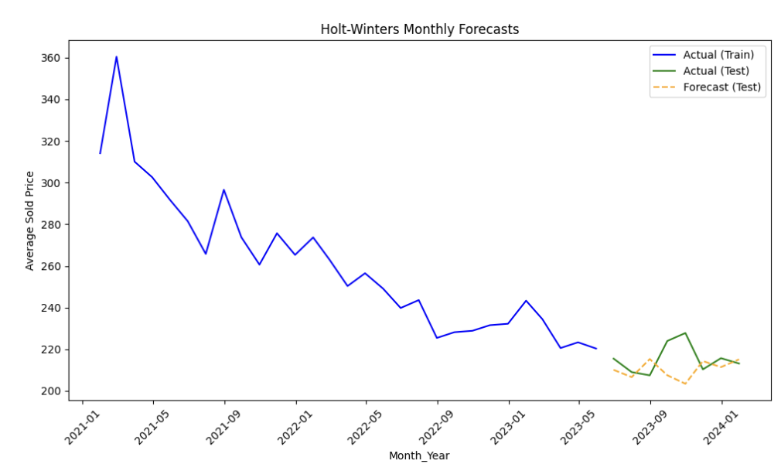

***Figure 24:*** *Holt-Winters Monthly Forecast for brand Jordan*

The dashed yellow line indicates the model's forecasts for the test period, generated from identified trend and seasonality components learned from the training data. However, the actual test data diverges from these forecasts from early 2023 onwards, suggesting the model's struggle to fully anticipate price variations.

Initial observation reveals a declining trend in average sold prices in the training data. While the forecast continues this trend initially, it fails to fully capture the variability observed in the actual test data. This indicates potential limitations in accounting for all influencing factors or unexpected market changes beyond historical patterns alone.

Regarding performance metrics, the Holt-Winters model exhibits an RMSE of approximately 11.18, an MAE of around 8.34, and a MAPE of about 3.79%. Despite these deviations, the model demonstrates reasonably good performance overall based on the provided error metrics.

The plot illustrates the residuals of a Holt-Winters forecasting model applied to Jordan brand data from January 2021 to July 2023. Residuals represent the differences between observed and predicted values. Ideally, these residuals would appear as random noise around zero, indicating accurate predictions.

Upon inspection, the plot shows no systematic pattern, suggesting no consistent bias in predictions like unaccounted seasonal effects. Sporadic spikes in residuals indicate occasional deviations between predicted and actual values, possibly due to irregular events.

For the Jordan brand, understanding these deviations is vital as they may relate to marketing campaigns, product launches, or seasonal trends impacting sales. The lack of a discernible pattern in residuals suggests the Holt-Winters model effectively captures the main aspects of the brand's performance.

# Prediction Model for Adidas Resale Price using SARIMA

Time series analysis is a powerful tool for understanding and predicting temporal patterns in data. In the domain of Adidas sneaker sale prices, we employ Autocorrelation Function (ACF) and Partial Autocorrelation Function (PACF) plots to decipher the underlying structure of the data and guide the specification of a suitable forecasting model.

**SARIMA Model Training**

The training of the predictive model for Adidas sneaker sale prices began with a detailed examination of the time series data through ACF and PACF plots to understand the underlying autocorrelation structure. The ACF plot revealed a rapid decay in correlation after the initial lag, indicating a potential for a non-seasonal ARIMA component. Meanwhile, the PACF plot exhibited a significant spike at the first lag with no further significant correlations, guiding us toward a possible AR(1) component for the model.

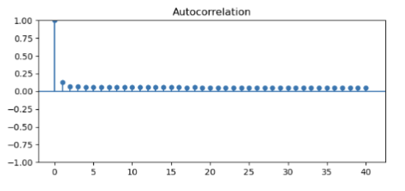

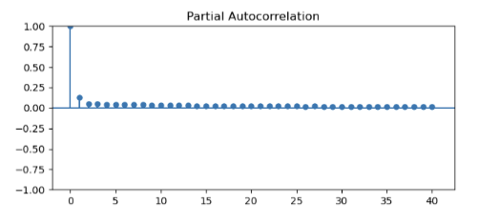

***Figure 20:*** *ACF and PACF plots for brand Adidas*

As part of the model training phase, the time series data for Adidas sneaker sale prices was decomposed to discern the trend, seasonal, and irregular components. The decomposition plot(Figure 21) highlighted a downward trend over the training period, suggesting a general decrease in sale prices that the model would need to capture. Seasonality was also evident, with patterns aligning with the expected timing of new releases and sales campaigns, which were incorporated into the SARIMA model's seasonal components.

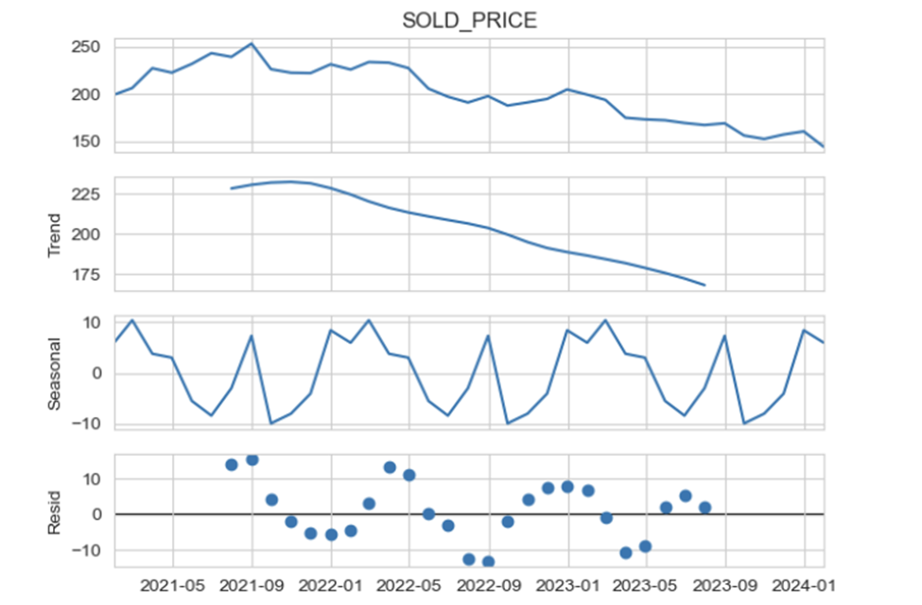

***Figure 21:*** *Decomposition graph for brand Adidas*

The analysis of the residuals, which are the errors of the model after accounting for trend and seasonality, provided evidence of an effective fit. Residuals appeared as random fluctuations around the zero line, suggesting that the model's non-systematic components were well-calibrated and that the model had successfully captured the essential dynamics of the time series.

**SARIMA Model Testing**

In the testing phase, the SARIMA model's accuracy was assessed using the remaining 20% of the time series data set aside for this purpose. This test dataset included unseen prices of Adidas sneakers to ensure that the model's predictive capabilities could generalize beyond the training data. During testing, the ACF and PACF plots were re-examined to ensure that the model's assumptions held on the out-of-sample data. The ACF plot maintained its characteristic drop-off pattern, and the PACF confirmed the absence of significant correlations beyond the first lag, consistent with the training data's characteristics.

# Comparative Evaluation of Prediction Models for Adidas Resale Price

After a thorough examination of both models' out-of-sample forecasting capabilities, the SARIMA model emerged with a slightly superior performance, particularly in capturing the nuances of the seasonality in Adidas sneaker prices.

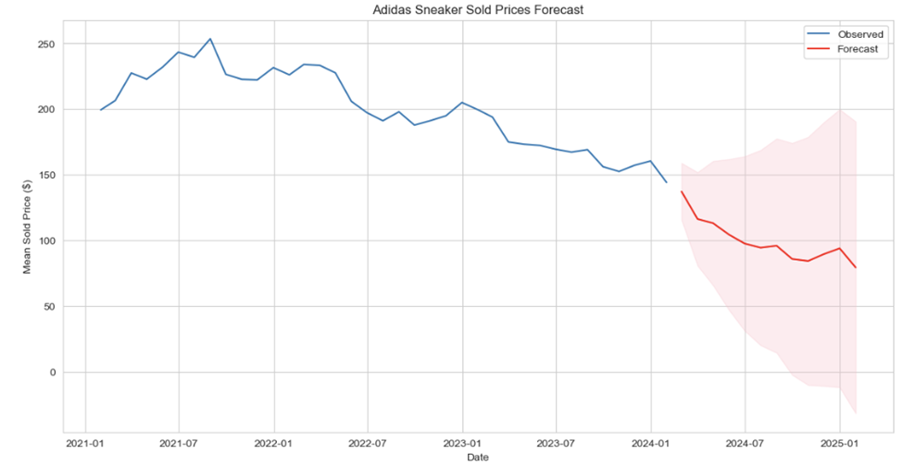

***Figure 27:*** *Forecast of Adidas Sneakers Resale Price for 2024*

This graph (Figure 27) represents the culmination of this modeling process. The historical prices, denoted by the blue line, show a clear trend and variability within the training dataset. Moving forward, the red line presents the forecasted prices for the years 2024 and 2025. These forecasts are based on the identified patterns in the historical data and project how Adidas sneaker prices might behave in the absence of external market changes or shocks.

The shaded area around the forecast line offers a visual representation of the 95% confidence interval, underscoring the forecast's precision and the level of certainty. This range indicates where future prices are likely to fall.

# Prediction Model for Converse Resale Price using SARIMA and Exponential Smoothing

For my modeling, we applied SARIMA (Seasonal AutoRegressive Integrated Moving Average) and Exponential Smoothing methods to forecast the resale price of Converse sneakers. The dataset was comprised of daily recorded sales, spanning from January 2021 to the latest data point.

**SARIMA Model Training**

We conducted a time series analysis on the resale price of Converse sneakers, commencing with a decomposition of the data to examine underlying trends, seasonality, and residuals (Figure 28). The trend component indicated a non-stationary series with variations over time, while the seasonality plot suggested periodic fluctuations likely tied to consumer buying patterns.

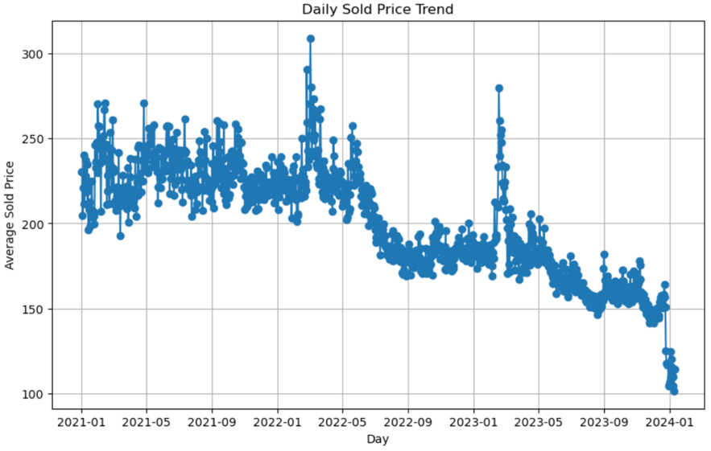

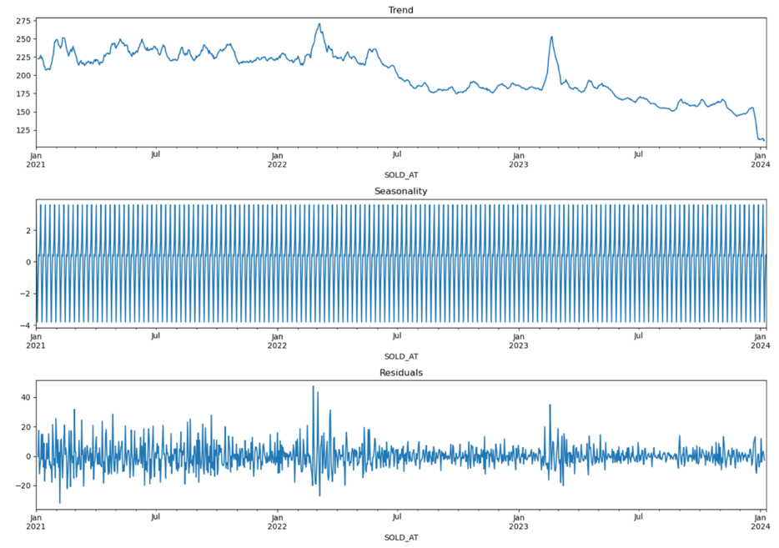

***Figure 28:*** *Decomposition graph for brand Converse*

**SARIMA Model Testing**

The Autocorrelation Function (ACF) and Partial Autocorrelation Function (PACF) plots (Figure 29) guided the SARIMA model specification by revealing autocorrelation in the series that SARIMA could account for.

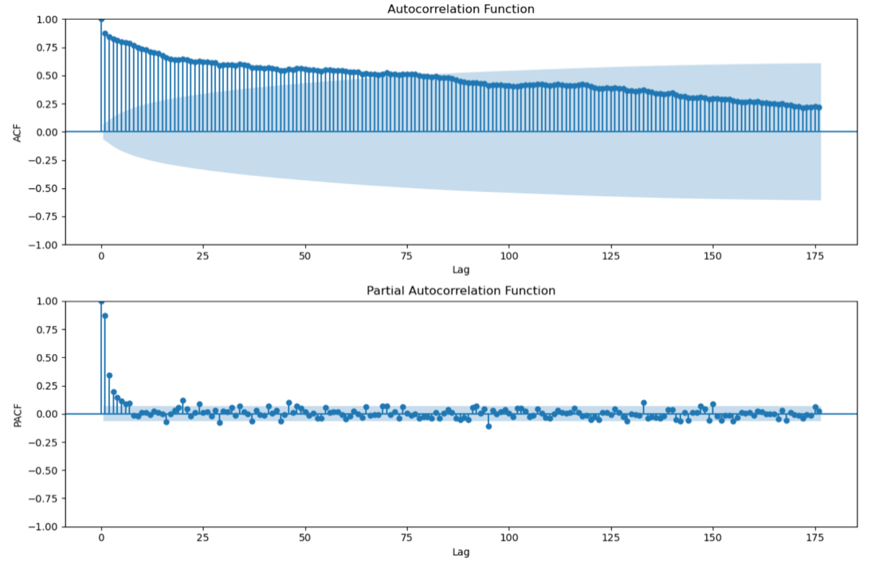

***Figure 29:*** *ACF and PACF plots for brand Converse*

The ACF shows a gradual decrease in autocorrelation as the lag increases, starting close to 1 and slowly tapering off. This pattern suggests a long-memory process or a non-stationary time series where shocks have a prolonged effect over time. There is no clear cut-off point, which is common in data that might require differencing to achieve stationarity.

The PACF shows a spike at lag 1, then the partial autocorrelations drop off quickly towards zero, remaining within the significance bounds. This suggests that the immediate past value (lag 1) has a significant correlation with the current value when the effects of the intermediary values are removed.

**Exponential Smoothing Model Training**

Simultaneously, an Exponential Smoothing model was trained on the same dataset, leveraging the weighted historical data to forecast future prices. This method assumes the recent observations have more weight in influencing the forecasts than the older ones, a reasonable assumption for the volatile sneaker market.

**Exponential Smoothing Model Testing**

The model's efficacy was evaluated against actual sales data, with the performance measured using standard forecasting accuracy metrics like MAE, RMSE, and MAPE. The results showed a close fit to the actual data, capturing the general trends and cyclical movements in sneaker resale prices.

# Comparative Evaluation of Prediction Models for Converse Resale Price

Both SARIMA and Exponential Smoothing models were assessed based on their forecast accuracy on the test data, representing the final 20% of my dataset. The forecast comparison graph (Figure 30) illustrates the predictive capabilities of both models against the actual resale prices. While both models adeptly tracked the price trends, the Exponential Smoothing model demonstrated slightly better accuracy with lower MAE, RMSE, and MAPE values.

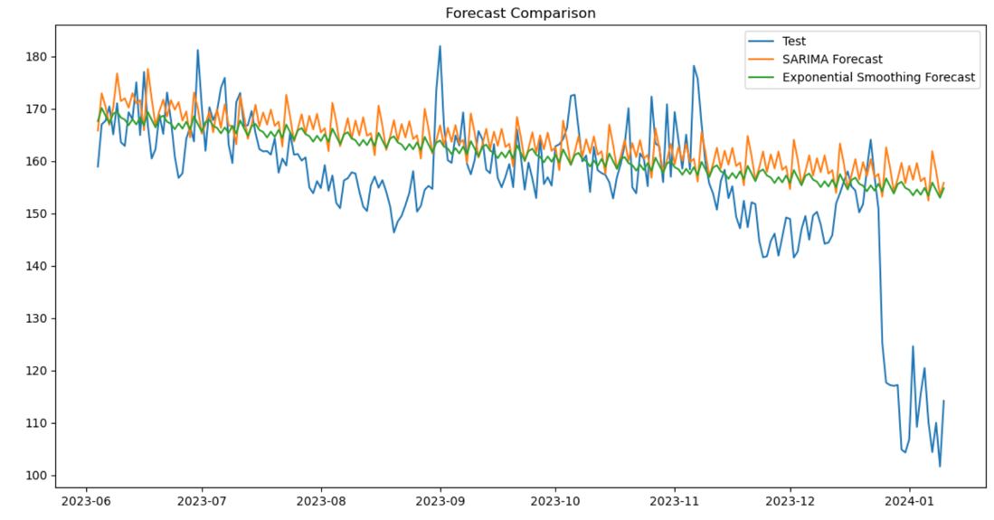

***Figure 30:*** *Forecast of Converse Sneakers Resale Price*

We recommend the Exponential Smoothing model for short-term forecasting due to its superior performance metrics and its ability to quickly adapt to changes, which is critical in the dynamic sneaker resale market. However, the SARIMA model's ability to capture the seasonal patterns in the data makes it an invaluable tool for long-term strategic planning and inventory management. Future iterations will focus on refining these models and exploring ensemble methods to leverage the strengths of both approaches for improved prediction accuracy.

# Prediction Model for New Balance Resale Price using SARIMA and Exponential Smoothing

The retail market for sneakers has displayed substantial volatility, influenced by various economic factors, brand releases, and market demand. As part of my analytical approach, we scrutinized the resale prices utilizing SARIMA and Exponential Smoothing forecasting techniques.

**SARIMA Model Training**

We began by applying a SARIMA model to understand and forecast the pricing trends based on historical data. Given the complexities inherent in resale pricing, characterized by noise and sudden market shifts, we employed the SARIMA model for its robustness in handling non-stationary data with underlying seasonal patterns.

We undertook a decomposition of the series (Figure 31), revealing a declining trend across the observed timeline. This decomposition allowed us to understand the distinct components influencing the pricing: trend, seasonality, and random fluctuations, which SARIMA models are adept at capturing.

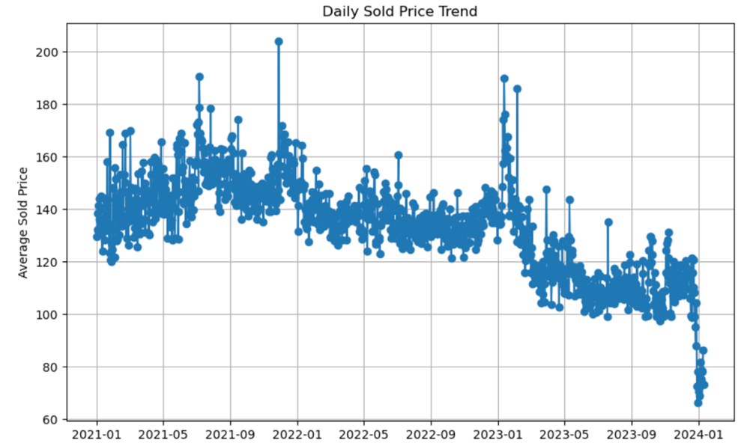

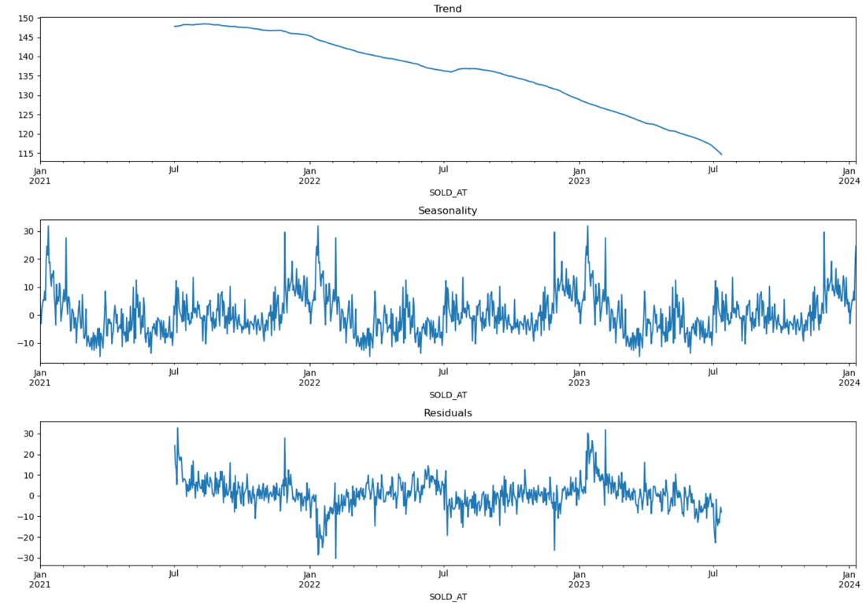

***Figure 31:*** *Decomposition graph for brand Converse*

The ACF and PACF plots (Figure 32) were instrumental in selecting the initial parameters, suggesting the presence of an AR(1) component.

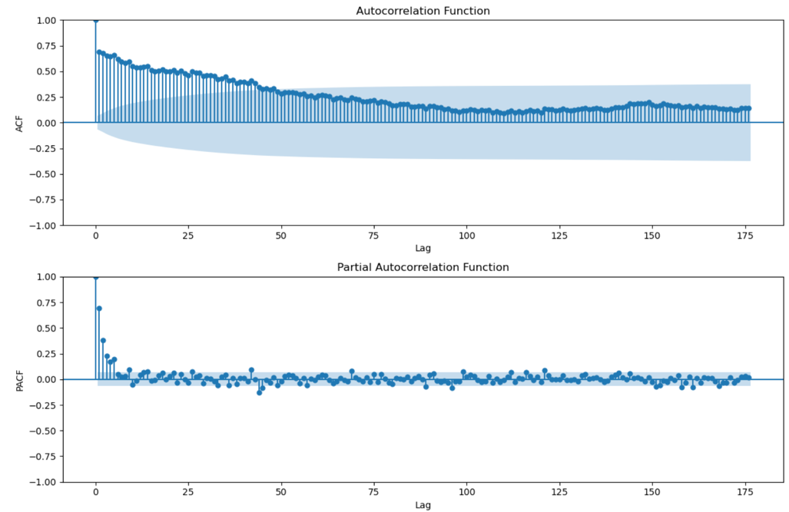

***Figure 32:*** *ACF and PACF plots for brand New Balance*

Like the "Converse" ACF plot, we see a gradual decrease in autocorrelation as the lag increases. This pattern is indicative of a non-stationary process where past values have a diminishing but prolonged impact on future values. The PACF plot, like the "Converse-" PACF plot, shows a significant spike at lag 1, which then diminishes rapidly to near zero and remains within the significance bounds, suggesting that only the most recent past value has a direct effect on the current value.

My training involved calibrating the SARIMA model using 80% of the dataset, iteratively adjusting the parameters to minimize the AIC and BIC, thus optimizing the model's performance. The time series data, split into training and validation sets, underwent rigorous analysis, with model assumptions continually evaluated via diagnostic checks to ensure the residuals conformed to white noise, indicating an adequately specified model.

**SARIMA Model Testing**

Transitioning to model validation, the SARIMA model's predictive capacity was put to the test on the remaining 20% of the data, representing the most recent sales information. The effectiveness of the model was gauged against actual sales figures, providing an empirical basis to assess its forecasting prowess.

The results from the SARIMA model were promising, reflecting a considerable degree of accuracy when juxtaposed with the actual resale prices. Although slight deviations were observed, potentially attributable to outliers or unaccounted variables, the model demonstrated commendable predictive performance. This was evident in the convergence of the forecasted and actual values, underscoring the model's capability in capturing the principal dynamics of the series. However, as with any model dealing with volatile market data, caution was exercised in interpreting the results, recognizing the limitations posed by external market shocks and trends not encapsulated within the historical data.

**Exponential Smoothing Model Training**

Concurrently, we trained an Exponential Smoothing model for the New Balance sneaker resale prices. This model, with its foundational premise that more recent observations have a higher predictive influence, was selected for its simplicity and effectiveness in various forecasting scenarios, particularly where data exhibits a level of volatility.

The training of the Exponential Smoothing model followed a systematic approach, employing weighted averages and smoothing constants optimized through a process of trial and error, guided by the error metrics from the validation set. By contrasting the smoothed values with actual sales figures, we refined the model parameters to achieve the least error, thus tailoring the model closely to the unique characteristics of the New Balance data.

**Exponential Smoothing Model Testing**

The testing phase for the Exponential Smoothing model involved applying the trained model to the test set. The forecast generated by the model was overlaid onto the actual resale prices to visually and quantitatively measure its accuracy. The forecast produced by the Exponential Smoothing method was found to closely track the test data, suggesting a high level of reliability for near-term forecasting.

# Comparative Evaluation of Prediction Models for New Balance Resale Price

The forecast capabilities of my models were evaluated through a comparison of their predictions against the actual resale prices of New Balance sneakers. As depicted in Figure 33, both the SARIMA and Exponential Smoothing models were able to capture the general trend of the data, though with varying degrees of accuracy. The evaluation metrics presented below Figure 26 demonstrate that the Exponential Smoothing model achieved a lower MAE, RMSE, and MAPE compared to the SARIMA model, suggesting a better fit to the test data. These results highlight the strengths of using Exponential Smoothing for modeling the resale price of sneakers where recent trends carry more predictive weight.

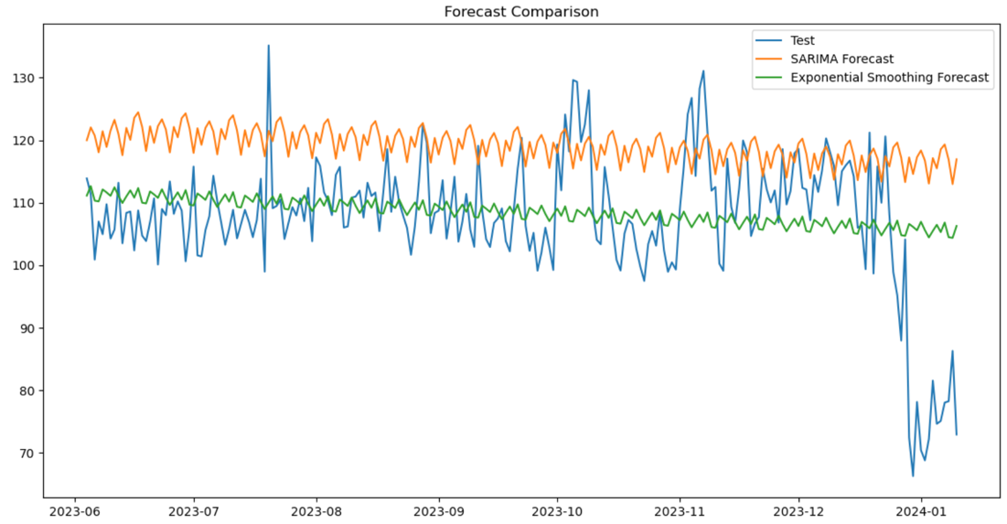

***Figure 33:*** *Forecast of New balance Sneakers Resale Price*

Based on these findings, we recommend the Exponential Smoothing model for short-term forecasting due to its superior performance metrics. However, for long-term forecasting or for capturing the effect of external factors that might impact trends more significantly, the SARIMA model's comprehensive approach to integrating seasonality may offer valuable insights.

# References

1. Retail Insider. (2024, February 5). *Predictive analytics: Forecasting future trends in retail*. <https://retail-insider.com/articles/2024/02/predictive-analytics-forecasting-future-trends-in-retail/>
2. Keara Dowd(2023, May 5). *How predictive analytics in retail works*. Technology Solutions That Drive Business. <https://biztechmagazine.com/article/2020/03/guide-predictive-analytics-retail-perfcon>