***Problem Definition***

Given a 15-word vector/ sentence we need to show which language does this belong to from Dutch & French

***Dataset***

Text data was obtained from Gutenberg project, it is present in the Dutch & English folders.

We use dataset_maker.py to make testing & training data.

For making training dataset,

Type ’python3 dataset_maker training <source_path> <language_of_source_file(en/nl)> <output_path>’

For making testing dataset,

Type ’python3 dataset_maker training <source_path> <language_of_source_file(en/nl)> <output_path_of_test_cases> <output_path of test_labels>’

Additionally, I make use of dutch_stopwords.txt & dutch_stopwords.txt for my feature formation. The path to them was hardcoded in the start of train & predict methods in lab2.py. Please, change it accordingly to run.

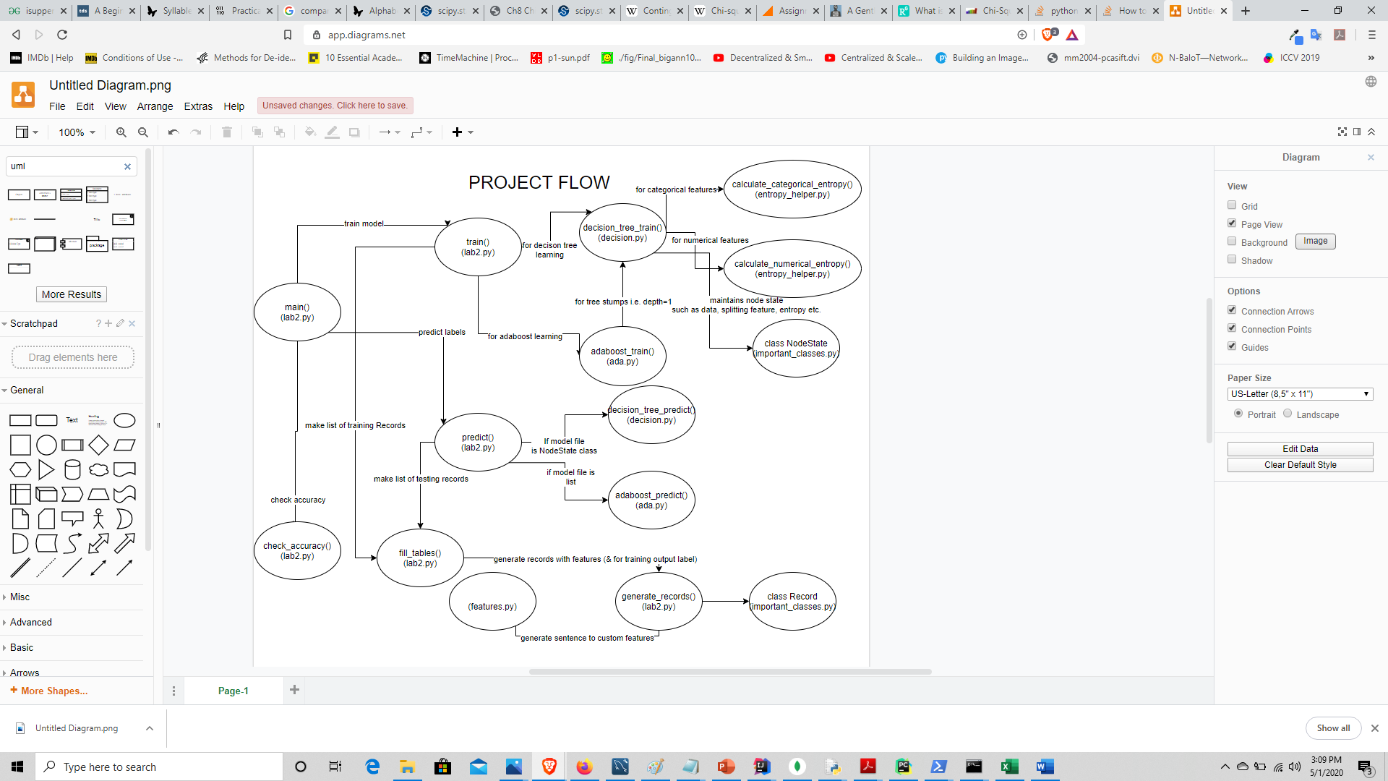

***Features***

|  |  |  |  |
| --- | --- | --- | --- |
| *Feature* | *Description* | *Feature Type* | *Reason for use* |
| Dutch stopword checker | Checks from a list of dutch stop words(dutch_stop_words.txt required). | Categorical | Chances of them being present is high & they indicate for Dutch language |
| English Stopword checker | Checks from a list of english stop words(english_stop_words.txt required). | Categorical | Chances of them being present is high & they indicate for English language |
| Length of longest word | Check for length of longest word in each sentence. | Numerical | Dutch contains compound words which end up being longer |
| Weird ascii char checker | Presence of non-english like alphabet symbols. | Categorical | Dutch contains extra alphabets |
| Longest streak consonants | Length of Longest continuous sequence of consonants. | Numerical | English or dutch will surely have longer consonant. |
| Longest streak vowels | Length of Longest continuous sequence of vowels. | Numerical | English usually has less than 3 vowels at a time. |
| Percent frequency of c | Percentage of c from the all alphabets used. | Numerical | Dutch has lower frequency of c |
| Percent frequency of k | Percentage of k from all alphabets used. | Numerical | English has lower frequency of k |
| Average word length | Average length of word  For each sentence. | Numerical | Due to compound words average word length is higher in dutch. |
| Average letter distribution | Takes the ordinal values of alphabets, sums them up & averages them. | Numerical | It helps in finding a estimate of distribution |

They are defined in features.py

For categorical features, my code will allow multiple categories for testing, for numerical features my code will sort by feature value & then find optimal split value.

Categorical features are never considered again down the tree, but for numerical I have allowed for new split threshold for the corresponding data values to be made.

For future scope we can make use of monogram, bigram & diagram distributions and do a chi square goodness of fit test for comparing observed & expected frequency so as to get an estimate of the p-values for rejecting null hypothesis for both languages. A test implementation (not used in current features) of how it will look like is present in features.py (monogram chi test).

***Decision Tree Learning***

The decision tree allows for max depth cutoff as well as max entropy cut off (i.e. lower prefered) which is set in set in lab2.py in train().

My decision tree works on two different types of data, numerical and categorical.

It has been implemented as a stack. Given a minimum accuracy(upto which to be trained) for the dataset, I estimate the cutoff value for entropy. The algorithm can be seen as a bfs.

For numerical data I first perform a sorting operation, post which it could possibly be split into two categories-less than a splitting value and greater than the splitting value. Where each split value is the mean of feature value of successive records in the sorted data.

Information Gain, split value = ${arg⁡_max}_{Information Gain}^{} H\left(Target\right)- \frac{i *Entropy\left(Output | feature value<split value\right)+(Dataset_{size}-i) *Entropy\left(Output | feature value≥split value\right) }{Dataset_size}$

Where i from 1 to data_set size-1.(First & Last no need to check since they don’t make a split.)

For categorical data ,

Information Gain = ${arg⁡_max}_{Information Gain}^{} H\left(Target\right)- \sum_{each value of the feature}{P(feature value)*Entropy\left(Output | feature value\right)}$

We consider of all **these** (present in the that tree node) features for selecting the splitting feature.

For predicting I have iteratively traversed the model for each feature for the testing record & return the plurality value for that leaf node(There are no 0 record nodes created, so we don’t need to check for parent).

For training the code can be run as

’python3 lab2.py training <training_source_path> <hypothesis_output_path> <output_path_of_test_cases> dt <dutch_stopwords_path> <English_stopwords_path> ’

For predicting labels

’python3 lab2.py testing <testing_model_path> <testing_data_path> <predicted labels path> <dutch_stopwords_path> <English_stopwords_path> ’

***Boosting***

For adaboost I make use of n(=30, set in lab2.py in train()) estimators. I make use of decision tree of depth 1 for each weak classifier. Later we could improve by taking decreasing amount of depths. I have put an additional smoothening value of 1/data_set size & the formula for significance becomes significance = 0.5 $\log_{10}^{}(\frac{1-error_{rate}+epsilon}{error_{rate}+epsilon})$* . This solves the error_rate = 0 condition.

Algorithm for training.

Repeat For ith estimator:

Find a decision tree stump of depth 1

Find the count of erroneous records for each split branches

Calculate error rate by adding these count and dividing by dataset size.

Calculate significance alpha.

Now initial sample weight value was 1/data_set size.

For each record in the current data update is value as

W = W $e^{-alpha}$* , for correct values

W = W $e^{alpha}$* , for wrong values

Normalize these weights.

Find the cumulative weights.

To make the new dataset, for each ith record (i goes till initial data_set size),

Randomly select a value between 0 & 1. Then use binary search to find the the record with smallest cumulative weight greater than that value.

Algorithm for predicting.

Set y = 0

Repeat For ith estimator:

Find decision tree prediction of stump

For English add the stump’s significane value to y & substract it otherwise.

If y greater than 0 return English, else return French.

For training data

’python3 lab2.py training <training_source_path> <hypothesis_output_path> <output_path_of_test_cases> dt <dutch_stopwords_path> <English_stopwords_path> ’

For predicting labels

’python3 lab2.py testing <testing_model_path> <testing_data_path> <predicted labels path> <dutch_stopwords_path> <English_stopwords_path> ’

***Accuracy***

|  |  |  |
| --- | --- | --- |
|  | Decision Tree | Adaboost |
| Accuracy limit for training | 0.99 | - |
| No of estimators | - | 30 |
| Test Size | 1659 | 1659 |
| Accuracy | 95.05 | 94.87 |
| False ‘en’ | 43 | 43 |
| False ‘nl’ | 39 | 42 |