**Introduction**

This project focuses on processing data API and mashup data, inserting it to NoSQL database (MongoDB), and then querying. For convenience I had made web- UI to facilitate all these tasks. I have used Django as the backend and React.js as the front end.

**Pre-processing**

In this assignment the file is read using the pandas library, date-time values are fixed, list items are loaded as comma-separated strings(Django models are problematic when loading he array fields) and finally empty NaN values are replaced by empty strings. This takes place for the API and Mashup data. Then 2 collections are put inside mongodb- Mashup and API.

**Pre-requisite Libraries.**

Python= pandas, django, django-cors-headers, djangorestframework, djongo, tqdm

Node= node & npm packages, run ‘npm install’ inside the front-end directory or refer to package.json.

MongoDB

**How-to-run**

1. Go to the WSDashBoard folder, run ‘python manage.py migrate’.
2. Then start the back-end server by using ‘python manage.py runserver 8080’, which starts the backend at port 8080.
3. Go to the frontend folder, run ‘npm start’.
4. Then open your browser and open ‘http://localhost:3000’.

**P. T. O**

**Website Design**

This is Home page of the website, since this is not a fresh run we have remaining data from previous runs, hence the records.

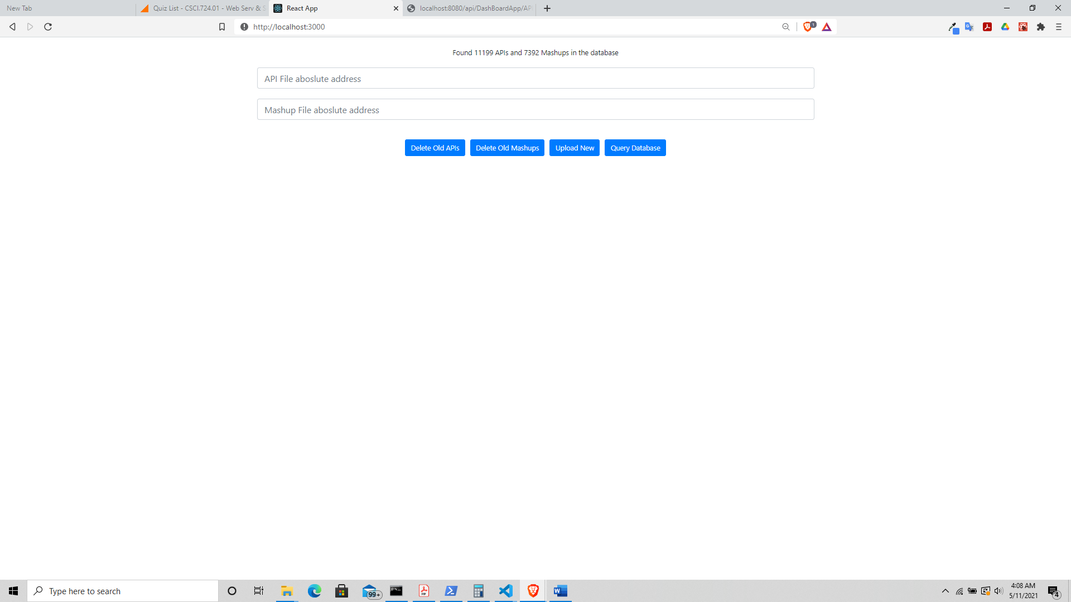

Deleting old API’s and Mashup’s by pressing the respective buttons.

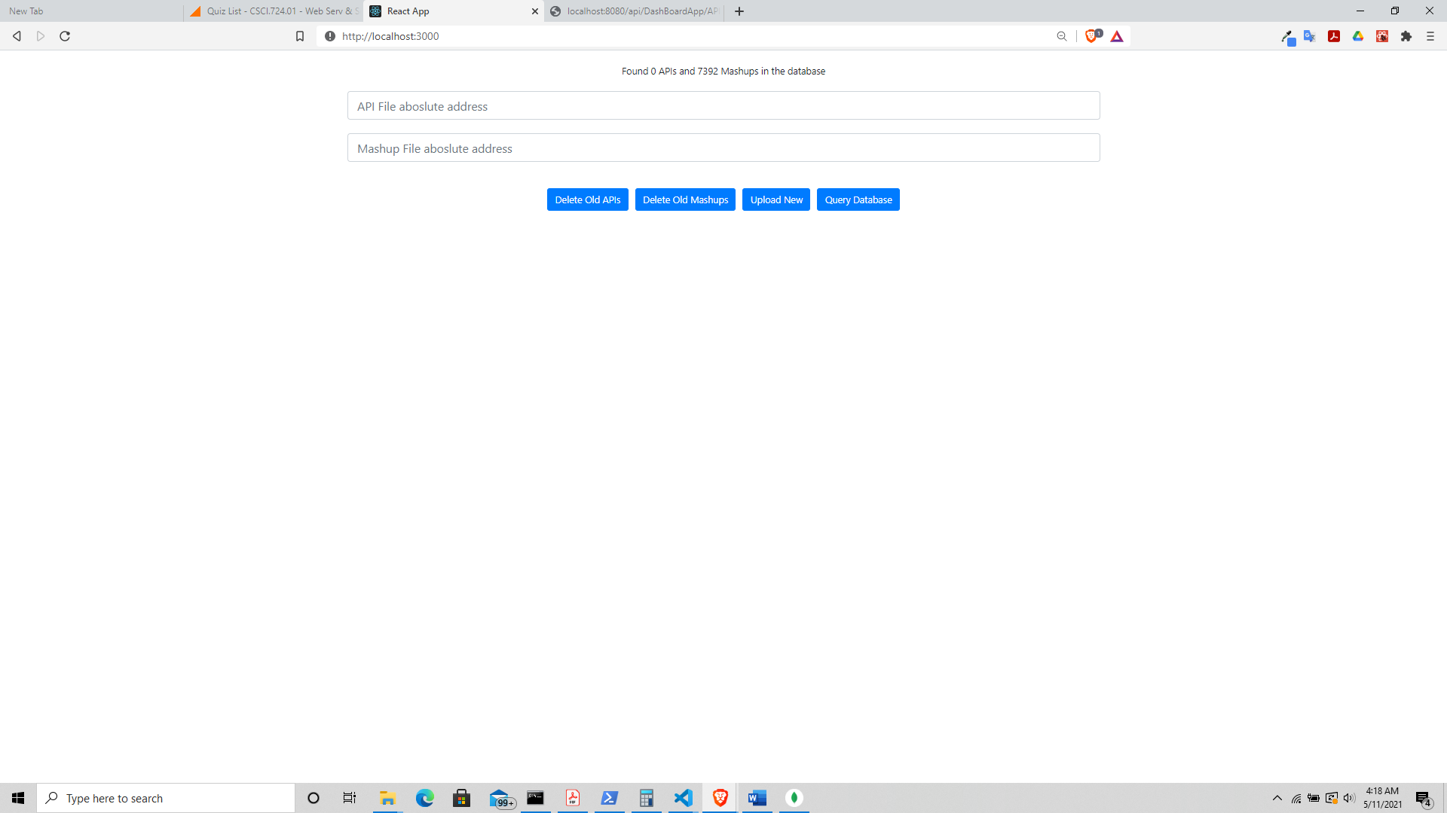

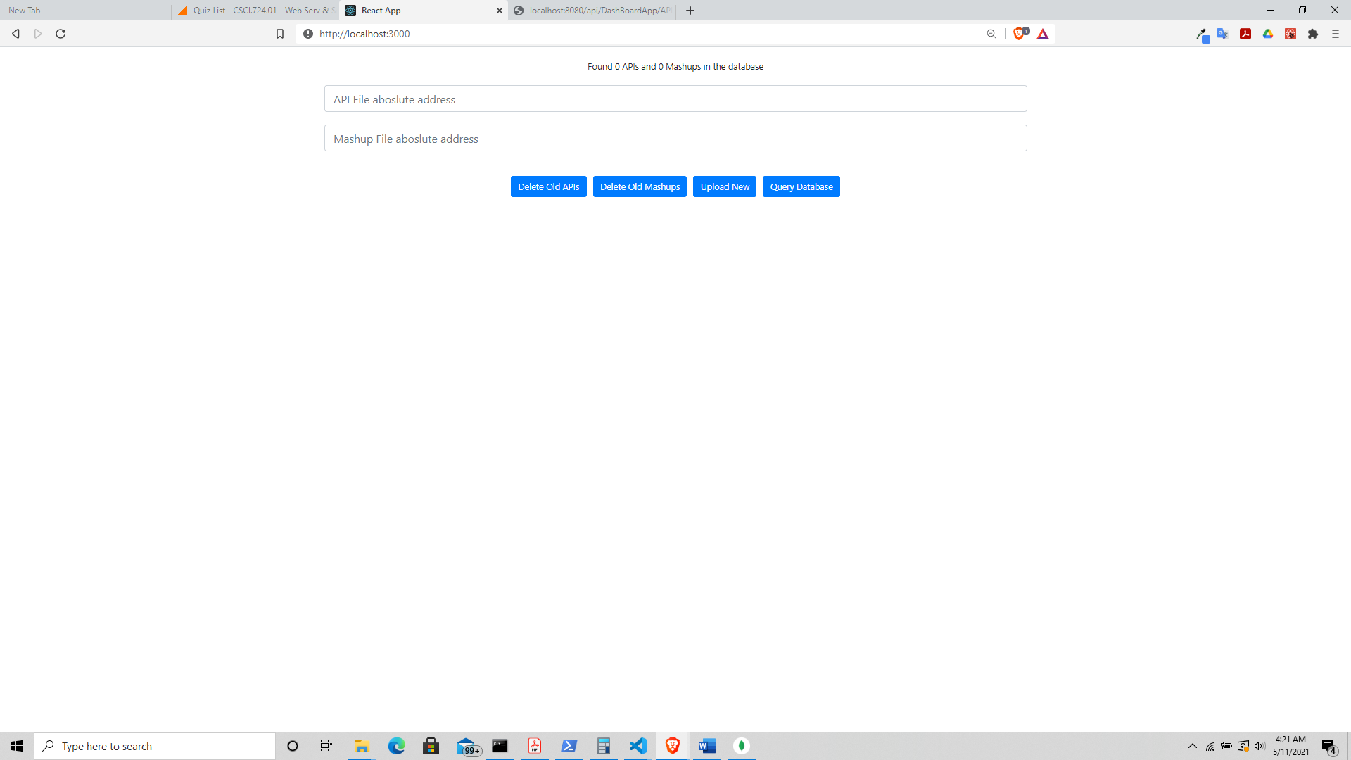

Refilling the databases by giving absolute paths. More data can also be added later subsequently.

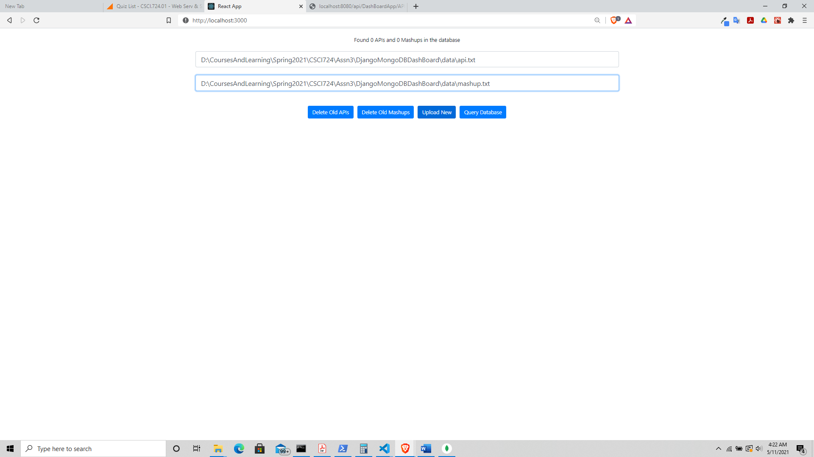

Data added, going to query the database.

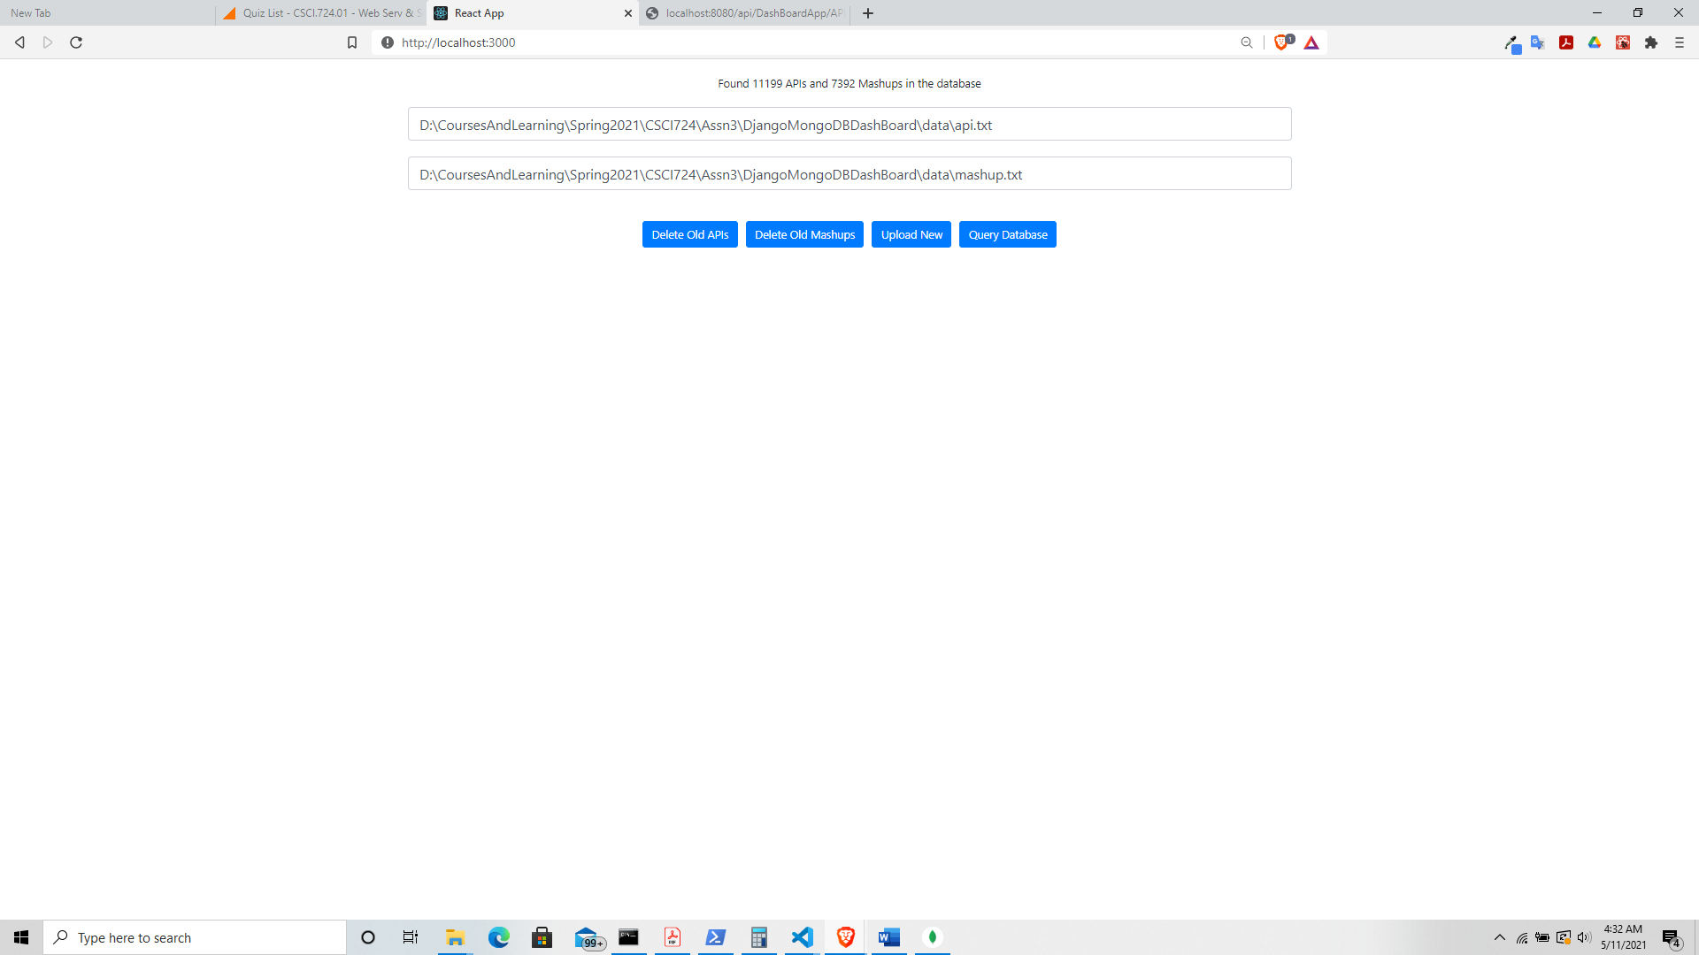

A lot of the query columns have drop down options to select from.

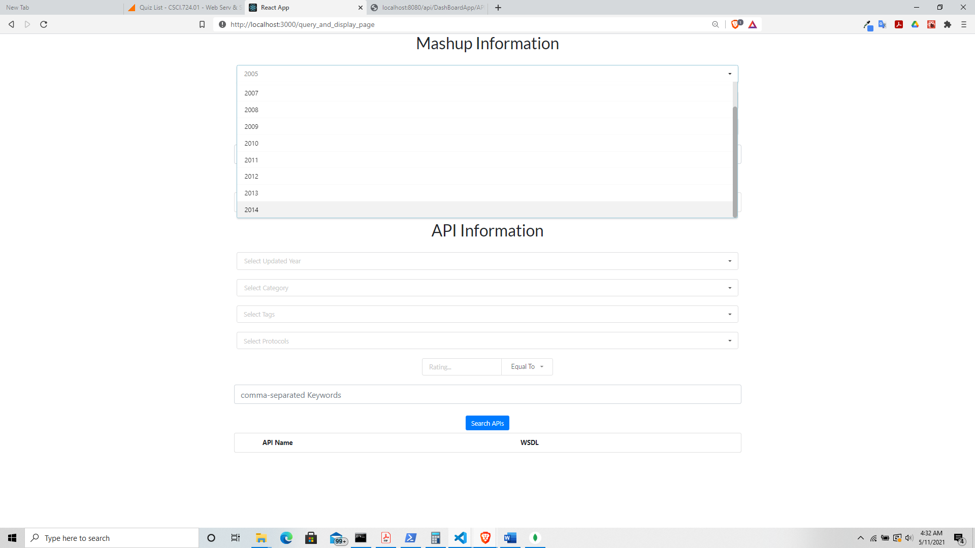

Some items like Tags, API Names etc. allow multiple search selection. The result is two columns the API/Mashup Name and their WSDL/url-link.

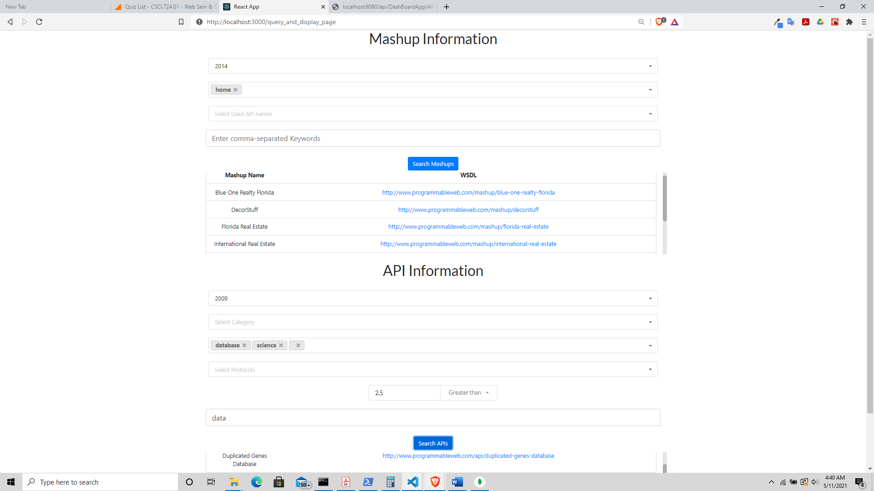

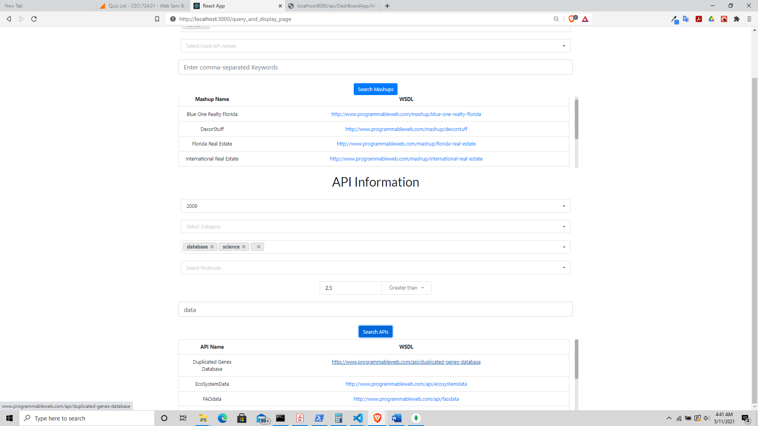

Proof of data having been entered using the Django backend.

