Software Requirements Specification

for

NU Hostel Tour

**Version 1.1 approved**

**Prepared by Rishabh Shah**

**Kenneth Prabakaran**

**Sachin Kumar**

**NIIT University**

**19-09-2018**

**Table of Contents**

**Table of Contents**

**Revision History**

**1. Introduction**

1.1 Purpose

1.2 Document Conventions

1.3 Intended Audience and Reading Suggestions

1.4 Product Scope

1.5 References

**2. Overall Description**

2.1 Product Perspective

2.2 Product Functions

2.3 User Classes and Characteristics

2.4 Operating Environment

2.5 Design and Implementation Constraints

2.6 User Documentation

2.7 Assumptions and Dependencies

**3. External Interface Requirements**

3.1 User Interfaces

3.2 Hardware Interfaces

3.3 Software Interfaces

3.4 Communications Interfaces

**4. System Features**

4.1 System Feature 1 – Creating a Profile

4.2 System Feature 2 - Login

4.3 System Feature 3 - Logout

4.4 System Feature 4 - Room Search by room number

4.5 System Feature 5 - Search for room based on features

4.6 System Feature 6 - View Room Structure

4.7 System Feature 7 - Signal Test

4.8 System Feature 8 - Giving Feedback for a room

4.9 System Feature 9 - Free roam

4.10 System Feature 10 - View Metadata of the rooms

4.11 System Feature 11 - Know your Neighbor

4.12 System Feature 12 - Bug Report

**5. Other Nonfunctional Requirements**

5.1 Performance Requirements

5.2 Safety Requirements

5.3 Security Requirements

5.4 Software Quality Attributes

5.5 Business Rules

**6. Other Requirements**

**Appendix A: Glossary**

**Appendix B: Analysis Models**

**Appendix C: To Be Determined List**

**Revision History**

|  |  |  |  |
| --- | --- | --- | --- |
| **Name** | **Date** | **Reason For Changes** | **Version** |
| Rishabh Shah | 15/09/2018 | Initial Draft | 0.1 |
| Kenneth Prabakaran | 16/09/2018 | Added features 4.1, 4.2, 4.2 | 0.2 |
| Sachin Kumar | 18/09/2018 | Added feature 4.4 and 4.5 | 0.3 |
| Rishabh Shah | 19/09/2018 | Added Safety and Performance requirements | 0.4 |
| Sachin Kumar | 19/09/2018 | Added Safety requirements and operating systems | 0.5 |
| Rishabh Shah | 20/09/2018 | Added feature 4.6, 4.7 and 4.8 | 0.6 |
| Kenneth Prabakaran | 20/09/2018 | Added feature 4.9, 4.10 | 0.7 |
| Sachin Kumar | 21/09/2018 | Added more non-functional requirements | 0.8 |
| Kenneth Prabakaran | 21/09/2018 | Added External Interface Requirements | 0.9 |
| Rishabh Shah | 23/09/2018 | Added feature 4.11 and 4.12 | 1.0 |
| Group | 23/09/2018 | Finalized Draft | 1.1 |

# Introduction

## Purpose

This Android Application will provide the 3D map for the hostels in which you would be able to free roam and see the infrastructure of the Hostels and rooms. It will have specific information about every room like the cell reception, Wi-Fi signal, proximity to washrooms, etc. It will have models for different room types. It will extend to all the hostel buildings (UG1, UG2, PG1, PG2). It will not only help students while reserving their room but the parents for know their child’s neighboring students, the faculty to know the resident of a particular room without looking into registers too. This app will automate a lot of things and will make life easier.

## Document Conventions

The document uses Arial font for headings (size-14) and Arial font for the body (size-11).

## Intended Audience and Reading Suggestions

This software is intended for everyone who has problems regarding the location of the rooms and have limited information around their room. The software depicts the campus infrastructure at NIIT University in a 3D model and a character with a first person camera settings for easy maneuvering. The software being in the form of a game is easy to understand, so there are no reading suggestions.

## Product Scope

As a student I always had the problem when choosing my room for my next year. While choosing our rooms we don’t have the basic knowledge about the location of nearby facilities like Washroom. On times, when our parents want to know the students residing around us we become numb as we don’t know our neighbours. I had this problem of very weak cell reception in my room in 3rd Year which could be avoided if I knew the problems I will face in the room. This app is the solution to all the problems for all the students be it the present ones or the ones coming in future.

## References

Srs_template-ieee.doc.

# Overall Description

## Product Perspective

NU Hostel Tour is a mobile application for Android Devices. It uses Unity3d which is a game engine to show the tour. It will help the user to experience the infrastructure of buildings in NIIT University on mobile.

## Product Functions

NU Hostel Tour provides users the following functions/features:

* let’s the user roam around the building of Hotels
* Search for particular rooms
* Sort the rooms on chosen parameter by the user
* Check certain features of a particular room like proximity to facilities, cell reception, etc.
* Submit log for Wi-Fi and cell phone reception

## User Classes and Characteristics

For version 1.0 there will be two types of users:

* User

This can be a student, teacher, parent, etc. They will have all the features of the application available to them. They can free roam, search for a room, Test and submit signals to the database, etc.

* Admin

Admins will also have all the features of the app with additional features of updating the signal tests for rooms, changing proximity, etc. The admin privilege will be given to the developers, course instructor and dean student affairs.

## Operating Environment

NU Hostel Tour will run on phones having Android Operating systems with the following specifications:

* Android OS 6.0 or more
* 2 GB Ram
* Processor: Snapdragon 425 or greater or Helios A22 or greater or Kirin 970

## Design and Implementation Constraints

If a phone has Android OS above 6.0 but doesn’t have 2GB ram or more app will have some lag in the free roam. The backend database which contains data for the rooms and signal test is kept in firebase which is relatively slower than others services.

## User Documentation

In-app guide tour will be provided when the application is run for the first time by the user.

There will be a help guide provided in a menu for the user which will instruct them to perform any task they have liberty to do so. For any other queries they will be able to email the developers to guide them through their problem.

## Assumptions and Dependencies

NU Hostel Tour makes the following assumptions:

* We assume that the user has access to an Android mobile device and clears the minimum requirements.
* We assume that the user is aware of common functionalities of Android mobile devices.
* We assume that the user has internet access.

# External Interface Requirements

## User Interfaces

User interface of our application will be easy to use and understandable. Moreover, the user is expected to know how to use Android mobile devices and to be able to write and read messages (for feedback) and use buttons. User interfaces are explained in details below:

**3.1.1 Login Interface**

In this interface, there will be a button register. If user have not registered to the application, she/he will use register button and register to it. Having two text fields one for username and password, and a login button to access the application.

**3.1.2 Register Interface**

In this interface user register to the system by giving information of himself in a provided text field. There will be a button register. After user filled the required fields with his/her related information (username, name, password, gender, batch, program, university email id), click to the register button and be able to login the application.

**3.1.3 Roam Mode Interface** In this interface, there will be a 3D environment for our character to freely roam as per user control. Having a directional keys for controlling the movements of the character and the view angle control for changing the view angle.

**3.1.4 Navigation interface**

This interface is used to access the rest of the features like searching the room, conducting tests, sending feedbacks, reporting bugs.

**3.1.5 Searching the room interface**

This interface consists of text boxes for taking the room number as input to search a particular room. And consists of some checkboxes to filter the rooms as per the users’ conditions.

**3.1.6 Feedbacks and Bug reports Interface**

Both of them would consists of a drop down menu containing categories and a message box to report or comment in them. And a submit button below.

## Hardware Interfaces

The application is intended to be a stand-alone, single-user system. The application will run on an Android mobile device or an Android emulator. No further hardware devices or interfaces will be required.

## Software Interfaces

Since this application is a mobile application, it will only need an Android version 6.0 or higher in order to perform.

## Communications Interfaces

Our application communicates with firebase database in order to store information provided by administrator and read information for the user.

# System Features

## System Feature 1 – Creating a Profile

4.1.1 Description and Priority

Users not yet registered are asked to register to the system. User should click to register button in order to register the system. This will be the first screen that will appear on the screen when the application is run for the first time.

4.1.2 Stimulus/Response Sequences

The form displayed on the system will require the following details:

* Username
* Name
* Password
* Gender
* Batch
* Programme
* University Mail ID

The user will fill the form as required to make a profile for the application aad then press the register button to make a new profile as per the given records.

4.1.3 Functional Requirements

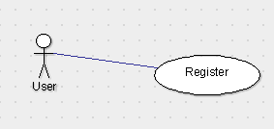

REQ-1: Username should be alphanumeric and unique. Username not satisfying this criteria will make the username box render as red which will indicate the error and the user will have to change the username to satisfy the requirement.

REQ-2: Password should have at least 8 character comprising:

* at least one capital letter
* at least one small letter
* at least one number
* at least one symbol and,
* should not contain space

REQ-3: The email ID should be of the university and not of any other domain.

REQ-4: The device must have internet access in order to register themselves.

## System Feature 2 - Login

4.2.1 Description and Priority

This feature will appear if the user click on ‘Already a user?’ button. It will require credentials of the user and will redirect them into the application.

4.2.2 Stimulus/Response Sequences

The form displayed on the system will require the following details:

* Username or Email
* Password

The user will fill their respective credentials in the window then press ‘Login’ button to access the application.

4.2.3 Functional Requirements

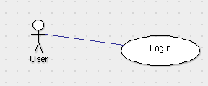

REQ-1: Credentials must be valid and the user should be registered.

REQ-2: Device should be connected to the internet.

## System Feature 3 - Logout

4.3.1 Description and Priority

Logs the user out of the application.

4.3.2 Stimulus/Response Sequences

Once the user clicks on ‘Logout’ button they will be redirected to the ‘Login’ page of the application.

4.3.3 Functional Requirements

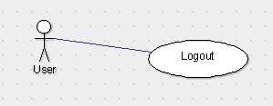

REQ-1: Device should be connected to the internet

## System Feature 4 - Room Search by room number

4.4.1 Description and Priority

Searches for room based on the room number provided by the user in the form.

4.4.2 Stimulus/Response Sequences

The screen will display a form which will require the room number to search in the building for the metadata of the room.

4.4.3 Functional Requirements

REQ-1: The room number should be valid and present in the database.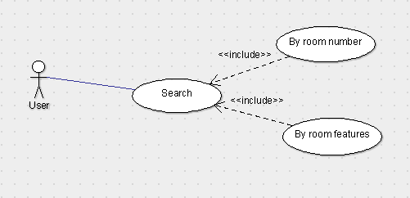

REQ-2: To get the latest metadata of a room the device must be connected to the internet

## System Feature 5 - Search for room based on features

4.5.1 Description and Priority

Searches for room based on the features selected by the user in the database of the application and then displays the room number that matches the criteria.

4.5.2 Stimulus/Response Sequences

The user will be required to select features from the given options like:

* Washroom vicinity
* Water dispenser vincity
* Activity room facility(TT room, Gym, Common Room, etc)
* Wifi signal Strength
* Cell Phone signal strength(Carrier Wise)
* View from room window
* Room Structure
* Location
* Room type(Single,Double or Triple)

4.5.3 Functional Requirements

REQ-1: The user shall select atleast one features to populate the list in the application. If not, then the application will show a dialog box asking to select a feature.

REQ-2: The device should be connected to the internet.

## System Feature 6 - View Room Structure

4.6.1 Description and Priority

This will show the 3D preview of rooms based on their types. User will also have the option to see a sample 360° photo of the selected room type.

4.6.2 Stimulus/Response Sequences

User will have two options to preview the room:

* 3D
* 360° photo view

The user will be required to select one feature to preview.

4.6.3 Functional Requirements

REQ-1: The user should select the mode in which he/she want to preview the room structure.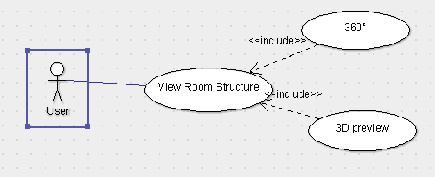

## System Feature 7 - Signal Test

4.7.1 Description and Priority

User will have an option to test their cell phone signal strength, Wifi strength, Wifi internet speed and submit it to the database for verification as per their current location. The test results submitted to the database will be first verified by the admins and then will be updated on the application.

4.7.2 Stimulus/Response Sequences

Application will require certain permission to acquire signal tests and strength of their device. The second button will test their wifi internet speed. Submit button will send all the results of the test conducted by the user to the database which will then be verified by the admins. The user can cancel the test anytime even after carrying out the test if they don't want to submit the results to get it verified.

4.7.3 Functional Requirements

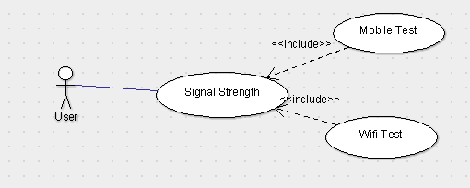

REQ-1: The user will be asked certain permission to:

* get sim strength
* wifi strength
* internet speed

The user should give the permission to the application in order to conduct the test.

REQ-2: The user must be connected to wifi in order to test the wifi strength and internet speed.

REQ-3: The user must be connected to the internet to submit the test results.

## System Feature 8 - Giving Feedback for a room

4.8.1 Description and Priority

Providing the user, the option to comment on the rooms they stayed in their previous years, about the quality and other important details that makes every room unique.

4.8.2 Stimulus/Response Sequences

The process will take in input from the user about their past experiences of their room along with their room number and gets listed in the review section.

4.8.3 Functional Requirements

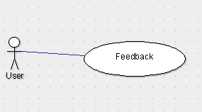

REQ-1: The user must have stayed in that particular room in order to give feedback for the room.

REQ-2: Device must be connect to the internet in order to submit the feedback to the database.

## System Feature 9 - Free roam

4.9.1 Description and Priority

Being one of the main feature of our application is being able to control your character as per your controls using the on screen directionals keys. Being able to explore the environment within the boundaries of the Hostel.

4.9.2 Stimulus/Response Sequences

As the character is free to move anywhere within the boundaries with the help of directional keys present at the right side of the screen and the view angle changer at the left side of the screen.

4.9.3 Functional Requirements

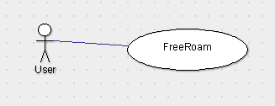

REQ-1: TBD

## System Feature 10 - View Metadata of the rooms

4.10.1 Description and Priority

Provides the user the option to read the comments submitted by the previous user and display those test results that has been updated frequently by the admins.

4.10.2 Stimulus/Response Sequences

The user is to supposed to enter the room number and press the enter button in order to view the comments and the updated test results. And if the room number is not a valid number, a dialog box appears displaying an error “Invalid Room Number”.

4.10.3 Functional Requirements

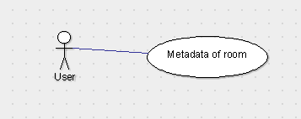

REQ-1:The device must be connected to the internet to fetch the data from the database.

REQ-2:The room number should be a valid one.

## System Feature 11 - Know your Neighbor

4.11.1 Description and Priority

This feature provides the user to know the owner of a particular room in case if the room owner has registered themselves according to System Feature 11.

4.11.2 Stimulus/Response Sequences

When the user drives his character in front of any room, it would display the residents of that particular room in a box, with their programme and batch.

4.11.3 Functional Requirements

REQ-1:The device must be connected to the internet to fetch the data from the database.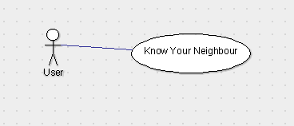

REQ-2:The user should have opted for this feature to know their nearby residents.

## System Feature 12 - Bug Report

4.12.1 Description and Priority

This feature provides the user to report any glitches or bugs present in the current version of the application, which would be fixed in the upcoming update.

4.12.2 Stimulus/Response Sequences

When the user clicks on the “Bug Report” option, a form would pop up. A drop down list for categorizing the issue would be at the start. As user selects the option from the drop down list an empty space is provided to report about the issue. And if no category option is selected from the user, it would be selected as “Other issues”. And a submit button to send the report to the admins for immediate fix.

4.12.3 Functional Requirements

REQ-1: The device must be connected to the internet to submit the report to the admins.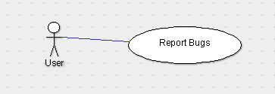

REQ-2: There should be some content in the message box.

# Other Nonfunctional Requirements

## Performance Requirements

5.1.1. System Resource Consumption

Resource consumption of this application should not reach an amount that renders the mobile device unusable. The application should be capable of operating in the background should the user wish to utilize other applications.

5.1.2. Prominent,Usage Search feature

The search feature should be prominent and easy to find for the user. The different search options must be evident, simple and easy to understand.

5.1.3. System dependability

The fault tolerance of the system, if the system losses the internet connection or the system gets some strange input, the user should be informed about the change.

The system should respond to each user input within 2 seconds. There are no other performance requirements.

## Safety Requirements

To ensure that no data is being stored except after the registration is done. The software will meet all of the functional requirements without any unexpected behavior. At no time

should the output display any incorrect or outdated information without alerting the user to potential errors.

## Security Requirements

There are no specific security and privacy requirements, other than those generally governing use of students, teachers and parents login account in NIIT University.

## Software Quality Attributes

NU Hosel Tour provides the user with simple features. Due to its well designed and easy to use interface it can be used by both experts and typical users. However, users must have the basic knowledge of controlling a character and differentiating between the icons previewed during the Tour.

## Business Rules

All the database information including the metadata, signal strength test results, model data, bug reports info will be accessible to the admins only. The user will only be able to see the metadata, conduct test, report bugs and see the model.

# Other Requirements

**Appendix A: Glossary**

**.apk**: The file extension of an Android application.

**Apps:** Short for "applications." The programs you download and run on a smartphone. Can be free, or for sale.

**Keyboard:** Either "physical" or "on-screen," depending on the phone.

**Services:** Portions of code that run in the background to provide content and services to applications.

**Operating System:** An operating system is the software that manages computer hardware and software. In other terms, it is a platform on which the app will run.

**Snapdragon:** It is a processor variant which is drives the device.

**Helio:** It is also a processor variant.

**Kirin:**  Processor variant.

**Unity:** Game development platform

**Firebase:** Realtime database

**Appendix B: Analysis Models**

**Appendix C: To Be Determined List**

1. *Section 4.9.3 - Functional Requirements*