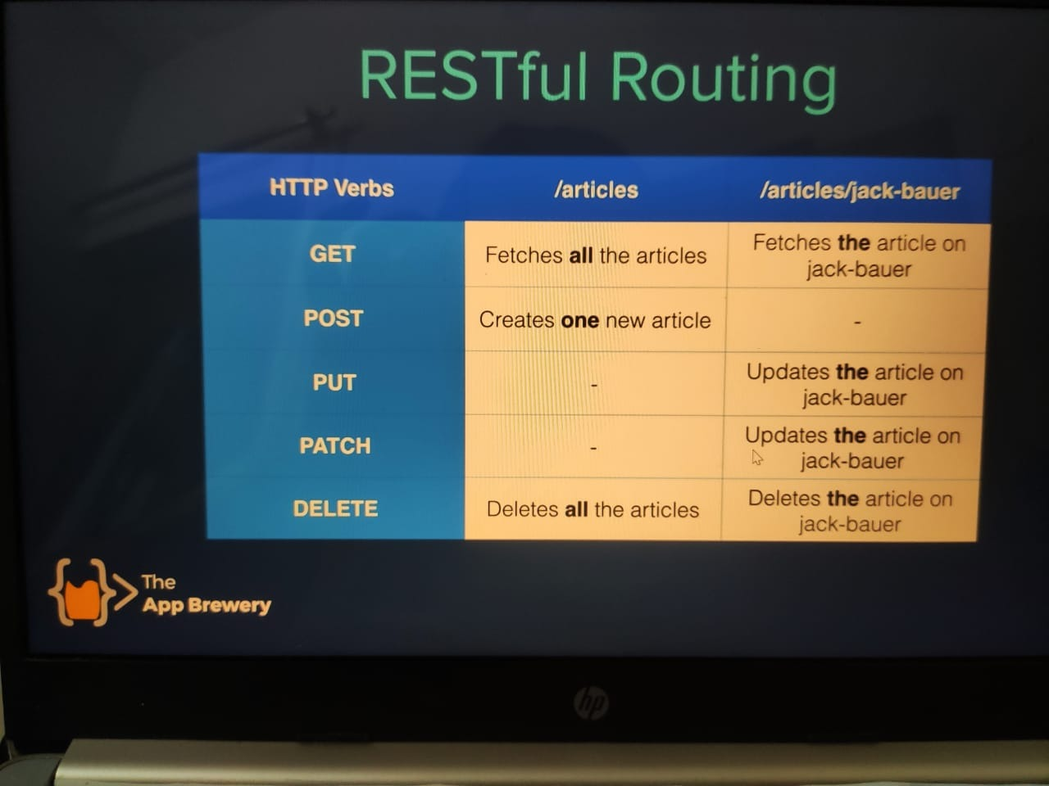

Authentication and security :

Basic type of security-



NOTE: levels commit (D:\web full stack\zz authentication and security\Authentication-Secrets) in this open readme where you will get a gitrepository link on that see all the logs ;

Their varies level of securities basically 6

Level 1: email and password for login

Level 2: password encryption using .env file and encrypt module //envirement variables

Level 3: hashing (using md5 module )//require and use it in pass word and login

In the level 3 we can add some salt (say some extra word and store in with the data with other info or create separate database for each user and add it in the pass to increase its length)

Level 4: bcrypt //this will save from static and dictonary attack

Level 5 : using passport and seesion (cookies)