The block diagram for the proposed Gesture recognition system is given below.

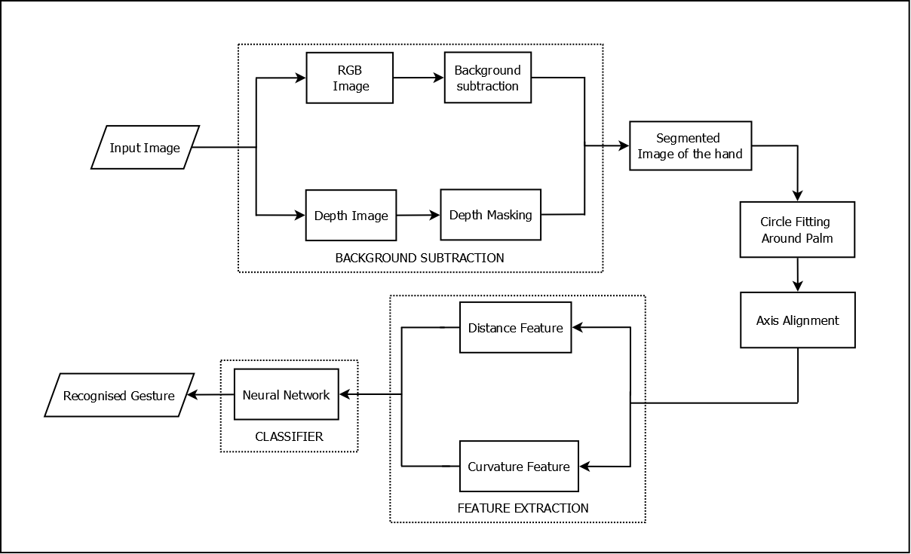

Figure 1: Architecture of the proposed Gesture recognition system

### Depth image background subtraction (Image segmentation)

This section deals with extracting the hand segment from the depth image. A block diagram of the hand segmentation process is shown below.

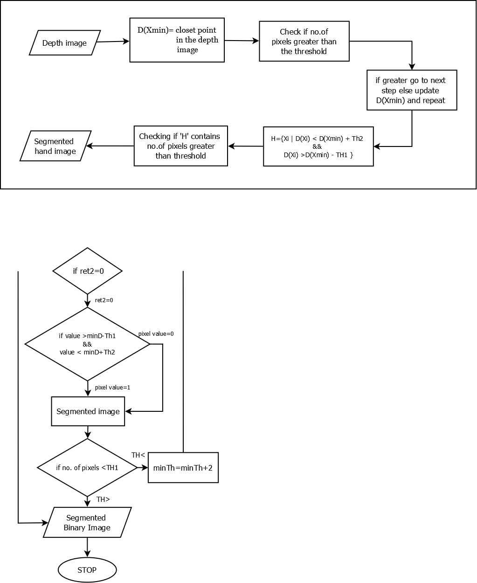

Figure 2: Flow of the depth segmentation algorithm

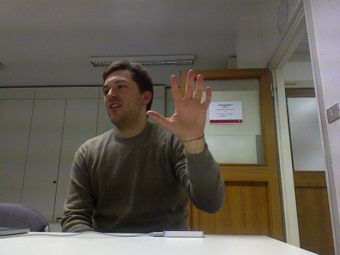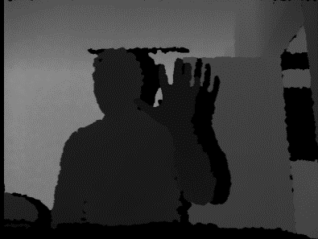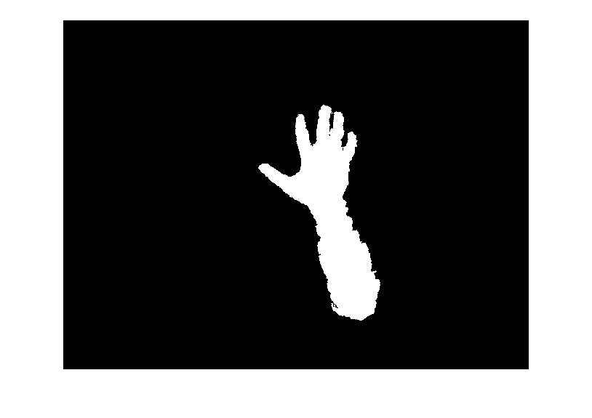

###### **a) b) c)**

Figure 3: Hand segmentation. a) Acquired colour image;

b) Acquired depth map; c) segmented hand image

In the later stages, the part of the wrist and the arm will be eliminated and only the palm and fingers will in the segmented image. Additional checks can also be used like to check whether the colour of the segmented image is similar to the skin colour or check if the height of the segemented image greater than some specifed height. Even though in the segmented image only the hand has been extracted, it has to be processed further so that it can be used for feature extraction. A very crucial step in this is estimating the center of the palm. This step forms the fundamental process for both the feature extraction process. The process of extracting the centroid is explained in the next section.

### Acquiring the hand centroid

The region of the hand extracted in the above section is used to define an indicator function on the points of ‘**H**’;

hm = 2

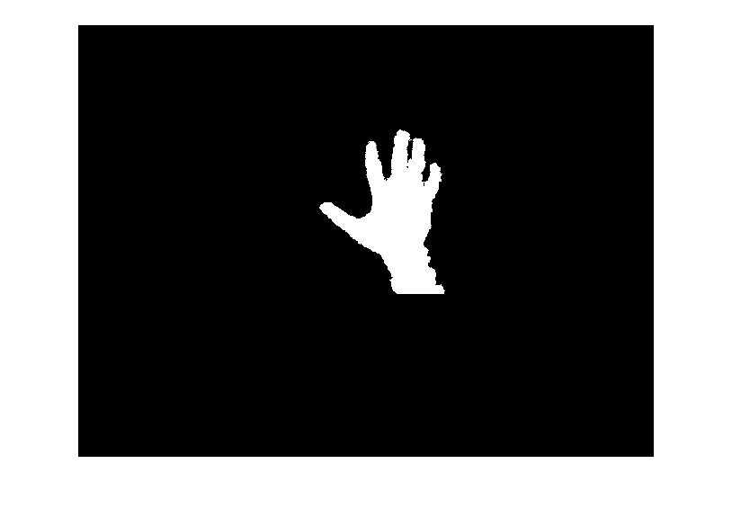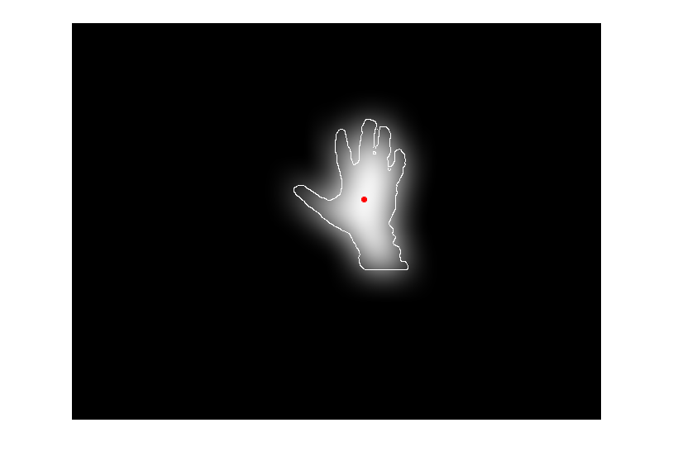

**a) b) c)**

Figure 4: Hand centroid estimation a) Acquired depth map;

b) Segmented hand; c) output of the Gaussian filtering on the segmented hand image

After filtering, the denser regions in the image become more populated with brighter pixels, whereas the pixel intensity decreases with the decrease in pixel density. The region with the brightest pixels can be approximated as the center of the palm, since the palm is larger than the forearm and the pixel density in the palm region is more than that in the finger region. But if the region of the palm is smaller than the region of the arm, there can be two spots in the image that can both qualify as the center. In such cases, the point that is nearer to closest point Xmin is selected. Once we have found the center of the palm, the next step is to segment in the hand into separate regions like the region containing fingers, the palm and the wrist.

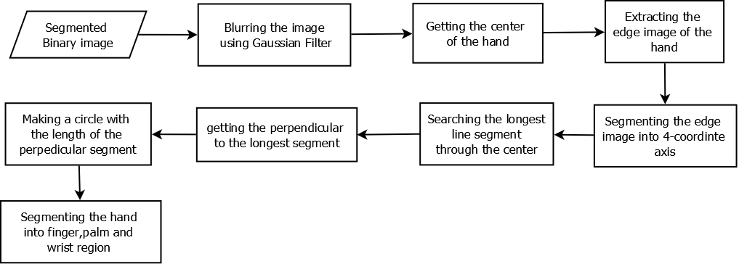

Figure 5: Flow of the centroid extraction and Axis alignment algorithm

### Axis alignment and orientation normalization

In this section, the main objective is to calculate the radius of the largest circle that can completely covers the entire region of the palm and to find the reference major and minor axis that can be used to determine the orientation of the hand.

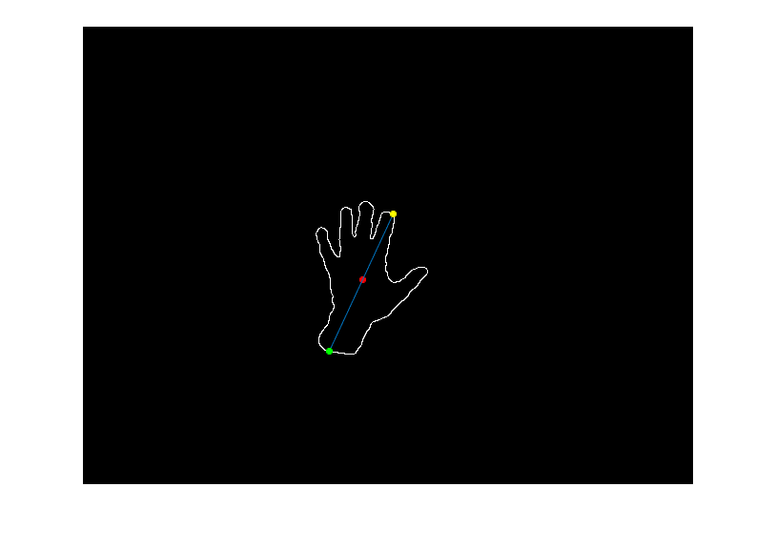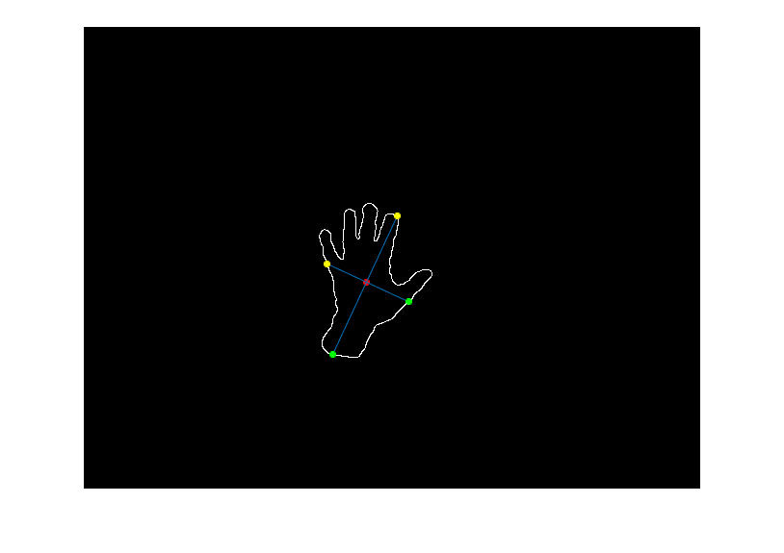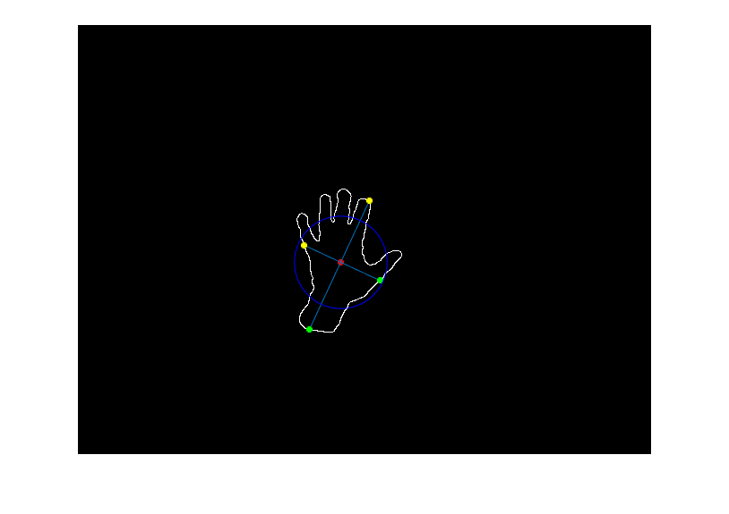

**a) b) c)**

Figure 6: Axis Orientation with the longest segment a) the longest line segment passing through the centre; b) the perpendicular to the longest segment; c) measuring the length of the perpendicular segment to evaluate the radius of the circle

The next step now is to estimate the radius of the circle that will completely cover the palm region. Since the longest line segment that passes through the center of the palm is already calculated, the next step will be to draw the perpendicular line to the major axis.

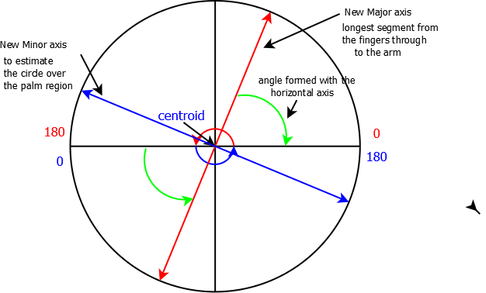

Figure 7: A description of the process of axis alignment

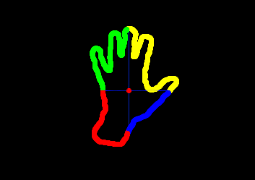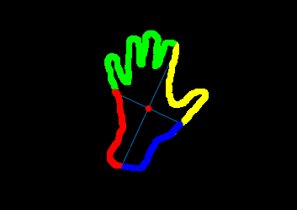

**a) b)**

Figure 8: Axis Alignment a) axis before alignment; b) axis after alignment

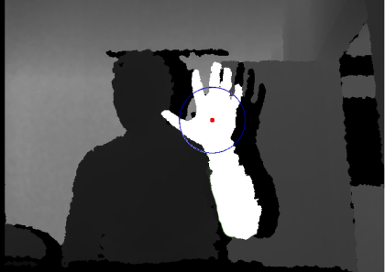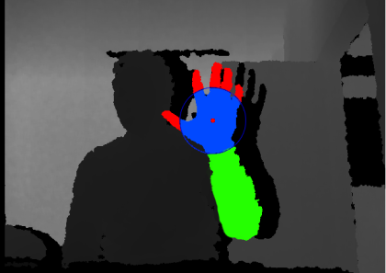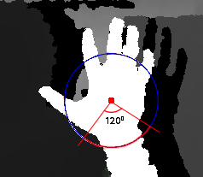

**a) b) c)**

Figure 9: Segmenting the hand into different regions; the finger region, the palm region and the wrist region

## Feature extraction

In the proposed system two sets of feature vectors are used; the distance feature and the curvature feature. The detailed description for the feature extraction for both there technique is given below.

### Distance feature

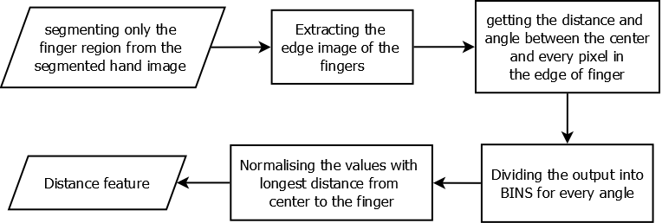

Figure 10: Flow of the distance feature extraction algorithm

The block diagram in fig.16 describes the process for the extraction of the distance feature. At this stage, as seen in fig.13.b) the segmented hand image has been split into three regions; the fingers, the palm and the wrist and the region containing the wrist have been eliminated as shown in fig.17.c). Now only the region containing the finger region is separated from the palm and the edges of this image are extracted as seen in fig. 17.a). The pixel value of the edge image of the fingers is actually the value of the angle the point is at according to the centroid of the hand. It should be noted that the angle values have been updated according to the newly formed major and minor axis as shown in fig.12.

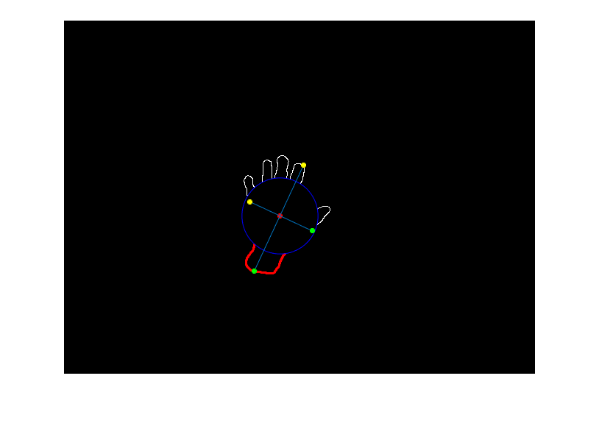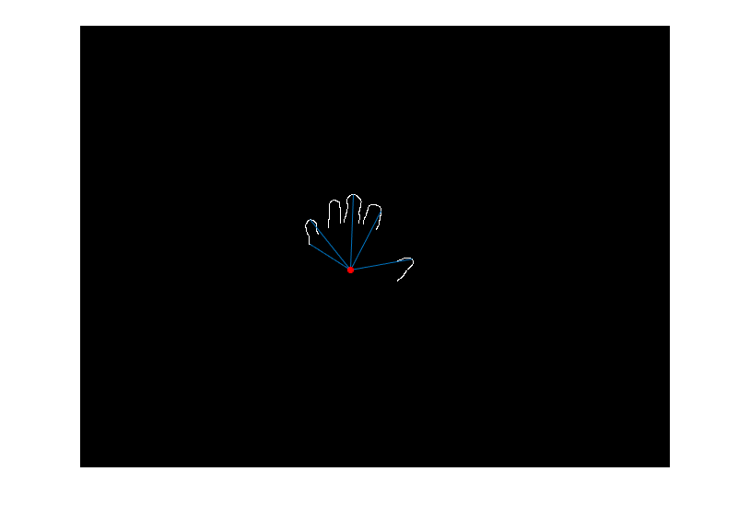

**a) b)**

Figure 11: Finger region extraction a) extraction of finger region; b) the distance between the centroid and the finger region edge pixels

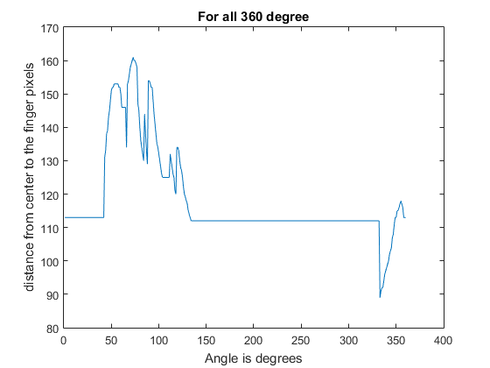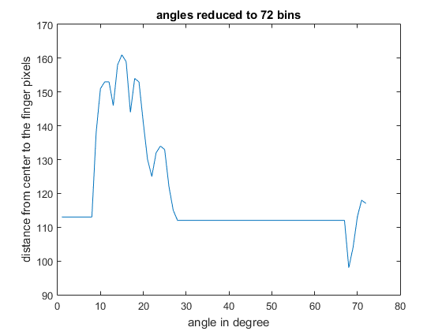

**a) b)**

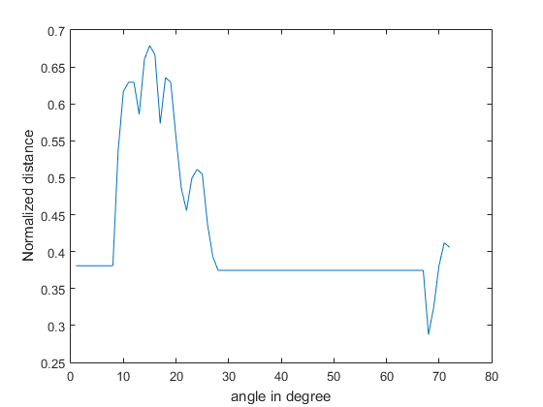

**c)**

Figure 12: Graphical representation of the distance feature (distance vs angle) a) distance for all the 3600 b) 3600 is divided into 72 equal bins, for every 5 angle only the element with maximum distance is selected; c) the distance is normalized by subtracting the radius and divided with the maximum distance value.

### Curvature features

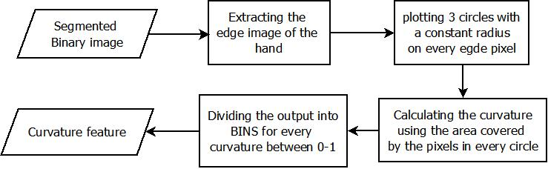

Figure 13: Flow of the curvature feature extraction algorithm

For the curvature feature extraction, the processes of axis alignment and orientation normalization are not required. The input for these features is the segmented image of the hand, which is shown in fig.9.c). The edges of the hand are extracted using the canny edge detector. Now three circles with different diameter are plotted on all the edge pixels in the image, as shown in fig.20.a). Then, the area of the circle that falls inside the region of the hand is calculated. This area is now divided by the area of the circle itself. It can be seen from fig.20.b), that the according to this ratio it can be evaluated whether the curvature of the line is convex, concave or straight.

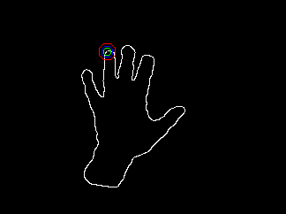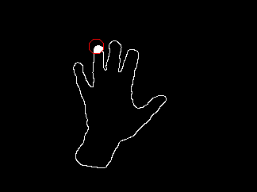

Figure 14: Description of the curvature feature extraction process a) representation of the circles on one of the edge pixel; b) the area of the hand covering the circle

Accordingly, if the ratio is less than 0.5, it can be inferred that the line inclosing that point is convex and if the ratio is greater than 0.5, then the line is concave, and if the ratio is about 0.5, then it is a straight line. In these curvature features are used for identification of plant species. Thus, there will be 3 sets of curvature values that range of 0.1 to 0.9 for each of the edge pixels. This number of edge pixels will vary for every image, but if the histogram is used with bins equally place from 0 to 1, the number of elements for the curvature feature for all the images will be the same.

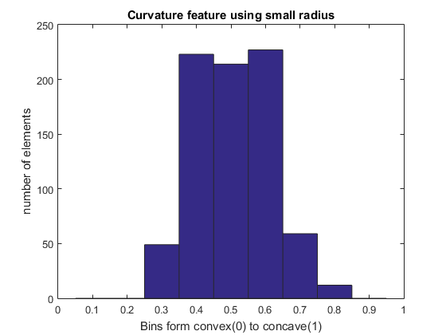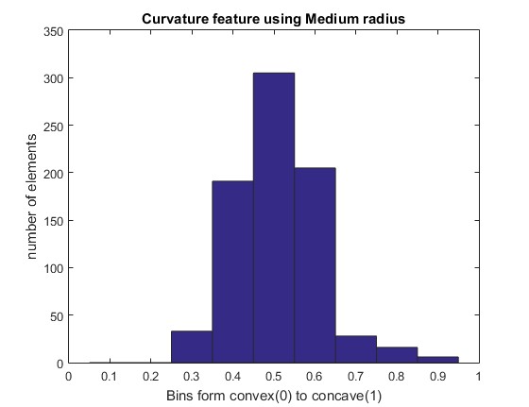

**a) b)**

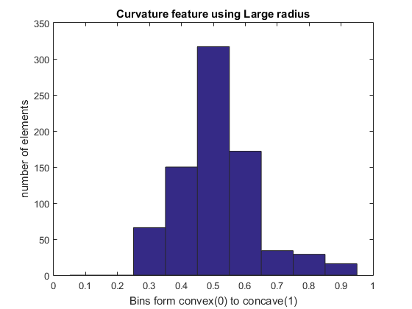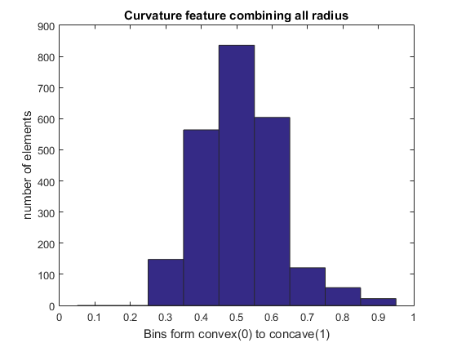

**c) d)**

Figure 15: Histogram representation of curvature feature for all 3 circle independently and the combination a) histogram of curvature feature vector for the smallest circle b) histogram of curvature feature vector for the medium circle c) histogram of curvature feature vector for the largest circle d) histogram of curvature feature vector for the concatenated feature vector

The radius of the circle in this approach is kept constant and it will be same irrespective of the image in context, but in the radius is dynamically modified according to the distance at which the hand is from the camera, this can help to make the features more robust. An example of all the gestures and the distance and feature vectors is given below.

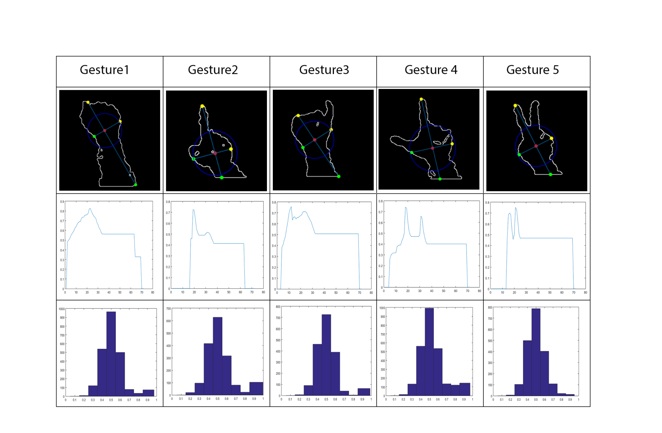

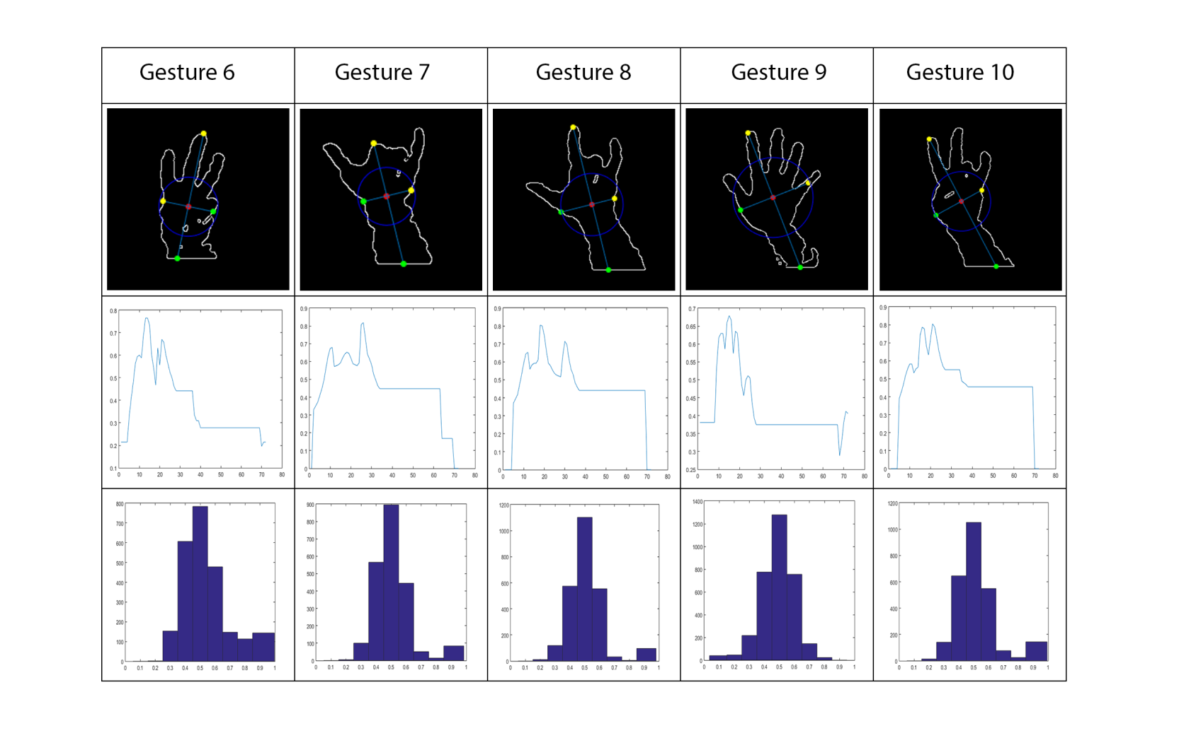

Figure 16: All the different gestures that are used and a graphical representation of the distance and curvature feature for all these gestures

**Hand segmentation:**

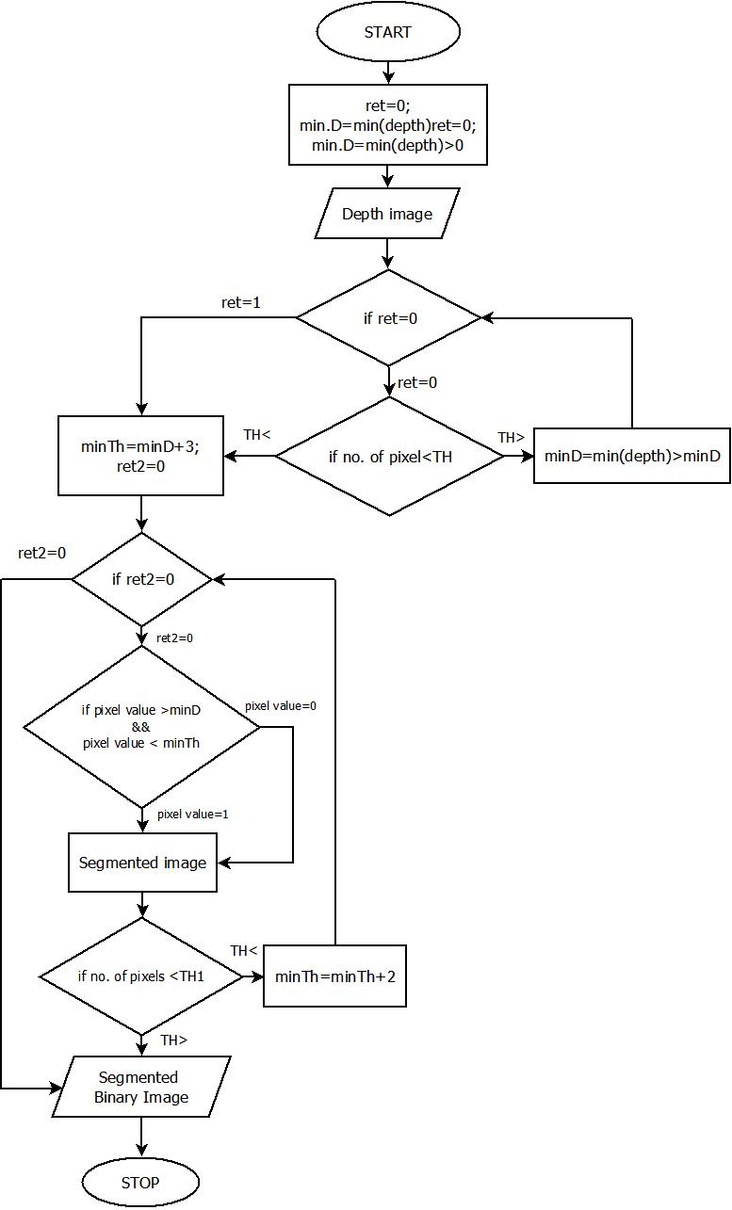

Figure 26: Flowchart for Segmentation Alogorithm