Internship Report
On
Development of a Village-Level Geographic Data API Platform
and a Nifty 100 Financial Intelligence & Business Analytics System
Submitted To
School of Computer Science and Engineering
IILM University, Greater Noida, U.P.
In partial fulfilment of the requirement of degree of
B.Tech CSE

By
Roll Number of Student: CS2341839
Name of Student: RISHABH SINGH
Batch:
2026-27

Candidate's Declaration
I, Rishabh Singh, do hereby declare that the internship report titled “Development of a Village-Level Geographic Data API Platform and a Nifty 100 Financial Intelligence & Business Analytics System” has been completed by me to fulfil the requirement for the award of the degree of Bachelor of Technology in CSE. All the references have been quoted and I have not taken as such any material from any other source. I affirm to you that this report is my own and has not been submitted to any other institute for any degree/diploma requirement and further I shall be solely responsible for any kind of copyright violation in this regard.

Student Name: Rishabh Singh
Roll No.: CS2341839

Acknowledgement
I am using this opportunity to express my gratitude to everyone who supported me throughout the Internship Program. I am thankful for their aspiring guidance, invaluably constructive criticism and friendly advice during this work. I am sincerely grateful to them for sharing their truthful and illuminating views on a number of issues related to this work.
I would like to thank my Internship Mentor and the entire team at Codveda Technologies for giving me the opportunity to work on live, production-grade projects and for their continuous support during the development of the Village-Level Geographic Data API Platform and the Nifty 100 Financial Intelligence & Business Analytics System. I am also thankful to the faculty of the School of Computer Science and Engineering, IILM University, for their guidance throughout the internship period.
I express my gratitude to my parents for their blessings.

Student Name: Rishabh Singh
Roll No.: CS2341839

3. Internship Completion Certificate
The internship offer letter issued by Codveda Technologies, confirming the internship placement of Rishabh Singh as a Data Analysis Intern, is reproduced below. The final internship completion certificate, once issued at the end of the internship, should be attached immediately after this page along with any other communication proof, as required in Section 4.10 of this report.
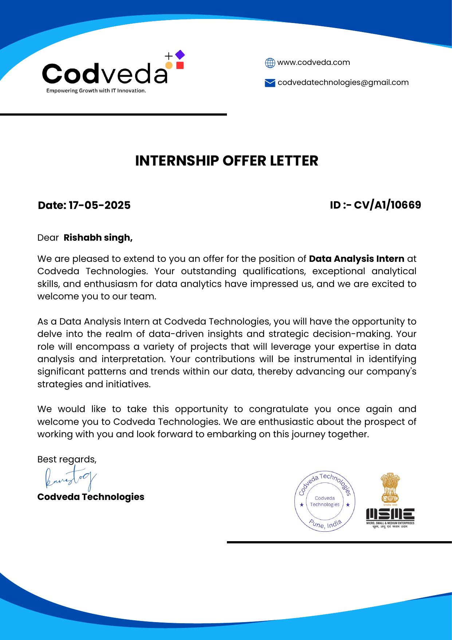

Table of Contents
Chapter No. | Chapter Name | Page Nos.
 | Cover Page | ---
1. | Candidate's Declaration | i
2. | Acknowledgement | ii
3. | Internship Completion Certificate | iii
4. | Project Description | 1
 | 4.1 Introduction | 1
 | 4.2 Organization Profile | 1
 | 4.3 Problem Statement | 3
 | 4.4 Project Objectives | 3
 | 4.5 Scope of the Project | 5
 | 4.6 Technologies and Tools Used | 5
 | 4.7 System Architecture | 7
 | 4.8 Methodology | 9
 | 4.9 Expected Outcomes | 10
 | 4.10 Certificates of Completion / Communication Proof | 10
5. | Bibliography/References | 12

4. Project Description
4.1 Introduction
This report documents the work carried out during my internship, which was structured around two parallel, production-oriented software projects. The first project, the Village-Level Geographic Data API Platform, is a Software-as-a-Service (SaaS) backend that provides India's complete village-level administrative hierarchy — State, District, Sub-District and Village — through a fast, standardized REST API intended for B2B clients building address drop-downs and autocomplete features. The second project, the Nifty 100 Financial Intelligence & Business Analytics System, is a full-stack data analytics platform covering Power BI dashboards, a Python-based ETL and machine-learning pipeline, and a Django web application/API, built around twelve years of historical financial data for India's Nifty 100 listed companies.
Although the two projects serve different domains — geospatial reference data and financial analytics — they share a common engineering philosophy: both required designing a normalized relational data model, building a robust ETL/import pipeline to load large third-party datasets, exposing the processed data through clean interfaces (REST APIs and/or dashboards), and applying performance techniques such as caching and indexing to serve data reliably at scale. Working on both projects together gave me hands-on exposure to backend engineering, data engineering, business intelligence and applied machine learning within a single internship.
The remainder of this chapter describes the organization profile, the problem each project addresses, the objectives and scope of the work, the technologies used, the system architecture, the development methodology followed, and the outcomes achieved.
4.2 Organization Profile
Codveda Technologies is a technology-driven organization working at the intersection of data infrastructure and analytics. Its engineering teams build backend platforms and data products that other businesses and analysts rely on — ranging from geospatial reference data services used by e-commerce, logistics and fintech companies for address validation, to financial data and business-intelligence tooling used by investors, analysts and research teams to evaluate publicly listed companies. The organization follows modern, cloud-native engineering practices, including serverless deployment, managed databases, containerized local development, and scheduled background processing, and encourages interns to work on real, production-bound features rather than isolated academic exercises.
During the internship, I was placed with the engineering team at Codveda Technologies responsible for these two initiatives and was involved in the design, data engineering, and implementation stages of both projects under the guidance of my mentor(s).

4.3 Problem Statement
4.3.1 Village-Level Geographic Data API Platform
- There is no single standardized, reliable source of village-level address data for Indian businesses building e-commerce, logistics or service platforms.
- Maintaining a local copy of this geographical hierarchy requires constant updates, validation and storage overhead for every business that needs it.
- Populating drop-down menus with hundreds of thousands of villages directly from a raw dataset causes poor UI performance and slow page loads.
- Address formats differ across regions and data sources, making it difficult to present a consistent address string to end customers.
4.3.2 Nifty 100 Financial Intelligence System
- Twelve years of financial data for 100 companies, exported from a legacy MariaDB source, exists only as raw, inconsistently formatted tables (e.g. year values appear as 'Mar 2024', 'Sep 2024', 'Mar-24' or 'TTM') that are not analysis-ready.
- Investors, analysts and business heads need to study company fundamentals — growth, profitability, leverage, cash flow and dividend history — without writing SQL queries themselves.
- There was no automated way to score a company's overall financial health, detect anomalies in its historical performance, or surface data-backed pros and cons for quick decision-making.
- Channel partners needed programmatic, well-documented access to the same financial data through a REST API rather than manual exports.
4.4 Project Objectives
4.4.1 Village-Level Geographic Data API Platform
- Import and normalize India's complete State → District → Sub-District → Village hierarchy from the MDDS source dataset into a relational database.
- Design and expose a REST API that returns standardized address data (Area Name (Village), Sub-District, District, State, India) suitable for autocomplete and drop-down use cases.
- Achieve sub-100ms API response times for 95% of requests through caching and database indexing.
- Support tiered subscription plans (Free, Premium, Pro, Unlimited) with API-key based authentication and per-plan rate limiting.
- Provide administrator and B2B client dashboards for user management, API key issuance, and usage analytics, targeting scalability to 1M+ daily API requests.
4.4.2 Nifty 100 Financial Intelligence System
- Build a clean, star-schema PostgreSQL data warehouse from the raw MariaDB export covering companies, balance sheets, profit & loss, cash flow, growth analysis, pros/cons and annual-report documents.
- Develop Python ETL pipelines that extract, clean, standardize and load the data, including derived metrics such as debt-to-equity, net profit margin and free cash flow.
- Design and build seven production-grade Power BI dashboards covering market overview, company deep-dive, sector comparison, financial health, growth & valuation, debt & leverage, and dividend/shareholder returns.
- Build a machine-learning-based financial health scoring engine and an automated pros-and-cons rule engine for every company.
- Expose the processed data through a Django-based public website and a REST API (documented with drf-spectacular) for channel partners.

4.5 Scope of the Project
The scope of the Village-Level Geographic Data API Platform covers the complete data pipeline from raw MDDS Excel data to a production API: data validation and import, relational schema design, backend API development (Node.js/Express), caching (Redis), authentication and rate limiting, and admin/B2B portal features. It is limited to Indian geographical data at the village level and does not, at this stage, extend to international address data beyond the schema's built-in provision for future country expansion.
The scope of the Nifty 100 Financial Intelligence System spans three parallel streams: (a) Power BI analytics dashboards for end users, (b) data engineering, ETL and Python-based analytics/ML scoring, and (c) a Django web application and REST API for channel partners. The scope is limited to the 100 companies constituting the Nifty 100 index and to the roughly twelve years of historical data provided in the source export; it does not include real-time market data or live trading functionality.
4.6 Technologies and Tools Used
4.6.1 Village-Level Geographic Data API Platform
Table 4.1: Technology stack — Geographic Data API Platform
Component | Selected Technology | Justification
Backend Runtime | Node.js + Express.js | High throughput for I/O-bound API operations
Database | NeonDB (PostgreSQL) | Serverless PostgreSQL with automatic scaling
ORM | Prisma | Type-safe database queries and schema migrations
Frontend Framework | React.js + Vite | Fast development, mature ecosystem
Charting Library | Recharts | React-native, declarative, customizable charts
Caching Layer | Redis (Upstash) | Global edge caching, low latency
Rate Limiting | express-rate-limit + Redis | Distributed rate limiting across regions
Authentication | JWT + bcrypt | Stateless, secure, scalable authentication
Hosting Platform | Vercel | Automatic deployments, edge network, serverless functions

4.6.2 Nifty 100 Financial Intelligence System
Table 4.2: Technology stack — Nifty 100 Financial Intelligence System
Category | Tool | Purpose
Primary BI Tool | Power BI Desktop + Power BI Service | All 7 analytics dashboards
DAX | Data Analysis Expressions | Calculated measures, KPIs, dynamic filtering
Power Query | Power Query (M language) | Data transformation inside Power BI
ETL Language | Python 3.11 + pandas + SQLAlchemy | Data cleaning, transformation, loading
Data Warehouse | PostgreSQL 15 | Clean star-schema warehouse consumed by Power BI
Source Database | MySQL/MariaDB (SQL dump) | Raw source financial data
Python Analytics | pandas, numpy, scipy, scikit-learn, matplotlib, seaborn | Analysis scripts and ML scoring
Python Notebooks | Jupyter Notebook | Exploratory data analysis and quick analysis
Web Framework | Django 4.2 + Django REST Framework | Public website and channel-partner API
Background Tasks | Celery + Redis | Scheduled ETL refresh and ML scoring
Visualization (Web) | Chart.js | Interactive charts on the website
API Documentation | drf-spectacular (Swagger/OpenAPI) | Channel-partner API documentation
Version Control | Git + GitHub | Code, notebooks and PBIX files
Containerization | Docker + Docker Compose | Local PostgreSQL, Redis, Django and Celery

4.7 System Architecture
4.7.1 Geographic Data API Platform — Architecture
The platform is organized into three layers. The Client Layer consists of the Admin User and B2B Client React single-page applications and a Demo Client contact form. All client traffic passes through an Edge Network layer, which hosts an API Gateway responsible for rate limiting (backed by Redis), JWT validation and CORS handling, followed by a set of serverless Node.js functions grouped by route prefix (/api/v1/*, /api/admin/*, /api/b2b/* and /api/auth/*). The Data Layer consists of the NeonDB PostgreSQL database, which stores the geographic hierarchy (State, District, Sub-District, Village) along with User, ApiKey and ApiLog tables, working alongside a Redis cache used for API keys, rate-limit counters, session data and query caching.
Table 4.3: API request flow
Step | Action
1 | Client sends request with API Key header
2 | Edge gateway validates API key format
3 | Rate limiter checks Redis for daily usage
4 | Authentication middleware validates key + secret
5 | Request routed to the appropriate handler
6 | Database query executed (served from cache where available)
7 | Response formatted with standardized address
8 | API log asynchronously recorded
9 | Response returned to client

The database follows Third Normal Form (3NF): a Country table sits at the root of the hierarchy, with State, District, Sub-District and Village tables each carrying a foreign key to their parent, which eliminates duplicate data and supports efficient hierarchical queries and future international expansion.
Table 4.4: Entity relationship summary
Table | Purpose | Foreign Key To
Country | Root of hierarchy | –
State | State-level data | Country.id
District | District-level data | State.id
SubDistrict | Block/Taluka level | District.id
Village | Village/area level | SubDistrict.id
User | B2B client accounts | –
ApiKey | API credentials | User.id
UserStateAccess | Access control | User.id, State.id
ApiLog | Usage tracking | ApiKey.id, User.id

Performance is achieved primarily through indexing: a trigram index on Village.name for fast text search, foreign-key indexes on SubDistrict, District and State for efficient joins, a composite index on ApiLog (createdAt, userId) for time-series analytics, and a unique index on ApiKey.key for authentication lookups.
4.7.2 Nifty 100 Financial Intelligence System — Architecture
This system is built around a star-schema data warehouse in PostgreSQL. Dimension tables — dim_company, dim_year, dim_sector and dim_health_label — describe the entities being analyzed, while fact tables — fact_profit_loss, fact_balance_sheet, fact_cash_flow, fact_analysis, fact_ml_scores and fact_pros_cons — store one row per company per year (or per scoring run) for each financial statement. Power BI connects directly to this warehouse and all seven dashboards are built on a single shared data model, with fact tables joined to dim_company (via symbol) and dim_year (via year_id) using many-to-one relationships, and dim_company joined to dim_sector for sector-level roll-ups.
Upstream of the warehouse sits a three-stage Python ETL pipeline: an extraction script parses the raw MariaDB SQL dump into per-table CSV files; a cleaning/transformation script standardizes inconsistent year labels, parses the analysis table's compound growth strings, handles null values, cleans company names, classifies each company into a sector, and computes derived metrics such as debt-to-equity and free cash flow; and a loading script performs an idempotent, upsert-based load of dimension tables followed by fact tables into the warehouse, with data-quality checks run after every load. A Django + Django REST Framework application sits alongside the warehouse to serve the public website and the channel-partner API, with Celery and Redis used to run the ETL refresh, health-scoring and anomaly-detection jobs on a daily and weekly schedule.

4.8 Methodology
4.8.1 Geographic Data API Platform — Data Import Methodology
The import of roughly 600,000 rows of MDDS village-level data was carried out in four phases. Phase 1 (Environment Setup) provisioned the NeonDB PostgreSQL instance and installed the Python dependencies (pandas, psycopg2, openpyxl). Phase 2 (Data Validation) verified that column headers matched the expected schema, checked for null values in required fields, and identified duplicate or malformed codes. Phase 3 (Incremental Import) inserted or verified the Country record for India, then upserted State, District and Sub-District records — deduplicating by code and linking each level to its correct parent — before batch-inserting Village records in chunks of 5,000. Phase 4 (Verification) ran count queries against expected totals, spot-checked random villages for correct hierarchy placement, and confirmed there were no orphaned records. Any failed rows were logged with reason codes, processing continued past non-fatal errors, and a manual review queue was maintained for ambiguous records.
4.8.2 Nifty 100 System — Development Methodology
Development followed a data-first methodology: the warehouse and ETL pipeline were built and validated before any dashboard or API work began, since every downstream deliverable depends on it. Within the ETL stage, work was organized as three standalone Python modules (extract → clean/transform → load) so that each stage could be tested and re-run independently and idempotently. Exploratory data analysis was carried out first in Jupyter notebooks (distribution analysis, correlation checks, null-value and outlier analysis) to validate data quality before it was used to train or calibrate the health-scoring model. The financial health score itself was developed iteratively: dimension-level scores (profitability, growth, leverage, cash-flow quality, dividend track record and growth trend) were computed and weighted, then cross-validated by manually checking well-known companies (e.g. TCS, HDFCBANK, WIPRO) to confirm the scores were directionally sensible, followed by a sensitivity analysis on the dimension weights. Power BI dashboards were then built dashboard-by-dashboard on top of the validated warehouse and a shared library of reusable DAX measures, and the Django application and REST API were developed last, consuming the same warehouse and exposing it through documented endpoints. Scheduled Celery tasks (daily ETL refresh, health scoring, pros/cons generation; weekly anomaly and trend detection) were added to keep the warehouse and dashboards current without manual intervention.
4.9 Expected Outcomes
4.9.1 Geographic Data API Platform
- A fully normalized database covering all Indian states, districts, sub-districts and villages, imported from the MDDS source.
- A production REST API returning standardized address data with sub-100ms response times for 95% of requests.
- Tiered subscription plans with JWT authentication, API-key/secret validation and Redis-backed rate limiting.
- Admin and B2B portal dashboards for user management, API key issuance and usage analytics.
- A platform architecture capable of scaling to 1M+ daily API requests.
4.9.2 Nifty 100 Financial Intelligence System
- A clean, query-ready star-schema PostgreSQL warehouse covering 100 companies and roughly twelve years of financial history.
- Seven production-grade Power BI dashboards (Executive Market Overview, Company Deep Dive, Sector Comparison Analyzer, Financial Health Scorecard, Growth & Valuation Analytics, Debt & Leverage Monitor, and Dividend & Shareholder Returns) usable without writing SQL.
- An ML-based financial health scoring engine with EXCELLENT/GOOD/AVERAGE/WEAK/POOR labels and an automated pros-and-cons rule engine for every company.
- A Django public website and a documented REST API for channel partners, refreshed automatically through scheduled Celery tasks.
4.10 Certificates of Completion and Other Communication Mail Proof
The internship offer letter issued by Codveda Technologies is attached in Section 3 of this report. The internship completion certificate, along with any other supporting communication proof such as the internship confirmation email or relieving letter, should be attached immediately after this page before final submission, in accordance with the university's report format requirements.

5. Bibliography/References
1. Node.js Foundation. Node.js Documentation. https://nodejs.org/en/docs
2. Express.js. Express — Node.js Web Application Framework. https://expressjs.com/
3. Prisma Data Platform. Prisma ORM Documentation. https://www.prisma.io/docs
4. Neon, Inc. Neon Serverless Postgres Documentation. https://neon.tech/docs
5. Redis Ltd. / Upstash. Redis Documentation. https://redis.io/docs/
6. React. React Documentation. https://react.dev/
7. Vercel Inc. Vercel Documentation. https://vercel.com/docs
8. Ministry of Panchayati Raj, Government of India. Mission Antyodaya / MDDS Codes for Indian Administrative Divisions.
9. Microsoft Corporation. Power BI Documentation. https://learn.microsoft.com/power-bi/
10. Django Software Foundation. Django Documentation. https://docs.djangoproject.com/
11. Django REST Framework. DRF Documentation. https://www.django-rest-framework.org/
12. Celery Project. Celery Documentation. https://docs.celeryq.dev/
13. PostgreSQL Global Development Group. PostgreSQL 15 Documentation. https://www.postgresql.org/docs/15/
14. NumFOCUS. pandas Documentation. https://pandas.pydata.org/docs/
15. scikit-learn developers. scikit-learn Documentation. https://scikit-learn.org/stable/
16. National Stock Exchange of India (NSE) and BSE Ltd. — Company financial statement references for Nifty 100 constituents.

