Task and Algorithm | Uniqueness | Explanation | Case Study
Image Processing: Gaussian Blur | Smooths images by reducing noise. | Helps make images clearer by blurring fine details. | Used in medical images for better visibility.
Image Processing: Histogram Equalization | Enhances image contrast for better visibility. | Adjusts brightness across the image for improved clarity. | Applied in satellite images for land analysis.
Image Processing: Canny Edge Detection | Detects edges with high accuracy. | Uses multiple steps to find strong edges effectively. | Utilized in self-driving cars for lane detection.
Feature Detection: SIFT | Finds features that are scale and rotation invariant. | Identifies key points that remain consistent under transformations. | Used in 3D modeling of buildings from photos.
Feature Detection: SURF | Fast detection of robust features in images. | Offers quicker processing while still finding important features. | Employed in stitching images for panoramas.
Feature Detection: ORB | Efficient and quick feature detection. | Combines speed and effectiveness for real-time applications. | Implemented in real-time facial recognition.
Object Detection: YOLO | Real-time object detection in a single pass. | Analyzes the entire image in one go for immediate results. | Deployed in surveillance systems for spotting intruders.
Object Detection: Faster R-CNN | Accurate detection by focusing on specific regions. | Uses region proposals to improve accuracy in finding objects. | Used in medical imaging to detect tumors.
Object Detection: SSD | High-speed detection of multiple objects. | Detects objects at different sizes in a fast manner. | Implemented in drones for tracking moving objects.
Image Segmentation: U-Net | Effective for image segmentation with a clear structure. | Designed specifically for segmenting images into meaningful parts. | Applied in biomedical image analysis for cell detection.
Image Segmentation: Mask R-CNN | Provides detailed masks for individual objects. | Creates precise outlines of objects in an image. | Used in self-driving cars for environment understanding.
Image Segmentation: FCN | Achieves pixel-level segmentation in images. | Treats image segmentation as a classification task for each pixel. | Utilized in satellite imagery for land use classification.
Image Classification: CNN | Core model for image classification using layers. | Learns to recognize patterns through multiple processing layers. | Applied in image recognition for social media.
Image Classification: ResNet | Uses skip connections to improve learning in deep networks. | Helps prevent issues with training very deep networks. | Used in facial recognition for user authentication.
Image Classification: VGG | Simple architecture that performs well on image tasks. | Provides a straightforward structure that’s easy to implement. | Used in visual search engines for product identification.

Task | Memory Trick
Image Processing | Think of Gaussian Blur as "softening the image" and Histogram Equalization as "leveling brightness like a field." Remember Canny Edge Detection as "Can see edges clearly."
Feature Detection | SIFT is "Scale Invariant Feature Transform," and SURF is "Surf quickly over images." ORB is "round and quick."
Object Detection | YOLO means "You Only Look Once" for quick detection, while SSD is "Single Shot Detector." Faster R-CNN is "Faster region proposals."
Image Segmentation | U-Net is "U" shape for its design, and Mask R-CNN "creates outlines for objects." FCN means "Fully Connected" for every pixel.
Image Classification | CNN stands for "Layers of learning," ResNet uses "Residual connections," and VGG is "simple and effective structure."

Task | Algorithm | Uniqueness | Case Study 1 | Case Study 2
Optical Flow and Motion Analysis | Lucas-Kanade Method | Tracks movement by looking at changes in pixels. | Used in video editing to smooth out shaky footage. | Helps security cameras follow moving people.
 | Horn-Schunck Method | Creates smooth motion by looking at the entire image. | Helps self-driving cars see and follow lanes. | Used in sports to analyze player movements.
Face Recognition | DeepFace | Uses deep learning for very accurate face matching. | Facebook uses it to tag friends in photos. | Security systems use it to allow or deny access.
 | FaceNet | Compares faces using special mathematical tools. | Google Photos sorts pictures by recognizing faces. | Mobile apps use it for unlocking phones.
Image Generation | Generative Adversarial Networks (GANs) | Creates realistic images by having two models compete. | Artists use it to generate new types of artwork. | Fashion designers create new clothing styles.
 | StyleGAN | Generates high-quality images with specific styles. | Video games use it for creating realistic characters. | Ads use it to make unique product images.
Tracking Algorithms | Kalman Filter | Predicts the location of moving objects over time. | Robots use it to know where they are going. | Augmented reality apps track user movements.
 | Deep SORT | Uses deep learning for better object tracking. | Self-driving cars track people and other cars. | Sports broadcasts track players during games.
Optical Character Recognition (OCR) | Tesseract | Open-source tool that reads text from images. | Companies use it to digitize printed papers. | Apps use it to scan and translate text instantly.
 | CRNN | Combines different models to read text in images. | Used to pull text from scanned documents. | Analyzes videos to read and subtitle text on screen.
Ocr->tensor-act(c-rnn) track-kal+mansort
Here’s the table with an additional column for the modern technologies used in each case study:

Task | Case Study 1 | Case Study 2 | Case Study 3 | Technology Used
Text Generation | A marketing team used GPT-3 to create catchy slogans for their products. | A novelist used GPT-3 to generate character dialogues, enriching the story. | A game developer used LLMs to create immersive narratives for video games. | GPT-3, OpenAI API
Text Classification | An e-commerce site classified customer reviews into positive, negative, and neutral. | A news aggregator used LLMs to sort articles by topics like politics, sports, and technology. | A spam filter used text classification to detect and block unwanted emails. | BERT, DistilBERT
Question Answering | A customer service bot provided instant answers to common questions about products. | A medical app answered patient inquiries based on trusted health resources. | An educational platform used LLMs to answer student questions about course material. | RoBERTa, ALBERT
Language Translation | A travel app translated local restaurant menus into multiple languages for tourists. | A multinational company translated its employee handbook for global staff. | An online learning platform provided translations of courses to reach a wider audience. | Marian NMT, mBART
Summarization | A news website used LLMs to summarize long articles, giving readers quick updates. | A research tool summarized academic papers, helping users grasp key findings. | A corporate dashboard provided summaries of performance reports for quick reviews. | T5, GPT-3
Sentiment Analysis | A brand analyzed social media mentions to understand customer feelings about new products. | A movie studio gauged audience reactions to trailers to shape marketing strategies. | A retailer assessed customer feedback to improve service and product offerings. | LSTM, VADER
Chatbots and Virtual Assistants | A financial institution implemented a chatbot to assist customers with banking inquiries. | A healthcare provider used a virtual assistant to schedule appointments and answer FAQs. | An e-commerce site employed a chatbot to guide users through the shopping process. | Dialogflow, Rasa
Content Personalization | A streaming service recommended shows based on viewer preferences and watch history. | An online bookstore personalized reading suggestions using user behavior data. | A news app tailored articles based on user interests and reading habits. | Collaborative Filtering, TensorFlow
Data Extraction | An HR tool extracted key information from resumes, such as skills and work experience. | A legal firm used LLMs to pull relevant clauses from contracts for quick reviews. | A research organization extracted data from surveys for analysis and reporting. | Named Entity Recognition, SpaCy
Text Simplification | An educational app simplified complex scientific articles for younger audiences. | A public health campaign rewrote health guidelines into clear language for broader understanding. | A legal service provided simplified documents to help clients understand their rights and options. | TextRank, SimpleNLP
+ make class answer translate into chat, simplify, extract

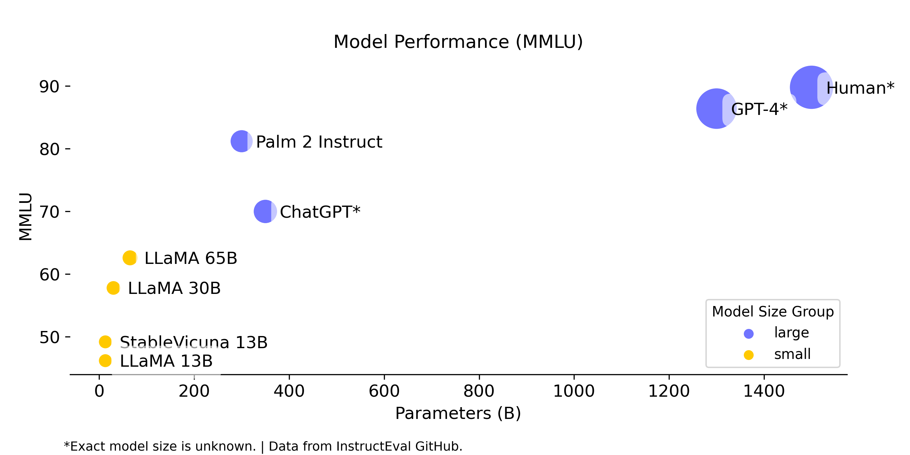
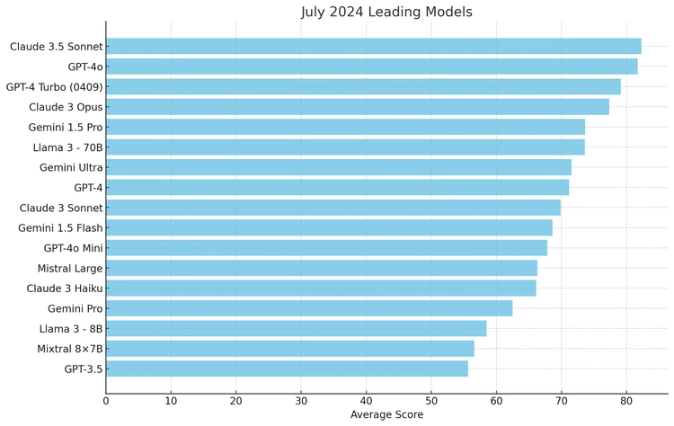
Falcon 180b

Transformers are a type of model architecture in machine learning that has significantly impacted natural language processing (NLP) and beyond. Here’s an overview of the Transformer architecture, its components, and its applications:

Key Features of Transformers
- Attention Mechanism:
  - Transformers utilize a self-attention mechanism that allows the model to weigh the importance of different words (or tokens) in a sequence. This is crucial for capturing long-range dependencies without relying on sequential processing.
- Parallel Processing:
  - Unlike recurrent neural networks (RNNs), which process tokens sequentially, Transformers process all tokens in parallel. This leads to faster training times and the ability to handle longer sequences effectively.
- Positional Encoding:
  - Since Transformers do not have a built-in sense of sequence order, positional encodings are added to the input embeddings to give the model information about the position of tokens in the sequence.

Transformer Architecture
The Transformer model consists of two main components:
- Encoder:
  - Composed of multiple identical layers (usually 6-12). Each layer has:
    - Multi-Head Self-Attention: Computes attention scores for each token concerning others in the input.
    - Feed-Forward Neural Network: Applies non-linear transformations.
    - Layer Normalization and Residual Connections: Helps stabilize and improve training.
- Decoder:
  - Also composed of multiple identical layers, with an additional attention mechanism to focus on the encoder's output.
  - Similar structure to the encoder, but includes:
    - Masked Multi-Head Self-Attention: Prevents the model from attending to future tokens during training.

Applications of Transformers
- Natural Language Processing:
  - Machine Translation: Models like BERT and GPT have excelled in translating text between languages.
  - Text Generation: Generating coherent and contextually relevant text, as seen in chatbots and language models.
  - Sentiment Analysis: Classifying the sentiment of text based on its content.
- Vision and Multimodal Tasks:
  - Vision Transformers (ViTs): Adapting the Transformer architecture for image classification and segmentation.
  - Multimodal Models: Combining text and image data, like CLIP and DALL-E, for tasks that require understanding both modalities.
- Reinforcement Learning:
  - Utilizing Transformers for decision-making processes in complex environments.
- Time Series Forecasting:
  - Applying the architecture to predict future values in time series data, leveraging its ability to capture temporal relationships.

Steps to Train a Custom Dataset on a Pretrained Transformer
- Prepare the Dataset:
  - Collect and label your dataset according to the specific task (e.g., classification, regression, segmentation).
  - Organize your data into training, validation, and test sets, ensuring proper labeling.
- Load the Pretrained Model:
  - Choose an appropriate pretrained Transformer model based on your task, such as BERT for text or ViT for images.
  - Initialize the model with the correct configuration for your task.
- Preprocess the Data:
  - Tokenize the text or preprocess the images to ensure they are in the correct format for the model.
  - Apply any necessary transformations, such as padding or normalization.
- Create Datasets and DataLoaders:
  - Organize your data into a suitable format for training, typically using a Dataset class.
  - Create DataLoader objects for batching and shuffling the data during training.
- Set Up Training Parameters:
  - Define the optimizer, learning rate, and any other hyperparameters necessary for training.
  - Choose a suitable loss function based on the task.
- Train the Model:
  - Fine-tune the pretrained model on your custom dataset by iterating over the training data.
  - Monitor the training process to ensure convergence and avoid overfitting.
- Evaluate the Model:
  - Assess the model’s performance on the validation dataset to measure accuracy or other relevant metrics.
  - Make adjustments as necessary based on evaluation results.
- Save the Model:
  - After training, save the model and tokenizer to disk for future use or deployment.
- Deployment or Inference:
  - Load the saved model and tokenizer to perform inference on new data or integrate into an application.

Machine Learning Type | Task | Evaluation Metrics | Description
Regression | Predicting Numbers | Mean Absolute Error (MAE) | Average distance between predicted numbers and actual numbers.
 |  | Mean Squared Error (MSE) | Average of the squares of the differences between predicted and actual numbers.
 |  | Root Mean Squared Error (RMSE) | Square root of MSE; gives error in the same units as the numbers being predicted.
 |  | R-squared (R²) | Shows how well the model explains the data; ranges from 0 (poor fit) to 1 (perfect fit).
Binary Classification | Classifying into Two Groups | Accuracy | The percentage of correct predictions out of all predictions made.
 |  | Precision | The percentage of true positives out of all predicted positives; tells how many were correct.
 |  | Recall | The percentage of true positives out of all actual positives; tells how many actual positives were found.
 |  | F1 Score | A balance between precision and recall; useful when classes are imbalanced.
 |  | Area Under the ROC Curve (AUC-ROC) | Measures how well the model can separate the two groups; higher is better.
Multi-Class Classification | Classifying into Multiple Groups | Accuracy | Same as binary accuracy but for multiple groups.
 |  | Precision (Macro/Micro) | Average precision across classes (Macro) or overall precision (Micro).
 |  | Recall (Macro/Micro) | Average recall across classes (Macro) or overall recall (Micro).
 |  | F1 Score (Macro/Micro) | Average F1 score across classes (Macro) or overall F1 score (Micro).
 |  | Confusion Matrix | A table showing correct and incorrect predictions for each class.
Clustering | Grouping Data | Silhouette Score | Measures how similar an object is to its own group compared to other groups (ranges from -1 to 1).
 |  | Davies-Bouldin Index | Lower values indicate better separation between groups.
 |  | Adjusted Rand Index (ARI) | Compares two different groupings of data; ranges from -1 (bad) to 1 (good).
Natural Language Processing | Text Classification | Accuracy | Percentage of correct classifications for text data.
 |  | Precision, Recall, F1 Score | Same definitions as in binary and multi-class but for text data.
Transformers (NLP) | Generating Text | Perplexity | Measures how well a model predicts the next word in a sentence; lower is better.
 |  | BLEU Score | Compares generated text to a reference text, often used for translation.
 |  | ROUGE Score | Measures overlap between generated and reference texts, useful for summarization.

